Design – Login

[Username-Password / OTP/ Bio]

Background

The Registration Officer/Supervisor can be used the provided ways to login to the registration client. The provided ways are Username/Password, OTP and Bio [Fingerprint/Iris/Face]. The login will be maintained by the configurable un-successful login attempts. If the RO/RS crossed the limit the same should be locked and release after the configurable login period.

The **target users** are

* Supervisor
* Officer

The key **requirements** are

* Provide login screen to validate Registration officer or supervisor credentials.
* Mode of login:
* Offline
* User id and Password

1. User has to be authenticated WRT to the login details exists in the local DB
2. The password should be converted into hashed format [SHA-256] and compare it with the data available in the db.

* Finger Print[Thumb] Authentication

1. User can provide any finger print to login to the application.
2. The finger print validation should be checked against the local DB finger print miniature/ ISO template image.

* Online
* User id and Password

1. Invoke the ‘Auth’ online service, to validate the user id and password and receive valid token id.

* OTP

1. As initial login the user can provide his UIN number to get the OTP.
2. The OTP has limited time validity and the RO/RS has to enter the OTP.
3. The OTP will be validated against the server.
4. The Resend-OTP should able to communicate the individual with the new OTP.
   * All the desired login methodologies [Password / OTP / Bio] or should be configurable. Based on this configuration the screen should be displayed.
   * Country can even enable the multifactor authentication. [Like: password and OTP based login]
   * Admin can configure the number of un-successful login attempts and the un-locking period.
   * For the each un-successful login attempts [any mode] should be captured and stored in the DB.
   * On un-successful login attempts reached, the respective user account will be locked.
   * After the un-locking period the same account will be un-locked and RO/RS can able to login.
   * If any point of time, with in the limit of un-successful attempts if the RO/RS will be able to login successfully then the un-successful attempts will be rested.

The key **non-functional requirements** are

* Security:
  + No ware we should not store the RO/RS plain text credentials or any sensitive information.
  + The password should be not stored as raw data. It should be stored in hashed format.
  + Based on the policy the password should get modified by synching with the server.
  + Don’t store the OTP data into the db.
  + Don’t pull the finger print /bio information from the server to local machine.
  + Entire Session object should be cleared off once the user log off from the application.
* Log the each state of the packet view/approve/reject/hold:
  + As a security measures the UIN or any sensitive individual information should not be logged.
* Cache:
  + The bio data shouldn’t be cached into the session object.
  + Once logged off the session object should be cleared.
* Other standard NFR, need to be taken care:
  + Logging, audit, exception handling.

**Solution**

The detailed technical process for Registration Login is provided below:

**Login API:**

* Create a UI to accept and submitted credentials from the client application.
* Create a Java component as ‘LoginController’ with ‘login’ method to accept the Defined DTO structure.
* Based on the user input check the mode of login (user id and password, OTP and fingerprint [Thumb] login).
* Create java component “ValidateUser” with ‘validate’ method to accept the Defined DTO structure.
* The validation should be performed based on the configuration.
* Check the client system is connected with internet and verify the user credentials synched job is done.
* Login with user id and password:
  + As part of the initial login to the system, the RO/RS should be in online.
  + In case system doesn’t have internet connection get the password against the user ID from DB. Then check the entered credentials are valid.
  + If the system has internet connection getTokenID from server by passing user id and password as parameter to the REST service call.
    - TBD : Identify the REST Service name.
  + Return the appropriate alert message to user based on the response as success or failure message.
* Login With OTP:
* Internet connectivity is must to login with OTP.
* Invoke the respective REST service to get the OTP from the service.
* If request for generate or regenerate OTP, respective service has to be called to generate the same.
* Then the requested and response OTP has been validated.
* Return the appropriate alert message to user based on the response as success or failure message.
* Login with Bio[Fingerprint/Iris/Photo]:
* All the Bio image [ISO template] and miniature should be available in db table.
* Capture the single finger image from the user and validate against all the fingers of a specific user. If the match reaches the threshold limit then allow the user to login.
* Capture the Iris image from the user and validate against the iris of a specific user. If the match reaches the threshold limit then allow the user to login.
* Capture the Photo image form the user and validate against the photo of a specific user. If the match happened then allow the user to login.
* Login attempts:
* Get the Admin configured number of un-successful login attempts and the un-locking time period.
* If any mode, the RO/RS login failure should be counted.
* If the RO/RS while reaching the limits, the respective account should be locked.
* The same account should be unlocked, after the un-locking period time reached.

**Logout API:**

* When user click on the ‘logout’ button in the screen, invoke the respective method in the *BaseController.logoff()* control to kill the current session context and audit the information and logout the application.
  + Refer the Session context document to know more about it.

Solution

Class Diagram

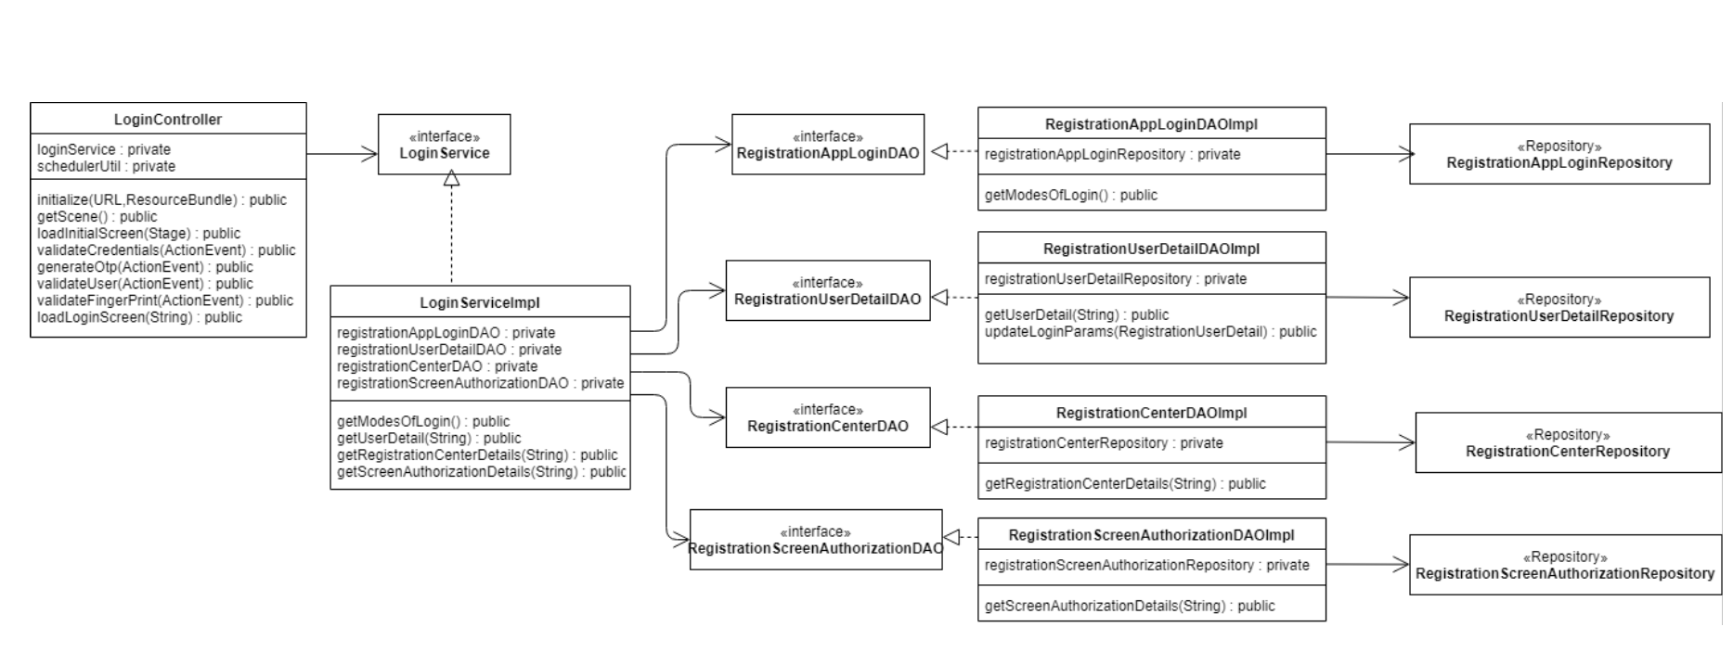

Sequence Diagram

