Design – Update UIN

# **Background**

On login successful, the user can select the “Update UIN” option in the screen if any individual requested for the same. The key requirement and respective technical design is covered below.

The **target users** are

* Individual
* Registration officer
* Registration Supervisor
* Registration Processor

The key **requirements** are

* As part of the update UIN, the individual can provide the UIN number to update corresponding the details.
* The details should be configurable from the admin configuration, while edit section based on this the editable columns should be displayed.
* While selecting, the user can choose the relevant option to update as part of the UIN.
* The individual can choose the below option to Update for UIN.
  + Name
  + Age/DOB
  + Gender
  + Address
  + Contact Details [Email/Mobile Number...]
  + Biometric-Exception [Finger Print/Iris/Face …]
  + Biometric-Iris
  + Biometric-Fingerprint
* Based on the selection the required fields should be editable.
* The capture of bio-metric should be a configurable form the admin configuration. Based on the configuration the capture should be done for the individual.
* We need to provide the information to the registration processor, regarding this update.

The key **non-functional requirements** are

* Security:
  + We should not store the RO/RS plain text credentials or any sensitive information.
  + The password should be not stored as raw data. It should be stored in hashed format.
  + The data resided in the database should be encrypted.
* Network
  + URL should be communicated using the SSL mode.
* Log the each state of the packet Yet To Receive/Received/RID Generated/Deleted:
  + As a security measures the UIN or any sensitive individual information should not be logged.
* Other standard NFR, need to be taken care:
  + Logging, audit, exception handling.

**Solution**

1. Get the required configuration to display for the Update UIN screen from the Global Configuration Parameter table.
2. Create the controller for the **RegistrtaionEditController** to display the list of the required editable section on the screen. [Provide submit method to capture the details and maintains in the Registration DTO].
3. Display the Registration Screen based on the selection of the editable fields.
4. After enter all the fields from the screen, we will call the Packet Handler service to do the rest of the process.
5. The same procedure for this follows the registration procedure only the specific fields which are editable should be captured along the packet data.
6. The **RegsitrationValdiiator** should validate the fields against the selection.
7. The **RegistrtaionController** also should displays based on the editable sections.
8. Finally the desired data will be persisted as part of the Registration /Registration Transaction tables.

Note:

The similar code which we are using the registration should be used for this, with the name as Update UIN.

As part of the packet Meta we need to provide which packet it is and the UIN number also we need to provide.

Class Diagram:

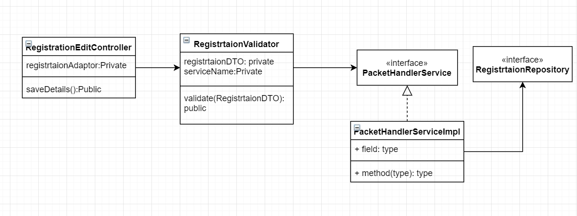

Sequence Diagram:

