**Biometric Exception Marking**

**(Wireframe 1.17)**

**Test Case Description:**

If the Biometric exception is marked in the demographic page then the Biometric exception page should be shown and let us mark the exception fingers/iris.

**Screen Shots:**

The biometric exception is turned on.

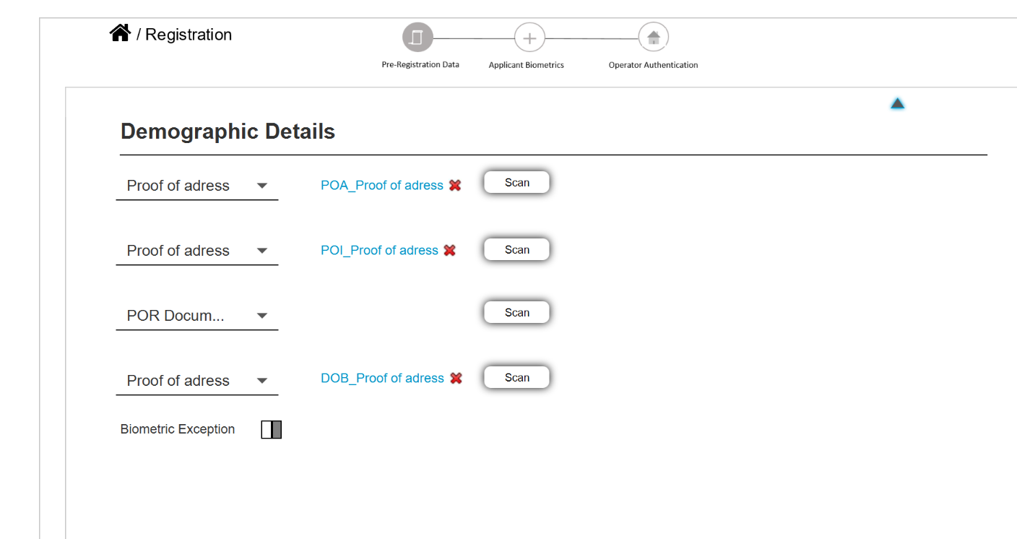

Clicking on the next button will show the Biometric exception page and we can mark the exceptions.

