TestCase : When all fields are configured for update UIN .

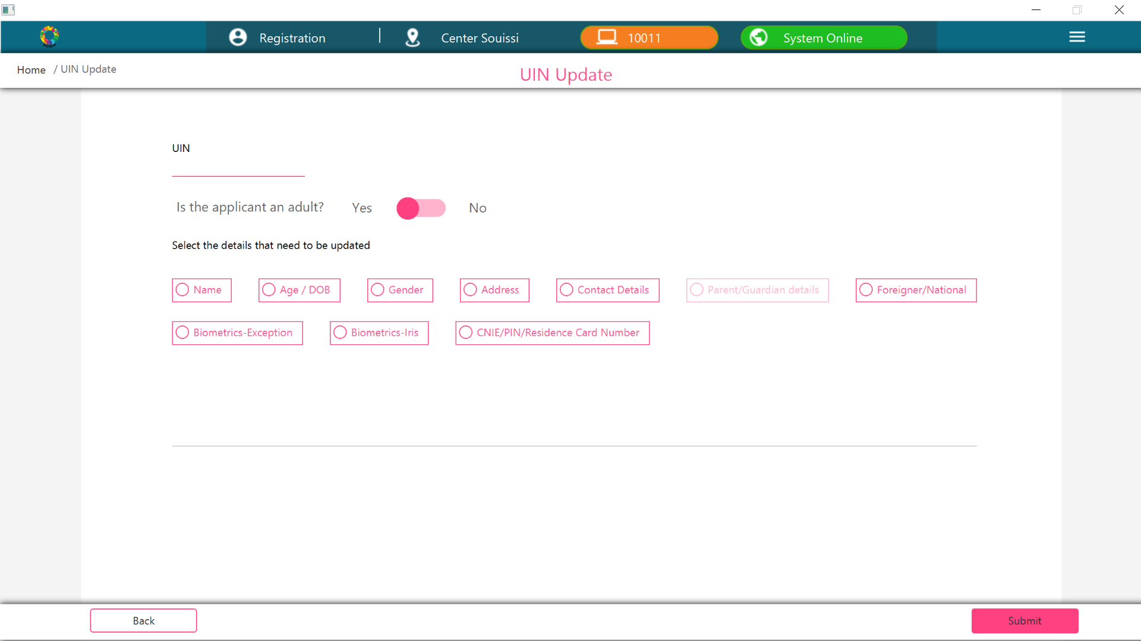

TestCase : When name,Age/DOB,Gender fields are not configured for update UIN .

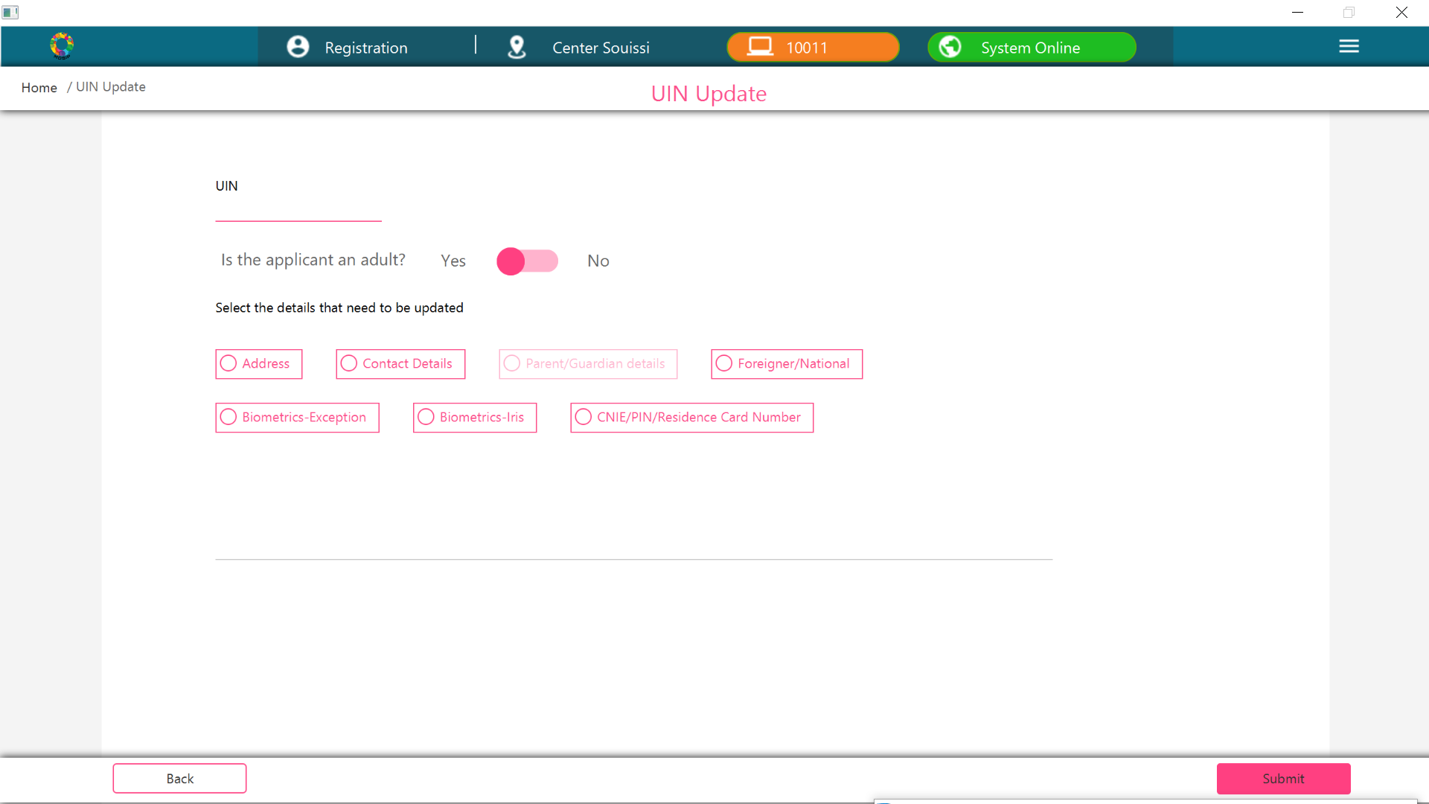

TestCase : When Address,ContactDetails,Parent/Guardian Details fields are not configured for update UIN .

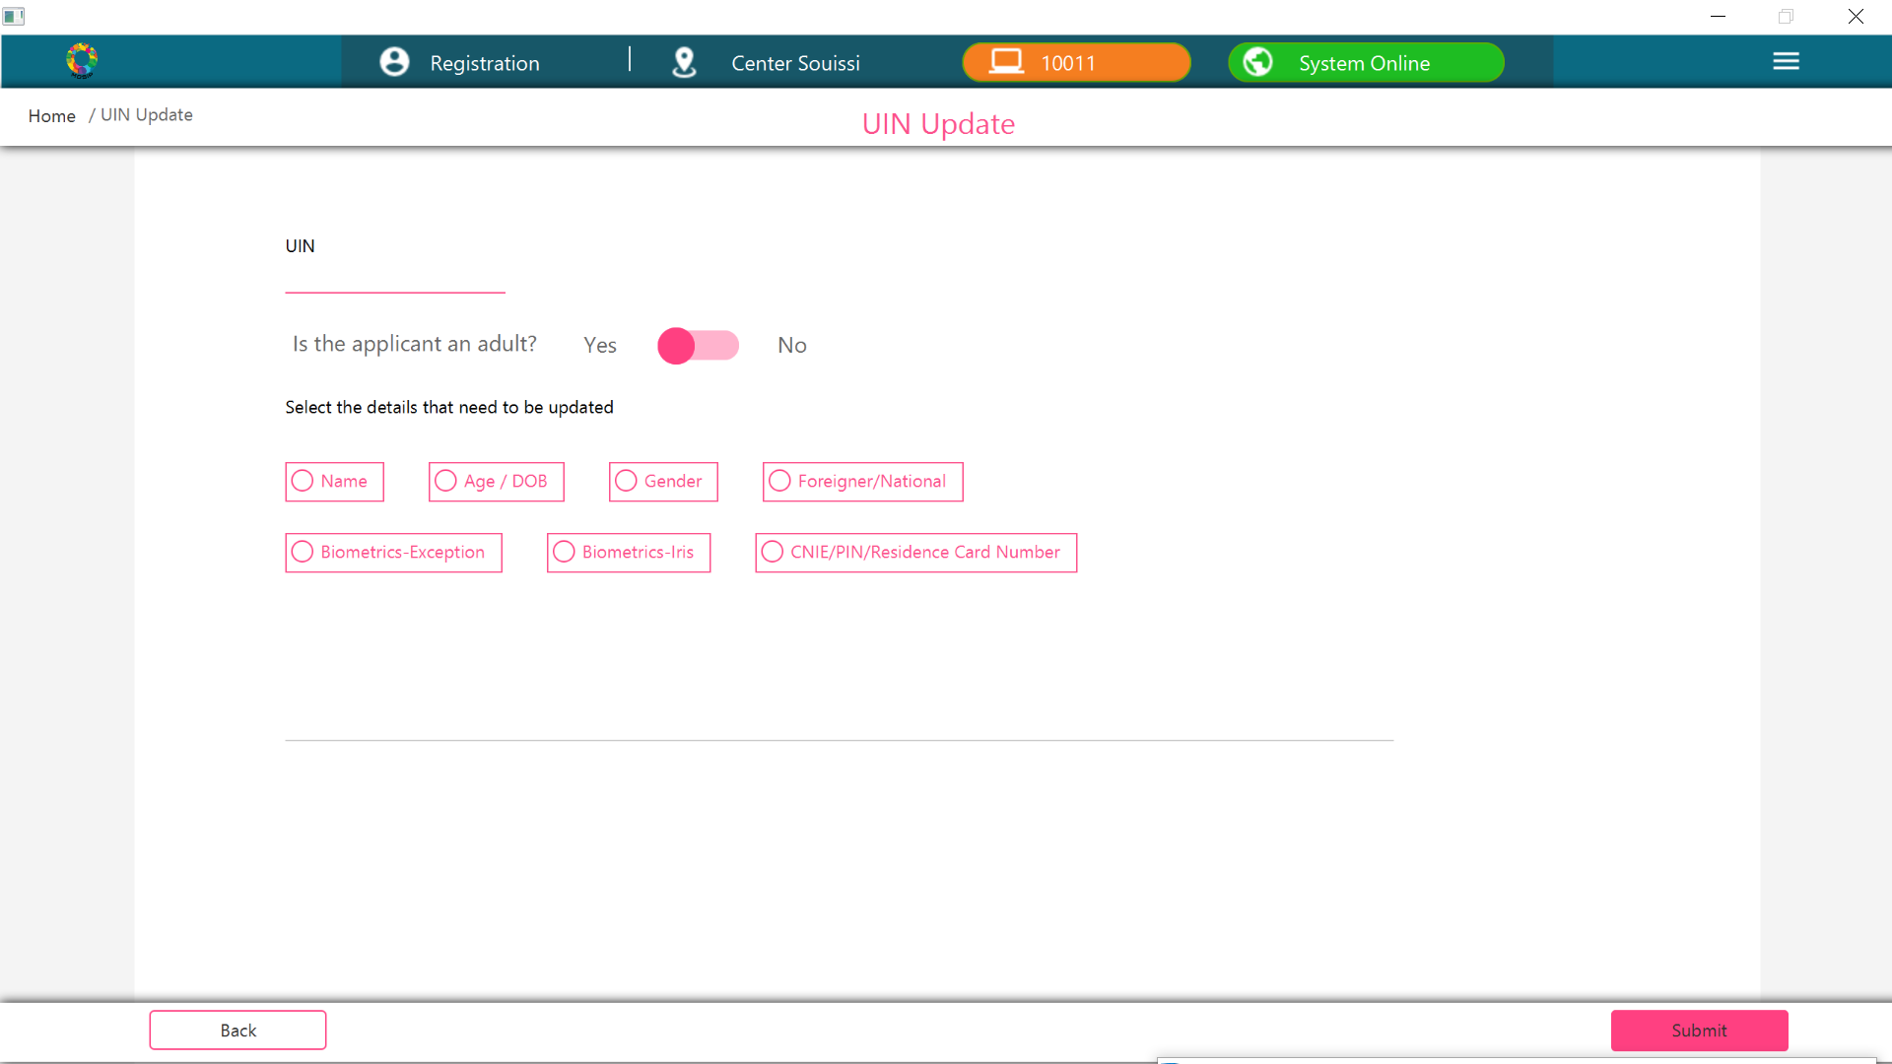

TestCase : When Biometric-Exception, Biometric-Iris,Cnie/Pin Numberfields are not configured for update UIN .

