**UI Testing**

**MOS-13080: Visual design changes -** Modified Registration Approval page, Preview page and Acknowledgement page according to the latest VD’s

**Screenshots:**

1. Preview for Registration

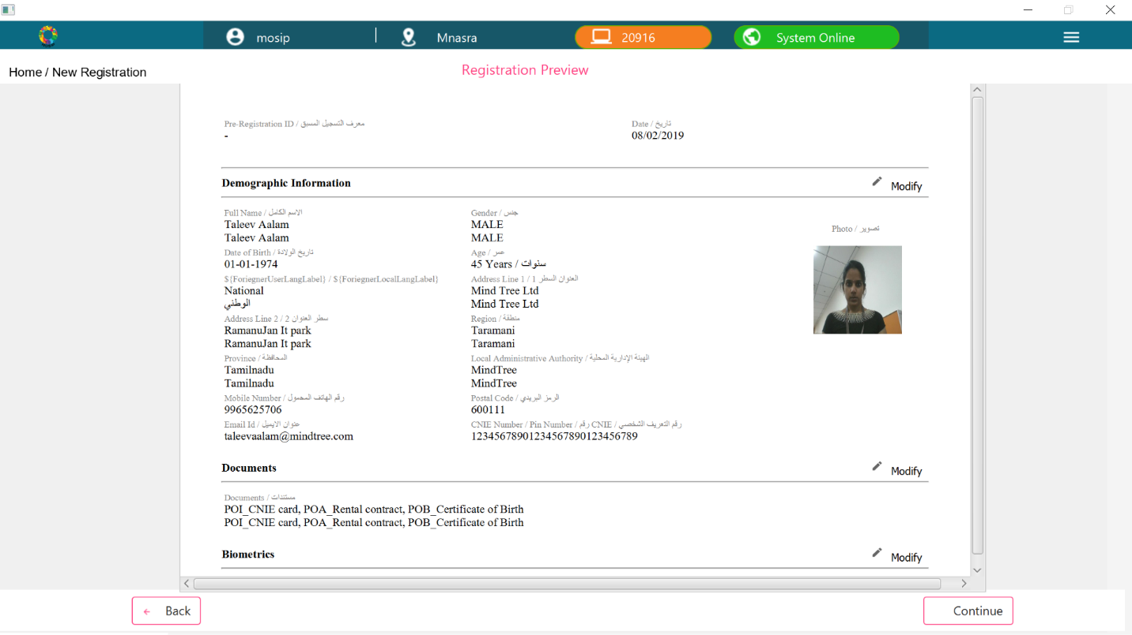

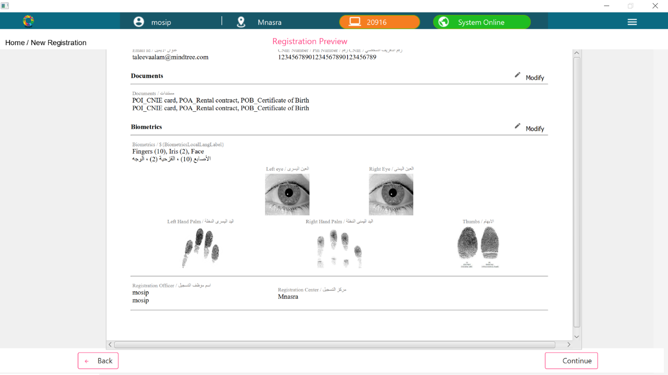

1. Registration Acknowledgement Page

