**Packet Export**

**Test Case Description:**

The Packets needs to be exported from the local to external device incase if the network is not available.

**Screen Shots:**

Click on Export Button will prompt to select the path, which we need to export.

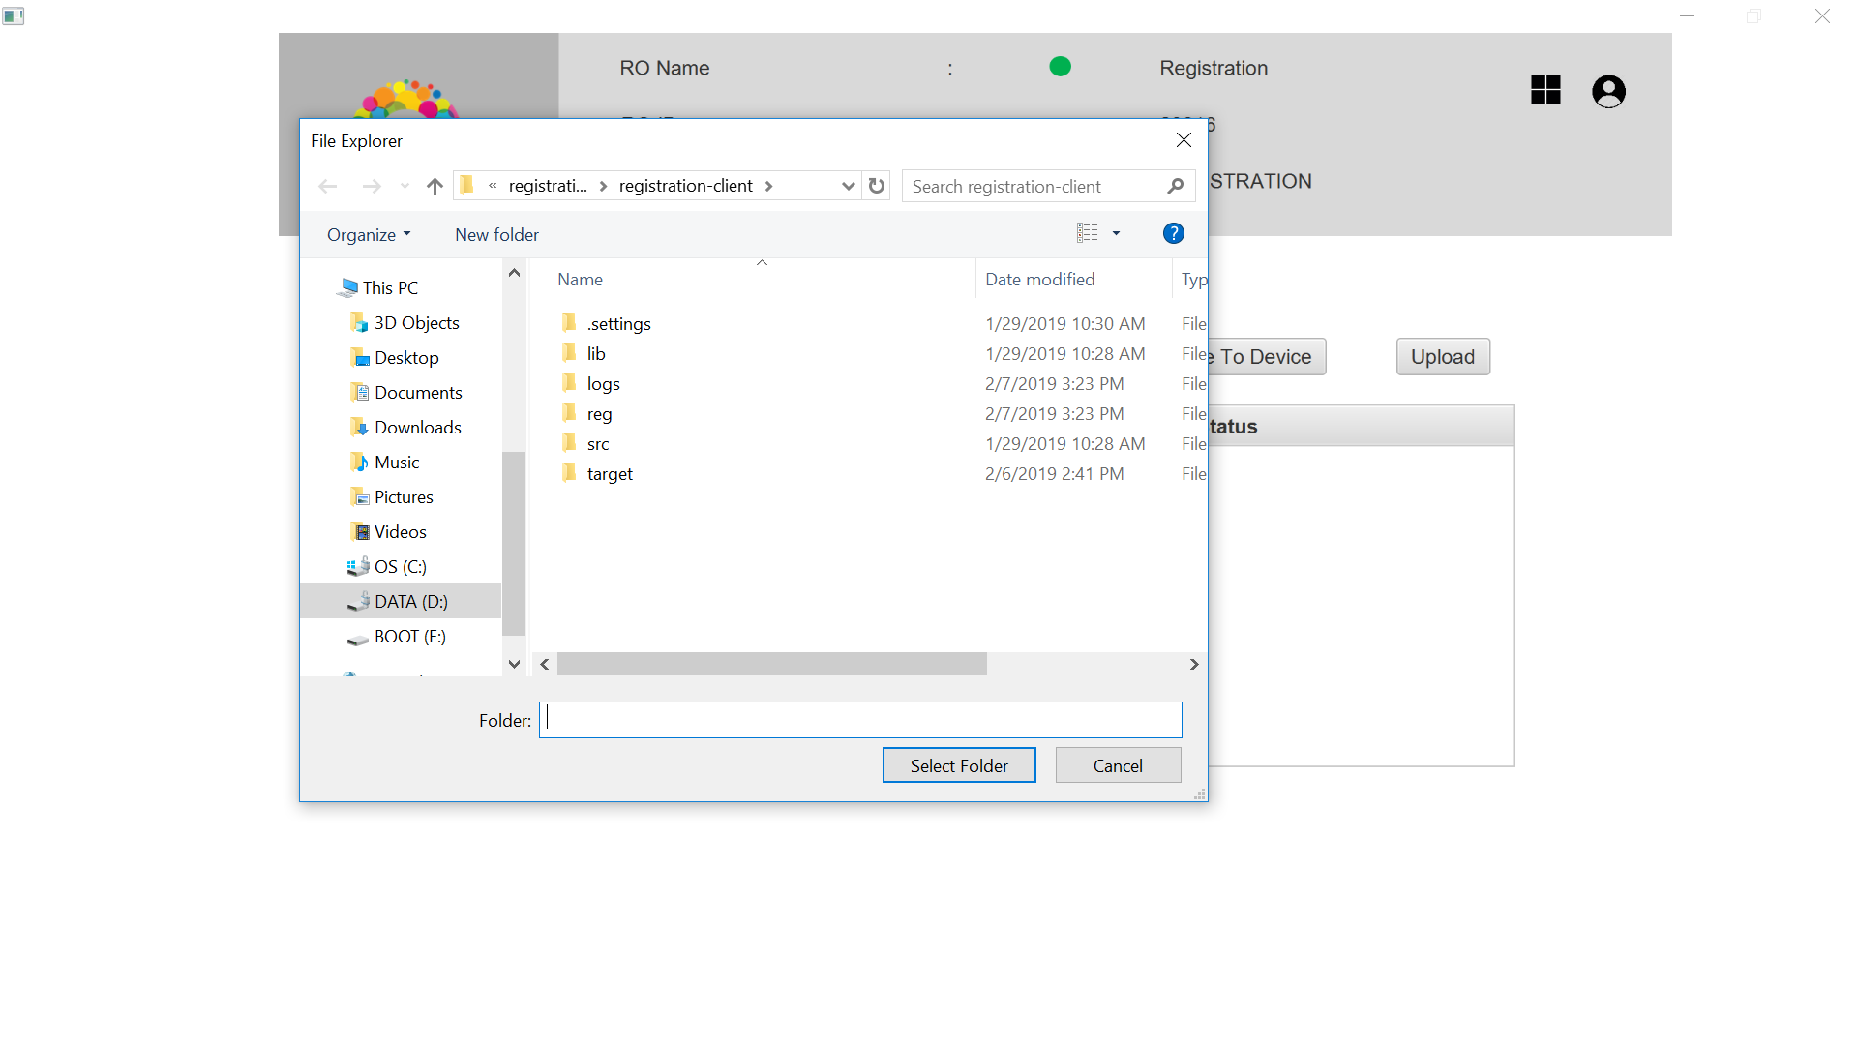

2. After the path got selected, the packet will get exported and the Success message will shown.

