TestCase : When the Configuration for Update UIN is set to Y[i.e., Enable]

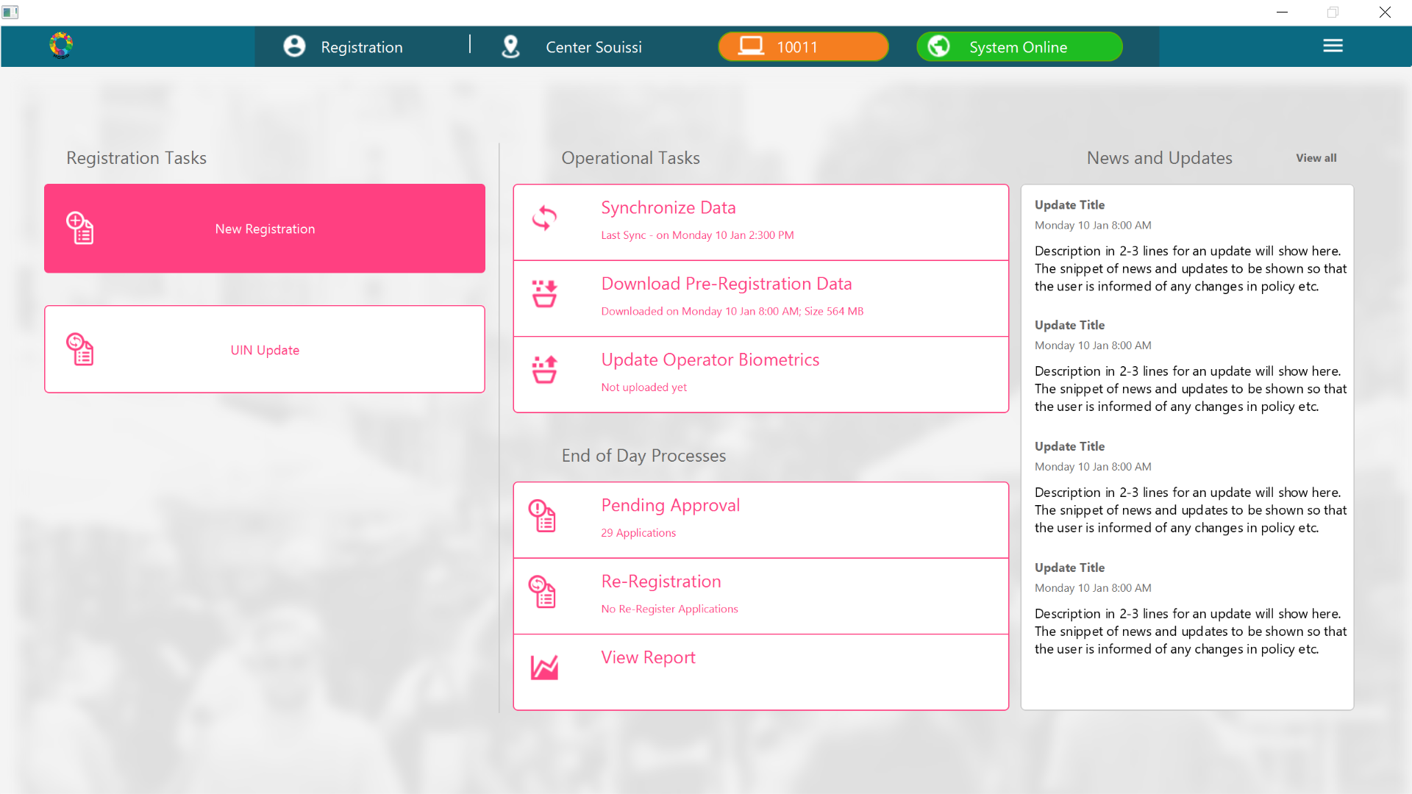

TestCase : When the Configuration for Update UIN is set to N[i.e., Disable]

