**UI Testing**

**User Story:**

**MOS-16109** : **STUB - As the Registration Officer, I should be able to mark low quality biometrics as exceptions**

As per the user story, the RO has to mark the reason for exception whether “Missing Biometrics” or “Low Quality of Biometrics”. If the applicant doesn’t have any missing biometrics, but the quality score didn’t meet the threshold after maximum retries (i.e., any biometrics are force captured), then the system should flag the reason automatically and exception capture should be enabled.

The UI testing for this user story is done as follows:

For a registration, two fingers (left index and ledt middle finger), and one iris (left iris) are marked as misssing biometrics:

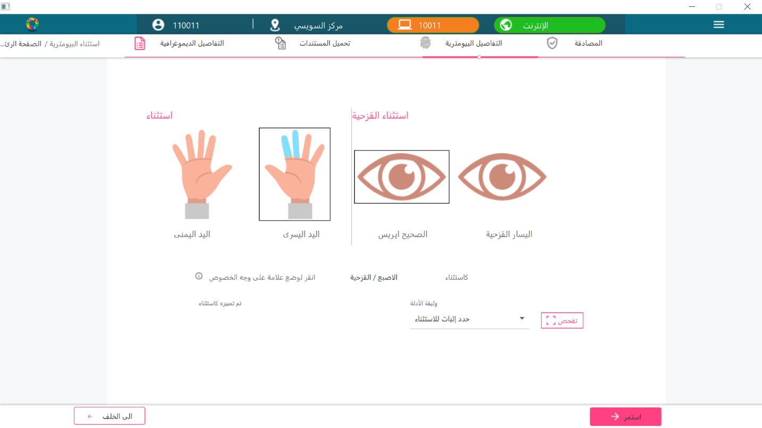

For right eye, the threshold quality (which is 80%) didn’t meet even after configured number of retries reached. Hence it is force-captured.

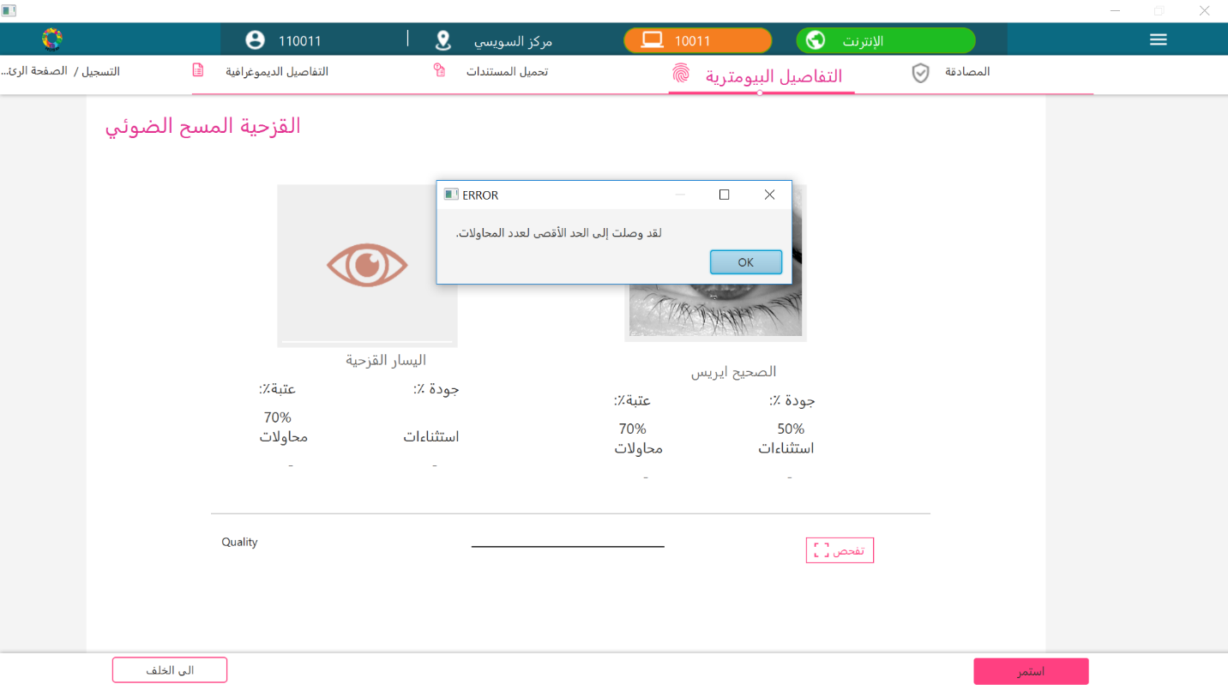

These reasons will be marked by the system automatically and they will be a part of PacketMetaInfo json which is generated after successful packet creation. If the generated packet is decrypted, the packet Meta info json will have the exception biometrics like this:

