**Supervisor Authentication for Low Quality Biometrics**

1. Low quality for Right Irirs

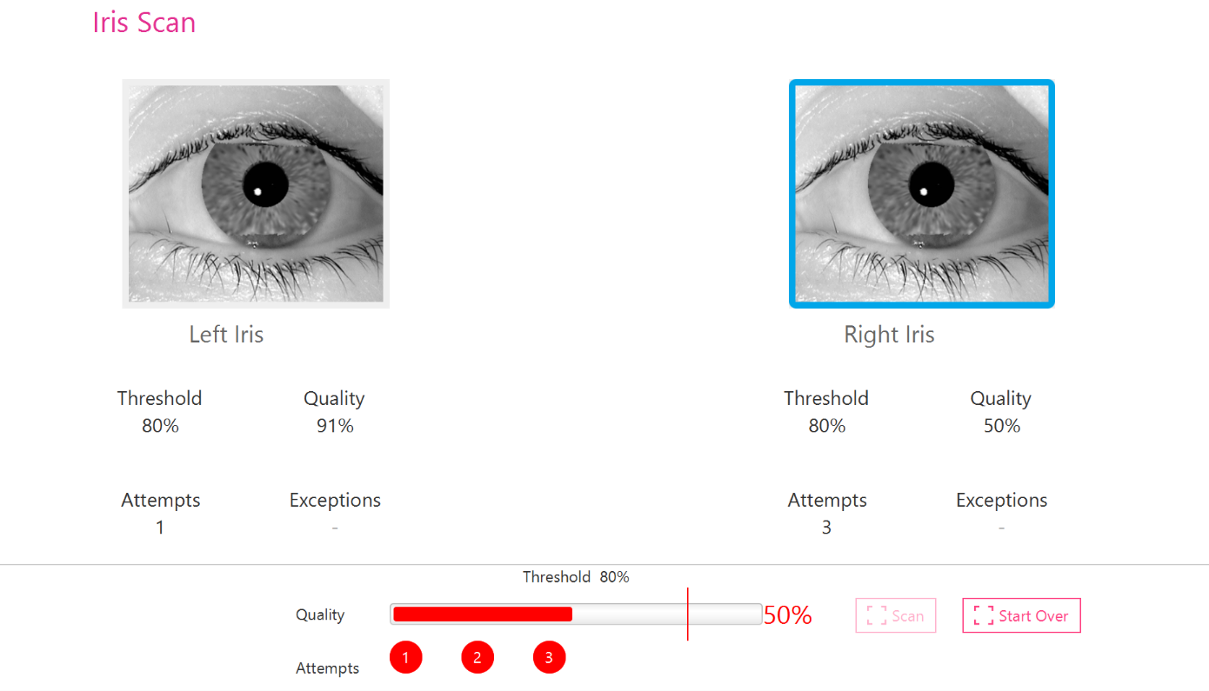

1. Prompts for Supervisor authentication

