**UI Testing**

**MOS-21929: As a Registration Officer, I should be able to search for packets on the Upload page**

**Business Rules:**

1. The RO should be able to type characters in a ‘search’ text box.
2. Search the RID field for characters entered by the user. As the user starts typing the matching registrations will be filtered and display in the list.
3. On clearing the search (deleting characters) the entire list will be displayed.

**Screenshots:**

1. The Packet Upload page will be appearing like the below screenshot with a search box on top of it.

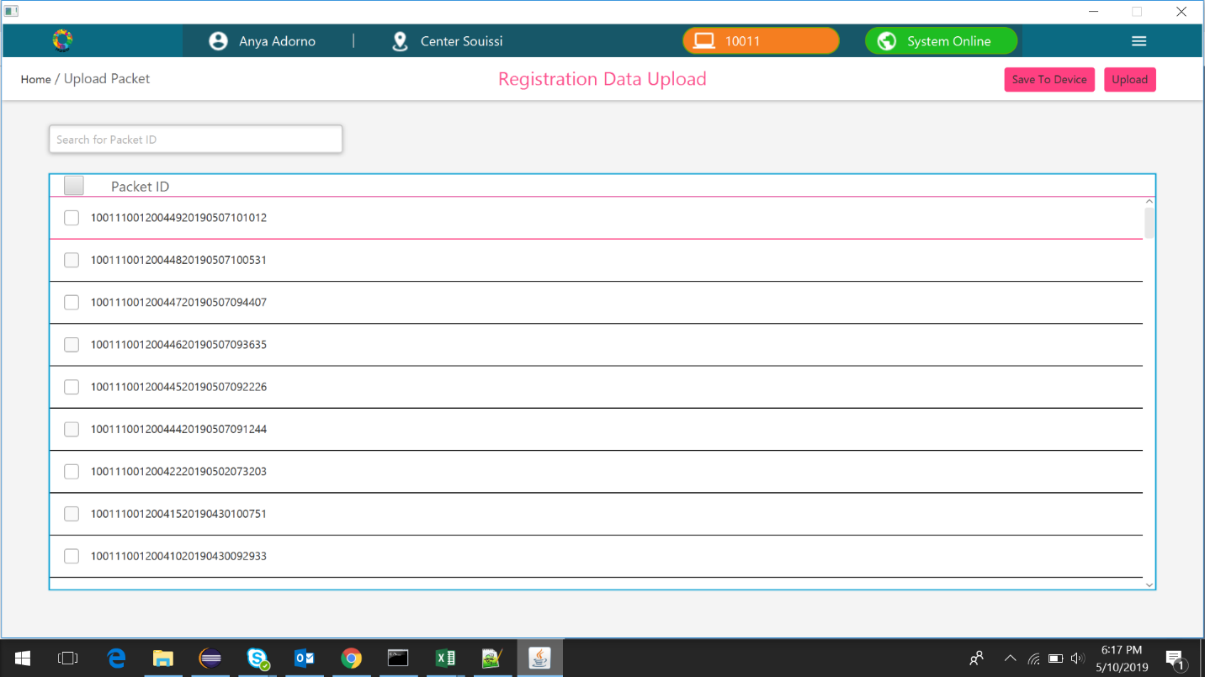

1. The RID field can be searched by entering characters in the search box. The list of RID’s that matches the entered text will be displayed in the list.

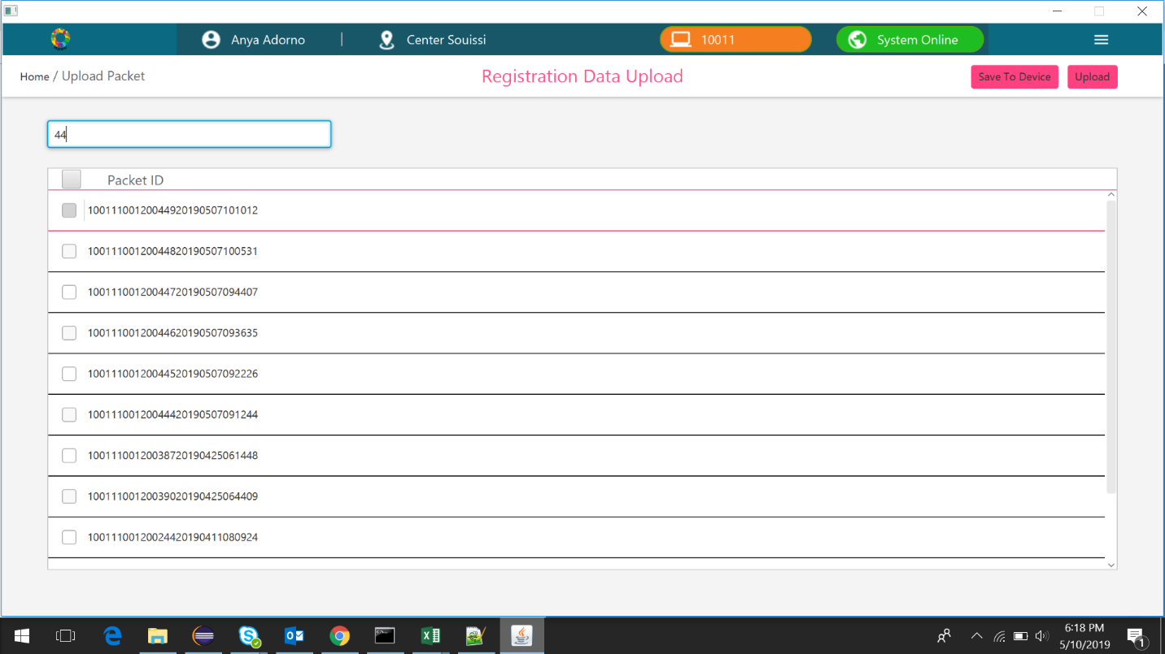

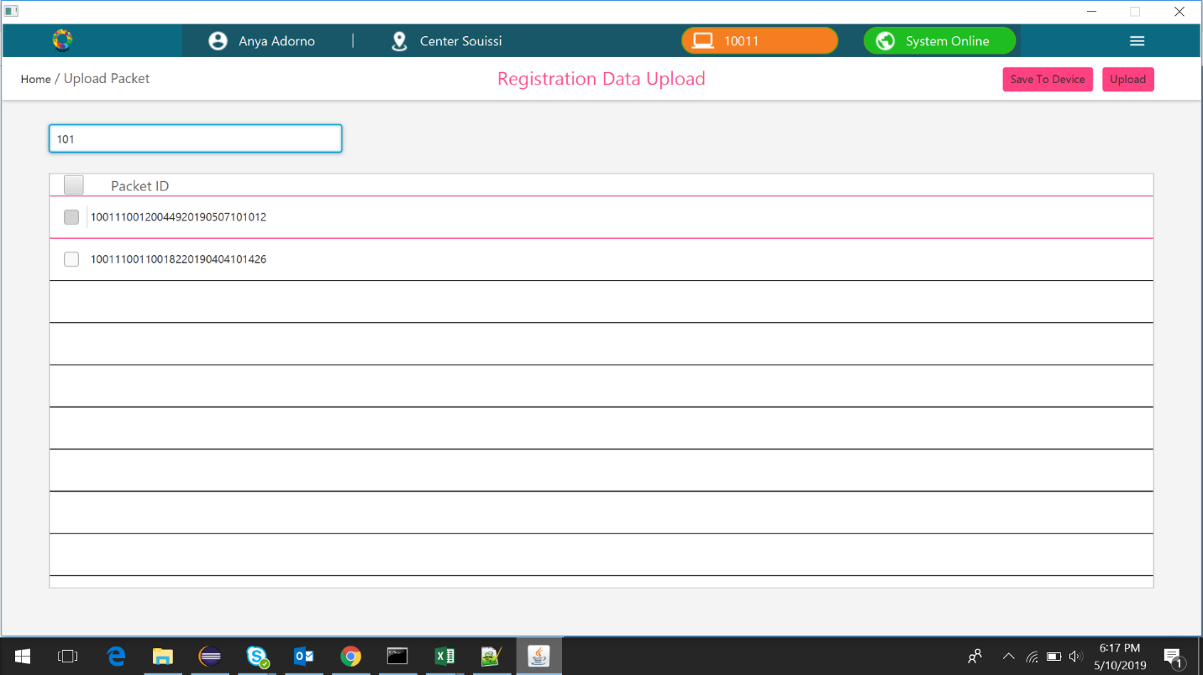

1. On clearing the text in the search box, the entire list will be displayed.

