Login Screen with FingerPrint -

If Fingerprint Configuration is enabled then login screen will look as follows

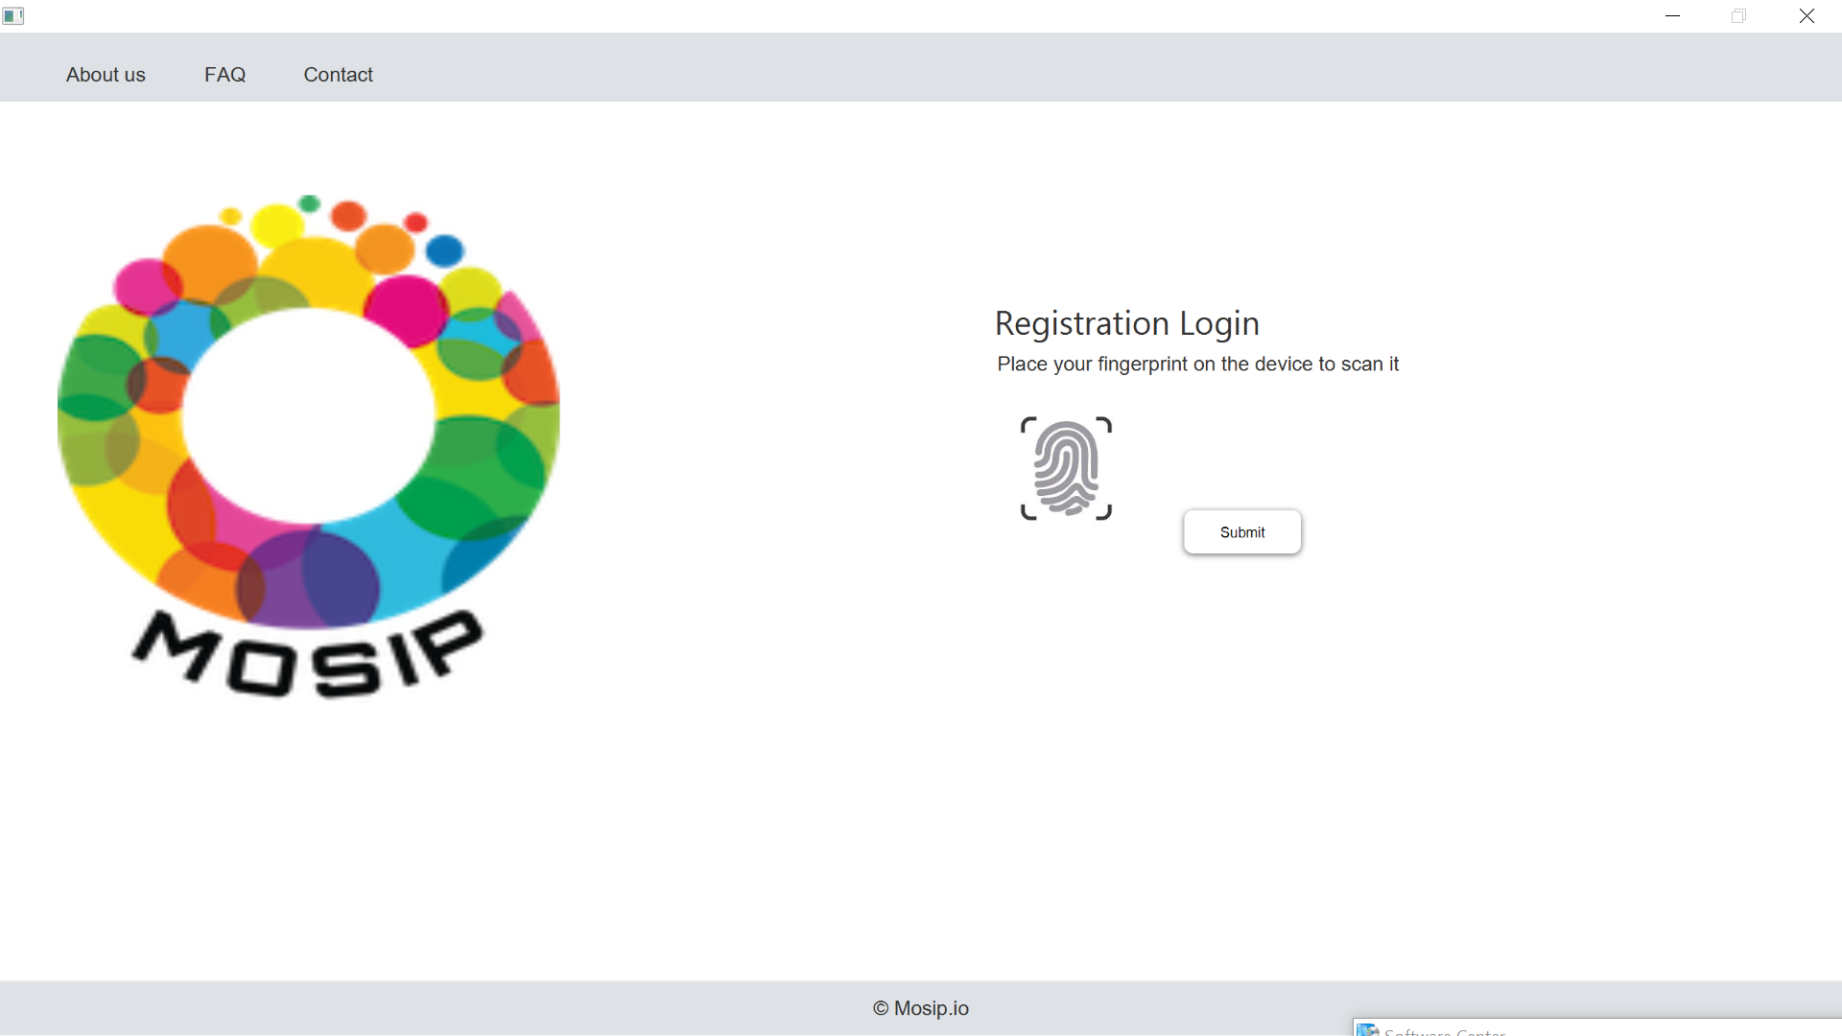

If Fingerprint Configuration is disabled then login screen will look as follows

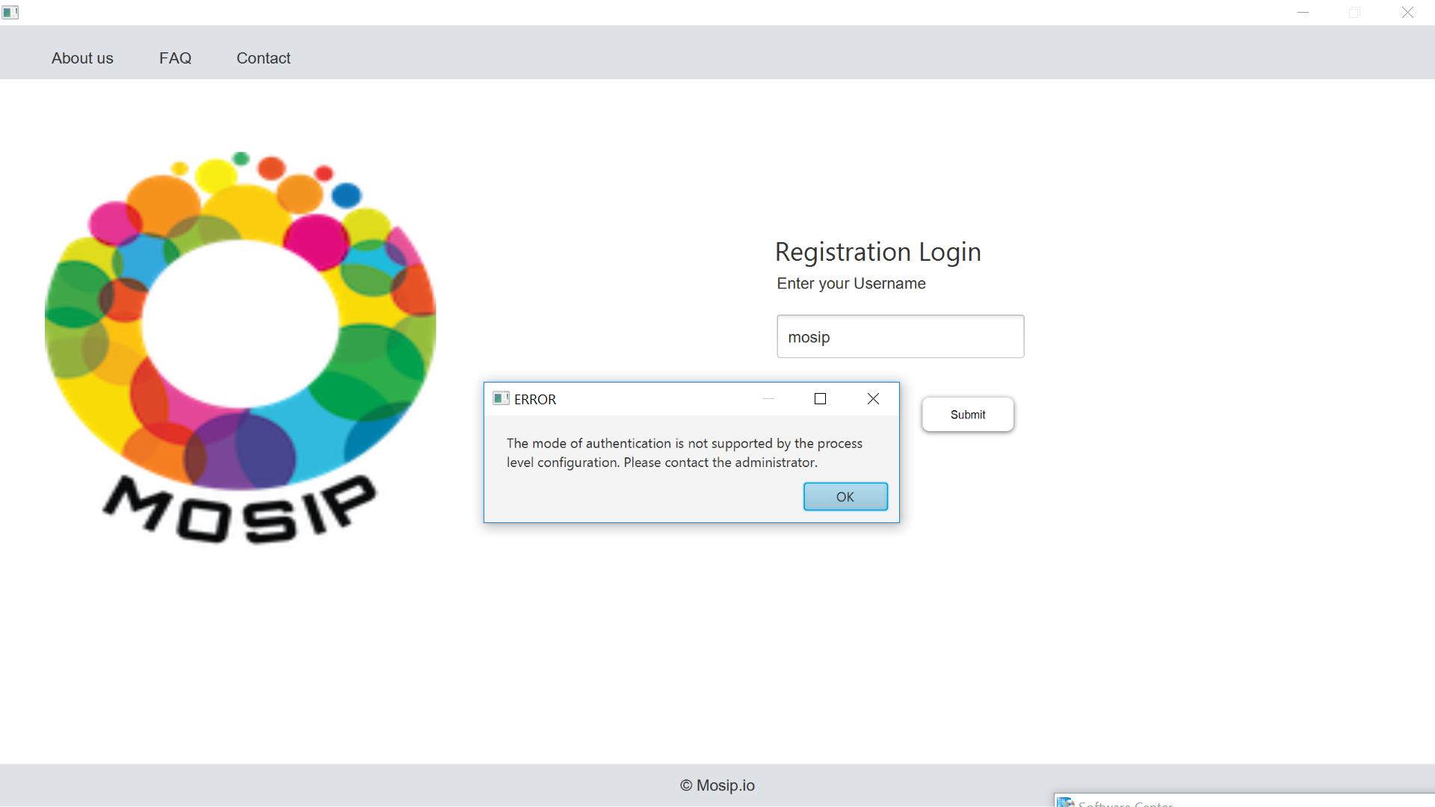

EOD Process with FingerPrint Authentication-

If FingerPrint Authentication is enabled then EOD Process will look as follows

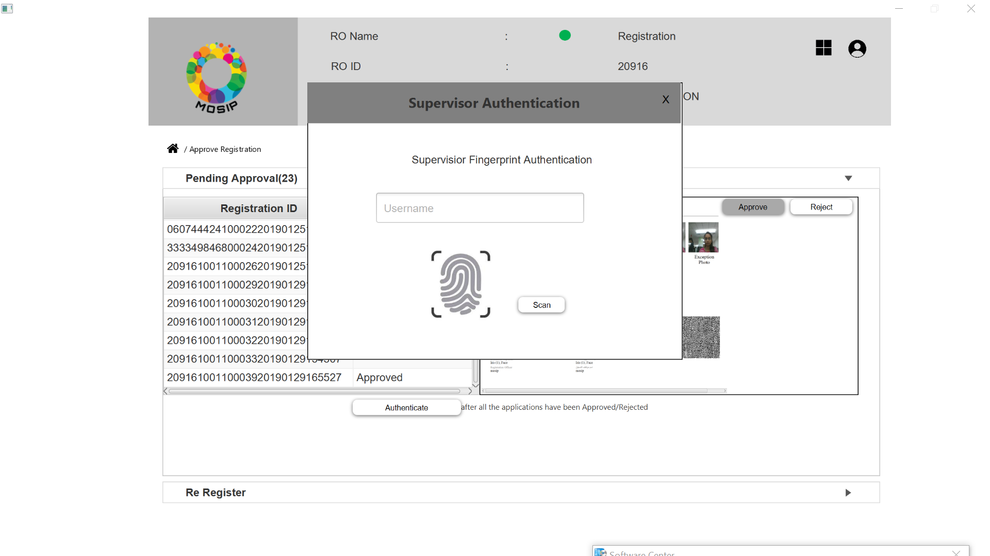

If FingerPrint Authentication is disabled then EOD Process will look as follows

