1. **“fetch-multiple” – send multiple random files back to the client**

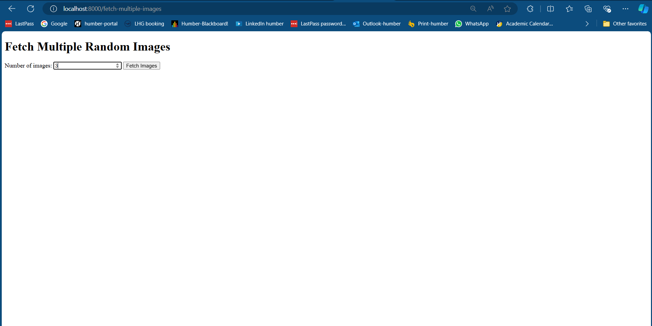

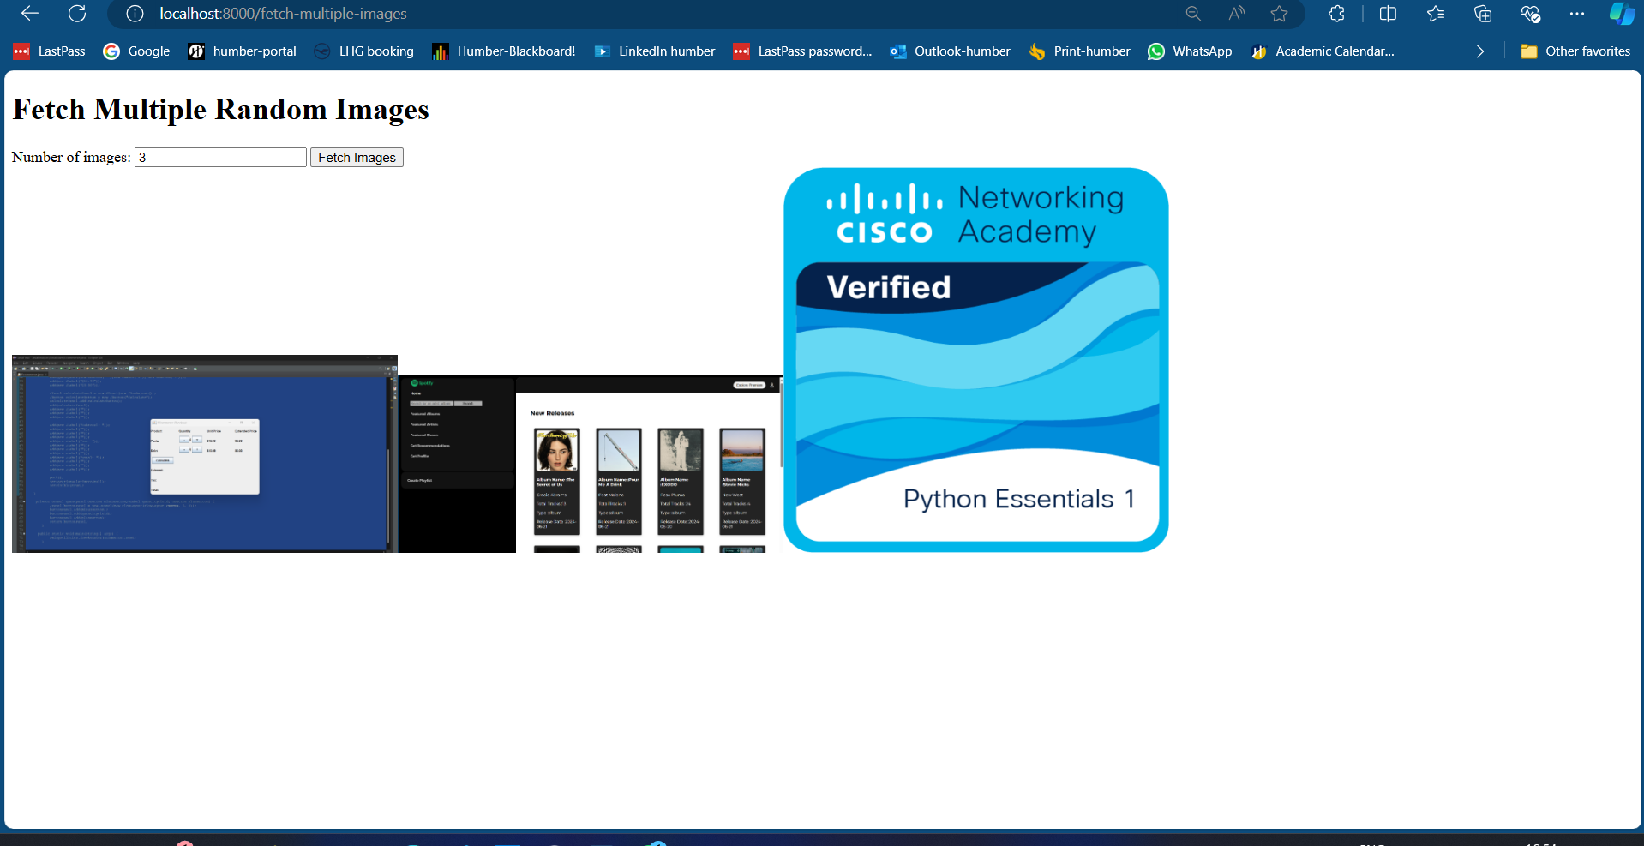

1. **“fetch-all” – send all image files back to the client**

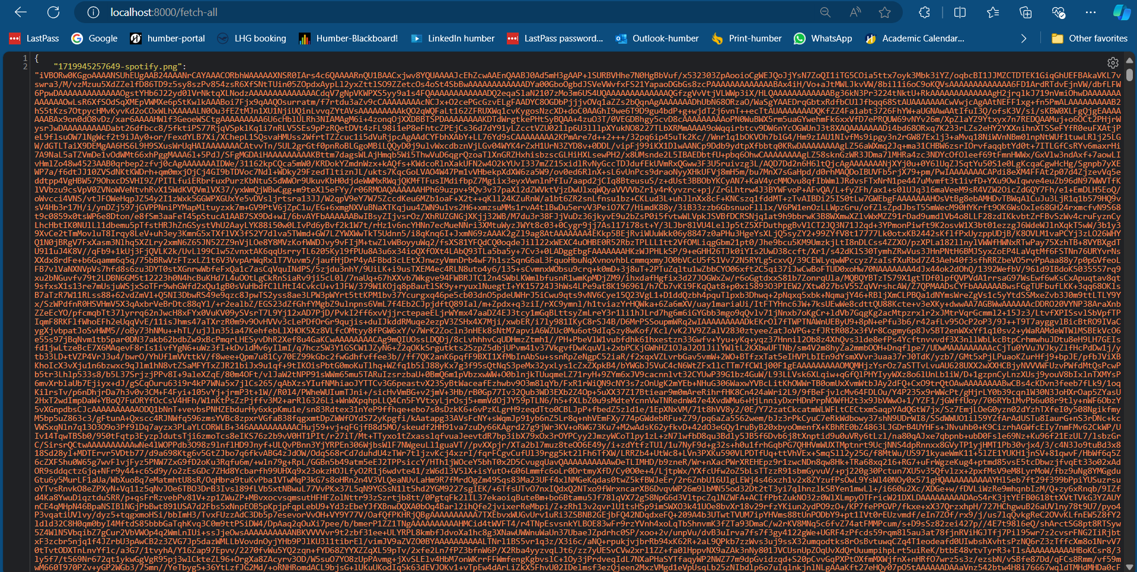

**c. “gallery” – showcase all the files on the server.**

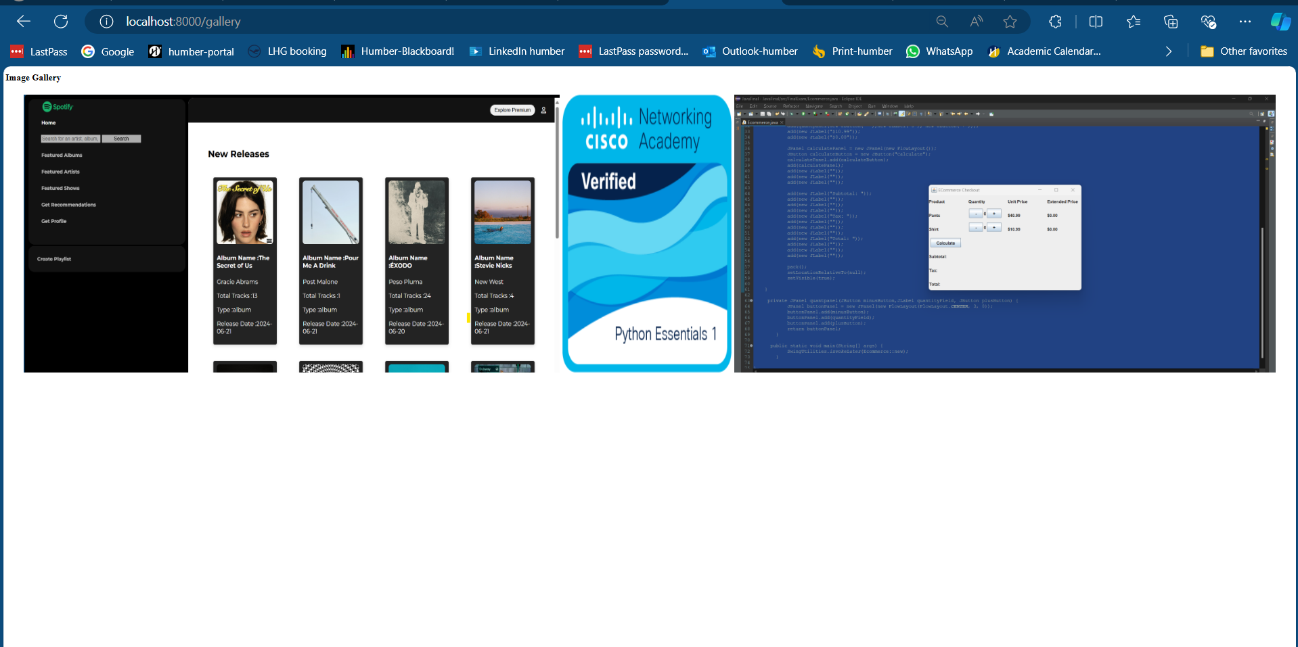

**d. “gallery-pagination” – Showcase all the files using pagination**

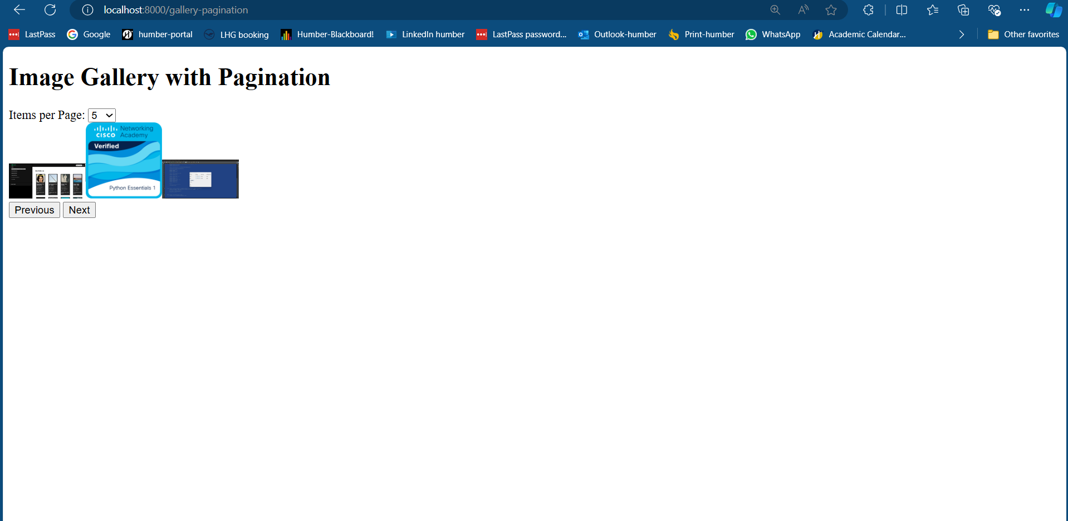

**Github Link:**

[gurpreetkaur3011/Assignment2-Framework: Web Framework handlebars for fetch-mutliple/ gallery/ gallery with pagination (github.com)](https://github.com/gurpreetkaur3011/Assignment2-Framework)