**Week9**

1. **List all books:  
   URL : http://localhost:8000/books**

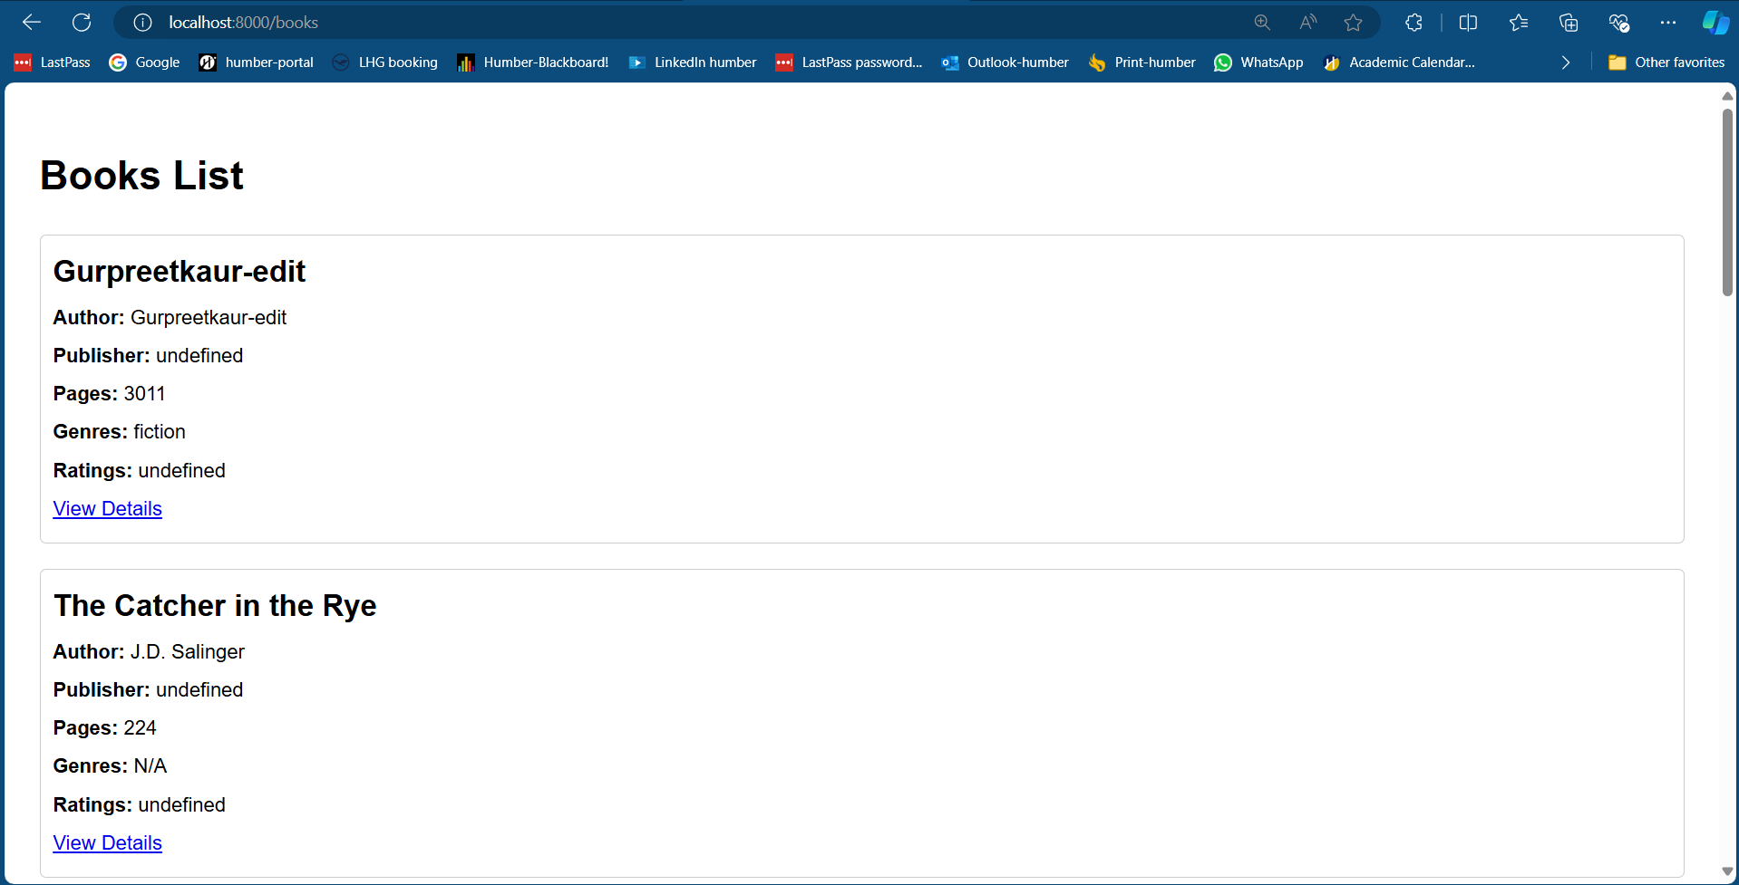

1. **Add a book**

**URL :** **http://localhost:8000/book/add  
Add form:  
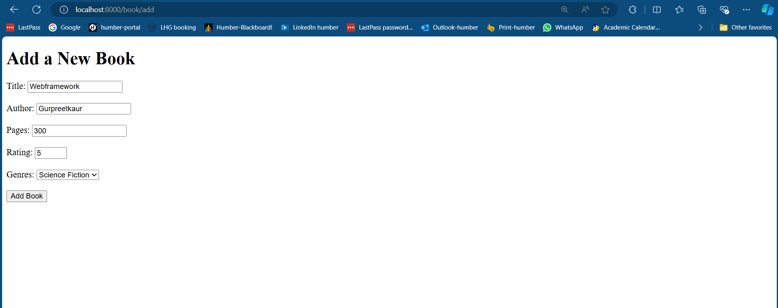**

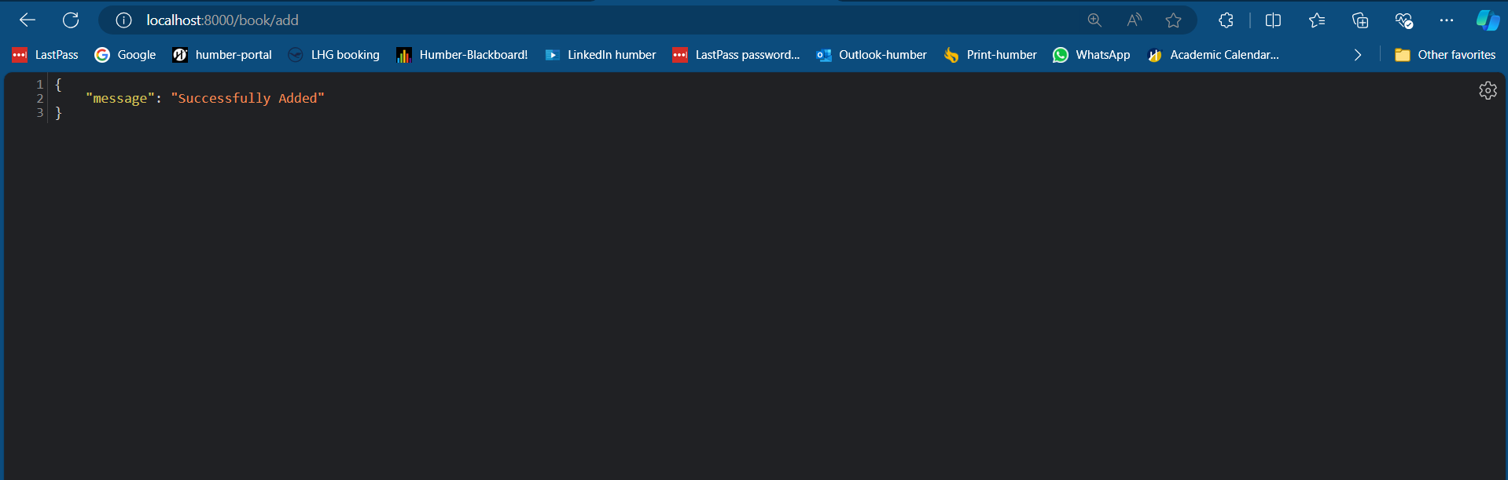

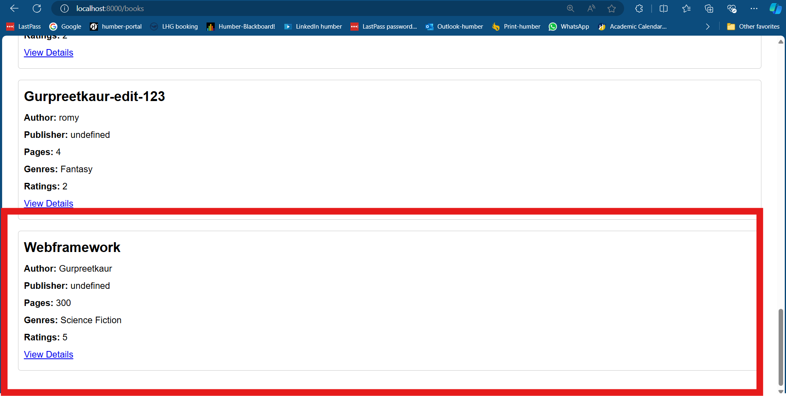

1. **Edit Book**

**URL : http://localhost:8000/book/edit/668eccd419d1c2cc96143506**

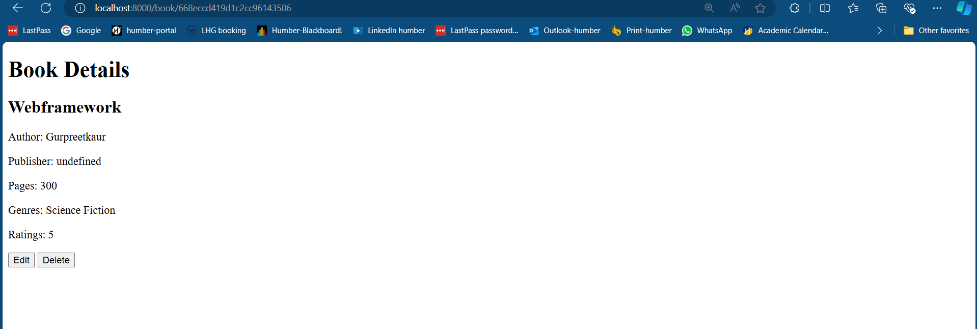

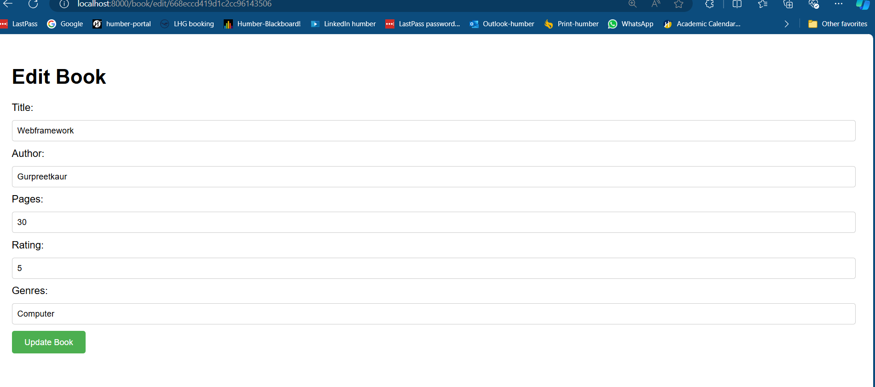

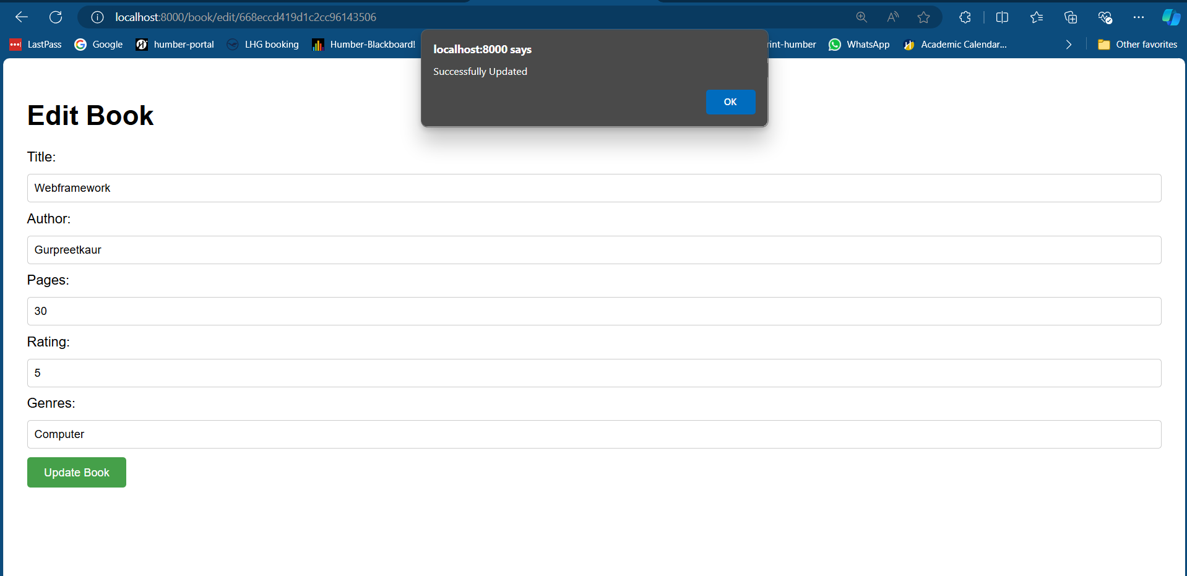

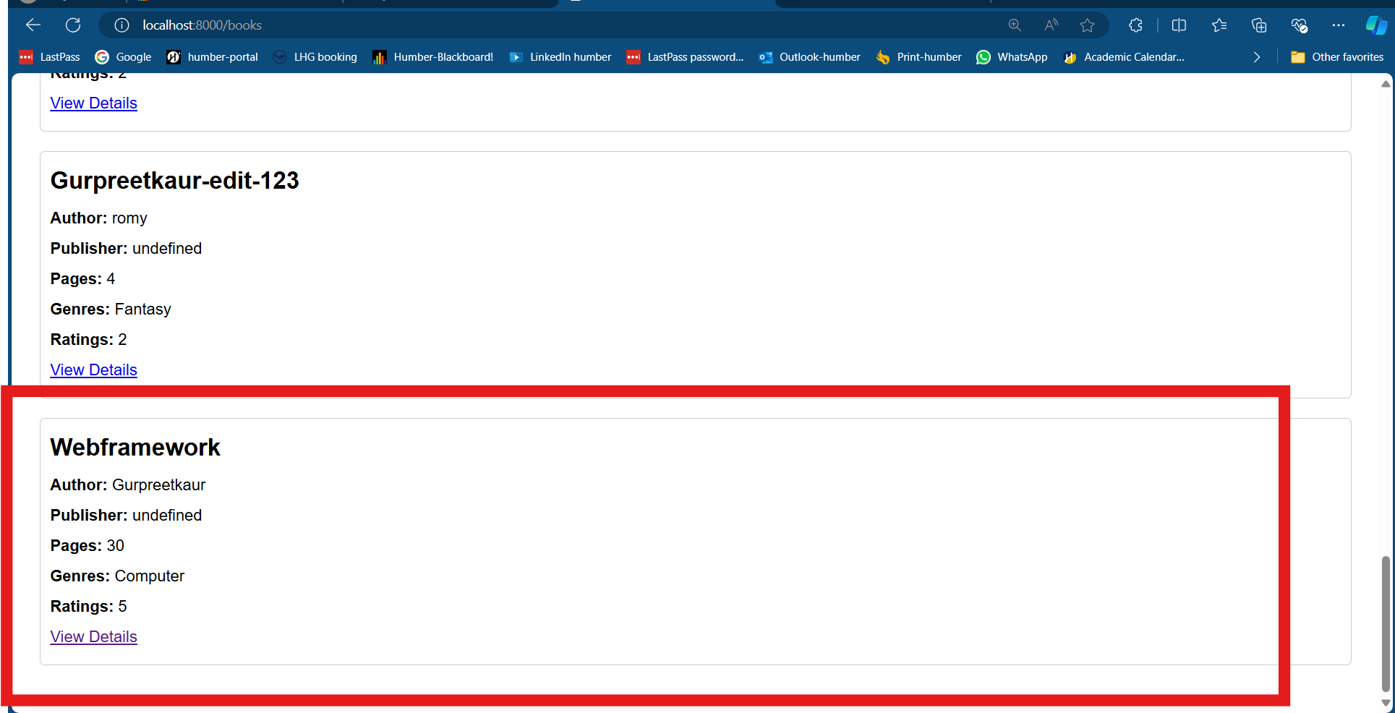

1. **Delete a book**

