GitHub URL

<https://github.com/gurpreetrk/World_weather.git>

URL for Application

<http://localhost:8080/CityWeather/weather>

**Important** :

Create folder on your **c:\\WeatherDetails\\CityName\\** and put **CityName.json** in same

Or please go through **Special Comments** the comments in **CityWeather.java**

**Or create given folder in you drive where tomcat/server is installed**

**\\WeatherDetails\\CityName\\**

Maven

maven-archetype-webapp

Clean Install

**Cities in Dropdown**

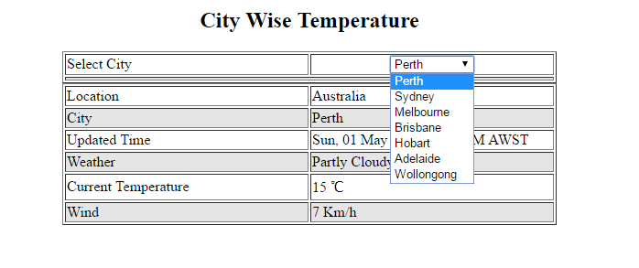

**Details After Selecting city**

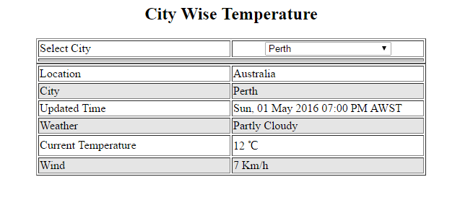

Details after selecting another city

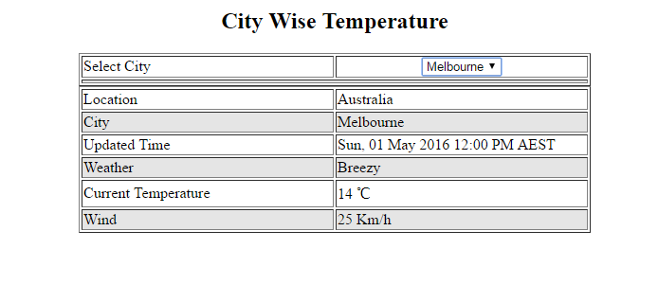

Adding some more cities in CityName.json

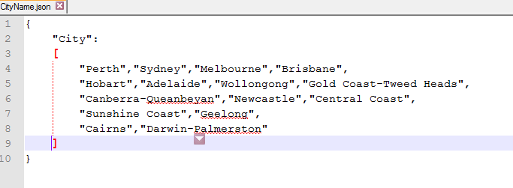

Dropdown after adding more cities in CityName.json

