MongoDB Update Operations
$unset · $rename · upsert

Name: Gurpreet
Subject: Database Management Systems – Practical
Topic: MongoDB Update Operations (FACE Webinar 19)
Date: 4 June 2026
Tool Used: MongoDB Compass + mongosh

1. $unset — Removing Fields
The $unset operator removes a specified field from a document. The field is deleted entirely — it does not become null or empty; it disappears from the document structure.

1.1 Syntax
db.<collection>.updateOne(
<filter>,
{ $unset: { <fieldName>: "" } }
)

1.2 Sample Dataset
A collection employees was created with three documents containing the fields: _id, name, dept, salary, and age.

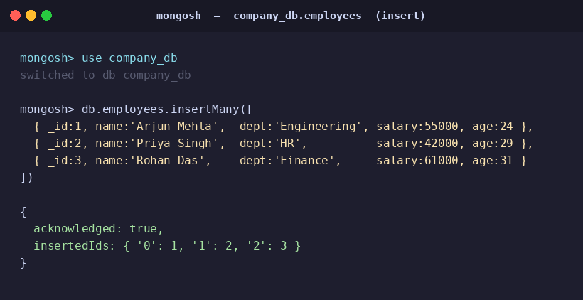
Fig 1.1 — insertMany() to set up the employees collection

1.3 Removing a Single Field
The salary field was mistakenly added to the document with _id: 1. $unset is used to remove it.

Before — salary field is present
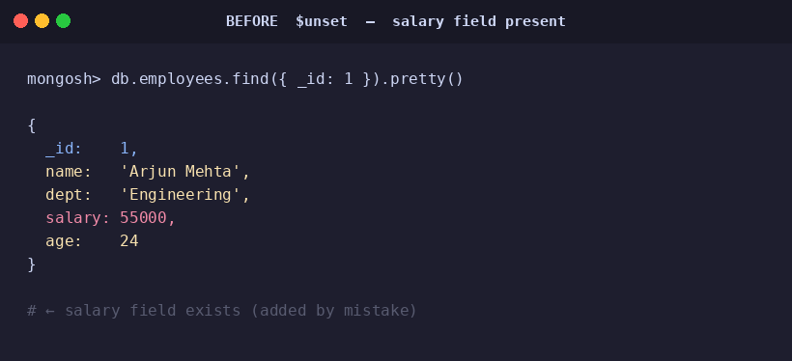
Fig 1.2 — Document state before $unset
Command
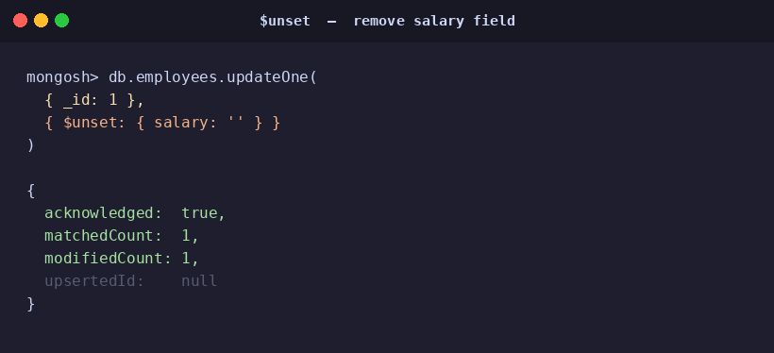
Fig 1.3 — $unset command and acknowledgement
After — salary field removed
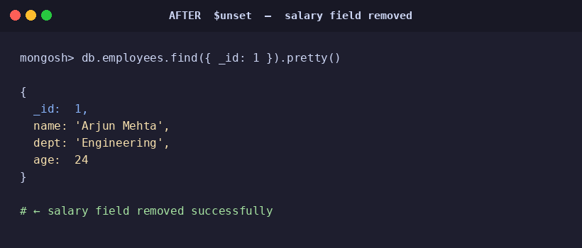
Fig 1.4 — Document verified after $unset
📝 modifiedCount: 1 confirms the field was removed. Refreshing in Compass shows the field is gone.

1.4 Removing Multiple Fields at Once
$unset accepts multiple field names in the same update, removing all of them in one operation.
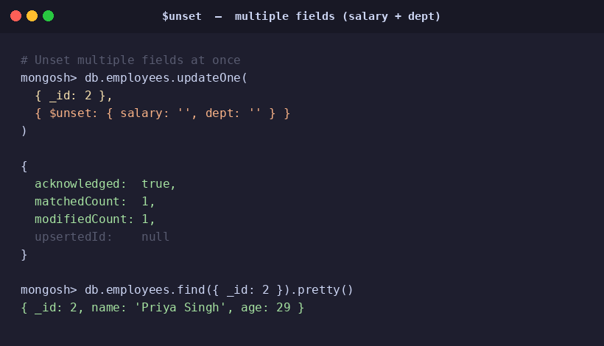
Fig 1.5 — $unset applied to salary and dept simultaneously
📝 Both salary and dept are removed from _id: 2 in a single updateOne() call.

2. $rename — Renaming Fields
The $rename operator changes the name of a field in a document. The value is preserved; only the key changes. It can be applied to top-level fields, nested fields, and array-related structures.

2.1 Syntax
db.<collection>.updateOne(
<filter>,
{ $rename: { "<oldName>": "<newName>" } }
)

2.2 Renaming age → employee_age
The field age in document _id: 3 is renamed to employee_age to follow a more descriptive naming convention.

Before — field name is age
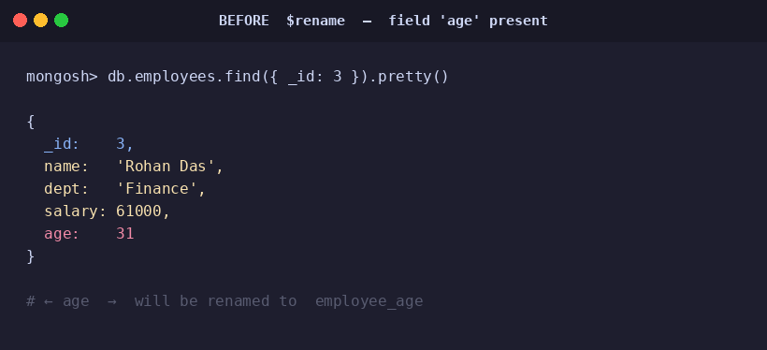
Fig 2.1 — Document before $rename
Command
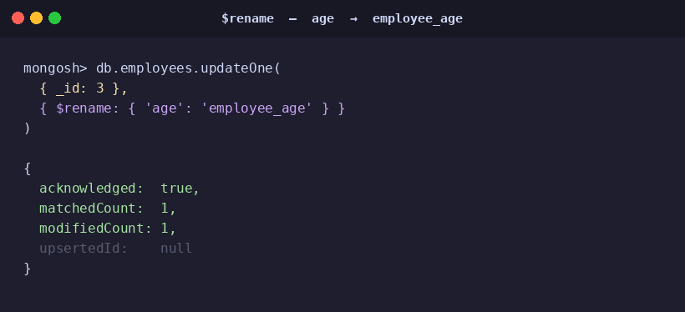
Fig 2.2 — $rename command and acknowledgement
After — field renamed to employee_age
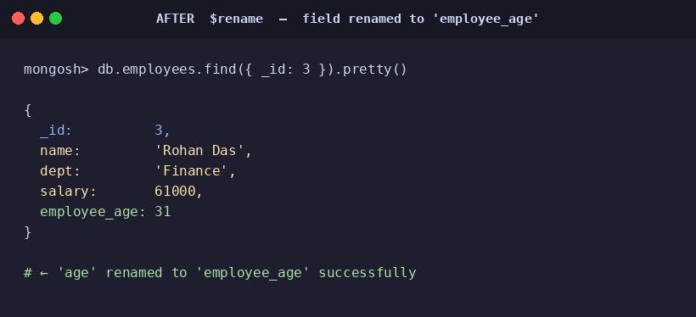
Fig 2.3 — Document verified after $rename
📝 The value 31 is retained under the new field name. modifiedCount: 1 confirms success.

3. upsert — Update + Insert
upsert is not a separate operator but an option passed to updateOne() or updateMany(). When { upsert: true } is set:
→ If a matching document is found, MongoDB updates it.
→ If no matching document is found, MongoDB inserts a new document.

3.1 Syntax
db.<collection>.updateOne(
<filter>,
{ $set: { <field>: <value> } },
{ upsert: true }
)

3.2 Scenario A — Matching Document Exists (UPDATE)
Product with id: 6 already exists in the products_db collection. The price is updated to 999.
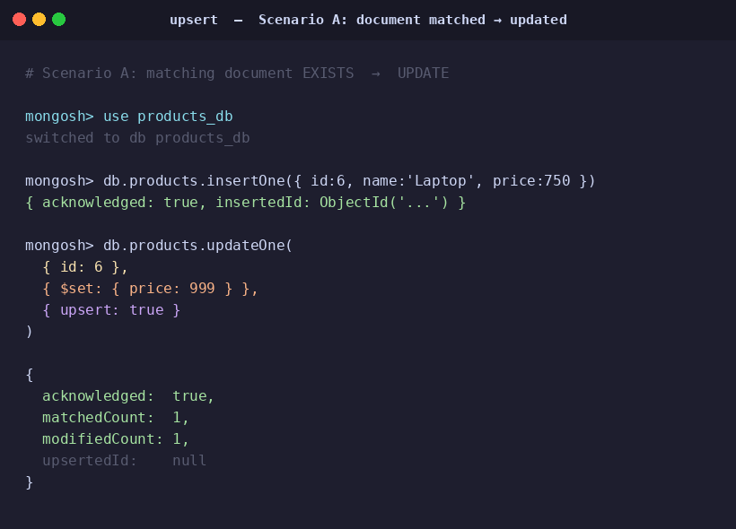
Fig 3.1 — upsert when a matching document exists (update path)
📝 matchedCount: 1 and upsertedId: null confirm an update occurred, not an insert.

3.3 Scenario B — No Match Found (INSERT)
No document with id: 99 exists. MongoDB inserts a new document with the filter fields merged with the $set values.
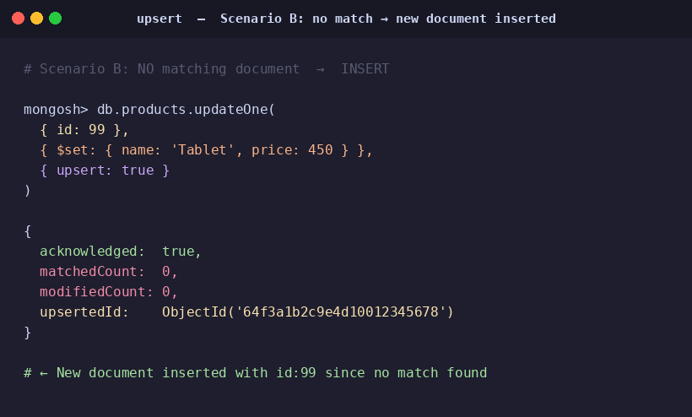
Fig 3.2 — upsert when no match is found (insert path)
📝 matchedCount: 0 and a populated upsertedId confirm a new document was inserted.

3.4 Final State — Verification
After both operations, the products collection contains two documents: the updated laptop (price: 999) and the newly inserted tablet (id: 99).
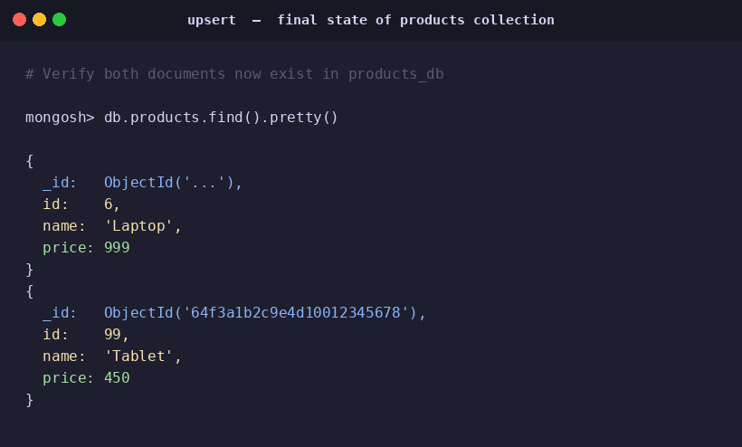
Fig 3.3 — products collection final state after upsert operations

4. Summary

Operator / Option | Description | Example Usage
$unset | Removes a field from a document | { $unset: { salary: "" } }
$rename | Renames an existing field (value preserved) | { $rename: { "age": "employee_age" } }
upsert | Updates if match found; inserts if not found | { upsert: true } as 3rd argument

