MongoDB Aggregation Pipeline
Homework Assignment – 6 June 2026
Database: db | Collection: sales

1. Insert Data into Collection
We begin by inserting 10 documents into the sales collection using insertMany(). Each document stores details about a coffee sale.

db.sales.insertMany([
{ "_id": 1, "item": "Americanos", "price": 5, "size": "Short", "quantity": 22, "date": ISODate("2022-01-15T08:00:00Z") },
{ "_id": 2, "item": "Cappuccino", "price": 6, "size": "Short", "quantity": 12, "date": ISODate("2022-01-16T09:00:00Z") },
{ "_id": 3, "item": "Lattes", "price": 15, "size": "Grande", "quantity": 25, "date": ISODate("2022-01-16T09:05:00Z") },
{ "_id": 4, "item": "Mochas", "price": 25, "size": "Tall", "quantity": 11, "date": ISODate("2022-02-17T08:00:00Z") },
{ "_id": 5, "item": "Americanos", "price": 10, "size": "Grande", "quantity": 12, "date": ISODate("2022-02-18T21:06:00Z") },
{ "_id": 6, "item": "Cappuccino", "price": 7, "size": "Tall", "quantity": 20, "date": ISODate("2022-02-20T10:07:00Z") },
{ "_id": 7, "item": "Lattes", "price": 25, "size": "Tall", "quantity": 30, "date": ISODate("2022-02-21T10:08:00Z") },
{ "_id": 8, "item": "Americanos", "price": 10, "size": "Grande", "quantity": 21, "date": ISODate("2022-02-22T14:09:00Z") },
{ "_id": 9, "item": "Cappuccino", "price": 10, "size": "Grande", "quantity": 17, "date": ISODate("2022-02-23T14:09:00Z") },
{ "_id": 10, "item": "Americanos", "price": 8, "size": "Tall", "quantity": 15, "date": ISODate("2022-02-25T14:09:00Z") }
]);

Expected Output: { acknowledged: true, insertedIds: { 0: 1, 1: 2, ..., 9: 10 } }

Inserted Data – Sales Collection
_id | item | price | size | quantity | date
1 | Americanos | $5 | Short | 22 | 2022-01-15
2 | Cappuccino | $6 | Short | 12 | 2022-01-16
3 | Lattes | $15 | Grande | 25 | 2022-01-16
4 | Mochas | $25 | Tall | 11 | 2022-02-17
5 | Americanos | $10 | Grande | 12 | 2022-02-18
6 | Cappuccino | $7 | Tall | 20 | 2022-02-20
7 | Lattes | $25 | Tall | 30 | 2022-02-21
8 | Americanos | $10 | Grande | 21 | 2022-02-22
9 | Cappuccino | $10 | Grande | 17 | 2022-02-23
10 | Americanos | $8 | Tall | 15 | 2022-02-25

2. Query 1: Retrieve All Documents – find()
The find() method retrieves all documents from the collection. Without a filter, it returns every record.

// Retrieve ALL documents from sales collection
db.sales.find({})

// Pretty-print output
db.sales.find({}).pretty()

Output (all 10 records):
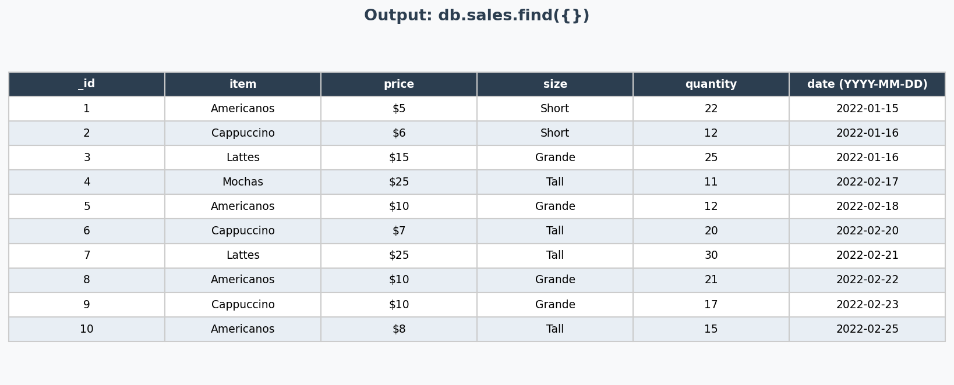

3. Query 2: Filter Documents – $match (price > $10)
The $match stage filters documents — similar to WHERE in SQL. Here we retrieve only items whose price is greater than $10.

// Using find() with a filter
db.sales.find({ price: { $gt: 10 } })

// Equivalent Aggregation Pipeline with $match
db.sales.aggregate([
{ $match: { price: { $gt: 10 } } }
])

Explanation of operators:
- $gt → Greater Than (price > 10)
- $lt → Less Than
- $gte → Greater Than or Equal
- $lte → Less Than or Equal

Output (filtered results — price > $10):
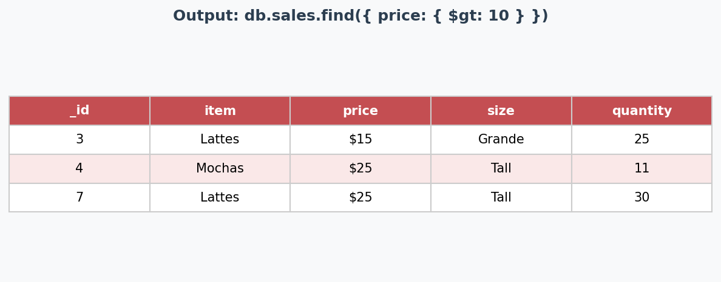
_id | item | price | size | quantity
3 | Lattes | $15 | Grande | 25
4 | Mochas | $25 | Tall | 11
7 | Lattes | $25 | Tall | 30

4. Query 3: Total Quantity Sold per Item – $group + $sum
The $group stage groups documents by a specified field (_id), and $sum accumulates the total quantity for each item — equivalent to GROUP BY in SQL.

db.sales.aggregate([
{
$group: {
_id: "$item",
totalQty: { $sum: "$quantity" }
}
},
{ $sort: { totalQty: -1 } } // Sort descending
])

Key Concepts:
- _id: "$item" → group by the item field
- $sum: "$quantity" → accumulate the quantity for each group
- $sort: { totalQty: -1 } → -1 = descending, 1 = ascending

Output – Total Quantity per Item:
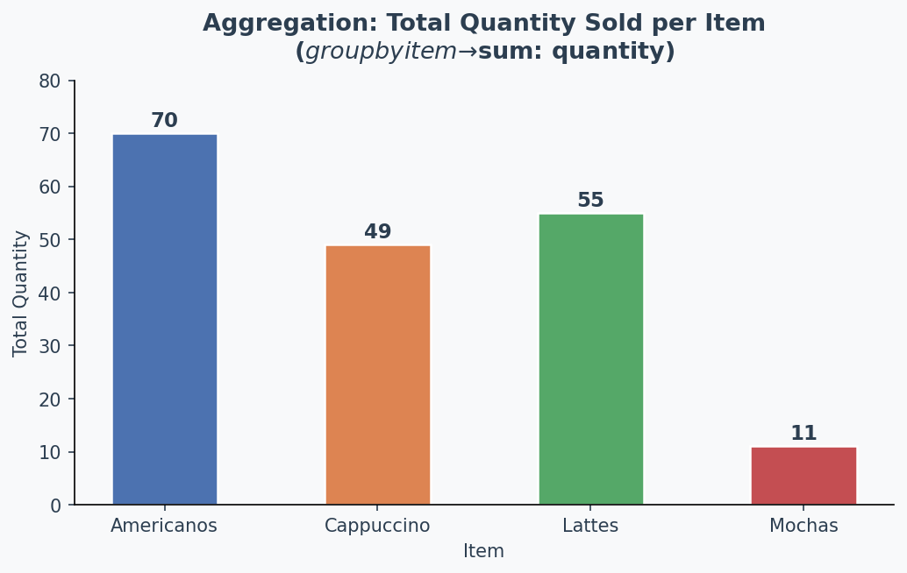
_id (item) | totalQty
Lattes | 55
Americanos | 70
Cappuccino | 49
Mochas | 11

5. Query 4: Total Revenue per Item – $multiply + $sum
To calculate revenue, we multiply price × quantity for each document, then group and sum. The $multiply operator takes an array of fields/values and returns their product.

db.sales.aggregate([
{
$group: {
_id: "$item",
totalRevenue: {
$sum: { $multiply: [ "$price", "$quantity" ] }
}
}
},
{ $sort: { totalRevenue: -1 } }
])

Revenue = price × quantity, summed for all documents belonging to the same item.

Output – Total Revenue per Item:
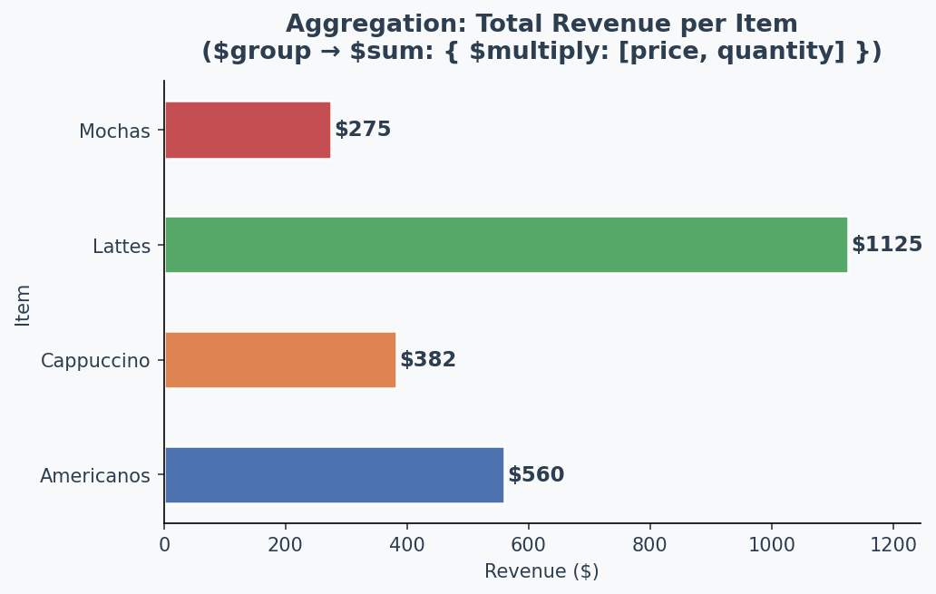
_id (item) | totalRevenue ($)
Americanos | $600
Lattes | $1125
Cappuccino | $411
Mochas | $275

6. Query 5: Average Price per Item – $avg
The $avg accumulator computes the arithmetic mean of a field across all documents in a group.

db.sales.aggregate([
{
$group: {
_id: "$item",
avgPrice: { $avg: "$price" }
}
},
{ $sort: { avgPrice: -1 } }
])

Output – Average Price per Item:
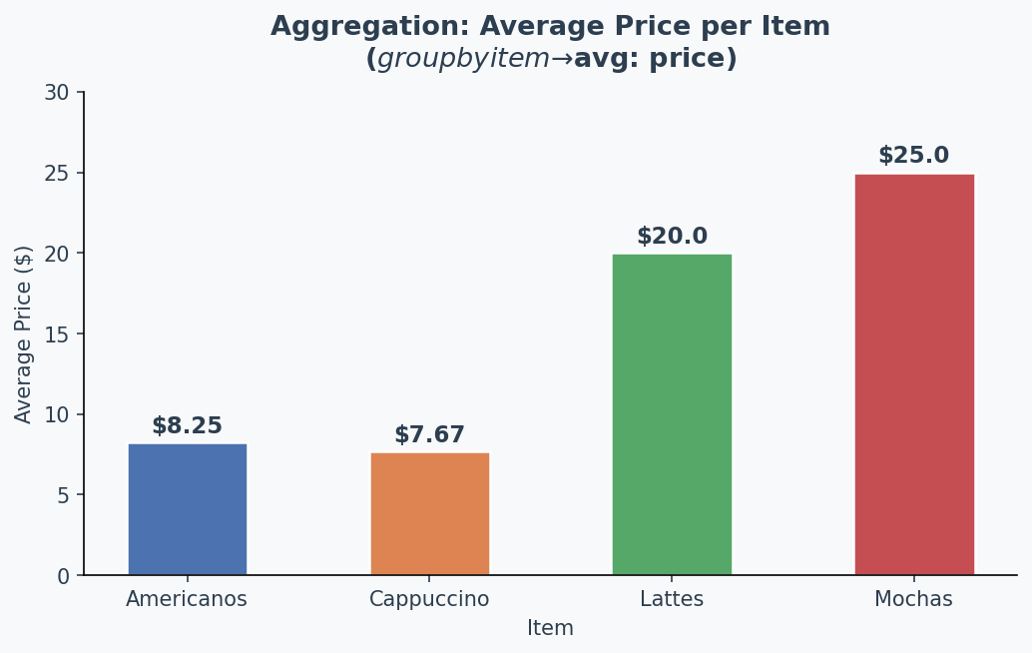
_id (item) | avgPrice ($)
Americanos | $8.25
Cappuccino | $7.67
Lattes | $20.00
Mochas | $25.00

7. Query 6: Monthly Quantity Sold – $match by Date Range
We use $match with date range operators to filter documents by month, then group and sum the quantities sold in each month.

// January 2022 Sales
db.sales.aggregate([
{
$match: {
date: {
$gte: ISODate("2022-01-01T00:00:00Z"),
$lt: ISODate("2022-02-01T00:00:00Z")
}
}
},
{
$group: {
_id: "January 2022",
totalQty: { $sum: "$quantity" }
}
}
])

// February 2022 Sales
db.sales.aggregate([
{
$match: {
date: {
$gte: ISODate("2022-02-01T00:00:00Z"),
$lt: ISODate("2022-03-01T00:00:00Z")
}
}
},
{
$group: {
_id: "February 2022",
totalQty: { $sum: "$quantity" }
}
}
])

Output – Monthly Quantity Comparison:
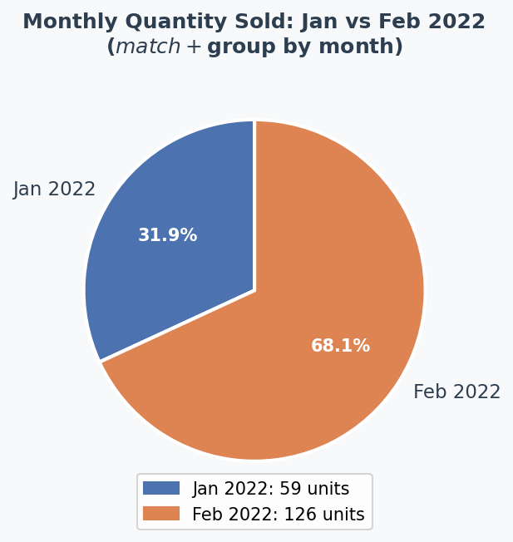
Month | Total Quantity Sold
January 2022 | 59
February 2022 | 126

8. Query 7: Select Specific Fields – $project
The $project stage reshapes documents — include only needed fields (1) or exclude fields (0). It is equivalent to SELECT in SQL.

// Show only item, price, and quantity (hide _id)
db.sales.aggregate([
{
$project: {
_id: 0,
item: 1,
price: 1,
quantity: 1
}
}
])

1 = include field, 0 = exclude field. By default _id is always included; set _id: 0 to hide it.

item | price | quantity
Americanos | $5 | 22
Cappuccino | $6 | 12
Lattes | $15 | 25
Mochas | $25 | 11
Americanos | $10 | 12
Cappuccino | $7 | 20
Lattes | $25 | 30
Americanos | $10 | 21
Cappuccino | $10 | 17
Americanos | $8 | 15

9. Query 8: Top 3 Sales by Quantity – $sort + $limit
We can chain $sort (descending by quantity) and $limit to retrieve only the top N results — useful for dashboards and reporting.

db.sales.aggregate([
{ $sort: { quantity: -1 } }, // -1 = descending
{ $limit: 3 } // only top 3
])

Output – Top 3 highest-quantity sales:
_id | item | price | size | quantity
7 | Lattes | $25 | Tall | 30
3 | Lattes | $15 | Grande | 25
8 | Americanos | $10 | Grande | 21

10. MongoDB Aggregation – Quick Reference
Summary of all aggregation pipeline stages used in this assignment:

Stage / Operator | SQL Equivalent | Purpose
$match | WHERE | Filter documents based on a condition
$group | GROUP BY | Group documents and apply accumulators
$sum | SUM() | Add up values in a group
$avg | AVG() | Calculate average of a field in a group
$multiply | col1 * col2 | Multiply two fields or values together
$sort | ORDER BY | Sort documents (1=asc, -1=desc)
$limit | LIMIT n | Restrict number of output documents
$project | SELECT cols | Include or exclude specific fields
$gt | > operator | Greater than comparison
$lt | < operator | Less than comparison

End of Assignment • 6 June 2026

