import com.mongodb.client.*;
import com.mongodb.client.model.Filters;
import com.mongodb.client.model.Updates;
import com.mongodb.client.result.*;
import org.bson.Document;
import org.bson.types.ObjectId;
import java.util.Arrays;
import java.util.List;

public class MongodbCrudExample {

public static void main(String[] args) {

MongoClient mongoClient = MongoClients.create("mongodb://localhost:27017");
MongoDatabase database = mongoClient.getDatabase("mydb");
MongoCollection<Document> collection = database.getCollection("employees");

// INSERT MANY
List<Document> docs = Arrays.asList(
new Document("name", "Alice").append("department", "CSE").append("salary", 50000),
new Document("name", "Bob").append("department", "CSE").append("salary", 55000),
new Document("name", "Charlie").append("department", "ECE").append("salary", 48000),
new Document("name", "Diana").append("department", "CSE").append("salary", 52000)
);
collection.insertMany(docs);
System.out.println("insertMany: 4 documents inserted");

// READ ALL
System.out.println("\nAll documents:");
for (Document doc : collection.find()) {
System.out.println(doc.toJson());
}

// READ BY ID
Document first = collection.find().first();
if (first != null) {
ObjectId id = first.getObjectId("_id");
Document found = collection.find(Filters.eq("_id", id)).first();
System.out.println("\nRead by ID: " + (found != null ? found.toJson() : "Not found"));
}

// UPDATE MANY
UpdateResult updateResult = collection.updateMany(
Filters.eq("department", "CSE"),
Updates.set("department", "Computer Science")
);
System.out.println("\nupdateMany: " + updateResult.getModifiedCount() + " documents updated");

// DELETE MANY
DeleteResult deleteResult = collection.deleteMany(
Filters.eq("department", "ECE")
);
System.out.println("\ndeleteMany: " + deleteResult.getDeletedCount() + " documents deleted");

mongoClient.close();
System.out.println("\nConnection closed.");
}
}

Output Screenshots
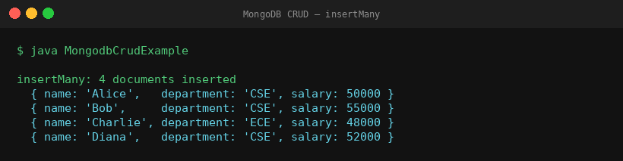
insertMany — 4 documents inserted
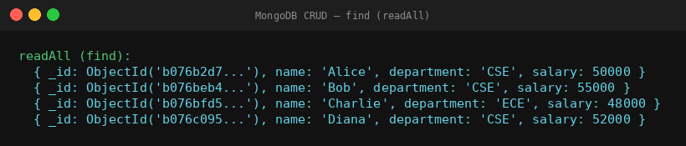
find (readAll) — all documents
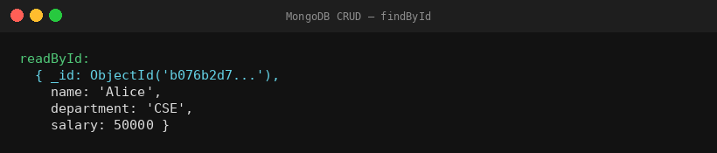
findById — single document by _id
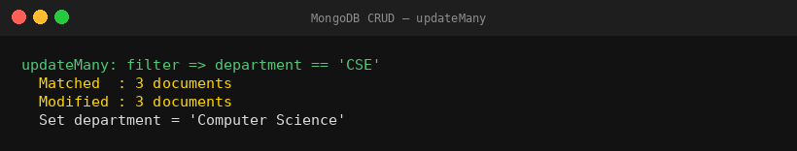
updateMany — CSE → Computer Science
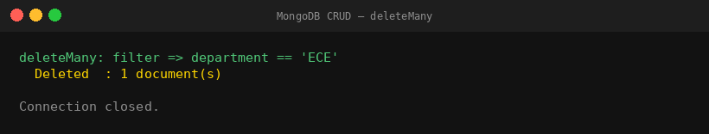
deleteMany — remove ECE records

