MongoDB Replica Set Setup on Windows
Step-by-Step Guide | Date: 10 June 2026

Prerequisites
An existing MongoDB 4.4 instance is already running on the system with the following configuration:

Parameter | Value
Binary Location | C:\Program Files\MongoDB\Server\4.4\bin
--dbpath | C:\Program Files\MongoDB\Server\4.4\data\db
--logpath | C:\Program Files\MongoDB\Server\4.4\log\mongod.log
--port | 27017
--storageEngine | wiredTiger

ℹ Open all Command Prompt windows as Administrator (right-click > Run as administrator) to avoid access-denied errors.

Replica Set Overview
Three mongod instances will form one replica set named prodrep:

Node | Role | Port | dbpath | replSet
Node 0 | PRIMARY | 27017 | C:\Program Files\MongoDB\Server\4.4\data | prodrep
Node 1 | SECONDARY | 27020 | c:\data1\db | prodrep
Node 2 | SECONDARY | 27030 | c:\data2\db | prodrep

Phase 1 — Create Directory Structure

Step 1 — Create folders for both slave nodes
Open Command Prompt as Administrator and run:
mkdir c:\data1\config c:\data1\db c:\data1\log
mkdir c:\data2\config c:\data2\db c:\data2\log
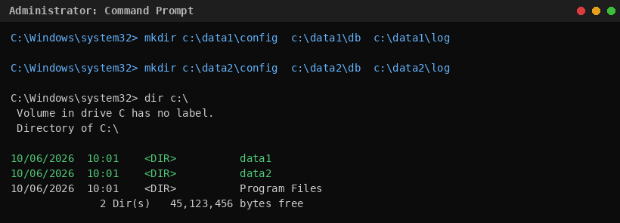

Phase 2 — Create Configuration Files

Step 2a — Config file for Slave Node 1 (port 27020)
notepad c:\data1\config\mongod.cnf
Paste the following content and save:
dbpath=c:\data1\db
logpath=c:\data1\log\mongod.log
port=27020
storageEngine=wiredTiger
replSet=prodrep

Step 2b — Config file for Slave Node 2 (port 27030)
notepad c:\data2\config\mongod.cnf
Paste the following content and save:
dbpath=c:\data2\db
logpath=c:\data2\log\mongod.log
port=27030
storageEngine=wiredTiger
replSet=prodrep
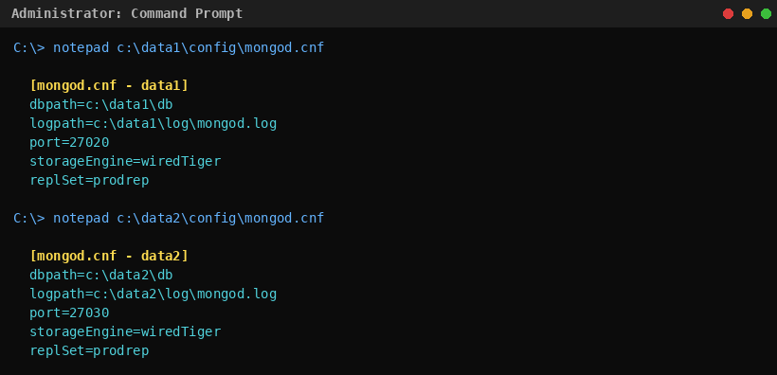

Phase 3 — Start All mongod Instances

Step 3 — Stop the default MongoDB service
Open services.msc and stop the MongoDB service, or run from an elevated prompt:
net stop MongoDB
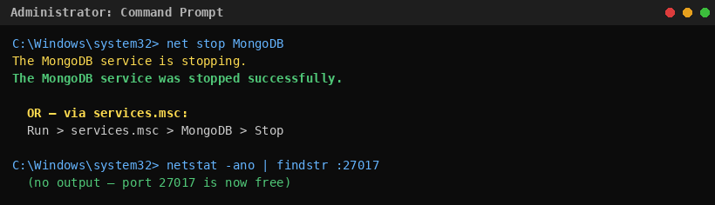
⚠ Note: If port 27017 remains in use, check with: netstat -ano | findstr :27017 and kill the PID via Task Manager.

Step 4 — Start Primary Node (Terminal 1)
Open a new Administrator Command Prompt and run:
mongod --dbpath "C:\Program Files\MongoDB\Server\4.4\data"
--logpath "C:\Program Files\MongoDB\Server\4.4\log\mongod.log"
--port 27017 --storageEngine=wiredTiger
--journal --replSet prodrep
Leave this window open. Expected output:
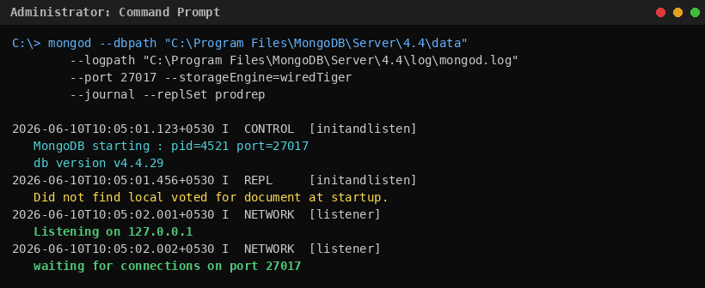

Step 5 — Start Slave Node 1 (Terminal 2) & Slave Node 2 (Terminal 3)
Open two more Administrator Command Prompt windows:
// Terminal 2 — Slave Node 1
mongod --dbpath "c:\data1\db"
--logpath "c:\data1\log\mongod.log"
--port 27020 --storageEngine=wiredTiger
--journal --replSet prodrep

// Terminal 3 — Slave Node 2
mongod --dbpath "c:\data2\db"
--logpath "c:\data2\log\mongod.log"
--port 27030 --storageEngine=wiredTiger
--journal --replSet prodrep
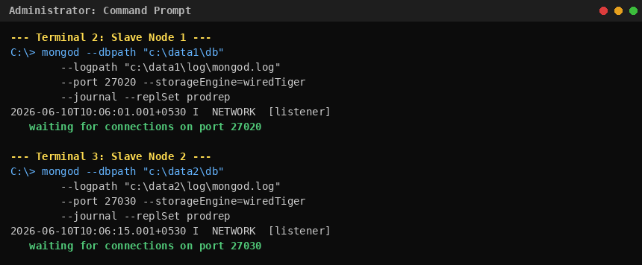

Phase 4 — Initialize the Replica Set

Step 6 — Connect to Primary and initialize
Open a 4th Command Prompt window (does not need to be Administrator):
mongo --port 27017
Once inside the mongo shell, define the replica set config and initiate:
rsconf = { _id: "prodrep", members: [ { _id: 0, host: "localhost:27017" } ] }
rs.initiate(rsconf)
After pressing Enter twice, the prompt changes to prodrep:PRIMARY>
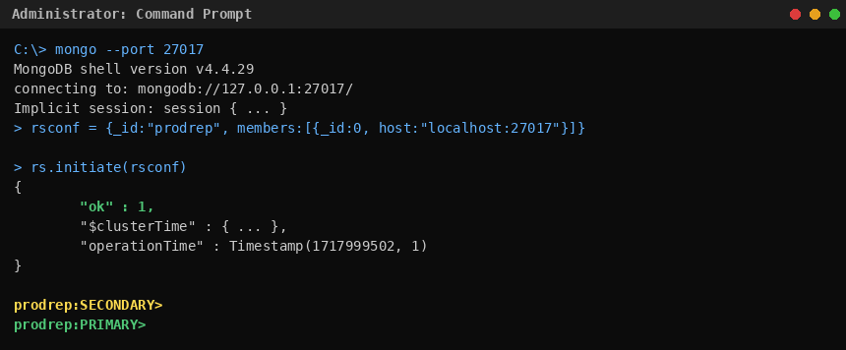

Step 7 — Add Slave Nodes to the Replica Set
From the prodrep:PRIMARY> prompt, run:
rs.add("localhost:27020")
rs.status()
rs.add("localhost:27030")
rs.status()
The rs.status() output should show one PRIMARY and two SECONDARY members, all with health: 1.
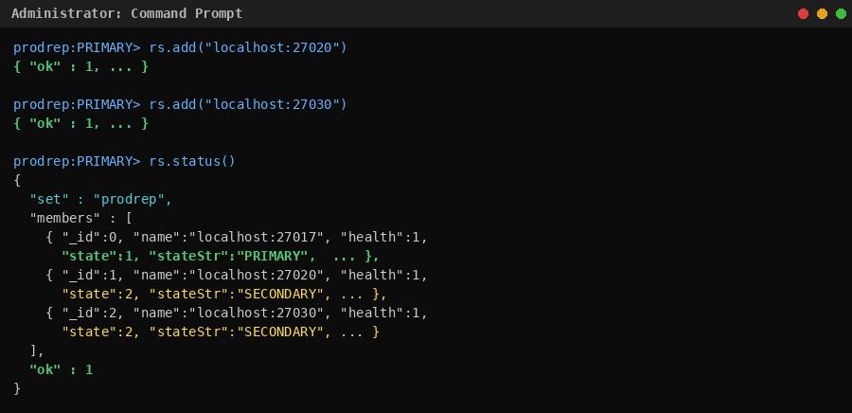

Phase 5 — Enable Reads on Secondary Nodes

Step 8 — Connect to Slave 1 (port 27020) and enable reads
mongo --port 27020
rs.slaveOk()
show dbs

Step 9 — Connect to Slave 2 (port 27030) and enable reads
mongo --port 27030
rs.slaveOk()
show dbs
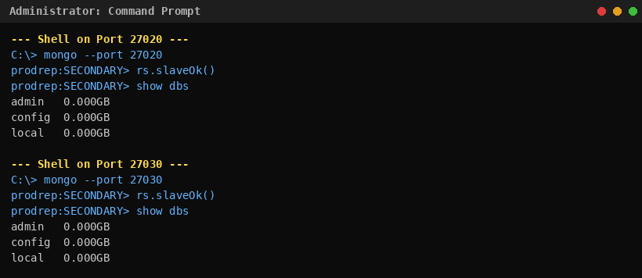
⚠ Note: rs.slaveOk() is required on each secondary shell to allow read queries. Without it, queries on secondary nodes return an error.

Phase 6 — Test Replication

Step 10 — Insert data on Primary
From the prodrep:PRIMARY> prompt:
use repdb1
db.student.insert({ "name": "Avi" })
show dbs
db.student.find()
Expected: repdb1 appears in show dbs and the inserted document is returned.
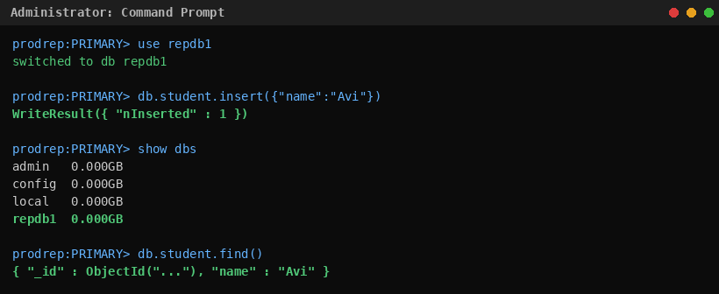

Step 11 — Verify replication on both Secondary nodes
Switch to each secondary shell and confirm the database and document were replicated:
// On port 27020 shell
show dbs
use repdb1
db.student.find()

// On port 27030 shell
show dbs
use repdb1
db.student.find()
Both secondaries must display repdb1 in show dbs and return { "name": "Avi" } from db.student.find(). This confirms successful replication.
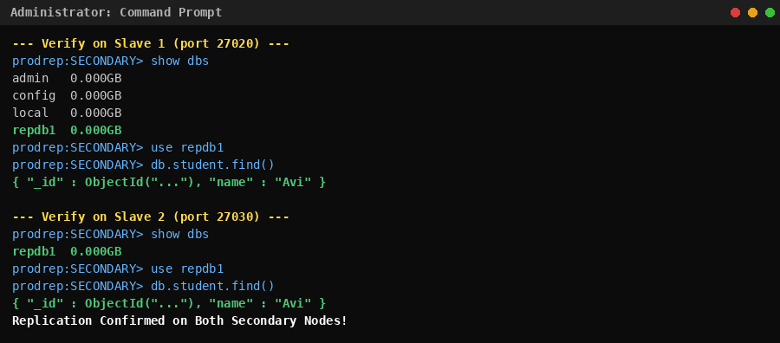

Summary
- Created directory structure for two slave nodes under c:\data1 and c:\data2.
- Created mongod.cnf configuration files for each slave node.
- Stopped the default MongoDB service on port 27017.
- Started all three mongod instances with --replSet prodrep.
- Initialized the replica set with rs.initiate() and added both slave nodes with rs.add().
- Enabled reads on secondary nodes with rs.slaveOk().
- Confirmed successful replication by inserting data on the primary and verifying on both secondaries.

ℹ Replication provides high availability: if the primary node goes down, one secondary is automatically elected as the new primary and operations continue without manual intervention.

