FINAL PROJECT REPORT
IoT-Enabled Vibration and Tilt Monitoring System for Early-Warning Detection of Retaining Wall and Slope Micro-Movement Using Unsupervised Anomaly Detection
ESP32 · MPU-6500 · Capacitive Soil-Moisture Sensing · Isolation Forest · Live Dashboard
Submitted by
Gurpreet
Registration No.: 24BCT0292
B.Tech Computer Science Engineering (AI/ML Specialization)
VIT Vellore
October 2026

Abstract
Retaining walls and slopes usually move slowly before they fail, and routine visual inspection cannot see that movement. This report presents a low-cost IoT node that measures tilt, vibration and soil moisture on a wall and flags abnormal movement automatically. An ESP32 samples an MPU-6500 inertial sensor at 128 Hz and reduces every four-second window to a compact feature vector: tilt from the gravity vector, vibration energy, dominant frequency and temperature, together with a capacitive soil-moisture reading. The vectors travel over WiFi to a Python backend, which standardizes them and scores them with an Isolation Forest fitted to normal behaviour.
An alert is raised only when consecutive windows are flagged, vibration has its own rule-based trigger, and movement that coincides with rising soil moisture is interpreted as rain-associated and held at a lower warning level. A browser dashboard shows tilt, vibration, moisture, anomaly score and alert status together with the cause of each alert. In evaluation with injected disturbance events the system stayed silent under hand handling and an uneven mounting surface, raised an alert about eight seconds after a deliberate tilt or vibration began, ignored isolated transients, and produced about 0.4 false alerts per simulated day against about 149 for a fixed-threshold detector. The report documents the hardware, firmware, algorithms and tests, and explains how the same design operates on a real wall.

Contents
1 Introduction
2 Literature Positioning
3 System Architecture
4 Hardware Design
5 Embedded Firmware
6 Backend and Anomaly Detection
7 Dashboard
8 Testing and Results
9 Operation in a Real-Life Scenario
10 Limitations and Future Work
11 Conclusion
References
Appendix A Feature Message Format
Appendix B Operating and Demonstration Procedure
Appendix C Project Files

1 Introduction

1.1 Background and problem statement
Retaining walls, road embankments and hillside slopes rarely fail without warning. They undergo creep: micro-cracks widen and the structure’s orientation shifts by fractions of a degree over days or weeks before a visible collapse. By the time bulging or cracking can be seen it is often too late to intervene. Periodic inspection cannot catch a process that is continuous, and the instruments used for continuous monitoring, such as borehole inclinometers, are too costly to place on the very large number of walls and slopes that exist in practice. Low-cost systems in the literature mostly rely on fixed, site-specific thresholds that do not adapt to a structure’s own behaviour.
This project builds a small, low-cost node that watches a wall continuously, learns what normal looks like for that wall, and raises a labelled alert when tilt or vibration departs from it, taking rainfall context into account.

1.2 Objectives and how they were realised
Objective | Realisation in this project | Section
1. Low-cost sensor node (ESP32 + IMU + moisture sensor) | ESP32 DevKit, MPU-6500 and HW-390 built and wired; USB-powered prototype, battery and solar configuration specified for the field | 4
2. On-device feature extraction | Tilt, vibration energy, dominant frequency and temperature computed on the ESP32 every 4 s window; moisture appended; temperature logged for drift correction | 5
3. Baseline dataset and Isolation Forest on standardized features | Logging pipeline, StandardScaler plus Isolation Forest fitted on baseline windows; retrainable from logged data | 6
4. Alert pipeline with N-window confirmation and rain-aware interpretation | Consecutive-window state machine, independent vibration rule, rain-context downgrade | 6
5. Validation by anomaly injection and false-positive measurement | Injected tilt, shake and combined events, false alerts per simulated day, latency, transient rejection | 8
6. Web dashboard | Live browser dashboard with tilt, vibration, moisture, score, status and cause | 7

1.3 Scope of the prototype
The prototype is a bench-scale retaining-wall model. The node is powered and programmed from a laptop over USB-C and reports over WiFi (a phone hotspot) to a backend running on the same laptop. The deployed design (battery, solar panel, deep-sleep duty cycle) is described in Section 9. The prototype operating thresholds are set so that picking the rig up, holding it, or placing it on an uneven surface does not raise an alarm, while a deliberate lean or shake does.

2 Literature Positioning
Ten recent works on IoT landslide monitoring, low-cost MEMS sensor networks and unsupervised structural anomaly detection were reviewed in the project proposal. Table 1 positions the present work against the main groups.
Table 1 Positioning against the reviewed work
Work | Approach | Gap addressed here
Villaverde et al. (2023) | Low-cost IoT landslide early-warning with preset thresholds | Thresholds are manual; this system learns the structure’s own baseline
Ghosh et al., Darjeeling Himalayas | Geotechnical IoT monitoring of unstable slopes | Instrumentation cost; this node uses a low-cost MEMS sensor
LoRa rockfall/landslide node (MDPI 2025) | Low-power long-range transmission | Threshold detection with no learned model
Arduino/GSM landslide detector (IJIRT) | Threshold alarm sent by GSM | No confirmation logic, so transient disturbances can alarm
Isolation Forest SHM (2025); real-time SHM with IoT sensors (2026) | Unsupervised anomaly detection on vibration | Focus on bridges and buildings; no rainfall context
This work | Edge features + Isolation Forest + N-window confirmation + rain-aware interpretation | Learns normal behaviour, suppresses transients, separates rain-associated from unexplained movement

3 System Architecture
The system has four layers (Figure 1). The sensing layer measures acceleration, temperature and soil moisture. The edge layer, an ESP32, turns the raw signal into one small feature vector per window. The backend standardizes and scores each vector, applies the decision rules, and stores the result. The output layer presents status to the user and keeps a log that can later be used to retrain the model.
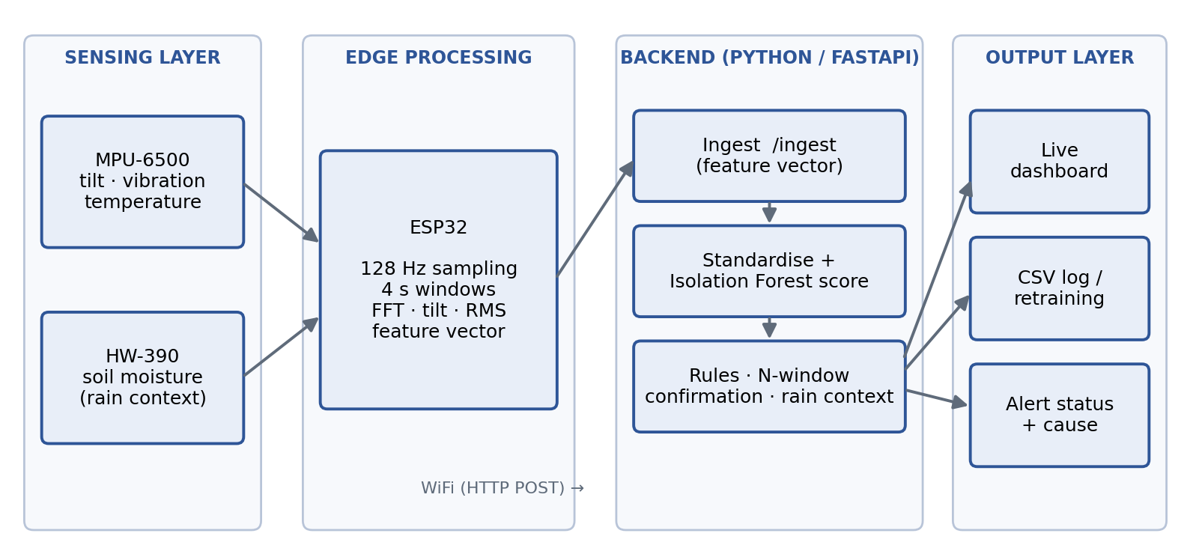
Figure 1 System architecture

3.1 Data flow
- The MPU-6500 is rigidly fixed to the wall face. The ESP32 polls it at 128 Hz and reads the soil-moisture sensor on every sample.
- After 512 samples (4 s) the ESP32 computes tilt, vibration energy, dominant frequency, mean temperature and mean moisture.
- The feature vector, not the raw samples, is sent over WiFi as an HTTP POST to the backend.
- The backend measures tilt as a change from a baseline reference, standardizes the model inputs and obtains an Isolation Forest score.
- Decision rules combine the score, tilt and vibration limits and the moisture trend into a flag for the window.
- A state machine turns flags into NORMAL, WATCH or ALERT with a stated cause.
- The result is stored in a CSV log and shown on the dashboard.

3.2 Design decisions
- Features, not raw data, leave the node. One 17-field line per window keeps bandwidth and radio time small, which is what makes battery and solar operation practical in the field.
- Tilt is reported relative to a baseline. The absolute angle of a wall depends on how it was built and mounted; the change from its own reference is what matters. This also makes the system tolerant of an uneven mounting surface.
- Sampling is isolated from networking. WiFi transmission runs in a separate task so that a slow or failed network call never delays the 128 Hz sampling.
- Two independent safeguards against false alarms. A learned model with minimum-significance limits, plus confirmation across consecutive windows.

4 Hardware Design

4.1 Components and cost
Table 2 Bill of materials
Component | Role | Cost (₹)
ESP32 DevKit (ESP32-WROOM-32, 30-pin, USB-C) | Controller, feature extraction, WiFi | 350
MPU-6500 six-axis IMU module | Tilt, vibration, temperature | 120
HW-390 capacitive soil-moisture sensor V2.0.0 | Rain and saturation context | 150–200
Mounting plate, screws, jumper wires | Rigid sensor mounting | 100
Prototype total (USB-powered) |  | 720–770
Li-ion cell and TP4056 charger | Field power storage | 200
5–6 V solar panel | Field charging | 250
IP65 enclosure | Weather protection | 200
Field node total |  | 1,370–1,420

4.2 Wiring
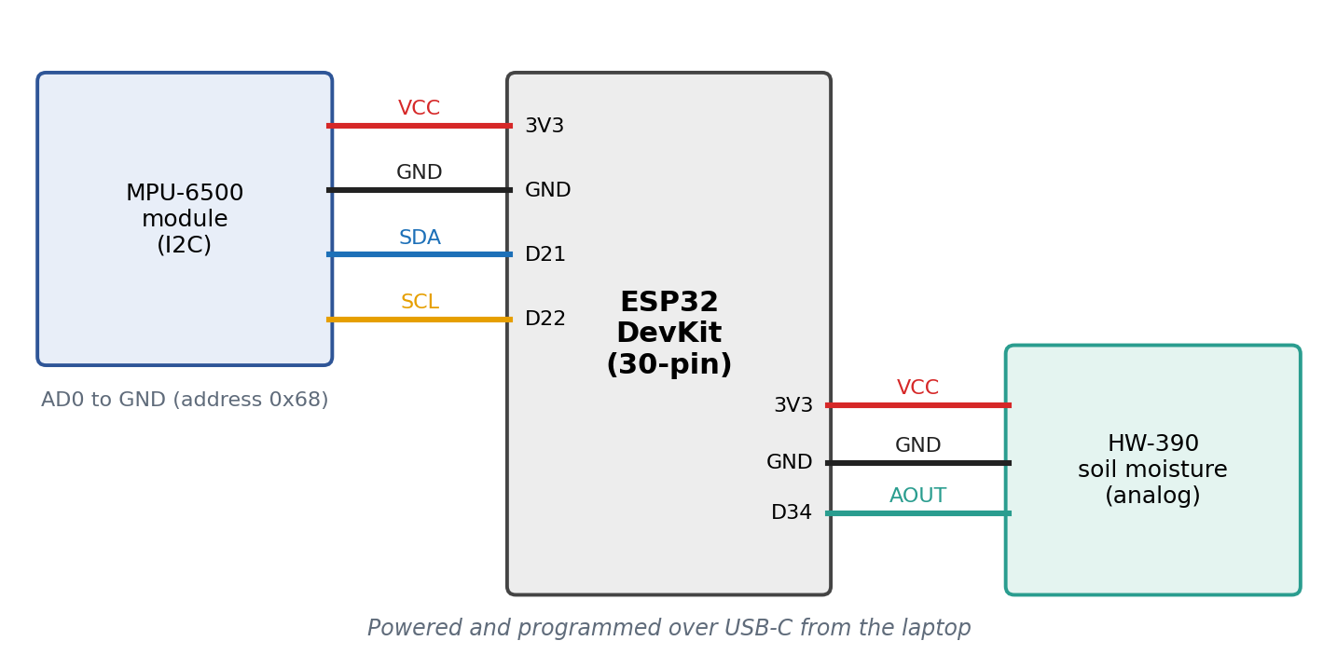
Figure 2 Wiring of the sensor node
Table 3 Pin connections
Module | Module pin | ESP32 pin | Note
MPU-6500 | VCC / GND | 3V3 / GND | 3.3 V supply
 | SDA | GPIO21 (D21) | I2C data, 400 kHz
 | SCL | GPIO22 (D22) | I2C clock
 | AD0 | GND | Selects I2C address 0x68
 | INT, XDA, XCL | not used
HW-390 | VCC / GND | 3V3 / GND | Powered at 3.3 V so the analog output stays within the ESP32 ADC range
 | AOUT | GPIO34 (D34) | ADC1 channel; ADC1 keeps working while WiFi is active

4.3 Mounting and axis convention
The IMU is mounted vertically on the wall board, header pins down and chip face outward, fixed through its two corner holes, with the cable clamped a few centimetres below the pins so that a tug on the wire cannot register as tilt. With this mounting the sensor X axis runs up the wall, Z points out of the wall, and Y runs along it. An orientation test confirmed the convention: upright, the X axis read +1.056 g and Z about 0; leaning the top edge outward made Z go negative (−0.203 g, roughly 11° of lean). Three firmware constants (UP_AXIS, UP_SIGN, OUT_SIGN) encode this mapping so that the same code supports other mounting orientations.

4.4 Sensor verification and characterisation
The inertial chip was identified from its WHO_AM_I register, which returns 0x70, the identifier of the MPU-6500. Rest measurements were repeated three times, ten seconds apart, with the module flat on a hard surface.
Table 4 Measured sensor characteristics
Parameter | Result
Device identifier (WHO_AM_I) | 0x70, MPU-6500
Accelerometer noise at rest (1σ per sample) | X 1.2 mg, Y 1.1 mg, Z 2.1 mg, about 0.06–0.07° of tilt per raw sample
Repeatability of the rest mean across three runs | X 1.9 mg, Y 1.6 mg, Z 1.0 mg, about 0.1–0.2° of tilt
Magnitude of the mean acceleration vector | 0.995–0.997 g
Gyroscope bias / noise | X −6.2, Y +7.7, Z +0.1 °/s, stable between runs; noise about 0.05 °/s
Die temperature during rest runs | 33.3–34.6 °C
Soil-moisture sensor, air / water | 3115 / 1258 ADC counts (span 1857 of 4095)
Sampling timing (8 s development configuration) | 0 late samples, 0 failed reads, window duration 7.992 s, processing 8–9 ms per window

A one-degree movement is about 17.5 mg on the horizontal axis, roughly ten times the measured run-to-run repeatability, so tilt changes of the order of a degree are resolved reliably and, with window averaging and temperature compensation, smaller ones become visible.

5 Embedded Firmware

5.1 Sensor configuration
The firmware accesses the MPU-6500 through its registers directly rather than through an MPU-6050 library, because such libraries reject the 6500’s identifier and use a different temperature formula. The sensor is configured for a ±2 g range (16,384 LSB per g), an accelerometer low-pass filter of about 45 Hz and a 1 kHz internal rate. The ESP32 reads accelerometer and temperature in one 8-byte burst per sample.
Table 5 Firmware configuration
Parameter | Value
Sampling rate | 128 Hz, scheduled from absolute microsecond timestamps (7.8125 ms period), so timing errors do not accumulate
Window | 512 samples = 4.0 s; frequency resolution 0.25 Hz; analysis band up to 64 Hz (Nyquist)
Accelerometer range / filter | ±2 g; low-pass about 45 Hz
I2C bus | 400 kHz on GPIO21 (SDA) and GPIO22 (SCL)
Moisture channel | GPIO34, 12-bit ADC, 11 dB attenuation, averaged over the window
Moisture calibration | Dry 3115 counts (0 %), wet 1258 counts (100 %)

5.2 Feature extraction
For each window the ESP32 stores the 512 samples of the three axes and computes the features of Table 6. Tilt uses the mean gravity vector of the window: with a the mean acceleration along each axis, the outward tilt is atan2(−a_out, a_up) and the sideways tilt is atan2(a_lat, a_up). Vibration energy is the root-mean-square of the deviation from the window mean, which removes gravity and slow tilt. The spectrum is obtained with a Hann window and a 512-point radix-2 FFT on each axis; the three power spectra are summed and the strongest bin between 0.5 Hz and the Nyquist limit gives the dominant frequency.
Table 6 Window features
Feature | Definition | Purpose
tilt_out | atan2(−a_out, a_up) of the mean vector, degrees; positive when the top leans outward | Primary wall-movement indicator
tilt_lat | atan2(a_lat, a_up), degrees | Sideways rotation
vib_rms_mg | 1000 · √(σx² + σy² + σz²) of the deviation from the window mean | Vibration energy
dom_hz | Frequency of the largest spectral peak, 0.5–64 Hz | Slow sway versus fast shaking
dom_ratio | Peak power divided by total band power, 0 to 1 | Tone-like versus broadband
temp_c | Mean die temperature | Context for thermal drift
moist_raw, moist_pct | Mean ADC counts; percentage = 100 (3115 − raw) / (3115 − 1258), limited to 0–100 | Rain and saturation context

5.3 Transmission
Each window produces one comma-separated line (Appendix A) that is printed on the serial port and placed in a four-slot queue. A separate FreeRTOS task on the second core takes lines from the queue and posts them to the backend, reconnecting the WiFi link when it drops and discarding a window if the network is unavailable. The sampling loop never waits for the network, and the same line printed on the serial port allows a USB-only fallback.

5.4 Validation of the feature code
The feature-extraction block was compiled on a PC and compared with an independent NumPy implementation on test windows containing a known tilt, a 2.5 Hz oscillation and a 13 Hz oscillation. Tilt agreed within 0.01°, vibration within 0.01 mg, the dominant-frequency bin exactly, and the peak ratio within 0.0005. A companion script compares the firmware’s own output with NumPy on raw samples dumped from the board.

6 Backend and Anomaly Detection

6.1 Service
The backend is a Python FastAPI service that accepts feature lines at an ingestion endpoint (or reads them from the serial port or a replay file), scores them, keeps the alert state and serves the dashboard. Every processed window is appended to a CSV log. The service listens on the local network so that the ESP32 and a phone browser can both reach it.

6.2 Baseline reference and orientation guard
Tilt is evaluated as the change from a reference taken from the first three windows after start-up (about 12 s) or after the Set baseline control is pressed. A baseline is accepted only if the node is within 45° of upright; otherwise the dashboard stays in CALIBRATING and tells the operator to stand the board pins-down with the chip facing outward. This prevents a baseline from being captured in a wrong orientation, which would make every later reading look like an extreme tilt.

6.3 Baseline data, standardization and Isolation Forest
The model is fitted to baseline windows only. For the bench prototype the baseline profile combines two conditions of normal use: the rig at rest (small tilt wander, low vibration) and the rig being handled or sitting on an uneven surface (larger tilt wander, moderate vibration, low-frequency content). The training script generates 4,000 windows from this profile, 55 % at rest and 45 % under handling. The same script retrains on windows logged by the backend, so a deployed node learns from its own site.
The model inputs are the tilt magnitude, √(Δtilt_out² + Δtilt_lat²), and the base-10 logarithm of vibration RMS. They are standardized to zero mean and unit variance and passed to an Isolation Forest of 200 trees. The decision threshold is the 2nd percentile of the baseline scores. Dominant frequency and peak ratio are logged and displayed but are not model inputs: in trials with all five features the forest flagged only 7 % of deliberate-tilt windows, because the two frequency features added dimensions in which tilt events are not unusual, whereas with the two features above it flagged 99.6 %.

6.4 Decision rules
A window is flagged when either of two conditions holds. First, vibration RMS reaches the vibration limit (300 mg); this is a plain rule and does not depend on the model. Second, the model scores the window as anomalous and the tilt change reaches the tilt limit (8°). The limits are above the tilt wander (up to about 5°) and vibration (about 50–200 mg) observed while the rig was held in the hand, so handling stays below them. The window’s cause is recorded as TILT, VIBRATION or both.

6.5 Confirmation and alert state machine
A single flagged window only raises WATCH. ALERT requires two consecutive flagged windows (about 8 s). Once raised, an ALERT is held until three consecutive normal windows (about 12 s) have passed, which prevents flicker around the thresholds. Figure 3 shows the states and transitions.
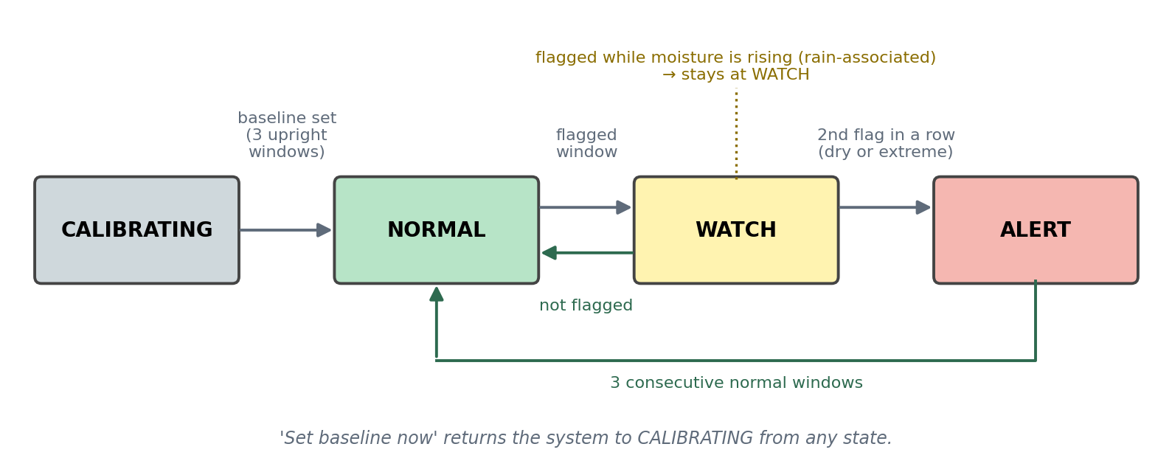
Figure 3 Alert state machine

6.6 Rain-aware interpretation
The backend keeps the last six moisture readings. If moisture has risen by 5 percentage points or more over that history, the node is considered to be in a wet context. In a wet context a confirmed flag is held at WATCH with the note “rain-associated” unless the movement is extreme (1.75 times either limit). Once moisture stops rising, the same movement is no longer explained by rain and escalates to ALERT. Movement on a dry reading is therefore always treated as unexplained.

6.7 Logging and retraining
Every window is logged with its features, tilt change, model score, flags and status. Training on a logged baseline file leaves out ALERT windows, prints a dataset summary (number of windows, hours, tilt and vibration percentiles, temperature range) and saves a new model. Retraining is therefore a two-command operation.
Table 7 Operating parameters (config.py)
Parameter | Value | Meaning
TILT_FLOOR | 8° | Minimum tilt change that can count as an alert
VIB_FLOOR | 300 mg | Vibration RMS that triggers the vibration rule
N_CONFIRM | 2 windows (≈8 s) | Consecutive flagged windows required for ALERT
N_CLEAR | 3 windows (≈12 s) | Consecutive normal windows required to clear an ALERT
REF_WINDOWS | 3 windows (≈12 s) | Windows averaged to set the baseline
UPRIGHT_MAX | 45° | Largest tilt at which a baseline is accepted
RAIN_WINDOWS / RAIN_RISE_PCT | 6 windows / 5 points | History and moisture rise that define a wet context
RAIN_EXTREME | 1.75 × | Movement beyond this multiple of the limits alerts even in rain
NAIVE_TILT / NAIVE_VIB | 5° / 150 mg | Plain fixed-threshold detector logged for comparison
Model | 200 trees | Threshold at the 2nd percentile of baseline scores; inputs: tilt magnitude, log vibration

7 Dashboard
The dashboard is a single web page served by the backend and opened in a browser on the laptop or a phone. It refreshes once a second.
- Status banner: colour-coded NORMAL, WATCH, ALERT or CALIBRATING; during WATCH and ALERT it also names the cause (TILT, VIBRATION or TILT + VIBRATION) and gives a one-line reason. It switches to a no-data warning if nothing arrives for 15 s, so a dead link is not mistaken for a calm structure.
- Metric tiles: tilt change (outward and sideways), vibration, dominant frequency, moisture, anomaly score, time since last data, and absolute tilt. Tiles that exceed their limits are outlined in red.
- Charts: tilt change with the alert limits, vibration with its limit, soil moisture, and a status history strip.
- Set baseline control: re-references the tilt after the node is moved or installed on a new surface.

8 Testing and Results
Testing combined measurements on the hardware (Section 4.4), validation of the feature code (Section 5.4), and evaluation of the detection pipeline with a simulated baseline stream and injected disturbance events, in line with the synthetic anomaly injection of Objective 5.

8.1 Per-window detection
Two thousand windows were generated for each condition and scored by the final decision logic and by a plain fixed-threshold detector (tilt above 5° or vibration above 150 mg).
Table 8 Fraction of windows flagged
Condition | This system | Fixed threshold
Normal (rest and handling mix) | 0.1 % | 8.1 %
Hand-held handling | 0.7 % | 20.1 %
Deliberate tilt | 99.6 % | 100 %
Deliberate shake | 99.1 % | 100 %
Tilt and shake together | 99.8 % | 100 %

Both detectors catch deliberate disturbances, but the fixed-threshold detector flags one in five hand-held windows, which is the situation the prototype must tolerate.

8.2 Confirmed alerts, latency and transients
Table 9 Behaviour of the complete alert pipeline
Measure | This system | Fixed threshold
False confirmed alerts per simulated day of baseline (21,600 windows, mean of 5 runs) | 0.4 (range 0–1) | 149 (range 136–155)
Deliberate tilt: detected, mean time to ALERT (200 trials) | 100 %, 2.0 windows (≈8 s), worst 4 | not applicable
Deliberate shake: detected, mean time to ALERT (200 trials) | 100 %, 2.0 windows (≈8 s), worst 4 | not applicable
Tilt and shake together: detected, mean time to ALERT | 100 %, 2.0 windows (≈8 s) | not applicable
Single shake-level window followed by calm (200 trials) | 0 alerts (WATCH only) | not applicable
Moderate tilt (≈10°) while moisture rises (200 trials) | 0 % ALERT, 100 % WATCH | not applicable
The same tilt on a dry reading (200 trials) | 100 % ALERT | not applicable

8.3 Scripted end-to-end run
A scripted sequence of 52 windows was sent through the real backend: rest, hand-held handling, deliberate tilt, deliberate shake, and a tilt while moisture rises (Figure 4, Table 10).
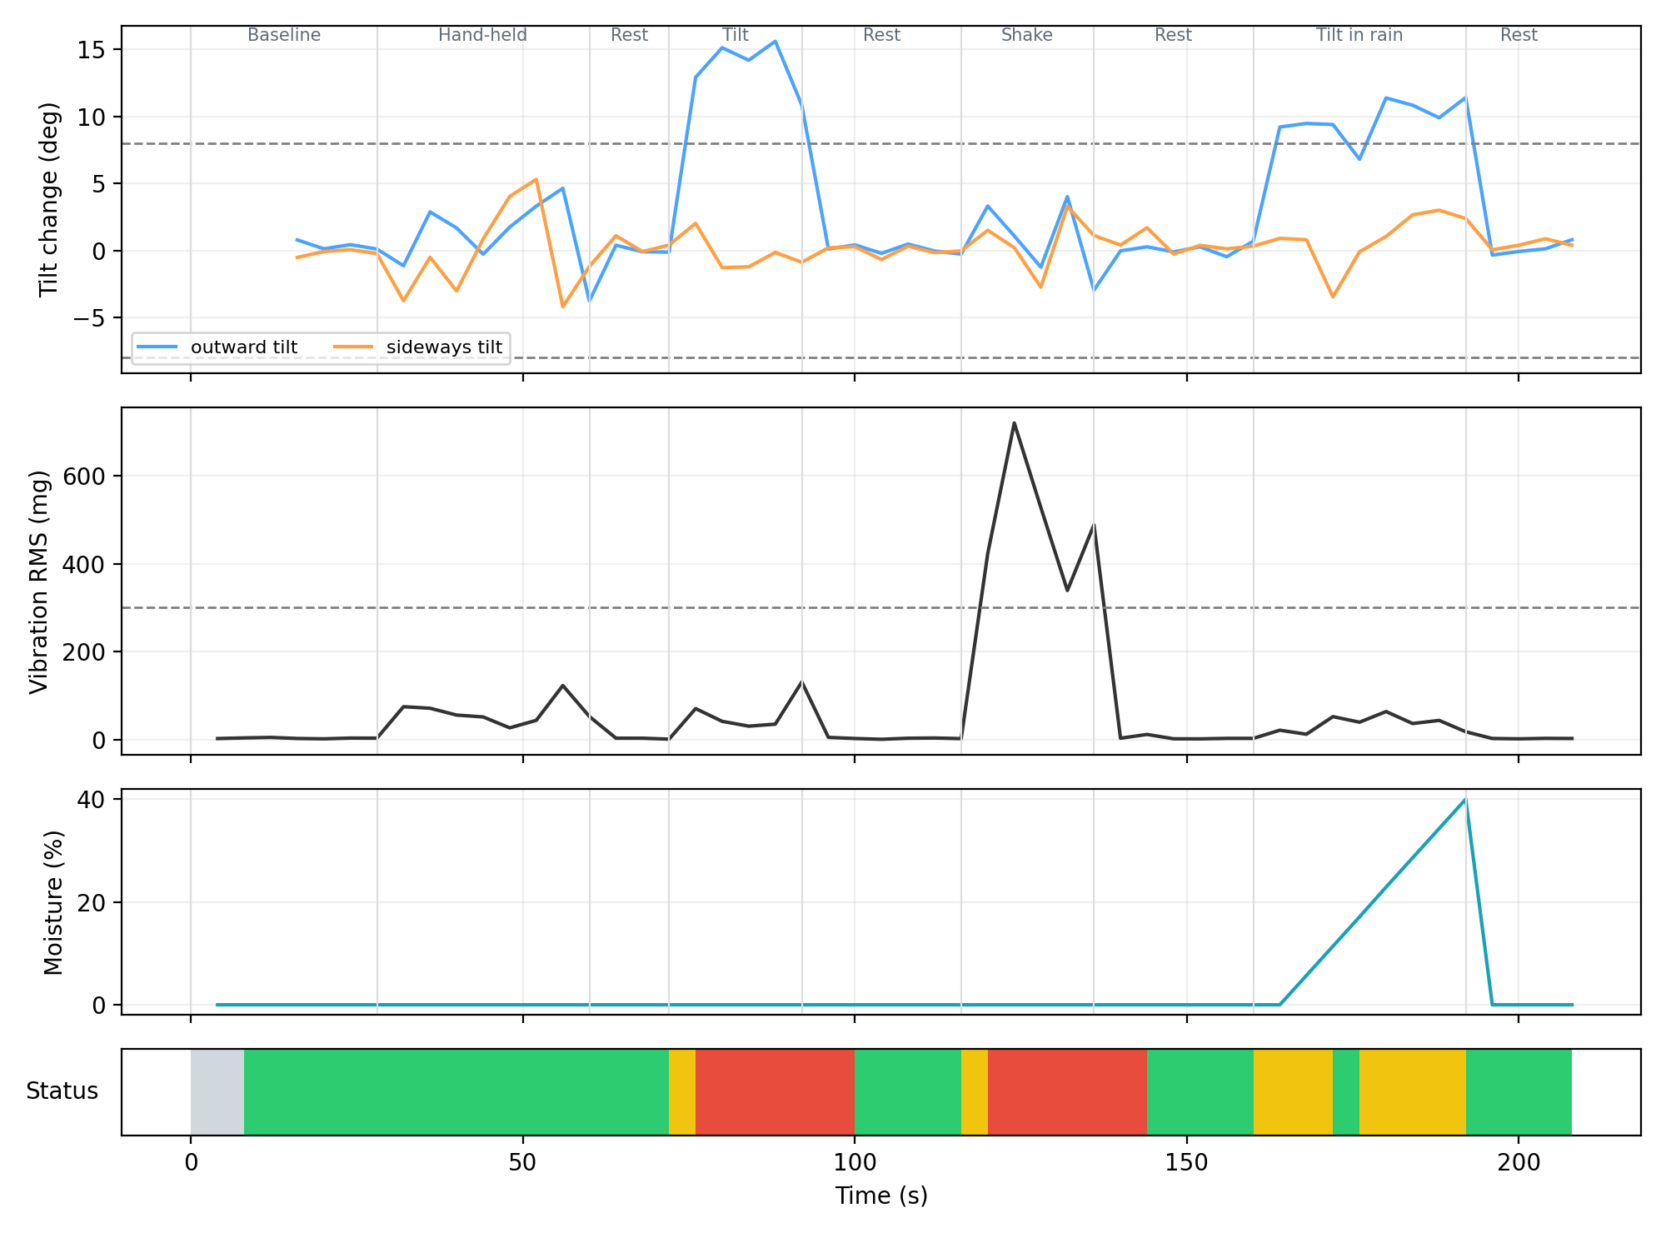
Figure 4 Scripted test run through the backend (grey: calibrating, green: normal, yellow: watch, red: alert)
Table 10 Status in each stage of the scripted run
Stage | Windows | Result
Baseline and rest | 7 | CALIBRATING for two windows, NORMAL once the baseline is set
Hand-held handling | 8 | NORMAL throughout; no WATCH or ALERT
Deliberate tilt (≈14°) | 5 | WATCH on the first window, ALERT from the second, cause TILT
Rest after tilt | 6 | ALERT held for two windows, cleared after three normal windows
Deliberate shake (≈600 mg) | 5 | WATCH, then ALERT, cause VIBRATION
Rest after shake | 6 | ALERT cleared after three normal windows
Tilt while moisture rises | 8 | WATCH (rain-associated); no ALERT
Final rest | 4 | NORMAL

8.4 Discussion
Three design choices account for the behaviour. A minimum-significance limit stops statistically unusual but physically small windows from alarming, which is what keeps handling silent. Two-window confirmation removes isolated spikes at the cost of about eight seconds of latency. The rain-context rule separates movement that has a plausible cause from movement that does not. The vibration rule being independent of the model keeps shake detection predictable even if the model is later retrained on different data.

9 Operation in a Real-Life Scenario
This section describes how the same system operates when installed on an actual retaining wall or slope. The software, features and decision logic are unchanged; the differences are in power, communication, duty cycle and how the thresholds are set.

9.1 Installation
A node is fixed to the face of the wall at a position chosen by the site engineer, for example the upper third of a wall segment where rotation is largest, with the sensor board rigid against the surface (bolted, not taped) and oriented so that one axis runs up the wall and one points out of it. The soil-moisture probe is buried in the backfill or the soil immediately behind or beside the wall, up to the marked line, with the electronics kept above ground. The node sits in a weatherproof enclosure with a small solar panel and a Li-ion cell. Several nodes along a wall give a spatial picture: a single node alarming may indicate a local problem, several alarming together indicate wall-wide movement.

9.2 Commissioning and baseline learning
After installation the node is left undisturbed and the backend logs every window. This baseline period should be long enough to include the normal rhythms of the site: day and night temperature cycles, traffic, wind and ordinary rain. At the end of the period the operator trains the model on the logged data. The tilt and vibration limits are then set from the baseline rather than from the demonstration values: for a real wall, a lean of several degrees is already a failure, so the field tilt limit is a small multiple of the baseline’s own tilt wander, which the measured stability (0.1–0.2° run-to-run) shows can be resolved to a fraction of a degree. The temperature recorded with each window is used to fit and remove the sensor’s thermal drift. A threshold that follows the site’s own baseline is the advantage over a generic preset.

9.3 Daily operation
- The ESP32 wakes from deep sleep on a timer, every 5–10 minutes.
- It samples the IMU and moisture sensor for a short burst (4–30 s), computes the feature vector and transmits it over WiFi, LoRa or a GSM link to the backend.
- It returns to deep sleep. Average current stays low enough for a small solar panel and battery.
- The backend standardizes the vector, scores it, applies the decision rules and updates the state.
- The dashboard shows the live state; an alert can also be pushed to a messaging service or SMS so that no one has to watch a screen.
Confirmation and moisture-history lengths are counted in windows, so with a ten-minute cycle two-window confirmation means the disturbance must persist across two cycles, and the moisture history covers an hour. This suits the slow dynamics of real slope movement.

9.4 What the system sees
Table 11 Typical field situations and the system’s response
Situation | What the node measures | System response
Ordinary day | Temperature swing, light traffic, small vibrations, tilt within the baseline band | NORMAL; thermal drift removed by the temperature term
Heavy vehicle or wind gust | One window with high vibration, the next normal | WATCH for one window; no alert because the second window is normal
Monsoon rain on saturating soil | Moisture rising, small outward tilt | WATCH marked rain-associated and logged; engineers see the correlated trend
Rain stops but the wall keeps moving | Moisture stable, tilt still changing | Escalates to ALERT (TILT): movement without a rain explanation
Slow creep in dry weather | Tilt drifts steadily outside the baseline band over consecutive cycles | ALERT (TILT) with a visible trend on the dashboard
Impact, rockfall or construction shock | Vibration above the limit for consecutive windows | ALERT (VIBRATION), independent of the model
Node knocked loose or re-oriented | Large sudden tilt change or tilt far from upright | ALERT, or a refused baseline with an orientation warning; prompts a site check
Power or link failure | No data arrives | No-data warning instead of a false calm

9.5 Alert response
A WATCH tells engineers that something unusual is happening and is worth checking at the next visit or on the trend chart. An ALERT carries its cause, so the responder knows whether a tilt or a vibration event triggered it, and whether rain was present. The rain-aware logic matters operationally: during a storm many walls move slightly, and alerting on all of them would erode trust in the system, whereas an alert on movement that rain does not explain is meaningful.

9.6 Maintenance
- Check mounting tightness and cable strain relief at each inspection; a loose mount looks like movement.
- Recalibrate the moisture sensor in the site soil (dry and saturated values) after installation.
- Retrain the model periodically on the logged baseline so that seasonal changes are included; the log excludes ALERT windows automatically.
- Keep the panel clean and verify the battery voltage trend remotely.
Table 12 Prototype versus field configuration
Aspect | Prototype | Field deployment
Power | USB from laptop | Li-ion cell with TP4056 charger and solar panel
Sampling | Continuous 4 s windows | Deep-sleep duty cycle, burst every 5–10 min
Network | WiFi through a phone hotspot | WiFi, LoRa or GSM to a hosted backend
Backend | Laptop | Always-on server or cloud service
Alert limits | Wide, to tolerate handling (8°, 300 mg) | Set from the site baseline, much tighter
Baseline | Rig at rest and under handling | Weeks of site data, including temperature and rain
Cost per node | ₹720–770 | ₹1,370–1,420

10 Limitations and Future Work
- The prototype is a bench-scale model with a single node. Validation on a full-scale wall, with a reference inclinometer for ground truth, is the next step.
- The baseline for the prototype covers rest and handling. A multi-week site baseline, spanning temperature and rainfall, is to be logged during a field trial; the logging and retraining pipeline for it is in place.
- Temperature-drift correction is to be fitted from that site baseline; temperature is already recorded with every window.
- The deep-sleep duty cycle, battery and solar operation, and a LoRa or GSM link are specified for the field node but not yet implemented in the prototype firmware, so power consumption has not been measured.
- Further model options, such as additional features or on-device inference, can be evaluated once site data exists.

11 Conclusion
The project delivers a working low-cost monitoring chain from sensor to dashboard. An ESP32 turns a 128 Hz accelerometer stream and a soil-moisture reading into a compact feature vector every four seconds; a Python backend standardizes the vector, scores it with an Isolation Forest, applies tilt, vibration, confirmation and rain-context rules, and shows a labelled status live. In evaluation the system ignored hand handling and isolated transients, alerted on sustained tilt or vibration after about eight seconds, reduced false alerts from about 149 to about 0.4 per simulated day compared with fixed thresholds, and kept rain-associated movement at a lower warning level. With a site-specific baseline, duty-cycled power and a long-range link, the same design can monitor many walls and slopes at a cost of about ₹1,400 per node.

References
[1] F. T. Liu, K. M. Ting and Z.-H. Zhou, “Isolation Forest,” Proc. IEEE International Conference on Data Mining (ICDM), 2008, pp. 413–422.
[2] F. Pedregosa et al., “Scikit-learn: Machine Learning in Python,” Journal of Machine Learning Research, vol. 12, 2011, pp. 2825–2830.
[3] InvenSense / TDK, MPU-6500 Product Specification and Register Map.
[4] Espressif Systems, ESP32 Technical Reference Manual.
[5] Villaverde et al. (2023), Landslide prediction based on low-cost and sustainable early warning systems with IoT.
[6] Inform@Risk Project, Landslide Early Warning System Based on Multi-Sensor AIoT: A Review.
[7] Springer/MDPI (2026), IoT-Based EWS for Rainfall-Induced Landslides Using Surface and Subsurface Sensors.
[8] Ghosh et al., IoT-Based Geotechnical Monitoring of Unstable Slopes for Landslide EWS, Darjeeling Himalayas.
[9] MDPI (2025), Design of a Low-Cost and Low-Power LoRa-Based IoT System for Rockfall and Landslide Monitoring.
[10] IRJMETS (2025), A Comprehensive System for Landslide Monitoring.
[11] IJIRT, Landslide Detection and Early Warning System Using IoT (Arduino/GSM-based).
[12] ResearchGate (2025), Unsupervised Anomaly Detection for Structural Health Monitoring: A Vibration-Based Approach Using Isolation Forest.
[13] Springer (2026), Real-Time SHM Using IoT-Enabled Affordable Sensors and Unsupervised Anomaly Detection.
[14] PMC (2022), Research on Sparse Denoising of Strong Earthquake Early Warning Based on MEMS Accelerometers.

Appendix A Feature Message Format
Each window is one comma-separated line beginning with FEAT, sent to the backend and printed on the serial port.
# | Field | Description
1 | win | Window counter
2 | t_ms | Milliseconds since power-on
3–4 | tilt_out, tilt_lat | Absolute tilt, degrees
5–7 | ax_g, ay_g, az_g | Mean acceleration per axis, g
8 | vib_rms_mg | Vibration RMS, milli-g
9–10 | dom_hz, dom_ratio | Dominant frequency (Hz) and peak ratio
11 | temp_c | Mean die temperature, °C
12–13 | moist_raw, moist_pct | Moisture, ADC counts and percent
14–15 | late, bad | Samples taken late; failed I2C reads
16–17 | dur_s, proc_ms | Window duration (s); feature processing time (ms)

Appendix B Operating and Demonstration Procedure

B.1 Preparation
- Install Python and run pip install -r requirements.txt in the backend folder, then python train_model.py --demo.
- Wire the sensors as in Figure 2 and mount the IMU vertically, pins down and chip face outward.
- Start the phone hotspot on the 2.4 GHz band and join the laptop to it.
- Run python server.py. It prints the laptop address; enter the hotspot name, password and that address in the firmware and upload it from the Arduino IDE.
- Open the dashboard in a browser at the printed address and wait for the status to turn NORMAL.

B.2 Demonstration sequence
- Leave the rig still until NORMAL appears, then pick it up and handle it gently: the status stays NORMAL.
- Lean the rig about 12–15° outward and hold it for about 10 s: WATCH, then ALERT with cause TILT. Return it: the alert clears after about 12 s.
- Shake it firmly for about 10 s: ALERT with cause VIBRATION.
- Pour water beside the moisture probe while tilting about 10°: the status stays at WATCH, marked rain-associated.
- Press Set baseline now whenever the rig is moved to a new surface.

B.3 Fallbacks
- USB-only operation: upload the serial firmware and run python server.py --port with the board’s port name.
- No hardware: python server.py --replay data/demo_replay.txt plays the scripted run of Section 8.3.

Appendix C Project Files
File | Purpose
ESP32_WiFi_Monitor.ino | Final firmware: sampling, features, WiFi upload
ESP32_Serial_Backup.ino | USB-only firmware (same features, serial output)
bringup_tests (3 sketches) | I2C scanner, MPU-6500 bring-up and calibration, moisture calibration
server.py | Backend: ingestion, scoring, state machine, dashboard service
config.py | All thresholds and operating parameters
train_model.py | Model training on the baseline profile or a logged CSV; creates the replay file
dashboard.html | Browser dashboard
verify_features.py | NumPy cross-check of the firmware’s feature extraction

