**INDEE Team**



**Dr. Armin Hafner**

Professor

NTNU, Norway

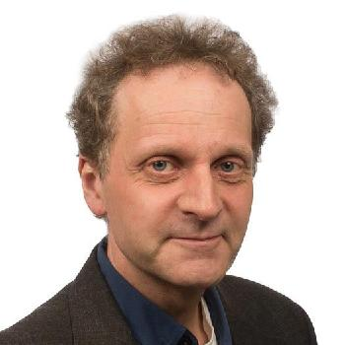

**Dr. Petter Neksa**

Chief Scientist

SINTEF Norway



**Dr. M. P. Maiya**

Professor

IIT Madras, India

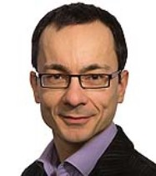

**Dr.** **Krzysztof Banasiak**

Research Scientist

SINTEF Norway

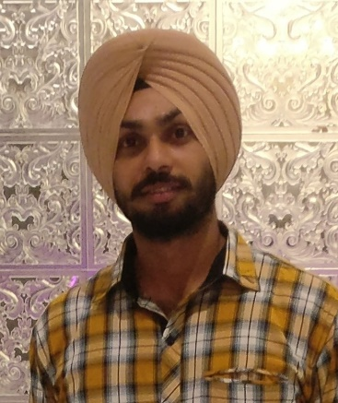

**Dr. Simarpreet Singh**

Post Doctorate Fellow

IIT Madras, India