**Solution Design Document**

**Countries Sync**

*ENP-SDD-Countries-Sync*

Contents

1. Object Information 4

2. Document Control 5

Change History 5

Reviewers 5

Approvers 5

3. Overview 6

Introduction 6

Volume Metrics – Table 1 6

Key Contributors and Contacts – Table 2 6

Document References – Table 3 6

4. Assumptions 7

5. Requirements 8

Interface Requirements – Table 4 8

Prerequisite Setups 8

6. Process Design 9

Process Description 9

Data Extraction Criteria 10

Data Transformation and Validation 11

Report/Screen Layout 11

7. Technical Design 13

Design Description 13

Program Details 13

Connection Details (for Integrations) 13

Lookup Details 13

API Details: 14

Database Objects 14

BIP Reports 14

Report Parameters 14

8. Data Mapping 15

Data/Field Mapping – Table 5 15

9. Notifications 16

Success Notification 16

Error Notification 16

Warning Notification 17

10. Exception Handling 18

Exception Handling 18

11. Error Handling 19

Error Reprocessing 19

Backup Requirements 19

Reprocessing Strategy 19

Planned Outage Strategy 19

Cutover Plan 19

12. SOX & Security Considerations 20

13. Acceptance Criteria 21

Test Conditions and Results – Table 6 21

10. Open / Closed Issues 23

Open/Closed Issues – Table 7 23

11. Appendix 24

# Object Information

|  |  |
| --- | --- |
| Project Name | Channel Management (CHM) |
| RICEW ID | CHMCOUNTRIESSYNCERPTOCHM |
| Interface Name | CHMCountriesSyncERPtoCHM |
| RICEW Short Description | Countries Sync from Oracle Fusion Cloud ERP to CHM |
| Primary RICEW Group | IT |
| Complexity | Low |
| Application Module | Oracle Financials Cloud Middleware Extensions for Applications |
| Interface Type | Scheduled |
| Source Systems | Oracle Cloud Fusion (ERP Cloud) |
| Destination System | Channel Management (CHM) |
| Expected Data Volumes | ~250 |
| Frequency | Ad hoc |
| Category |  |

# Document Control

## Change History

| Date | Author | Version | JIRA Ticket # | Change Reference |
| --- | --- | --- | --- | --- |
| 14-Jul-2023 | Gurpreet Singh (Transform Edge) | 1.0 |  | Initial. |

## Reviewers

| Name | Position | Date |
| --- | --- | --- |
| Rahul Ambika Shrivastava | Principal Consultant |  |

## Approvers

| Name | Position | Date |
| --- | --- | --- |
| Kathiresan K | Delivery Head |  |

# Overview

## Introduction

This document defines the technical components required to implement Interface for syncing Countries from Oracle Fusion Cloud (ERP Cloud) to Channel Management (CHM) using Oracle Integration Cloud (OIC) as integration layer.

## Volume Metrics – Table 1

| # | Source System | Transaction Type | Transaction Volume |
| --- | --- | --- | --- |
| 1 | Oracle ERP Cloud | Countries |  |

## Key Contributors and Contacts – Table 2

| System / Module Name | Primary Contact | | Secondary Contact(s) | |
| --- | --- | --- | --- | --- |
| Name | Email | Name | Email |
| Oracle Integration Cloud | Gurpreet Singh | gusingh@enphaseenergy.com |  |  |

## Document References – Table 3

| # | Document | Document link / Reference ID |
| --- | --- | --- |
| 1 | Master Mapping | [MasterMapping.xlsx](https://enphase.sharepoint.com/:x:/r/sites/ChannelManagementIT/Shared%20Documents/General/TE%20Deliverables/Tech%20Design/ReferenceDocuments/MasterMapping.xlsx?d=w0a4cf4a63cc34a018cd862395a83ecac&csf=1&web=1&e=vUGsJc&nav=MTVfezMxNjg0QzRCLTREMEMtNDFGQy1BNTBCLTk5RDg4NUU1QzdDNX0) |
| 2 | Cutover Plan | [CutoverPlan.xlsx](https://enphase.sharepoint.com/:x:/r/sites/ChannelManagementIT/Shared%20Documents/General/TE%20Deliverables/Tech%20Design/ReferenceDocuments/CutoverPlan.xlsx?d=wce5093cef7c94ea6bd9ae5bc16fa14e8&csf=1&web=1&e=Msa6Wv) |
| 3 | Countries Report SQL | [CountriesReport.sql](https://enphase.sharepoint.com/:u:/r/sites/ChannelManagementIT/Shared%20Documents/General/TE%20Deliverables/Tech%20Design/ReportSQLs/CountriesReport.sql?csf=1&web=1&e=pDYt1I) |
| 4 | Table Design | [TableDesign.xlsx](https://enphase.sharepoint.com/:x:/r/sites/ChannelManagementIT/Shared%20Documents/General/TE%20Deliverables/Tech%20Design/ReferenceDocuments/TableDesign.xlsx?d=w96b9745c41c6429684069e901be4a07a&csf=1&web=1&e=yypc7E&nav=MTVfezg4MDQ0QkVDLTY0RTEtNDNBNC1CQjNBLTQzMjg4NjRFRUJDNH0) |

# Assumptions

**Assumptions – Table 4**

| # | Assumptions |
| --- | --- |
| 1 |  |
| 2 |  |
| 3 |  |

# Requirements

## Interface Requirements – Table 4

|  |  |
| --- | --- |
| Requirement ID | Requirement Description |
|  |  |

## Prerequisite Setups

|  |
| --- |
| Prerequisite Setups |
| 1. All the required connections are configured in OIC 2. All required setups and configurations (like Countries etc.) are available in Oracle Fusion Cloud ERP |

# Process Design

## Process Description

The design below is the high-level process flow for the syncing Countries from Oracle Fusion to Channel Management.

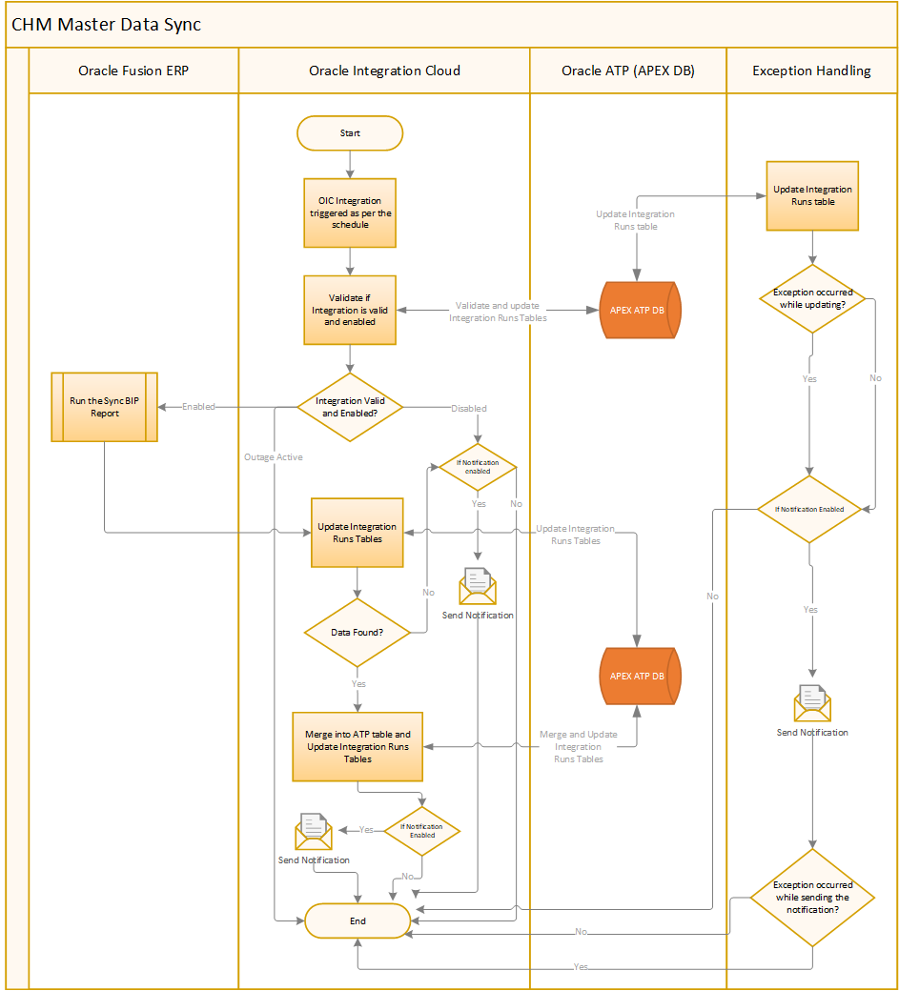

|  |  |
| --- | --- |
| **Step** | **Description** |
| 1 | The OIC end point is triggered as per the schedule |
| 2 | Validation will be performed to check if Integration is valid and enabled in Channel Management. Integration run record will be created in CHM_INTEGRATION_RUNS table to track the current run. There can be three scenarios for an Integration:   * **Integration is valid and enabled** – Integration is registered in Channel Management and enabled, so the execution will continue normally * **Integration is valid and outage flag is checked**– Integration is registered in Channel Management and enabled but outage active flag is set for the integration, so the execution will be stopped * **Integration is invalid or disabled** – Integration is either not registered in Channel Management or disabled, so an error notification will be sent (using Disabled template configured in lookup which is described in Lookup Details section if enabled) and the execution will be stopped |
| 3 | If Integration valid and enabled then and BIP Report will be triggered to get the Countries data from Oracle Fusion Cloud. If run report operation is successful, then integration run record will be updated. There can be two scenarios for an integration:   * **Data fetched from BIP Report** – Records will be merged into CHM_TERRITORIES table, integration run record will be updated and success notification will be sent (using Success template configured in lookup which is described in Lookup Details section if is enabled) * **No Data fetched from BIP Report** – Error notification will be sent (using Warning template configured in lookup which is described in Lookup Details section if is enabled) |
| 4 | In case of any error, exception handling mechanism will start which is described in exception handling section in this document. |

## Data Extraction Criteria

Report will return the below list of columns

* ENTERPRISE_ID
* LANGUAGE
* TERRITORY_CODE
* TERRITORY_SHORT_NAME
* NLS_TERRITORY
* DESCRIPTION
* ALTERNATE_TERRITORY_CODE
* ISO_TERRITORY_CODE
* CURRENCY_CODE
* EU_CODE
* ISO_NUMERIC_CODE
* OBSOLETE_FLAG
* ENABLED_FLAG

## Data Transformation and Validation

* Get the all records which are available in Oracle Fusion Cloud ERP.

**Pseudo code for BIP report**

* BIP report will fetch the records from below fusion tables
  + FND_TERRITORIES_B
  + FND_TERRITORIES_TL
* New records will be inserted into ATP database table using INSERT statement
* Existing records (based on key columns) will be merged into ATP Database using UPDATE statement
* Key columns are ENTERPRISE_ID,LANGUAGE,TERRITORY_CODE

## Report/Screen Layout

* Below screen will be used to register the integration in APEX. User can perform the below actions:
  + Enable or disable the integration
  + Enable or disable the outage flag for integration
  + View last run details of the integration
  + CHM_INTEGRATIONS table will store these details for the integration

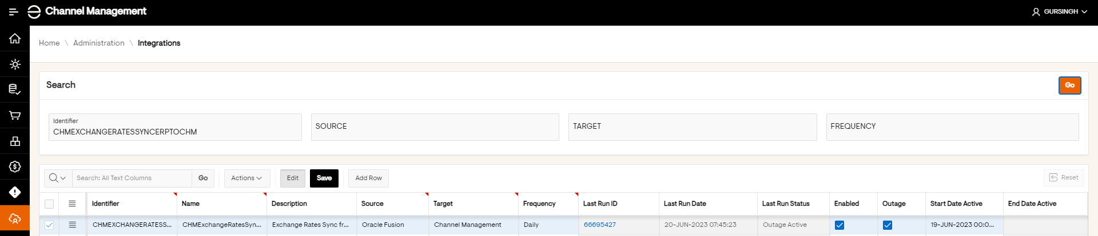

* Below screen will be used to view the integration runs in APEX. User can perform the below actions:
  + View the integration runs of the integration
  + Below are the combination of Phase and Status for the integration:

|  |  |  |
| --- | --- | --- |
| **Phase** | **Status** | **Description** |
| Running | Normal | Integration is running normally |
| Completed | Success | Integration completed successfully |
| Completed | Error | Integration completed in error |
| Completed | Outage Active | Integration’s outage flag is enabled |
| Completed | Disabled | Integration is disabled |
| Completed | Warning | No data found for processing |

* + View last run details of the integration
  + CHM_INTEGRATION_RUNS table will store these run details for the integration

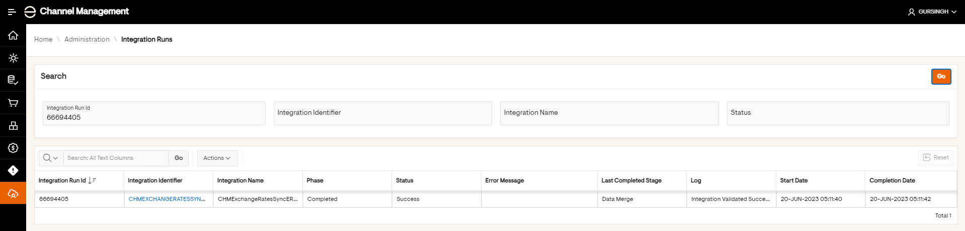

# Technical Design

## Design Description

**CHMCountriesSyncERPtoCHM** is a scheduled integration which will sync Countries from Oracle Fusion Cloud (ERP Cloud) to Channel Management (CHM). The design below is the high-level process flow for the syncing Countries from Oracle Fusion Cloud (ERP Cloud) to Channel Management

## Program Details

|  |  |  |  |  |  |
| --- | --- | --- | --- | --- | --- |
| **Component Name** | **Package Name** | **Operation/ Method** | **Sync / Async/ One way** | **Communication protocol** | **Description** |
| CHMCountriesSyncERPtoCHM | com.enphase.chm | POST | Synchronous | SOAP | Integration to sync Countries |

## Connection Details (for Integrations)

|  |  |  |  |  |
| --- | --- | --- | --- | --- |
| **Connection Name** | **Type** | **WSDL** | **Role** | **Description** |
| CHMATPDBConnection | Oracle ATP |  | Trigger & Invoke | Oracle ATP Connection for CHM schema of APEX ATP DB |
| ReportServiceSOAPConnection | SOAP | ExternalReportWSSService | Trigger & Invoke | SOAP connection for ERP External Report Web Service |

## Lookup Details

|  |  |
| --- | --- |
| **Lookup Name** | **Lookup description** |
| LookupCHMIntegrations | Lookup for CHM Integrations |
| Domain Name | |
| Integration_Identifier-Notification_Type | |
| From_Email | |
| Email_Recipients | |
| Email_Subject | |
| Email_Body | |
| Notification_Enabled | |

|  |  |
| --- | --- |
| **Lookup Name** | **Lookup description** |
| LookupCHMIntegrationReports | Lookup for CHM Integration Reports storing Report Path |
| Domain Name | |
| Integration_Identifier | |
| Report_Path | |

## API Details:

NA

## Database Objects

|  |  |  |  |
| --- | --- | --- | --- |
| **Object Name** | **Object Type** | **Schema** | **Description** |
| CHM_INTEGRATIONS | Table | CHM | CHM Common Table for storing Integration details |
| CHM_INTEGRATION_RUNS | Table | CHM | CHM Common Table for storing Integration Runs details |
| CHM_INTEGRATIONS_PKG | Package | CHM | CHM Common Package for validating Integrations and updating CHM_INTEGRATIONS & CHM_INTEGRATION_RUNS tables |
| CHM_COUNTRIES | Table | CHM | CHM Table for storing Countries Records |
| CHM_COUNTRY_PKG | Package | CHM | CHM Package for Countries |

## BIP Reports

|  |  |  |  |  |
| --- | --- | --- | --- | --- |
| **Report Name** | **Report Description** | **Report Path** | **Integration Name using the BIP** | **ESS Job Name** |
| CountriesSync | BIP to fetch Countries | /shared/Custom/Channel Management/Countries Sync | NA | NA |

Actual report query used in BIP is uploaded in SharePoint and link has been given in Reference Document section

## Report Parameters

|  |  |  |  |  |  |
| --- | --- | --- | --- | --- | --- |
| **Report Name** | **Parameter Name** | **Display Label** | **Data Type** | **Parameter Type** | **Mandatory** |
|  |  |  |  |  |  |

# Data Mapping

## Data/Field Mapping – Table 5

Master Mapping is available in [MasterMapping.xlsx](https://enphase.sharepoint.com/:x:/r/sites/ChannelManagementIT/Shared%20Documents/General/TE%20Deliverables/Tech%20Design/ReferenceDocuments/MasterMapping.xlsx?d=w0a4cf4a63cc34a018cd862395a83ecac&csf=1&web=1&e=vUGsJc&nav=MTVfezMxNjg0QzRCLTREMEMtNDFGQy1BNTBCLTk5RDg4NUU1QzdDNX0)

# Notifications

## Success Notification

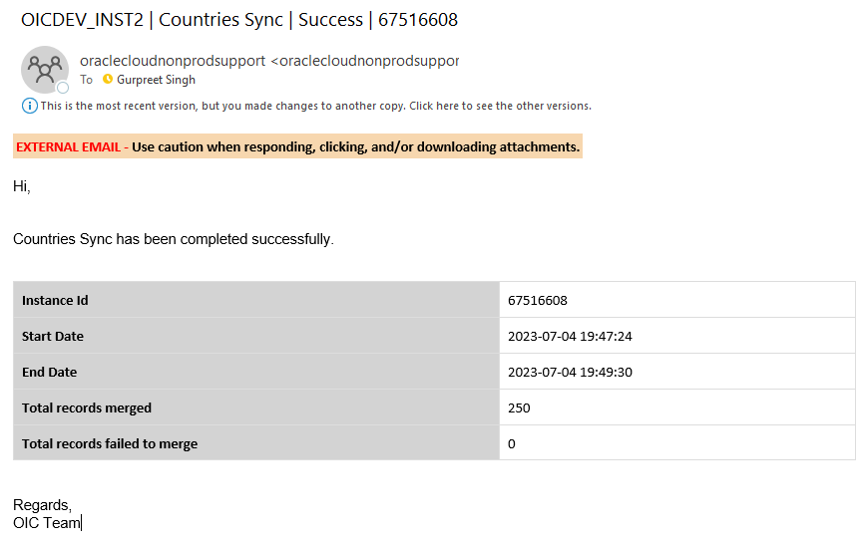

## Error Notification

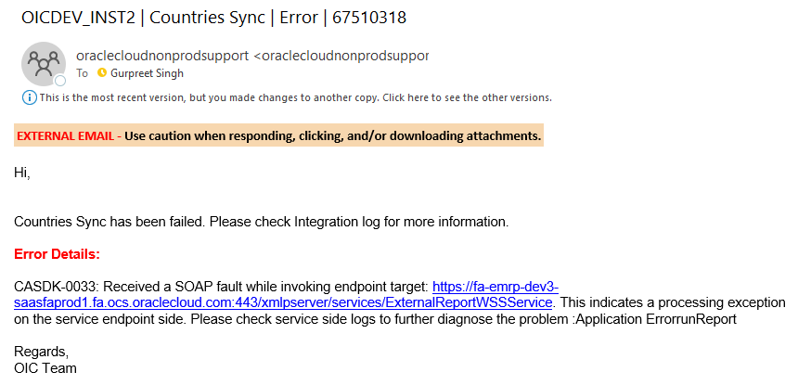

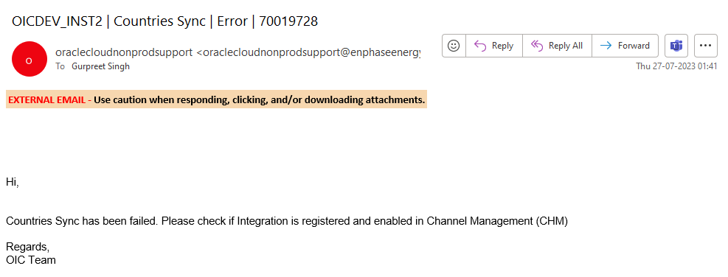

## Warning Notification

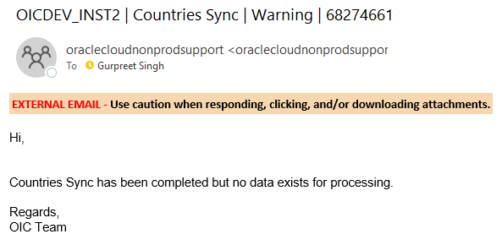

# Exception Handling

## Exception Handling

In case of any exception occurred while execution, integration will be errored out and below exception handling mechanism will be used:

* **Updating Integration Runs** – Integration runs table will be updated with error message and status as Error. There can be two scenarios in this case:
  + **Update Successful** – If update is successful, then integration execution will proceed for next steps.
  + **Update Unsuccessful** – If update is successful, then integration execution will proceed for next steps.
* **Sending the email notification** – Email notification will be sent out after completing (even if they complete successfully or not) the above step. Here Integration Exception template will be used to send the notification which is configured in the lookup described in Lookup Details Section if enabled. In case there is an exception in the send email notification, integration will stop further execution and it will be errored out.

# Error Handling

## Error Reprocessing

| Error Reprocessing |
| --- |
| * In case integration is errored out resubmit the integration via an Ad-Hoc run after properly investigating and performing the RCA |

## Backup Requirements

| Backup Requirements |
| --- |
| * Submit an Ad hoc run of Integration and records will be reinstated again after sync from Oracle Fusion Cloud (ERP Cloud) |

## Reprocessing Strategy

| Reprocessing Strategy |
| --- |
| * In case of import failures, submit an Ad hoc run of Integration. |

## Planned Outage Strategy

| Planned Outage Considerations |
| --- |
| * Set the **Outage Active** flag of the integration in Channel Management |

## Cutover Plan

| Cutover Plan Considerations |
| --- |
| To migrate this integration code to upper environment, below are the high-level overview of steps to be performed, detailed cutover plan for entire project has been prepared separately, link to which can be found in reference document section.   * SQL Script will be executed to deploy the database objects like, Sequences, Tables, Packages and seed data * Integration will be registered and enabled in Channel Management APEX application * Integration will be deployed on next environment along with lookups and connections will be configured * Integration schedule will be set |

# SOX & Security Considerations

| SOX Control ID |
| --- |
|  |

| Job Scheduling and Monitoring Process |
| --- |
| * Integration will be scheduled from OIC Instance * Integration can be monitored in two ways:   + From APEX - Screen has been designed to monitor the integrations. Navigation is **Home**-> **Administration** -> **Integration Runs**   + From OIC – Integration Tracking screen can be used to monitor the integration and download the logs |

| Access and Data Security Requirements |
| --- |
| * User should have access to OIC Instance to schedule the integration, monitor the integration and download the integration logs * User should have access to APEX Application to monitor the integration from APEX and viewing the synced records |

# Acceptance Criteria

## Test Conditions and Results – Table 6

| No | Test Condition | Expected Results |
| --- | --- | --- |
| 1 | Integration not registered in CHM APEX Application but present in OIC | Integration got completed and records not synced in CHM and email notification sent. |
| 2 | Integration is enabled in CHM APEX Application | Integration got completed and records synced in CHM and email notification sent. |
| 3 | Integration is disabled in CHM APEX Application | Integration completed but no record synced in CHM and email notification sent. |
| 4 | Integration is in outage mode in CHM APEX Application | Integration completed but no record synced in CHM with no email notification sent. |
| 5 | Integration is enabled in CHM APEX Application and resubmitted | Integration got completed and records synced & merged in CHM and email notification sent |

**Integration Testing Checklist:**

1. Need to test with Real Time Data.
2. Scenarios to test all validation rules.
3. Testing to validate the Error Handling scenarios.
4. Validate and Reconcile data loaded or extracted through the established reports or front-end screen.
5. Volume and Load Testing.
6. Performance Testing.

**Report Testing Checklist - NA**

|  |  |
| --- | --- |
| **Category** | **Validations to be performed** |
| Completeness | Match the record count with an Existing established report or Standard Oracle Report |
| Completeness | Match the report totals with an Existing established report or Standard Oracle Report |
| Completeness | Match the report totals with Front End Inquiry Screen |
| Accuracy | Validate calculations being performed on the Report (e.g. Row Totals, Column Totals etc.) |
| Accuracy | Validate data in each column by comparing with Oracle/Front End Inquiry screens |
| Accuracy | Validate that we are not printing blank values for some of the columns (e.g. in sub-ledger detail report, receipt number is not printed for journal source receiving) |
| Accuracy | Try validating the report output for one of the closed periods (or bigger date range) to ensure that various data conditions are tested. |
| Accuracy | Ensure that new transactions processed are appearing on the report accurately |
| Formatting/Layout | Review the formatting of all the columns (Date, Amount and Text format) |
| Formatting/Layout | Review the column headings/naming conventions |
| Formatting/Layout | Review the different output formats (Excel, PDF, CSV etc.) |
| Parameters | Review the Parameter LOV's |
| Parameters | Validate data based on the parameters selected |
| Parameters | Ensure that we print the parameters on report output (including standard fields like submitted date, submitted by) |
| Performance | Is the report completing within reasonable time. |
| Performance | Consider growth in data volumes. Try running report for entire year to test the data load. |
| Negative Testing | Try running report with incorrect parameters (e.g. Invalid value, To Date lower than From date etc.) |
| Data Security | Validate that report is accessible by authorized users |
| Data Security | Validate that results are displayed based on the data access available to user |

# Open / Closed Issues

## Open/Closed Issues – Table 7

|  |  |  |  |  |  |  |
| --- | --- | --- | --- | --- | --- | --- |
| **#** | **Issue** | **Raised By/ Date Needed** | **Assigned/ Responsibility** | **Resolution** | **Resolved By/ Date Completed** | **Status** |
|  |  |  |  |  |  |  |
|  |  |  |  |  |  |  |
|  |  |  |  |  |  |  |
|  |  |  |  |  |  |  |
|  |  |  |  |  |  |  |
|  |  |  |  |  |  |  |

# Appendix

NA