**Channel Management**

**Marketing System Incentive (MSI)**

**Low Level Design Document – Channel Management**

**Selectiva Systems, Inc.**

# **Document Control**

Change History

|  |  |  |  |  |
| --- | --- | --- | --- | --- |
| **Date** | **Author** | **Version** | **JIRA Ticket #** | **Change Reference** |
| 01/31/2025 | Raj V | 1.0 |  | Initial version. |
|  |  |  |  |  |

Draft Reviewers

|  |  |  |
| --- | --- | --- |
| **Name** | **Position** | **Date** |
| Ravi N | Director, IT |  |

Approvers

|  |  |  |
| --- | --- | --- |
| **Name** | **Position** | **Date** |
| Preet S | Director, Financial Reporting and Revenue |  |
| Pravin V | Senior Director, Marketing Science and Pricing |  |
| Mary E | VP and Chief Accounting Officer |  |

Table of Contents

Document Control 2

Introduction 5

Assumptions 5

References 5

Acronyms 5

System Overview 6

Architecture Overview 6

System Components 6

Backend Logic (Oracle PL/SQL) 7

Database Layer (Oracle Database) 7

Functional Modules & Workflow - Rebate Calculation & Payment Processing 8

Key Design Decisions 8

Site & Activation Data Collection 10

Activation Data Enrichment 10

Rebate Qualification 11

Rebate Calculation 11

Rebate Payment 11

Rebate Eligibility, Calculation and Payment Processing – Detailed Design 12

Activation Data Enrichment & Rebate Qualification 12

Rebate Calculation 13

Rebate Batch Processing 15

SFDC → CHM Installer Account Sync 15

SFDC → CHM AVR SPA Sync 16

User Roles & Security 17

Audit Capabilities 18

User Roles Report 18

User Access Report 19

Database Design 19

Performance & Optimization Strategies 20

Security & Compliance 20

Deployment & DevOps 20

Historical Data Conversion 21

Oracle Shipments with Serial Number 21

Enlighten Sites and Device Activation 21

Reporting 22

Operational Reporting 22

List of Reports 22

Integration with Incorta 22

Open & Closed Items 24

Appendix 26

Technical Flows 26

Proposed ERD 27

Activation Data Additional Attributes Derivation 28

UX Mocks 29

# Introduction

This document covers the Detailed Solution design for the Channel Management scope of MSI/AVR process. Currently Enphase is using Service activation rebate in a limited way and the process is manual. As part of this program, with an objective to curb the Grey Market, we are building the Minimum Viable Product (MVP) to pilot the new automated AVR process.

# Assumptions

|  |  |
| --- | --- |
| # | Assumptions |
| 1 | Pilot in 4 countries (ITA, GBR, ESP, AUS) covering around 300 Installers. |
| 2 | Only products that have “activation” will be within the scope of AVR |
| 3 | Geo Fencing solution is not covered as part of this document |
| 4 | Installers will be required and able to manage their account hierarchies within Enlighten. Sales user will be able to select the child accounts eligible for rebate at the time AVR/MSI SPA creation |
| 5 | This document does not cover the details of pre-pilot manual simulation |
| 6 | In case of scenario where Distributor is also part of eligibility criteria for AVR rebate, user needs to add the Primary and Sub Disti to the SPA for Installer to be eligible to receive the rebate. All AVR/MSI payments will be to the Installer. |

# References

|  |  |  |
| --- | --- | --- |
| # | Document | Link |
| 1 | Business Requirements Document | [Activations Volume Rebate BRD 2.0.docx](https://enphase.sharepoint.com/:w:/s/ChannelManagement/EYRobaR2QF5OvkTcwxJvH-YBcEBixDlyylRfnHzZVe80aA?e=EaGWqa) |
| 2 | Solution Design Document | [AVR_Solution_Design_Document.docx](https://enphase.sharepoint.com/:w:/r/sites/ChannelManagement/_layouts/15/Doc.aspx?sourcedoc=%7BBBD8B431-7790-49A9-B4E8-E10B5B29D399%7D&file=AVR_Solution_Design_Document.docx&action=default&mobileredirect=true) |
| 3 | Technical Design Document – SFDC | [Channel Management MSI Technical Design v1.docx](https://enphase.sharepoint.com/:w:/r/sites/ChannelManagement/Shared%20Documents/Grey%20Market%20Project/Solution%20Design/Channel%20Management%20MSI%20Technical%20Design%20v1.docx?d=w3f9b3e06405d4900947f87426540ebfb&csf=1&web=1&e=UoSvLH) |
| 4 | High Level Technical Design | [MSI_AVR_Tech_Architecture.pptx](https://enphase.sharepoint.com/:p:/r/sites/ChannelManagementIT/Shared%20Documents/AVR_Program_IT/Discovery%20%26%20Design/MSI_AVR_Tech_Architecture.pptx?d=wa5dd35c9f9da4bedb385822d1b8c5691&csf=1&web=1&e=VuLBdd) |
| 5 | User Stories | [AVR, MSI User Stories](https://enphase.sharepoint.com/:x:/r/sites/ChannelManagementIT/Shared%20Documents/AVR_Program_IT/Discovery%20%26%20Design/AVR,MSI%20Backlogs.xlsx?d=w895fe98d3ea948eab9d5e08af41ec678&csf=1&web=1&e=d4H99I) |

# Acronyms

|  |  |  |
| --- | --- | --- |
| # | Acronym | Description |
| 1 | AVR | Activation Volume Rebate |
| 2 | SPA | Special Pricing Agreement |
| 3 | CHM | Channel Management Application |
| 4 | SFDC | Salesforce.com Application |
| 5 | BRD | Business Requirements Document |
| 6 | SDD | Solutions Design Document |
| 7 | OCI | Oracle Cloud Infrastructure |
| 8 | OIC | Oracle Integration Cloud |
| 9 | MSI | Marketing Service Incentive |

## System Overview

The **Rebate Calculation & Payment Processing System** automates rebate processing by integrating activation data collection, enrichment, qualification, calculation, and payment settlement. The system leverages **Oracle APEX for UI, Oracle OIC for integrations, Oracle PL/SQL for backend logic, and Oracle Database for storage**.

## Architecture Overview

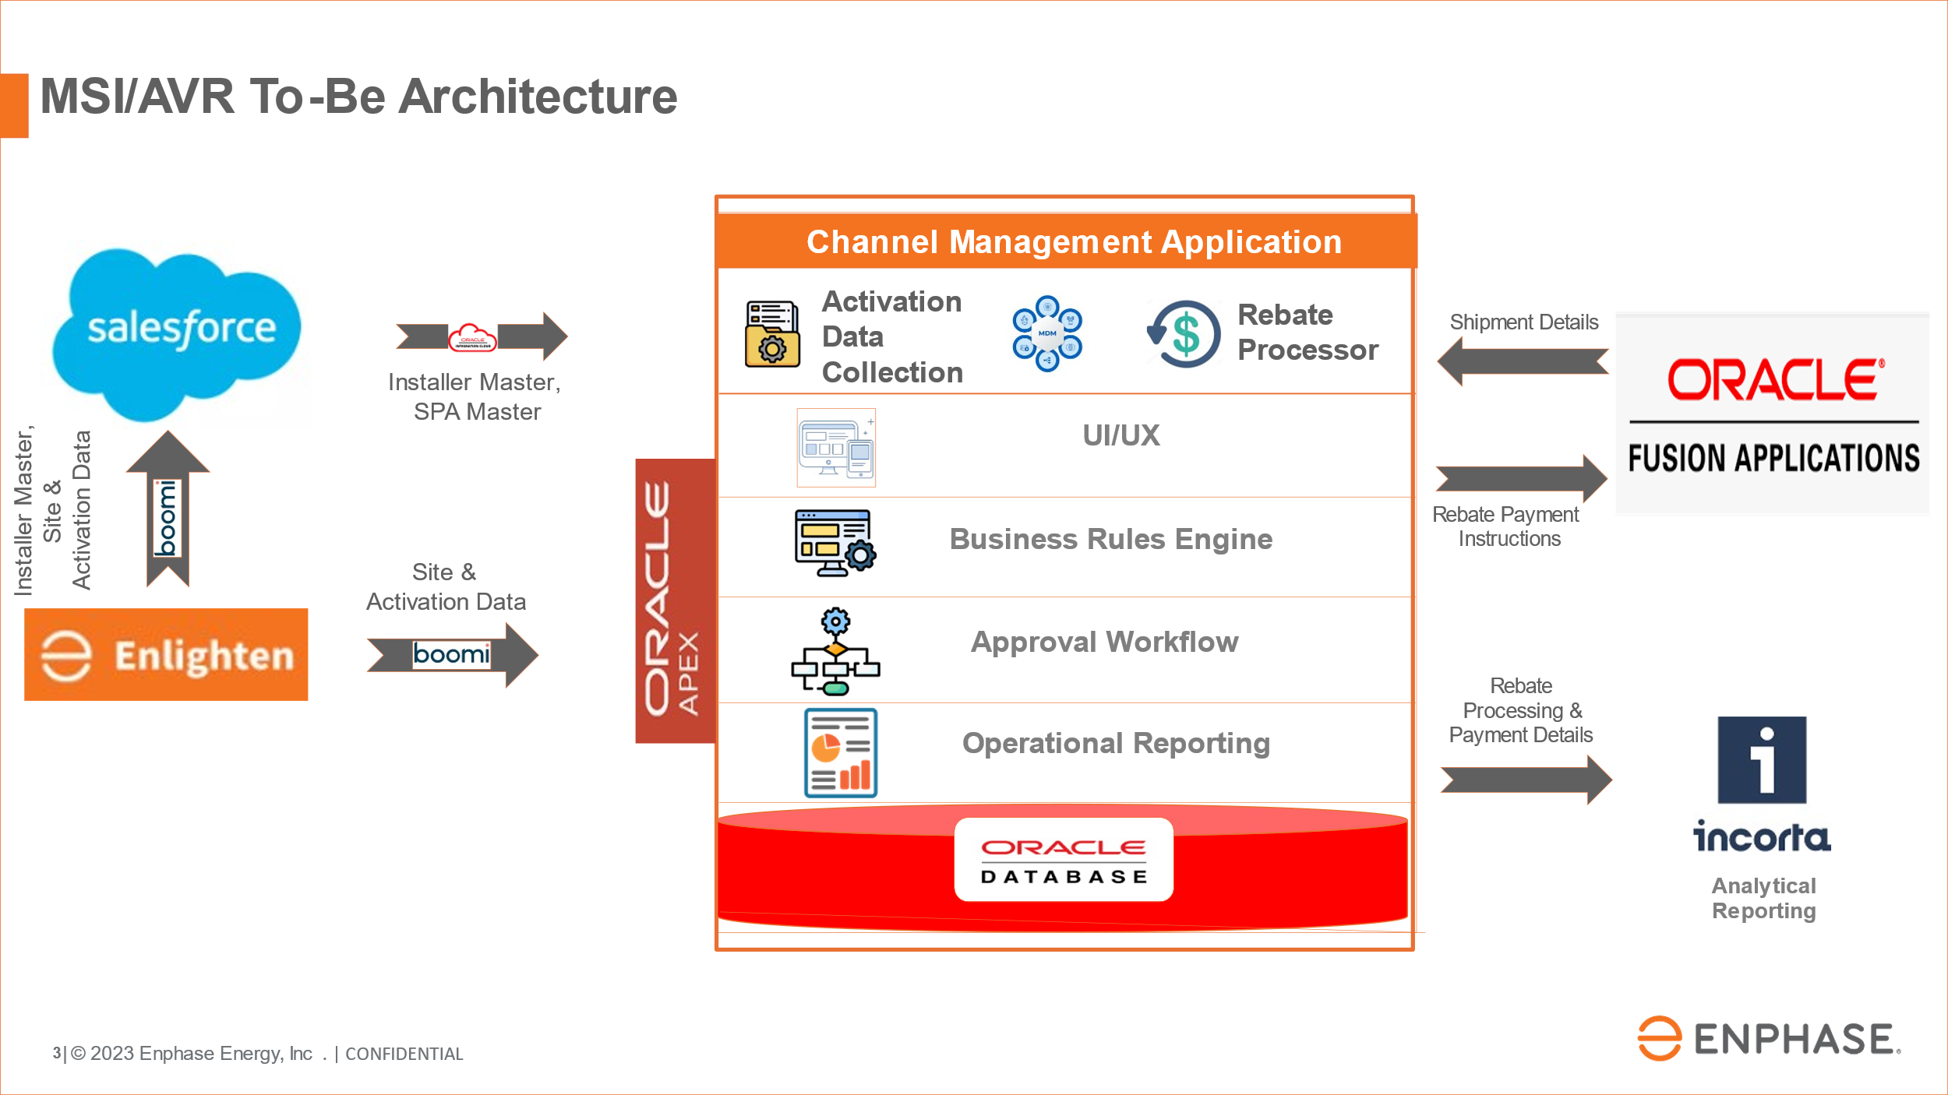

### System Components

1. **Frontend (Oracle APEX)**
   * Provides UI to view master and transactional data.
   * Displays **rebate eligibility, calculations, and payment status**.
2. **Integration Layer (Oracle OIC)**
   * Extracts activation data from Enlighten System.
   * Inserts or updates activation data in CHM Application.
   * Extracts shipment data from Oracle Fusion.
   * Inserts or updates shipment data in CHM Application.
   * Facilitates communication with Oracle Financials for payments.

### Backend Logic (Oracle PL/SQL)

* + Executes Serial # (S/N) lookups for shipment validation.
  + Implements rebate qualification & calculation rules.
  + Processes payments based on payee type.

### Database Layer (Oracle Database)

* + Stores **activation records, rebate rules, transaction logs, and payment status**.
  + Ensures **data integrity through upsert operations**.

## Functional Modules & Workflow - Rebate Calculation & Payment Processing

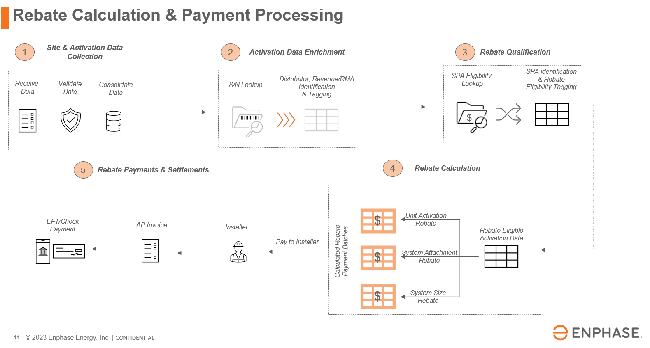

## 

## Key Design Decisions

|  |  |
| --- | --- |
| Functional Area | Design Decision |
| Enlighten Site & Activation Data | Stage Attribute on the Enlighten Site will be used to determine eligibility.  Since CHM receives updates, and site can go from Stage 2 to stage 4 within a few hours, CHM will use the logic Stage >=3 to determine Site Eligibility. System will capture the Effective date on which the activation stage 3 or above was received from Enlighten. Refer open item # 13 |
| Enlighten Site & Activation Data | CHM receives updates from Enlighten for Sites and Device Activations.  CHM will use Upsert logic to maintain the data. Audit will be enabled on CHM tables where Site and Activation data is stored. |
| Enlighten Site & Activation Data | Site ID is considered as the Unique ID on Enlighten Site.  Site ID + SKU + Serial Number is considered as the Unique ID on Enlighten Device Data |
| Enlighten Site & Activation Data | The data is populated in CHM multiple times daily. The same schedule that applies to writing the data into SFDC will be the same schedule that will be applied on CHM |
| Distributor Shipment Information | The Shipment data will be sourced from Oracle Fusion. This information will be used to ensure that the order type is not RMA and also to identify the Distributor to whom the serial # was shipped. Enable system loses the shipment details especially when an RMA is initiated for a particular Serial # |
| Distributor Shipment Information | SKU + Serial Number is considered as the Unique ID on Oracle Shipment Data |
| Distributor Shipment Information | Oracle Fusion shipment information will be ETL’ed into CHM daily to support Serial # (S/N) Lookup for determining Distributor and Order Type information |
| Rebate Eligibility – Alternate SKUs | Existing CHM Alternate SKU functionality will be used for determining SKU eligibility per AVR/MSI SPA |
| Rebate Eligibility – Geo | The Country, State, Zip Codes on the SPA will be used as an exact match on the Site Address fields to determine Geo Eligibility. Based on how the Geo eligibility is stored on AVR/MSI SPA, the corresponding fields will be validated on the activation record for Site address. Any changes to Geo need to be updated upstream on SFDC AVR/MSI SPA |
| Rebate Eligibility | Any changes to SPA definition will happen upstream in SFDC SKU Addition, Geo Addition, Disti Addition, Installer Child account Addition, SPA End-Date extension.  All changes will be additions. No deletions are allowed. |
| Rebate Payments – Single Batch | System will batch all previous month eligible rebates into a single batch |
| Rebate Payments – Auto Approved | All Rebates will be auto approved and sent to Oracle Fusion for payments to Installers or credit memo creation in case of Distributors automatically |
| Rebate Payments Calculation – Data lookup start date | Rebate calculations will happen MONTHLY.  All Device Activations data that are older than 1 month from the current month will be considered for calculations.  For ex: if we are calculating rebate on 07-APR-2025, we will consider all device data starting from 01-MAR-2025  This cut off is required so we do not continuously process old data that is not eligible any longer. 30 days will help cover any data that needs to be looked at in case there is a backdated SPA. |
| Adjustments or Claw backs from the Installers or Distributors | Any adjustments (positive or negative) or Claw backs from Installer or Distributors will be handled outside CHM application manually. |
| Analytical Reporting | Analytical reporting capabilities are provided in Incorta. Incorta will pull the data from CHM on a frequent schedule (to be determined by Incorta team). Dashboards and canned reports will be created on Incorta. |

## Site & Activation Data Collection

* **Data Source**: Enlighten System.
* **Integration**: OIC extracts activation data and pushes it into **CHM Application**.
* **Processing**:
  + Data **upsert operation** ensures accurate updates.
  + PL/SQL triggers handle **duplicate checks & data validation**.

## Activation Data Enrichment

* **Serial Number (S/N) Lookup**:
  + Queries **Shipments Database** to check:
    - Validity of the **S/N**.
    - The **distributor who received the S/N**.
    - If it was a **Revenue Shipment** or an **RMA Shipment**.
  + Determines the **Effective Date for Rebate Eligibility** using:
    - **Device Activation Date**.
    - **Site Stage**.
    - **First Interval Date**.
* **Storage**: Enriched data is stored for rebate qualification.

## Rebate Qualification

* **Eligibility Check**:
  + Queries **SPA (Special Pricing Agreement) database** to validate eligibility.
* **Rebate Type Identification**:
  + Determines whether rebate is for:
    - **Unit Incentive**.
    - **System Attachment**.
    - **System Size**.

## Rebate Calculation

* **Calculation Logic**:
  + Computes rebate amounts using **SPA definitions**.
  + Applies formulas based on **S/N details & effective dates**.
* **Payee Identification**:
  + Determine the Enlighten ID/SFDC Key that needs to be paid against

## Rebate Payment

* **Payment Processing**:
  + **~~If Payee is a Distributor~~**~~→ Generate~~**~~AR Credit Memo~~**~~.~~
  + **If Payee is an Installer** → Generate **AP Invoice in Oracle Financials**.
* **OIC Integration** ensures smooth **financial transaction execution**.

## Rebate Eligibility, Calculation and Payment Processing – Detailed Design

Refer Technical Flow Diagrams here [MSR_AVI_Tech_Design_Flows](https://enphase.sharepoint.com/:u:/r/sites/ChannelManagement/_layouts/15/Doc.aspx?sourcedoc=%7B69254b33-51e7-43b2-a103-93b308374108%7D&action=edit&wdPreviousSession=2d9d0e3e-45d5-4a6c-9679-fb46bcba27b0&or=PrevEdit)

### Activation Data Enrichment & Rebate Qualification

1. Fetch device data where **Distributor (Disti) information** is missing. In case a particular serial # is not found in the shipment data, the system will treat this as an exception and email alert will be sent to support and sales finance team to investigate on a daily basis.
2. Perform **Serial Number (S/N) lookup** against the **Oracle Shipments Database**.
3. Identify the **Distributor** to which the S/N was originally shipped.
4. Update the **Device Data** with the **Distributor ID**.
5. Fetch device data where **Order Type (Revenue/RMA)** is not derived.
6. Determine the **Order Type** by matching **S/N with Shipment Data**.
7. Update the **Device Data** with the **Order Type** (Revenue/RMA).
8. Fetch device data where **Effective Date is not derived,** and **Site Stage is greater than or equal to 3**.
9. Determine the **Effective Date** for rebate eligibility based on:
   * **Device Activation Date**
   * **Site Stage**
   * **First Interval Date**
10. Update the **Device Data** with the **Effective Date**.
11. Fetch device data where **MSI/AVR Site Eligibility** is not marked as "Yes".
12. Verify if the **device meets eligibility criteria** for MSI/AVR rebates.
13. Update **Device Data** with MSI/AVR Eligibility status.

### Rebate Calculation

#### Unit Incentive Rebate Calculation

1. Fetch device data where **Unit Activation Rebate is not calculated**.
2. Check if the **Order Type is Revenue**.
3. Verify if an **MSI/AVR SPA exists for the Installer**.
4. Confirm if the **SKU exists on the MSI/AVR SPA Unit Activation Rebate Table**.
5. If SKU is not found, **derive alternate SKUs** and check eligibility again.
6. Verify if the **Device Effective Date falls within the Start and End Date of the MSI/AVR SPA**.
7. Ensure that the **Installer Site Geo is covered under MSI/AVR SPA GEO**. Need to validate the address attributes captured on AVR/MSI SPA as State and Zip/Postal code are optional
8. If all conditions are met:
   * Calculate **Unit Activation Rebate** based on **SPA Definition**.
   * Insert the **rebate value and Payment Eligible Date** into the system.
   * Tag the **Device Data with the Unit Rebate Activation SPA**.

#### System Attachment Rebate Calculation

1. Fetch device data where **System Attachment Rebate is not calculated**.
2. Check if the **Order Type is Revenue**.
3. Verify if an **MSI/AVR SPA exists for the Installer**.
4. Confirm if the **SKU exists on the MSI/AVR SPA Unit Activation Rebate Table**.
5. If SKU is not found, **derive alternate SKUs** and check eligibility again.
6. Verify if the **Device Effective Date falls within the Start and End Date of the MSI/AVR SPA**.
7. Ensure that the **Installer Site Geo is covered under MSI/AVR SPA GEO**.
8. Confirm that **at least one Microinverter is installed at the same site**.
9. Verify that the **Microinverter installation date falls within the SPA Start and End Date**.
10. If all conditions are met:
    * Calculate the **System Attachment Rebate** based on the **SPA Definition**.
    * Insert the **rebate value and Payment Eligible Date** into the system.

#### System Size Rebate Eligibility & Calculation

1. Fetch device data where **System Size Rebate is not calculated**.
2. Check if the **Order Type is Revenue**.
3. Verify if an **MSI/AVR SPA exists for the Installer**.
4. Confirm if the **SKU exists on the MSI/AVR SPA Unit Activation Rebate Table**.
5. If SKU is not found, **derive alternate SKUs** and check eligibility again.
6. Verify if the **Device Effective Date falls within the Start and End Date of the MSI/AVR SPA**.
7. Ensure that the **Installer Site Geo is covered under MSI/AVR SPA GEO**.
8. If all conditions are met:
   * Update the **Device Data Record** with **Qty 1** for that Site and mark **System Size Incentive as Eligible**.
9. Identify distinct **SPA & SKU combinations** marked as eligible for **System Size Incentive**.
10. Count the number of eligible devices and determine the **Eligibility Tier.** All Alternate SKUs should be grouped into 1 SKU to determine the Tier (refer open item # 14):
    * **Tier 1**: If the number of devices is between **Min and Max for Tier 1**.
    * **Tier 2**: If the number of devices is between **Min and Max for Tier 2**.
    * **Tier 3**: If the number of devices is between **Min and Max for Tier 3**.
    * **Tier 4**: If the number of devices is greater than **Min and Max for Tier 4**.
    * **Tier 5**: If the number of devices is greater than **Min and Max for Tier 5**.
11. Based on the **tier**, calculate the corresponding **rebate value**.
12. Insert rebate records for **each tier level** along with the **Payment Eligible Date**.

### Rebate Batch Processing

1. Fetch all **rebate records that are NOT processed yet**.
2. Filter records by:
   * **Country**
   * **Installer**
   * **Distributor**
   * **Rebate Type (Unit, Attachment, System Size)**
   * **Effective Date**
3. Create a **Rebate Batch** for processing.
4. Update the **Rebate Line Status** to "SUBMITTED FOR PAYMENT".
5. Review the batch for **approval**:
   * If **approved**, update the batch status to "APPROVED".
     1. Update the **Rebate Line Status** to " APPROVED ".
   * If **rejected**, update the batch status to "REJECTED".
     1. Update the **Rebate Line Status** to "RE-ELIGIBLE ".
6. **Process Payment Based on Payee Type**:
   * If the **Payee is an Installer**, create an **AP Invoice**.
7. Create the **Payment Document in Oracle Fusion**.

## SFDC à CHM Installer Account Sync

CHM will receive an additional attribute “Bank Account Flag” from SFDC.

**Changes to OIC Interface:**

Existing OIC Interface that sends SFDC Account Master data into CHM will be modified to source this flag.

**Changes to CHM Database:**

1. New column BANK_SHARED_FLAG VARCHAR2(100) will be added to the table CHM_SFDC_ACCOUNT_MASTER
2. The flag will either be NULL, ‘Y’ or ‘N’. If NULL it will be treated as ‘N’

**Changes to CHM UI:**

The additional Attribute BANK_ACCOUNT_FLAG will be shown additionally in the existing CHM UI that displays the Installer Master.

## SFDC à CHM AVR SPA Sync

CHM will receive MSI/AVR SPA information from SFDC.

Following filters apply to the MSI/AVR SPA that will be interfaced into CHM

1. Quote to Buy = Yes
2. Status = Approved OR Cancelled post Approval
3. Both new records and updated records will be pushed into SFDC

The SPA information will have the following details

1. SPA Header
2. SPA Installers
3. SPA Distributors
4. SPA Contacts
5. SPA Geos
6. SPA Unit Activation Rebates
7. SPA System Attachment Rebates
8. SPA System Size Tier Rebates
9. SPA System Size Tier Information

**Changes to OIC Interface:**

New OIC Interface that sends SFDC MSI/AVR SPA data into CHM will be created to source this information.

**Changes to CHM Database:**

Following tables will be created in CHM Database

|  |  |
| --- | --- |
| Table Name | Information Stored |
| CHM_MSI_SPA_HEADER | SPA Header |
| CHM_MSI_SPA_INSTALLERS | SPA Installers |
| CHM_MSI_SPA_DISTRIBUTOR | SPA Distributors |
| CHM_MSI_SPA_CONTACTS | SPA Contacts |
| CHM_MSI_SPA_GEO_DETAILS | SPA Geos |
| CHM_MSI_SPA_UNIT_ACTIVATION_INCENTIVES | SPA Unit Activation Rebates |
| CHM_MSI_SPA_SYSTEM_ATTACHMENT_INCENTIVES | SPA System Attachment Rebates |
| CHM_MSI_SPA_SYSTEM_SIZE_INCENTIVES | SPA System Size Tier Rebates |
| CHM_MSI_SPA_SYSTEM_SIZE_INCENTIVE_DETAIL | SPA System Size Tier Information |

**Changes to CHM UI:**

New CHM UI screens will be built to show the following information

|  |
| --- |
| SPA Header |
| SPA Installers |
| SPA Distributors |
| SPA Contacts |
| SPA Geos |
| SPA Unit Activation Rebates |
| SPA System Attachment Rebates |
| SPA System Size Tier Rebates |
| SPA System Size Tier Information |

## User Roles & Security

Existing Roles for CHM Sales Ops and Finance will be leveraged for this.

|  |
| --- |
| Role Name |
| FINANCE_MANAGER |
| FINANCE_USER |
| IT_SUPPORT_ANALYST |
| IT_SYS_ADMIN |
| SALES_OPS_INQUIRY |
| SALES_OPS_MANAGER |
| SALES_OPS_USER |
| SUPER_ADMIN |

All these Roles will be given additional permissions granted to view and transact with the MSI/AVR Rebate UI functionalities.

## Audit Capabilities

All tables will have the WHO following columns to track information

|  |  |
| --- | --- |
| Column Name | Information |
| CREATED_BY | Who created the Record |
| CREATION_DATE | Timestamp of Record Creation |
| LAST_UPDATED_BY | Who Last Updated the Record |
| LAST_UPDATE_DATE | Timestamp of the Last Update on Record |

In addition, all PL/SQL programs will use debug log tables to write messages to enable debugging and auditing.

The current CHM UAR (User Access Report) will be leveraged to provide details on the User Roles and Permissions.

### User Roles Report

### User Access Report

## Database Design

**Table Definition:** New table(s) will be created in the appropriate schema and used to support this process.

**Indexes:** Index will be defined for the table.

**Grants:** Appropriate database grants will be defined on the Application table.

**Auditability:** All tables will have WHO Columns to track changes and maintain auditability.

**Scalability & Flexibility:** All tables will have additional attribute columns to support any future enhancements. This will reduce or eliminate the need to modify the database structures.

The following WHO Columns & other attributes will be added to all tables to enhance auditability.

|  |  |
| --- | --- |
| Column Name | Description/Purpose |
| CREATED_BY | User ID who created the record |
| CREATION_DATE | Date the record was first created |
| LAST_UPDATED_BY | User ID who last updated the record |
| LAST_UPDATE_DATE | Date the record was last updated |
| ATTRIBUTE1 | Additional column for future needs |
| ATTRIBUTE2 | Additional column for future needs |
| ATTRIBUTE3 | Additional column for future needs |
| ATTRIBUTE4 | Additional column for future needs |
| ATTRIBUTE5 | Additional column for future needs |
| ATTRIBUTE6 | Additional column for future needs |
| ATTRIBUTE7 | Additional column for future needs |
| ATTRIBUTE8 | Additional column for future needs |
| ATTRIBUTE9 | Additional column for future needs |
| ATTRIBUTE10 | Additional column for future needs |
| ATTRIBUTE11 | Additional column for future needs |
| ATTRIBUTE12 | Additional column for future needs |
| ATTRIBUTE13 | Additional column for future needs |
| ATTRIBUTE14 | Additional column for future needs |
| ATTRIBUTE15 | Additional column for future needs |

**Validation Logic**

#### Error Conditions:

When an unexpected error occurs, the UI will throw the appropriate exceptions/messages with Pre-defined Error Codes.

#### Warning Conditions:

When an unexpected warning occurs, the UI will throw the appropriate exceptions/messages with Pre-defined Warning Codes.

## Performance & Optimization Strategies

* **PL/SQL Bulk Processing**  for handling large rebate calculations.
* **Indexing & Partitioning** on Oracle Database for **fast S/N lookups**.
* **Oracle Materialized Views** for pre-aggregated rebate eligibility results.
* **Separate Schema** to hold the Oracle Shipments database. Archive data every 2 years since the longest time that a S/N remains unsold or activated is around 18 Months.

## Security & Compliance

* **RBAC (Role-Based Access Control)** to manage access permissions on CHM.
* **Audit Logging** for tracking rebate transactions and changes.

## Deployment & DevOps

* **Version Control (Bitbucket)** for OIC, APEX & PL/SQL stored procedure changes.
* **OIC Monitoring & Alerts** for system health tracking.

## Historical Data Conversion

### Oracle Shipments with Serial Number

**Scope:** Bring shipment data at the serial number (S/N) level into CHM.

**Purpose:** Enable **S/N validation** functionality for Activation Data (Distributor Identification and Revenue vs. RMA Order Type)

**Key Decision:** Determine the historical data range for migration (e.g., 2 years).

**Factors to Consider:**

* + Business requirement for S/N validation across specific timeframes.
  + Volume and format of historical shipment data.
  + Performance impact of bringing extensive historical data into CHM.

**Import Method:**

Leverage the OIC Interface built for getting Shipment Information and execute it in batches of 1 month at a time.

### Enlighten Sites and Device Activation

**Scope:** Migrate Enlighten sites and activation data into CHM.

**Purpose**: Support Rebate Calculations within the system

**Key Decision**: Determine the historical data range for migration (e.g., past activations within 3-5 years).

**Factors to Consider:**

* + Business rules for rebate calculations based on historical activations.
  + Data format and volume challenges during migration.
  + Dependency on historical rebate data for compliance or audits.

**Import Method:**

**Option 1** - Write a one time SQL* Loader script to load the data into CHM

**Option 2** - Write a one time OIC script to load the data into CHM

## Reporting

Channel Management Application will provide operational reporting. Channel Management Applications will leverage Standard Oracle APEX reporting capabilities to solve the Operations Reporting requirements. Channel Management Application will also have limited Adhoc & Analytical reporting capabilities. In addition to Channel Management, we will also integrate Channel Management data with Incorta to enable enterprise analytical reporting capabilities.

### Operational Reporting

Key Operational Reports and Audit Reports will be made available within Channel Management Application. Channel Management will provide reporting capabilities for daily business operations, answering specific questions, transactions research and to quickly share insights to easily collaborate with the team.

### Integration with Incorta

Channel Management will also integrate with Incorta to enable enterprise analytical reporting capabilities. Incorta is Enphase’s enterprise data lake and business intelligence platform that is widely used across all business functions. Integrating Channel Data Management into Incorta data lake will not only enable the current Incorta users to report on Channel Management but also allows this data to be connected to different dimensions across multiple applications such as Order Management in Oracle, Opportunity Management in SFDC, Installer and End Customer Data from Enlighten.

## Open & Closed Items

|  |  |  |  |  |  |  |  |
| --- | --- | --- | --- | --- | --- | --- | --- |
| # | Functional Area | Issue | Raised By/ Date Needed | Assigned/ Responsibility | Resolution | Resolved By/ Date Completed | Status |
| 1 | Rebate Payments | How do we identify the Ledger and Operating unit of the Installer to create an AP Invoice? | Selectiva/ 2/14/2025 |  |  |  | Open |
| 2 | Rebate Payments | Do you need summary lines or detailed lines on the AP Invoice? | Selectiva/ 2/14/2025 |  |  |  | Open |
| 3 | Rebate Eligibility | What date should we use as an effective date to determine SPA eligibility? First Interval Date or Device Creation Date? | Selectiva/ 2/14/2025 |  |  |  | Open |
| 4 | AP Invoice | Need data format and details required for AP Invoice Files to upload into Oracle Fusion | Selectiva/ 2/14/2025 |  |  |  | Open |
| ~~5~~ | ~~AR Credit Memo~~ | ~~Need data format and details required for AR Credit Memo Files to upload into Oracle Fusion~~ | ~~Selectiva/ 2/14/2025~~ |  | ~~No Payments to Distributors per Business Requirement~~ | ~~2/13/25~~ | ~~Closed~~ |
| 6 | Cross-Sell & Up-Sell Devices | How to identify the Cross-Sell and Up-Sell Devices to exclude from Calculations | Selectiva/ 2/14/2025 |  |  |  | Open |
| 7 | Reporting | List of Reports and fields needed for Operational Reports to be built on CHM | Selectiva/ 2/14/2025 |  |  |  | Open |
| 8 | Data Conversion | How much historical Shipment Data should be imported into CHM | Selectiva/ 2/14/2025 |  |  |  | Open |
| 9 | Data Conversion | How much historical Enlighten Site and Device Activation Data should be imported into CHM | Selectiva/ 2/14/2025 |  |  |  | Open |
| 10 | Approvals | What is the approval flow for Payment Batches? | Selectiva/ 2/14/2025 |  |  |  | Open |
| 11 | Shipment Master | Do we get the Shipment master into CHM for all shipments or do a lookup against Oracle Fusion for Shipments? | Selectiva/ 2/14/2025 |  |  |  | Open |
| 12 | Shipment Master | How to identify Revenue Order Type? | Selectiva/ 2/14/2025 |  |  |  | Open |
| 13 | Activations/Calculation | Need to consider scenario where a device or site was created before the SPA term but reached Stage 3 or above post go-live or AVR/MSI SPA creation. | Anton B |  |  |  | Open |
| 14 | System Size Rebate | All Alternate SKUs should be grouped into 1 SKU to determine the Tier for system size incentive. | Anand L |  | Need to be incorporated in the solution |  | Open |

## Appendix

### Technical Flows

[MSR_AVI_Tech_Design_Flows](https://enphase.sharepoint.com/:u:/r/sites/ChannelManagement/_layouts/15/Doc.aspx?sourcedoc=%7B69254b33-51e7-43b2-a103-93b308374108%7D&action=edit&wdPreviousSession=2d9d0e3e-45d5-4a6c-9679-fb46bcba27b0&or=PrevEdit)

### Proposed ERD

### Activation Data Additional Attributes Derivation

### UX Mocks

