**Channel Management**

**Marketing System Incentive (MSI)**

**Technical Design Document – OIC Interfaces**

**Selectiva Systems, Inc.**

# **Document Control**

Change History

|  |  |  |  |  |
| --- | --- | --- | --- | --- |
| **Date** | **Author** | **Version** | **JIRA Ticket #** | **Change Reference** |
| 01/31/2025 | Raj V | 1.0 |  | Initial draft for review. |
|  |  |  |  |  |

Draft Reviewers

|  |  |  |
| --- | --- | --- |
| **Name** | **Position** | **Date** |
| Ravi N | Director, IT |  |

Approvers

|  |  |  |
| --- | --- | --- |
| **Name** | **Position** | **Date** |
| Preet S | Director, Financial Reporting and Revenue |  |
| Pravin V | Senior Director, Marketing Science and Pricing |  |
| Mary E | VP and Chief Accounting Officer |  |

Table of Contents

Document Control 2

Introduction 4

Assumptions 4

References 4

Acronyms 4

System Overview 5

Architecture Overview 5

System Components 5

Backend Logic (Oracle PL/SQL) 6

Database Layer (Oracle Database) 6

SFDC → CHM MSI SPA Sync 6

Changes to OIC Interface: 7

Changes to CHM Database: 7

Changes to CHM UI: 7

Error Handling 8

Table and Column Mapping 8

# Introduction

This document covers the Detailed Solution design for the Channel Management scope of MSI/AVR process. Currently Enphase is using Service activation rebate in a limited way and the process is manual. As part of this program, with an objective to curb the Grey Market, we are building the Minimum Viable Product (MVP) to pilot the new automated AVR process.

# Assumptions

|  |  |
| --- | --- |
| # | Assumptions |
| 1 | Pilot in 4 countries (ITA, GBR, ESP, AUS) covering around 300 Installers. |
| 2 | Only products that have “activation” will be within the scope of AVR |
| 3 | Geo Fencing solution is not covered as part of this document |
| 4 | Installers will be required and able to manage their account hierarchies within Enlighten. Sales user will be able to select the child accounts eligible for rebate at the time AVR/MSI SPA creation |
| 5 | This document does not cover the details of pre-pilot manual simulation |
| 6 | In case of scenario where Distributor is also part of eligibility criteria for AVR rebate, user needs to add the Primary and Sub Disti to the SPA for Installer to be eligible to receive the rebate. All AVR/MSI payments will be to the Installer. |

# References

|  |  |  |
| --- | --- | --- |
| # | Document | Link |
| 1 | Business Requirements Document | [Activations Volume Rebate BRD 2.0.docx](https://enphase.sharepoint.com/:w:/s/ChannelManagement/EYRobaR2QF5OvkTcwxJvH-YBcEBixDlyylRfnHzZVe80aA?e=EaGWqa) |
| 2 | Solution Design Document | [AVR_Solution_Design_Document.docx](https://enphase.sharepoint.com/:w:/r/sites/ChannelManagement/_layouts/15/Doc.aspx?sourcedoc=%7BBBD8B431-7790-49A9-B4E8-E10B5B29D399%7D&file=AVR_Solution_Design_Document.docx&action=default&mobileredirect=true) |
| 3 | Technical Design Document – SFDC | [Channel Management MSI Technical Design v1.docx](https://enphase.sharepoint.com/:w:/r/sites/ChannelManagement/Shared%20Documents/Grey%20Market%20Project/Solution%20Design/Channel%20Management%20MSI%20Technical%20Design%20v1.docx?d=w3f9b3e06405d4900947f87426540ebfb&csf=1&web=1&e=UoSvLH) |
| 4 | Technical Design Document – CHM | [MSI_Technical_Design_Document_CHM_Scope.docx](https://enphase.sharepoint.com/:w:/r/sites/ChannelManagement/Shared%20Documents/Grey%20Market%20Project/Solution%20Design/MSI_Technical_Design_Document_CHM_Scope.docx?d=w7d7423f7032e4d00a1ac0aee114fd5f3&csf=1&web=1&e=EOHoDd) |
| 5 | High Level Technical Design | [MSI_AVR_Tech_Architecture.pptx](https://enphase.sharepoint.com/:p:/r/sites/ChannelManagementIT/Shared%20Documents/AVR_Program_IT/Discovery%20%26%20Design/MSI_AVR_Tech_Architecture.pptx?d=wa5dd35c9f9da4bedb385822d1b8c5691&csf=1&web=1&e=VuLBdd) |

# Acronyms

|  |  |  |
| --- | --- | --- |
| # | Acronym | Description |
| 1 | AVR | Activation Volume Rebate |
| 2 | SPA | Special Pricing Agreement |
| 3 | CHM | Channel Management Application |
| 4 | SFDC | Salesforce.com Application |
| 5 | BRD | Business Requirements Document |
| 6 | SDD | Solutions Design Document |
| 7 | OCI | Oracle Cloud Infrastructure |
| 8 | OIC | Oracle Integration Cloud |
| 9 | MSI | Marketing Service Incentive |

## System Overview

The **Rebate Calculation & Payment Processing System** automates rebate processing by integrating activation data collection, enrichment, qualification, calculation, and payment settlement. The system leverages **Oracle APEX for UI, Oracle OCI for integrations, Oracle PL/SQL for backend logic, and Oracle Database for storage**.

## Architecture Overview

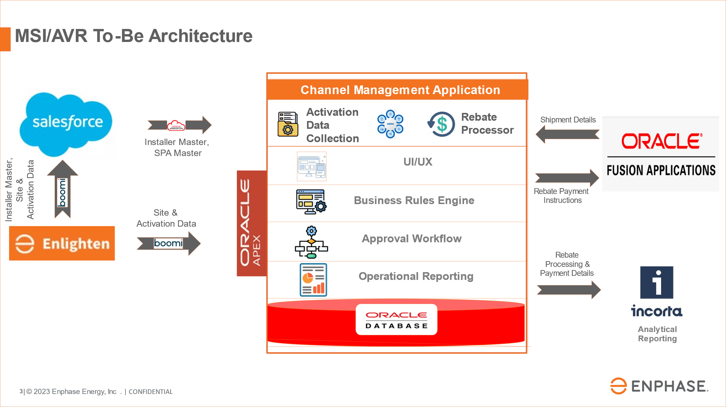

### System Components

1. **Frontend (Oracle APEX)**
   * Provides UI to view master and transactional data.
   * Displays **rebate eligibility, calculations, and payment status**.
2. **Integration Layer (Oracle OIC)**
   * Extracts activation data from Enlighten System.
   * Inserts or updates activation data in CHM Application.
   * Extracts shipment data from Oracle Fusion.
   * Inserts or updates shipment data in CHM Application.
   * Facilitates communication with Oracle Financials for payments.

### Backend Logic (Oracle PL/SQL)

* + Executes Serial # (S/N)lookups for shipment validation.
  + Implements rebate qualification & calculation rules.
  + Processes payments based on payee type.

### Database Layer (Oracle Database)

* + Stores **activation records, rebate rules, transaction logs, and payment status**.
  + Ensures **data integrity through upsert operations**.

## SFDC à CHM MSI SPA Sync

CHM will receive MSI/AVR SPA information from SFDC.

Following filters apply to the MSI/AVR SPA that will be interfaced into CHM

1. Quote to Buy = Yes
2. Status = Approved OR Cancelled post Approval
3. Both new records and updated records will be pushed into SFDC

The SPA information will have the following details

1. SPA Header
2. SPA Installers
3. SPA Distributors
4. SPA Contacts
5. SPA Geos
6. SPA Unit Activation Rebates
7. SPA System Attachment Rebates
8. SPA System Size Tier Rebates
9. SPA System Size Tier Information

### Changes to OIC Interface:

New OIC Interface that sends SFDC MSI/AVR SPA data into CHM will be created to source this information.

### Changes to CHM Database:

Following tables will be created in CHM Database

|  |  |
| --- | --- |
| Table Name | Information Stored |
| CHM_MSI_SPA_HEADER | SPA Header |
| CHM_MSI_SPA_INSTALLERS | SPA Installers |
| CHM_MSI_SPA_DISTRIBUTORS | SPA Distributors |
| CHM_MSI_SPA_CONTACTS | SPA Contacts |
| CHM_MSI_SPA_GEO | SPA Geos |
| CHM_SPA_UNIT_ACTIVATION_DETAIL | SPA Unit Activation Rebates |
| CHM_SPA_SYSTEM_ATTACHMENT_DETAIL | SPA System Attachment Rebates |
| CHM_SPA_SYSTEM_SIZE_DETAIL | SPA System Size Tier Rebates |
| CHM_SPA_SYSTEM_SIZE_TIER_MASTER | SPA System Size Tier Information |
|  |  |
|  |  |

### Changes to CHM UI:

New CHM UI screens will be built to show the following information

|  |
| --- |
| SPA Header |
| SPA Installers |
| SPA Distributors |
| SPA Contacts |
| SPA Geos |
| SPA Unit Activation Rebates |
| SPA System Attachment Rebates |
| SPA System Size Tier Rebates |
| SPA System Size Tier Information |

### Error Handling

#### Error Conditions:

When an unexpected error occurs, the UI will throw the appropriate exceptions/messages with Pre-defined Error Codes.

#### Warning Conditions:

When an unexpected warning occurs, the UI will throw the appropriate exceptions/messages with Pre-defined Warning Codes.

### Table and Column Mapping

[MSI_SFDC_CHM_Object_Mapping_Details.xlsx](https://enphase.sharepoint.com/:x:/r/sites/ChannelManagementIT/Shared%20Documents/AVR_Program_IT/Discovery%20%26%20Design/MSI_SFDC_CHM_Object_Mapping_Details.xlsx?d=we15645269f25441a9d7c37e16691f3d5&csf=1&web=1&e=Hvqehd)