**Channel Management**

**Marketing System Incentive (MSI)**

**Technical Design Document - Salesforce**

# **Document Control**

## **Change History**

|  |  |  |  |  |
| --- | --- | --- | --- | --- |
| **Date** | **Author** | **Version** | **JIRA Ticket #** | **Change Reference** |
| 01/13/2025 | Raj V  Adarsh M | 1.0 |  | Initial draft for review. |
| 02/05/2025 | Adarsh | 1.1 |  | Incorporate review comments from Ravi N and Milind. |
| 2/12/20205 | Adarsh | 1.1 |  | Review comments and changes incorporated. |

## **Draft Reviewers**

|  |  |  |
| --- | --- | --- |
| **Name** | **Position** | **Date** |
| Ravi N | Director, IT |  |
| Milind Pande | Business Partner , IT |  |
| Prasanna Roti | Director , IT |  |

## **Approvers**

|  |  |  |
| --- | --- | --- |
| **Name** | **Position** | **Date** |
| Ravi N | Director, IT |  |
| Prasanna R | Director, IT |  |

Table of Contents

Document Control 1

Change History 2

Draft Reviewers 2

Approvers 2

Introduction 3

Assumptions 4

References 4

Acronyms 5

Process Areas 5

Technical Components 6

SFDC Objects 6

EnlightenàSFDC Installer Account Sync 7

2. Updating Boomi Integration job to include this bank account flag 7

MSI SPA SKU restrictions 7

3. Adding flag on Product 8

4. Update the Product2-> Product page 8

MSI SPA Creation and Approval 8

5. Create new fields on SPA object 9

6. SPA New page layout 10

7. Standard Validations on SPA Creation 11

8. SPA Trigger change: 12

9. Create a new object to SPA Branch Installer 13

10. Validation on SPA Branch Installer 14

11. Create a new object to store Unit Activation incentives. 14

12. Flow/ Validations on Unit Activation incentives. 14

13. Create a new object to store System attachment information. 15

14. Flow/ Validations on system attachment incentives. 15

15. Create a new object to store System size/volume incentives. 15

16. Flow/ Validations on system size incentives. 16

17. Create a new LWC to add and display System size/incentive: 16

18. Create a new object to store System size/volume incentives for CHM consumption 17

19. Custom Object to store Tier Min /Max Range. 17

20. SPA Geography details for incentive 18

21. Geography Zip code size validation metadata 18

22. Trigger on the SPA Geography Detail for incentive 18

23. SPA Distributor 19

24. SPA Approval Processes 20

### 

# **Introduction**

This document covers the High-Level Solution design for the AVR process. Currently Enphase is using Service activation rebate in a limited way and the process is manual. As part of this program, with an objective to curb the Grey Market, we are building the Minimum Viable Product (MVP) to pilot the new automated AVR process.

# **Assumptions**

|  |  |
| --- | --- |
| # | Assumptions |
| 1 | Pilot in 4 countries (ITA, GBR, ESP, AUS) covering around 300 Installers. |
| 2 | Only products that have “activation” will be within the scope of AVR |
| 3 | Geo Fencing solution is not covered as part of this document |
| 4 | Installers will be required and able to manage their account hierarchies within Enlighten |
| 5 | This document does not cover the details of pre-pilot manual simulation |
| 6 | In case of scenario where AVR needs to be paid to Distributor, for RTR and Sub-Disti transactions AVR will be paid to Distributor to whom Enphase shipped the goods. Sub-Disti scenarios will be out of scope for AVR program. |

# **References**

|  |  |  |
| --- | --- | --- |
| # | Document | Link |
| 1 | Business Requirements Document | [Activations Volume Rebate BRD 2.0.docx](https://enphase.sharepoint.com/:w:/s/ChannelManagement/EYRobaR2QF5OvkTcwxJvH-YBcEBixDlyylRfnHzZVe80aA?e=EaGWqa) |
| 2 | Solution Design Document | [AVR_Solution_Design_Document.docx](https://enphase.sharepoint.com/:w:/r/sites/ChannelManagement/_layouts/15/Doc.aspx?sourcedoc=%7BBBD8B431-7790-49A9-B4E8-E10B5B29D399%7D&file=AVR_Solution_Design_Document.docx&action=default&mobileredirect=true) |
| 3 | CHM Technical Design Document | [MSI_Technical_Design_Document_CHM_Scope.docx](https://enphase.sharepoint.com/:w:/r/sites/ChannelManagement/Shared%20Documents/Grey%20Market%20Project/Solution%20Design/MSI_Technical_Design_Document_CHM_Scope.docx?d=w7d7423f7032e4d00a1ac0aee114fd5f3&csf=1&web=1&e=EOHoDd) |

# **Acronyms**

|  |  |  |
| --- | --- | --- |
| # | Acronym | Description |
| 1 | AVR | Activation Volume Rebate |
| 2 | SPA | Special Pricing Agreement |
| 3 | CHM | Channel Management Application |
| 4 | SFDC | Salesforce.com Application |
| 5 | BRD | Business Requirements Document |
| 6 | SDD | Solutions Design Document |

# **Process Areas**

**In Scope**

|  |  |  |
| --- | --- | --- |
| # | Process Area | Description |
| 1 | Enlighten à SFDC Installer Account Sync | Ability to sync Additional Enlighten Attributes to the Installer Account in SFDC.  *For ex: Bank Information Provided (True/False)* |
| 2 | Activation Volume Rebate (AVR) SPA Creation and Approval in SFDC | Ability for Sales to create, update, cancel and Pricing to approve/reject Activation Volume Rebate SPA in SFDC |
| 3 | SFDC à CHM Installer Account Sync | Ability to sync Additional Enlighten Attributes to the Installer Account in CHM.  *For ex: Bank Information Provided (True/False)* |
| 4 | SFDC à CHM AVR SPA Sync | Ability to sync AVR SPA Information into CHM to help with Rebate calculations. |
| 5 | AVR Rebate Calculations | Calculate eligible AVR Rebate based on Enlighten Activation Data and AVR SPA details |
| 6 | AVR Rebate AP Payments | Ability to create an AP Payment file for approved rebate payments to Installers via Oracle Fusion AP |
| 7 | AVR Rebate AR Credit Memo | Ability to create an AR Credit Memo file for approved rebate payments to Installers via Oracle Fusion AR |
| 8 | Operational Reporting | Ability for the user to run canned Operational Reports |
| 9 | User Roles and Security | Ability to define roles and security matrix for access to AVR Rebates process in CHM Application |
| 10 | Audit Capabilities | Ability to capture Audit information on data in CHM application – created by, creation date, last updated by, last update date |
| 11 | Approval Workflow | Ability to route AVR Rebate payments for approval in CHM Application |

# Technical Components

|  |  |  |
| --- | --- | --- |
| # | Process Area | Technical Components |
| 1 | Enlighten à SFDC Installer Account Sync | Modify existing interfaces to include the new fields |
| 2 | Activation Volume Rebate (AVR) SPA Creation and Approval in SFDC | New Component to build |
| 3 | SFDC à CHM Installer Account Sync | Modify existing interfaces to include the new fields |
| 4 | SFDC à CHM AVR SPA Sync | New Component to build |
| 5 | AVR Rebate Calculations | New APEX Screens, PL/SQL Packages |
| 6 | AVR Rebate AP Payments | New APEX Screens, PL/SQL Packages |
| 7 | AVR Rebate AR Credit Memo | New APEX Screens, PL/SQL Packages |
| 8 | Operational Reporting | New APEX Screens, PL/SQL Packages |
| 9 | User Roles and Security | New APEX Screens, PL/SQL Packages |
| 10 | Audit Capabilities | New APEX Screens, PL/SQL Packages |
| 11 | Approval Workflow | New APEX Screens, PL/SQL Packages |

# SFDC Objects

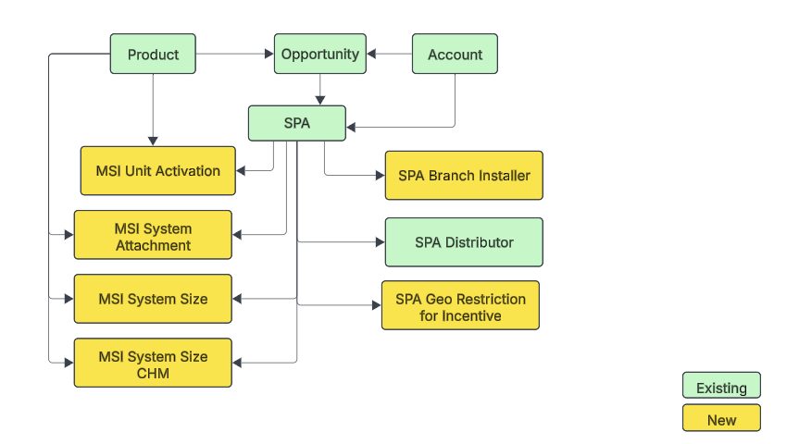

# EnlightenàSFDC Installer Account Sync

Installer accounts created in Enlighten and it's already synchronized to Salesforce using the Boomi Integration.

As part of this project, we would be adding a section on Enlighten to capture the Installer’s bank detail. We need to capture this flag back to SFDC so that Marketing Services Incentive SPA level validations/restrictions can be appropriately implemented.

Changes needed:

1. Adding Bank Account flag to Account object

|  |  |  |  |
| --- | --- | --- | --- |
| **Object** | **Field** | **New/ Existing** | **Description** |
| Account | IsInstallerBankAccount_Shared__c | New | To store true/false. Value coming from Enlighten. |

## Updating Boomi Integration job to include this bank account flag

This job is already synching the installer account from Enlighten to SFDC. Need to add Bank account flag as additional attribute

# MSI SPA SKU restrictions

Marketing incentives would be allowed only on selected products.

MSI SPA can contain only those SKU/Products.

## Adding flag on Product

These flags would be used to filter out/restrict the products considered for MSI

|  |  |  |  |
| --- | --- | --- | --- |
| **Object** | **Field** | **New/ Existing** | **Description** |
| Product2 | IsMarketingIncentive_Allowed__c | New | To store true/false. Value to be manually set in SFDC |
| Product2 | IsMSI_SystemAttachment | New | To store true/false. Value to be manually set in SFDC |

## Update the Product2-> Product page

This flag would be updated directly in Salesforce and would be maintained by the Pricing team.

Below is suggested page layout change.

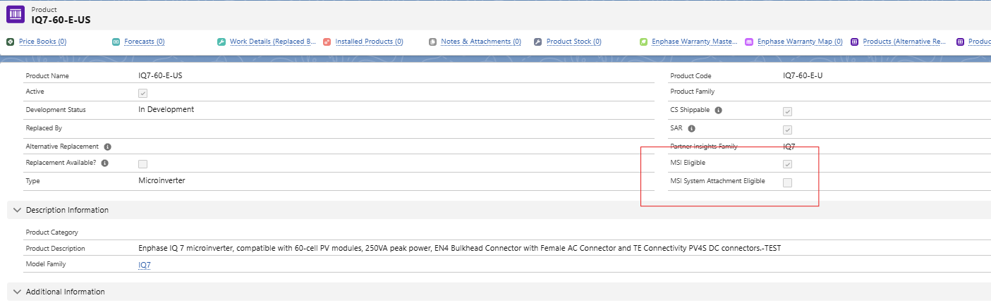

# MSI SPA Creation and Approval

Below is the flow that shows the lifecycle of the MSI SPA.

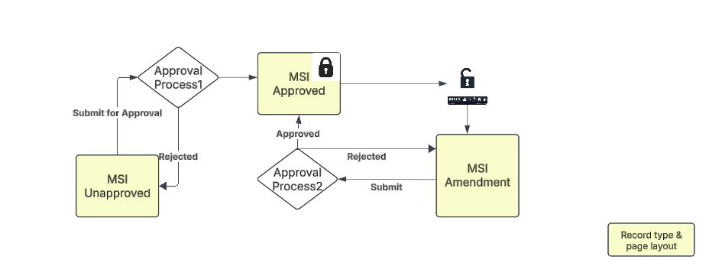

Marketing service incentive SPA would include the product which allows that incentive.

SPA would further specify the Euro/Dollar value of the incentive being offered.

**Changes to SPA Object**

## Create new fields on SPA object

|  |  |  |  |
| --- | --- | --- | --- |
| **Object** | **Field** | **New/ Existing** | **Description** |
| SPA | RecordType | Existing | Add a new recordtype for MSI SPA so that field on layout can be as per MSI requirements and other SPA type layouts are not impacted.  **MSI Unapproved SPA**  **MSI Approved SPA**  **MSI Amendment SPA** |
| SPA | Status | Existing | Draft (default),  Submitted, Approved, ReOpen |
| SPA | ReOpened Status | New | Draft (default),  Submitted, Approved, Rejected |
| SPA | Special_Pricing_Type__c | Existing | Add value  **MSI Installer**  **MSI Quarterly** |
| SPA | Installer bank account shared | New/Formula | Formula field to be displayed on SPA |
| SPA | Contact | new | Lookup to contact record so that approval email can be sent to installer’s contact |
| SPA | How many Tiers | New | To store how many tiers are built on SPA for System Size (max 5) |
| SPA | Tier1_Min | New | Tier1 min value (needed for PDF) |
| SPA | Tier2_Min | New | Tier2 min value |
| SPA | Tier3_Min | New | Tier3 min value |
| SPA | Tier4_Min | New | Tier4 min value |
| SPA | Tier5_Min | New | Tier5 min value |
| SPA | Tier1_Max | New | Tier1 Max value |
| SPA | Tier2_Max | New | Tier2 Max value |
| SPA | Tier3_Max | New | Tier3 Max value |
| SPA | Tier4_Max | New | Tier4 Max value |
| SPA | Tier5_Max | New | Tier5 Max value |
| SPA | Unit incentive count | New | Rollup field on how many unit incentive rows in Draft status. Needed to put as entry criteria for approval (sum of unit/attachment/system size should be > 0) |
| SPA | System attachment count | New | Rollup field on how many System attachment rows in Draft status |
| SPA | System size count | New | Rollup field on how many Systems sizes row count in Draft |
| SPA | Modified Expiry Date | New | When Approved SPA is under modification, this field would be only one directly on SPA which can be modified |

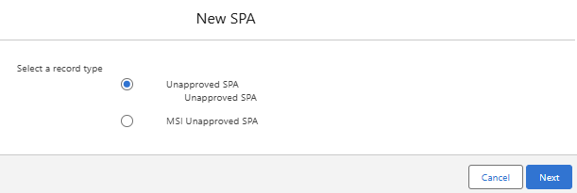

## SPA New page layout

Create a new Page layout for Unapproved MSI SPA Record type to keep relevant fields on page.

* Layout name: MSI Unapproved Layout: For initial SPA. Most sections/fields are editable.
* Layout name: MSI Approved Layout: For approved SPA. Nothing is editable.
* Layout name: MSI ReOpen Layout: For reopen SPA Limited field like End date is editable. Also, this layout can also display Status__c field on all child objects (Unit Incentive, System Attachment, Branch Installer, Geo Details for incentive) so that user would know which records are already approved v/s which are added recently.

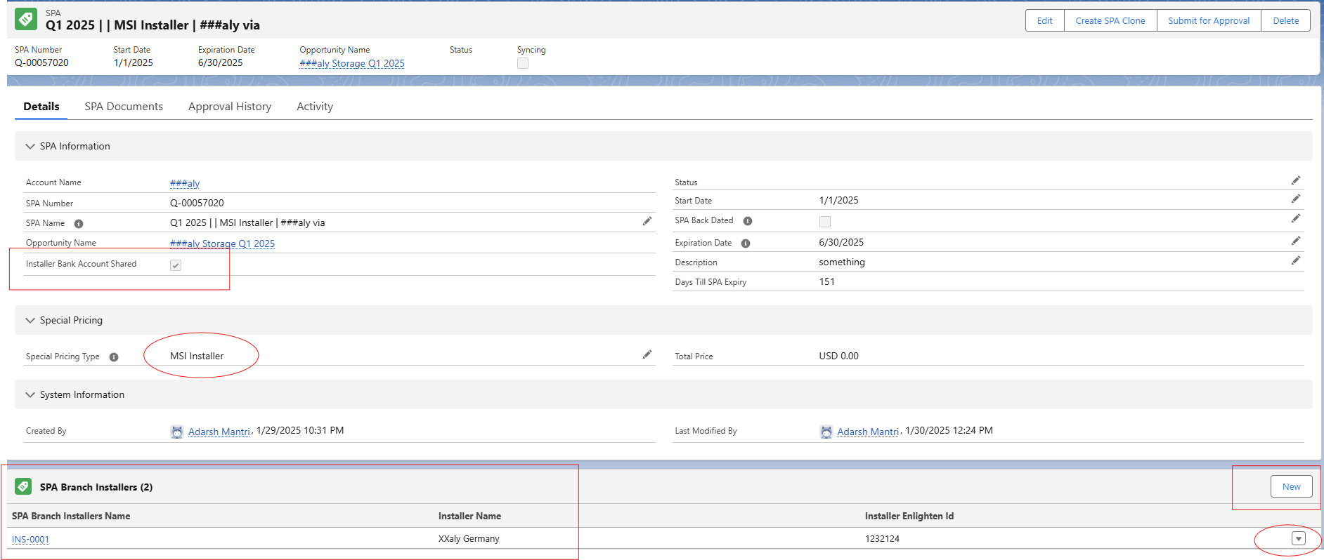

Screen with fresh SPA created

* Installer Bank account flag on SPA
* New values in Special Pricing type
* List of installer branches gets added on SPA creation
* Ability for sales team to remove or add any branch installer at later time

## Standard Validations on SPA Creation

A. Bank Account flag should be true

When Special Pricing Type in (‘MSI Installer’, ‘MSI Quarterly’),

AND Installer's -> IsInstallerBankAccount_Shared__c is false, then show error:

<Need error message>

B. Installer Enlighten Id should be present

When Special Pricing Type in (‘MSI Installer’, ‘MSI Quarterly’),

AND Installer's -> Enlighten_Installer_ID__c is empty, then show error:

<Need error message>

C. Installer’s country restriction

When Special Pricing Type in (‘MSI Installer’, ‘MSI Quarterly’),

AND Installer's -> Country__c not in (‘GB’, ‘IT’, ‘AU’, ‘ES’), then show error:

<Need error message>

D. Installers on SPA should not have parent account

When Special Pricing Type in (‘MSI Installer’, ‘MSI Quarterly’),

AND Installer's -> ParentId NOT BLANK, then show error:

<Need error message>

E. Installers on SPA should be Contact’s Account

When Special Pricing Type in (‘MSI Installer’, ‘MSI Quarterly’ ),

AND Contact <> ‘’

AND Contact.AccountId <> InstallerId

<Need error message. Contact does not belong to same installer>

F. Modified Expiry Date cannot be earlier than today

When Special Pricing Type in (‘MSI Installer’, ‘MSI Quarterly’),

SPA -> Modified Expiry Date < TODAY

<Need error message...Modified Expiry Date cannot be earlier than today>

## SPA Trigger change:

There would be following change on SPA trigger

* **After insert trigger**: if record type is MSI Unapproved,

Get list of all branch installer for primary installer

[SELECT id from Account where ParentId = SPA__c.AccountId

and RecordType.Name = 'Installer’;

insert this list into SPA Branch installer table which is described in below section.

* **After update trigger**
  + if record type is MSI Unapproved or MSI Amendment

AND Status is changed to Approved,

THEN

1. VALIDATE that For Given Installer, start date and end date, there is no other Approved SPA for same installer (including D SPA): Include installer’s child account which are selected for comparison

a. Create list of installer+ installer branch account Id on SPA

b. Select id, SPA_Start_Date__c, ExpirationDate, AccountId

From Quote

WHERE AccounId in ( installerAndBranchList)

And Status = ‘Approved’

AND (

( SPA_Start_Date__c > startDate AND SPA_Start_Date__c < endDate ) OR

( ExpirationDate > startDate AND ExpirationDate < endDate ) OR

( SPA_Start_Date__c < startDate AND ExpirationDate > endDate )

)

2. Move all SPA child records from Draft, Rejected to Approved

- Branch Installer

- Unit Activation incentive

- System attachment incentive

- System Size incentive

- SPA Geography Detail for Incentive

Query all records from above table where status__c = ‘Draft’ and move that to ‘Approved’

* + if record type is MSI Unapproved or MSI Amendment

AND Stauts is changed to Rejected,

THEN move all SPA child records from Draft to Rejected

- SPA Branch Installer

- SPA MSI Unit Activation incentive

- SPA MSI System attachment incentive

- SPA MSI System Size incentive

- SPA MSI Geography Detail for Incentive

Query all records from above table where status__c = ‘Draft’ and move that to ‘Approved’

## Create a new object to SPA Branch Installer

|  |  |  |  |
| --- | --- | --- | --- |
| **Object** | **Field** | **New/ Existing** | **Description** |
| SPA Branch Installer | Installer Name | New Lookup(Account) | Lookup to Account |
| SPA Branch Installer | Installer Enlighten Id | New/Formula | To derive enlighten id from Installer record |
| SPA Branch Installer | SPA__c | New | Master Detail Lookup with SPA(Quote) |
| SPA Branch Installer | Status__c | New | Draft(default), Approved, Rejected |

## Validation on SPA Branch Installer

- Installer getting added to this table must be child account of Installer account on SPA

Installer_Name__c.ParentId == SPA__c.AccountId

- Approved records cannot be modified

IsChanged(Installer Name) && Status__c = ‘Approved’

<Cannot change Approved installer>

- Flow trigger to stop deletion of SPA Branch once stauts__c = ‘approved’

## Create a new object to store Unit Activation incentives.

|  |  |  |  |
| --- | --- | --- | --- |
| **Object** | **Field** | **New/ Existing** | **Description** |
| SPA MSI Unit Activation | Product | New | Lookup to product with filter over IsMarketingIncentive_Allowed__c  To be true |
| SPA MSI Unit Activation | Min Quantity | New | To hold min quantity on which incentive is allowed |
| SPA MSI Unit Activation | Per Unit Incentive | New | Numeric value of incentive in Installer’s currency |
| SPA MSI Unit Activation | SPA__c | New | Master Detail with SPA(Quote) |
| SPA MSI Unit Activation | Unique key | New | Unique text field which would be combination of ProductId & SPAId , to ensure product is added just once on SPA |
| SPA MSI Unit Activation | Status__c | New | Draft(default), Approved, Rejected |

## Flow/ Validations on Unit Activation incentives.

- On create & update flow

- Set Unique key = SPA__c + Product__c field

- Check if status = ‘Approved’ and Status__c is not changed (meaning something else changed), throw error.

- On delete flow, stop deletion of unit activation which have status__c = Approved

## Create a new object to store System attachment information.

|  |  |  |  |
| --- | --- | --- | --- |
| **Object** | **Field** | **New/ Existing** | **Description** |
| SPA MSI System Attachment | Product | New | Lookup to product with filter over IsMarketingIncentive_Allowed__c  To be true |
| SPA MSI System Attachment | Min Quantity | New | To hold a minimum quantity for which incentive is allowed per site. |
| SPA MSI System Attachment | Per Unit Incentive | New | Numeric value of incentive in Installer’s currency |
| SPA MSI System Attachment | SPA__c | New | Master Detail with SPA(Quote) |
| SPA MSI System Attachment | Unique key | New | Unique text field which would be combination of ProductId & SPAId , to ensue product is added just once on SPA |
| SPA MSI System Attachment | Status__c | New | Draft(default), Approved, Rejected |

## Flow/ Validations on system attachment incentives.

- On create & update flow

- Set Unique key = SPA__c + Product__c field

- Check if status = ‘Approved’ and Status__c is not changed (meaning something else changed), throw error.

- On delete flow, stop deletion of system attachment record which have status__c = Approved

## Create a new object to store System size/volume incentives.

Field here would store the incentive. The range of the tier would be dynamically set for each SPA, and the value of each tier mininum-maximun value would come from newly added fields on SPA object.

This oject would be used for SPA PDF generation while on UI, the data would be displayed using LWC.

|  |  |  |  |
| --- | --- | --- | --- |
| **Object** | **Field** | **New/ Existing** | **Description** |
| SPA MSI System Size Incentive | Product | New | Lookup to product with filter over IsMarketingIncentive_Allowed__c  To be true |
| SPA MSI System Size Incentive | SPA | New | Master detail to SPA |
| SPA MSI System Size Incentive | Tier1 Incentive | New | To hold incentive for Quantities in Tier1 |
| SPA MSI System Size Incentive | Tier 2 Incentive | New | To hold incentive for Quantity in Tier2 |
| SPA MSI System Size Incentive | Tier 3 Incentive | New | To hold incentive for Quantity in Tier3 |
| SPA MSI System Size Incentive | Tier 4 Incentive | New | To hold incentive for Quantity in Tier4 |
| SPA MSI System Size Incentive | Tier 5 Incentive | New | To hold incentive for Quantity in Tier5 |
| SPA MSI System Size Incentive | Unique key | New | Unique text field which would be combination of ProductId & SPAId , to ensue product is added just once on SPA |
| SPA MSI System Size Incentive | Status__c | New | Draft(default), Approved, Rejected |

## Flow/ Validations on system size incentives.

- On create & update flow

- Set Unique key = SPA__c + Product__c field

- Check if status = ‘Approved’ and Status__c is not changed (meaning something else changed), throw error.

- On delete flow, stop deletion of system size record which have status__c = Approved

## Create a new LWC to add and display System size/incentive:

msi_SystemSizeIncentiveLWC LWC would display information like below UI

|  |  |  |  |  |
| --- | --- | --- | --- | --- |
| How many Tiers needed | **4** | | | |
|  | **Micro Units per Site + Add Product (Button)** | | | |
|  | **Tier 1** | **Tier 2** | **Tier 3** | **Tier 4** |
| Min Qty | **30** | **51** | **151** | **301** |
| Max Qty | **50** | **150** | **300** | **9999999** |
|  | **30 - 50** | **51-150** | **151-300** | **300+** |
| [IQ8HC-72-M-INT](https://enphase.lightning.force.com/lightning/r/0QLPs0000022tUBOAY/view) | €5 | €6.5 | €7.5 | €8.5 |
| IQ8MC-72-M-INT | €6 | €9 | €12 | €15 |
| [IQ8P-80-M-INT](https://enphase.lightning.force.com/lightning/r/0QLPs0000022tUCOAY/view) | €7 | €10.5 | €14 | €17.5 |

Mix Qty and Max Qty rows would be prepopulated based on data from MSI SPA Tier Range object.

Those rows would be editable.

Min and Max quantity field data would be stored in the new fields created on SPA Object.

## Create a new object to store System size/volume incentives for CHM consumption

This schema would not be directly exposed on UI but would be transferred over to CHM for their consumption of calculation.

|  |  |  |  |
| --- | --- | --- | --- |
| **Object** | **Field** | **New/ Existing** | **Description** |
| SPA MSI System Size for CHM | Product | New | SKU |
| SPA MSI System Size for CHM | SPA | New | Master detail with SPA |
| SPA MSI System Size for CHM | Tier Name | New | Tier1/Tier2 etc |
| SPA MSI System Size for CHM | Min Qty | New | To hold minimum quantity for given tier for current SPA |
| SPA MSI System Size for CHM | Max Qty | New | To hold maximum quantity for given tier for current SPA |
| SPA MSI System Size for CHM | Tier Incentive | New | Money value of the incentive offered. |

## Custom Object to store Tier Min /Max Range.

This table would be maintained by the Pricing team. It stores the default value which would come up on the Tier screen while adding the System Size incentive.

|  |  |  |  |
| --- | --- | --- | --- |
| **Object** | **Field** | **New/ Existing** | **Description** |
| MSI SPA Tier Range_c | Type__c | New /Unique field | Microinverter  Battery |
| MSI SPA Tier Range_c | Tier1_Min_Qty__c | New | Number field to denote min qty for Tier1 |
| MSI SPA Tier Range_c | Tier1_Max_Qty__c | New | Number field to denote max qty for Tier1 |
| MSI SPA Tier Range_c | Tier2_Min_Qty__c | New | Number field to denote min qty for Tier2 |
| MSI SPA Tier Range_c | Tier2_Max_Qty__c | New | Number field to denote max qty for Tier2 |
| MSI SPA Tier Range_c | Tier3_Min_Qty__c | New | Number field to denote min qty for Tier3 |
| MSI SPA Tier Range_c | Tier3_Max_Qty__c | New | Number field to denote max qty for Tier3 |
| MSI SPA Tier Range_c | Tier4_Min_Qty__c | New | Number field to denote min qty for Tier4 |
| MSI SPA Tier Range_c | Tier4_Max_Qty__c | New | Number field to denote max qty for Tier4 |

Access to this object would be given only to the pricing team. They should be able to change tier and not type. Also, type would be unique so that duplicate records cannot be created.

Initial data would be set up as part of deployment.

## SPA Geography details for incentive

This section would contain approved geographies where incentive on activation is approved.

No records on this would mean all activations for installer are approved for incentive but one or more records in this table would restrict the incentive only to those geographies.

|  |  |  |  |
| --- | --- | --- | --- |
| **Object** | **Field** | **New/ Existing** | **Description** |
| SPA MSI Geo Detail | Country | New | GB, IT, AU, ES |
| SPA MSI Geo Detail | State | New | Dependent picklist from Country |
| SPA MSI Geo Detail | Zip code | New | Large text field to store upto 10000 characters to store multiple zip delimited by ; |
| SPA MSI Geo Detail | Status | New | Draft(default), Approved, Rejected |
| SPA MSI Geo Details | SPA__c | New | Master Detail with SPA(Quote) |

## Geography Zip code size validation metadata

This metadata would mention how many characters are valid for a given country

|  |  |  |  |
| --- | --- | --- | --- |
| **Object** | **Field** | **New/ Existing** | **Description** |
| Geo zipcode size | Country | New | GB, IT, AU, ES |
| Geo zipcode size | Min Size | New | Like 4 |
| Geo zipcode size | Max Size | New | Like 8 |

## Trigger on the SPA Geography Detail for incentive

This trigger would

1. Tokenize all zip code by its delimiter
2. Based on country, check if all tokens are within the min/max range. If not, throw error
3. No zip code is duplicate by adding zip code to a Set and checking set.constains(newZip) if there is match, throw error
4. Create a string of whole row: Country + state + one zip from list (4 zips would create 4 row tokens)
5. Add each row token to set
6. Check if set.contains(newRowToken) if there is match, throw error

## SPA Distributor

This is an existing object, which would be used as is. Just need to add 1 new field

|  |  |  |  |
| --- | --- | --- | --- |
| **Object** | **Field** | **New/ Existing** | **Description** |
| SPA Distributor | Line Status | New | Draft(default), Approved, Rejected |

## SPA Approval Processes

Two new approval process needs to be built

1. Initial approval for Draft status SPA

Entry criteria: All criteria should be met to enter

* Record Type is MSI Unapproved SPA
* Status of SPA should be Draft
* Unit Incentive record count + System attachment record count + System size record count should be > Zero
* Expiry Date for SPA should be in future

On Approval it should

* Generate SPA PDF
* Update Status of SPA to be Approved
* Change record type to MSI Approved SPA
* Send out email to Opportunity Owner & Installer contact put on SPA record.

2. Reapproval of amended MSI SPA

Entry criteria: All criteria should be met to enter

* Record Type is MSI Amendment SPA
* Status of SPA should be Reopen
* ReOpen status of SPA should be Draft
* Draft record count of Unit Incentive record + System attachment record + System size record > Zero OR
  + Modified Expiry Date should be not blank OR
  + Draft count of Geo Restriction for incentive should be >0 OR
  + Draft count of Branch Installer should be >0 OR
  + Draft count of SPA Distributor should be >0 OR
* Expiry Date or Modified Expiry Date for SPA should be in future

On Approval it should

* Generate SPA PDF
* Update Status of SPA to be Approved
* Change record type to MSI Approved SPA
* Send out email to Opportunity Owner & Installer contact put on SPA record.

1. Button and Flow to Reopen an approved SPA

Like the Cancel SPA button, we would have ReOpen SPA Button on MSI Approved SPA which would invoke flow to

1. Move record type from MSI Approved SPA -> MSI Amendment SPA

2. Set Status to ReOpen

3. Set Reopen status to Draft

1. MSI SPA PDF Configuration
2. A new PDF needs to be configured (MSI SPA Template) as per details in user story.
3. Another PDF template MSI Budgetary SPA template needs to be created.

GenerateQuotePdfDocument class would be updated to generate MSI SPA Template or MSI Budgetary SPA based on Special pricing type and Quote To Buy/Budgetary field value.

1. Lightning Record Page

A new lightning record page (MSI SPA Record) would be created to represent the data layout as shared below

1. Layout screenshot

Visuals about some options on how this page can look like

#1 Some lists in right hand side bar

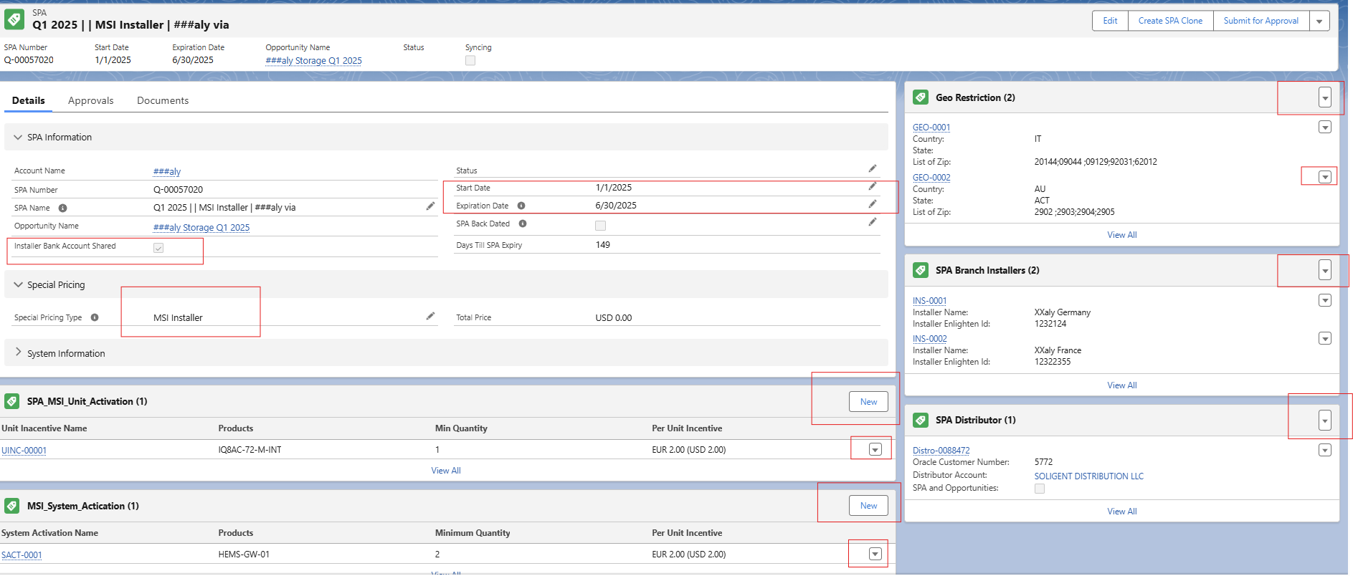

|  |  |  |  |  |
| --- | --- | --- | --- | --- |
|  | **Micro Units per Site + Add Product ( Button)** | | | |
|  | **Tier 1** | **Tier 2** | **Tier 3** | **Tier 4** |
|  | **30 - 50** | **51-150** | **151-300** | **300+** |
| [IQ8HC-72-M-INT](https://enphase.lightning.force.com/lightning/r/0QLPs0000022tUBOAY/view) | €5 | €6.5 | €7.5 | €8.5 |
| IQ8MC-72-M-INT | €6 | €9 | €12 | €15 |
| [IQ8P-80-M-INT](https://enphase.lightning.force.com/lightning/r/0QLPs0000022tUCOAY/view) | €7 | €10.5 | €14 | €17.5 |

#2 No right bar. All data on main section

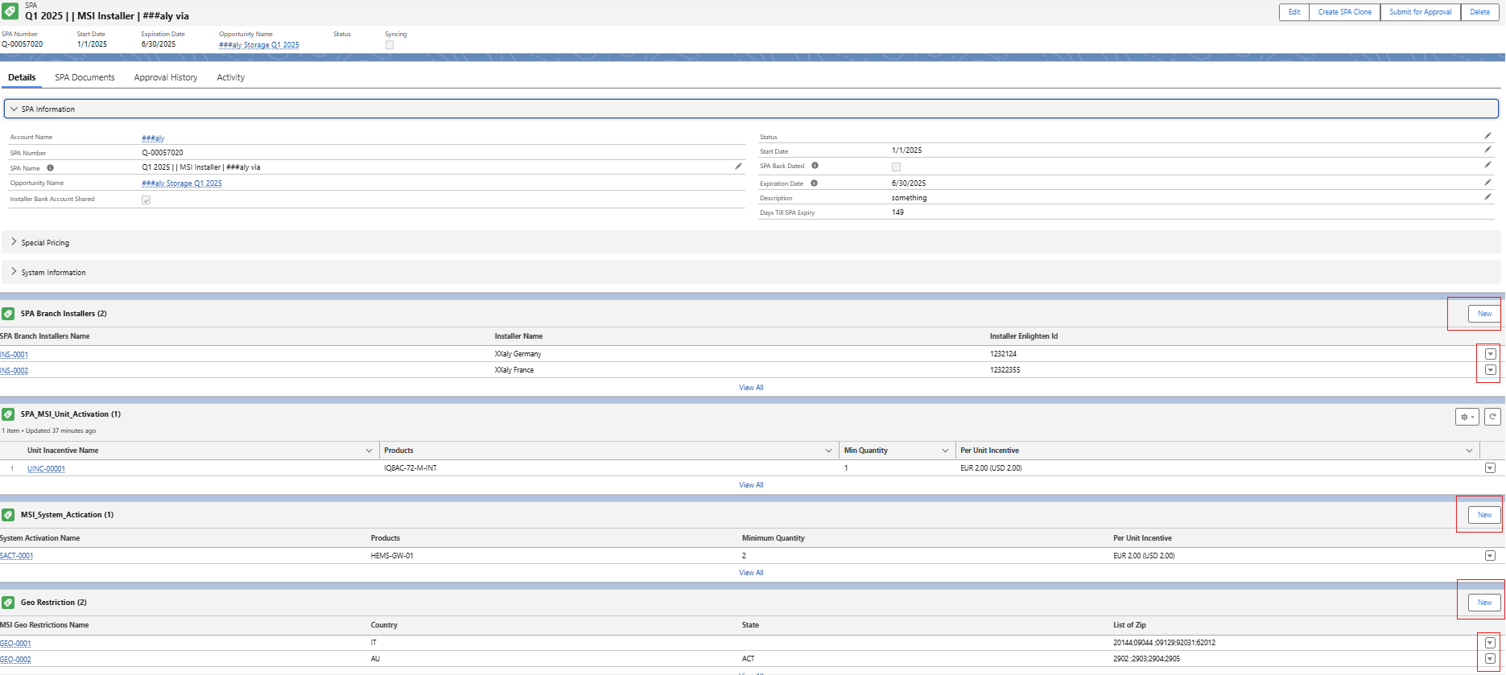

**Assumption/Concern/Recommendation**

1. As the requirement around PDF generation is but dynamic based on which sections of the spa are filled , it is recommended to use rrobus PDF builder tool like Conga composer/ Docusign etc.