**Solution Design Document**

**MSI Shipment Details Sync**

*ENP-SDD-MSI-Shipment-Details-Sync*

Contents

1. Object Information 4

2. Document Control 5

Change History 5

Reviewers 5

Approvers 5

3. Overview 6

Introduction 6

Volume Metrics – Table 1 6

Key Contributors and Contacts – Table 2 6

Document References – Table 3 6

4. Assumptions 7

5. Requirements 8

Interface Requirements – Table 4 8

Prerequisite Setups 8

6. Process Design 9

Process Description 9

Data Extraction Criteria 10

Data Transformation and Validation 12

Report/Screen Layout 12

7. Technical Design 14

Design Description 14

Program Details 14

Connection Details (for Integrations) 14

Lookup Details 14

API Details: 15

Database Objects 15

BIP Reports 15

Report Parameters 15

8. Data Mapping 16

Data/Field Mapping – Table 5 16

9. Notifications 17

Success Notification 17

Error Notification 17

Warning Notification 18

10. Exception Handling 19

Exception Handling 19

11. Error Handling 20

Error Reprocessing 20

Backup Requirements 20

Reprocessing Strategy 20

Planned Outage Strategy 20

Cutover Plan 20

12. SOX & Security Considerations 21

13. Acceptance Criteria 22

Test Conditions and Results – Table 6 22

10. Open / Closed Issues 24

Open/Closed Issues – Table 7 24

11. Appendix 25

# Object Information

|  |  |
| --- | --- |
| Project Name | Channel Management (CHM) |
| RICEW ID | CHMMSISHIPMENTDETAILSYNCERPTOCHM |
| Interface Name | CHMMsiShipmentDetailSyncERPtoCHM |
| RICEW Short Description | MSI Shipment Detail Sync from Oracle Fusion Cloud ERP to CHM |
| Primary RICEW Group | IT |
| Complexity | High |
| Application Module | Oracle Fusion Order Management |
| Interface Type | Scheduled |
| Source Systems | Oracle Cloud Fusion (ERP Cloud) |
| Destination System | Channel Management (CHM) |
| Expected Data Volumes | ~1Million per month |
| Frequency | Daily |
| Category |  |

# Document Control

## Change History

| Date | Author | Version | JIRA Ticket # | Change Reference |
| --- | --- | --- | --- | --- |
| 18-Mar-2025 | Gurpreet Singh | 1.0 |  | Initial. |
|  |  |  |  |  |
|  |  |  |  |  |
|  |  |  |  |  |

## Reviewers

| Name | Position | Date |
| --- | --- | --- |
|  |  |  |

## Approvers

| Name | Position | Date |
| --- | --- | --- |
|  |  |  |

# Overview

## Introduction

This document defines the technical components required to implement Interface for syncing MSI Shipment Details from Oracle Fusion to Channel Management (CHM) using Oracle Integration Cloud (OIC) as integration layer.

## Volume Metrics – Table 1

| # | Source System | Transaction Type | Transaction Volume |
| --- | --- | --- | --- |
| 1 | Oracle ERP Cloud | Shipment Data | ~1 Million per month |

## Key Contributors and Contacts – Table 2

| System / Module Name | Primary Contact | | Secondary Contact(s) | |
| --- | --- | --- | --- | --- |
| Name | Email | Name | Email |
| Oracle Integration Cloud | Gurpreet Singh | gusingh@enphaseenergy.com |  |  |

## Document References – Table 3

| # | Document | Document link / Reference ID |
| --- | --- | --- |
| 1 | Master Mapping | [MasterMapping.xlsx](https://enphase.sharepoint.com/:x:/r/sites/ChannelManagementIT/Shared%20Documents/General/TE%20Deliverables/Tech%20Design/ReferenceDocuments/MasterMapping.xlsx?d=w0a4cf4a63cc34a018cd862395a83ecac&csf=1&web=1&e=SiXC5F&nav=MTVfe0YzMDFCRURFLThBOUUtNEYyRC1BQjNBLUU0MzYzNkI2MDg1MX0) |
| 2 | Shipment Detail Report SQL | [MsiShipmentDetailsDM.sql](https://enphase.sharepoint.com/:u:/r/sites/ChannelManagementIT/Shared%20Documents/AVR_Program_IT/Deliverables/OIC/Report%20SQLs/MsiShipmentDetailsDM.sql?csf=1&web=1&e=Fh9thI) |
| 3 | Table Design | [TableDesign.xlsx](https://enphase.sharepoint.com/:x:/r/sites/ChannelManagementIT/Shared%20Documents/General/TE%20Deliverables/Tech%20Design/ReferenceDocuments/TableDesign.xlsx?d=w96b9745c41c6429684069e901be4a07a&csf=1&web=1&e=sPhrhP&nav=MTVfezc1QzZBMjEzLTQwMzUtNDEwNC1CRTQ3LUVDMEJFQ0U1QjIwMn0) |

# Assumptions

**Assumptions – Table 4**

| # | Assumptions |
| --- | --- |
| 1 |  |
| 2 |  |
| 3 |  |

# Requirements

## Interface Requirements – Table 4

|  |  |
| --- | --- |
| Requirement ID | Requirement Description |
|  |  |

## Prerequisite Setups

|  |
| --- |
| Prerequisite Setups |
| 1. All the required connections are configured in OIC 2. All required setups and configurations (like Accounts, Order Types, Inventory Orgs etc.) are available in Oracle Fusion |

# Process Design

## Process Description

The design below is the high-level process flow for the syncing Installer Master from SFDC to Channel Management.

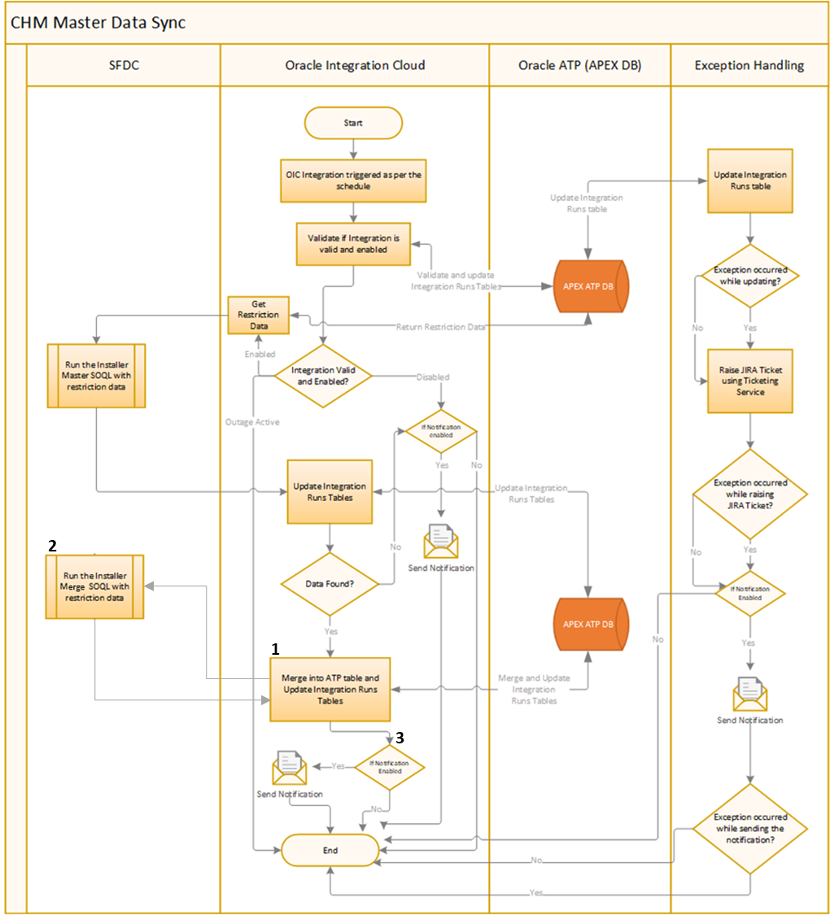

|  |  |
| --- | --- |
| **Step** | **Description** |
| 1 | The OIC end point is triggered as per the schedule |
| 2 | Validation will be performed to check if Integration is valid and enabled in Channel Management. Integration run record will be created in CHM_INTEGRATION_RUNS table to track the current run. There can be three scenarios for an Integration:   * **Integration is valid and enabled** – Integration is registered in Channel Management and enabled, so the execution will continue normally * **Integration is valid and outage flag is checked**– Integration is registered in Channel Management and enabled but outage active flag is set for the integration, so the execution will be stopped * **Integration is invalid or disabled** – Integration is either not registered in Channel Management or disabled, so an error notification will be sent (using Disabled template configured in lookup which is described in Lookup Details section if enabled) and the execution will be stopped |
| 3 | If Integration valid and enabled then restriction data will be fetched from CHM_LOOKUP_VALUES table for lookup type **CHM_INSTALLER_RECORD_TYPE_RESTRICTION** and then SOQL will be triggered to get the Installer Master data from SFDC for each restriction data (i.e. Installer Record Type). If fetch operation is successful, then integration run record will be updated. There can be two scenarios for an integration:   * **Data fetched from SOQL**–   1. Records will be merged into CHM_SFDC_ACCOUNT_MASTER and CHM_SFDC_ACCOUNT_SITES table, integration run record will be updated & schedule run parameter (Last Run Date) will be updated with current run date.   2. Merge SOQL will be triggered to fetch all **SFDC_ACCOUNT_ID** values from date **01-Jan-2012** and that will be stored in CHM_SFDC_ACCOUNT_MASTER_KEYS table.   3. For all those records of CHM_SFDC_ACCOUNT_MASTER which are not present in CHM_SFDC_ACCOUNT_MASTER_KEYS, **ACCOUNT_STATUS** will be set to as ‘Merged’ and also **ATTRIBUTE2** will set to current date to mark the date when this record is Merged. * **No Data fetched from SOQL** – Error notification will be sent (using Warning template configured in lookup which is described in Lookup Details section if enabled) |
| 4 | In case of any error, exception handling mechanism will start which is described in exception handling section in this document. |

V1.2 - ITSD-289813 Below Package Spec and body used in this integration which is using OIC_INSTANCE_ID are converted from number to varchar datatype.

* CHM_INSTALLER_PKG

## Data Extraction Criteria

Master SOQL will return the below list of columns

* ID
* NAME
* CUSTOMER_KEY__C
* ACCOUNT_TYPE__C
* OWNER_NAME__C
* ENLIGHTEN_INSTALLER_ID__C
* PARENT.NAME
* PARENTID
* RECORDTYPE.NAME
* OWNER.ALIAS
* GEOGRAPHY__C
* TERRITORY__C
* SUB_TERRITORY__C
* ENLIGHTEN_ADMIN__C
* ENLIGHTEN_INSTALLER_FLAG__C
* BILLINGSTREET
* BILLINGCITY
* BILLINGSTATE
* BILLINGPOSTALCODE
* SHIPPINGSTREET
* SHIPPINGCITY
* SHIPPINGSTATE
* SHIPPINGPOSTALCODE
* COUNTRY__C
* CREATEDBY.NAME
* CREATEDDATE
* LASTMODIFIEDBY.NAME
* LASTMODIFIEDDATE
* BILLINGCOUNTRY
* SHIPPINGCOUNTRY
* OWNERID
* ORACLE_CUSTOMER_NUMBER__C
* RELATIONSHIP__C
* CURRENCYISOCODE
* CHANNELINSIGHT__CI_SYNCH__C
* REGION__C
* GEOGRAPHY_OWNER__C
* FORECASTABLE__C
* REGIONS__C
* ACCOUNT_STATUS__C
* STATUS__C
* Is_InstallerBankAccount_Shared__c

V1.3 Added Is_InstallerBankAccount_Shared__c

Merge SOQL will return the below list of columns

* ID

**Adding Sample Installer Screen from SFDC <Added by Raj>**

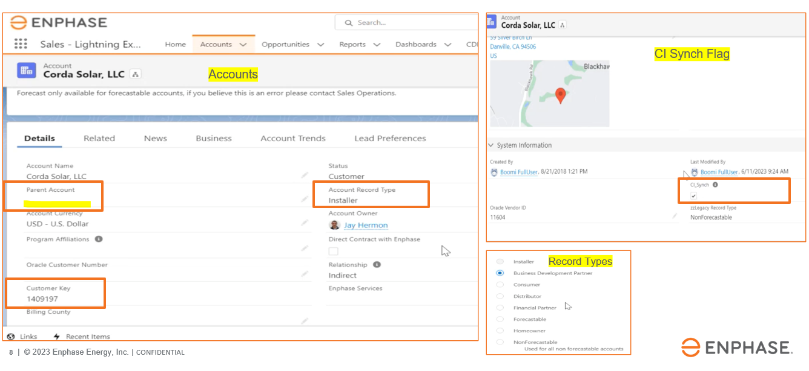

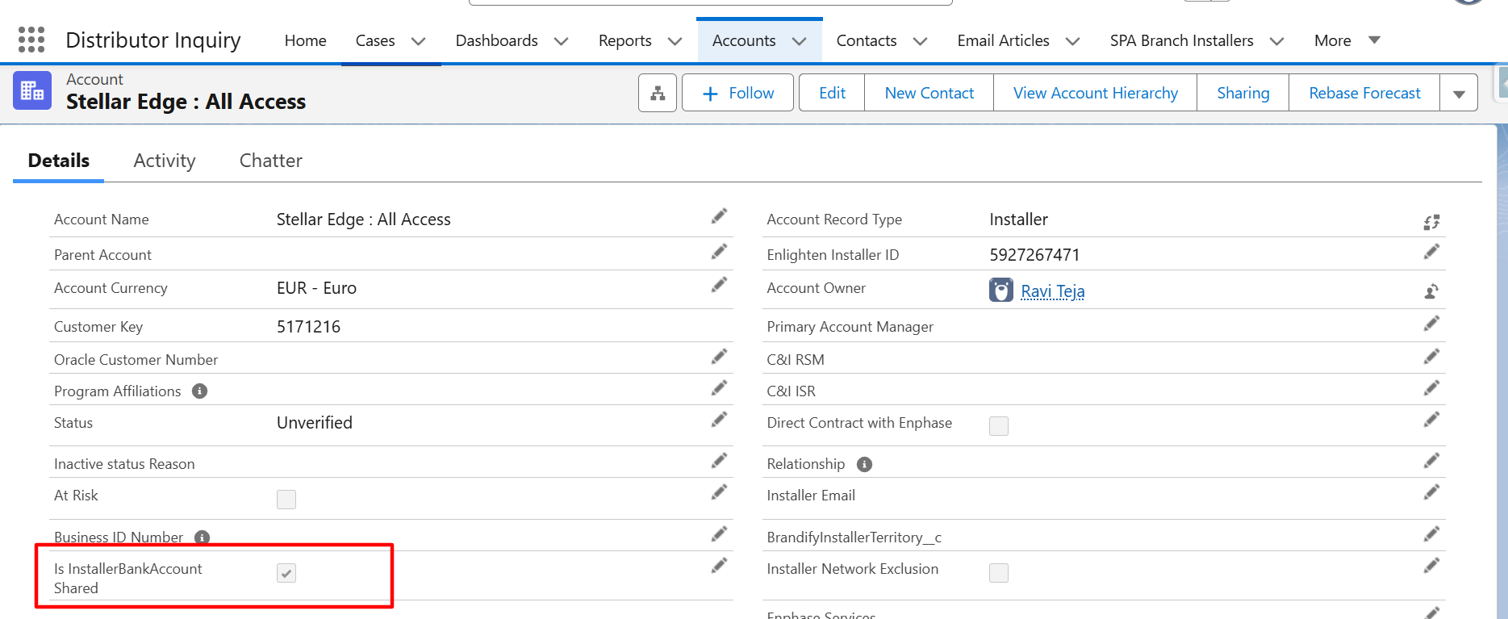

V1.3 – Addition of BANK_DETAILS_FLAG (Is InstallerBankAccount Shared)

## Data Transformation and Validation

* Data will be fetched based on restriction data from CHM
* Data will be fetched only for records where last update date is greater than the provided run date

**Pseudo code for SOQL**

* SOQL will fetch the records from below SFDC tables based on restriction data from CHM data passed in the parameter. Restriction data is available in lookup type **CHM_INSTALLER_RECORD_TYPE_RESTRICTION** (to restrict Record Type)
  + ACCOUNT
* New records will be inserted into ATP database table using INSERT statement.
* Existing records (based on key columns) will be merged into ATP Database using UPDATE statement
* Key columns are **SFDC_ACCOUNT_ID**
* Merge SOQL will fetch the ID Column from below SFDC tables with sync from date as **01-Jan-2012** based on restriction data from CHM data passed in the parameter. Restriction data is available in lookup type **CHM_INSTALLER_RECORD_TYPE_RESTRICTION** (to restrict Record Type)
  + ACCOUNT
* New records will be inserted into ATP database table using INSERT statement.
* Existing records (based on key columns) will be merged into ATP Database using UPDATE statement
* Key columns are **SFDC_ACCOUNT_ID**

## Report/Screen Layout

* Below screen will be used to register the integration in APEX. User can perform the below actions:
  + Enable or disable the integration
  + Enable or disable the outage flag for integration
  + View last run details of the integration
  + CHM_INTEGRATIONS table will store these details for the integration

* Below screen will be used to view the integration runs in APEX. User can perform the below actions:
  + View the integration runs of the integration
  + Below are the combination of Phase and Status for the integration:

|  |  |  |
| --- | --- | --- |
| **Phase** | **Status** | **Description** |
| Running | Normal | Integration is running normally |
| Completed | Success | Integration completed successfully |
| Completed | Error | Integration completed in error |
| Completed | Outage Active | Integration’s outage flag is enabled |
| Completed | Disabled | Integration is disabled |

* + View last run details of the integration
  + CHM_INTEGRATION_RUNS table will store these run details for the integration

# Technical Design

## Design Description

**CHMInstallerMasterSyncSFDCtoCHM** is a scheduled integration which will sync Installer Master from SFDC to Channel Management (CHM). The design below is the high-level process flow for the syncing Installer Master from SFDC to Channel Management

## Program Details

|  |  |  |  |  |  |
| --- | --- | --- | --- | --- | --- |
| **Component Name** | **Package Name** | **Operation/ Method** | **Sync / Async/ One way** | **Communication protocol** | **Description** |
| CHMInstallerMasterSyncSFDCtoCHM | com.enphase.chm | POST | Synchronous | SOAP | Integration to sync Installer Master |

## Connection Details (for Integrations)

|  |  |  |  |  |
| --- | --- | --- | --- | --- |
| **Connection Name** | **Type** | **WSDL** | **Role** | **Description** |
| CHMATPDBConnection | Oracle ATP |  | Trigger & Invoke | Oracle ATP Connection for CHM schema of APEX ATP DB |
| SFDCConnectionCHM | Salesforce |  | Trigger & Invoke | SFDC Connection |

## Lookup Details

|  |  |
| --- | --- |
| **Lookup Name** | **Lookup description** |
| LookupCHMIntegrations | Lookup for CHM Integrations |
| Domain Name | |
| Integration_Identifier-Notification_Type | |
| From_Email | |
| Email_Recipients | |
| Email_Subject | |
| Email_Body | |
| Notification_Enabled | |

## API Details:

OIC would leverage the below OIC component as webservice

|  |  |  |
| --- | --- | --- |
| Interface Name | Type | End Point URL |
| CHMTicketingService | OIC | /ic/api/integration/v1/flows/rest/CHMTICKETINGSERVICE/1.0/logJiraTicket |

## Database Objects

|  |  |  |  |
| --- | --- | --- | --- |
| **Object Name** | **Object Type** | **Schema** | **Description** |
| CHM_INTEGRATIONS | Table | CHM | CHM Common Table for storing Integration details |
| CHM_INTEGRATION_RUNS | Table | CHM | CHM Common Table for storing Integration Runs details |
| CHM_INTEGRATIONS_PKG | Package | CHM | CHM Common Package for validating Integrations and updating CHM_INTEGRATIONS & CHM_INTEGRATION_RUNS tables |
| CHM_INSTALLER_PKG | Package | CHM | CHM Package for Installer Master to merge data in staging tables |
| CHM_SFDC_ACCOUNT_MASTER | Table | CHM | CHM Table to store Installer Master Header |
| CHM_SFDC_ACCOUNT_SITES | Table | CHM | CHM Table to store Installer Master Site |

## BIP Reports

|  |  |  |  |  |
| --- | --- | --- | --- | --- |
| **Report Name** | **Report Description** | **Report Path** | **Integration Name using the BIP** | **ESS Job Name** |
|  |  |  |  |  |

## Report Parameters

|  |  |  |  |  |  |
| --- | --- | --- | --- | --- | --- |
| **Report Name** | **Parameter Name** | **Display Label** | **Data Type** | **Parameter Type** | **Mandatory** |
|  |  |  |  |  |  |
|  |  |  |  |  |  |

# Data Mapping

## Data/Field Mapping – Table 5

Master Mapping is available in [MasterMapping.xlsx](https://enphase.sharepoint.com/:x:/r/sites/ChannelManagementIT/Shared%20Documents/General/TE%20Deliverables/Tech%20Design/ReferenceDocuments/MasterMapping.xlsx?d=w0a4cf4a63cc34a018cd862395a83ecac&csf=1&web=1&e=SiXC5F&nav=MTVfe0YzMDFCRURFLThBOUUtNEYyRC1BQjNBLUU0MzYzNkI2MDg1MX0)

**V1.3** - Added new mapping for BANK_DETAILS_FLAG in master mapping

# Notifications

## Success Notification

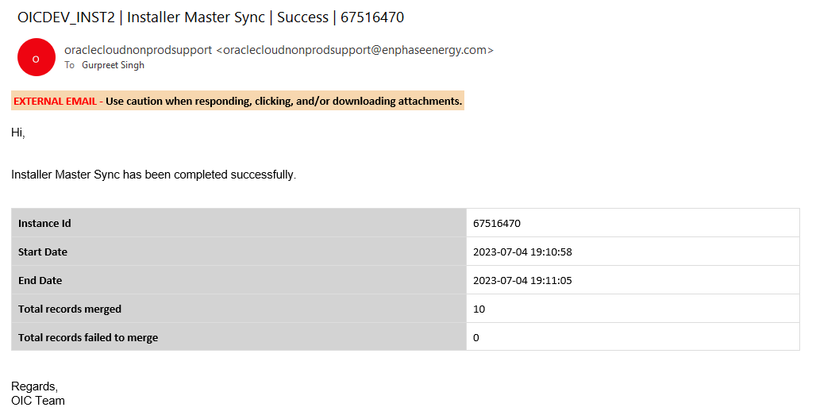

## Error Notification

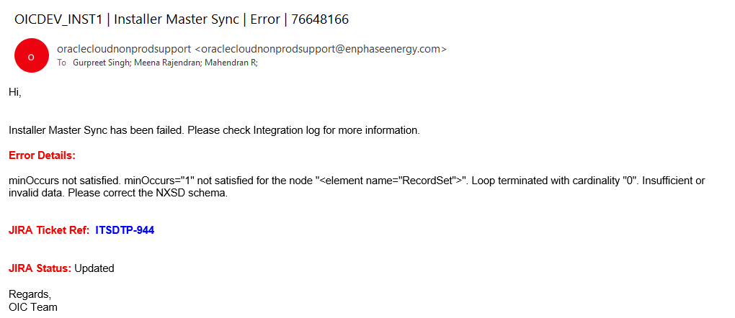

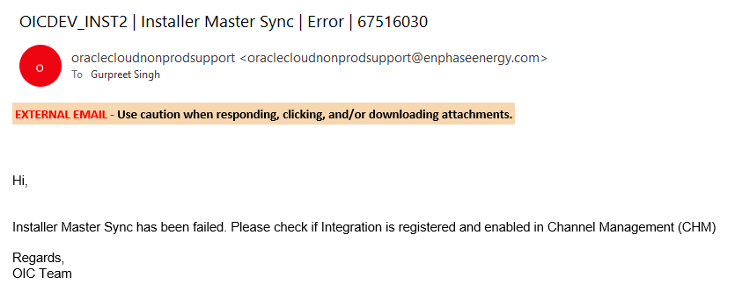

## Warning Notification

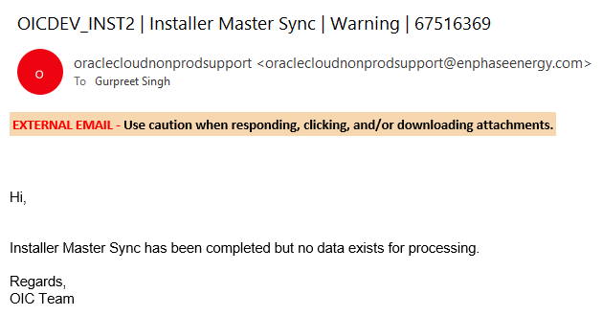

# Exception Handling

## Exception Handling

In case of any exception occurred while execution, integration will be errored out and below exception handling mechanism will be used:

* **Updating Integration Runs** – Integration runs table will be updated with error message and status as Error. There can be two scenarios in this case:
  + **Update Successful** – If update is successful, then integration execution will proceed for next steps.
  + **Update Unsuccessful** – This exception will be caught in scope handler to prevent further failure of integration execution.
* **Raising JIRA Ticket Integration Runs** – A JIRA ticket will be raised with error details. For raising the ticket, we will be reusing the existing ticketing service. There can be two scenarios in this case:
  + **Ticket Raising Successful** – If Ticket is raised successfully, then email notification will also be sent with ticket and error details.
  + **Ticket Raising Unsuccessful** – If Ticket raising is unsuccessful, then email notification will be sent with error details.
* **Sending the email notification** – Email notification will be sent out after completing (even if they complete successfully or not) the above two steps. Here Integration Exception template will be used to send the notification which is configured in the lookup described in Lookup Details Section if enabled. In case there is an exception in the send email notification, integration will stop further execution and it will be errored out.

# Error Handling

## Error Reprocessing

| Error Reprocessing |
| --- |
| * In case integration is errored out resubmit the integration via an Ad-Hoc run after properly investigating and performing the RCA |

## Backup Requirements

| Backup Requirements |
| --- |
| * Submit an Ad hoc run of Integration and records will be reinstated again after sync from SFDC |

## Reprocessing Strategy

| Reprocessing Strategy |
| --- |
| * In case of import failures, submit an Ad hoc run of Integration. |

## Planned Outage Strategy

| Planned Outage Considerations |
| --- |
| * Set the **Outage Active** flag of the integration in Channel Management |

## Cutover Plan

| Cutover Plan Considerations |
| --- |
| To migrate this integration code to upper environment, below are the high-level overview of steps to be performed, detailed cutover plan for entire project has been prepared separately, link to which can be found in reference document section.   * SQL Script will be executed to deploy the database objects like, Sequences, Tables, Packages and seed data * Integration will be registered and enabled in Channel Management APEX application * Integration will be deployed on next environment along with lookups and connections will be configured * Integration schedule will be set |

# SOX & Security Considerations

| SOX Control ID |
| --- |
|  |

| Job Scheduling and Monitoring Process |
| --- |
| * Integration will be scheduled from OIC Instance * Integration can be monitored in two ways:   + From APEX - Screen has been designed to monitor the integrations. Navigation is **Home**-> **Administration** -> **Integration Runs**   + From OIC – Integration Tracking screen can be used to monitor the integration and download the logs |

| Access and Data Security Requirements |
| --- |
| * User should have access to OIC Instance to schedule the integration, monitor the integration and download the integration logs * User should have access to APEX Application to monitor the integration from APEX and viewing the synced records |

# Acceptance Criteria

## Test Conditions and Results – Table 6

| No | Test Condition | Expected Results |
| --- | --- | --- |
| 1 | Integration not registered in CHM APEX Application but present in OIC | Integration got completed and records not synced in CHM and email notification sent. |
| 2 | Integration is enabled in CHM APEX Application | Integration got completed and records synced in CHM and email notification sent. |
| 3 | Integration is disabled in CHM APEX Application | Integration completed but no record synced in CHM and email notification sent. |
| 4 | Integration is in outage mode in CHM APEX Application | Integration completed but no record synced in CHM with no email notification sent. |
| 5 | Integration is enabled in CHM APEX Application and resubmitted | Integration got completed and records synced & merged in CHM and email notification sent |
| 6 | Integration is enabled in CHM APEX Application and failed with exception | JIRA Ticket raised and email notification sent |

**Integration Testing Checklist:**

1. Need to test with Real Time Data.
2. Scenarios to test all validation rules.
3. Testing to validate the Error Handling scenarios.
4. Validate and Reconcile data loaded or extracted through the established reports or front-end screen.
5. Volume and Load Testing.
6. Performance Testing.

**Report Testing Checklist - NA**

|  |  |
| --- | --- |
| **Category** | **Validations to be performed** |
| Completeness | Match the record count with an Existing established report or Standard Oracle Report |
| Completeness | Match the report totals with an Existing established report or Standard Oracle Report |
| Completeness | Match the report totals with Front End Inquiry Screen |
| Accuracy | Validate calculations being performed on the Report (e.g. Row Totals, Column Totals etc.) |
| Accuracy | Validate data in each column by comparing with Oracle/Front End Inquiry screens |
| Accuracy | Validate that we are not printing blank values for some of the columns (e.g. in sub-ledger detail report, receipt number is not printed for journal source receiving) |
| Accuracy | Try validating the report output for one of the closed periods (or bigger date range) to ensure that various data conditions are tested. |
| Accuracy | Ensure that new transactions processed are appearing on the report accurately |
| Formatting/Layout | Review the formatting of all the columns (Date, Amount and Text format) |
| Formatting/Layout | Review the column headings/naming conventions |
| Formatting/Layout | Review the different output formats (Excel, PDF, CSV etc.) |
| Parameters | Review the Parameter LOV's |
| Parameters | Validate data based on the parameters selected |
| Parameters | Ensure that we print the parameters on report output (including standard fields like submitted date, submitted by) |
| Performance | Is the report completing within reasonable time. |
| Performance | Consider growth in data volumes. Try running report for entire year to test the data load. |
| Negative Testing | Try running report with incorrect parameters (e.g. Invalid value, To Date lower than From date etc.) |
| Data Security | Validate that report is accessible by authorized users |
| Data Security | Validate that results are displayed based on the data access available to user |

# Open / Closed Issues

## Open/Closed Issues – Table 7

|  |  |  |  |  |  |  |
| --- | --- | --- | --- | --- | --- | --- |
| **#** | **Issue** | **Raised By/ Date Needed** | **Assigned/ Responsibility** | **Resolution** | **Resolved By/ Date Completed** | **Status** |
| 1 | Record_Type_Name__c not available in shared SOQL | Gurpreet | Harisha/SFDC Team | Correct Column Name provided | SFDC Team | Closed |
| 2 | Mapping Required for “Account Owner Alias” column in CHM_INSTALLER_STAGING table from SFDC | Gurpreet | Harisha/SFDC Team | Mapping provided | SFDC Team | Closed |
| 3 | Table Design Link for Staging Table | Gurpreet | Kathik/APEX Team | Link Provided | Gurpreet Singh | Closed |
| 4 | Mapping document required for source and target columns | Gurpreet | Kathik/APEX Team | Mapping provided | Gurpreet Singh | Closed |
|  |  |  |  |  |  |  |
|  |  |  |  |  |  |  |

# Appendix

NA