E-commerce Sales & Customer Analytics
Sales analysis and customer segmentation using RFM and K-Means clustering

Project Report

Submitted by: G Kranthi Kumar
AICTE | IBM SkillsBuild Data Analytics with AI Internship 2026
Conducted by BharatCares in association with AICTE

Table of Contents
1. Introduction and Objectives
2. Dataset Description
3. Tools and Methodology
4. Data Quality and Cleaning
5. Exploratory Data Analysis
6. Customer Segmentation
7. Recommendations
8. Limitations
9. Conclusion
References

1. Introduction and Objectives
Online retailers collect large amounts of order data, but the value comes from turning it into decisions: which products and channels make money, where discounts hurt, and which customers deserve different treatment. This project analyses five years of e-commerce orders to answer those questions.
Objectives
- Check the quality of the data and prepare it for analysis.
- Measure the main business indicators: sales, profit, order value, returns, cancellations and ratings.
- Explore sales over time and by channel, geography, product category, discount level and delivery performance.
- Segment customers with RFM features and K-Means clustering, and recommend an action for each segment.

2. Dataset Description
The project uses the Kaggle dataset "E-Commerce Sales and Customer Analytics" (https://www.kaggle.com/datasets/datascikhan/e-commerce-sales-and-customer-analytics). It covers orders from 1 January 2021 to 31 December 2025.
File | Rows | Description
ecommerce_sales_customer_analytics_150k.csv | 138,116 | One row per order, 46 columns (customer, payment, delivery, return, marketing, sales and profit fields)
order_items.csv | 397,569 | One row per product line in an order
product_catalog.csv | 1,175 | Product category, brand, supplier, price, cost, rating
customer_master.csv | 25,000 | Customer profile, tier and acquisition cost
dataset_statistics.csv | 1 | Publisher's summary statistics, used to check my results

The data holds 24,911 customers who placed orders and 1,175 products. Order status is Completed (82.2%), Returned (6.9%), Cancelled (6.1%) or Pending (4.8%).

3. Tools and Methodology
The analysis was done in Python (pandas, NumPy, Matplotlib, Seaborn, scikit-learn) in a Jupyter Notebook. The steps were:
- Load the five files and check data quality.
- Clean the data and create features (date parts, discount rate, status flags).
- Compute the KPIs and compare them with the publisher's statistics.
- Explore the data with charts and grouped summaries.
- Build RFM features per customer from completed orders, transform and scale them.
- Choose the number of clusters with the elbow method and silhouette score, then run K-Means.
- Profile, name and interpret the segments, then link them to the customer master.

4. Data Quality and Cleaning
- No duplicate rows or duplicate order IDs. No missing values in the order items, product catalogue or customer master.
- Missing values in the sales file are structural, not errors: delivery, rating and review fields are empty exactly for the 24,557 orders that are not Completed (8,398 cancelled, 9,462 returned and 6,697 pending); return fields are empty when the order was not returned; coupon and campaign fields are empty when none was used. They were kept, not imputed.
- No order has zero or negative quantity or net sales. Only 0.9% of orders (1,296) have negative profit, almost all with discounts of 50% or more. They are real outcomes, so they were kept.
- Order dates were converted to dates, and year, month, hour, weekday and discount rate were derived.
- Revenue analysis uses Completed orders (113,559). Cancelled, returned and pending orders do not generate revenue.
- The computed totals match the publisher: net sales 177,134,263.74, profit 76,146,395.76, average order value 1,282.50, return rate 6.85% and cancellation rate 6.08%.

5. Exploratory Data Analysis

5.1 Sales trend
Net sales from completed orders are flat: about 29.3M in 2021, then 28.7M, 28.9M, 28.7M and 28.6M. There is a strong yearly pattern. November and December together bring about a quarter of annual sales, while February is the weakest month.
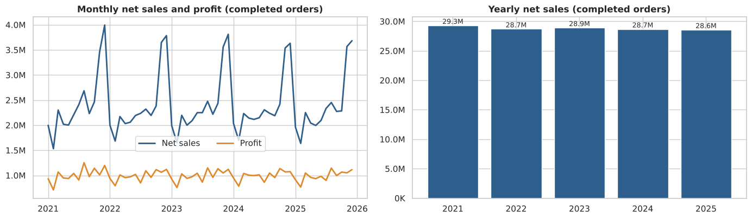
Figure 1: Monthly net sales and profit, and yearly net sales

5.2 Channels and geography
The four sales channels perform almost identically, with an average order value near 1,270 and a margin near 41%. Mobile App is the largest by order count. Organic Search is the largest marketing channel, followed by Google Ads and Direct. The USA gives about 58% of net sales, the UK 16% and Germany 9%.
Sales channel | Orders | Net sales (M) | Avg order value | Margin
Mobile App | 45,505 | 57.6 | 1,266 | 41.4%
Website | 39,606 | 50.3 | 1,271 | 41.5%
Marketplace | 16,987 | 21.8 | 1,282 | 41.3%
Social Media | 11,461 | 14.5 | 1,261 | 41.6%

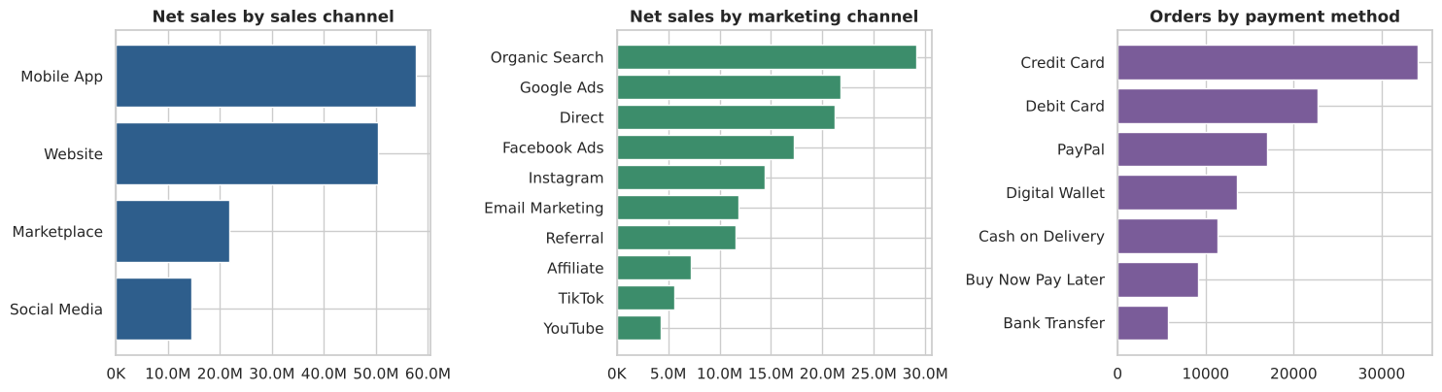
Figure 2: Net sales by sales channel and marketing channel, orders by payment method
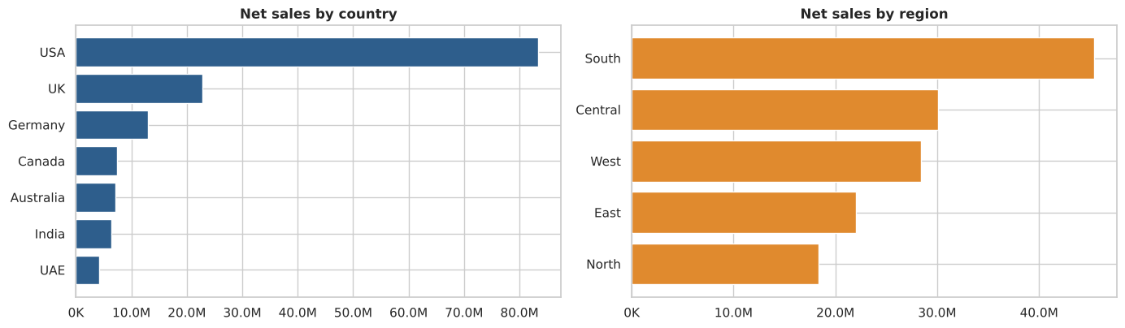
Figure 3: Net sales by country and region

5.3 Products
Electronics has the highest net sales (33.5M) but the lowest margin (32.6%). Jewelry and Home Appliances follow with margins near 40%. Grocery (54%) and Books & Media (51%) have the best margins but small sales. The top brands by net sales are Samsung, LG, OnePlus, Asus and HP.
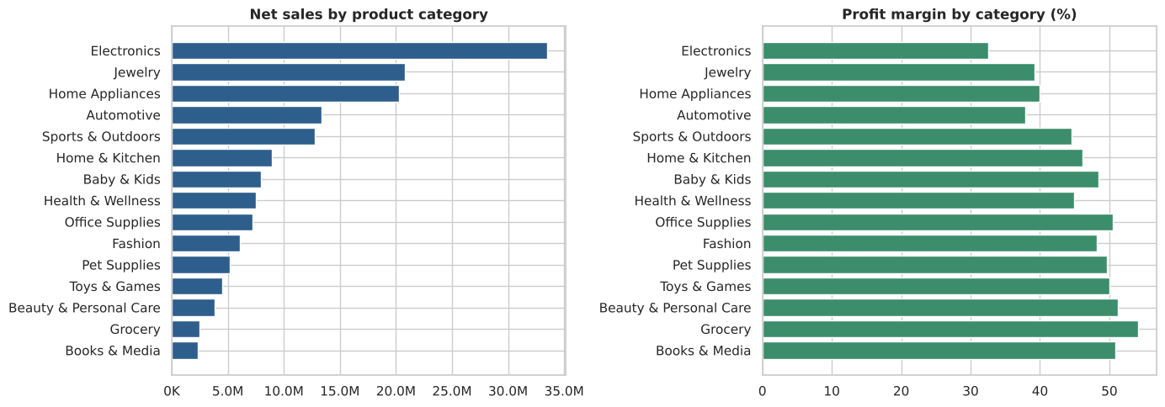
Figure 4: Net sales and profit margin by product category

5.4 Discounts and profit
Discount level | Orders | Profit margin | Loss-making orders
0% | 17,864 | 52.6% | 0.0%
0-10% | 35,031 | 49.2% | 0.0%
10-20% | 49,198 | 44.9% | 0.0%
20-30% | 17,729 | 37.6% | 0.0%
30-50% | 16,565 | 24.8% | 3.1%
50% or more | 1,729 | -2.7% | 44.9%

Margin falls steadily as discounts rise and becomes negative at 50% or more, where almost half of the orders lose money.
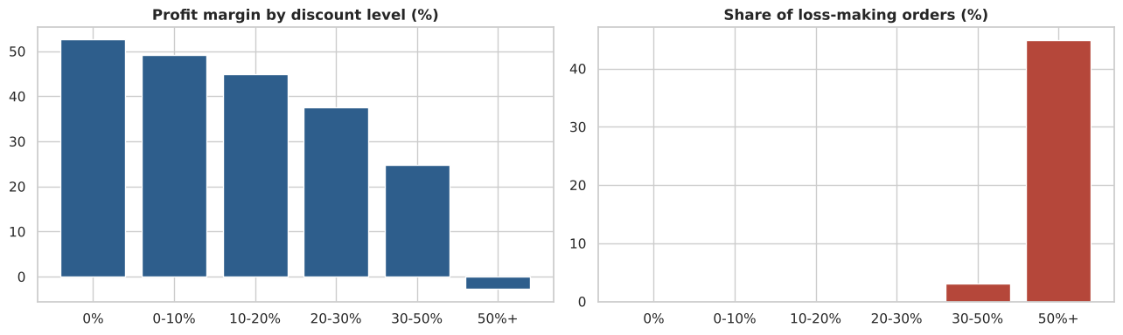
Figure 5: Profit margin and loss-making share by discount level

5.5 Delivery and customer satisfaction
About 15% of delivered orders arrive late. Delayed orders average a rating of 3.2, against 3.7 for on-time and 4.0 for early deliveries. Of reviews, 69% are positive, 30% neutral and under 1% negative. The 9,462 returns are spread almost evenly over wrong product, other, changed mind, size issue and defective product, so there is no single dominant cause.
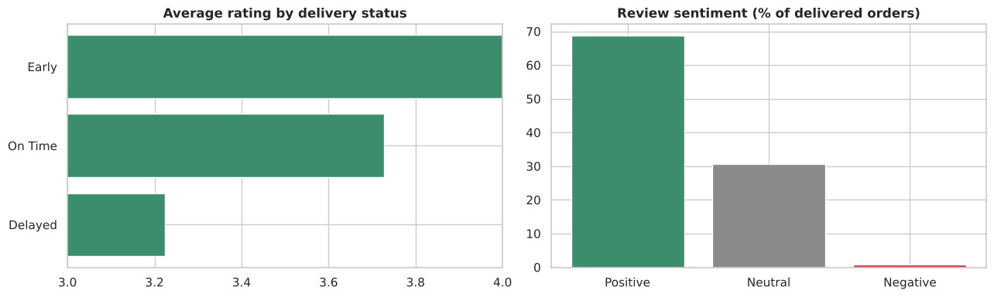
Figure 6: Rating by delivery status and review sentiment

5.6 Correlations
Gross and net sales move together (correlation 0.97) and profit follows gross sales (0.79). The discount amount is the main drag on margin (-0.60). Customer rating has only weak links to the numeric variables; the strongest is delivery days (-0.16), so longer deliveries go with lower ratings.
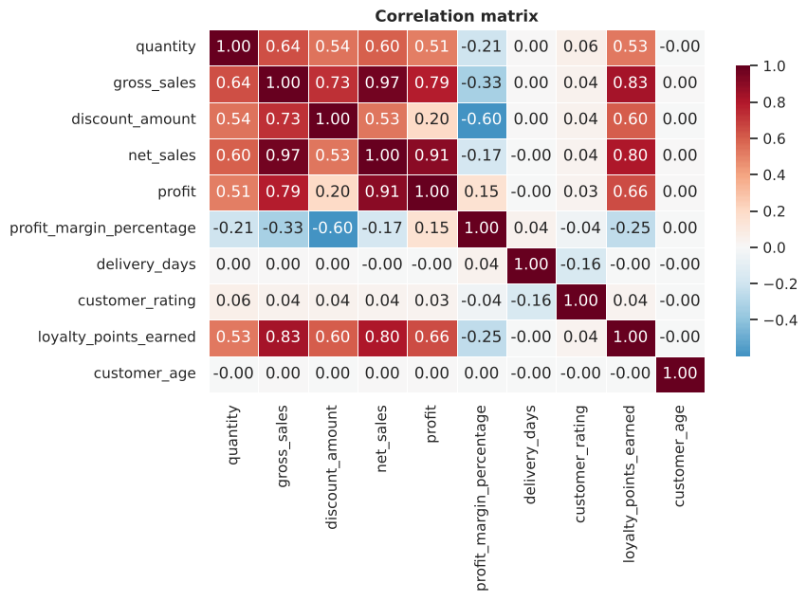
Figure 7: Correlation matrix of key numeric variables

6. Customer Segmentation

6.1 Features
For each of the 24,748 customers with at least one completed order, four features were built: Recency (days since last order, relative to 1 January 2026), Frequency (number of completed orders), Monetary (total net sales) and Average Discount Rate. Frequency and Monetary were log-transformed because they are skewed, and all features were standardised. Identifiers and postal codes were excluded because they carry no behaviour.

6.2 Choosing the number of clusters
k | Inertia | Silhouette
2 | 66,359 | 0.347
3 | 55,146 | 0.294
4 | 46,769 | 0.243
5 | 41,459 | 0.258
6 | 37,282 | 0.236
7 | 34,071 | 0.218
8 | 32,028 | 0.214

Silhouette is highest at k = 2, which only splits active from inactive customers. The elbow flattens gradually after k = 4. I chose k = 4 as the smallest number that gives clearly different, actionable segments.
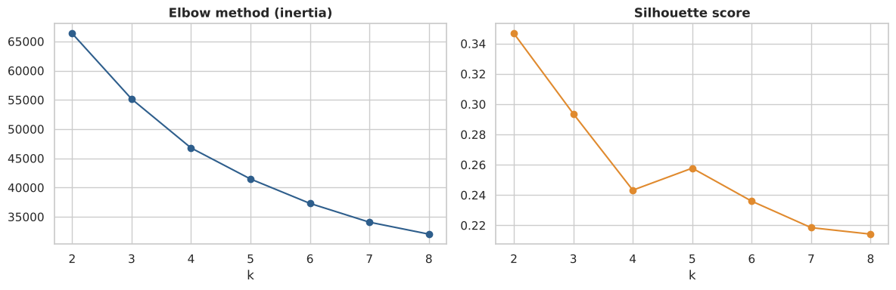
Figure 8: Elbow method and silhouette score

6.3 Segment profiles
Segment | Customers | Avg recency (days) | Avg orders | Avg spend | Avg discount | Revenue share
Champions | 9,956 (40%) | 191 | 6.5 | 8,818 | 17% | 61%
Steady Regulars | 7,909 (32%) | 377 | 3.7 | 4,359 | 14% | 24%
Discount Seekers | 3,946 (16%) | 335 | 3.5 | 4,142 | 27% | 11%
At-Risk / Lapsed | 2,937 (12%) | 957 | 1.9 | 1,904 | 15% | 4%

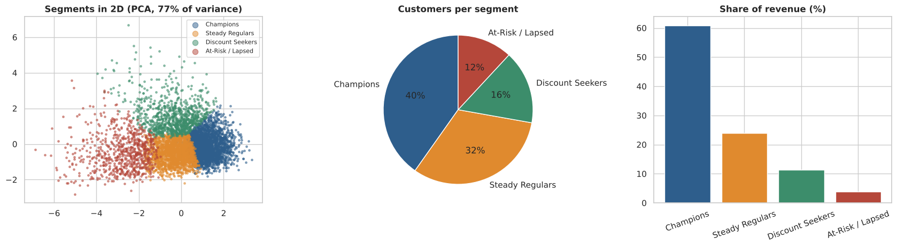
Figure 9: Segments in two dimensions (PCA), customers per segment and revenue share
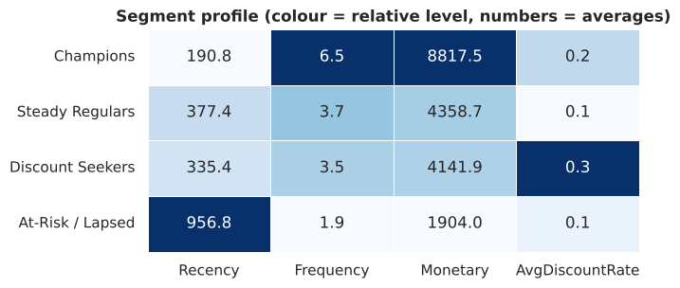
Figure 10: Relative profile of each segment
The 40% of customers in the Champions segment generate 61% of revenue. Discount Seekers are over-represented in the company's own Premium and VIP tiers (about 59%, against 26% to 34% in the other segments), so the existing tier system does not prevent heavy discounting.

7. Recommendations
Area | Recommendation
Champions | Protect them with loyalty rewards, early access and priority delivery. They bring 61% of revenue.
Steady Regulars | Cross-sell and bundle offers to raise order value and move them toward Champions.
Discount Seekers | Cap discounts below 30%, use minimum-spend offers and avoid blanket deals above 50%.
At-Risk / Lapsed | Run win-back email campaigns with a time-limited offer. The group is small (4% of revenue), so keep the cost low.
Pricing | Review discounting on Electronics, where margin is already the lowest.
Seasonality | Prepare stock and delivery capacity for November and December, and run campaigns in February.
Delivery | Reduce late deliveries (15% of orders). Delayed orders score about 0.5 rating points lower.
Markets | Reduce dependence on the USA (58% of sales) by growing the UK, Germany and Canada.

8. Limitations
- Amounts are in seven currencies but are not converted, so totals are in the dataset's own units.
- The silhouette score at k = 4 is 0.24: segments overlap and form a continuum, so they are useful for targeting but their boundaries are not exact.
- The data looks simulated (very even distributions and no growth trend), so findings describe this dataset and may not match a real business.
- Segmentation uses completed orders only; 163 customers with no completed order are excluded.
- The analysis is descriptive. It shows associations, not causes.

9. Conclusion
The analysis shows a business with flat, seasonal sales, concentrated in one country and in a low-margin category (Electronics), and with discounting that loses money at the high end. RFM and K-Means split customers into four meaningful groups, of which a minority of Champions provide most of the revenue. The next steps are to predict which Champions are likely to lapse, test discount caps with an A/B experiment, and convert all amounts to one currency for a true revenue figure.

References
- Kaggle dataset: E-Commerce Sales and Customer Analytics, https://www.kaggle.com/datasets/datascikhan/e-commerce-sales-and-customer-analytics
- scikit-learn documentation: KMeans, StandardScaler, PCA, silhouette_score, https://scikit-learn.org
- pandas documentation, https://pandas.pydata.org

