Advance research topics in data science
Student ID : 24142787
Name : Laxmi Narasimha Gurrala

Introduction
Accurate short-term energy forecasting is increasingly useful in smart homes, as household electricity consumption can vary significantly throughout the day. Appliance usage is influenced by factors such as the time of day, previous consumption patterns, weather conditions and household activities, making it difficult to predict sudden changes in demand. This study therefore focuses on forecasting household appliance energy consumption using the Appliances Energy Prediction dataset, which contains appliance energy measurements alongside indoor temperature, humidity and outdoor weather variables. The original dataset contains 19,735 observations collected at ten-minute intervals over approximately four and a half months (Candanedo, Feldheim and Deramaix, 2017) and is publicly available through the UCI Machine Learning Repository (Candanedo, 2017). For this analysis, the data were converted to an hourly frequency, with Appliances selected as the target variable and a 24-hour forecasting horizon.
To assess forecasting performance from different perspectives, the study compares Mean, Naive, Daily Seasonal Naive, Weekly Seasonal Naive, Drift, SARIMAX, Random Forest and Chronos-Bolt. The data were divided into 3,266 training observations and 24 testing observations, with the test period representing the final 24 hours used for evaluation.

Data Preparation and Exploratory Analysis

Dataset and Pre-processing
The Appliances Energy Prediction dataset was selected because it provides both the target energy-consumption variable and a range of environmental variables that may influence household energy use. The original data contain appliance energy consumption measured in watt-hours together with temperature and relative-humidity measurements from different areas of the house. Outdoor variables such as outdoor temperature, outdoor humidity, atmospheric pressure, windspeed and visibility are also available (Candanedo, Feldheim and Deramaix, 2017).
The hourly dataset contained 3,266 training observations and 24 testing observations, with a 24-hour forecasting horizon. MAE, RMSE and MAPE were used for evaluation.
The chronological split was used rather than randomly dividing the observations. This is important for time-series forecasting because randomly mixing observations could allow future information to influence the training process.

Overall Appliance Energy Consumption
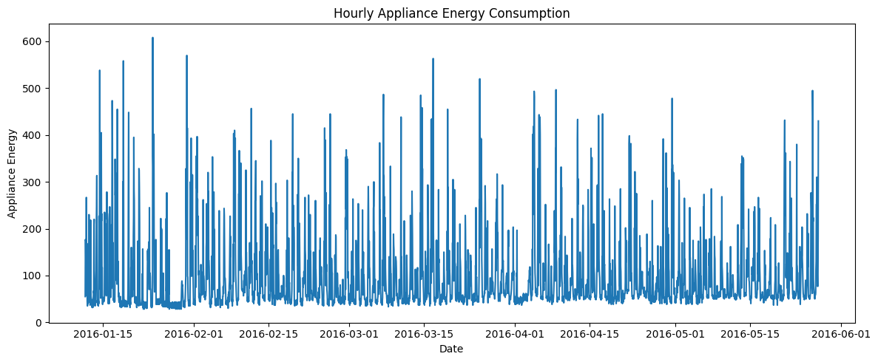
Figure 2.1 Hourly Appliance Energy Consumption
Figure 2.1 shows substantial variation in hourly appliance consumption, including several short-term peaks. The absence of a clear long-term trend suggests that recent consumption and temporal patterns are important for forecasting.

Seasonality and Stationarity Analysis

Daily and Weekly Seasonality
The lag-24 and lag-168 correlations were 0.3073 and 0.3282 respectively, indicating daily and weekly temporal dependence. The ACF also showed repeated patterns around seasonal lags, supporting the use of lag features and a 24-hour seasonal component. Although weekly dependence was present, daily seasonality was prioritised because the forecasting horizon was 24 hours.

Stationarity Testing
The ADF test indicated that the original series was stationary (ADF = −8.9489, p < 0.001). The first-differenced series was also stationary (ADF = −16.9526, p < 0.001). Therefore, differencing was not required and d = 0 was used in SARIMAX.

Benchmark Forecasting Models
The benchmark results were:
Table 1. Benchmark model performance
Model | MAE | RMSE | MAPE (%)
Mean | 74.514 | 107.631 | 49.178
Daily Seasonal Naive | 63.681 | 113.641 | 38.928
Weekly Seasonal Naive | 74.306 | 117.973 | 36.749
Naive | 111.737 | 124.033 | 138.838
Drift | 111.973 | 124.262 | 139.257
No single benchmark model achieved the best performance across all three evaluation metrics. The Mean model achieved the lowest RMSE (107.631), Daily Seasonal Naive achieved the lowest MAE (63.681), and Weekly Seasonal Naive achieved the lowest MAPE (36.749%). For the seasonal comparison, Daily Seasonal Naive was selected as the strongest seasonal benchmark because it directly captures the 24-hour repeating pattern relevant to the forecasting horizon.

SARIMAX Modelling

Model Selection
Based on the stationarity and seasonality analysis, SARIMAX was selected to model hourly appliance energy consumption. The ADF test showed that the original series was stationary, so first-order differencing was not required (d = 0). The ACF analysis also showed a clear daily pattern at lag 24, supporting a seasonal period of 24 hours.
A grid search was performed across candidate non-seasonal parameters, with p, d and q evaluated over the required ranges. Candidate models were compared using the Akaike Information Criterion (AIC), with the model having the lowest AIC selected for the final analysis.
A grid search tested 147 combinations of p, d and q, with the seasonal order fixed at (1,0,1,24). Models were compared using AIC, and the lowest-AIC specification, (1,0,6), was selected with an AIC of 35798.06. SARIMAX used five exogenous variables: T_out, RH_out, Windspeed, hour_sin and hour_cos.

SARIMAX Forecast Performance
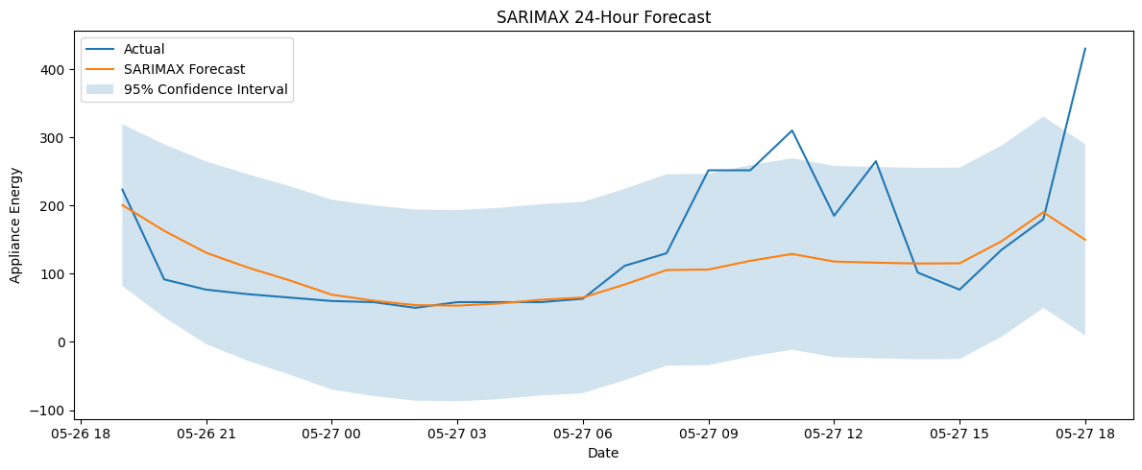
Figure 5.1 SARIMAX 24-Hour Forecast
The SARIMAX model produced a 24-hour forecast for the test period. As shown in Figure 5.1, the model followed the general pattern of appliance consumption but was less successful in reproducing sudden peaks. The model achieved an MAE of 55.082, RMSE of 89.169 and MAPE of 31.217%, representing a 17.15% improvement in RMSE compared with the Mean benchmark.

SARIMAX Residual Analysis
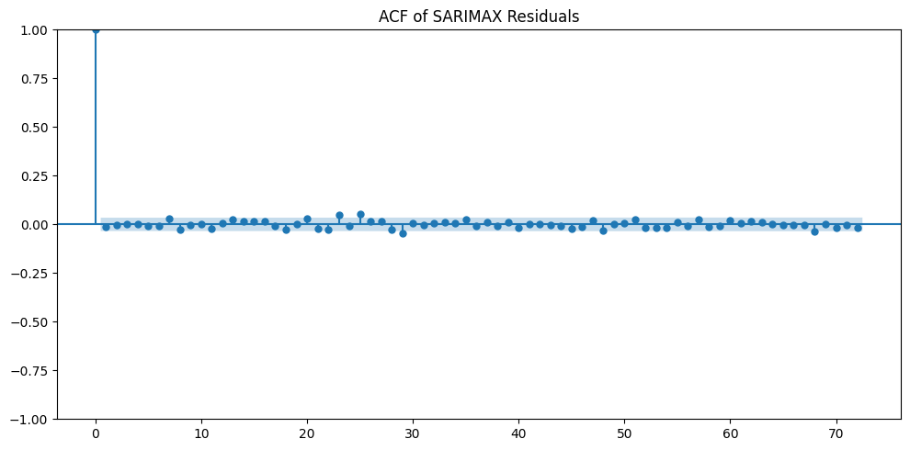
Figure 5.2 ACF of SARIMAX Residuals
Residual analysis was performed to assess whether important temporal structure remained after fitting the model.
Compared with the original series, the residual autocorrelation is considerably reduced. This indicates that SARIMAX has removed a significant amount of systematic temporal dependence.
Nevertheless, some residual variation remains. This means that the model does not explain every change in appliance consumption. In particular, large errors are likely to occur when the actual appliance demand suddenly increases or decreases.
The residual distribution provides further information about model errors. The concentration of residuals around the central region indicates that many predictions are reasonably close to the observed values. However, the presence of larger residuals demonstrates that some observations are substantially harder to forecast.
This is an important limitation of the statistical approach. SARIMAX is effective at modelling systematic temporal patterns, but it cannot know household actions that are not included in the data.
The best model obtained an AIC of 35798.06, and this model was retained for forecasting because a lower AIC indicates a preferable balance between model fit and complexity among the candidate specifications.

Random Forest Feature-Based Forecasting
Random Forest achieved MAE 74.256, RMSE 90.488 and MAPE 68.999%. Appliances_lag_1 was the dominant feature (importance = 0.3951), followed by Appliances_lag_24, hour_cos and Appliances_lag_168. This indicates that recent appliance consumption and temporal information were more useful than individual environmental variables.

Feature Importance
Appliances_lag_1 was the most important feature (0.3951), followed by Appliances_lag_24, hour_cos and Appliances_lag_168. This indicates that recent consumption and daily/weekly temporal patterns were more influential than the environmental variables.
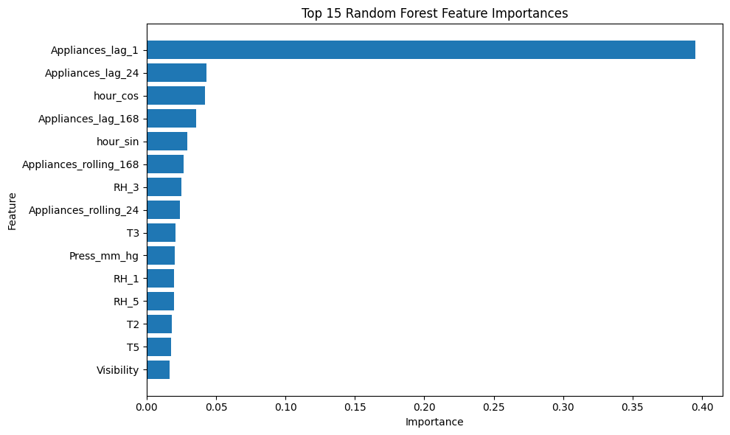
Figure 6.1 Random Forest Feature Importance

Random Forest Forecast
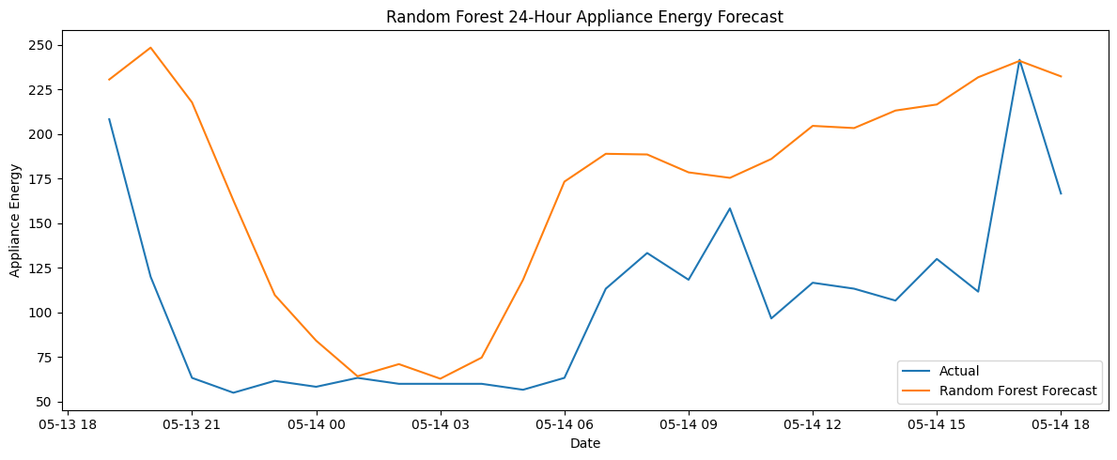
Figure 6.2 Random Forest 24-Hour Forecast
The Random Forest model was evaluated over a 24-hour forecasting period using the same evaluation metrics as the other forecasting models. The model achieved an MAE of 74.256, RMSE of 90.488 and MAPE of 68.999%.
The Random Forest forecast was able to follow some of the general movement in appliance consumption, but it struggled with sudden peaks. Its RMSE was slightly higher than SARIMAX (89.169), indicating that the additional lag, temporal and environmental features did not produce a better overall forecast than the statistical model.
This is an important finding because adding more features does not necessarily lead to better forecasting performance. Much of the predictive information was already contained in the recent history of the target variable.

Chronos-Bolt Foundation Model
Chronos-Bolt is a time-series foundation model designed for zero-shot forecasting. It uses a patch-based approach based on the T5 architecture to generate multiple future values efficiently (Ansari et al., 2024). In this study, it was used to forecast the next 24 hourly appliance-consumption values.
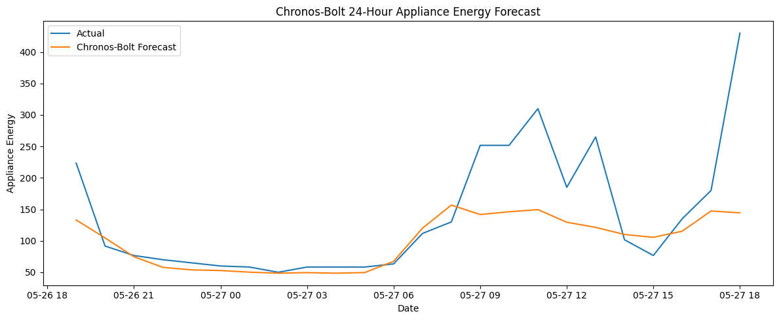
Figure 7.1 Chronos-Bolt 24-Hour Forecast
Chronos-Bolt achieved the best results, with MAE 48.412, RMSE 83.243 and MAPE 23.685%. It reduced RMSE by 22.66% compared with the Mean benchmark and by approximately 6.64% compared with SARIMAX. However, some sudden consumption peaks were still not captured accurately.

Overall Model Comparison
Table 2 presents the performance of all forecasting models using MAE, RMSE and MAPE.
Model | MAE | RMSE | MAPE (%)
Mean | 74.514 | 107.631 | 49.178
Naive | 111.737 | 124.033 | 138.838
Daily Seasonal Naive | 63.681 | 113.641 | 38.928
Weekly Seasonal Naive | 74.306 | 117.973 | 36.749
Drift | 111.973 | 124.262 | 139.257
SARIMAX | 55.082 | 89.169 | 31.217
Random Forest | 74.256 | 90.488 | 68.999
Chronos-Bolt | 48.412 | 83.243 | 23.685
Chronos-Bolt achieved the best overall performance, recording the lowest MAE, RMSE and MAPE. SARIMAX also provided strong performance, while the benchmark models provided useful reference points for evaluating the more advanced forecasting approaches.

Critical Discussion

Which benchmark model is strongest?
No single benchmark was best across all three metrics. Mean achieved the lowest RMSE, Daily Seasonal Naive achieved the lowest MAE, and Weekly Seasonal Naive achieved the lowest MAPE. Daily Seasonal Naive was therefore selected as the strongest seasonal benchmark because it captures the 24-hour repeating pattern relevant to the forecasting task.

Does SARIMAX improve on the strongest seasonal benchmark?
Yes. SARIMAX improved on the Daily Seasonal Naive benchmark. RMSE decreased from 113.641 to 89.169, representing an improvement of approximately 21.53%. SARIMAX therefore provided additional predictive value by modelling autocorrelation, daily seasonality and selected exogenous variables.

Does the feature-based model improve when additional features are added?
The Random Forest model used lagged variables, rolling-window statistics, time-of-day variables and sensor/weather measurements. Its final performance was an MAE of 74.26, RMSE of 90.49 and MAPE of 69.00%, so it did not improve on SARIMAX. The feature-importance analysis showed that Appliances_lag_1 was by far the most useful feature, with an importance of 0.395. Other useful features included Appliances_lag_24, hour_cos, Appliances_lag_168, hour_sin, and rolling appliance features. This suggests that recent consumption and temporal features were more useful than individual environmental variables for the Random Forest model.

Does the foundation model outperform the other approaches?
Yes. Chronos-Bolt achieved the best overall performance, with an MAE of 48.41, RMSE of 83.24 and MAPE of 23.69%. It outperformed the strongest benchmark, SARIMAX and Random Forest. Compared with the Mean benchmark, Chronos-Bolt reduced RMSE by approximately 22.66%. The improvement is meaningful because it was observed across all three evaluation metrics. Therefore, although the foundation model introduces additional computational and deployment considerations, its higher forecasting accuracy makes it attractive for applications where prediction quality is the main priority.

Which variables would genuinely be known at the forecast origin?
The SARIMAX evaluation uses the corresponding test-period values of T_out, RH_out and Windspeed as exogenous inputs. Therefore, the result should be interpreted as a conditional forecast rather than a completely independent real-world forecast. The Random Forest evaluation should also be interpreted as conditional when future environmental variables from the test period are used as input features.

Which model is recommended for practical smart-home forecasting?
Considering accuracy, interpretability, uncertainty, computational cost and ease of deployment, the choice depends on the main practical objective. Chronos-Bolt is recommended when forecasting accuracy is the highest priority, as it produced the lowest MAE, RMSE and MAPE. However, SARIMAX may be preferable when interpretability and the ability to incorporate known external variables are more important. SARIMAX also provides statistical diagnostics and confidence intervals, making its uncertainty easier to communicate. Therefore, for a practical smart-home system with sufficient computational resources, Chronos-Bolt would be the preferred forecasting model, while SARIMAX provides a strong, interpretable alternative where transparency and environmental covariates are important.

Limitations
- Short test period: Only 24 observations were used for final testing, limiting generalisability. Unpredictable peaks: Sudden appliance-use events were difficult to forecast.
- Limited behavioural data: Occupancy and detailed household activity information were unavailable.
- Model limitations: SARIMAX depends on future exogenous variables, while Chronos-Bolt may require greater computational resources.

Future Improvements
- Walk-forward validation: Evaluate the models across multiple rolling 24-hour forecasting windows instead of using only one test period.
- Real future weather data: Use actual weather forecasts as external inputs for SARIMAX to create a more realistic operational forecasting scenario.
- Additional behavioural features: Include information such as occupancy, appliance-specific usage and household activity patterns where available.
- Foundation-model comparison: Compare Chronos-Bolt with other recent time-series foundation models to determine whether its performance advantage is consistent.

Conclusion
This study compared benchmark, statistical, machine learning and foundation models for 24-hour appliance energy forecasting. Chronos-Bolt achieved the best overall performance, with an MAE of 48.412, RMSE of 83.243 and MAPE of 23.685%, while SARIMAX provided a competitive and interpretable alternative. The benchmark analysis showed that no single simple model was best across all metrics, although Daily Seasonal Naive provided the strongest seasonal baseline. The results also showed that recent consumption and temporal patterns were important for forecasting, while sudden household activity remained difficult to predict.

References
- Ansari, A.F., Stella, L., Turkmen, C., Zhang, X., Mercado, P., Shen, H., Shchur, O., Rangapuram, S.S., Pineda Arango, S., Kapoor, S., Zschiegner, J., Maddix, D.C., Wang, H., Mahoney, M.W., Torkkola, K., Wilson, A.G., Bohlke-Schneider, M. and Wang, Y. (2024) ‘Chronos: Learning the language of time series’, Transactions on Machine Learning Research. Available at: Amazon Science publication page (Accessed: 11 August 2026).
- Ansari, A.F., Turkmen, C., Shchur, O. and Stella, L. (2024) ‘Fast and accurate zero-shot forecasting with Chronos-Bolt and AutoGluon’, Amazon Web Services Machine Learning Blog, 2 December. Available at: AWS Chronos-Bolt article (Accessed: 11 August 2026).
- Box, G.E.P., Jenkins, G.M., Reinsel, G.C. and Ljung, G.M. (2015) Time Series Analysis: Forecasting and Control. 5th edn. Hoboken, NJ: Wiley.
- Breiman, L. (2001) ‘Random forests’, Machine Learning, 45(1), pp. 5–32.
- Candanedo, L.M., Feldheim, V. and Deramaix, D. (2017) ‘Data driven prediction models of energy use of appliances in a low-energy house’, Energy and Buildings, 140, pp. 81–97.
- Candanedo, L. (2017) Appliances Energy Prediction. UCI Machine Learning Repository. DOI: 10.24432/C5VC8G. Available at: UCI Appliances Energy Prediction dataset (Accessed: 11 August 2026).
- Dickey, D.A. and Fuller, W.A. (1979) ‘Distribution of the estimators for autoregressive time series with a unit root’, Journal of the American Statistical Association, 74(366), pp. 427–431.
- Hyndman, R.J. and Athanasopoulos, G. (2021) Forecasting: Principles and Practice. 3rd edn. Melbourne: OTexts.

