Week-1. Lists, Links and Images
1a)
AIM: Write a HTML program, to explain the working of lists.
Note: It should have an ordered list, unordered list, nested lists and ordered list in an
unordered list and definition lists.
Description:
In HTML, list tags are used to display a group of related items in a structured way. HTML provides different types of lists, each serving a specific purpose.
<ul> | - Creates an unordered list (bulleted).

<ol> | - Creates an ordered list (numbered or lettered).

<li> | - Defines a list item inside <ul> or <ol>.

<dl> | - Creates a description list (used for definitions or terms).

<dt> | - Defines a term/name in a description list.

<dd> | - Defines a description/detail for the term in <dt>.
Code: list.html
<!DOCTYPE html>
<html>
<head>
<title>HTML Lists Example</title>
</head>
<body>
<h1>Working with Lists in HTML</h1>
<!-- Ordered List -->
<h2>Ordered List</h2>
<ol>
<li>HTML</li>
<li>CSS</li>
<li>JavaScript</li>
</ol>
<!-- Unordered List -->
<h2>Unordered List</h2>
<ul>
<li>Apple</li>
<li>Banana</li>
<li>Cherry</li>
</ul>
<!-- Nested Lists -->
<h2>Nested List</h2>
<ol>
<li>Frontend
<ul>
<li>HTML</li>
<li>CSS</li>
<li>JavaScript</li>
</ul>
</li>
<li>Backend
<ul>
<li>Node.js</li>
<li>Python</li>
</ul>
</li>
</ol>

<!-- Ordered List inside Unordered List -->
<h2>Ordered List inside Unordered List</h2>
<ul>
<li>Web Technologies
<ol>
<li>HTML</li>
<li>CSS</li>
<li>JavaScript</li>
</ol>
</li>
<li>Database
<ol>
<li>MySQL</li>
<li>MongoDB</li>
</ol>
</li>
</ul>

<!-- Definition List -->
<h2>Definition List</h2>
<dl>
<dt>HTML</dt>
<dd>HyperText Markup Language</dd>
<dt>CSS</dt>
<dd>Cascading Style Sheets</dd>
<dt>JS</dt>
<dd>JavaScript – Scripting language for web pages</dd>
</dl>
</body>
</html>

✅ Output:
The web page displays a properly structured list showing ordered, unordered, and nested lists clearly formatted.
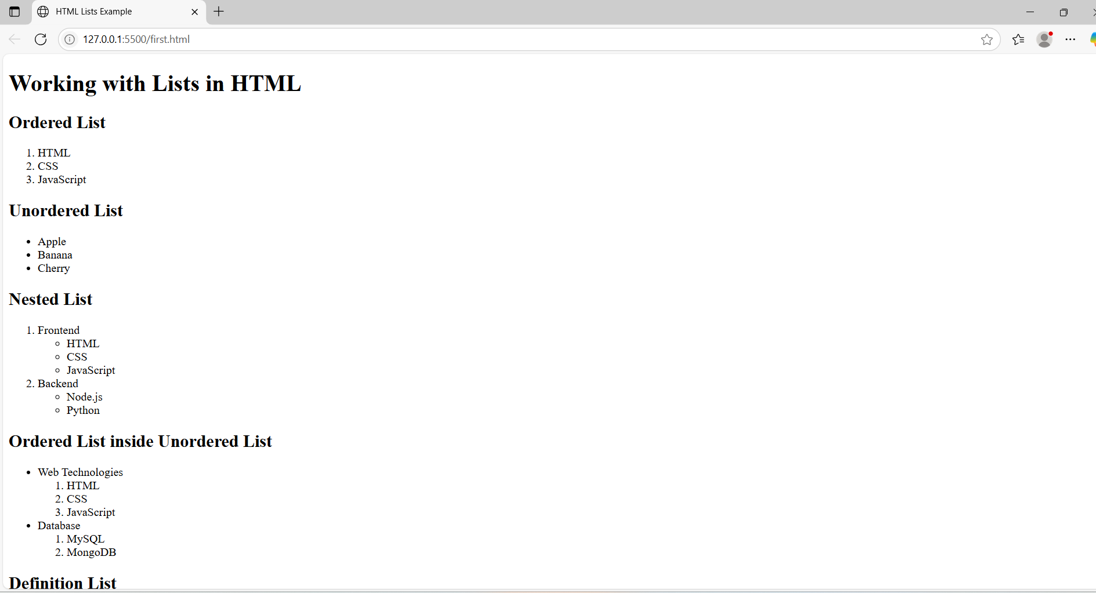

1 b)
AIM: Write a HTML program, to explain the working of hyperlinks using <a> tag and href, target Attributes.
Note: Use text to link https://www.aec.edu.in/
Use image to link https://www.aec.edu.in/?p=Gallery
Description:
<a> (Anchor Tag):
Used to create hyperlinks to other web pages, email addresses, or files.
href (Hypertext REFerence):
Specifies the URL or link destination.
target Attribute:
Specifies where to open the linked document.
_blank opens the link in a new tab.
_self (default) opens in the same tab.
<img> (Image Tag):
Used to embed images in a web page.
src defines the image path.
alt provides alternative text if the image doesn't load.
width sets the image width in pixels.
Code:
<!DOCTYPE html>
<html>
<head>
<title>Hyperlink Example</title>
</head>
<body>
<h1>Working with Hyperlinks in HTML</h1>
<!-- Text Link -->
<h2>Text Hyperlink</h2>
<p>
Visit the official website of
<a href="https://www.aec.edu.in/" target="_blank">Aditya Engineering College</a>
for more information.
</p>

<!-- Image Link -->
<h2>Image Hyperlink</h2>
<p>Click the image below to visit the AEC Gallery:</p>
<a href="https://www.aec.edu.in/?p=Gallery" target="_blank">
<img src="test.PNG" alt="AEC Gallery" width="50" height="50">
</a>
</body>
</html>

✅ Output:
The page opens hyperlinks in a new tab and displays linked images that navigate to given URLs.
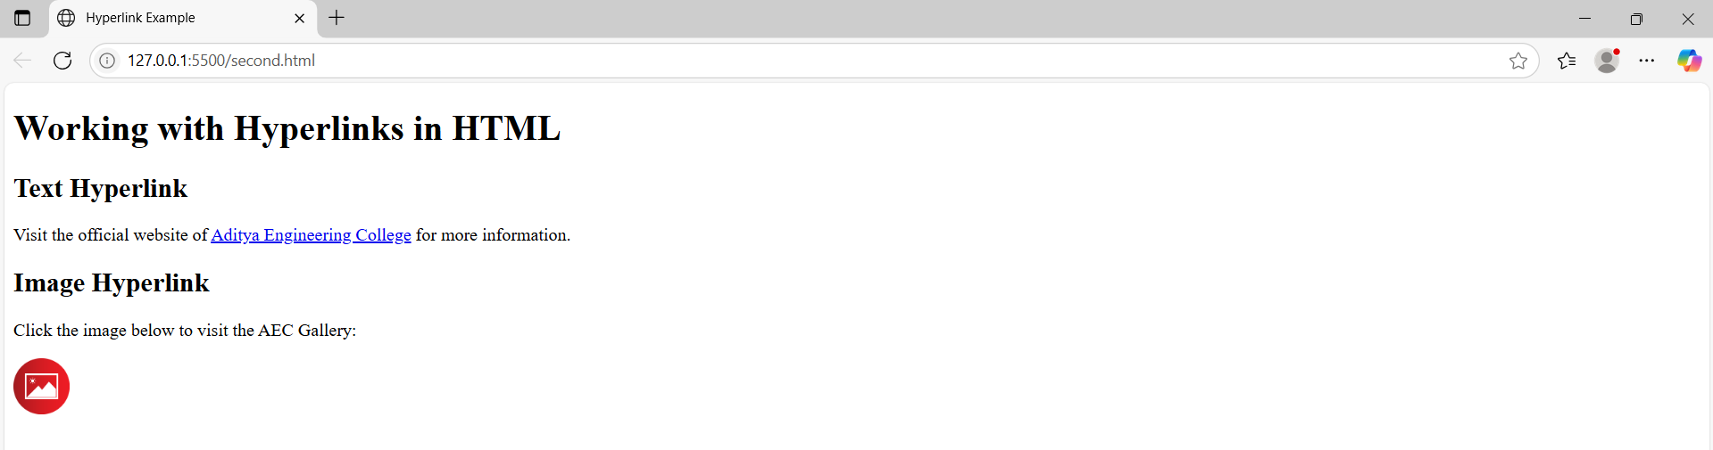

1 c)
AIM: Create a HTML document that has your image and your friend’s image with a specific height and width. Also when clicked on the images it should navigate to their respective profiles.
<!DOCTYPE html>
<html>
<head>
<title>Profile Image Links</title>
</head>
<body>
<h1>My Profile and My Friend's Profile</h1>
<!-- Your Image -->
<a href="https://www.linkedin.com/in/your-profile" target="_blank">
<img src="first_person.jpg" alt="My Profile" width="100" height="100"> </a>
<p>Click on my image to visit my profile</p>
<!-- Friend's Image -->
<a href="https://www.linkedin.com/in/friends-profile" target="_blank">
<img src="second_pesron.jpeg" alt="Friend's Profile" width="100" height="100">
</a>
<p>Click on my friend's image to visit their profile</p>
</body>
</html>
✅ Output:
The profile images appear side by side with clickable links redirecting to respective LinkedIn profiles.
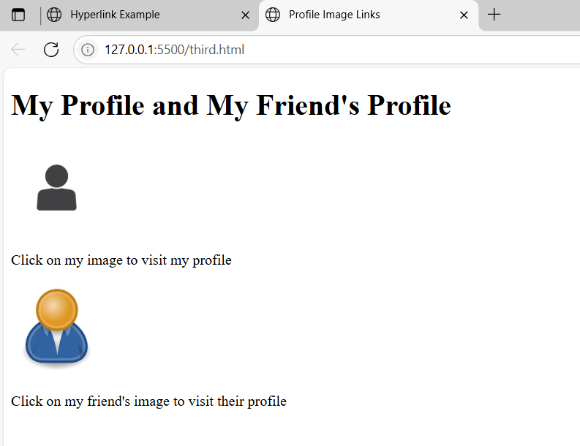
1 d)
AIM: Write a HTML program in such a way that rather than placing large images on a page, the preferred technique is to use thumbnails by setting the height and width parameters to something like to 100*100 pixels. Each thumbnails image is also a link to a full-sized version of the image. Create an image gallery using this technique.
<!DOCTYPE html>
<html>
<head>
<title>Thumbnail Image Gallery</title>
</head>
<body>
<h1>Thumbnail Image Gallery</h1>
<p>Click on any image to view the full-size version.</p>
<!-- Gallery Thumbnails -->
<a href="JBL.jpg" target="_blank">
<img src="JBL.jpg" width="100px" height="100px">
</a>
<a href="https://picsum.photos/id/1015/600/400" target="_blank">
<img src="https://picsum.photos/id/1015/100/100" alt="Image 1"> </a>
<a href="https://picsum.photos/id/1016/600/400" target="_blank">
<img src="https://picsum.photos/id/1016/100/100" alt="Image 2">
</a>
<a href="https://picsum.photos/id/1018/600/400" target="_blank">
<img src="https://picsum.photos/id/1018/100/100" alt="Image 3">
</a>
<a href="https://picsum.photos/id/1020/600/400" target="_blank">
<img src="https://picsum.photos/id/1020/100/100" alt="Image 4">
</a>
<a href="https://picsum.photos/id/1021/600/400" target="_blank">
<img src="https://picsum.photos/id/1021/100/100" alt="Image 5">
</a>
</body>
</html>
✅ Output:
A responsive thumbnail gallery is shown; clicking on any image opens the full-size version in a new tab.
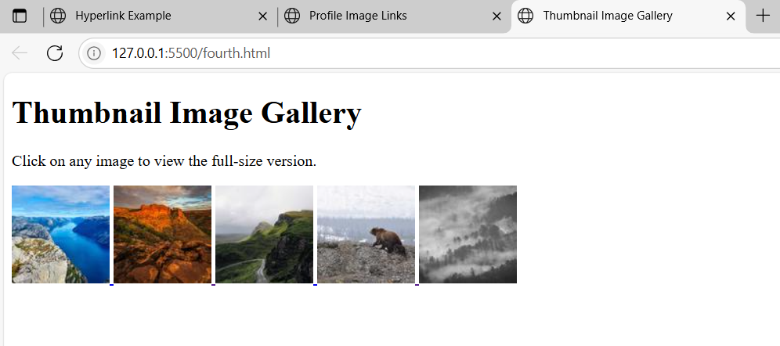

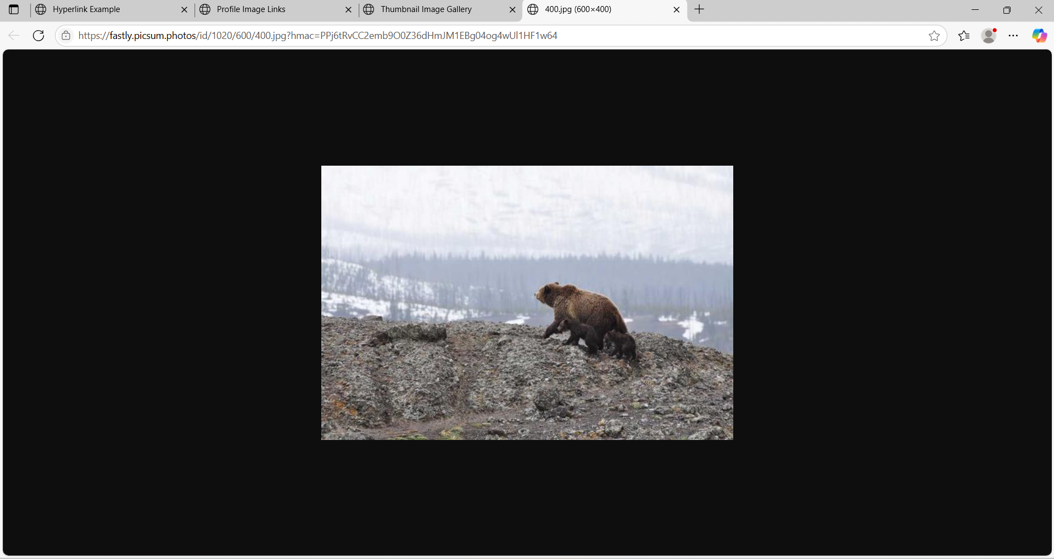

Viva Questions:
- What is the difference between <ol> and <ul>?
Ans) <ol> creates an ordered list with numbers or letters; <ul> creates an unordered list with bullets.
- Which tag is used to define a list item?
Ans) The <li> tag is used inside <ul> or <ol> to define a list item.
- How do you create a hyperlink in HTML?
Ans) By using the <a> tag. Example: <a href="https://example.com">Click here</a>.
- What attribute is required in the <a> tag to define the link?
Ans) The href attribute specifies the URL of the link.
- What is the use of the target="_blank" attribute in an anchor tag?
Ans) It opens the linked page in a new tab or window.
- Which tag is used to insert an image in HTML?
Ans) The <img> tag is used to embed an image.
- What are the required attributes of the <img> tag?
Ans) src (image URL) and alt (alternate text).
- Can we make an image clickable? If yes, how?
Ans) Yes, wrap the <img> tag inside an <a> tag.
Example: <a href="page.html"><img src="img.jpg" alt="Image"></a>
- What is the use of the <dl>, <dt>, and <dd> tags?
Ans) They create a description list:
- <dl>: starts the list
- <dt>: defines the term
- <dd>: gives the definition
- How can you display an image of fixed size?
Ans) Use width and height attributes.
Example: <img src="pic.jpg" width="200" height="100">

Week-2: Tables, Forms and Frames
2 a)
AIM: Write a HTML program, to explain the working of tables. (use tags: <table>, <tr>, <th>, <td> and attributes: border, rowspan, colspan).
Description:
The <table> tag in HTML is used to create a table structure to display data in rows and columns.
Tag | - Purpose
<table> | - Starts the table structure.
<tr> | - Defines a table row.
<th> | - Defines a header cell (bold and centered by default).
<td> | - Defines a data cell (normal text).
<thead> | - Groups the header content. Helps in accessibility and styling.
<tbody> | - Groups the main body content of the table.
<tfoot> | - Groups the footer content, usually summary or totals.
<caption> | - Adds a title to the table (appears above the table).
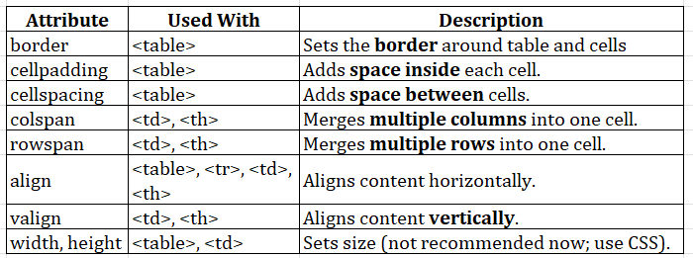

Code:
<!DOCTYPE html>
<html>
<head>
<title>Employee Information Table</title>
</head>
<body> <h1>Company Employee Information</h1>
<table border="1" cellpadding="10" cellspacing="0">
<!-- Table Header -->
<tr>
<th rowspan="2">Emp ID</th>
<th rowspan="2">Name</th>
<th rowspan="2">Department</th>
<th rowspan="2">Designation</th>
<th colspan="2">Contact Info</th>
<th rowspan="2">Salary</th>
<th rowspan="2">Address</th>
</tr>
<tr>
<th>Email</th>
<th>Phone</th>
</tr>
<!-- Employee 1 -->
<tr>
<td>EMP101</td>
<td>Alice Johnson</td>
<td>HR</td>
<td>Manager</td>
<td>alice.hr@company.com</td>
<td>9876543210</td>
<td>$60,000</td>
<td>New York, USA</td>
</tr>
<!-- Employee 2 -->
<tr>
<td>EMP102</td>
<td>Bob Smith</td>
<td>IT</td>
<td>Software Engineer</td>
<td>bob.it@company.com</td>
<td>9123456780</td>
<td>$80,000</td>
<td>San Francisco, USA</td>
</tr>
<!-- Employee 3 -->
<tr>
<td>EMP103</td>
<td>Charlie Lee</td>
<td>Finance</td>
<td>Analyst</td>
<td>charlie.finance@company.com</td>
<td>9988776655</td>
<td>$70,000</td>
<td>Chicago, USA</td>
</tr>
</table>
</body>
</html>

✅ Output:
Displays a neat employee information table with header, row, and column alignment correctly formatted.
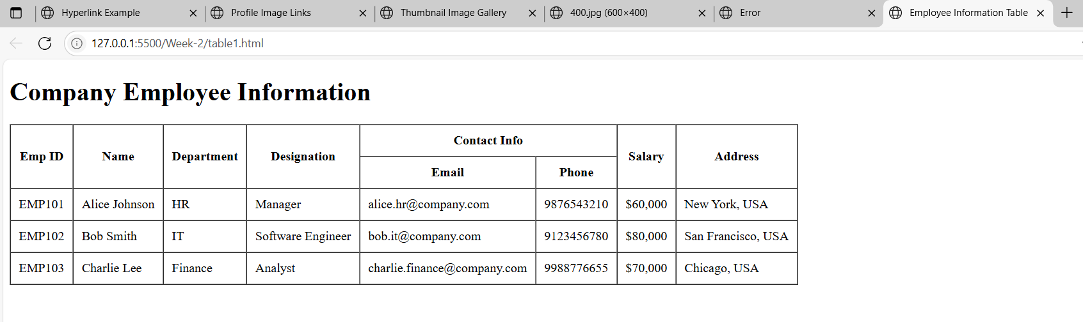

2 b)
AIM: Write a HTML program, to explain the working of tables by preparing a timetable. (Note: Use <caption> tag to set the caption to the table & also use cell spacing, cell padding, border, rowspan, colspan etc.).
Code:
<!DOCTYPE html>
<html>
<head>
<title>B.Tech I Semester Timetable</title>
</head>
<body>
<h1 align="center">B.Tech I Semester Timetable</h1>
<table border="2" cellspacing="4" cellpadding="10" align="center">
<caption><strong>Department of Computer Science & Engineering</strong></caption>
<tr>
<th>Day</th>
<th>9:00 - 10:00</th>
<th>10:00 - 11:00</th>
<th>11:00 - 12:00</th>
<th>12:00 - 1:00</th>
<th>1:00 - 2:00</th>
<th>2:00 - 3:00</th>
<th>3:00 - 4:00</th>
</tr>
<!-- Monday -->
<tr>
<td>Monday</td>
<td>Mathematics-I</td>
<td>Physics</td>
<td>English</td>
<td rowspan="5" align="center"><strong>Lunch Break</strong></td>
<td>Python Programming</td>
<td>Engineering Graphics</td>
<td>Library</td>
</tr>
<!-- Tuesday -->
<tr>
<td>Tuesday</td>
<td>Engineering Chemistry</td>
<td>English</td>
<td>Workshop</td>
<td>Mathematics-I</td>
<td>Physics</td>
<td>Sports</td>
</tr>
<!-- Wednesday -->
<tr>
<td>Wednesday</td>
<td>Python Lab</td>
<td colspan="2">Python Programming Lab</td>
<td>English</td>
<td>Engineering Graphics</td>
<td>Mentoring Hour</td>
</tr>
<!-- Thursday -->
<tr>
<td>Thursday</td>
<td>Physics Lab</td>
<td colspan="2">Physics Laboratory</td>
<td>Engineering Chemistry</td>
<td>Mathematics-I</td>
<td>Workshop</td>
</tr>
<!-- Friday -->
<tr>
<td>Friday</td>
<td>Engineering Graphics</td>
<td>Physics</td>
<td>Mathematics-I</td>
<td>Python Programming</td>
<td>Library</td>
<td>Sports</td>
</tr>
</table>
</body>
</html>

✅ Output:
Shows a college timetable with merged cells, colored headers, and clearly aligned subjects per day.
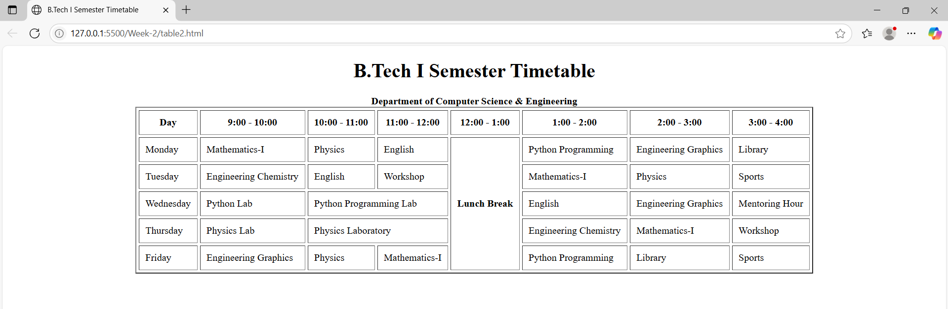

2 c)
AIM: Write a HTML program, to explain the working of forms by designing Registration form.
(Note: Include text field, password field, number field, date of birth field, checkboxes, radio buttons, list boxes using <select>&<option> tags, <text area> and two buttons ie: submit and reset. Use tables to provide a better view).
Description:
The <form> tag is used to create an HTML form for collecting user input. Forms can be used to send data to a server, such as login information, feedback, survey responses, or file uploads.
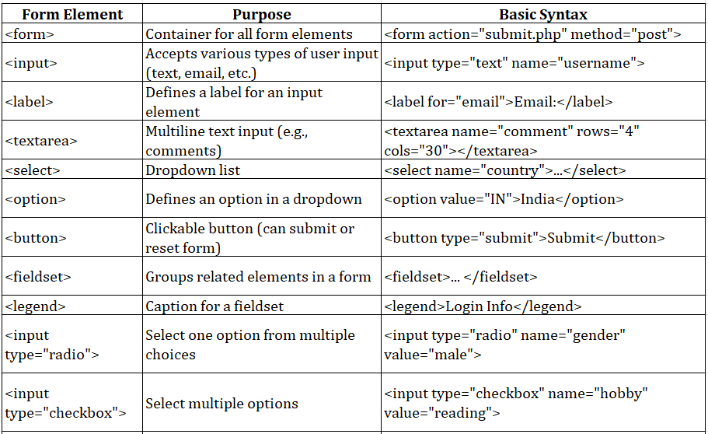
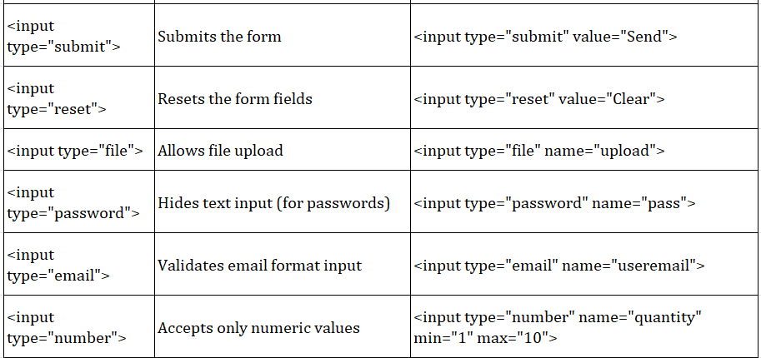
Important Attributes in <form>:
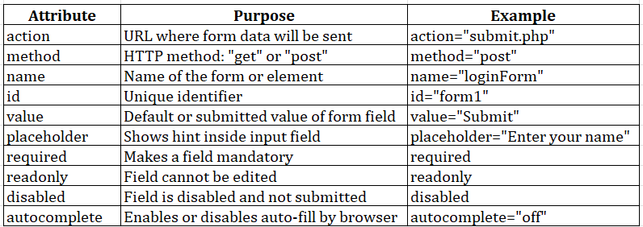
Code:
<!DOCTYPE html>
<html>
<head>
<title>Extended Student Registration Form</title>
</head>
<body>
<h2 align="center">Extended Student Registration Form</h2>
<form action="#" method="post" enctype="multipart/form-data">
<table border="1" cellpadding="10" cellspacing="0" align="center">
<caption><strong>Student Details</strong></caption>
<tr>
<th>Full Name:</th>
<td><input type="text" name="fullname" placeholder="Enter full name"
required></td>
</tr>
<tr>
<th>Email:</th>
<td><input type="email" name="email" placeholder="example@email.com"
required></td>
</tr>
<tr>
<th>Password:</th>
<td><input type="password" name="password" required></td>
</tr>
<tr>
<th>Mobile Number:</th>
<td><input type="tel" name="phone" pattern="[0-9]{10}" placeholder="10-digit
number" required></td>
</tr>
<tr>
<th>Age:</th>
<td><input type="number" name="age" min="17" max="30"></td>
</tr>
<tr>
<th>Date of Birth:</th>
<td><input type="date" name="dob"></td>
</tr>
<tr>
<th>Gender:</th>
<td>
<input type="radio" name="gender" value="Male"> Male
<input type="radio" name="gender" value="Female"> Female
<input type="radio" name="gender" value="Other"> Other
</td>
</tr>
<tr>
<th>Courses Interested:</th>
<td>
<input type="checkbox" name="course" value="C"> C
<input type="checkbox" name="course" value="C++"> C++
<input type="checkbox" name="course" value="Java"> Java
<input type="checkbox" name="course" value="Python"> Python
<input type="checkbox" name="course" value="Web"> Web Development
</td>
</tr>
<tr>
<th>Branch:</th>
<td>
<select name="branch">
<option value="">--Select Branch--</option>
<option value="CSE">Computer Science</option>
<option value="ECE">Electronics</option>
<option value="EEE">Electrical</option>
<option value="MECH">Mechanical</option>
<option value="CIVIL">Civil</option>
</select>
</td>
</tr>
<tr>
<th>College Website:</th>
<td><input type="url" name="website"
placeholder="https://www.example.com"></td>
</tr>
<tr>
<th>Address:</th>
<td><textarea name="address" rows="4" cols="30" placeholder="Enter your
address"></textarea></td>
</tr>
<tr>
<th>Upload Resume:</th>
<td><input type="file" name="resume"></td>
</tr>
<tr>
<th>Preferred Time Slot:</th>
<td><input type="time" name="timeslot"></td>
</tr>
<tr>
<th>Skill Level (0-10):</th>
<td><input type="range" name="skill" min="0" max="10"></td>
</tr>
<tr>
<th>Favorite Color:</th>
<td><input type="color" name="color"></td>
</tr>
<!-- Hidden Field -->
<tr>
<td colspan="2">
<input type="hidden" name="registration_type" value="student">
</td>
</tr>
<tr>
<th colspan="2" align="center">
<input type="submit" value="Submit">
<input type="reset" value="Reset">
</th>
</tr>
</table>
</form>
</body>
</html>

✅ Output:
Registration form opens with text fields, dropdowns, radio buttons, and submit/reset buttons functioning well.
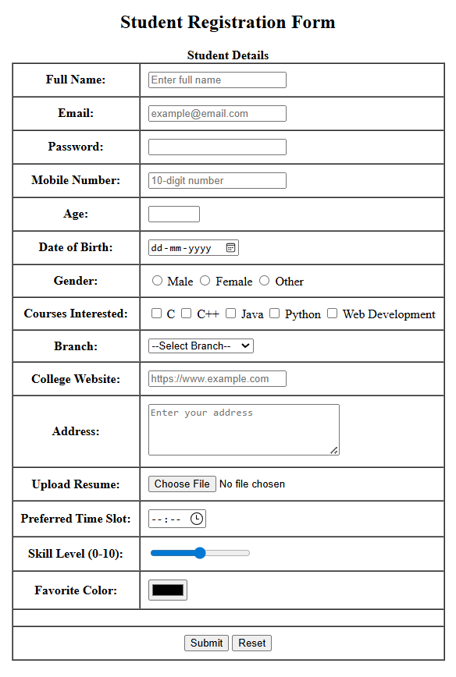

2 d)
AIM: Write a HTML program, to explain the working of frames, such that page is to be divided into 3 parts on either direction. (Note: first frame image, second frame paragraph, third frame hyperlink. And also make sure of using “no frame” attribute such that frames to be fixed).
Description:
The <frameset> tag was used in HTML 4 to divide the browser window into multiple frames, each capable of displaying a different HTML document simultaneously. It replaces the <body> tag and allows developers to create a multi-pane view in one browser window.
Purpose of <frameset>:
- To split the web page into rows or columns.
- To load multiple documents at the same time within one page.
- To enable side-by-side navigation, like menus and content areas.
Code:
image.html:
<!DOCTYPE html>
<html>
<head>
<title>Image Frame</title>
</head>
<body>
<h2 align="center">Welcome to Our Site</h2>
<div align="center">
<img src="people.jpeg" alt="Sample Image" width="600">
</div>
</body>
</html>
paragraph.html:
<!DOCTYPE html>
<html>
<head>
<title>Paragraph Frame</title>
</head>
<body>
<h3 align="center">About Us</h3>
<p align="justify" style="padding: 10px;">
This website demonstrates the usage of HTML frames by dividing the layout into three horizontal sections.
The first frame shows an image, the second frame provides some descriptive text, and the third frame lists useful links.
Frames are used to present multiple HTML documents within a single browser window.
</p>
</body>
</html>
links.html:
<!DOCTYPE html>
<html>
<head>
<title>Links Frame</title>
</head>
<body>
<h3 align="center">Useful Links</h3>
<ul style="text-align: center; list-style-type: none;">
<li><a href="https://www.google.com" target="_blank">Google</a></li>
<li><a href="https://www.wikipedia.org" target="_blank">Wikipedia</a></li>
<li><a href="https://www.w3schools.com" target="_blank">W3Schools</a></li>
</ul>
</body>
</html>

framesetdemo.html:
<!DOCTYPE html>
<html>
<head>
<title>Frameset Example</title>
</head>
<frameset rows="30%,40%,30%">
<frame src="image.html" name="frame1">
<frame src="paragraph.html" name="frame2">
<frame src="links.html" name="frame3">
<noframes>
<body>
<p>This page uses frames but your browser does not support them.</p>
</body>
</noframes>
</frameset>
</html>
✅ Output:
Frames are divided into 3 sections—image, paragraph, and hyperlinks displayed correctly.
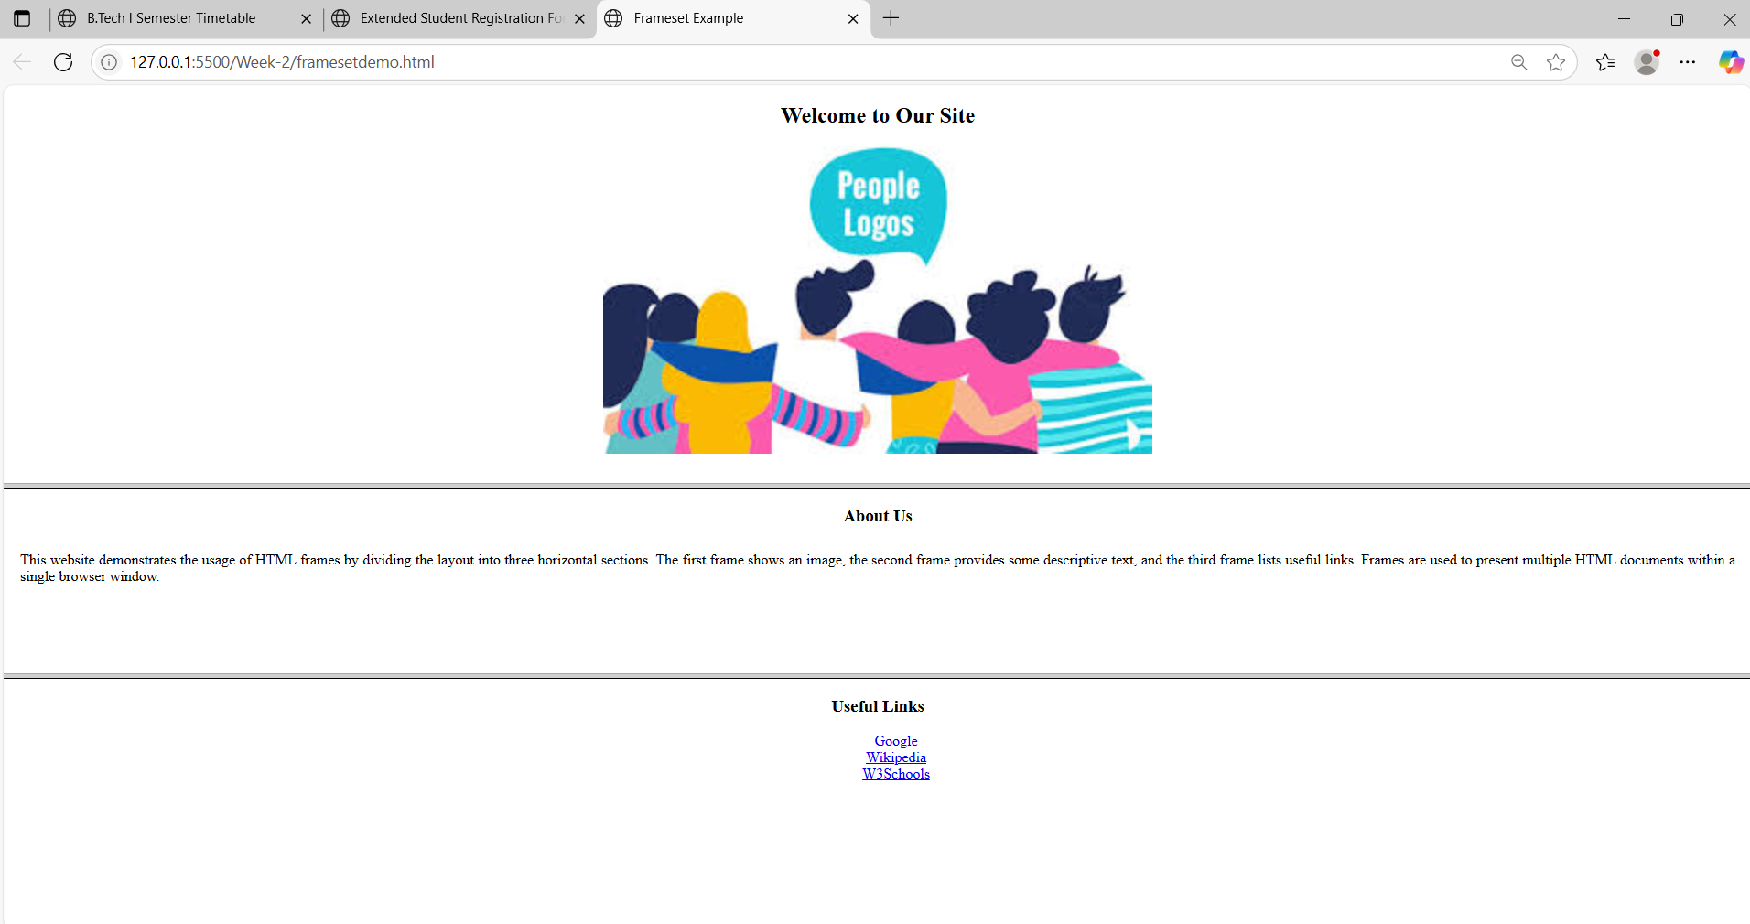

Viva Questions:
  - What is the use of the <table> tag?
Ans) It creates a table to display data in rows and columns.
  - What is the difference between <th> and <td>?
Ans) <th> is a header cell (bold), <td> is a normal cell.
  - Which tag is used to give a title to a table?
Ans) <caption> is used to add a title to the table.
  - What is the default alignment of <th> text?
Ans) Center aligned and bold.
  - What is the use of colspan?
Ans) It merges two or more columns into one cell.
  - What is the use of rowspan?
Ans) It merges two or more rows into one cell.
  - What does cellpadding do?
Ans) It adds space inside the table cell.
  - What does cellspacing do?
Ans) It adds space between the table cells.
Working with Forms
  - What is the purpose of the <form> tag in HTML?
Ans) The <form> tag is used to create a form that collects user input and sends it to a server.
  - What are the two main attributes of the <form> tag?)
Ans) action: URL where the form data is sent
method: HTTP method (GET or POST) used to submit the form
  - What is the use of the <input> tag?)
Ans) The <input> tag is used to create various input fields like textboxes, checkboxes, radio buttons, etc.
  - What is the difference between radio and checkbox inputs?
Ans) radio: allows only one option to be selected from a group and checkbox: allows multiple options to be selected

  - What is the use of the <select> and <option> tags?
Ans) <select> creates a dropdown menu and <option> defines each choice in the dropdown
  - What does the required attribute do in form fields?
Ans) It makes the input field mandatory, so the form can't be submitted without filling it.
Working with Frameset:
  - What is the purpose of the <frameset> tag in HTML?
Ans) The <frameset> tag is used to divide the browser window into multiple sections (frames), where each frame can display a different HTML document.
  - What attribute is used in <frameset> to split the window vertically?
Ans) The cols attribute is used to divide the screen into vertical frames (columns).
Example: <frameset cols="30%,70%">
  - What attribute is used in <frameset> to split the window horizontally?
Ans) The rows attribute is used to divide the screen into horizontal frames (rows).
Example: <frameset rows="50%,50%">
  - Which tag is used inside <frameset> to define each frame?
Ans) The <frame> tag is used to define each frame and load separate documents.
  - How do you load a webpage in a frame?
Ans) Use the src attribute in the <frame> tag.
Example: <frame src="menu.html">
  - What is the use of the noresize attribute in <frame>?
Ans) It prevents the user from resizing the frame manually.

Week-3: HTML5 and CSS
3a)
AIM: Write a HTML program, that makes use of <article>, <aside>, <figure>, <figcaption>, <footer>, <header>, <main>, <nav>, <section>, <div>, <span> tags.
Description:
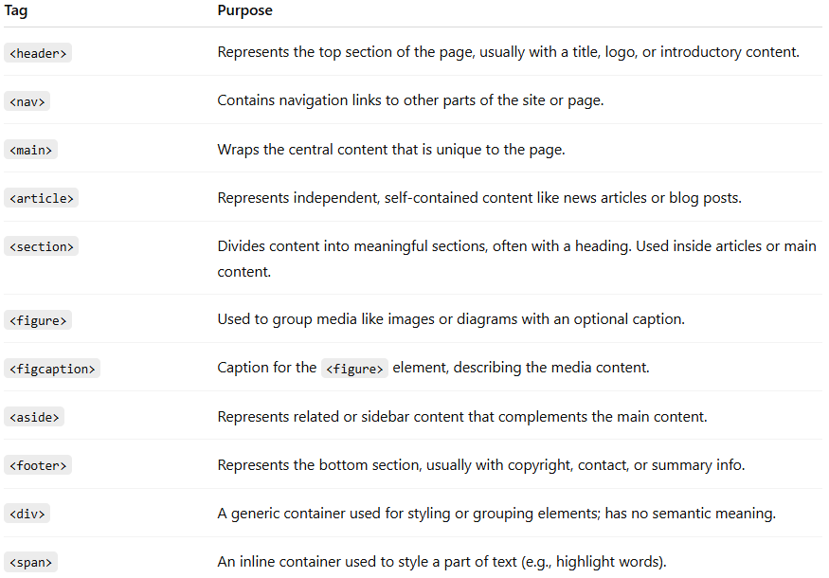

Code:
<!DOCTYPE html>
<html lang="en">
<head>
<meta charset="UTF-8">
<title>Aside as Sidebar</title>
<style>
body {
margin: 0;
font-family: Arial, sans-serif;
}
header, footer {
background-color: #333;
color: white;
padding: 10px;
text-align: center;
}

nav {
background-color: #eee;
padding: 10px;
}

nav a{
margin-right: 10px;
}

.container {
display: flex;
width: 100%;
height: 400px;
}

main {
flex: 3;
padding: 10px;
background-color: #f9f9f9;
}

aside {
/* flex: 1;
padding: 20px;
background-color: #dfefff; */
width: 15%;
padding: 15px;
margin-left: 25px;
float: right;
font-style: italic;
background-color: #f0f0f0;
border-left: 3px solid #0070d0;
}

footer {
margin-top: 10px;
}
</style>
</head>
<body>

<header>
<h1>Welcome to My College News Portal</h1>
</header>

<nav>
<a href="#">Home</a>
<a href="#">Departments</a>
<a href="#">Events</a>
<a href="#">Contact</a>
</nav>

<div class="container">
<main>
<h2>Main Content</h2>
<p>This is the main content of the page.</p>

<article>
<h2>Annual Tech Fest 2025</h2>
<section>
<p>The Tech Fest 2025 will be held from September 10 to 12. It will include coding contests, robotics, and workshops.</p>
</section>
<figure>
<img src="/Week3/techfest.jpeg" alt="Tech Fest Banner" width="300">
<figcaption>Figure: Tech Fest 2025 Poster</figcaption>
</figure>
</article>
</main>

<aside>
<h3>Sidebar Tips</h3>
<p>Use semantic tags for clean HTML structure.</p>
</aside>
</div>

<footer>
<p>&copy; 2025 My Website</p>
</footer
</body>
</html>

✅ Output:
HTML5 layout with header, navigation, article, sidebar, and footer displayed using semantic tags.

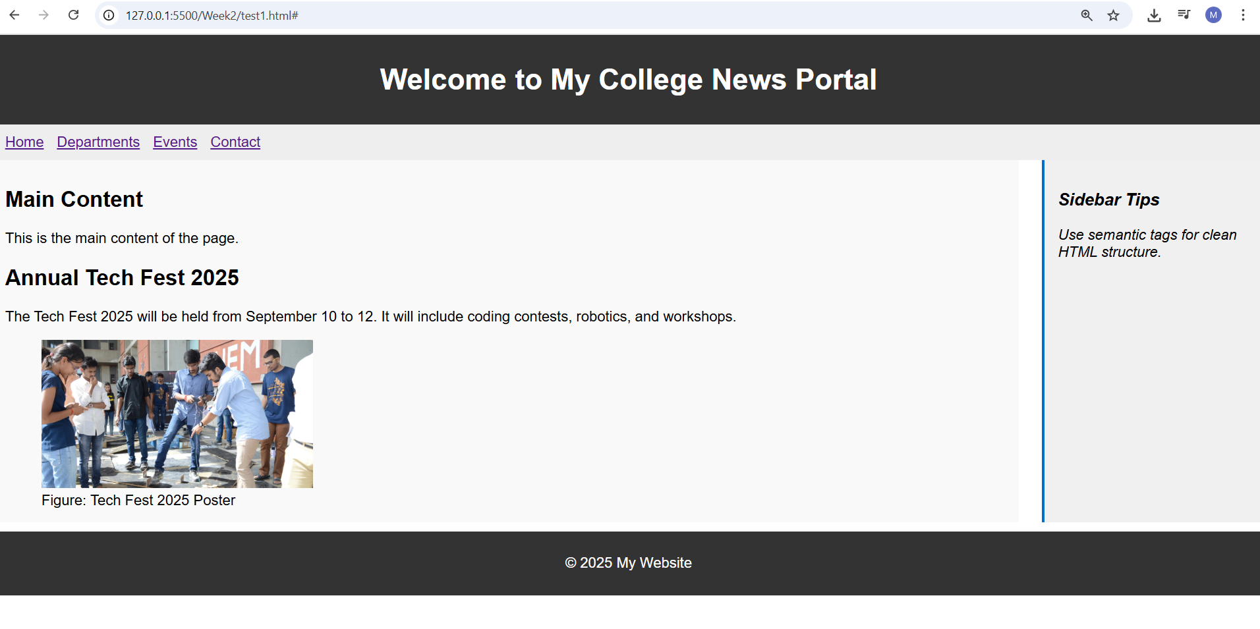

3 b)
AIM: Write a HTML program, to embed audio and video into HTML web page
<!DOCTYPE html>
<html>
<head>
<title>Embedding Audio and Video</title>
</head>
<body>
<h2>HTML5 Audio and Video Embedding</h2>
<!-- Embed Audio -->
<section>
<h3>Audio Example:</h3>
<audio controls>
<source src="https://www.soundhelix.com/examples/mp3/SoundHelix-Song-1.mp3" type="audio/mpeg"> Your browser does not support the audio element.
</audio>
</section>
<br>
<!-- Embed Video -->
<section>
<h3>Video Example:</h3>
<video width="600" height="340" controls>
<source src="https://www.w3schools.com/html/mov_bbb.mp4" type="video/mp4">
Your browser does not support the video tag.
</video>
</section>
</body>
</html>

✅ Output:
Audio and video components embedded successfully with play/pause controls visible on the page.
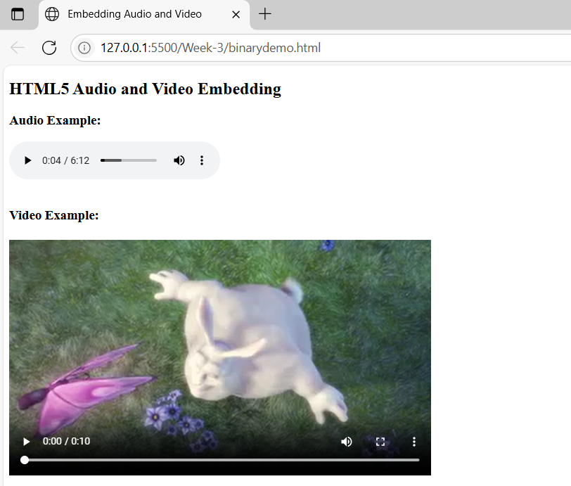

3 c)
AIM: Write a program to apply different types (or levels of styles or style specification formats) -inline, internal, external styles to HTML elements. (identify selector, property and value).
Description:
CSS Style Specification Formats:
- Inline CSS – inside the HTML tag using style attribute
- Internal CSS – inside a <style> block in the <head>
- External CSS – in a separate .css file and linked using <link> (simulated here)

Each CSS rule has:
- Selector – the HTML element(s) to style
- Property – the style attribute to change
- Value – the setting for that property
Syntax:
selector {
property: value;
}
Example 1 (from inline CSS):
<h1 style="color: blue;">Hello</h1>
- Selector: h1 (implied, though it's inline)
- Property: color
- Value: blue

Example 2 (from internal CSS):
h2 {
color: darkgreen;
font-family: Georgia, serif;
}
Selector: h2
- First:
  - Property: color
  - Value: darkgreen
- Second:
  - Property: font-family
  - Value: Georgia, serif

Example 3 (from external CSS):
.external-paragraph {
font-size: 18px;
color: darkred;
}
Selector: .external-paragraph (a class selector)
- First:
  - Property: font-size
  - Value: 18px
- Second:
  - Property: color
  - Value: darkred

ID Selector:
Syntax:
#idname {
property: value;
}
Ex:
<!DOCTYPE html>
<html>
<head>
<style>
#highlight {
background-color: yellow;
border: 2px solid orange;
padding: 10px;
}
</style>
</head>
<body>
<p>This is a normal paragraph.</p>
<p id="highlight">This paragraph has an ID and special style.</p>
</body>
</html>

Code:
index.html:
<!DOCTYPE html>
<html lang="en">
<head>
<meta charset="UTF-8">
<title>CSS Styles Demo</title>
<!-- Internal CSS -->
<style>
h2 {
color: darkgreen;
font-family: Georgia, serif;
}
.internal-box {
background-color: lightyellow;
border: 2px solid orange;
padding: 10px;
}
</style>
<!-- External CSS -->
<link rel="stylesheet" type="text/css" href="styles.css">
</head>
<body>

<h1 style="color: blue; font-size: 28px;">Inline Styled Heading (h1)</h1>
<h2>Internal Styled Heading (h2)</h2>
<div class="internal-box">
This box uses <strong>internal CSS</strong> for styling.
</div>
<br>
<p class="external-paragraph">
This paragraph is styled using <strong>external CSS</strong>.
</p>
</body>
</html>

styles.css:
/* External CSS styles */
.external-paragraph {
font-size: 18px;
color: darkred;
background-color: #f0f0f0;
padding: 12px;
border-left: 4px solid red;
}

✅ Output:
Inline, internal, and external CSS styles apply properly with visible font, color, and background differences.
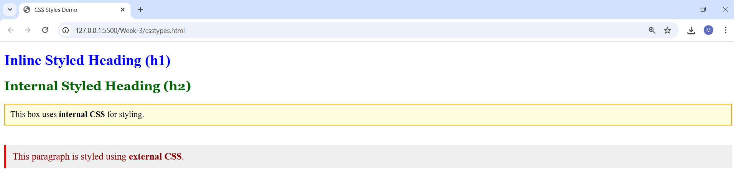

Viva Questions:

1. What is the purpose of the <article> tag in HTML?
Ans) The <article> tag is used to represent independent, self-contained content such as blog posts, news articles, or forum posts.

2. What does the <aside> tag represent in HTML?
Ans) The <aside> tag is used for content that is tangentially related to the main content, like sidebars, tips, or advertisements.

3. What is the <figure> tag used for?
Ans) The <figure> tag is used to enclose media or illustrations, such as images, diagrams, or code snippets.

4. What is the role of <figcaption> in HTML?
Ans) The <figcaption> tag provides a caption or description for the content inside the <figure> tag.

5. What does the <footer> tag define?
Ans) The <footer> tag represents the footer of a document or a section, typically containing copyright, contact info, or related links.

6. What is the <header> tag used for?
Ans) The <header> tag defines the introductory content or navigation links for a section or entire webpage.

7. What is the use of the <main> tag in HTML5?
Ans) The <main> tag specifies the central content of a webpage that is unique and not repeated across pages like headers or footers.

8. What is the purpose of the <nav> tag?
Ans) The <nav> tag is used to define a section that contains navigation links like menus, tables of contents, etc.

9. How is the <section> tag different from <div>?
Ans) <section> is a semantic tag used to group related content with a heading, while <div> is a generic container without any semantic meaning.

10. What is the difference between <div> and <span> tags?
Ans) <div> is a block-level container used for structuring page layout, while <span> is an inline container used for styling small portions of text.

Week-4: Selector Forms
4 a)
AIM: Write a program to apply different types of selector forms
i. Simple selector (element, id, class, group, universal)
ii. Combinator selector (descendant, child, adjacent sibling, general sibling)
iii. Pseudo-class selector
iv. Pseudo-element selector
v. Attribute selector

Description:
Simple Selector Type |  | Example |  | Description
Element |  | h1 |  | Selects all <h1>
ID |  | #main-title |  | Selects element with that ID
Class |  | .highlight |  | Selects elements with that class
Group |  | h2, p, li |  | Applies same rule to multiple elements
Universal |  | * |  | Applies to all elements
Combinator | Example |  | Matches...
Descendant | div p |  | All <p> inside <div>
Child | ul > li |  | Direct children only
Adjacent | h3 + p |  | First <p> immediately after <h3>
General | h3 ~ p |  | All <p> after <h3> siblings

Pseudo-class |  | Example
:hover |  | Link effects
:first-child, :nth-child(n) |  | Position-based selection
Pseudo-element | Example
::first-line | Style first line of text
::before, ::after | Inject content before/after element

Explanation Summary:

Attribute Selector | Example
[type="text"] | Exact attribute value
[href^="https"] | Starts with https
[placeholder*="name"] | Contains "name"

4 a) Simple Selectors
Code:
<!DOCTYPE html>
<html>
<head>
<title>Simple Selectors Demo</title>
<style>
/* Universal Selector */
* {
font-family: Arial, sans-serif;
}

/* Type Selector */
h1 {
color: darkblue;
}

/* Class Selector */
.highlight {
background-color: yellow;
font-weight: bold;
}

/* ID Selector */
#main-para {
color: green;
font-size: 18px;
}

/* Group Selector */
h2, p {
margin-bottom: 10px;
}
</style>
</head>
<body>

<h1>Welcome to the Selector Demo</h1>
<h2>This is a subheading</h2>
<p>This paragraph is affected by the group selector.</p>
<p id="main-para">This paragraph is styled using an ID selector.</p>
<p class="highlight">This paragraph uses a class selector for highlighting.</p>
</body>
</html>
✅ Output:
CSS selectors applied correctly showing variations using class, ID, element, and group selectors.
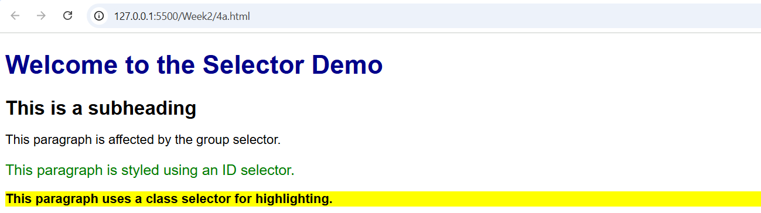

4 b) Combinator Selectors:
<!DOCTYPE html>
<html>
<head>
<style>
.university{
width: 50%;
border: 8px solid gray;
border-radius: 5px;
margin: 50px auto;
}
div p{
background-color: aquamarine;
}
/*div > p{
background-color: blanchedalmond;
} */
/* h2+p{
background-color: lightblue;
} */
/* h2~p{
background-color: lightgray;
} */
</style>
</head>
<body>
<h1>Aditya University Information</h1>
<div class="university">
<div class="department">
<h2>CSE</h2>
<p>Head: Ms. Sudha Rani T</p>
<p>Associate Profissor</p>
<div class="faculty">
<h2>Faculty</h2>
<p>Prof. Ramesh</p>
<p>Prof. Sivaram</p>
</div>
</div>
<div class="department">
<h2>IT</h2>
<p>Head: Ms.A. Rajababu</p>
<p>Associate Profissor</p>
<div class="faculty">
<h2>Faculty</h2>
<p>Prof. Balaram</p>
<p>Prof. Kalyan</p>
</div>
</div>
<p>This is testing University styles</p>
</div>
<p>This is for testing paragraph styles</p>
</body>
</html>
✅ Output:
Combinator selectors highlight nested and adjacent relationships among HTML elements visibly.
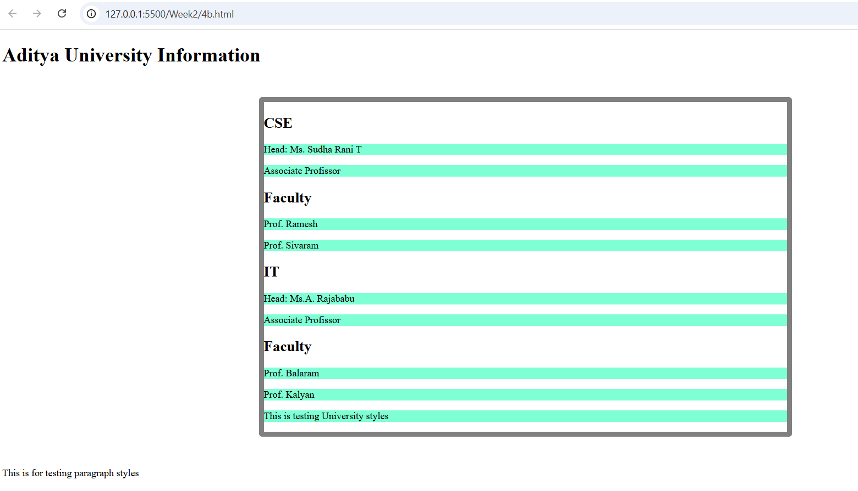

4 c) Pseudo-class selector
<!DOCTYPE html>
<html>
<head>
<title>Login Form with Pseudo-Classes</title>
<style>
body {
font-family: Arial, sans-serif;
padding: 20px;
}

.form {
width: 300px;
margin: auto;
padding: 20px;
border: 2px solid #ccc;
border-radius: 8px;
}

input[type="text"],
input[type="password"] {
width: 90%;
padding: 10px;
margin-bottom: 15px;
border: 1px solid #ccc;
border-radius: 4px;
}

/* Pseudo-class: when input is focused */
input:focus {
border-color: dodgerblue;
background-color: #f0f8ff;
}

/* Pseudo-class: hover effect on button */
button:hover {
background-color: dodgerblue;
color: white;
cursor: pointer;
}
/* Pseudo-class: visited link */
a:visited {
color: purple;
}
/* Pseudo-class: invalid input */
input:invalid {
border-color: red;
}
button {
width: 100%;
padding: 10px;
background-color: lightgray;
border: none;
border-radius: 4px;
}
</style>
</head>
<body>
<div class="form">
<h2>Login Form</h2>
<form>
<label>Username:</label>
<input type="text" required placeholder="Enter username"
<label>Password:</label>
<input type="password" required placeholder="Enter password">
<button type="submit">Login</button>
</form>
<p><a href="#">Forgot password?</a></p>
</div>
</body>
</html>
✅ Output:
Pseudo-classes like hover, focus, and invalid show interactive color and style changes.
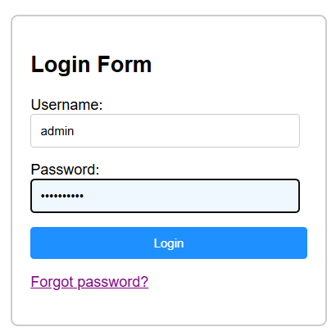

4 d) Pseudo Element Selector:
<!DOCTYPE html>
<html lang="en">
<head>
<title>Pseudo Element Selector Example</title>
<style>
h1::before {
content: "👉 ";
color: green;
}
h1::after {
content: " ✅";
color: blue;
}
p::first-line {
font-weight: bold;
color: red;
}
p::first-letter {
font-size: 24px;
color: purple;
}
</style>
</head>
<body>
<h1>Welcome to Web Design</h1>
<p>HTML and CSS are the building blocks of web development.
You can use selectors to style content in creative ways.
</p>
</body>
</html>

✅ Output:
Pseudo-elements (::before, ::after, ::first-line) add decorative text and style enhancements.
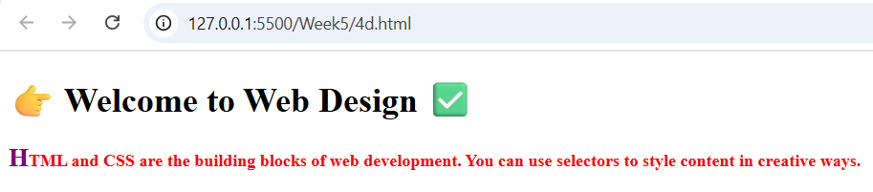

4 e) Attribute selector:
<!DOCTYPE html>
<html>
<head>
<title>Attribute Selector Demo</title>
<style>
input[type="text"] {
border: 2px solid blue;
}

a[href^="https"] {
font-style: italic;
}

input[placeholder*="name"] {
background-color: #f0f8ff;
}
</style>
</head>
<body>

<h2>Form Example</h2>

<input type="text" placeholder="Enter your name"><br><br>
<input type="password" placeholder="Enter password"><br><br>

<a href="https://example.com">Visit Example Site</a><br>
<a href="http://othersite.com">Visit Another Site</a>

</body>
</html>
✅ Output:
Attribute-based styling applied successfully; inputs and links styled differently based on attributes.
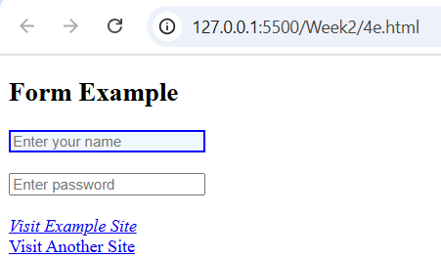
Viva Questions:
1. What is an element selector in CSS?
Ans) It selects HTML elements by their tag name.
Example: p { color: blue; } selects all <p> tags.

2. What is an ID selector?
Ans) It selects an element with a specific ID using #.
Example: #header { background: yellow; }

3. What is a class selector?
Ans) It selects all elements with a specific class using ..
Example: .box { border: 1px solid black; }

4. What is a group selector?
Ans) It groups multiple selectors to apply the same styles.
Example: h1, h2, h3 { font-weight: bold; }

5. What is the universal selector?
Ans) It selects all elements on the page using *.
Example: * { margin: 0; padding: 0; }

6. What is a descendant selector?
Ans) It selects all elements inside a specified element.
Example: div p { color: green; } selects all <p> inside <div>.

7. What is a child selector?
Ans) It selects direct child elements only using >.
Example: ul > li { list-style: none; }

8. What is an adjacent sibling selector?
Ans) It selects the next sibling immediately after a specified element using +.
Example: h1 + p { color: red; }

9. What is a general sibling selector?
Ans) It selects all siblings after the specified element using ~.
Example: h1 ~ p { font-style: italic; }

10. What is a pseudo-class in CSS?
Ans) It defines a special state of an element using :.
Example: a:hover { color: orange; }

11. What does :first-child do?
Ans) Selects the first child of a parent.
Example: li:first-child { color: red; }

12. What does :nth-child(n) do?
Ans) Selects the nth child of a parent.
Example: li:nth-child(2) { color: blue; }

13. What is a pseudo-element in CSS?
Ans) It styles specific parts of an element using ::.
Example: p::first-line { font-weight: bold; }

14. What does ::before do?
Ans) Inserts content before an element.
Example: h1::before { content: "★ "; }

15. What is an attribute selector in CSS?
Ans) It selects elements based on the presence or value of an attribute.
Example: input[type="text"] { border: 1px solid gray; }

Week-5: CSS with Color, Background, Font, Text and CSS Box Model
5 a) Write a program to demonstrate the various ways you can reference a color in CSS.
<!DOCTYPE html>
<html>
<head>
<title>CSS Color Referencing Demo</title>
<style>
/* 1. Named Color */
.named-color {
color: red;
background-color: lightyellow;
}
/* 2. Hexadecimal */
.hex-color {
color: #0000FF; /* Blue */
background-color: #F0F0F0;
}
/* 3. RGB */
.rgb-color {
color: rgb(0, 128, 0); /* Green */
background-color: rgb(230, 230, 250);
}
/* 4. RGBA */
.rgba-color {
color: rgba(255, 165, 0, 0.9); /* Orange with slight transparency */
background-color: rgba(255, 255, 255, 0.5);
}
/* 5. HSL */
.hsl-color {
color: hsl(240, 100%, 50%); /* Blue */
background-color: hsl(60, 100%, 90%);
}
/* 6. HSLA */
.hsla-color {
color: hsla(300, 100%, 50%, 0.8); /* Purple with transparency */
background-color: hsla(0, 0%, 100%, 0.5);
}
</style>
</head>
<body>
<h2>Different Ways to Apply Colors in CSS</h2>
<p class="named-color">This text uses a named color: <strong>red</strong>.</p>
<p class="hex-color">This text uses a hex code: <strong>#0000FF</strong>.</p>
<p class="rgb-color">This text uses RGB format: <strong>rgb(0, 128, 0)</strong>.</p>
<p class="rgba-color">This text uses RGBA: <strong>rgba(255, 165, 0, 0.9)</strong>.</p>
<p class="hsl-color">This text uses HSL: <strong>hsl(240, 100%, 50%)</strong>.</p>
<p class="hsla-color">This text uses HSLA: <strong>hsla(300, 100%, 50%, 0.8)</strong>.</p>
</body>
</html>
✅ Output:
Displays text in different color formats (HEX, RGB, HSL, etc.) correctly rendered on the screen.
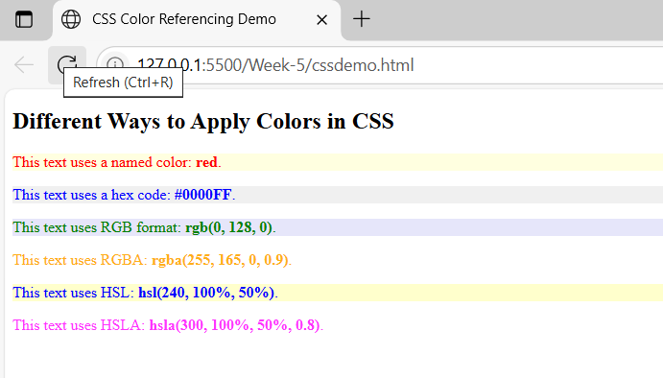
5 b) Write a CSS rule that places a background image halfway down the page, tilting it horizontally. The image should remain in place when the user scrolls up or down.
Description:
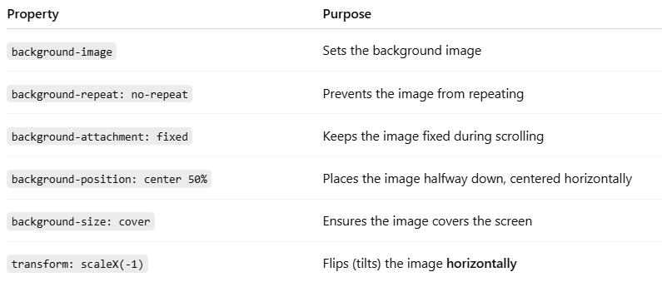
<!DOCTYPE html>
<html>
<head>
<title>Fixed Flipped Background Example</title>
<style>
body {
margin: 0;
height: 200vh; /* Makes the page scrollable */
}
.background {
position: fixed;
top: 20%; /* Halfway down the page */
left: 0;
width: 100%;
height: 200px; /* Adjust as needed */
background-image:url('https://picsum.photos/id/1015/600/400');
background-repeat: no-repeat;
background-size: cover;
background-position: center;
transform: rotate(-15deg); /* Flip horizontally */
z-index: -1; /* Place behind content */
}
.content {
padding: 50px;
font-size: 20px;
}
</style>
</head>
<body>
<div class="background"></div>
<div class="content">
<h1>Scroll Down</h1>
<p>This is an example page with a background image fixed halfway down and flipped horizontally.</p>
<p>Keep scrolling to see the background image stay in place.</p>
<p>Lorem ipsum dolor sit amet, consectetur adipiscing elit. Pellentesque luctus velit sit amet justo feugiat, vel cursus lorem tincidunt.</p>
</div>
</body>
</html>
✅ Output:
Background image remains fixed in place while scrolling with visible tilt transformation.
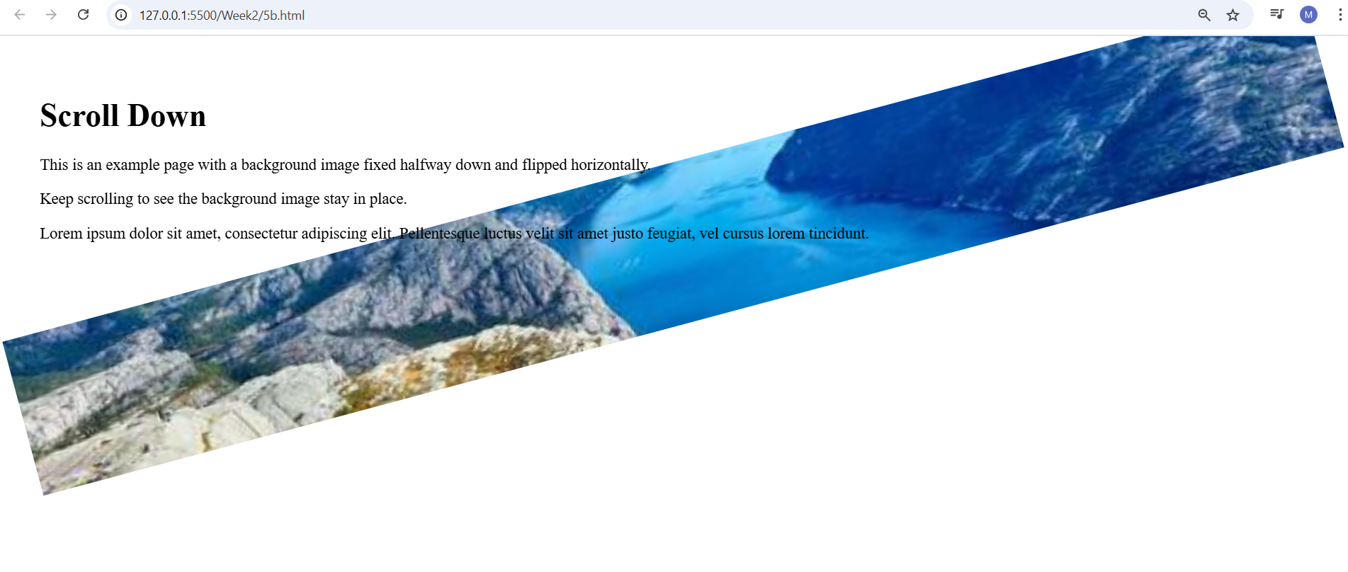
5 c) Write a program using the following terms related to CSS font and text:
i. font-size ii. font-weight iii. font-style
iv. text-decoration v. text-transformation vi. text-alignment
Code:
<!DOCTYPE html>
<html>
<head>
<title>CSS Font and Text Properties</title>
<style>
.font-size {
font-size: 24px; /* Increases text size */
}
.font-weight {
font-weight: bold; /* Makes text bold */
}
.font-style {
font-style: italic; /* Makes text italic */
}
.text-decoration {
text-decoration: underline; /* Underlines the text */
}
.text-transform {
text-transform:uppercase; /* Converts text to uppercase */
}
.text-align {
text-align: center; /* Centers the text */
}
</style>
</head>

<body>
<h2>CSS Font and Text Formatting Examples</h2>
<p class="font-size">This text uses <strong>font-size: 24px</strong>.</p>
<p class="font-weight">This text uses <strong>font-weight: bold</strong>.</p>
<p class="font-style">This text uses <strong>font-style: italic</strong>.</p>
<p class="text-decoration">This text uses <strong>text-decoration: underline</strong>.</p>
<p class="text-transform">This text uses <strong>text-transform: uppercase</strong>.</p>
<p class="text-align">This text uses <strong>text-align: center</strong>.</p>
</body>
</html>

✅ Output:
Text styling demonstrated with bold, italic, underline, uppercase, and centered alignment.
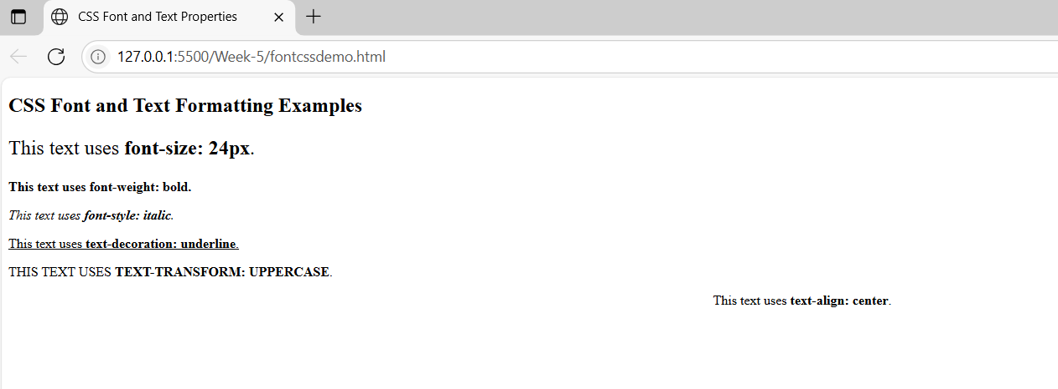

5 d) Write a program, to explain the importance of CSS Box model using
i. Content ii. Border iii. Margin iv. Padding
Description:
The CSS box model is essentially a box that wraps around every HTML element. It consists of content, padding, borders and margins.
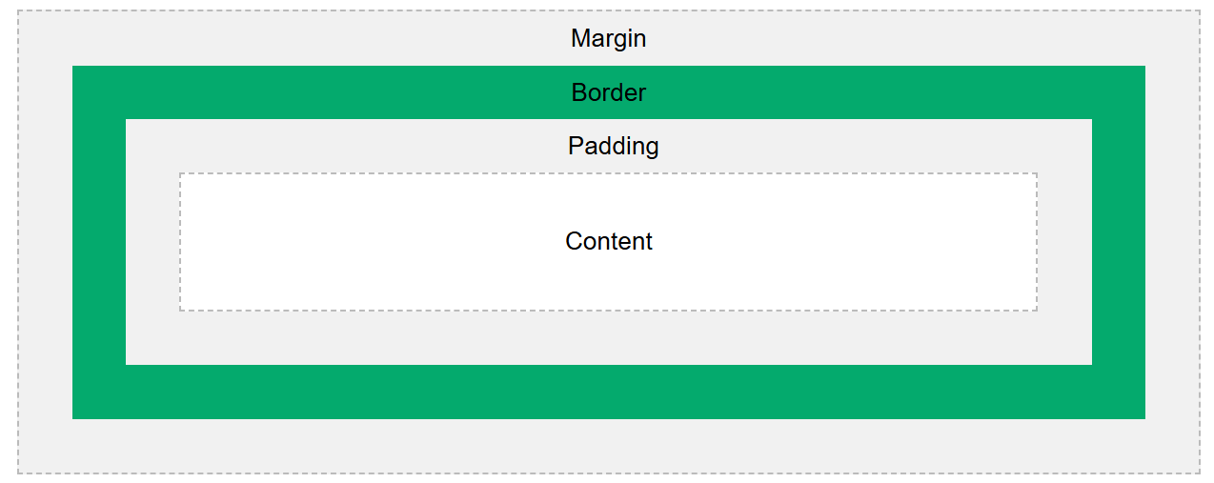
Code:
<!DOCTYPE html>
<html>
<head>
<title>CSS Box Model Demo</title>
<style>
.box {
width: 300px;
height: 100px;
background-color: lightyellow; /* Content background */
padding: 20px; /* Space inside border */
border: 5px solid orange; /* Border around content and padding */
margin: 30px auto; /* Space outside the border */
text-align: center;
font-size: 18px;
box-sizing: content-box; /* Default box model behavior */
}
body {
background-color: #f2f2f2;
font-family: Arial, sans-serif;
}
</style>
</head>
<body>
<h2 style="text-align:center;">CSS Box Model Explanation</h2>

<div class="box">
<strong>Content:</strong> This is the main content.<br>
<strong>Padding:</strong> Adds space inside the box.<br>
<strong>Border:</strong> Adds a visible edge around it.<br>
<strong>Margin:</strong> Adds space outside the box.
</div>
</body>
</html>

✅ Output:
CSS box model clearly shows margin, border, padding, and content area visually separated.

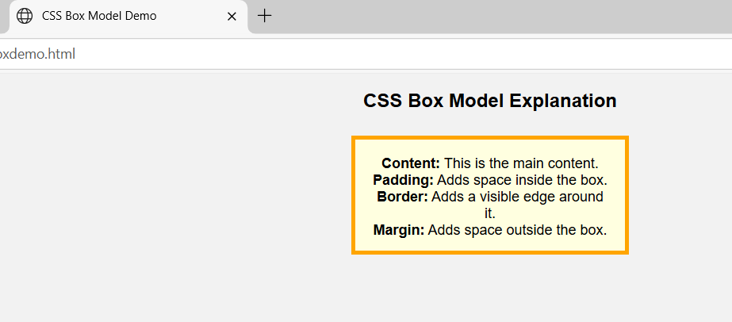

Viva Questions:
1) What is the difference between color and background-color in CSS?
Ans) color sets the text (foreground) color.
background-color sets the background color of an element.
2) What are the different ways to define colors in CSS?
Ans)
- Color names (e.g., red, blue)
- Hex codes (e.g., #ff0000)
- RGB values (e.g., rgb(255, 0, 0))
- RGBA (e.g., rgba(255, 0, 0, 0.5))
- HSL (e.g., hsl(0, 100%, 50%))
- HSLA (e.g., hsla(0, 100%, 50%, 0.5))
3) What does the a stand for in rgba or hsla?
Ans) It stands for alpha, which controls the transparency of the color (0 = fully transparent, 1 = fully opaque).
  - What is the Box Model in CSS?
Ans) The CSS Box Model is a layout concept that wraps every HTML element in four parts:
  - Content → Actual text or image
  - Padding → Space between content and border
  - Border → Line around padding and content
  - Margin → Space outside the border
  - What is the difference between padding and margin?
Ans)
- padding: Space inside the element, between content and border
- margin: Space outside the element, between border and neighboring elements

