VISVESVARAYA TECHNOLOGICAL UNIVERSITY
Jnana Sangama, Belagavi-590018

A Database Management System Mini Project Report on

DevMatch AI – Developer Portfolio & Hiring Platform
Submitted in Partial fulfillment of the Requirements for the VII Semester of the Degree of
Bachelor of Engineering in
Electronics and Communication Engineering
By
Name ____________________ USN ____________________
Name ____________________ USN ____________________
Name ____________________ USN ____________________
Under the Guidance of,
Guide name ____________________ Designation ____________________

DEPARTMENT OF ELECTRONICS AND COMMUNICATION ENGINEERING
CMR INSTITUTE OF TECHNOLOGY
Affiliated to VTU, Approved by AICTE, Accredited by NBA and NAAC with “A++” Grade
ITPL MAIN ROAD, BROOKFIELD, BENGALURU-560037, KARNATAKA, INDIA
2026-27
CMR INSTITUTE OF TECHNOLOGY
Affiliated to VTU, Approved by AICTE, Accredited by NBA and NAAC with “A++” Grade
ITPL MAIN ROAD, BROOKFIELD, BENGALURU-560037, KARNATAKA, INDIA
DEPARTMENT OF ELECTRONICS AND COMMUNICATION ENGINEERING
CERTIFICATE
This is to certify that the Database Management System Project work entitled "DevMatch AI – Developer Portfolio & Hiring Platform" has been carried out by ____________________, USN ____________________, ____________________, USN ____________________, and ____________________, USN ____________________, bonafide students of CMR Institute of Technology, Bengaluru in partial fulfillment for the award of the Degree of Bachelor of Engineering in Electronics and Communication Engineering of the Visvesvaraya Technological University, Belagavi during the year 2026-27. It is certified that all corrections/suggestions indicated for the Internal Assessment have been incorporated in the report deposited in the departmental library. This Database Management System Project report has been approved as it satisfies the academic requirements in respect of project work prescribed for the said Degree.
________________________  Signature of Guide  Name ______________  Designation __________ |  | ________________________  Signature of HOD  Name ______________  Designation __________
DECLARATION
We, the students of VII semester from the Department of Electronics and Communication Engineering, CMR Institute of Technology, Bangalore declare that the project work entitled "DevMatch AI – Developer Portfolio & Hiring Platform" has been successfully completed under the guidance of ____________________, designation ____________________, CMR Institute of Technology, Bengaluru. This project work is submitted in partial fulfillment of the requirements for the award of the Degree of Bachelor of Engineering in Electronics and Communication Engineering during the academic year 2026-2027. The matter embodied in the project report has not been submitted previously by anybody for the award of any degree or diploma to any university.
Place: ____________________
Date: ____________________
Team members:
Name ____________________  USN ____________________ | ____________________
Name ____________________  USN ____________________ | ____________________
Name ____________________  USN ____________________ | ____________________

ABSTRACT
DevMatch AI is a database driven developer portfolio and hiring platform. Developers manage profiles, skills, projects, resumes and applications, while recruiters publish jobs and review candidates. Flask and SQLAlchemy connect a responsive web interface to ten related MySQL tables. Normalized skill and technology records, integrity constraints, joins, views and a status audit trigger demonstrate DBMS concepts. PDF resume extraction supports transparent skill matching, with optional Gemini analysis. The system centralizes hiring information and allows recruiter review of automatically assigned application statuses.
Keywords: MySQL, Flask, Database Normalization, Developer Portfolio, Skill Matching
Acknowledgement
We express our gratitude to CMR Institute of Technology, Bengaluru, for providing the facilities and academic environment to carry out this Database Management System mini project.
We thank ____________________, Principal, CMR Institute of Technology, Bengaluru, for encouragement and institutional support.
We express our gratitude to ____________________, Head of the Department of Electronics and Communication Engineering, CMR Institute of Technology, Bengaluru, for support throughout the project.
We thank our guide ____________________, designation ____________________, CMR Institute of Technology, Bengaluru, for guidance during the project work.
We thank our parents, friends and team members for their support and cooperation during the completion of this project.
TABLE OF CONTENTS
Contents | Page No.
Certificate | ii
Declaration | iii
Abstract | iv
Acknowledgement | v
Table of Contents | vi
List of Figures | vii
List of Tables | viii
1 Introduction | 1
1.1 Objectives and 1.2 Scope of the project | 2
2 System Requirements | 3
2.1 Front End Tools and 2.2 Back End Tools | 3
3 Design | 4
3.1 Schema Diagram | 4
3.2 ER Diagram | 5
3.3 Database Tables | 6–9
4 Implementation | 10
4.1 Installation Steps | 10
4.2 Front-end Code | 11
4.3 Back-end Code | 12–15
5 Interpretation of Result | 16
5.1 Result Snapshots | 16–18
6 Conclusion and Future Scope | 19
References | 20
LIST OF FIGURES
Figure | Page No.
Fig 3.1 Relational schema | 4
Fig 3.2 Entity relationships and cardinalities | 5
Fig 5.1 Developer dashboard | 16
Fig 5.2 Job listing and skill match | 17
Fig 5.3 Recruiter applicant review | 18
LIST OF TABLES
Table | Page No.
Table 2.1 Development requirements | 3
Table 3.1 Account and profile tables | 6
Table 3.2 Portfolio tables | 7
Table 3.3 Job tables | 8
Table 3.4 Application and analysis tables | 9

CHAPTER 1

INTRODUCTION
DevMatch AI is a web application that brings developer portfolios, job postings and application tracking into one relational database. A developer can present skills and projects, upload a resume, search jobs and monitor applications. A recruiter can maintain a company profile, publish vacancies and examine the evidence behind each candidate’s skill match.
The project addresses the difficulty of keeping hiring information consistent when profiles, resumes, vacancies and application decisions are handled separately. Repeated candidate details and unstructured skill lists make searching and comparison difficult. DevMatch AI stores related information in dedicated MySQL tables and links records through primary and foreign keys.
The system uses Flask for request handling, SQLAlchemy for database access and HTML, CSS and JavaScript for presentation. PDF text extraction provides resume evidence. Gemini can optionally produce a structured analysis, while a deterministic extraction path allows the resume workflow to function without an AI service. Supabase is used only for optional private resume file storage.
The DBMS contribution is the design and implementation of ten application tables, normalized skill and project technology records, uniqueness constraints and relational queries. A separate SQL demonstration adds a view and an application status audit trigger. The report explains the requirements, design, implementation and results of these components.
Skill matching is intended to support review. The score measures coverage of a job’s recorded skill names, and it does not measure overall competence or predict hiring success. The recruiter can revise the initial application status after examining the portfolio and resume.

1.1 Objectives
• Maintain developer and recruiter accounts with role specific access to their records.
• Store portfolios, skills, jobs, applications and resume analyses in related MySQL tables.
• Normalize multivalued job skills and project technologies to support searching and integrity.
• Provide create, read, update and delete operations through the web interface.
• Calculate a visible skill match using profile skills and the latest extracted resume skills.
• Demonstrate keys, joins, filtering, grouping, views, transactions and a status history trigger.

1.2 Scope of the project
The implemented scope includes registration and login, profile maintenance, developer portfolio management, job search, recruiter job management, one application per developer and job, PDF resume analysis, candidate discovery and application status review. The DBMS demonstration page displays current job records from the same MySQL database used by the application.
CHAPTER 2

SYSTEM REQUIREMENTS
The system requires a browser, a Python application environment and a reachable MySQL database. Optional services extend resume analysis and deployment; the core profile, job and application functions use the same relational backend in both local and hosted configurations.

2.1 Front End Tools
HTML defines pages and forms; CSS provides responsive layouts, navigation, dashboards and job cards. Jinja templates bind server supplied records to the interface. JavaScript supports interactions such as copying job information and opening skill details. Form actions and database updates are processed by Flask rather than by browser access to MySQL.

2.2 Back End Tools
Python and Flask implement routes, sessions and role checks. Flask SQLAlchemy defines models and database transactions; PyMySQL supplies the MySQL connection. PyMuPDF extracts PDF text, requests supports Gemini API calls, and python dotenv loads local configuration. Flask Limiter throttles selected account actions. MySQL Workbench or the command line client supports SQL demonstrations. References [1]–[6] identify the relevant official documentation.
Table 2.1 Development requirements
Component | Requirement or role
Hardware | A computer capable of running Python, MySQL and a modern browser; 4 GB RAM and free storage are practical local starting points.
Software | Python 3.10 or later; MySQL 8; a browser; packages listed in requirements.txt.
Database | mysql+pymysql connection URL; dedicated database and account.
Optional services | Gemini API key; private Supabase resume bucket; Redis compatible limiter storage for production.
CHAPTER 3

DESIGN
The design separates shared account information from developer and recruiter data. Jobs belong to recruiters, while applications connect developers to jobs. Repeated skill and technology values are represented by child rows. Figure 3.1 summarizes the key links in the physical schema.

3.1 Schema Diagram
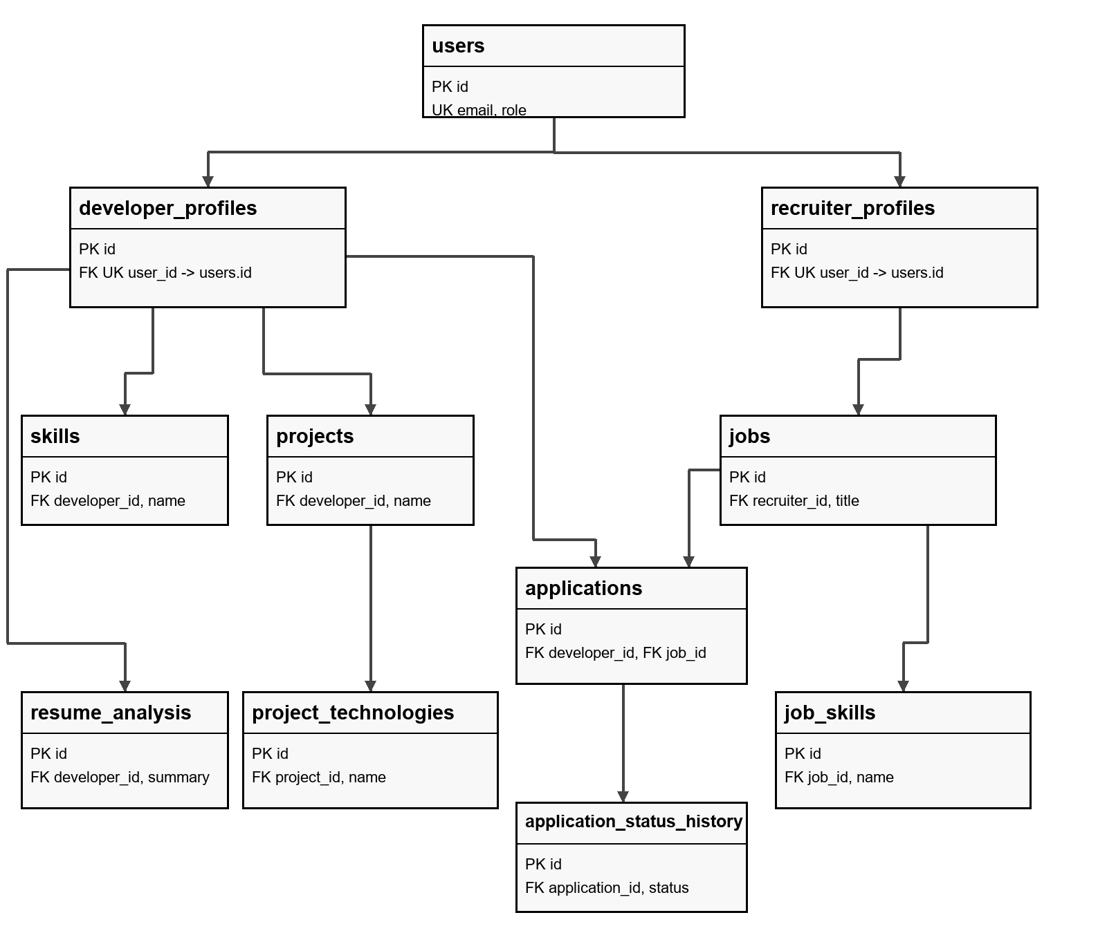
Fig 3.1 Relational schema
PK denotes a primary key, FK a foreign key and UK a unique key. Ten tables are created by the application models. The eleventh table, application_status_history, is an audit extension installed by mysql_demo.sql. The unique developer and job pair in applications prevents duplicate applications.

3.2 ER Diagram
Figure 3.2 shows the entity relationships and their cardinalities. Each profile references exactly one user, and a user has at most one profile of each kind. The application’s role logic selects the appropriate profile. Child entities can have zero or many records for their parent.
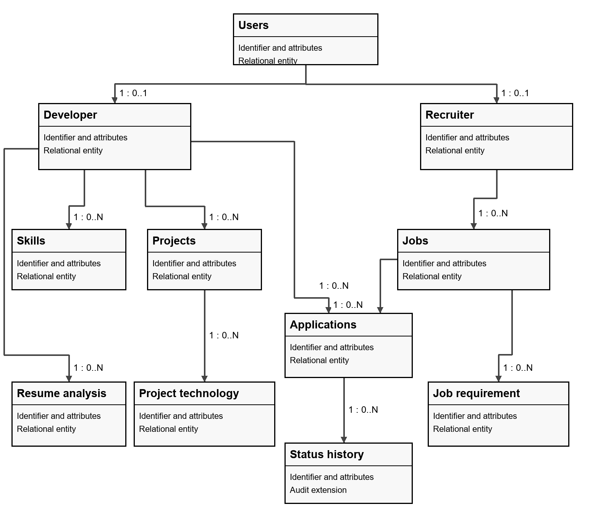
Fig 3.2 Entity relationships and cardinalities
The developer to job relationship is many to many and is resolved by Application. Each Application belongs to one Developer and one Job. Each Resume analysis and Skill belongs to one Developer. Each Job requirement belongs to one Job. The audit extension stores status transitions for an application.

3.3 Database Tables
Tables 3.1–3.4 describe the actual SQLAlchemy model columns. VARCHAR lengths are shown as String lengths in the model. Integer identifiers are surrogate primary keys. The profile user_id columns are unique foreign keys, so a user cannot have duplicate records in the same profile table.
Table 3.1 Account and profile tables
Table | Attribute | Type | Key or role
users | id | Integer | PK
users | name | String(120) | Attribute
users | email | String(190) | UNIQUE
users | password_hash | String(255) | Attribute
users | role | String(20) | Attribute
users | created_at | DateTime | Attribute
developer_profiles | id | Integer | PK
developer_profiles | user_id | Integer | FK users.id, UNIQUE
developer_profiles | bio | Text | Attribute
developer_profiles | phone | String(30) | Attribute
developer_profiles | location | String(100) | Attribute
developer_profiles | education | String(160) | Attribute
developer_profiles | experience | String(160) | Attribute
developer_profiles | github_url | String(250) | Attribute
developer_profiles | linkedin_url | String(250) | Attribute
developer_profiles | resume_path | String(255) | Attribute
recruiter_profiles | id | Integer | PK
recruiter_profiles | user_id | Integer | FK users.id, UNIQUE
recruiter_profiles | company_name | String(140) | Attribute
recruiter_profiles | company_description | Text | Attribute
recruiter_profiles | location | String(100) | Attribute
recruiter_profiles | website | String(250) | Attribute
Email is unique and the stored credential is a password hash. Phone and web links remain strings. User credentials are stored once and are referenced by the role specific profile.

3.3 Database Tables continued
Portfolio records are separated into skills, projects and project technologies. The developer owns each skill and project, and each technology belongs to a project. This avoids storing a comma separated technology list in the projects table.
Table 3.2 Portfolio tables
Table | Attribute | Type | Key or role
skills | id | Integer | PK
skills | developer_id | Integer | FK developer_profiles.id
skills | name | String(80) | Attribute
skills | level | String(30) | Attribute
skills | years | Float | Attribute
projects | id | Integer | PK
projects | developer_id | Integer | FK developer_profiles.id
projects | name | String(140) | Attribute
projects | description | Text | Attribute
projects | github_link | String(250) | Attribute
projects | project_link | String(250) | Attribute
project_technologies | id | Integer | PK
project_technologies | project_id | Integer | FK projects.id
project_technologies | name | String(80) | Attribute
project_technologies | category | String(40) | Attribute
project_technologies | version | String(40) | Attribute
project_technologies | added_at | DateTime | Attribute
The skills table has a uniqueness constraint on developer_id and name. Project technologies are unique on project_id and name. SQLAlchemy relationships provide access to these child rows, and form inputs are parsed into distinct entries before saving. The display properties can join values for presentation without reverting to a multivalued database column.

3.3 Database Tables continued
Jobs contain vacancy details while job_skills stores one named requirement per row. The recruiter_id foreign key connects each vacancy to its owner. Table 3.3 lists the job columns and requirement attributes.
Table 3.3 Job tables
Table | Attribute | Type | Key or role
jobs | id | Integer | PK
jobs | recruiter_id | Integer | FK recruiter_profiles.id
jobs | title | String(150) | Attribute
jobs | description | Text | Attribute
jobs | location | String(100) | Attribute
jobs | salary | String(100) | Attribute
jobs | experience_required | String(100) | Attribute
jobs | job_type | String(40) | Attribute
jobs | deadline | Date | Attribute
jobs | created_at | DateTime | Attribute
job_skills | id | Integer | PK
job_skills | job_id | Integer | FK jobs.id
job_skills | name | String(80) | Attribute
job_skills | importance | String(20) | Attribute
job_skills | minimum_years | Float | Attribute
job_skills | added_at | DateTime | Attribute
The job_id and name pair is unique in job_skills. Each job is linked to its recruiter through recruiter_id, and each requirement is linked to its job through job_id. These relationships support job management and skill matching without storing comma separated skill values in the jobs table.

3.3 Database Tables continued
Applications resolve the developer and job association. Resume analyses hold extracted information used by the matching function. Status history is a separate SQL audit table, created only when the demonstration script is run.
Table 3.4 Application and analysis tables
Table | Attribute | Type | Key or role
applications | id | Integer | PK
applications | developer_id | Integer | FK developer_profiles.id
applications | job_id | Integer | FK jobs.id
applications | status | String(30) | Attribute
applications | created_at | DateTime | Attribute
resume_analysis | id | Integer | PK
resume_analysis | developer_id | Integer | FK developer_profiles.id
resume_analysis | summary | Text | Attribute
resume_analysis | strengths | Text | Attribute
resume_analysis | missing_skills | Text | Attribute
resume_analysis | extracted_skills | Text | Attribute
resume_analysis | created_at | DateTime | Attribute
application_status_history | id | INT | PK
application_status_history | application_id | INT | FK applications.id
application_status_history | old_status | VARCHAR(30) | Nullable
application_status_history | new_status | VARCHAR(30) | Required
application_status_history | changed_at | DATETIME | Timestamp
CHAPTER 4

IMPLEMENTATION
The implementation connects browser forms to Flask routes, validates the request, reads or changes SQLAlchemy models and commits successful changes to MySQL. Jinja templates render the resulting records. The modules include accounts, portfolios, recruiter jobs, applications, resume analysis, skill matching and database demonstrations.

4.1 Installation Steps for Execution of the Project
Create a virtual environment in the devmatch-ai folder and install the project requirements. Create a MySQL database named devmatch_ai and an application user with access to that database. Copy .env.example to .env and set DATABASE_URL to the MySQL connection URL and SECRET_KEY to a private random value. Keep credentials outside source code.
python -m venv .venv
.venv\Scripts\Activate.ps1
pip install -r requirements.txt
flask --app app init-db
flask --app app seed-demo
flask --app app verify-dbms
flask --app app run --debug
Open the local Flask address in a browser. Run mysql_demo.sql in the same MySQL database to create the summary view, audit table and status trigger. The seed command supplies demonstration accounts and records; it should be used in a dedicated demo database. The verifier checks table rows, attributes and relationships.

4.2 Front-end Code
The front end is organized as Jinja templates extending base.html. Job cards are rendered from the current query results. Each application form includes a CSRF token, and developer only actions are conditionally displayed. The following code excerpts implement job listings and application submission in jobs.html.
{% for job in jobs %}
<article class="job-row">
<div class="small-muted">
{{job.recruiter.company_name}} · {{job.location}}
</div>
<h2>{{job.title}}</h2>
<p>{{job.description}}</p>
{% for skill in job.required_skills.split(',') %}
<span>{{skill.strip()}}</span>
{% endfor %}
</article>
{% endfor %}
The apply form submits to the Flask route for the selected job. The server rechecks identity, eligibility and existing applications; conditional rendering alone is not used as the access control.
<form method="post"
action="{{url_for('apply',id=job.id)}}">
<input type="hidden" name="csrf" value="{{csrf}}">
<button class="button small">Apply now ↗</button>
</form>
The developer dashboard summarizes skills, projects and applications, while the recruiter dashboard exposes job management and applicant review. Search forms use query parameters for role or skill and location. JavaScript enhances interaction, and responsive CSS adapts the page layout to available screen width.

4.3 Back-end Code
The backend defines the ten application tables as SQLAlchemy models. Password hashing is used for credentials. Session checks restrict authenticated workflows, and role checks protect developer and recruiter routes. Record ownership is checked before profile, job, skill or application changes.
Account and portfolio modules
# Login module excerpt
user = User.query.filter_by(email=email).first()
if user and check_password_hash(user.password_hash, password):
session.clear()
session['uid'] = user.id
return redirect(url_for('dashboard'))
# Profile module excerpt
profile = (user.developer if user.role == 'developer'
else user.recruiter)
for field in fields:
value = request.form.get(field, '').strip()
setattr(profile, field, value)
db.session.commit()
Registration validates account information and creates the role specific profile. Login checks the password hash and stores the authenticated user in the session. The developer portfolio module manages profile fields, skills and projects; technologies entered in a form are stored in project_technologies child rows. Recruiter profile fields describe the company rather than duplicating the shared credential record.
Application model and uniqueness
class Application(db.Model):
__tablename__ = 'applications'
id = db.Column(db.Integer, primary_key=True)
developer_id = db.Column(db.Integer,
db.ForeignKey('developer_profiles.id'), nullable=False)
job_id = db.Column(db.Integer,
db.ForeignKey('jobs.id'), nullable=False)
status = db.Column(db.String(30), default='Applied',
nullable=False)
created_at = db.Column(db.DateTime,
default=lambda: datetime.now(timezone.utc))
__table_args__ = (UniqueConstraint('developer_id',
'job_id', name='uq_application'),)

4.3 Back-end Code continued
The job module allows recruiters to create, edit and remove their own postings. Required skill values are stored as job_skills child records. The application module checks whether the job exists, whether its deadline has passed and whether the developer already applied. A successful submission creates an application and commits it to MySQL.
Skill matching and initial status
Let R be the set of case normalized job skill names and C the union of profile skill names and the latest extracted resume skills. The displayed score is round(100 × |R ∩ C| / |R|), or zero when R is empty. The shortlist decision uses the unrounded fraction and a strict threshold above 70 percent.
# Skill and project module excerpts
db.session.add(Skill(developer_id=current_user().developer.id,
name=name, level=request.form.get('level','Intermediate'),
years=max(0,min(50,float(request.form.get('years') or 0)))))
db.session.commit()
project.technology_items = [ProjectTechnology(name=technology)
for technology in parse_list_values(
request.form.get('technologies',''))]
db.session.add(project)
db.session.commit()
# Matching and application module excerpt
def should_shortlist(matched_count, required_count):
return (required_count > 0 and
100 * matched_count > 70 * required_count)
result = ats_match(developer, job)
status_value = ('Shortlisted' if
result['recommend_shortlist'] else 'Rejected')
db.session.add(Application(job_id=id,
developer_id=developer.id, status=status_value))
db.session.commit()
A candidate matching three of three skills scores 100 percent and meets the threshold; two of three scores 67 percent and does not. Exactly seven of ten skills produces 70 percent and is rejected initially. A job with no recorded skills also does not meet the threshold. The recruiter can change the status to Applied, Under Review, Shortlisted, Rejected or Selected after review.
The function exposes matched, missing, profile matched and resume matched skill lists. These lists explain the score. Matching is based on recorded names, not semantic equivalence, and does not use proficiency levels, years, minimum experience or protected personal characteristics.

4.3 Back-end Code continued
Resume analysis and storage modules
The resume route accepts a PDF within the configured 5 MB request limit, sanitizes the filename and extracts document text using PyMuPDF. Structured analysis is saved as a ResumeAnalysis row linked to the developer. The matching function uses the latest analysis rather than combining every historical upload.
# Resume analysis module excerpt
document = pymupdf.open(stream=data, filetype='pdf')
text = '\n'.join(page.get_text() for page in document)[:25000]
analysis = analyze_resume(text)
db.session.add(ResumeAnalysis(developer_id=developer.id,
summary=analysis['summary'],
strengths=', '.join(analysis['strengths']),
missing_skills=', '.join(analysis['missing_skills']),
extracted_skills=', '.join(analysis['skills'])))
db.session.commit()
# Job management module excerpt
job.skills = [JobSkill(name=skill) for skill in required]
db.session.add(job)
db.session.commit()
job = Job.query.filter_by(id=id,
recruiter_id=current_user().recruiter.id).first_or_404()
db.session.delete(job)
db.session.commit()
When a Gemini API key is configured, extracted resume text is submitted for structured analysis. Without a key or when the analysis request fails, the local extraction path identifies supported skills and returns a deterministic result. The career advisor uses the developer’s profile and current job listings as context. It requires the configured AI service.
Local development can store PDF files in the upload directory. Production configuration uses a private Supabase bucket, and the authenticated resume route retrieves the file. MySQL stores the application records and resume path; Supabase’s PostgreSQL database is not used by this project.

4.3 Back-end Code continued
SQL queries view and trigger
The supplied mysql_demo.sql demonstrates joins, grouping, filtering, a view and status auditing. The following view combines job ownership with application counts, including jobs with no applicants because the application join is a LEFT JOIN.
CREATE OR REPLACE VIEW job_application_summary AS
SELECT j.id AS job_id, j.title, r.company_name,
COUNT(a.id) AS applicant_count,
SUM(CASE WHEN a.status = 'Shortlisted'
THEN 1 ELSE 0 END) AS shortlisted_count
FROM jobs j
JOIN recruiter_profiles r ON r.id = j.recruiter_id
LEFT JOIN applications a ON a.job_id = j.id
GROUP BY j.id, j.title, r.company_name;
The status trigger creates an audit row only when an UPDATE changes the application status. The SQL script separately backfills initial status records for existing applications. It does not install an INSERT trigger for every future application.
DELIMITER $$
CREATE TRIGGER log_application_status
AFTER UPDATE ON applications FOR EACH ROW
BEGIN
IF OLD.status <> NEW.status THEN
INSERT INTO application_status_history
(application_id, old_status, new_status)
VALUES (NEW.id, OLD.status, NEW.status);
END IF;
END$$
DELIMITER ;
The script also uses ALTER TABLE to widen the salary column and demonstrates application INSERT, UPDATE and DELETE in a transaction ending in ROLLBACK. This keeps the transaction’s test application from persisting. Website CRUD actions commit their changes; a new request reads updated records. The /dbms-demo page queries MySQL again and disables browser caching.
CHAPTER 5

INTERPRETATION OF RESULT
This chapter presents the main results of DevMatch AI. The snapshots show developer portfolio management, job search and skill matching, and recruiter review of applications. Each figure is followed by an interpretation of the displayed result.

5.1 Result Snapshots
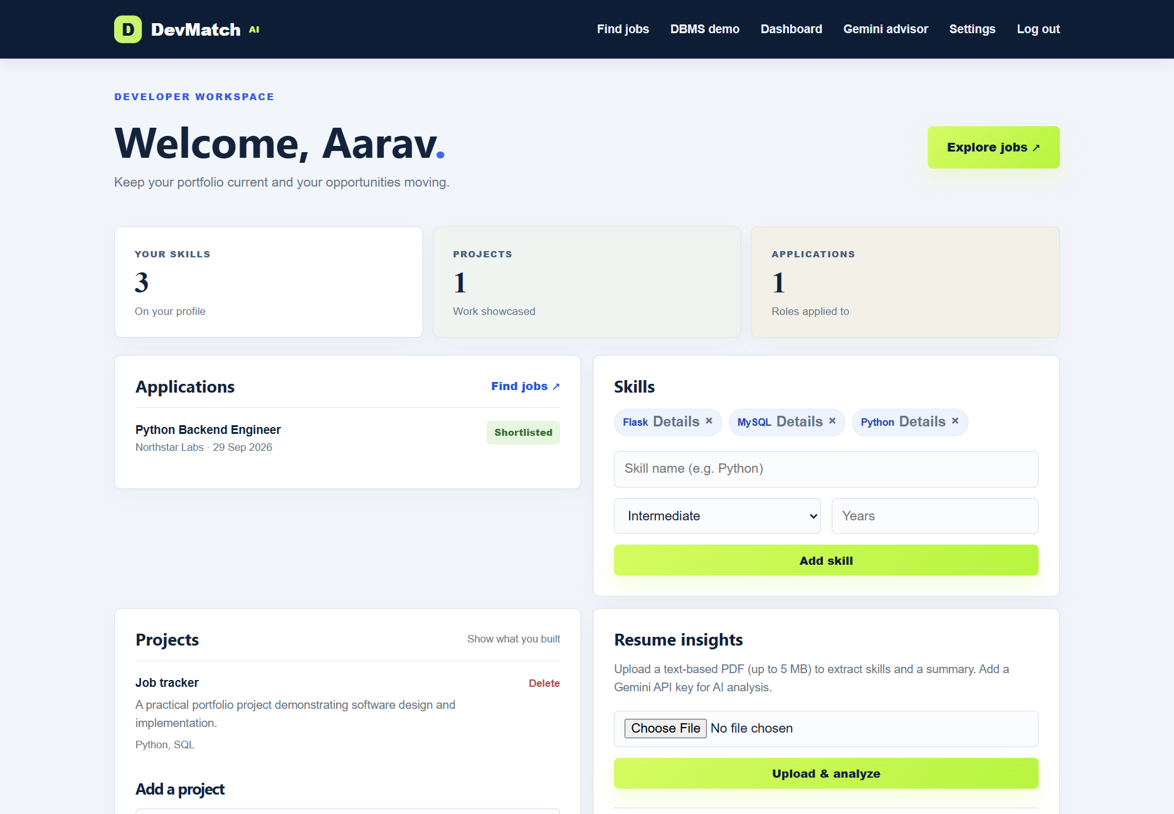
Fig 5.1 Developer dashboard
Interpretation: The developer dashboard displays the stored profile, skills, projects and applications. The sample developer has three skills, one project and one application. The application status is displayed alongside the job title. Skills and projects are stored in child tables linked to the developer profile, while resume analysis is linked separately. This result shows that portfolio information and application tracking are brought together through relational database queries.
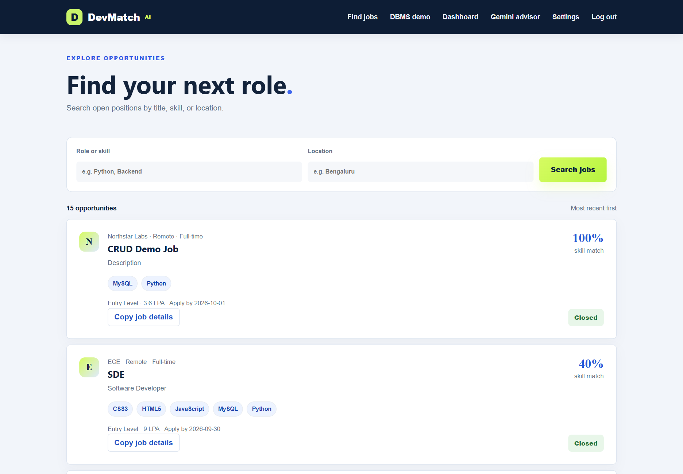
Fig 5.2 Job listing and skill match
Interpretation: The job page displays vacancies with company details, location, required skills and the developer’s skill match. Search fields filter the current database records. The match is calculated from the intersection of recorded job skills with profile skills and the latest extracted resume skills. The application action depends on login, the closing date and whether an application already exists. This result connects the jobs, job_skills, recruiter_profiles and applications tables in one workflow.
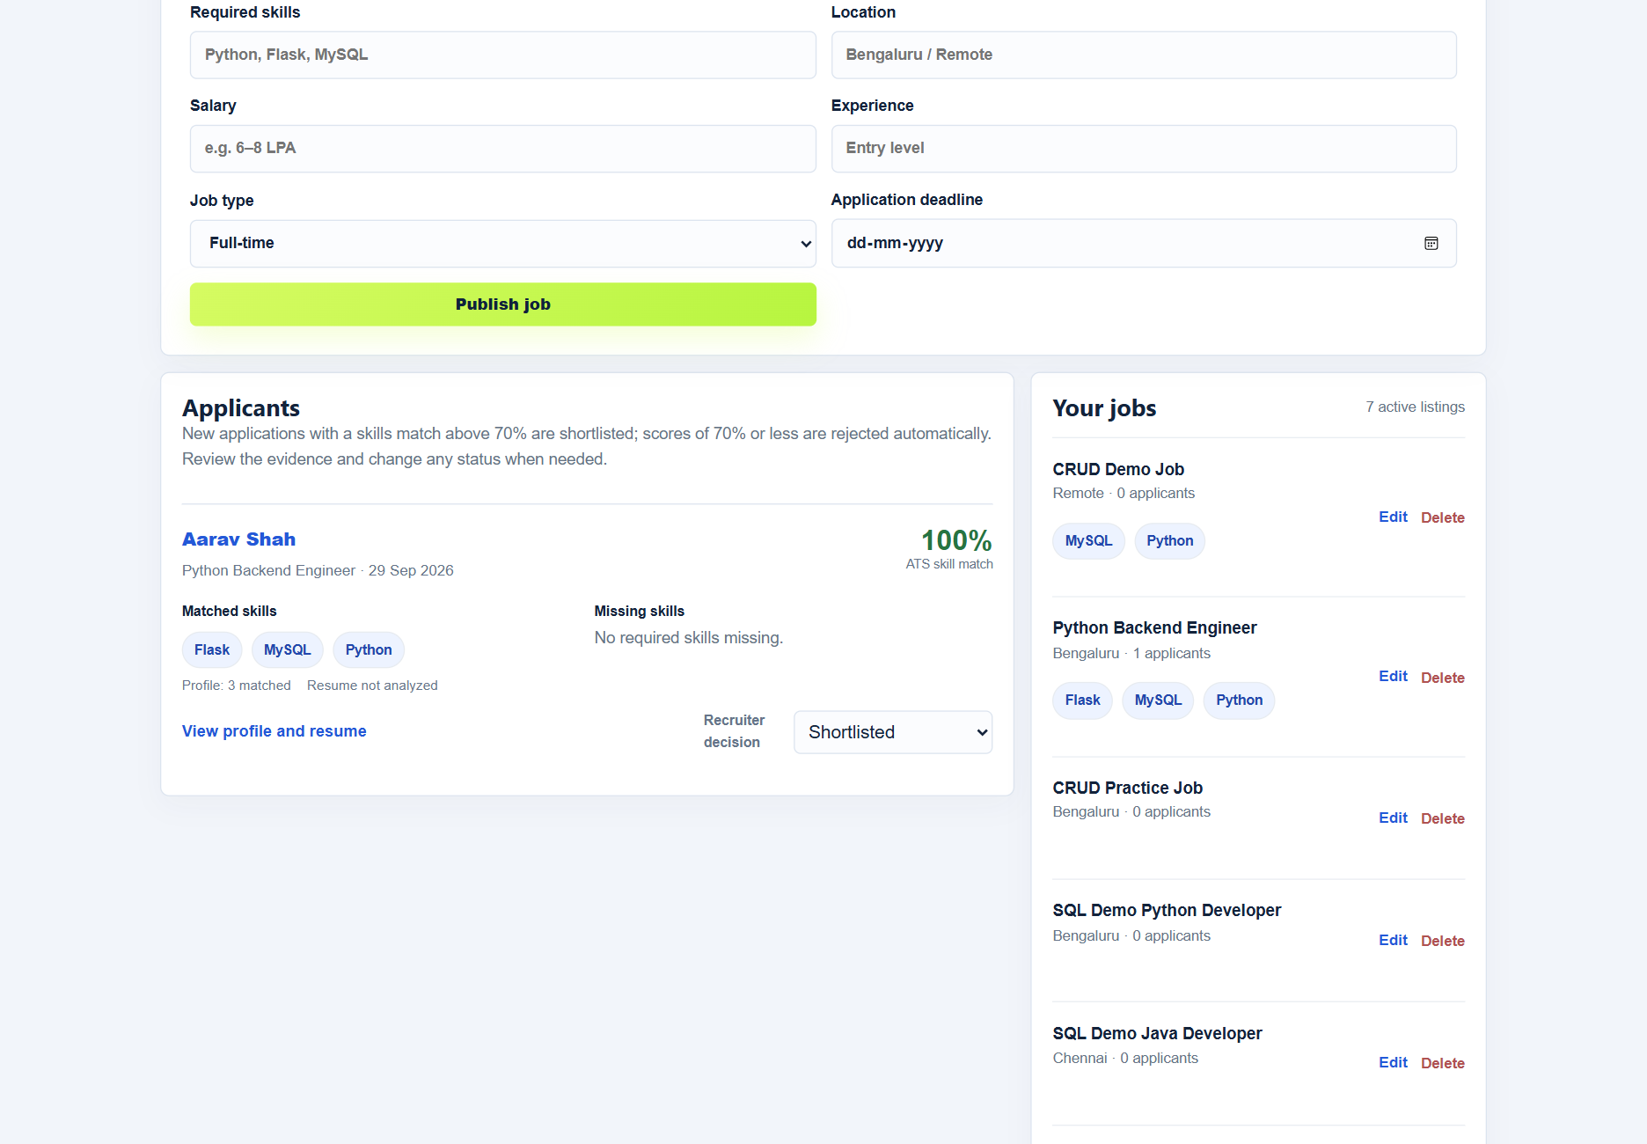
Fig 5.3 Recruiter applicant review
Interpretation: The recruiter dashboard displays applicants for the recruiter’s own jobs. The illustrated candidate matches Python, Flask and MySQL, giving a 100 percent skill match. The screen identifies the profile as the evidence source and states that the resume has not been analyzed. Matched and missing skills help the recruiter interpret the score. The status control allows the recruiter to review and revise the application decision, which is saved to the applications table.
CHAPTER 6

CONCLUSION AND FUTURE SCOPE
DevMatch AI implements a relational developer portfolio and hiring workflow with separate developer and recruiter accounts. The database connects profiles, skills, projects, vacancies, applications and resume analyses. The interface gives users a consistent way to maintain their information and gives recruiters a visible record of candidate skill matches and application decisions.
Database verification confirmed the required row counts, attributes and relationships for all ten application tables. The SQL audit extension was also present with related history records. The project demonstrates primary and foreign keys, uniqueness constraints, normalized repeating values, CRUD, joins, filtering, grouping, a summary view and a status change trigger. The website and SQL demonstration query the same MySQL database.
The project develops practical understanding of ER modeling, mapping cardinalities to foreign keys and bridge tables, removing multivalued attributes and connecting database transactions to user workflows. It also illustrates why ownership checks and constraints must support interface validation. Explainable matching shows how a computed result can be connected to stored evidence.
Future work can introduce schema migration tooling, automated regression tests, concurrency handling for duplicate submissions and a more complete event history. Resume analysis can add OCR for scanned documents, a controlled skill vocabulary and explicit evaluation against labeled examples. Matching can account for verified proficiency and job priorities, while keeping recruiter review available.
Further extensions include interview scheduling, notifications, analytics and accessibility improvements. Public deployment would benefit from file scanning, backups, monitoring and resume retention controls. MySQL remains the application database.

REFERENCES
[1] Oracle, MySQL 8.4 Reference Manual. https://dev.mysql.com/doc/refman/8.4/en/.
[2] Pallets, Flask Documentation. https://flask.palletsprojects.com/en/stable/.
[3] SQLAlchemy authors, SQLAlchemy 2.0 ORM Documentation. https://docs.sqlalchemy.org/en/20/orm/.
[4] Artifex, PyMuPDF Documentation. https://pymupdf.readthedocs.io/en/latest/.
[5] Google, Gemini API Documentation. https://ai.google.dev/gemini-api/docs.
[6] Supabase, Storage Documentation. https://supabase.com/docs/guides/storage.

