Deep Learning for Edge Computing in Indian Smart Cities: Real Time Analytics on Low Power Devices
Growing technologies converting all manual works to virtual environment where human can perform all manual activities virtually sitting at on place. Online health monitoring, shopping, online agriculture temperature monitoring, online road traffic monitoring and many more are the examples of virtual monitoring.
Virtual monitoring consists of small sensors which runs on battery power to sense its environment data and report to High computing devices like Cloud servers who will processed data to make decision. This sensors can be deployed to sense road traffic, human body vitals, smart home activities like electricity monitoring and many more.
Above virtual environment make human work easier but raised some issues like latency while transferring data from sensor to cloud, data leakage to cloud which leads to privacy issue. To combat against this issues we are utilizing Edge servers along with Deep Learning algorithms where Edge servers will deployed at shorter distance with heavy computation resources which will accept data from tiny sensors and then apply deep learning algorithm to processed data and to make decision and this decision data will be reported to cloud server.
Cloud server will received only decision data so privacy issue will be solved and Edge will send small processed data output so latency will also be reduced.
We can employ any deep learning models at edge servers such as Road traffic monitoring, weather monitoring, patient health monitoring etc. Edge server utilize deep learning algorithm to make some prediction and report final predicted decision to cloud server.
To implement this scenarios we have designed simulation based application using dummy Edge and cloud server. Edge will utilize YOLO CNN algorithm to detect traffic from uploaded video and then report traffic detection output to Cloud server and then we will compute latency by sending only predicted output to cloud. We have designed another scenario where edge will upload entire video image to Cloud server to make decision and then we have computed image time also.
To implement this project we have designed following modules
Cloud Server: this module will start Cloud server application which receive data from Edge server and then store processed data in memory
Edge Server: this module consists of following sub modules
- Train & Load Deep Learning Algorithm: this module will train and load YOLO CNN deep learning algorithm and then trained model will be applied on test data to calculate prediction accuracy
- Run Traffic Detection & Counting: here sensor will upload road traffic video and then post each video frame to edge server for detecting traffic and then detected traffic and processed output will be saved at Edge server. Note: we don’t have sensors so we are uploading traffic video
- Run Cloud to Report Image Data: in this module we are uploading traffic complete image to Cloud and then computing latency
- Run Edge to Report Processed Data: in this module we are uploading only processed and detected output to cloud using edge server and then computing latency
- Delay Comparison Graph: in this module we are showing latency comparison between Cloud processing complete image data and the processed data sent by edge server.
SCREEN SHOTS
To run project double click on ‘runCloudServer.bat’ file to start cloud server and then will get below page
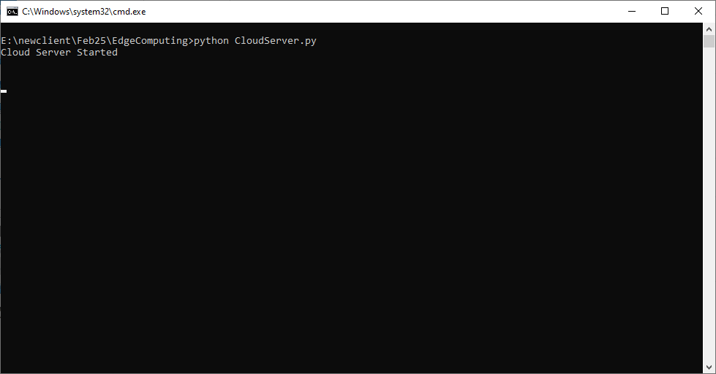
In above screen cloud server started and now double click on ‘run.bat’ file to start Edge Server and then will get below page
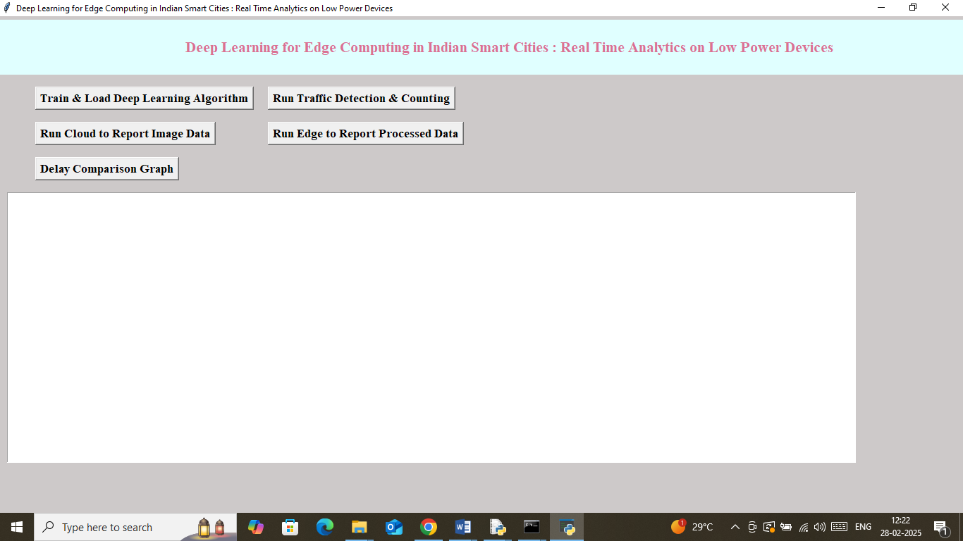
In above screen click on ‘Train & Load Deep Learning Algorithm’ button to train and load Deep Learning algorithm and then will get below output
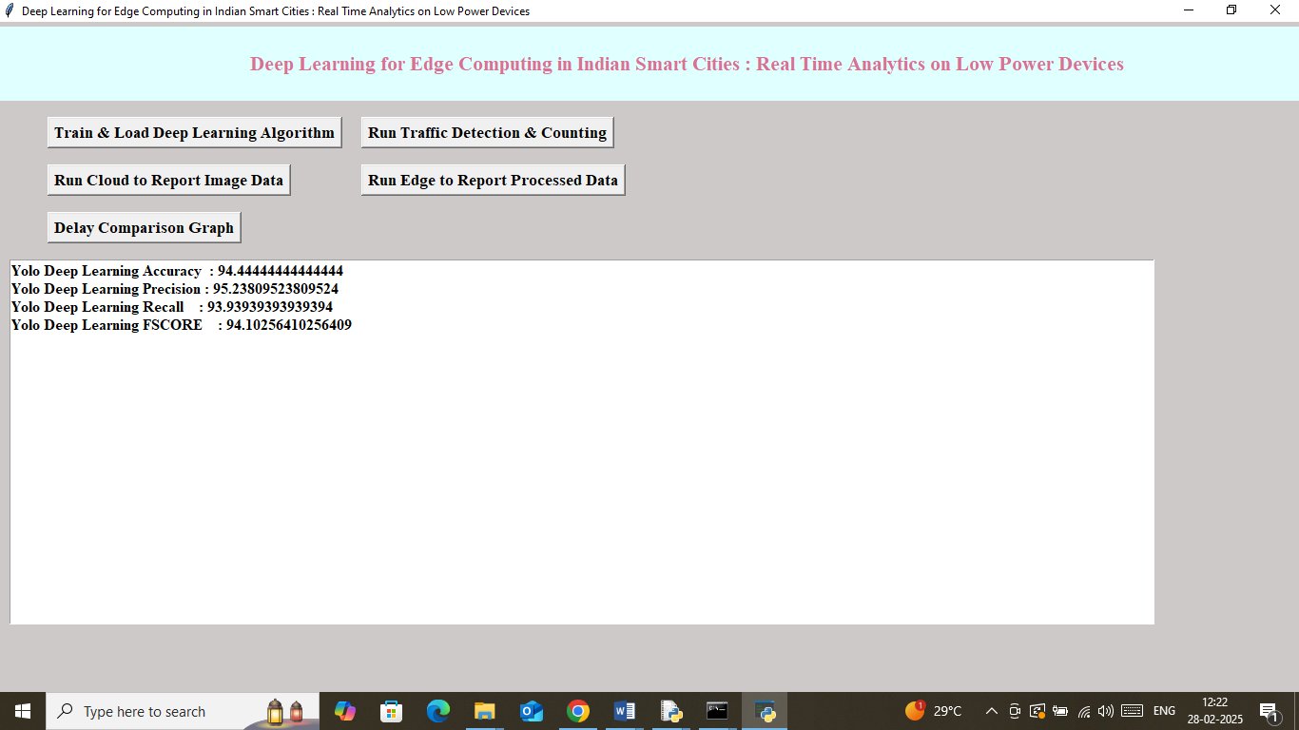
In above screen Deep Learning training completed and got 94% accuracy on test data prediction and now click on ‘Run Traffic Detection & Counting’ button to upload video and then will get below output
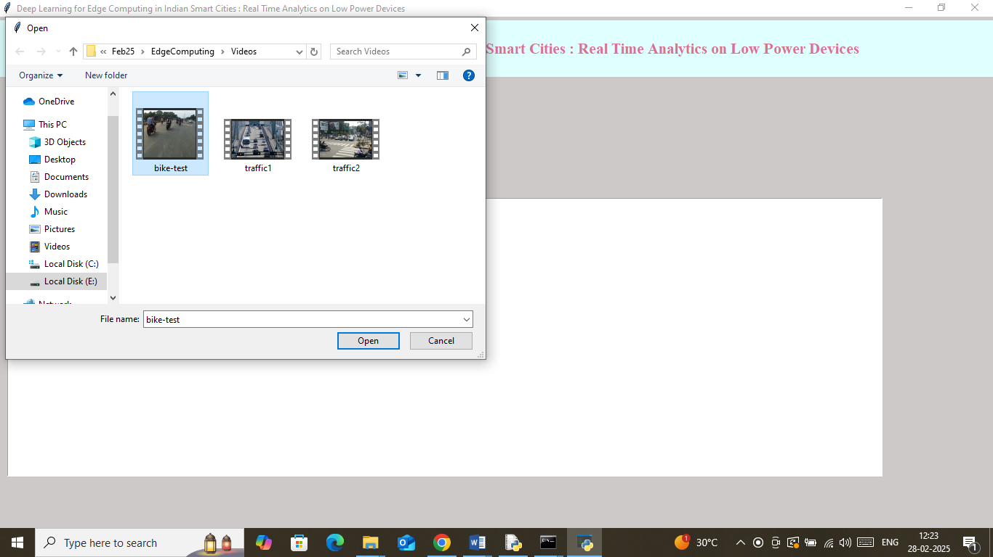
In above screen selecting and uploading video file and then click on ‘Open’ button to get below output
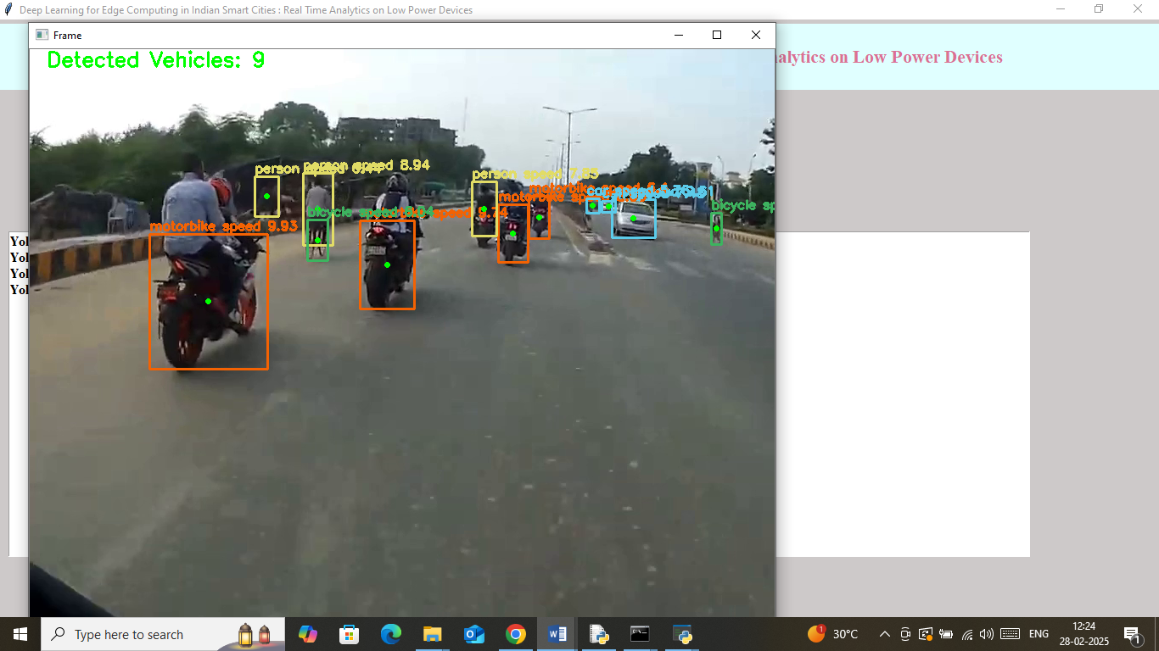
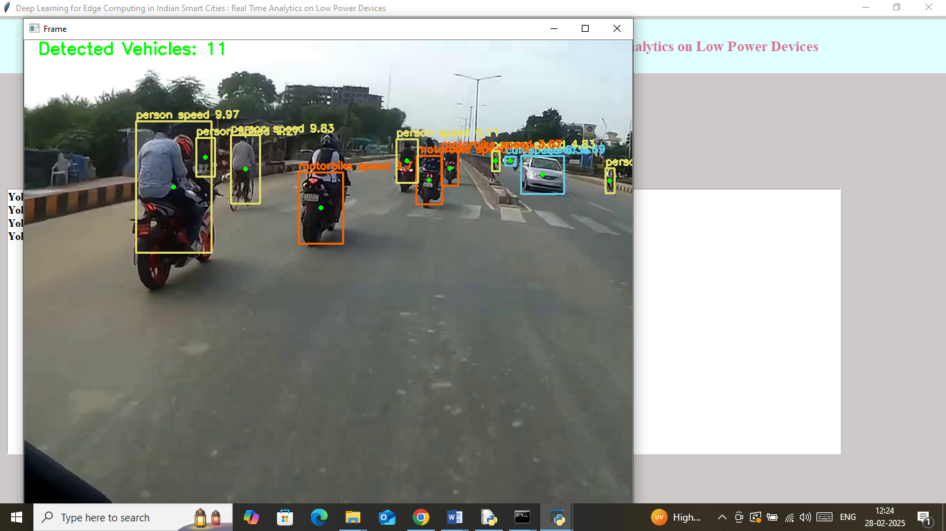
In above screen video started playing and then detecting traffic count and you can press ‘q’ key from keyboard to stop playing or play till the end. Once after processing you can click on ‘Run Cloud to Report Image Data’ button to upload entire image to cloud and then compute latency
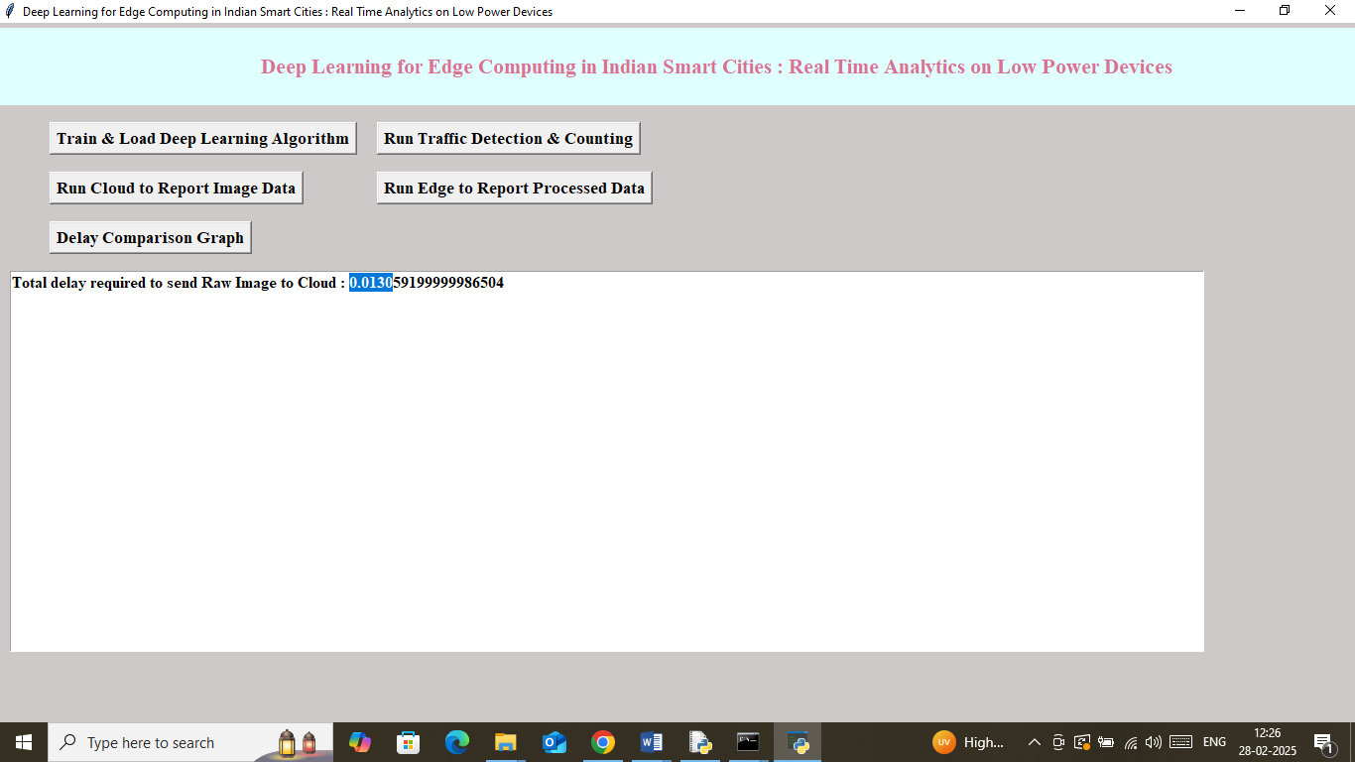
In above screen to send entire image raw data to Cloud Network taken 0.013 seconds and now click on ‘Run Edge to Report Processed Data’ button to send only detected and processed output to cloud and then will get below page
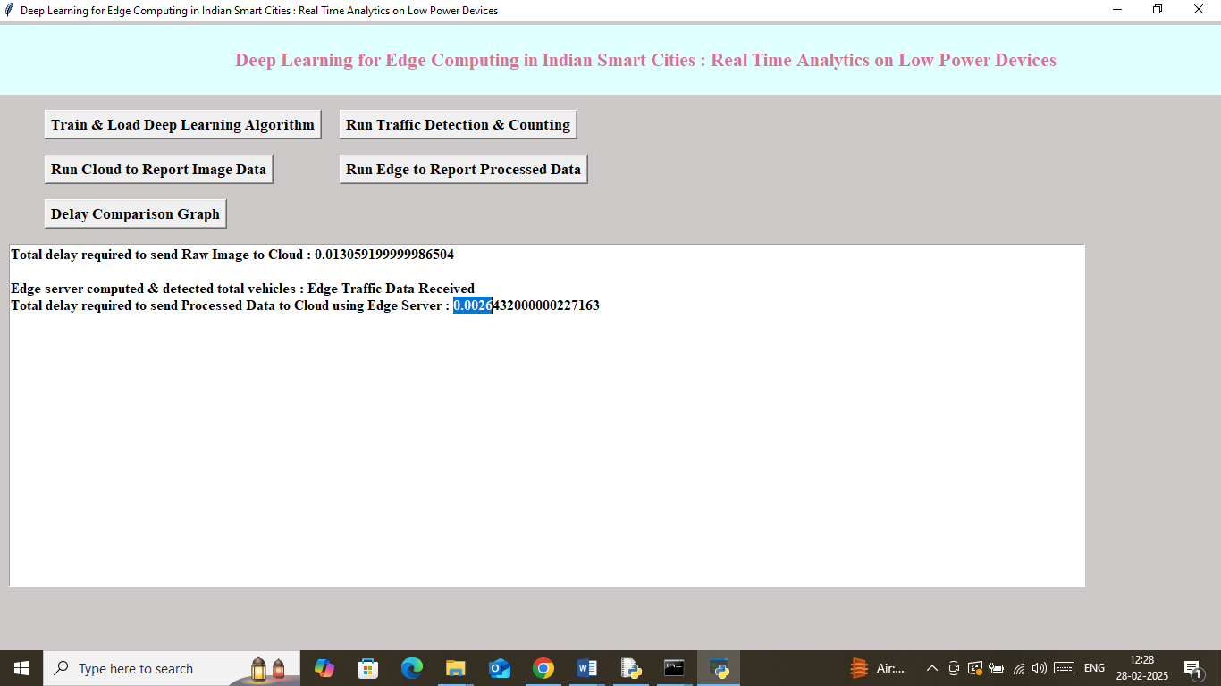
In above screen to send processed data edge server took ‘0.0026’ seconds which are lesser than sending entire data to cloud. In below cloud screen we can see entire log details
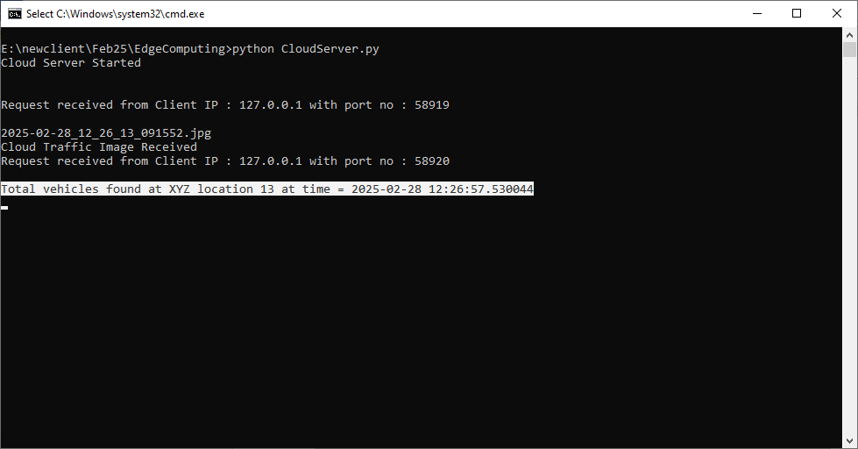
In above screen cloud server received edge data displaying in white colour text which saying 13 vehicles detected at XYZ location at given time. Similarly you can upload video and perform latency comparison by sending full or processed data to cloud. Now click on ‘Delay Comparison Graph’ button to get below page
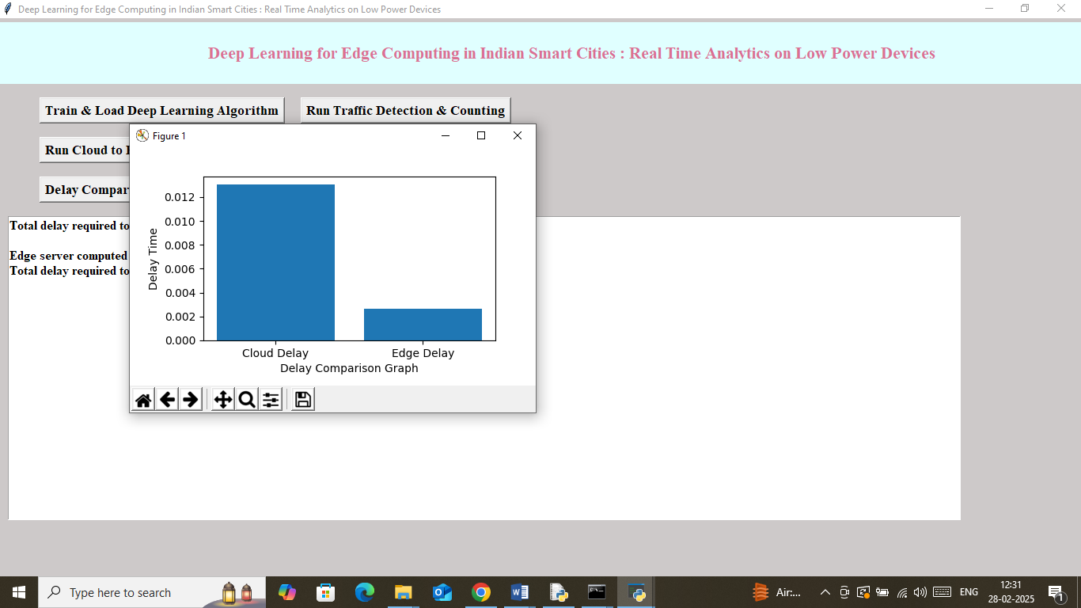
In above delay or latency graph x-axis represents ‘Technique Name’ and y-axis represents delay or latency time and then can see ‘Edge Server’ took only 25% time to send complete data to cloud.
So by using edge servers we can send and receive data faster without leaking privacy.

