Department of Computer Science and Engineering
2025-2026
Odd Semester


DATA STRUCTURES AND ALGORITHMS-3
(25CS2103E)

Optimal Binary Search Tree Using Dynamic Programming

Nikshitha 2520030512
Manasvi Nilesh Ghag 2520030335
Sai Pavani 2520030046

COURSE INSTRUCTOR

Dr. J Sirisha Devi
Professor
Department of Computer Science and Engineering
Optimal Binary Search Tree Using Dynamic Programming

1.1 Binary Search Trees
A Binary Search Tree (BST) is a binary tree in which every node stores one key, and the keys follow one ordering rule: every key in the left subtree of a node is smaller than the node's key, and every key in the right subtree is larger. Because of this rule, a search never has to look at the whole tree. It starts at the root, compares the target with the key stored there, and then continues only into the left or the right subtree. Each step goes one level deeper, so the number of comparisons needed to find a key is equal to its level in the tree, where the root is at level 1.
The same set of keys can be stored in many different BSTs. For n keys there are Catalan(n) possible shapes: 5 shapes for 3 keys, 14 for 4 keys and 9,694,845 for 15 keys. All of them are valid search trees, but they do not all search equally fast.
1.2 Why an Ordinary BST Can Be Slow
An ordinary BST is shaped by the order in which keys are inserted, and a balanced BST is shaped only by the number of keys. Neither of them looks at how often each key is searched. In real systems the search frequencies are rarely equal: a few keys are searched again and again, while others are searched only occasionally. If a frequently searched key ends up deep in the tree, every one of its searches pays for the extra levels. A tree with a small height can therefore still have a large total search cost, because height alone does not say where the popular keys are.
1.3 Optimal Binary Search Tree
An Optimal Binary Search Tree (OBST) is the BST that has the smallest total search cost for a given set of keys and their search frequencies. If key ai is searched p[i] times and sits at level(ai), finding it costs level(ai) comparisons each time, so the cost of a tree T is:
Cost(T) = Σ p[i] × level(ai), for i = 1 … n
Dividing this by the total frequency Σ p[i] gives the expected (average) number of comparisons per search. The optimal tree usually places frequently searched keys near the root and rarely searched keys lower down, while still obeying the BST ordering rule.
Example. Take the keys 10, 20 and 30, searched 5, 1 and 2 times (total 8). The table compares three of the five possible tree shapes.
Tree shape | Levels (10, 20, 30) | Cost(T) | Expected cost
Balanced: root 20, children 10 and 30 | 2, 1, 2 | 5×2 + 1×1 + 2×2 = 15 | 15 / 8 = 1.875
Chain: 10 → 20 → 30 (each a right child) | 1, 2, 3 | 5×1 + 1×2 + 2×3 = 13 | 13 / 8 = 1.625
Optimal: root 10, right child 30, 20 left of 30 | 1, 3, 2 | 5×1 + 1×3 + 2×2 = 12 | 12 / 8 = 1.500

The balanced tree has the smallest height, yet it is the most expensive of the three, because it puts the most popular key (10, searched 5 times) on level 2. The optimal tree puts 10 at the root and pays only 3 comparisons for the rarely searched key 20. The two shapes not shown cost 15 and 19, so 12 is the minimum.
1.4 Problem Statement
Given n keys a1 < a2 < … < an in sorted order, and a search frequency p[i] > 0 for each key ai, build the binary search tree whose total cost Σ p[i] × level(ai) is minimum, and report that minimum cost, the total frequency, the expected search cost (minimum cost divided by total frequency) and the shape of the tree. Only successful searches are considered: every search is for one of the given keys, so there are no unsuccessful-search frequencies (q values) and no dummy nodes.
1.5 Why Dynamic Programming Solves It
Trying every tree shape is not practical, because the number of shapes grows exponentially (Catalan(n) shapes). Dynamic programming works here because the problem has the two properties DP needs.
• Optimal substructure: if key ak is the root of an optimal tree for the keys ai+1 … aj, then its left subtree must be an optimal tree for the keys left of ak, and its right subtree an optimal tree for the keys right of ak. If either subtree could be improved, the whole tree could be improved too.
• Overlapping subproblems: every subproblem is a contiguous range of keys (an interval). The same interval appears again and again, as a subtree under many different choices of root. There are only about n²/2 intervals, so each one is solved once and its answer is stored in a table.
Because the subproblems are intervals and each interval is built from shorter intervals, this technique is called interval dynamic programming. The tables are filled from the shortest ranges to the longest, so every value needed is already available. Section 2 gives the exact recurrence.
1.6 Real-World Applications
• Dictionaries and spell checkers: common words are looked up far more often than rare ones, so placing them near the root speeds up most lookups.
• Compilers: the symbol table and the table of reserved keywords are searched for every token. Keywords such as "int" or "if" appear much more often than others.
• Databases: index structures and query optimisers use access statistics to keep frequently requested records cheap to reach.
• Search engines and autocomplete: popular queries and prefixes are searched much more often than unusual ones, so a frequency-aware structure reduces the average lookup time.
1.7 Our Solution
We built the Optimal BST Designer, a web application with two parts. The Java Spring Boot backend does all of the algorithm work: it checks the input, runs the interval DP, builds the optimal tree and returns everything as JSON from one endpoint, POST /api/obst/solve. The React frontend (built with Vite) never computes the DP itself. It only sends the input and displays the response. The website has the following features:
• Input form: a table with one row per key, where the user types a key and its frequency. It starts with one empty row; "+ Add key" adds rows up to 15 keys, × removes a row, and mistakes are shown next to the field while typing.
• Result card: shows the expected search cost to 4 decimal places with its working (minimum cost / total frequency), plus the minimum weighted cost, the total frequency and the number of keys.
• Optimal tree visualization: draws the optimal tree with labelled depth lines. Nodes searched more often are drawn larger and darker.
• View DP Table: shows the W, C and R values in the staircase format used in our course. Clicking any cell shows how it was calculated and highlights the cells it used.
• Search Simulation: the user enters a key and the search path is animated on the tree one node at a time, with the number of comparisons and whether the key was found.
• Minimum Cost Breakdown: a table listing every key with its frequency, depth, comparisons and cost contribution (frequency × depth), with totals that add up to the minimum cost. Hovering a row highlights that node in the tree.
• Hover tooltips on nodes: pointing at a node (or tapping it on a touch screen) shows its key, frequency, number of comparisons, cost contribution and the search path from the root.

ALGORITHM / PSEUDO CODE

2.1 Notation
The keys are a1 < a2 < … < an and p[k] is the search frequency of key ak. As in our course, the tables use indices 0 … n, and the pair (i, j) with i ≤ j stands for the keys ai+1, …, aj. So (i, i) is an empty range, and (0, n) is the full set of keys.
• W[i][j] — the total frequency of the keys ai+1 … aj.
• C[i][j] — the minimum cost of a BST built from the keys ai+1 … aj.
• R[i][j] — the index k of the key chosen as the root of that optimal tree.
This is the textbook OBST formulation with successful frequencies only: there are no q values and no dummy (external) nodes, so every q term in the textbook formula is 0.
2.2 Recurrence
Base case (empty range), for 0 ≤ i ≤ n:
W[i][i] = 0, C[i][i] = 0, R[i][i] = 0
For i < j:
W[i][j] = W[i][j−1] + p[j]
C[i][j] = min over i < k ≤ j { C[i][k−1] + C[k][j] } + W[i][j]
R[i][j] = the k that gives the minimum (ties keep the smallest k)
If ak is chosen as the root of (i, j), the left subtree holds the keys of (i, k−1) and the right subtree the keys of (k, j). Hanging both subtrees one level below the root adds one comparison to every search in the range, and the root itself costs one comparison per search. Together this adds exactly one p for every key in the range, which is W[i][j]. That is why W[i][j] is added once, outside the minimum.
The tables are filled by diagonal, j − i = 0, 1, …, n, because every C value on the right-hand side belongs to a shorter range. When all the tables are complete, the answers are:
• minimum cost = C[0][n], total frequency = W[0][n], root of the whole tree = R[0][n]
• expected search cost = C[0][n] / W[0][n], shown to 4 decimal places
2.3 Algorithm Steps
1. Read the keys and their frequencies from the input form. The backend checks them (Section 2.8) and sorts them by key if needed, so that a1 < a2 < … < an.
2. Set p[k] to the frequency of ak for k = 1 … n.
3. Create three (n+1) × (n+1) tables W, C and R. Set W[i][i] = C[i][i] = R[i][i] = 0 for every i. This is diagonal j − i = 0.
4. For each diagonal d = 1, 2, …, n, and for each i from 0 while i + d ≤ n, let j = i + d.
5. Compute W[i][j] = W[i][j−1] + p[j].
6. For every k from i+1 to j, compute C[i][k−1] + C[k][j]. Keep the smallest value and the k that gave it. Only a strictly smaller value replaces the current best, so on a tie the smaller k stays.
7. Set C[i][j] = smallest value + W[i][j] and R[i][j] = that k.
8. After the last diagonal, read the minimum cost C[0][n] and the total frequency W[0][n], and compute the expected search cost C[0][n] / W[0][n].
9. Build the tree recursively from R: the root of (i, j) is ak with k = R[i][j], its left subtree is built from (i, k−1) and its right subtree from (k, j). An empty range (i = j) gives no subtree.
10. Return the tables, the tree and the costs to the frontend, which displays them.
2.4 Pseudocode
Computing the tables
Algorithm OBST(a[1..n], p[1..n])
for i ← 0 to n do
W[i][i] ← 0; C[i][i] ← 0; R[i][i] ← 0
for d ← 1 to n do // diagonal j - i = d
for i ← 0 to n - d do
j ← i + d
W[i][j] ← W[i][j-1] + p[j]
best ← ∞; bestK ← -1
for k ← i + 1 to j do
sum ← C[i][k-1] + C[k][j]
if sum < best then // strict <, so ties keep the smaller k
best ← sum; bestK ← k
C[i][j] ← best + W[i][j]
R[i][j] ← bestK
expected ← C[0][n] / W[0][n]
return W, C, R, expected

Building the tree
Algorithm BuildTree(i, j) // keys a[i+1..j]
if i = j then
return null // empty range, no subtree
k ← R[i][j]
node ← new node with key a[k] and frequency p[k]
node.left ← BuildTree(i, k - 1)
node.right ← BuildTree(k, j)
return node

root ← BuildTree(0, n)

2.5 Worked Example
Input: keys 10, 20, 30, 40 with frequencies 4, 2, 6, 3, so n = 4. We ran this input through our backend solver; every value below is the solver's output, and each calculation is shown.
k | 1 | 2 | 3 | 4
Key ak | 10 | 20 | 30 | 40
p[k] | 4 | 2 | 6 | 3

Diagonal j − i = 0 (empty ranges)
• W[i][i] = 0, C[i][i] = 0, R[i][i] = 0 for i = 0, 1, 2, 3, 4.
Diagonal j − i = 1 (one key, so only one possible root)
• (0,1): W = W[0][0] + p1 = 0 + 4 = 4. k = 1: C[0][0] + C[1][1] = 0. C = 0 + 4 = 4, R = 1.
• (1,2): W = W[1][1] + p2 = 0 + 2 = 2. k = 2: C[1][1] + C[2][2] = 0. C = 0 + 2 = 2, R = 2.
• (2,3): W = W[2][2] + p3 = 0 + 6 = 6. k = 3: C[2][2] + C[3][3] = 0. C = 0 + 6 = 6, R = 3.
• (3,4): W = W[3][3] + p4 = 0 + 3 = 3. k = 4: C[3][3] + C[4][4] = 0. C = 0 + 3 = 3, R = 4.
Diagonal j − i = 2
• (0,2): W = W[0][1] + p2 = 4 + 2 = 6. k = 1: C[0][0] + C[1][2] = 0 + 2 = 2; k = 2: C[0][1] + C[2][2] = 4 + 0 = 4. Min = 2 (k = 1). C = 2 + 6 = 8, R = 1.
• (1,3): W = W[1][2] + p3 = 2 + 6 = 8. k = 2: C[1][1] + C[2][3] = 0 + 6 = 6; k = 3: C[1][2] + C[3][3] = 2 + 0 = 2. Min = 2 (k = 3). C = 2 + 8 = 10, R = 3.
• (2,4): W = W[2][3] + p4 = 6 + 3 = 9. k = 3: C[2][2] + C[3][4] = 0 + 3 = 3; k = 4: C[2][3] + C[4][4] = 6 + 0 = 6. Min = 3 (k = 3). C = 3 + 9 = 12, R = 3.
Diagonal j − i = 3
• (0,3): W = W[0][2] + p3 = 6 + 6 = 12. k = 1: C[0][0] + C[1][3] = 0 + 10 = 10; k = 2: C[0][1] + C[2][3] = 4 + 6 = 10; k = 3: C[0][2] + C[3][3] = 8 + 0 = 8. Min = 8 (k = 3). C = 8 + 12 = 20, R = 3.
• (1,4): W = W[1][3] + p4 = 8 + 3 = 11. k = 2: C[1][1] + C[2][4] = 0 + 12 = 12; k = 3: C[1][2] + C[3][4] = 2 + 3 = 5; k = 4: C[1][3] + C[4][4] = 10 + 0 = 10. Min = 5 (k = 3). C = 5 + 11 = 16, R = 3.
Diagonal j − i = 4 (the whole set of keys)
• (0,4): W = W[0][3] + p4 = 12 + 3 = 15. k = 1: C[0][0] + C[1][4] = 0 + 16 = 16; k = 2: C[0][1] + C[2][4] = 4 + 12 = 16; k = 3: C[0][2] + C[3][4] = 8 + 3 = 11; k = 4: C[0][3] + C[4][4] = 20 + 0 = 20. Min = 11 (k = 3). C = 11 + 15 = 26, R = 3.
No minimum in this example is a tie, so the tie rule does not change any R value.
Final W / C / R table (course staircase format)
Each row is one diagonal j − i and each column is i. A cell lists W, C and R for the range (i, j) with j = i + row number, and the subscript ij names that range.
j − i \ i | 0 | 1 | 2 | 3 | 4
j − i = 0 | w00 = 0  c00 = 0  r00 = 0 | w11 = 0  c11 = 0  r11 = 0 | w22 = 0  c22 = 0  r22 = 0 | w33 = 0  c33 = 0  r33 = 0 | w44 = 0  c44 = 0  r44 = 0
j − i = 1 | w01 = 4  c01 = 4  r01 = 1 | w12 = 2  c12 = 2  r12 = 2 | w23 = 6  c23 = 6  r23 = 3 | w34 = 3  c34 = 3  r34 = 4
j − i = 2 | w02 = 6  c02 = 8  r02 = 1 | w13 = 8  c13 = 10  r13 = 3 | w24 = 9  c24 = 12  r24 = 3
j − i = 3 | w03 = 12  c03 = 20  r03 = 3 | w14 = 11  c14 = 16  r14 = 3
j − i = 4 | w04 = 15  c04 = 26  r04 = 3

2.6 Building the Optimal Tree from R
• BuildTree(0,4): R[0][4] = 3, so the root is a3 = 30. Left range (0,2), right range (3,4).
• BuildTree(0,2): R[0][2] = 1, so the left child of 30 is a1 = 10. Its left range (0,0) is empty; its right range is (1,2).
• BuildTree(1,2): R[1][2] = 2, so 20 is the right child of 10.
• BuildTree(3,4): R[3][4] = 4, so the right child of 30 is a4 = 40.
30 level 1
/ \
10 40 level 2
\
20 level 3

Result: minimum cost C[0][4] = 26, total frequency W[0][4] = 15, expected search cost = 26 / 15 = 1.7333. Check from the tree: 6×1 + 4×2 + 3×2 + 2×3 = 6 + 8 + 6 + 6 = 26.
2.7 Time and Space Complexity
• Time: O(n³). There are about n²/2 ranges (i, j), and each one tries up to n roots k, each in O(1) time. Building the tree afterwards takes only O(n).
• Space: O(n²). The three tables W, C and R each have (n+1) × (n+1) entries.
2.8 Input Checks in Our Code
The input is checked twice. The frontend checks every row while the user types, so mistakes are shown immediately. The backend repeats the checks, because the API can also be called directly.
Frontend (InputPanel.jsx, validateRows)
• A key that is empty shows "Required". Otherwise, a key that does not match the pattern /^-?\d+$/ (an optional minus sign followed by digits) shows "Whole number". Otherwise, a key equal to one in an earlier row shows "Duplicate".
• A frequency that is empty shows "Required". A frequency that does not match the same pattern, or is ≤ 0, shows "Positive integer".
• With no rows the form shows "Add at least one key."; with more than 15 rows it shows "At most 15 keys are allowed." The "+ Add key" button is disabled once there are 15 rows.
• "Required" errors for empty fields are only shown after the first press of Generate, so a new empty row is not marked red at once. Generate sends the request only when there are no errors.
Backend (InputNormalizer.java)
• A missing body gives "Request body is required."; a missing "keys" or "frequencies" gives ""keys" is required." or ""frequencies" is required.". A body that is not valid JSON is rejected with a message showing the expected format.
• Keys and frequencies must have the same length, there must be at least 1 key, and at most 15.
• Every key must be a whole number that fits in a Java int; otherwise "Key in row r must be a whole number (got …)." Values such as 2.5 or "7" are rejected, not rounded.
• Every frequency must be a whole number greater than 0; otherwise "Frequency in row r must be a positive integer (got …)."
• Keys must be distinct; each repeated value is reported once as "Keys must be distinct: x appears more than once."
• All errors are collected and returned together with HTTP status 400, and the frontend lists them under the form.
• Unsorted keys: if the keys are valid but not in increasing order, the backend sorts the (key, frequency) pairs by key, so each frequency stays with its key, and the Result card shows the notice "Keys were not in increasing order, so they were sorted. Each frequency stays with its key." Unsorted input is accepted, not rejected.
Finally, the solver itself checks its preconditions again (equal lengths, at least one key, positive frequencies, strictly increasing keys) as a safety net, and the search box on the website accepts only a number ("Enter a key to search for." / "… is not a number.").

CODE

The excerpts below are copied from our project files without changes (only the common indentation at the left is removed). Paths are relative to the project-files folder. Note that the solver uses 1-based ranges [i..j] (keys i to j), so its cost[1][n] is the same value as C[0][n] in Section 2; CourseTableBuilder.java builds the course-format table with exactly the indices of Section 2.
3.1 DP Solver
File: backend/src/main/java/edu/dsa/obst/service/ObstSolver.java
/**
* Runs the DP.
*
* @param keys strictly increasing keys (validated and sorted beforehand)
* @param frequencies positive frequencies, same length as keys
* @return all DP tables, the candidate costs, the fill order and the final costs
* @throws IllegalArgumentException if the input breaks the preconditions above
*/
public ObstResult solve(int[] keys, int[] frequencies) {
checkPreconditions(keys, frequencies);

int n = keys.length;

// f[i] is the frequency of the i-th key using 1-based indices, to match the recurrence.
long[] f = new long[n + 1];
for (int i = 1; i <= n; i++) {
f[i] = frequencies[i - 1];
}

// Tables are (n + 2) x (n + 1). Row n + 1 exists so that cost[r+1][j] with r = j = n
// (an empty right subtree) is a valid lookup. Java initialises every cell to 0, which
// is exactly the base case: cost of an empty interval cost[i][i-1] = 0.
long[][] weight = new long[n + 2][n + 1];
long[][] cost = new long[n + 2][n + 1];
int[][] root = new int[n + 2][n + 1];

Map<String, List<Candidate>> candidates = new LinkedHashMap<>();
List<CellRef> fillOrder = new ArrayList<>();

// ---------------------------------------------------------------------------------
// INTERVAL DP: the outer loop is the interval LENGTH, from 1 up to n.
// All intervals of one length are finished before any longer interval is started,
// so every sub-interval an interval needs is already in the table.
// ---------------------------------------------------------------------------------
for (int length = 1; length <= n; length++) {

// All intervals [i..j] of this length, from left to right.
// The last valid start is i = n - length + 1 (so that j = n).
for (int i = 1; i <= n - length + 1; i++) {
int j = i + length - 1;

// w[i][j] = w[i][j-1] + f[j]. For length 1, w[i][i-1] is 0 so w[i][i] = f[i].
// w[i][j-1] has length - 1, so it was filled in the previous pass.
weight[i][j] = weight[i][j - 1] + f[j];

// Try every key r in [i..j] as the root of this interval.
long best = Long.MAX_VALUE;
int bestRoot = -1;
long[] leftCosts = new long[length];
long[] rightCosts = new long[length];
long[] totals = new long[length];

for (int r = i; r <= j; r++) {
long left = cost[i][r - 1]; // keys i..r-1; 0 when r = i (empty)
long right = cost[r + 1][j]; // keys r+1..j; 0 when r = j (empty)
long total = left + right + weight[i][j];

leftCosts[r - i] = left;
rightCosts[r - i] = right;
totals[r - i] = total;

// Strictly less than: on a tie we keep the earlier (smaller) r.
// This makes the result deterministic.
if (total < best) {
best = total;
bestRoot = r;
}
}

cost[i][j] = best;
root[i][j] = bestRoot;
fillOrder.add(new CellRef(i, j, length));

List<Candidate> list = new ArrayList<>(length);
for (int r = i; r <= j; r++) {
list.add(new Candidate(
r,
keys[r - 1],
leftCosts[r - i],
rightCosts[r - i],
weight[i][j],
totals[r - i],
r == bestRoot));
}
candidates.put(intervalKey(i, j), list);
}
}

long minCost = cost[1][n];
long totalFrequency = weight[1][n];
double expectedCost = (double) minCost / totalFrequency;

return new ObstResult(
keys.clone(),
frequencies.clone(),
weight,
cost,
root,
candidates,
fillOrder,
minCost,
totalFrequency,
expectedCost);
}

3.2 Course-Format W / C / R Table
File: backend/src/main/java/edu/dsa/obst/service/CourseTableBuilder.java
for (int d = 1; d <= n; d++) {
List<CourseCell> row = new ArrayList<>(n + 1 - d);

for (int i = 0; i + d <= n; i++) {
int j = i + d;

w[i][j] = w[i][j - 1] + p[j];

long best = Long.MAX_VALUE;
int bestK = -1;
List<CourseTerm> terms = new ArrayList<>(d);

for (int k = i + 1; k <= j; k++) {
long left = c[i][k - 1];
long right = c[k][j];
long sum = left + right;
terms.add(new CourseTerm(k, left, right, sum));

// Strictly less than: on a tie we keep the smaller k.
if (sum < best) {
best = sum;
bestK = k;
}
}

c[i][j] = best + w[i][j];
r[i][j] = bestK;
row.add(new CourseCell(i, j, w[i][j], c[i][j], r[i][j], terms));
}
diagonals.add(row);
}

3.3 Tree Building
File: backend/src/main/java/edu/dsa/obst/service/TreeBuilder.java
/** Builds the optimal tree for all keys, [1..n], from the DP result. */
public TreeNode buildOptimal(ObstResult result) {
return buildOptimal(result, 1, result.n(), 1);
}

/**
* Recursively builds the optimal subtree for keys i..j.
* Each call makes one node, so the whole tree takes O(n) time.
*/
private TreeNode buildOptimal(ObstResult result, int i, int j, int depth) {
if (i > j) {
return null; // empty interval, no subtree
}
int r = result.root()[i][j];
TreeNode left = buildOptimal(result, i, r - 1, depth + 1);
TreeNode right = buildOptimal(result, r + 1, j, depth + 1);
return new TreeNode(
result.keys()[r - 1],
result.frequencies()[r - 1],
depth,
new int[]{i, j},
left,
right);
}

3.4 API Controller
File: backend/src/main/java/edu/dsa/obst/controller/ObstController.java
package edu.dsa.obst.controller;

import edu.dsa.obst.model.SolveRequest;
import edu.dsa.obst.model.SolveResponse;
import edu.dsa.obst.service.ObstService;
import org.springframework.web.bind.annotation.PostMapping;
import org.springframework.web.bind.annotation.RequestBody;
import org.springframework.web.bind.annotation.RequestMapping;
import org.springframework.web.bind.annotation.RestController;

/**
* REST API of the OBST Designer.
*
* POST /api/obst/solve with { "keys": [...], "frequencies": [...] }
* 200: {@link SolveResponse} with the DP tables, the tree, candidates and fill order
* 400: {@link edu.dsa.obst.model.ErrorResponse} listing every validation problem
*/
@RestController
@RequestMapping("/api/obst")
public class ObstController {

private final ObstService service;

public ObstController(ObstService service) {
this.service = service;
}

@PostMapping("/solve")
public SolveResponse solve(@RequestBody(required = false) SolveRequest request) {
return service.solve(request);
}
}

3.5 Main Frontend Component (excerpt)
File: frontend/src/App.jsx
export default function App() {
const [rows, setRows] = useState([{ id: 0, key: '', freq: '' }]);
const [result, setResult] = useState(null);
const [serverErrors, setServerErrors] = useState([]);
const [loading, setLoading] = useState(false);
const [showDpTable, setShowDpTable] = useState(false);
const treeSearch = useTreeSearch(result?.tree ?? null);
const [hoveredKey, setHoveredKey] = useState(null);
const nodeTooltip = useNodeTooltip(result?.tree ?? null);

async function generate() {
setLoading(true);
setServerErrors([]);
try {
const keys = rows.map((row) => Number(row.key.trim()));
const frequencies = rows.map((row) => Number(row.freq.trim()));
setResult(await solveObst(keys, frequencies));
} catch (error) {
setServerErrors(error.messages ?? [error.message]);
} finally {
setLoading(false);
}
}

return (
<div className="page">
<header className="page-header">
<span className="hero-badge">INTERVAL DYNAMIC PROGRAMMING</span>
<h1>Optimal Binary Search Tree Designer</h1>
<p>
Visualize how interval dynamic programming transforms search frequencies into an
optimal BST.
</p>
</header>

<div className="top-grid">
<InputPanel
rows={rows}
onRowsChange={setRows}
onGenerate={generate}
loading={loading}
serverErrors={serverErrors}
/>
<ResultSummary result={result} />
</div>

3.6 How to Run
Requirements: Java 17 or newer with Maven, and Node.js with npm. Open two terminals in the project folder.
Backend (Spring Boot, port 8080)
cd project-files\backend
mvn spring-boot:run

Frontend (React + Vite, port 5173)
cd project-files\frontend
npm install
npm run dev

Then open http://localhost:5173 in a browser. The frontend sends its requests to the backend at http://localhost:8080/api/obst/solve.

RESULTS

For the example input (keys 10, 20, 30, 40 with frequencies 4, 2, 6, 3), the website gives a minimum weighted search cost of 26 and a total frequency of 15, so the expected search cost is 26 / 15 = 1.7333 comparisons per search. The optimal tree has 30 at the root because it is the most frequently searched key (6 searches); 10 (4 searches) and 40 (3 searches) are its children on level 2, and the least searched key, 20, is the right child of 10 on level 3. These values are identical to the hand calculation in Section 2.5, and the Minimum Cost Breakdown confirms them: 6×1 + 4×2 + 3×2 + 2×3 = 26. For comparison, the balanced BST for the same keys (root 20) would cost 2×1 + 4×2 + 6×2 + 3×3 = 31, about 19% more, because it ignores the frequencies and puts the popular key 30 on level 2.

Screenshots
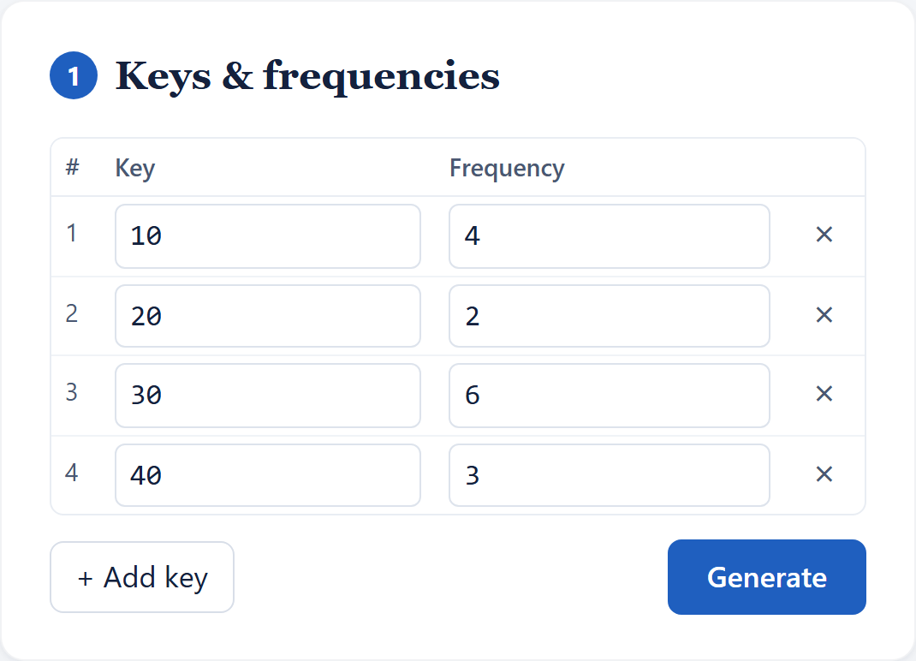
Figure 1: Input form with keys and frequencies
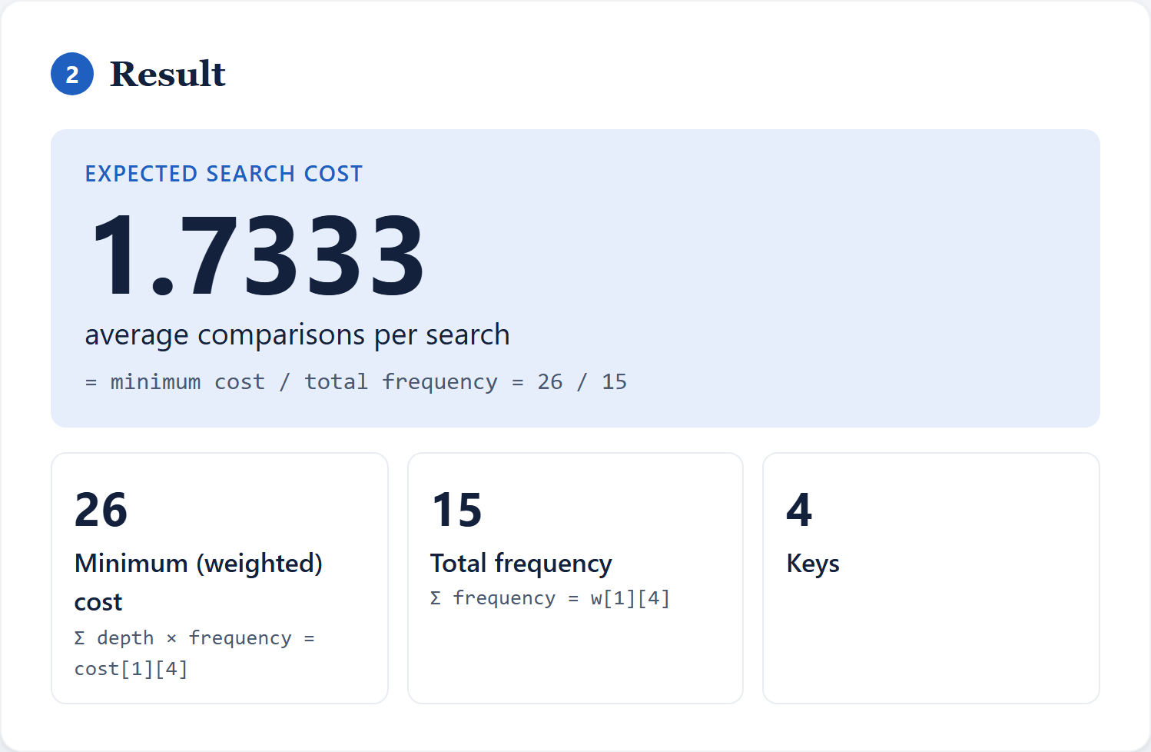
Figure 2: Result card showing expected search cost
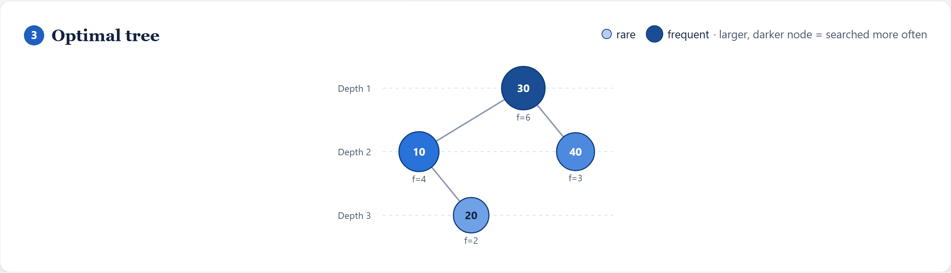
Figure 3: Optimal tree visualization
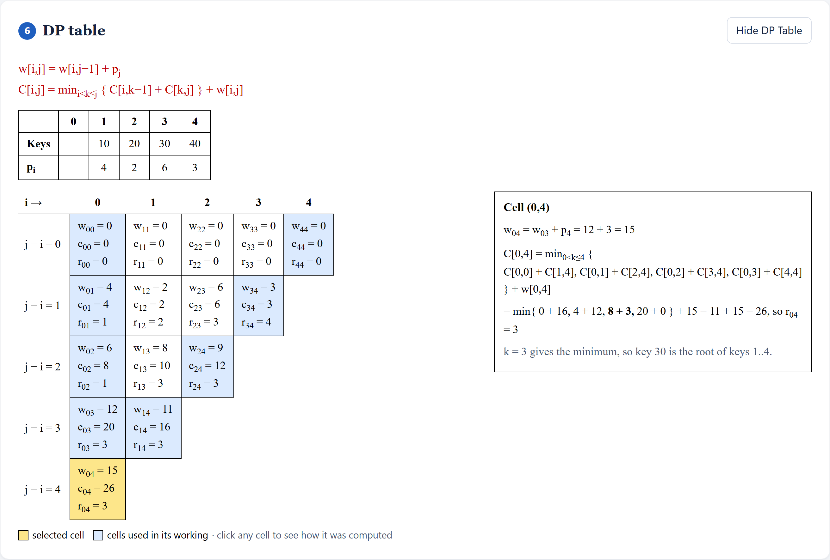
Figure 4: DP table in course format
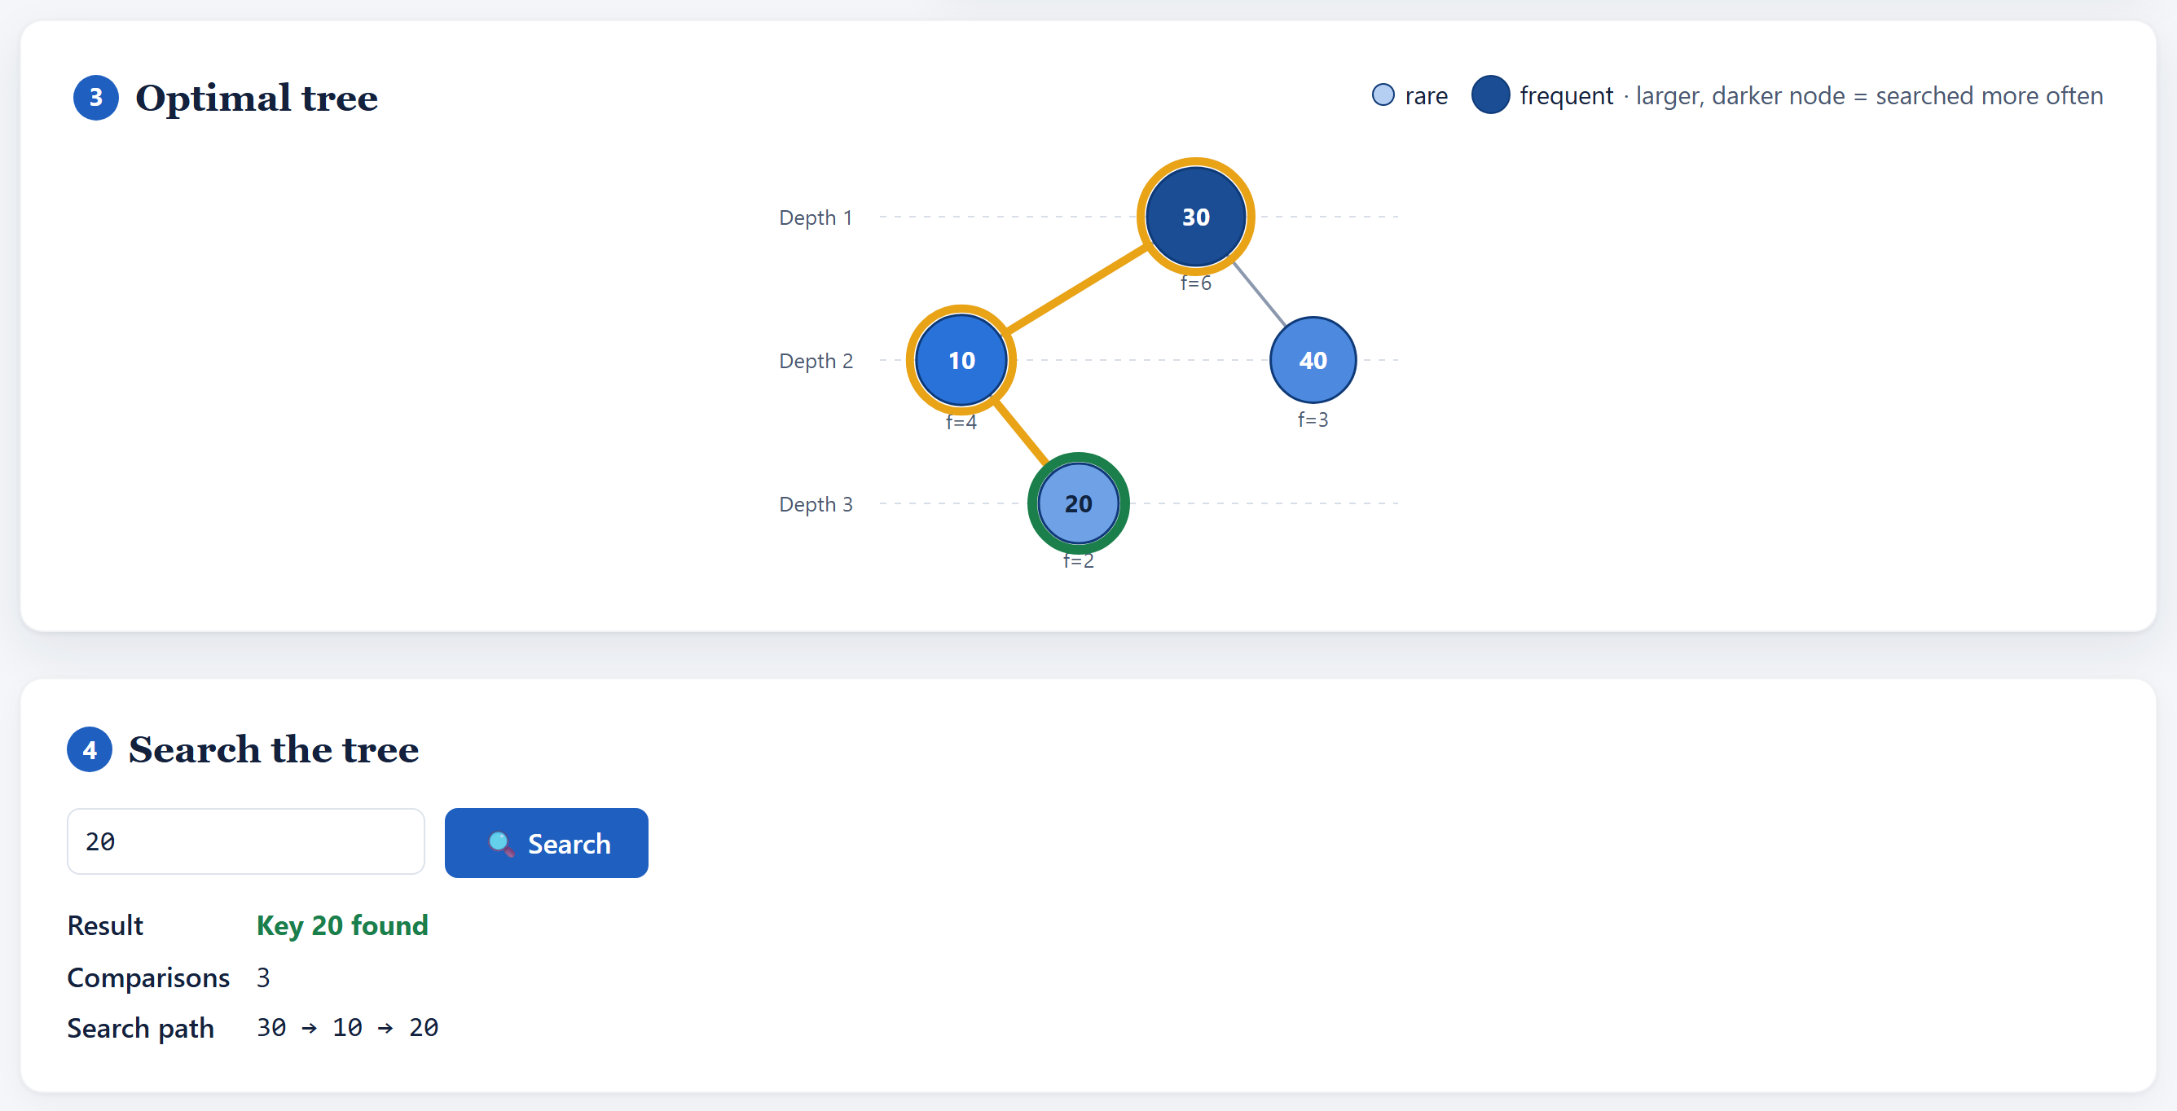
Figure 5: Search simulation showing the search path
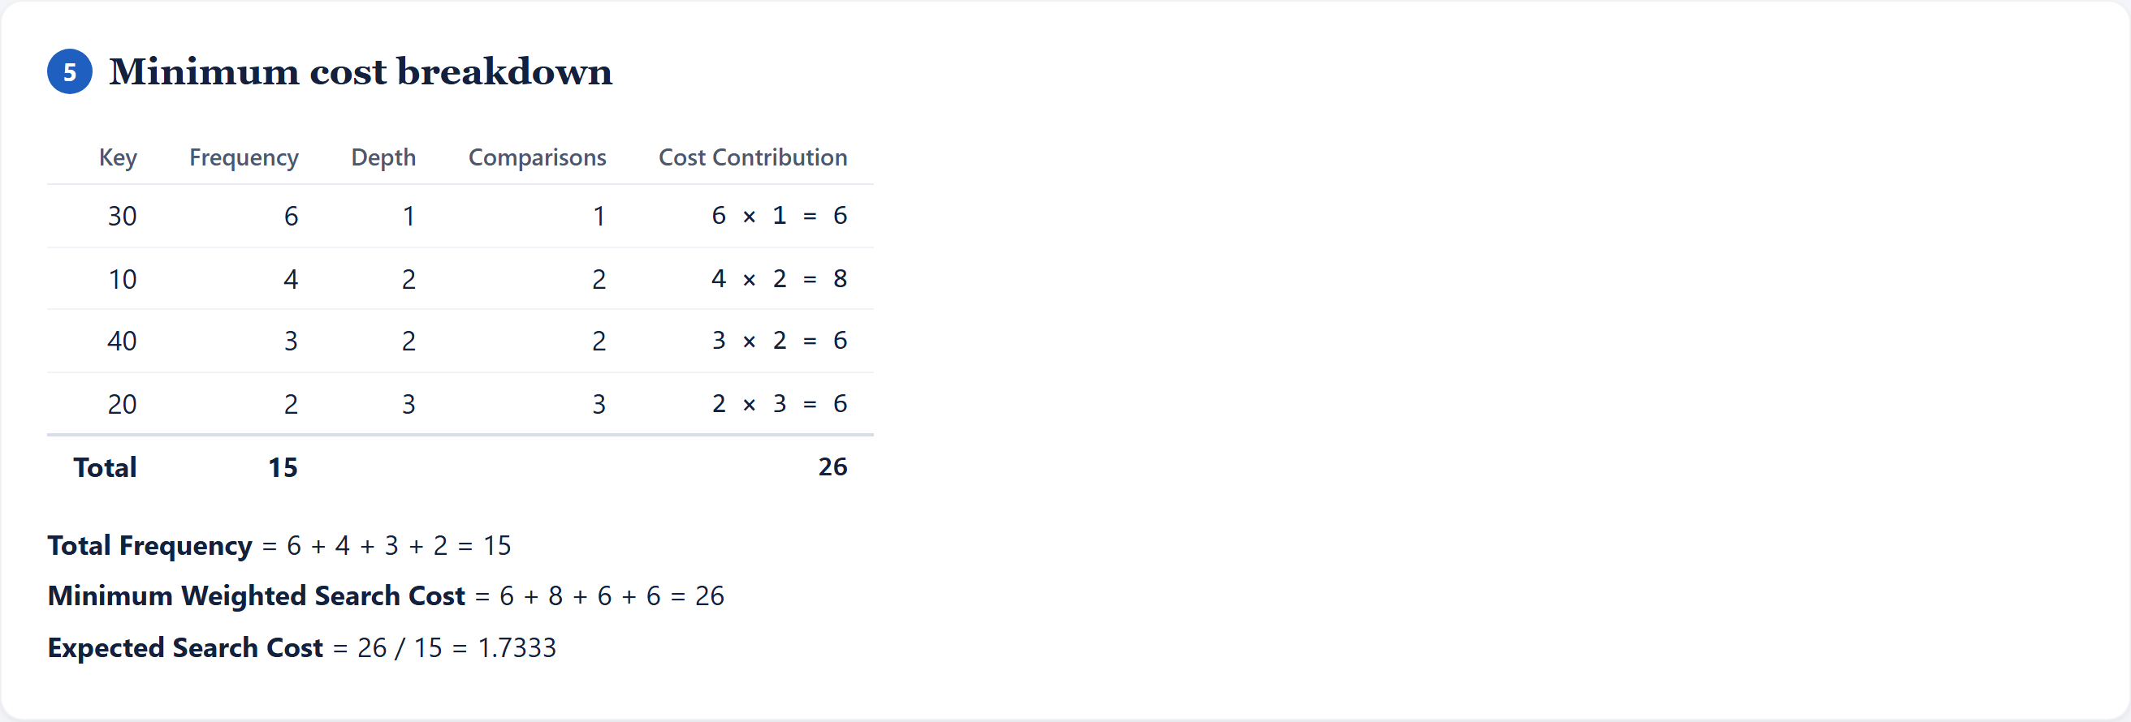
Figure 6: Minimum cost breakdown table
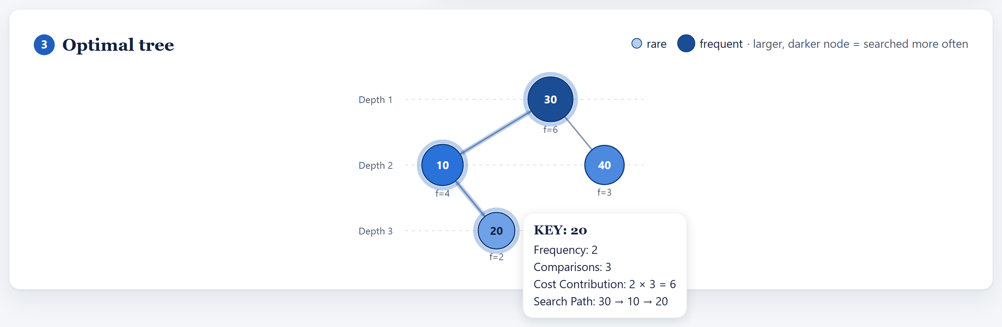
Figure 7: Hover tooltip on a tree node

