Business Requirements Document (BRD)

Project Name: Jewellers Block Digital Rater
Stakeholder: Total Risk Managers (TRM)
Version: 1.0
Date: February 17, 2026
Created by: Gemini

1. Summary
The goal is to build a web-based Quote Generation Application for "Jewellers Block" insurance. Currently, the process is manual, involving a PDF application form and an Excel-based rating sheet. We are digitizing this workflow to allow users (jewellers) to input their data online and receive an instant, indicative premium quote based on TRM's specific rating logic.

2. Product Scope
- Front-End: Angular-based responsive web portal. Includes user authentication and a multi-step "Smart Form". It must be user-friendly, responsive, and branded with TRM's corporate identity.
- Back-End: A Python/FastAPI engine that processes the inputs and executes the complex rating algorithms found in the S & S JB Rater.xlsx file.
- Output: A digital quote summary (on screen and/or PDF) displaying the breakdown of premiums and the final payable amount.

Functional Specifications (Technical Requirements)
3. Data Input Requirements (The "Smart Form")
The application must capture the following specific data points. All monetary fields are in CAD unless otherwise specified.
3.1 Section A: Business Profile
Field Name | Data Type | Constraint / Validation | Source Reference
company_name | String | Max 255 chars. Required. | PDF Pg 1
address | String | Required. | PDF Pg 1
business_type | Enum | Must be one of: Retail, Wholesale, Manufacturing, Pawn Broker. | PDF Pg 1 , Excel  +1
years_in_business | Integer | Min: 0. | PDF Pg 1

3.2 Section B: Inventory & Exposure (The Rating Core)
These inputs directly drive the mathematical model.
| Field Name | Data Type | Description & Validation | Source Reference |
| :--- | :--- | :--- | :--- |
| stock_value | Decimal (15,2) | Crucial. The max value of stock on premises. Min: 0. | PDF Q11(a) |
| money_value | Decimal (15,2) | Money in locked safe. Min: 0. | PDF Q11(b) |
| patterns_value | Decimal (15,2) | Value of patterns, molds, dies. Min: 0. | PDF Q11(c) |
| furniture_value | Decimal (15,2) | Value of fixtures/furniture. Min: 0. | PDF Q11(d) |
| improvements_value| Decimal (15,2) | Value of tenant improvements. Min: 0. | PDF Q11(e) |

3.3 Section C: Transit & Travel
Field Name | Data Type | Description | Source Reference
travel_in_town_limit | Decimal (15,2) | Max stock carried by sales staff in town. | PDF Q18 , Excel  +1
travel_out_town_limit | Decimal (15,2) | Max stock carried by sales staff out of town. | PDF Q18 , Excel  +1

3.4 Section D: Risk History & Security
Field Name | Data Type | Description | Source Reference
loss_ratio_percent | Decimal (5,2) | 5-year historical loss ratio (0-100%). Used for discounts. | Excel Risk Assessment
has_alarm | Boolean | Does the premise have a burglar alarm? | PDF Q21

4. System Logic & Processing Rules
4.1 The Rating Algorithm
The backend must implement the tiered rating structure defined in the S & S JB Rater file.
A. Premises Premium Calculation (Tiered): The stock_value is split into chunks, and each chunk is multiplied by a different rate:
- First $500,000: Rate = 1.667% (0.01667)
- Next $500,000: Rate = 1.500% (0.015)
- Next $500,000: Rate = 1.250% (0.0125)
- Next $500,000: Rate = 1.000% (0.01)
- Next $1,000,000: Rate = 0.750% (0.0075)
- Next $2,000,000: Rate = 0.500% (0.005)
- Over $5,000,000: Rate = 0.150% (0.0015)
B. Add-On Coverages:
- Money in Safe: money_value * 2.00% (0.02)
- Patterns & Molds: patterns_value * 0.25% (0.0025)
- Improvements: improvements_value * 0.50% (0.005)
C. Travel Premium:
- In Town: travel_in_town_limit * 1.80% (0.018)
- Out of Town: travel_out_town_limit * 4.00% (0.04)
D. Discounts (Technical Adjustment): Based on the loss_ratio_percent entered by the user:
- 0% - 25%: Apply 20% Discount (0.80 multiplier).
- 26% - 45%: Apply 10% Discount (0.90 multiplier).
- 46% - 65%: No Discount (1.00 multiplier).
- > 65%: Load accordingly (For MVP, trigger a "Refer to Underwriter" flag or 0% discount).
E. Final Broker Adjustment:
- Apply a standard 30% Commercial Discount to the final Technical Premium to get the "Sold Premium".
5. API Interface Specifications
Endpoint: POST /api/quote
Request Body (JSON):
{
"company_name": "ABC Jewelers",
"business_type": "Retail",
"stock_value": 745000.00,
"money_value": 50000.00,
"patterns_value": 150000.00,
"improvements_value": 35000.00,
"travel_in_town_limit": 25000.00,
"travel_out_town_limit": 0.00,
"loss_ratio_percent": 15.0
}

Success Response (200 OK):
{
"breakdown": {
"premises_premium": 12010.00,
"travel_premium": 450.00,
"money_premium": 1000.00,
"technical_discount_applied": 20.0
},
"technical_premium": 8232.04,
"final_total_premium": 5810.48
}

Failure Scenarios:
- 400 Bad Request: If stock_value is negative or missing.
- 400 Bad Request: If loss_ratio_percent is > 100.
- 500 Internal Error: Calculation engine failure.

6. User Interface (UI) Requirements
- Branding: Must strictly adhere to "Total Risk Managers" styling (Blue/Gold/White).
- Progressive Disclosure: Do not show all 7 pages of fields at once. Break it into:
  - Business Info
  - Inventory Values
  - Risk/History
  - Quote Result
- Disclaimer: The final screen must clearly state: "This proposal and declaration shall constitute a warranty should a Policy be issued." to ensure legal compliance.
7. Deliverables
- Angular Frontend: TypeScript source code utilizing Reactive Forms
- Python Backend: FastAPI application with the JewellersBlockRater class.
- Database Schema: PostgreSQL .sql file to store application data.
- Documentation: API documentation (Swagger/OpenAPI) auto-generated by FastAPI.
- Deployment Scripts: GitHub Actions for Azure App Service deployment.

Application User Flows
We have identified three distinct flows for the application based on the risk profile of the user.
Flow A: The "Happy Path" (Instant Quote)
- Scenario: A standard retailer with moderate stock values and a clean claims history.
- Process:
  - Landing: User visits the app and clicks "Get a Quote".
  - Data Entry: User completes Steps 1-3 (Business, Inventory, History).
  - Validation: System checks inputs against "Auto-Quote Rules" (e.g., Loss Ratio < 65%, Stock < $5M).
  - Calculation: Backend runs the JewellersBlockRater logic.
  - Output: User sees the "Official Quote" screen immediately and downloads the PDF.

Flow B: The "Referral" Path (High Risk/Manual Review)
- Scenario: A user with a high loss history (> 65%) or extremely high stock values (>$5M) that requires human underwriting.
- Process:
  - Data Entry: User completes Steps 1-3.
  - Validation Failure: System detects Loss Ratio > 65% or Stock > $5,000,000.
  - Interruption: Instead of showing a price, the system displays: "Based on the values provided, your application requires a specialist review."
  - Submission: The data is saved to the database with status UNDER_REVIEW.
  - Notification: An email is sent to the TRM Underwriting Team.
  - Resolution: TRM Underwriter manually calculates the premium and contacts the user offline.

Flow C: The "Draft & Resume" Path
- Scenario: A user starts the application but needs to check their inventory numbers before finishing.
- Process:
  - Partial Entry: User fills in Business Details.
  - Save: User clicks "Save Draft".
  - Token Generation: System sends a unique "Resume Link" to the user's email.
  - Resume: User clicks the link later, retrieving their data from the database, and completes the quote.

System Interaction Diagrams
Below are the technical diagrams showing how the Frontend, Backend, and Database communicate. You can view these diagrams by copying the code into a Mermaid viewer (like Mermaid.live).
Diagram 1: The User Journey (Flowchart)
This diagram illustrates the decision logic the system makes to decide whether to show a quote or refer to an underwriter.
Code snippet
graph TD
A [Start Application] --> B[Step 1: Business Details]
B --> C[Step 2: Inventory & Values]
C --> D[Step 3: Risk & History]
D --> E{Validation Check}
E -- "Loss Ratio > 65% OR Stock > $5M" --> F[Referral Path]
E -- "Standard Risk" --> G[Calculation Engine]
F --> H[Save to DB (Status: REVIEW)]
H --> I[Display: 'Application Received - Under Review']
I --> J[Email Alert to TRM Team]
G --> K[Run Python Rater Logic]
K --> L[Apply Discounts/Loads]
L --> M[Save to DB (Status: QUOTED)]
M --> N[Display Official Quote Letterhead]
N --> O[User Downloads PDF]

Diagram 2: System Sequence Diagram (Technical)
This diagram shows the exact API calls and data exchange between the React Frontend, Python Backend, and PostgreSQL Database.
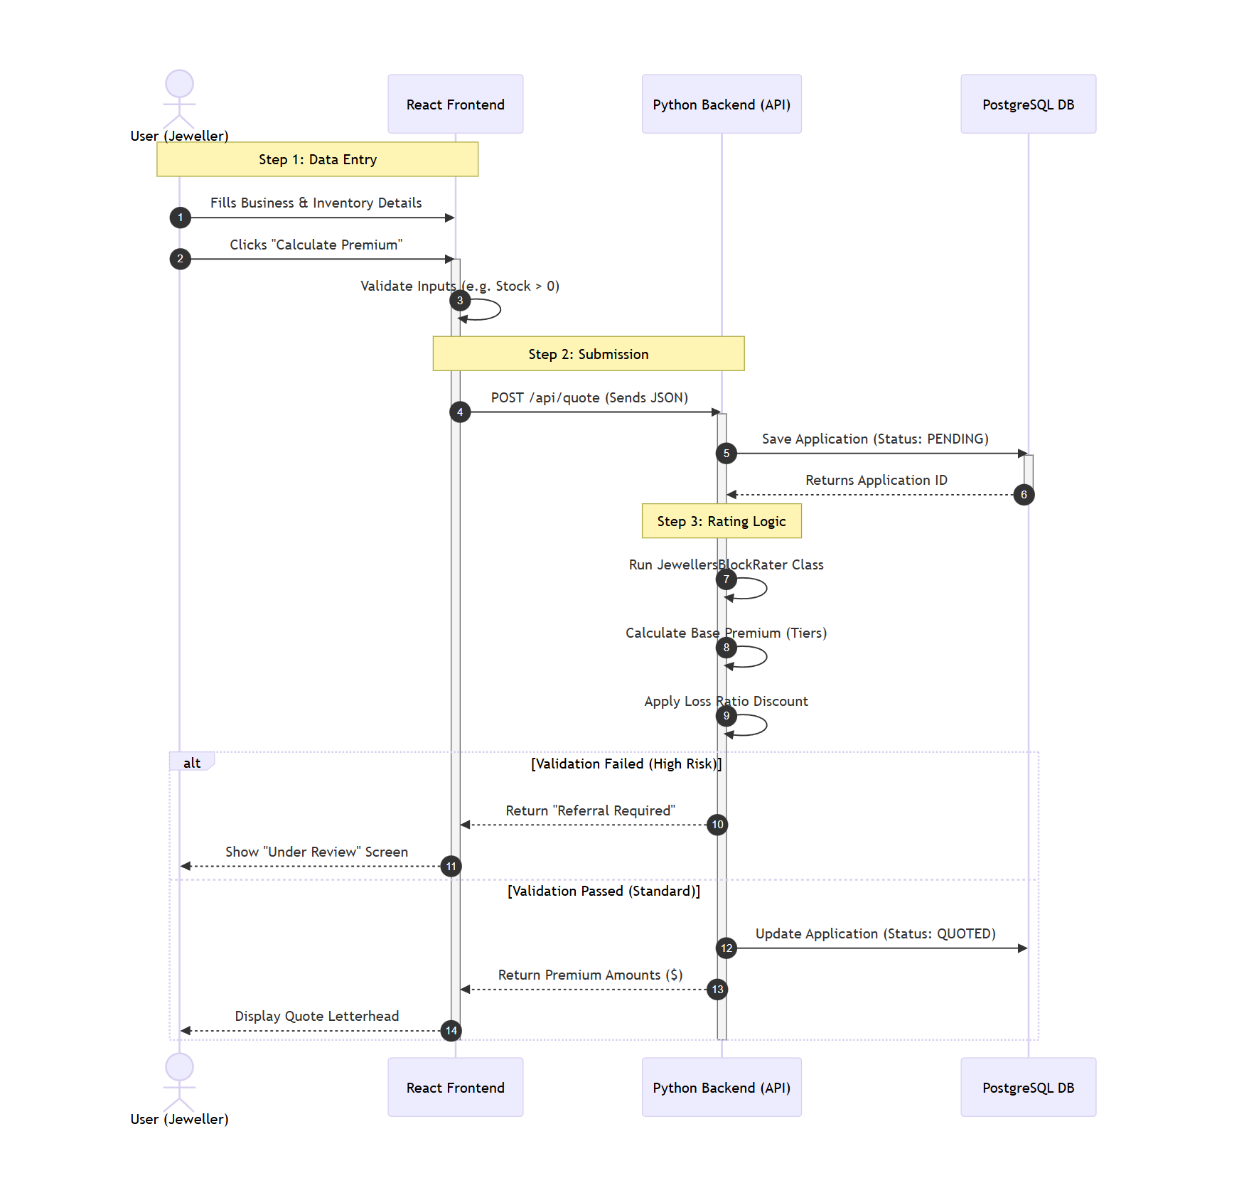

3. Data States (Lifecycle)
The application data will move through specific "States" in the database.
State Status | Trigger | System Action
DRAFT | User starts typing but hasn't submitted. | Data saved temporarily. No quote generated.
SUBMITTED | User clicks "Calculate" but logic fails validation (Referral). | Alert sent to admin. User sees "Under Review".
QUOTED | User clicks "Calculate" and logic passes. | Premium is fixed and displayed to user.
BOUND | User (or Admin) confirms purchase of policy. | Final policy documents generated.

4. Error Handling Flows
- Network Failure:
  - Scenario: Internet cuts out when clicking "Calculate".
  - System Response: Frontend detects failure -> Displays "Connection Error, retrying..." -> Retries request 3 times.
- Invalid Data:
  - Scenario: User enters negative numbers for stock value.
  - System Response: Frontend validation blocks the request before it reaches the API. Input field turns red with message "Value must be positive".

