Brief Idea:

The program shows the intermediate stages of transformation of **any affine transformed** image back to original or vice-versa depending on the order in which input is given.

Input 1 is transformed to Input 2 with the help of specified tie points of both the images.

The technique used is that for intermediate stage image’s point x there will be a corresponding point x1 in input1 and x2 in input2 . So, the coordinates of x are a function of x1,x2:

x= lambda*x1+(1-lambda)*x2

The intensity of x,x1,x2 is same.

Input Format:

A2a_Gurseerat_2018CSB1093_2020_CS517(input1, input2,prmts2,prmts1,toshow)

Input1: Original Image

Input2: Transformed Image

prmts1:Tie points of input1

prmts2: Corresponding Tie points of input2

If toshow==1; it displays the input1 and input2 images.

On running the program according to the specified format, a .gif file named GIF.gif will be formed which on running will show the intermediate stages of the transformation.

Sample Inputs with Tie Points:

A2a_Gurseerat_2018CSB1093_2020_CS517('test_pattern_tie_points.tif', test_pattern_transformed.tif',[626 486 ;662 1007; 139 680; 126 189],[619 78 ;601 611; 76 631; 114 111],1)

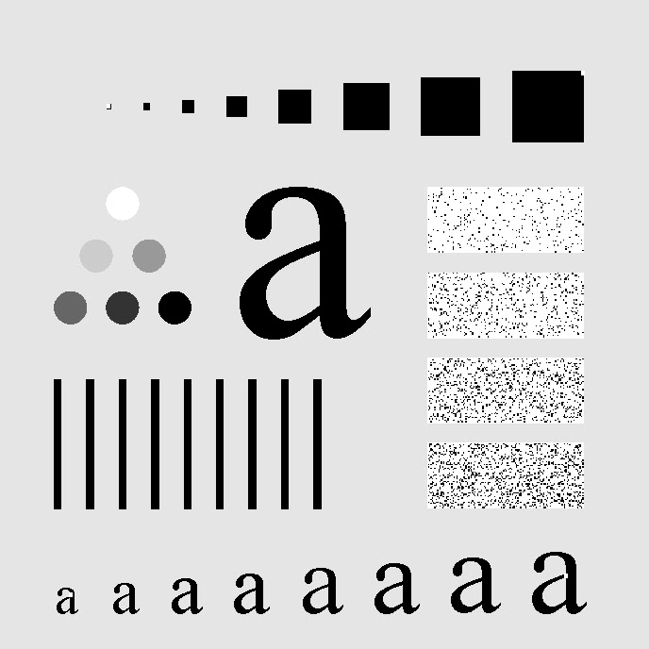

TIE POINTS: [619 78 ;601 611; 76 631; 114 111](prmts1)

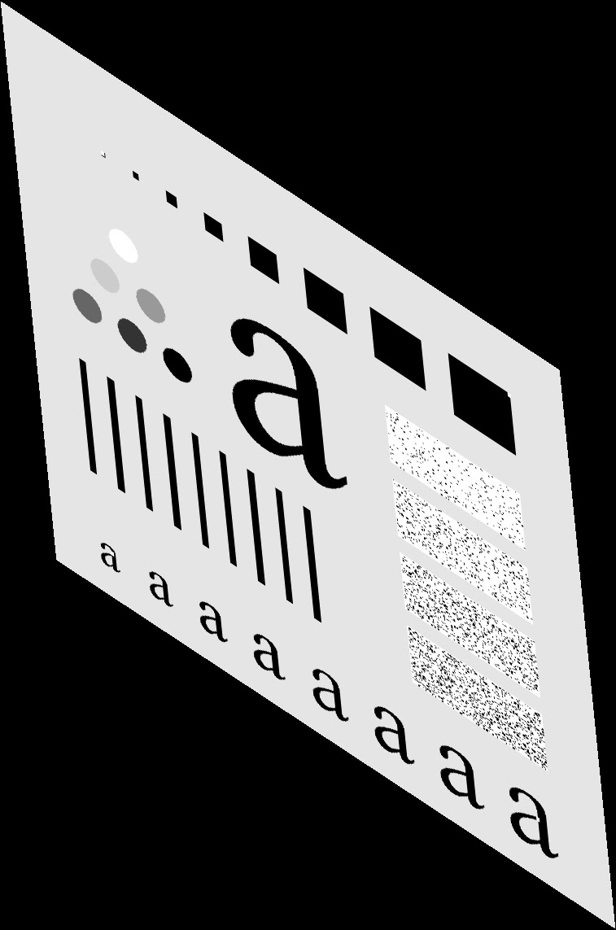

TIE POINTS : [626 486 ;662 1007; 139 680; 126 189](prmts2)

In the above input the **size of inputs is not same so the algorithm automatically resizes the images and changes the tie points accordingly.**

In the example below, the input sizes are the same so the resize operation is not done and same tie points are used.

You need to input TIE POINTS of the image you are sending as input (not the resized, the algorithm takes care of that itself)

A2a_Gurseerat_2018CSB1093_2020_CS517('Heart1.tif','Heart2.tif',[79 136; 133 109; 187 71; 185 209],[79 75; 157 80; 242 71; 150 244],1)

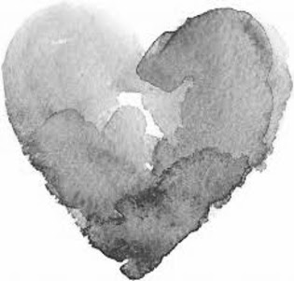

TIE POINTS:[79 75; 157 80; 242 71; 150 244](prmts1)

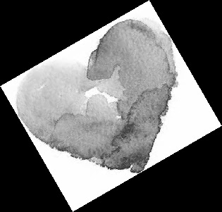

TIE POINTS: [79 136; 133 109; 187 71; 185 209] (prmts2)

The gifs corresponding to both the examples are attached in the zip folder.