**Assignment - 1 : Report**

The function ***collageCreate (address_folder_of_extracted_frames)*** calls *sortFrames* and *makeCollage* and then displays and returns the collage finally formed.

***sortFrames*** takes the 6 frames as input and arranges them in an order based on their color and edge information. The Brightness, Edges detected and the Contrast/Color Variation in the image are considered as follows :

Brightness :

The mean of intensity values are calculated for each of R,G,B and an average for the 3 colors is taken.

Edges :

Canny Edge detection is applied to obtain an edge map. In the edge map (1 bit image), a measure of the number of white pixels is taken. (fraction: no. of white pixels/ total pixels)

Contrast :

The contrast for the image has been calculated as the *standard deviation of the pixel intensities* for each color R,B,G (which are then averaged).

Sorting is done on the basis of ***image_information_value*** computed as a product of the above 3 parameters.

***makeCollage*** is given the sorted frames as input and it creates a collage as described below :

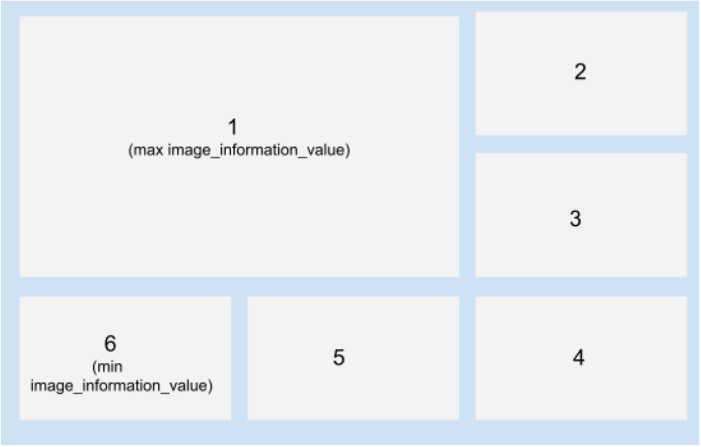

An example outputs folder has been added to the zip along with two frame sets to run the code.