Data Lake Architecture -

A Comprehensive Design Document
Medical Data Processing Company

Tracker

Revision, Sign off Sheet and Key Contacts

Change Record

Date | Author | Version | Change Reference
03/20/2026 | Gursevak Dhillon | 0.1 | Initial draft

Reviewers / Approval

Name | Version Approved | Position | Date
FirstName LastName | 1.0 | Udacity Reviewer  Enterprise Data Lake Architect

Key Contacts

Name | Role | Team | email
FirstName LastName | Data Architect | Medical Data Processing | student@email.com

Purpose
The main purpose of this document is to layout all the details about the data architecture plan for the SF based, EMR company. It will list all the gathered requirements, both business and technical, as well as any other constraint. Target audience for this document is technical people of EMR company, including developers, data engineers, data analysts, data architects etc.
This document contains summary of design principles, assumptions made during creation of this architecture, and actual architect diagram, and the design rationale and considerations.

I have covered technologies I proposed to be used in this design; however detailed explanation of those technologies is out of scope of this document. I will attach links for all the stack I am using for anyone to further dig into the details.

Requirements

Goal of architecture design is to move the existing database system to a ‘lake first’ system. New architecture should be able to meet following technical and business requirements.

Storage should be able to hold current and historical data. Systems should be able to ingest data from multiple sources such as API, FTP file system, and sql databases. System should be able to process data with super low latency and have infinite scaling capability. Reduce the 70+ ETL jobs to 3 or 4 standard ETL process for different file types.

Existing Technical Environment
- 1 Master SQL DB Server
- 1 Stage SQL DB Server
- 64 core vCPU
- 512 GB RAM
- 12 TB disk space (70% full, ~8.4 TB)
- 70+ ETL jobs running to manage over 100 tables
- 3 other smaller servers for Data Ingestion (FTP Server, data and API extract agents)
- Series of web and application servers (32 GB RAM Each, 16 core vCPU)

Current Data Volume
● Data coming from over 8K facilities
● 99% zip files size ranges from 20 KB to 1.5 MB
● Edge cases - some large zip files are as large as 40 MB
● Each zip files unzipped will provide either CSV, TXT, XML records
● In case of XML zip files, each zip file can contain anywhere from 20-300 individual XML files, each XML file with one record
● Average zip files per day: 77,000
● Average data files per day: 15,000,000
● Average zip files per hour: 3500
● Average data files per hour: 700,000
● Data Volume Growth rate: 15-20% YoY

Business Requirements
● Improve uptime of overall system
● Reduce latency of SQL queries and reports
● System should be reliable and fault tolerant
● Architecture should scale as data volume and velocity increases
● Improve business agility and speed of innovation through automation and ability to experiment with new frameworks
● Embrace open-source tools, avoid proprietary solutions which can lead to vendor lock-in
● Metadata driven design - a set of common scripts should be used to process different types of incoming data sets rather than building custom scripts to process each type of data source.
● Centrally store all the enterprise data and enable easy access

Technical Requirements
- Ability to process incoming files on the fly (instead of nightly batch loads today)
- Separate the metadata, data and compute/processing layers
- Ability to keep unlimited historical data
- Ability to scale up processing speed with increase in data volume
- System should sustain small number of individual node failures without any downtime
- Ability to perform change data capture (CDC), UPSERT support on a certain number of tables
- Ability to drive multiple use cases from same dataset, without the need to move the data or extract the data
- Ability to integrate with different ML frameworks such as TensorFlow
- Ability to create dashboards using tools such as PowerBI, Tableau, or Microstrategy
- Generate daily, weekly, nightly reports using scripts or SQL
- Ad-hoc data analytics, interactive querying capability using SQL

Data Lake Architecture design principles

Design principles:
Most of the tools used in this architecture are open source. This design aims to separate the whole system into independent sub systems. It aim to provide high cohesion, and low coupling. While in the older system, compute and storage were integrated, here we have separated these into its two different components managed, scaled and charged separately. All the tools we are using, beside the one allowed by EMR company, are open source, it avoid any vendor lock in. All these tools have robust open-source community support and are widely used in different industries including medical industry.

This design divides the whole process of processing data into 5 sub processes listed below:
- Ingestion
- Storage
- Processing
- Orchestration
- Serving

Ingestion: Source of data is 8k+ facilities, they provide data either by an API or FTP in zip format. It’s ingested into datalake bronze layer by utilizing Nifi. Data is stored in Apache Iceberg format.
Storage: Primary data storage is object storage (datalake). Main storage is Divided into 2 layer, bronze and gold. We can add another layer of silver if required. Metadata is stored in ‘Hive metastore.’
Processing: Data is processed (cleansed, transformed, aggregated) using spark computing cluster.
Orchestration: Orchestration will be supported by open-source software Apache Airflow. It will schedule the jobs to run every 2-5 minutes, thus providing the latest uploaded data with max of 10 minutes latency.
Serving: Data is primarily served by BI tools such as PowerBI, Tableau. Users can also do ad hoc query using sparksql, sql engine based on spark processing.

Assumptions

- I assumed 10 minutes latency with files arriving and being available in gold layer for consumption is acceptable.
- Assuming the structure of the file being provided by the facilities will remain same, and if it changes, it will be communicated.
- Ther is not any compliance requirement to keep the historical data in the form its being provided by the facilities as we are opening the zip files and writing the data to the lake in parquet format.
- Spark uses in memory processing, underneath it uses Linux operating system.
- Open-source tools used in this architecture are subject to changes, I am assuming they will stay same and any of the packages won’t be taken of off internet.
- There will be few seconds latency between data uploaded by the medical facilities and data available for the analytics dashboard and ML consumption.

Risks:
- Open-source tools might change and could lose support in the future.
- If cloud datalake utilized to store data, there is a risk, very low, it being hit by a natural catastrophe or something else which could lead to lose of the data, if lake is not configure to be geo redundant.

Data Lake Architecture for Medical Data Processing Company

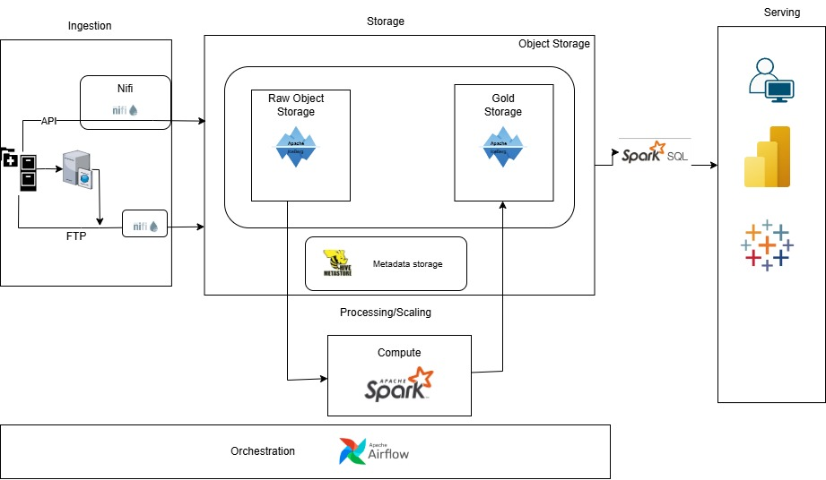

Design Considerations and Rationale

Ingestion Layer

Main sources of data are API, FTP server.
Data comes from more than eight thousand medical processing facilities. EMR company receive data from them in multiple ways. Currently they provide data using APIs, SMTP server, and direct upload to the SMTP server hosted by EMR company. I am assuming that this process will stay same, and we will have 3 sources to ingest data from.

Data will be directly ingested to the raw layer(bucket) in datalake and will be processed and moved to another layer(bucket) in the datalake, that where data will be consumed by Analytics dashboard, ML applications and other users. Nifi will provide zip files to spark, spark will be responsible for opening those zip files, filing metadata into hive metadata table, and writing data to the bronze layer in Apache Iceberg format.

Nifi will take care of:
- API & SFTP protocol handling
- Authentication per clinic
- Zip validation
- Fail-fast handling of corrupt archives
- Rate limiting and backpressure
- Per clinic routing and isolation

For API path, clinics send CSV/JSON payload, Nifi validates, normalizes, and for the SFTP path, facility drop the files into folder, Nifi polls, pulls, and validates data.

Why chose Nifi:
- Multi-tenant routing
- Retries/backpressure
- Credentials handling
- Auditability (track of who sent what and when)

With all the above built in feature, Nifi is a great choice as it can handle current workload and can handle scale easily for any future increase in the workload. It has great number of options available for connectors so if we get another source, it can handle that. It also allows customization on top of this tool, so we can add our own flavor for any niche requirements for this project.

Other tools considered:

Airbyte: It is very similar to Nifi, however, Nifi seems to have better open source community support. Also if we want to switch to Streaming data in the future, we can pair Nifi with Kafka, but its not that easy configurable for the airbyte.

Minio: It’s a great open-source tool to write data, but it does not have active support from open source community, and could get deprecated in the future.

Kafka: I heavily considered Kafka with Nifi or just Kafka by itself. While Kafka is a great tool for streaming data, in our use case it will be add unnecessary overhead as we don’t need mili second latency, and its better to have Airflow take care of scheduling the jobs for batch processing.

Storage Layer

Object storage, either S3 bucket or Azure datalake will be used as primary storage. It can easily support the current data load of 8TB and can scale infinity as its not limited by the storage capacity of a single machine, as it uses horizontal scaling. Object storage is also most cost efficient, highly scalable, and supports structured, unstructured and semi structured data. If we use a cloud based datalake, we have the option of making it geo or regional redundant. So, even if one of places where data is stored gets impacted, we will have data intact in other locations. For the separation of names, we can have another layer (or bucket) where we can backup all the data just in case of big system failure, which is very unlikely.

Data will be stored in the parquet format, using ‘Iceberg’ as storage layer. Parquet is a highly compressed, columnar level storage, best performance for read heavy processes. Using Iceberg as management layer makes the object storage stored data ACID compliant and efficient snapshot based queries by organizing the data files using a hierarchical metadata structure.
Storing data in infinite scalable object storage will improve uptime of overall system. Data will be duplicated into separate storage in case of any disruption to the current system, and making it reliable and fault tolerant.

With datalake storage, and use of tools like kafka, nifi for ingestion, spark for processing, and spark sql for ingestion, architecture can handle volume and velocity scale without any constraints.

Data Security:
- Data saved in datalake will be secured by using a firewall and using ‘Least privilege access principle’ (POLP). Only the people who need access will be provided access and all the other request will be blocker using firewall. We will use sparksql as delivery mechanism, so will setup rule for the permissions.
- Will also apply encryption at rest by enabling it when configuring datalake, or designing one in house.

Alternative storage options considered:
I have considered using HDFS, and in house creation of spark based storage, but that won’t be feasible option as it increase unnecessary overhead and require maintaining multiple resources.

Metadata storage:
Metadata storage acts as object relational mapper layer. HiveMetastore will be used be used as metadata storage. I am choosing hivemetastore as metadata storage as it connect well with hdfs, and cloud object storage as datalake and S3 buckets, as well as compute engine spark. It will store location of files along with list of tables these files will be queried under.

Processing Layer
Processing is basically cleaning, and consolidating data into multiple different table as required by the downstream data customers. I am using spark as main processing engine for this project. It will run jobs on scheduled basis to open zip files arriving from Nifi, write it tables in bronze layer, clean, transform data, write to refined and further aggregation then it will move it to produced. We are doing here batch processing, as streaming (real time processing) is not required as 10 minutes of latency is acceptable between arriving files and final consumption layer data. As the data is saved in Apache Iceberg format, PySpark Notebooks running on spark will take of care Rejecting bad records, and Change Data Capture Management (CDC).
<What other tools were considered? (3rd party tools, open source tools considered but did not make it to the architecture you are proposing). Are there other shortcomings to your selection of tools? If so what? Does the 3rd party tool solve that?>

Scale:
Spark is a distributed computing engine, it is not contrained by the computing power of a single machine, we can scale it as much as we want by adding more compute machine, which can divide the workload, as it supports horizontal scaling.

Other Processing tools considered:
- Apache Nifi: Instead of just using it for ingestion, we could have extended its use for processing as well. While it can be used for small scale processing, at the scale of 15M records/day, it will not be good fit.
- Apache Flink: It is best tool for super low latency. It will be a overkill here and add unnecessary operational complexity. Spark is better choice here as it’s a file based, not event stream.
- Apache Beam: It uses spark underneath and does not have super direct support for apache iceberg. It adds a unnecessary abstraction layer.

Serving Layer
Serving layer is where data will be consumed. I have data stored in the final layer of datalake, gold, in the Iceberg format. Serving layer will read from this layer via sparkSQL. SparkSQL will be used to connect to datalake by powerbi, tableu in the service layer and also for ad-hoc querying by analyts and engineers.

8. Conclusion
In this architecture we ingest data using Nifi and Kafka, store it in open source datalake, and process data using spark compute engine, and serve aggregated data using serving layer. It decouple most process in the system. Decoupling the metadata, computing, and storage enables the whole system to scale and grow independently. This architecture avoid any vendor lock in as it used mostly Open source systems.

9. References
1) https://nifi.apache.org/
2) https://spark.apache.org/
3) https://airflow.apache.org/
4) https://www.reddit.com/r/dataengineering/comments/t4kz8u/wtf_is_a_datalake/
5) https://medium.com/versent-tech-blog/how-does-hive-metastore-work-e9ba9f236454

