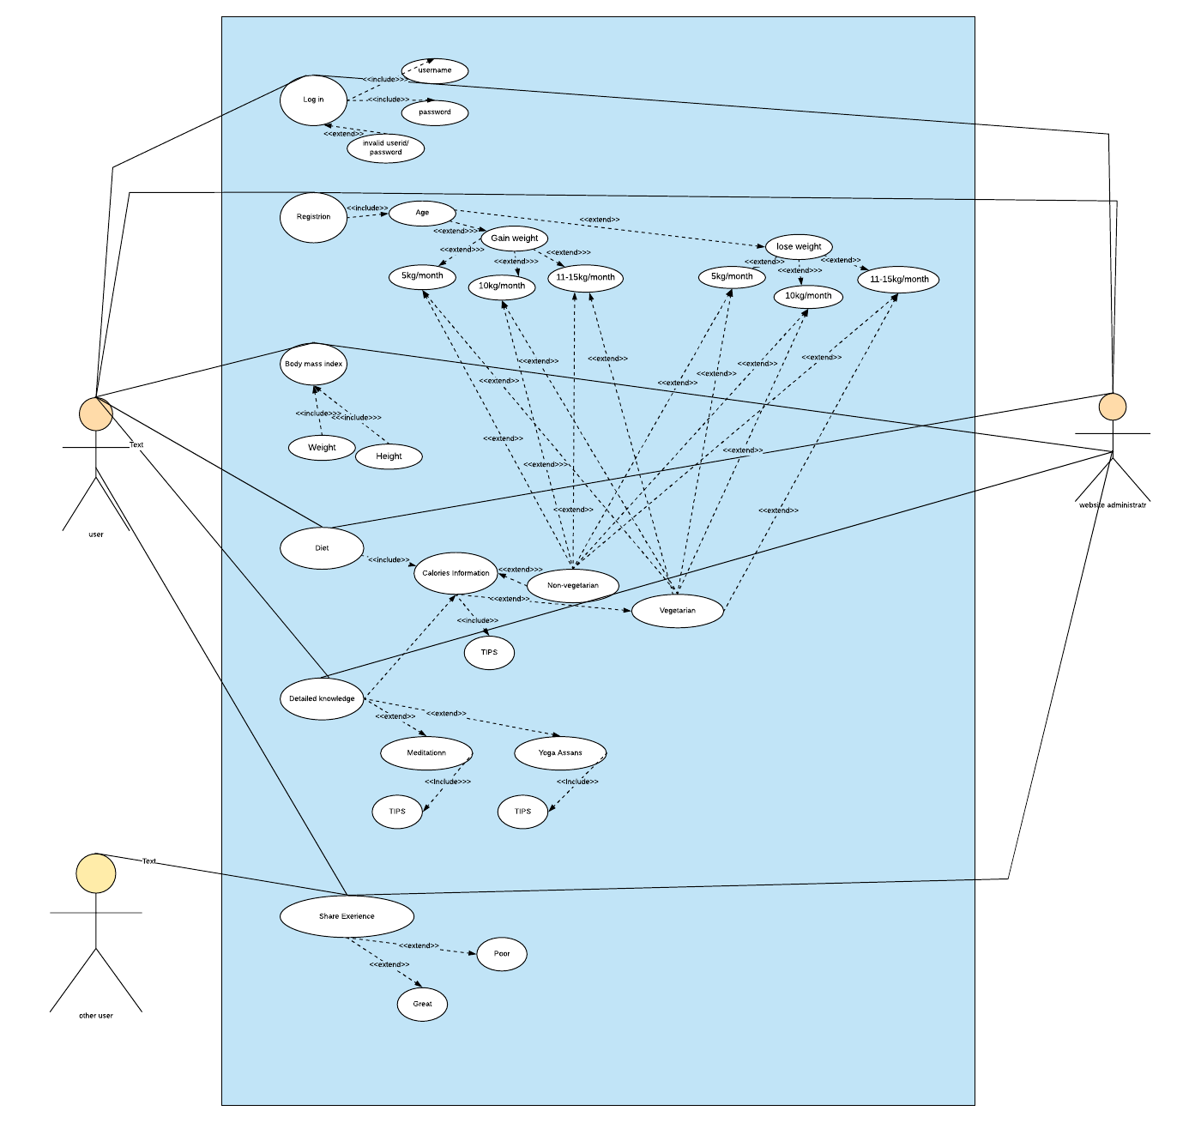

|  |
| --- |
| Use case title: The healthy life |
| Primary Actor: User, anyone who want the healthy lifestyle. |
|  |
| Level: Sea level |
| Preconditions: User must follow the instructions on website for result with web access. |
| Minimal Guarantee: At least half of the weight gain or weight loss if instructions are followed sequentially. |
| Success Guarantee: User will have the some positive changes in health if the user follows every instruction on daily basis. |
| Main success scenario:   1. Account created on the website 2. User will select the result type he/she desires (e.g: weight gain, weight loss). 3. User will choose the loss or gain of weight depending on what extend the user can work hard to achieve the perfect health (e.g: gain or loss 5 kg in month or 10-15kg in month) 4. User will get the body mass by providing the weight of body and height. 5. User will get the calories per gram information for every item after entering the type of food user eats (e.g: vegetarian , non-vegetarian) 6. User will also get the detailed knowledge of different exercise with tips (e.g: meditation, yoga) 7. User will share the experience with other users (e.g: Good or Poor) |
| Extensions:  1.a. Account can’t be created  1.a.1 User either didn’t accept the terms and conditions of the website or there is problem with accepting the terms and conditions with respect to the operating system.  3.a. Perfect health can’t be achieved  3.a.1 User either enter the value (weight he desire to loss or to gain ) too weight which is not possible (e.g: 50kg/month).  3.a.2 User either don’t accept the type of diet required to achieve the desired health.  5.a. Calories information not available  5.a.1 User either choose the food item and entered the amount less then 1gram or there is no food item available with the entered name (might due to spelling error).  6.a. Detailed tips(video tips) not available  6.a.1 User either have the video player which didn’t support the video type or.  6.a.2 User ’s web page is not refreshing continuously resulting in breaking the continuous buffering of the video.  1-7.a. The web page requested shows error message while loading or it is not found.  1-7.a.1 There is page not found error on the screen.  1-7.a.2 Clicking on refresh button loads the page successfully.  1-7.a.3 Continuous clicking on refresh button didn’t worked and the page is not loaded successfully;  1-7.a.4 User leaves the site open. |