SENSOR2

SENSOR1

For 6 bit data(to be sent to adc) For interrupt

MICROCONTROLLER

Circuit for an IR Ssensor

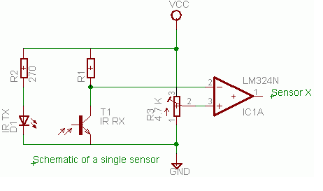

Program

#include<avr/io.h>

#include<avr/interrupt.h>

#include<util/delay.h>

#include<compat/deprecated.h>

ISR(INT0_vect ) //This called when for external interrupt request 0

{

sbi(PORTC,PIN1);

sbi(PORTC,PIN0);

_delay_ms(100);

cbi(PORTC,PIN1);

cbi(PORTC,PIN0);

}

void main(void)

{int i;

PORTC=0xFF;

//PortC output port

GICR=0X01000000;

//Internal interrupt 0 request enable

MCUCR=0X01;

//Any logical cange in value at int0 generates an interrupt

sei();

//Enable all global interrupts.

ADMUX=0b00100000;

//Setting result to left adjust

//Reference selected to AREF that we provide 4V

//Selecting Pin0 as input for sensor1 using mux pins

SFIOR=0x00;

//Setting auto trigger source to free running mode

ADCSRA=0b11100101;

//ADC enabled

//ADC conversion started

//ADTS enabled

while(1)

{

i=ADCH;

//ADCH stores value of converted data

i=i>>2;

i=i<<2;

//Making data 6 bit

PORTC=i;

//Whatever data we get is displayed in the six led. Last 2 will be always off.

}

}

This program takes data from the sensor and changes it into 6 bit data. Here we have made use of internal ADC available in ATMEGA16.

**ADMUX**

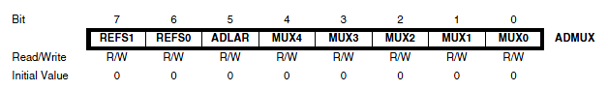

**Bit 7:6 – REFS1:0: Reference Selection Bits**

These bits select the voltage reference for the ADC. If these bits are

changed during a conversion, the change will not go in effect until this conversion is complete

(ADIF in ADCSRA is set). The internal voltage reference options may not be used if an external

reference voltage is being applied to the AREF pin.

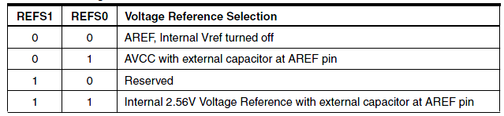

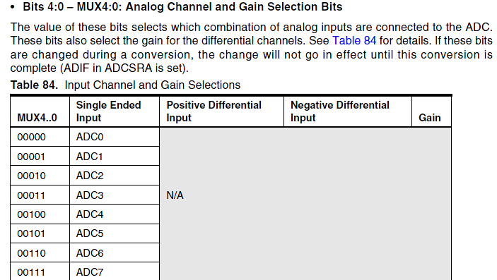

SFIOR

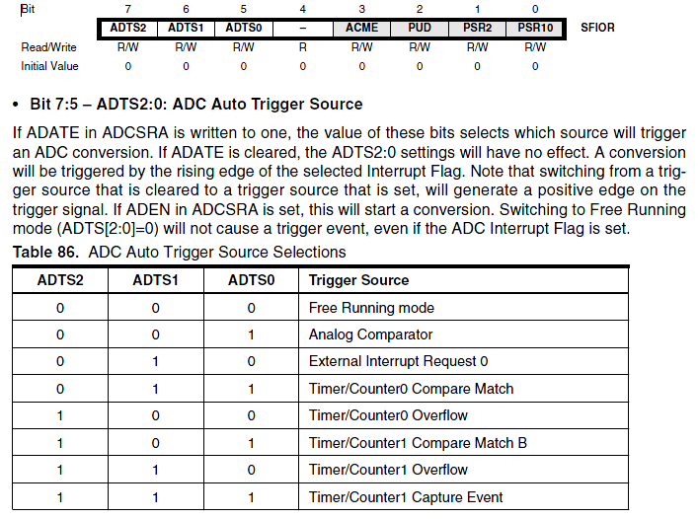

ADCSRA

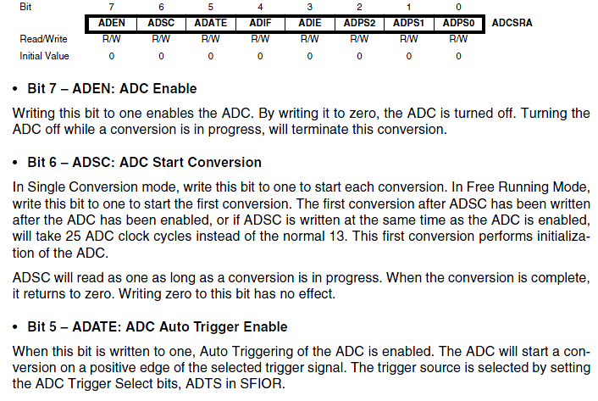

Rest of the pins are used to handle interrupts.

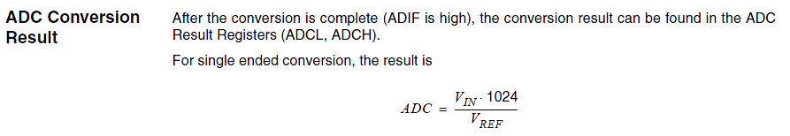

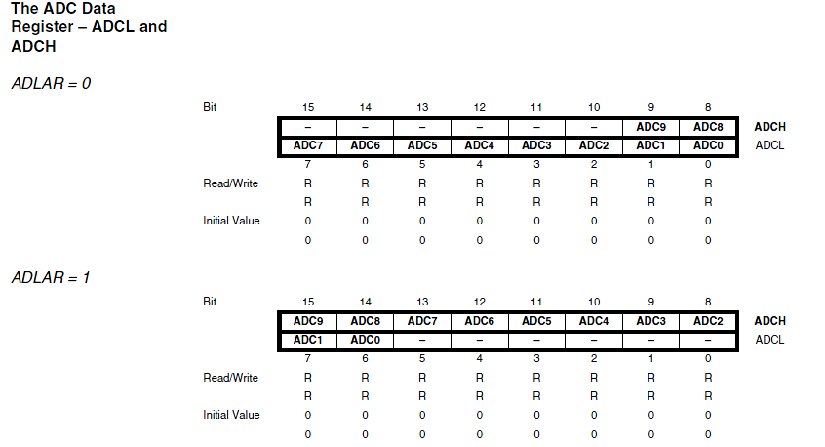

We therefore get 8 bit data by reading ADCH and then we convert it into 6 bit.

And the output is displayed to 1st 6 LED’s of PORTC.

Program part for sensor 2

This program is used to interrupt the normal running of the program and is used to glow the last 2 LED’s.

