RELAYS
A relay is an electrically operated switch. Electric current through the coil of the relay creates a magnetic field which attracts a lever and changes the switch contacts. The coil current can be on or off so relays have two switch positions and they are double-throw (changeover) switches.

old

EMBEDDED SYSTEM

An embedded system is a computer system designed to perform one or a few dedicated functions,^{[1]} often with real-time computing constraints. It is embedded as part of a complete device often including hardware and mechanical parts. In contrast, a general-purpose computer, such as a personal computer, is designed to be flexible and to meet a wide range of an end-user's needs. Embedded systems control many of the common devices in use today.
Since the embedded system is dedicated to specific tasks, design engineers can optimize it, reducing the size and cost of the product, or increasing the reliability and performance. _{{8}}
RISC/CISC

CISC – Complex Instruction Set Computer
One of the primary goal of the CPU designers was to provide more and more instructions in the instruction set of a CPU to ensure that CPU supports more function directly.Ofcourse every additional instruction in the instruction set of the CPU requires the necessary hardware circuitary to handle that instruction adding more circuitary hence inc the complicity of he CPU.

RISC – Reduced Instruction Set Computer.
In 1980s, some CPU designers realised that many instructions supported by CISC-based CPU are rarely used.Hence, an idea involved that the design complexity of a CPU can be reduced greatly by implementing the bare minimum and the frequently used instructions ones in the hardware circuitary (diff logic gates) of the CPU substituting the software for it. These systems use less power and are faster.

INSTRUCTION CODE

Every CPU has a built in ability to execute a set of machine instructions called its instruction code like to add, sub, mul ect. Most CPUs has 200 or more instruction code .The machine language supported by the CPU is based on the set of instuctions supported by the CPU in the instruction code.
Ref-Chapter7 Computer Fundamentals Pradeep K Sinha

ARM
The ARM is a 32-bit reduced instruction set computer (RISC) instruction set architecture (ISA) developed by ARM Limited. It was known as the Advanced RISC Machine, and before that as the Acorn RISC Machine. The ARM architecture is the most widely used 32-bit ISA.^{[1][2]} It is implemented in many microprocessors and microcontrollers for embedded systems. Because many ARM processors consume little power, they are dominant in the mobile electronics market, where low-power consumption is a critical design goal.
As of 2007, about 98 percent of the more than a billion mobile phones sold each year use at least one ARM processor _{{7}}

HARVARD ARCHITECTURE/Von Neumann architecture

The original Harvard architecture computer, the Harvard Mark I, employed entirely separate memory systems to store instructions and data. The CPU fetched the next instruction and loaded or stored data simultaneously and independently. This is by contrast with a Von Neumann architecture computer, in which both instructions and data are stored in the same memory system and (without the complexity of a cache) must be accessed in turn. The physical separation of instruction and data memory is sometimes held to be the distinguishing feature of modern Harvard architecture computers. With Microcontrollers (entire computer systems integrated onto single chips), the use of different memory technologies for instructions (e.g. Flash memory) and data (typically read/write memory) in von Neumann machines is becoming popular. The true distinction of a Harvard machine is that instruction and data memory occupy different address spaces. In other words, a memory address does not uniquely identify a storage location (as it does in a von Neumann machine); you also need to know the memory space (instruction or data) to which the address belongs. _{{9}}

8086 MICROPROCESSOR

8086 includes family of microprocessors from INTEL which includes commonly used PENTIUM series and others. These processors uses same basic ARCHITECTURE as well as BACKWARD COMPATIBILTY with 8086 so instruction code, registers are the same with some added features.

BUSSES

These are cables used to carry data from different parts of motherboard or some embedded system. Like from CPU to RAM ect . Different types of common bussses includes Data Bus, Address Bus, PCI bus ect.
TPU
Time Processing Unit or TPU for short is a sophisticated timer. In addition to counting down, the TPU can detect input events, generate output events, and perform other useful operations.
MICROCONTROLLERS

Microcontroller (also microcontroller unit, MCU or µC) is a small computer on a single integrated circuit consisting of a relatively simple CPU combined with support functions such as a crystal oscillator, timers, watchdog, serial and analog I/O etc. Program memory in the form of NOR flash or OTP ROM is also often included on chip, as well as a typically small amount of RAM.Microcontrollers are designed for small or dedicated applicationsThus, in contrast to the microprocessors used in personal computers and other high-performance or general purpose applications, simplicity is emphasized. They will generally have the ability to retain functionality while waiting for an event such as a button press or other interrupt; power consumption while sleeping (CPU clock and most peripherals off) may be just nanowatts, making many of them well suited for long lasting battery applications. _{{10}}

Interrupt Latency
When an electronic device causes an interrupt, the intermediate results (registers) have to be saved before the software responsible for handling the interrupt can run. They must also be restored after that software is finished. If there are more registers, this saving and restoring process takes more time, increasing the latency. Ways to reduce such context/restore latency include having relatively few registers in their central processing units (undesirable because it slows down most non-interrupt processing substantially), or at least not having hardware save them all (hoping that the software doesn't then need to compensate by saving the rest "manually"). Another technique involves spending silicon gates on "shadow registers": one or more duplicate registers used only by the interrupt software, perhaps supporting a dedicated stack.
Firmware
Firmware is software in the microcontrollers or microprocessors that are substitute for hardware eg that there is a fn that first add then subtract and the multiply, to get such a function we have to add new gates in the CPU or that we could have a softwate as a instruction code in the ROM of CPU that is included in its firmware.

DIP-Dual-in line package also known as DIL package

In microelectronics, a dual in-line package (DIP), sometimes called a DIL package, is an electronic device package with a rectangular housing and two parallel rows of electrical connecting pins. The pins are all parallel, point downward, and extend past the bottom plane of the package at least enough to be through-hole mounted to a printed circuit board (PCB), i.e. to pass through holes on the PCB and be soldered on the other side. DIP is also sometimes considered to stand for dual in-line pin, in which case the phrase "DIP package" is non-redundant. _{{11}}

PROM

There are two types ROM 1.Manufacturar programmed 2.User Programmed. A manufacturer programmed ROM is one in which data is BURNT by the manufacturer eg system boot programme.A user programmed ROM is one in which user can load and store read-only programmes and data eg micro programmes.

EPROM

Erasable pogrammable read only memory
In EPROM it is possible to erase information stored in EPROM chip and the chip can be reprogrammed.R&D personal use the micro programmes to test the efficiency of a computer system with new programmes
Two types………
1. UVEPROM(Ultra voilet EPROM) – in this stored information is erased by exposing the chip to ultra voilet light
2. EEPROM - Electrically erasable programmable read only memory
In this the stored information is erased by using high voltage electric pulses.
SRAM

Static random access memory is in contrast to DRAM(dynamic RAM) . Has following characteristics
- 1 It does not need to be periodically refreshed as dynamic RAM
- 2 Exhibits Data reminance ( but still is volatile in nature)
- 3 Expensive, faster and less power hungry which makes it ideal for embedded systems
- 4 Less dense than DRAM not to be user for high capacity applications

REGISTERS

In computer architecture, a processor register is a small amount of storage available on the CPU whose contents can be accessed more quickly than storage available elsewhere. Most, but not all, modern computers adopt the so-called load-store architecture. Under this paradigm data is shuffled from subordinated memory- be it L# cache or RAM- into registers, crunched therein by running instructions from the instruction set, then transferred out. A common property of computer programs is locality of reference: the same values are often accessed repeatedly; and holding these frequently used values in registers improves program execution performance.

Some common regisers are
1. Memory Address register
2. Memory Buffer Register
3. Instruction register
4. I/O register
ect _{{12}}

Wikipedia- processor registers

LOCK BITS

It is a technology in Atmel AVRs which when activated locks the bits so that no one can steal the original code working in the flash memory of the embedded system.

PWM

Pulse Width Modulation ( block makes it possible for the CPU to control power converters, resistive loads, motors, etc., without using lots of CPU resources in tight timer loops. Often used as a digital-to-analog conversion technique. A pulse train is generated and regulated with a low-pass filter to generate a voltage proportional to the duty cycle.
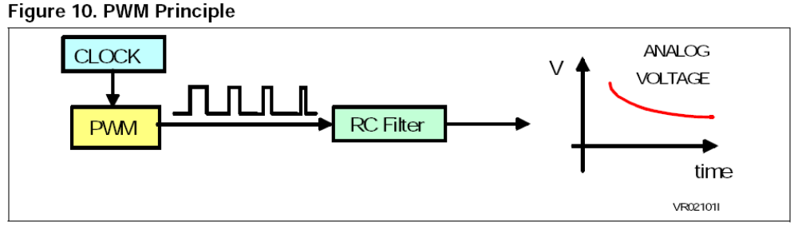
Pulse Accumulator

A pulse accumulator is an event counter. Each pulse increments the pulse accumulator register, recording the number of times this event has occurred.

Input Capture

Input Capture can measure external frequencies or time intervals by copying the value from a free running timer into the input capture register when an external event occurs.

Output Compare

Output Compare can time an external event by sending a value stored inside the output compare register.
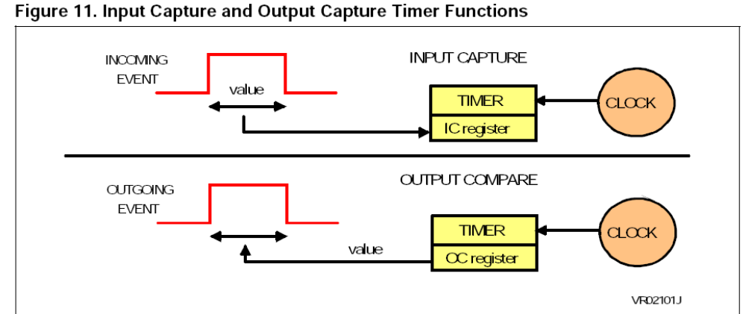

Watchdog timer

A watchdog timer provides a means of graceful recovery from a system problem. This could be a program that goes into an endless loop, or a hardware problem that prevents the program from operating correctly. If the program fails to reset the watchdog at some predetermined interval, a hardware reset will be initiated. The bug may still exist, but at least the system has a way to recover. This is especially useful for unattended systems.
Auto Reload Timer Compared to a standard timer, this timer automatically reloads its counting value when the count is over, therefore sparing a waste of CPU resource.
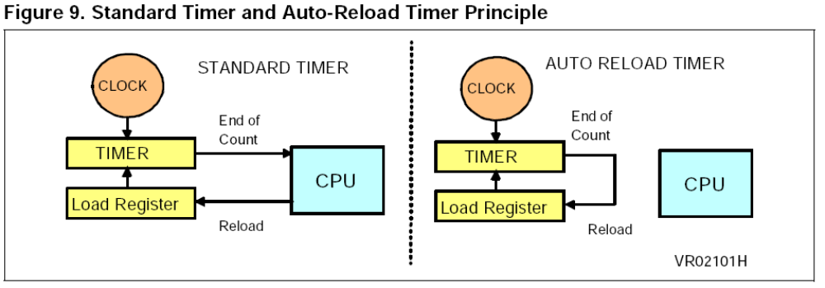

Comparator

One or more standard comparators can sometimes be placed on a microcontroller die. These comparators operate much like standard comparators however the input and output signals are available on the microcontroller bus.

SERIAL INTERFACE

Serial interface are used to exchange data with the external world. Many microcontrollers have both synchronous and synchronous communications peripherals built in. Usually, an asynchronous interface is called a serial communication interface (SCI or UART) while the synchronous interface is called a serial peripheral interface (SPI). A typical SCI application is to connect a PC for debugging purpose while a typical SPI application is to connect an external EEPROM. A synchronous bus includes a separate line for the clock signal which simplifies the transmitter and receiver but is more susceptible to noise when used over long distances. With an asynchronous bus the transmitter and receiver clocks are independent, and a resynchronization is performed for each byte at the start bit.

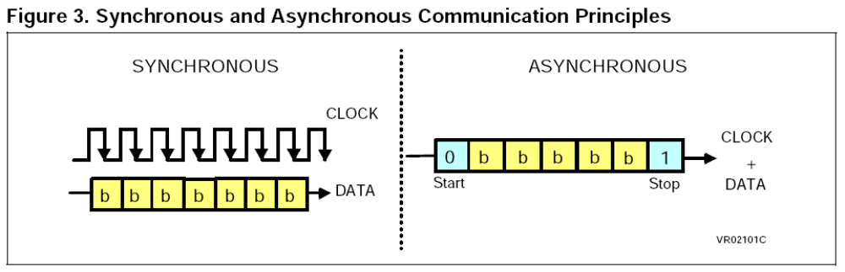

JTAG

It is a protocol used between programmer and embedded system having insystem protocol.
Refer ISP.
ISP

In-system programming is the ability to be programmed while installed in a complete system rather than require the chip to be programmed prior to installing it into the system.
Communication with the programmer is via a serial protocol. Most use a variant of JTAG protocol, other may use propietary protocol or protocol defined by older standards.
wiki
PULL UP REGISTERS

These are used in electronic logic circuits to ensure that inputs to logic system settle at expected logic levels if external devices are disconnected. It is required by I2C.
eg – to make 3v to 5v

Parallel Device
Device that communicates with binary data by sending the bits that represent each character simultaneously along a set of seprate data lines unlike a serial device.

BUS –I2C Inter-Integrated Circuit Bus

The I2C bus is a simple 2 wire serial interface developed by Philips. It was developed for 8 bit applications and is widely used in consumer electronics, automotive and industrial applications. In addition to microcontrollers, several peripherals also exist that support the I2C bus. The I2C bus is a two line, multi-master, multi-slave network interface with collision detection. Up to 128 devices can exist on the network and they can be spread out over 10 meters. Each node (microcontroller or peripheral) may initiate a message, and then transmit or receive data. The two lines of the network consist of the serial data line and the serial clock line. Each node on the network has a unique address which accompanies any message passed between nodes. Since only 2 wires are needed, it is easy to interconnect a number of devices.

UART
A UART (Universal Asynchronous Receiver Transmitter) is a serial port adapter for asynchronous serial communications. It makes it possible to receive and transmit data over a serial line with very little load on the CPU.
A universal asynchronous receiver/transmitter is a type of "asynchronous
receiver/transmitter", a piece of computer hardware that translates data between parallel and serial forms. UARTs are commonly used in conjunction with other communication standards such as EIA RS-232.
A UART is usually an individual (or part of an) integrated circuit used for serial
communications over a computer or peripheral device serial port, UART are now commonly included in microcontrollers.
The UART takes bytes of data and transmits the individual bits in a sequential fashion. At the destination, a second UART re-assembles the bits into complete bytes. Each UART contains a shift register which is the fundamental method of conversion between serial and parallel forms.
USART

A USART (Universal Synchronous / Asynchronous Receiver Transmitter) is a serial port adapter for either asynchronous or synchronous serial communications. Communications using a USART are typically much faster (as much as 16 times) than with a UART.

POLLING

Polling is what you have to do if your microcontroller does not have interrupts or if what you want to do is not time critical. It is a software technique whereby the controller continually asks a peripheral if it needs servicing. The peripheral sets a flag when it has data ready for transferring to the controller, which the controller notices on its next poll. Several peripherals can be polled in succession, with the controller jumping to different software routines, depending on which flags have been set.

INTERRUPT

Rather than have the microcontroller continually polling - that is, asking peripherals (timers / UARTS / A/Ds / external components) whether they have any data available (and finding most of the time they do not), a more efficient method is to have the peripherals tell the controller when they have data ready. The controller can be carrying out its normal function, only responding to peripherals when there is data to respond to. On receipt of an interrupt, the controller suspends its current operation, identifies the interrupting peripheral, then jumps to the appropriate interrupt service routine. The advantage of interrupts, compared with polling, is the speed of response to external events and reduced software overhead (of continually asking peripherals if they have any data ready). _{{12}}

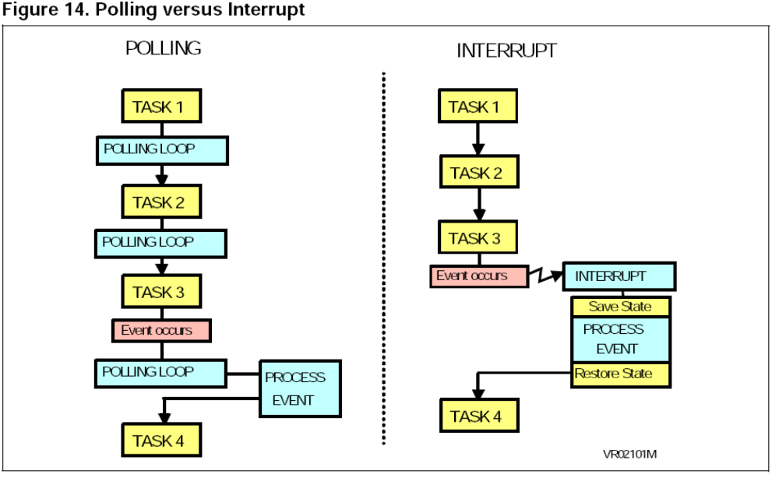

REF-MICROCONTROLLERS MADE EASY

FLASH MEMORY

Flash is an electrically erasable and programmable memory. It can be used instead of ROM to store program instructions and data. A key parameter of Flash memory is its endurance or the number of times it can be erased or reprogrammed. Depending on the technology used, flash endurance can be either 100 or 300,000 program/erase cycles.

Real Time
Generally used to describe system that guarantee a response to an external event within a given time.

REAL-TIME SYSTEM
Programs that respond to events in the world as they happen. Eg- an automatic pilot program in an aircraft must respond instantaneously in order to correct directions from its course.

SCALABLE FREQUENCY
It is a feature in power efficient microcontrollers by which it can slow down and consume less power while still awake listening to interrupts and doing light processing when requirement is not very intense thus lowering its speed.

BROWNOUT DETECTION

Monitors supply voltage during operation, is nothing more than a COMPARATOR.

CAN CONTROLLER

Controlled area network (CAN-BUS) is a vehicle bus standard designed to allow microcontrollers and devices to communicate with each other within a vehicle without a host computer.

CPU CLOCK

Operations are usually synchronized by a built in electronic clock that emits millions of regularly spaced electric pulses per second known as clock cycle. Instructions are fetched decoded and executed at proper intervals at intervals timed by a specific no of clock cycles.

CLOCK SPEED

Number of pulses produced per second. One clock is the time it takes to perform one operation such as moving a byte of data from one memory location to another.

OCD
On chip debugging

MISP
Millions of Instructions per second

