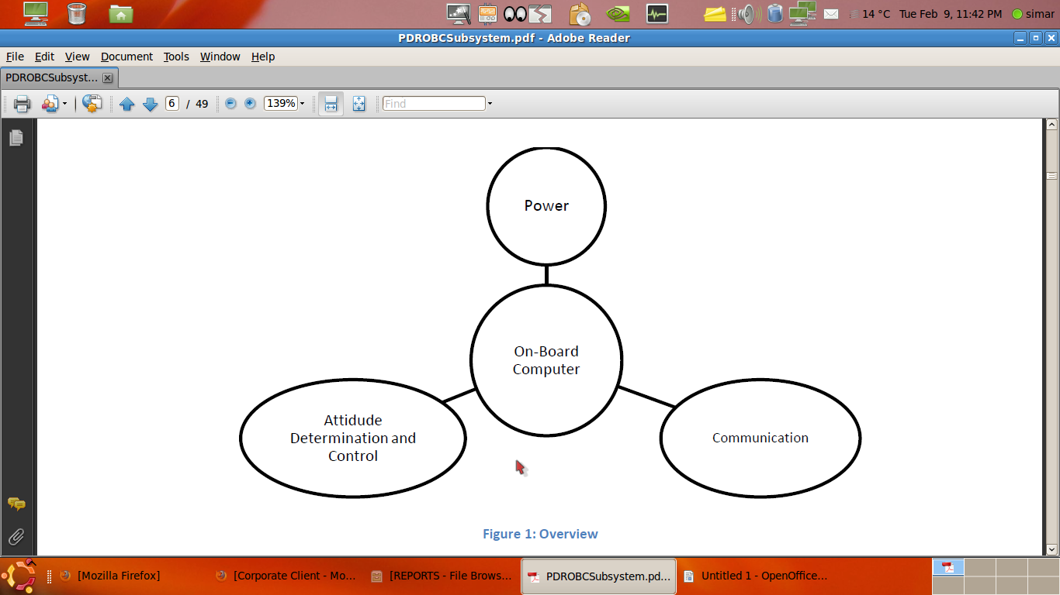

Power sub-system - receive information about the health of the various components of the satellite.
ADCS sub-system - to stabilize the satellite
Communication sub-system - to transmit data down to the ground-station.

Due to the nature of the system – a satellite in a regular, periodic orbit, the nominal operation of the satellite involves the cyclic execution of a series of predefined tasks in a predetermined order. This allows us to design the software without the need for an operating system or a complicated scheduler. This should greatly simplify the implementation and testing of the On-Board Computer

ADCS
The On-Board Computer is required to interface with sensors and actuators and execute the control-law calculations that determine the required actuation from the current position.

Interfaces:
The Onboard Computer must be able to interface with the sensors employed by the ADCS subsystem.
It must also interface with the CC1020 circuit employed by the communication subsystem.
Finally, it should be able to drive the actuators (magnetorquers) and communicate with the microcontroller used by the power subsystem.

The execution of the control law in a speed optimized manner necessitates the use of several tables for computational purposes. These tables will be stored in the on-chip EEPROM and the on-chip Flash memories.

To provide an accurate record of any failures or shut-downs and to keep a record of what the satellite was doing prior to these failures; a concise history will be maintained in the on-chip EEPROM. This will consist of flags signaling the state of the system before the most recent failure/shut-down

Sample computations, of a similar complexity as that of the final control law, have been executed on these microcontrollers and it has been determined that the amount of on-chip SRAM is sufficient for these purposes.
The microcontroller will be operated at the rated clock frequency of 16 MHz at 5 V.

2 MCUs
The Primary microcontroller handles the interfaces with the sensors and actuators of the ADCS and also runs the control law.
The secondary microcontroller interfaces with the CC1020 chip provided by the communications subsystem and handles the various subroutines involved in the downlink of data to earth.

Separation of data acquisition and data handling:
The primary microcontroller is responsible for the collection of data from the sensors as well as receiving health monitoring data from the Power subsystem. The secondary microcontroller stores this data in the external memory bank, encodes the data using Error Detection and Correction codes (EDACs) and transmits this data to the CC1020 chip packed in AX25 frames.

Simplification of the Operational sequence
When the satellite is over the ground-station, it must simultaneously execute 2 main functions – attitude determination and control, and downlink of accumulated data. In order to execute these tasks concurrently without the need for multi-threading or context-switching, these tasks are executed on two different microcontrollers.

Inter-Microcontroller Communication Interface
The two microcontrollers will be interfaced using the on-chip SPI peripheral communication interfaces. The primary microcontroller will always initialize any communication (act as a Master) and the secondary microcontroller will be hardcoded to act as the Slave. The SPI interface is a byte-oriented serial interface that is essentially two shift registers (one on each microcontroller) connected together. The transfer of bytes between this shift register is synchronized by a clock generated by the Master.

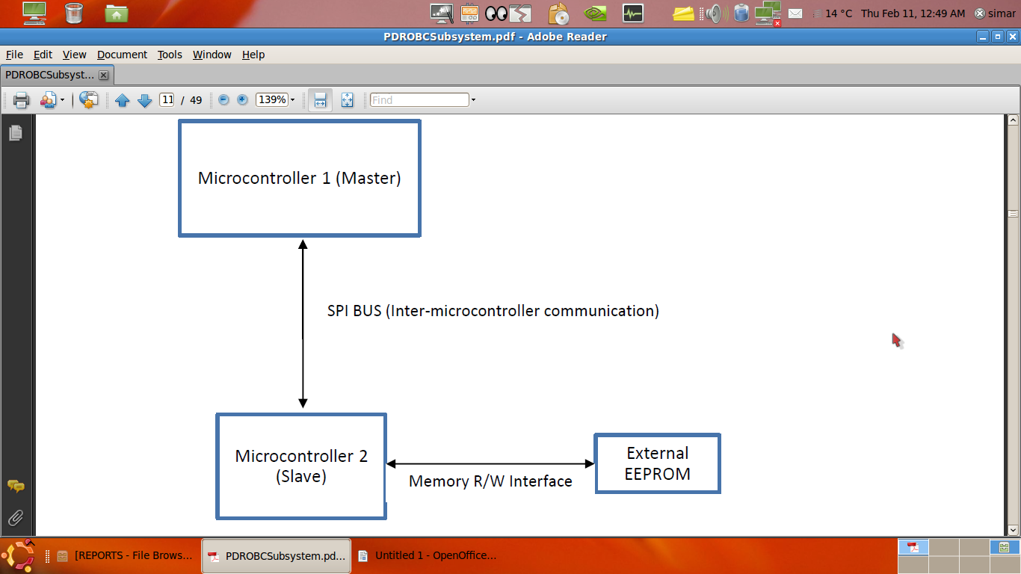

SOFTWARE

As part of the pre PDR phase, the Onboard Computer subsystem also completed a major portion of the software design.
To write code to drive the various peripherals of the microcontrollers. These codes would form part of a primitive hardware abstraction layer and would provide methods that other developers could use to drive the peripherals without going into the details of microcontroller programming.

Task Execution
The major tasks (like control law execution and downlink) are independent of each other and can be coded as separate blocks (each of these tasks can themselves be broken down into smaller sub-blocks – i.e. the control law task includes parsing of the GPS data as a sub-task). The coding of these sub-blocks formed one part of writing codes for task execution.

The List of Tasks:
1. Control Law Implementation
- Communication Routines
- Health Monitoring

DOUBTS
Is the MCU on OBC is the only MCU that is present?
What is the format of the data that COMM SUB SYS expects from us? Data encoding ..
Where will be the algorithms processed? In OBC_MCU or seprate MCU of COMM_SYS?
(Same for ADCS)

GLOSSARY
Round robin scheduler

