Program to draw a line using DDA Algorithm.
#include<iostream.h>
#include<stdio.h>
#include<graphics.h>
#include<conio.h>
#include<math.h>
#define round(a)((int)(a+.5))
void main()
{
int xa,ya,yb,xb,steps,k;
int gd=DETECT,gm;
initgraph(&gd,&gm,"");
setcolor(RED);
cout<<"enter the starting coordinates";
cin>>xa>>ya;
textcolor(10);
cout<<"enter the ending coordinates";
cin>>xb>>yb;

int dx = xb-xa;
int dy = yb-ya;
float xinc,yinc,x=xa,y=ya;
if(abs(dx)>abs(dy))
steps=abs(dx);
else
steps=abs(dy);
xinc=dx/float(steps);
yinc=dy/float(steps);
putpixel(round(x),round(y),10);
for(k=0;k<steps;k++)
{
x=x+xinc;
y=y+yinc;
putpixel(round(x),round(y),10);
}
}

Output:-

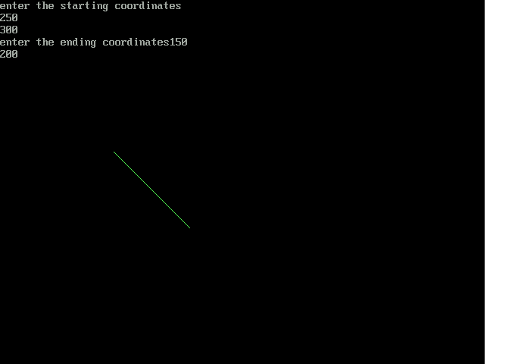

Program to draw a line using Bresenham’s Algorithm.
#include<stdio.h>
#include<iostream.h>
#include<conio.h>
#include<graphics.h>
#include<math.h>
void main()
{
int xa,ya,xb,yb,k,steps,xend,yend,x,y,dx,dy;
int gd=DETECT,gm;
initgraph(&gd,&gm, "");
cout<<"enter the starting coordinates";
cin>>xa>>ya;
cout<<"enter the ending coordinates";
cin>>xb>>yb;
dx=xb-xa;
dy=yb-ya;
int p=2*dy-dy;
int twody=2*dy;
int twodx=2*(dy-dx);
if(xa>xb)
{
x=xb;
y=yb;
xend=xa;
}
else
{
x=xa;
y=ya;
xend=xb;
}
putpixel(x,y,22);
while(x<xend)
{
x++;
if(p<0)
p=p+twody;
else
{
y++;
p=p+twodx;
}
putpixel(x,y,33);
}
}

OUTPUT:-

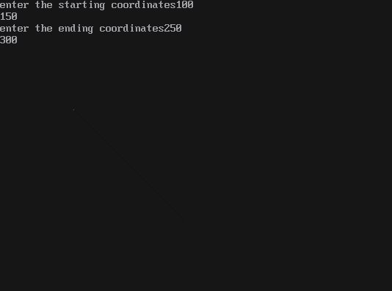

Program to draw a circle using BRESENHAM’S Algorithm
#include<iostream.h>
#include<conio.h>
#include<graphics.h>
#include<math.h>

void bcircle(int xcent,int ycent,int x,int y);

void main()
{
int gd=DETECT,gm;
initgraph(&gd,&gm," ");
int x=0,y,d,r,xcent=300,ycent=300;
cout<<"Enter the radius";
cin>>r;
y=r;
d=5/4-r;

while(x<=y)

{
bcircle(xcent,ycent,x,y);
if(d<0)
{
x=x+1;
d=d+2*x+1;
}
else
{
x=x+1;
y=y-1;
d=d+2*(x-y)+1;
}
}
}
void bcircle(int xcent,int ycent,int x,int y)
{
putpixel(xcent-x,ycent-y,15);
putpixel(xcent-y,ycent-x,15);
putpixel(xcent+y,ycent-x,15);
putpixel(xcent+x,ycent-y,15);
putpixel(xcent+x,ycent+y,15);
putpixel(xcent+y,ycent+x,15);
putpixel(xcent-y,ycent+x,15);
putpixel(xcent-x,ycent+y,15);
getch();
closegraph();
}

OUTPUT:-

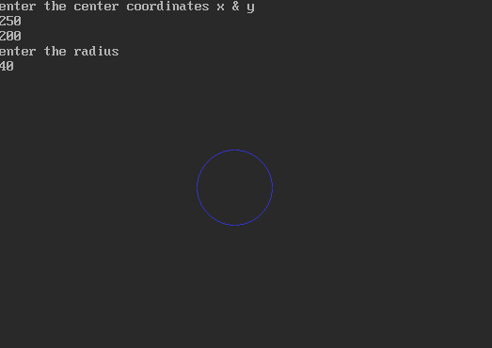

Program to draw a ellipse using BRESENHAM’S Algorithm.
#include<iostream.h>
#include<conio.h>
#include<graphics.h>
#include<math.h>
#include<dos.h>
int xc,yc,rx,ry;
void main()
{
void plotpoints(int,int);
int round(float);
int gd=DETECT, gm;
initgraph(&gd,&gm," ");
cout<<"enter the center point";
cin>>xc>>yc;
cout<<"enter major radius";
cin>>rx;
cout<<"enter minor radius";
cin>>ry;
long int p,px,py,x,y;
long int ry2=ry*ry;
long int rx2=rx*rx;
long int ry22=ry2*2;
long int rx22=rx2*2;
x=0;
y=ry;
plotpoints(x,y);
p=round(ry2-rx2*ry+(0.25*rx2));
px=0;
py=rx22*y;
while(px<py)
{
x++;
px=px+ry22;
if(p>=0)
{
y--;
py=py-rx22;
}
if(p<0)
p=p+px+ry2;

else
p=p+px+ry2-py;
plotpoints(x,y);
}
p=round(ry2*(x+0.5)*(x+0.5)+rx2*(y-1)*(y-1)-rx2*ry2);
while(y>0)
{
y--;
py=py-rx22;
if(p<=0)
{
x++;
px=px+ry22;
}
if(p>=0)
p=p-py+rx2;
else
p=p+px-py+rx2;
plotpoints(x,y);
}
getch();
closegraph();
}
void plotpoints(int x,int y)
{
setlinestyle(0,0,3);
line(xc+x,yc+y,xc+x,yc+y);
line(xc-x,yc+y,xc-x,yc+y);
line(xc+x,yc-y,xc+x,yc-y);
line(xc-x,yc-y,xc-x,yc-y);
}
int round(float x)
{
int y =abs(x);
if(x>(y+0.5))
return(y+1);
else
return(y);
}

OUTPUT:-

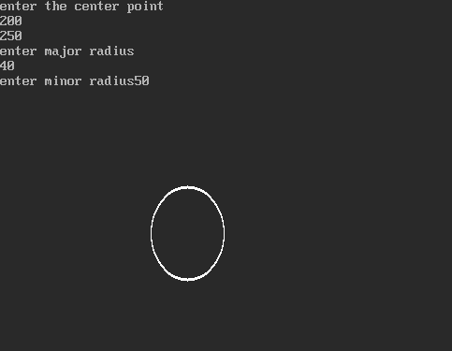

Program to fill the object using Flood Fill algorithm.
#include <graphics.h>
#include <stdlib.h>
#include <stdio.h>
#include <conio.h>
int main(void)
{
int gdriver = DETECT, gmode, errorcode;
int i, maxx, maxy;
int poly[8];
initgraph(&gdriver, &gmode, "");
errorcode = graphresult();
if (errorcode != grOk)
{
printf("Graphics error: %s\n", grapherrormsg(errorcode));
printf("Press any key to halt:");
getch();
exit(1);
}
maxx = getmaxx();
maxy = getmaxy();
poly[0] = 20;
poly[1] = maxy / 2;
poly[2] = maxx - 20;
poly[3] = 20;
poly[4] = maxx - 50;
poly[5] = maxy - 20;
poly[6] = maxx / 2;
poly[7] = maxy / 2;
for (i=EMPTY_FILL; i<USER_FILL; i++)
{
setfillstyle(i, getmaxcolor());
fillpoly(4, poly);
getch();
}
closegraph();
return 0;
}

OUTPUT:-

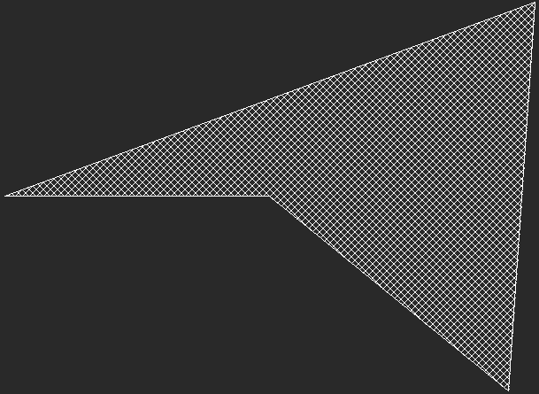

Program to fill the object using Boundary Fill Algorithm.
#include<iostream.h>
#include<conio.h>
#include<graphics.h>
#include<math.h>
#include<stdio.h>
void bfill(int,int,int,int);
void main()
{
clrscr();
int gd=DETECT,gm;
initgraph(&gd,&gm,"");
int cx,cy,r,nw,old;
cout<<"enter the radius to filled"<<endl;
cin>>r;
cout<<"enter the center coordinates of the circle to be filled"<<endl;
cin>>cx>>cy;
cout<<"enter the colorcode for the color to be filled"<<endl;
cin>>nw;
cout<<"enter the colorcode for the boundary color"<<endl;
cin>>old;
setcolor(old);
circle(cx,cy,r);
bfill(cx,cy,nw,old);
getch();
closegraph();
}
void bfill(int x,int y,int fill,int boundary)
{
int current;
current=getpixel(x,y);
if((current!=boundary)&&(current!=fill))
{
putpixel(x,y,fill);
bfill(x,y+1,fill,boundary);
bfill(x,y-1,fill,boundary);
bfill(x+1,y,fill,boundary);
bfill(x-1,y,fill,boundary);
}
}

int round(float a)
{
int t;
t=abs(a);
if(a>(t+0.5))
return(t+1);
else
return(t);
}

OUTPUT:-

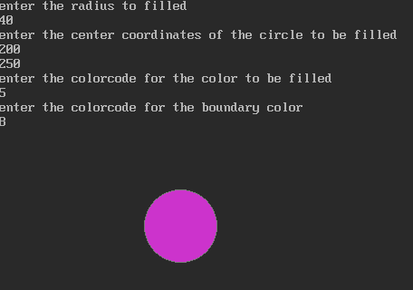

Program to translate the given object.
#include<iostream.h>
#include<stdio.h>
#include<conio.h>
#include<graphics.h>
#include<math.h>
void main()
{
clrscr();
int gd=DETECT,gm;
initgraph(&gd,&gm," ");
int x1=100;
int y1=100;
int x2=200;
int y2=200;
cleardevice();
rectangle(x1,y1,x2,y2);
cout<<"enter tranlation co-ordinates";
int tx,ty;
cin>>tx>>ty;
rectangle(x1+tx,y1+ty,x2+tx,y2+ty);
getch();
}
OUTPUT:-

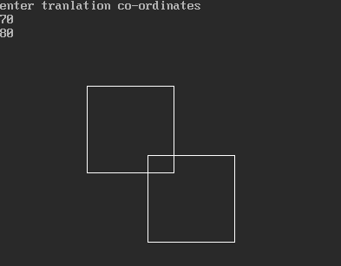
Program to scaling a given object.
#include<stdio.h>
#include<conio.h>
#include<graphics.h>
#include<math.h>
#include<iostream.h>
void main()
{
clrscr();
int gd=DETECT,gm;
initgraph(&gd,&gm," ");
int x1=50;
int y1=50;
int x2=100;
int y2=100;
int sx,sy;
cleardevice();
rectangle(x1,y1,x2,y2);
cout<<"enter scaling co-ordinates";
cin>>sx>>sy;
int a=x1*sx;
int b=y1*sy;
int c=x2*sx;
int d=y2*sy;
rectangle(a,b,c,d);
/////////scaling about a fixed or reference point
int xf,yf;
cout<<"enter fixed points";
cin>>xf>>yf;
int xa=(x1*sx)+xf*(1-sx);
int ya=(y1*sy)+yf*(1-sy);
int xb=(x2*sx)+xf*(1-sx);
int yb=(y2*sy)+yf*(1-sy);
rectangle(xa,ya,xb,yb);
}

Program to implement a Prespective view.
#include<iostream.h>
#include<conio.h>
#include<graphics.h>
void main()
{
int gdriver=DETECT,gmode;
initgraph(&gdriver,&gmode,"c:\\tc\\bgi");
int x[4],y[4];
int i;
cout<<"enter coordinate";
for(i=1;i<=4;i++)
{
cin>>x[i]>>y[i];
}
int x1,y1;
cout<<"enter x,y";
cin>>x1>>y1;
for(i=1;i<4;i++)
{
line(x[i],y[i],x[i+1],y[i+1]);
}
line(x[1],y[1],x[4],y[4]);
float m[4];
float b[4];
float ay[4];
int ax=250;
setcolor(YELLOW);
for(i=1;i<=4;i++)
{
line(x[i],y[i],x1,y1);
}
for(i=1;i<=4;i++)
{
m[i]=(float)(y1-y[i])/(x1-x[i]);
cout<<"\nm="<<m[i];
b[i]=(float)y[i]-m[i]*x[i];
cout<<"\nb="<<b[i];
if(i==1)
ay[i]=m[i]*(ax-40)+b[i];
else if(i==2)
ay[i]=m[i]*(ax-20)+b[i];
else if(i==3)
ay[i]=m[i]*(ax+20)+b[i];
else
ay[i]=m[i]*ax+b[i];
}
setcolor(RED);
line(ax-40,ay[1],ax-20,ay[2]);
line(ax-20,ay[2],ax+20,ay[3]);
line(ax+20,ay[3],ax,ay[4]);
line(ax,ay[4],ax-40,ay[1]);
outtextxy(ax-10,ax,"prespective view");
getch();
closegraph();
restorecrtmode();
}

Output:-

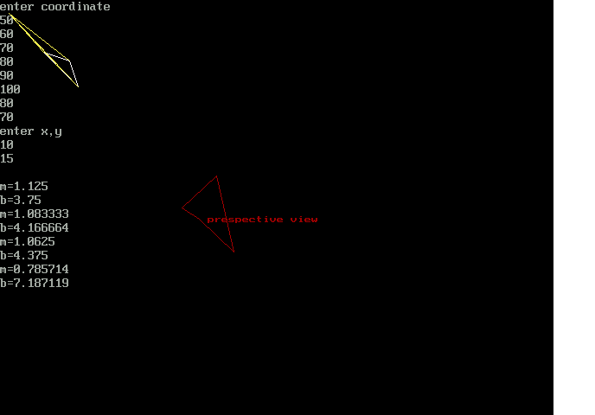
Program to implement the parallel projection.
#include<iostream.h>
#include<graphics.h>
#include<conio.h>
void main()
{
int gdriver=DETECT;
int gmode;
initgraph(&gdriver,&gmode,"c:\\tc\\bgi");
line(50,100,100,50);
line(120,170,170,120);
line(50,100,120,170);
line(100,50,170,120);
setcolor(RED);
line(400,20,400,400);
setcolor(YELLOW);
line(100,50,400,50);
line(50,100,400,100);
line(120,170,400,170);
line(170,120,400,120);
setcolor(BLUE);
line(400,50,400,100);
line(400,120,400,170);
setcolor(GREEN);
outtextxy(420,70,"ORTHOGRAPHIC VIEW");
line(20,400,400,20);
setcolor(CYAN);
line(50,100,50,370);
line(120,170,120,300);
line(170,120,170,250);
line(100,50,100,320);
setcolor(MAGENTA);
line(50,370,100,320);
line(120,300,170,250);
setcolor(BROWN);
outtextxy(50,400,"OBLIQUE VIEW");
getch();
closegraph();
//restorecrtmode();
}

Output:-

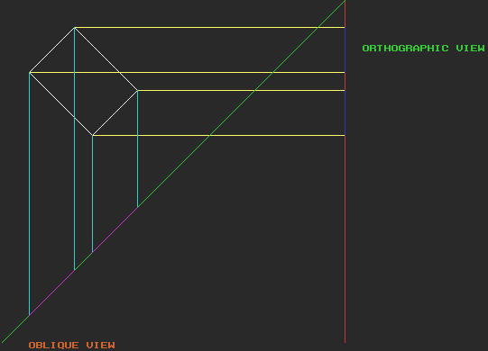

Progarm to draw a Bezier Curve.
#include<iostream.h>
#include<conio.h>
#include<graphics.h>
void main()
{

double steps,i,t;
float size;
int x1,x2,x3,x4,x;
int y1,y2,y3,y4,y;
int ax,bx,cx,dx;
int ay,by,cy,dy,gmode;
int gdriver=DETECT;
initgraph(&gdriver,&gmode,"");
x1=30;
y1=180;
x2=250;
y2=10;
x3=300;
y3=350;
x4=400;
y4=50;
ax=-x1+3*x2+(-3*x3)+x4;
ay=-y1+3*y2+(-3*y3)+y4;
bx=3*x1+(-6*x2)+3*x3;
by=3*y1+(-6*y2)+3*y3;
cx=-3*x1+3*x2;
cy=-3*y1+3*y2;
dx=x1;
dy=y1;
setcolor(MAGENTA);
steps=100;
size=1.0/(double)steps;
moveto(dx,dy);
for(i=0;i<steps;i++)
{
t=size*(double)i;
int bfn=(1-t)*(1-t)*(1-t)+3*t*(1-t)*(1-t)+3*t*t*(1-t)+t*t*t;
if(bfn!=1)
{
cout<<"\nBLENDING FUNCTIONS NOT EQUAL TO 1 at t="<<t<<"values"<<bfn;
}
x=ax*(t*t*t*t)+bx*(t*t)+cx*t+dx;
y=ay*(t*t*t*t)+by*(t*t)+cy*t+dy;
lineto(x,y);
}

outtextxy(100,100,"BEZIER CURVES");
getch();
closegraph();
}

Output:-
