Speech recognition system
How it works?
Audio through microphone gets converted to text.
Why we need it?
- Speech is most common means of communication.
- Majority people of world use speech as means of communication.
- It overcomes the barrier of literacy as well. Serves both illiterate and literate.
- Endangered languages can be stored in the inventory.
Challenges faced by speech recognition system are:
- Different variability in the speech are present. (Different style of speaking – American English, british english)
- Pronunciation are different.
- Environment (echo also makes a problem) an auditorium and a room will have different effect on the voice of speaker.
- Speaker characteristics. (old , new born, male, female)
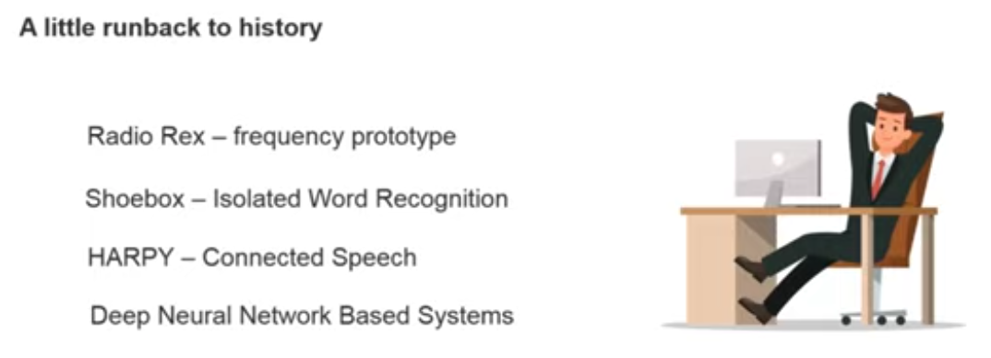
Packages used in python are:
- Apiai
- Assemblyai
- Google-cloud-speech
- SpeechRecognition

