**SQL**

What is SQL?

* Structured query language.
* Pronounced as S-Q-L or See-Qwell.
* Designed for managing data in RDBMS (Relational Database Management System).
* SQL is a database language used for database creation, insertion, deletion, fetching rows and modifying rows, etc.
* Based on relational algebra and tuple relational calculus.
* It is a query language and not a database.
* It performs queries on database for example oracle, MySQL, MongoDB, PostGre SQL, SQL server, DB2, etc.

Why SQL is required?

* To create new databases, tables and views
* To insert records in database.
* To update records in database.
* To delete records from database.
* To retrieve records from database.

What SQL does?

* We can query our database using English-like statements.
* User can access data from a relational database management system.
* Allows user to define and manipulate data when needed.
* Allow to set permission on tables, procedures, and views.

What is data?

* Collection of a distinct small unit of information
* used in a variety of forms like text, numbers, media, bytes, etc.
* In computing, Data is information that can be translated into a form for efficient movement and processing. Data is interchangeable.

What is Database?

* In computing, Data is information that can be translated into a form for efficient movement and processing. Data is interchangeable.
* You can organize data into tables, rows, columns, and index it to make it easier to find relevant information.
* **main purpose** is to operate a large amount of information by storing, retrieving, and managing data.
* There are many **dynamic websites** on the World Wide Web nowadays which are handled through databases. For example, a model that checks the availability of rooms in a hotel. It is an example of a dynamic website that uses a database.
* Modern databases are managed by the database management system (DBMS).
* **SQL** or Structured Query Language is used to operate on the data stored in a database.
* A cylindrical structure is used to display the image of a database.

The Evolution

File-Based

* 1968
* data was maintained in a flat file. Flat files are ones with no internal hierarchy.
* major advantages is that the file system has various access methods, e.g., sequential, indexed, and random.
* Disadvantage is it requires extensive programming in a third-generation language such as COBOL, BASIC.

Hierarchical Data model

* Used in 1968-1980
* Prominent hierarchical database model was IBM's first DBMS. It was called IMS (Information Management System). IMS helped NASA fulfil President Kennedy’s dream and also became the foundation for the database management system (DBMS) business.
* In this model, files are related in a parent/child manner.

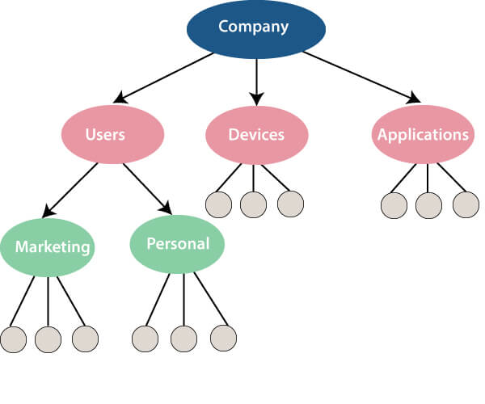

* Like file system, this model also had some limitations like complex implementation, lack structural independence, can't easily handle a many-many relationship, etc.

Network Data model

* Developed early 1960s but standardized in 1971 by CODASYL group (Conference on data systems languages).
* This model also had some limitations like system complexity and difficult to design and maintain.

Relational Database

* 1970 – present

Cloud database

* To create new databases, tables and views
* To insert records in database.
* To update records in database.
* To delete records from database.
* To retrieve records from database.

Why SQL is required?

* To create new databases, tables and views
* To insert records in database.
* To update records in database.
* To delete records from database.
* To retrieve records from database.

Why SQL is required?

* To create new databases, tables and views
* To insert records in database.
* To update records in database.
* To delete records from database.
* To retrieve records from database.

Why SQL is required?

* To create new databases, tables and views
* To insert records in database.
* To update records in database.
* To delete records from database.
* To retrieve records from database.