TOC

Automata:

1. Theoretical branch of computer science and mathematics
2. Study of abstract machines
3. The abstract machine is called automata.
4. Automata is plural of automaton
5. This automaton consists of states and transitions.
6. The State is represented by circles, and the Transitions is represented by arrows.
7. Automata is a machine which take input and input goes through a finite number of states and may enter in the final state.

Finite Automata:

1. An automaton with a finite number of states is called a Finite Automaton (FA) or Finite State Machine (FSM).

Formal definition of FA:

An automaton can be represented by a 5-tuple (Q, ∑, δ, q0, F), where −

* **Q** is a finite set of states.
* **∑** is a finite set of symbols, called the **alphabet** of the automaton.
* **δ** is the transition function.
* **q0** is the initial state from where any input is processed (q0 ∈ Q).
* **F** is a set of final state/states of Q (F ⊆ Q).

Related terminologies:

1. String:

* Definition − A string is a finite sequence of symbols taken from ∑.
* Example − ‘cabcad’ is a valid string on the alphabet set ∑ = {a, b, c, d}

1. Alphabet:

* Definition − An alphabet is any finite set of symbols.
* Example − ∑ = {a, b, c, d} is an alphabet set where ‘a’, ‘b’, ‘c’, and ‘d’ are symbols.

1. Length of String:

* Definition − It is the number of symbols present in a string. (Denoted by |S|).
* Examples −
* If S = ‘cabcad’, |S|= 6
* If |S|= 0, it is called an empty string (Denoted by λ or ε)

1. Kleene Star:

* Definition − The Kleene star, ∑*, is a unary operator on a set of symbols or strings, ∑, that gives the infinite set of all possible strings of all possible lengths over ∑ including λ.
* Representation − ∑* = ∑0 ∪ ∑1 ∪ ∑2 ∪……. where ∑p is the set of all possible strings of length p.
* Example − If ∑ = {a, b}, ∑* = {λ, a, b, aa, ab, ba, bb,………..}

1. Kleene Closure / Plus:

* Definition − The set ∑+ is the infinite set of all possible strings of all possible lengths over ∑ excluding λ.
* Representation − ∑+ = ∑1 ∪ ∑2 ∪ ∑3 ∪…….
* ∑+ = ∑* − { λ }
* Example − If ∑ = { a, b } , ∑+ = { a, b, aa, ab, ba, bb,………..}

1. Language:

* Definition − A language is a subset of ∑* for some alphabet ∑. It can be finite or infinite.
* Example − If the language takes all possible strings of length 2 over ∑ = {a, b}, then L = { ab, aa, ba, bb }

DFA

<https://www.tutorialspoint.com/automata_theory/deterministic_finite_automaton.htm>

Acceptance by finite automata

<https://www.tutorialspoint.com/automata_theory/non_deterministic_finite_automaton.htm>

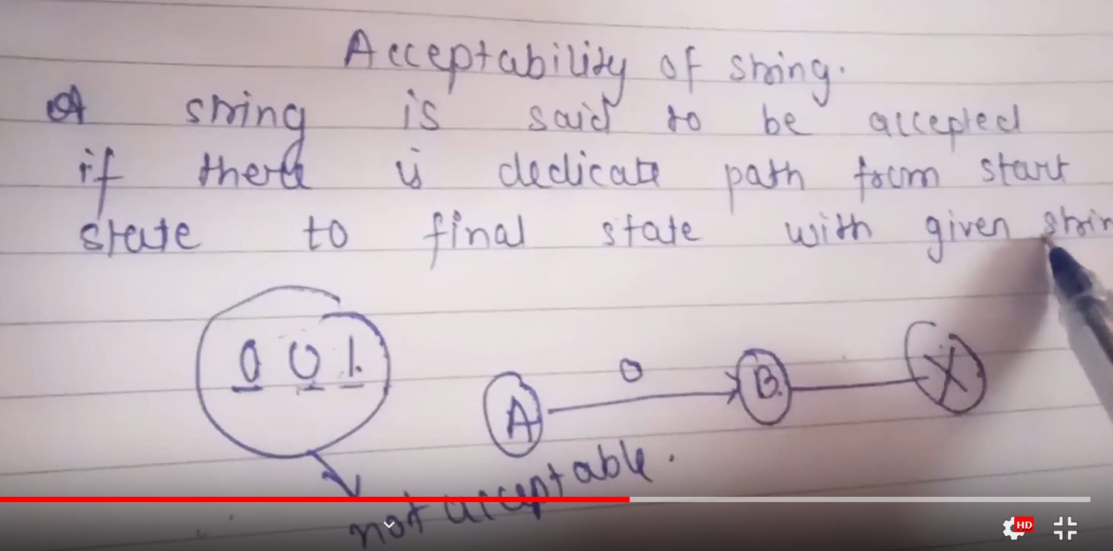

Transition system

<http://smartclassacademy.blogspot.com/2012/11/transition-system-transition-table.html>

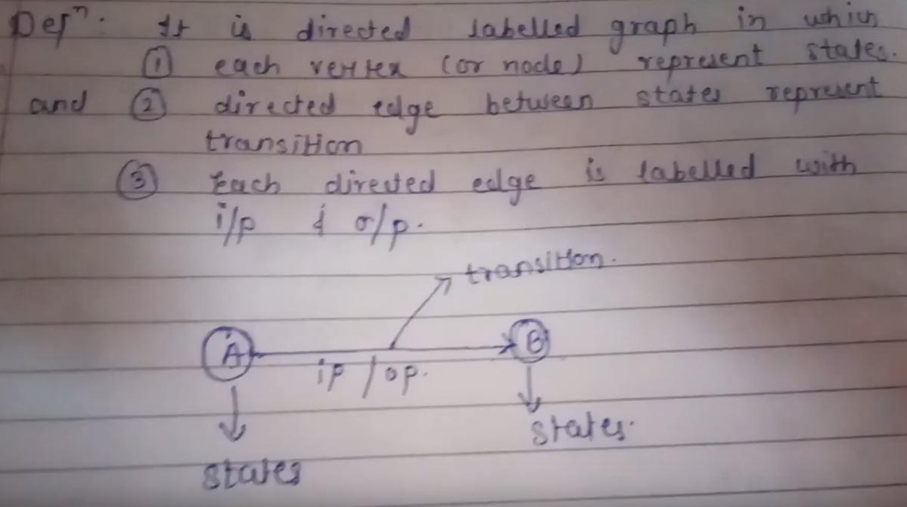

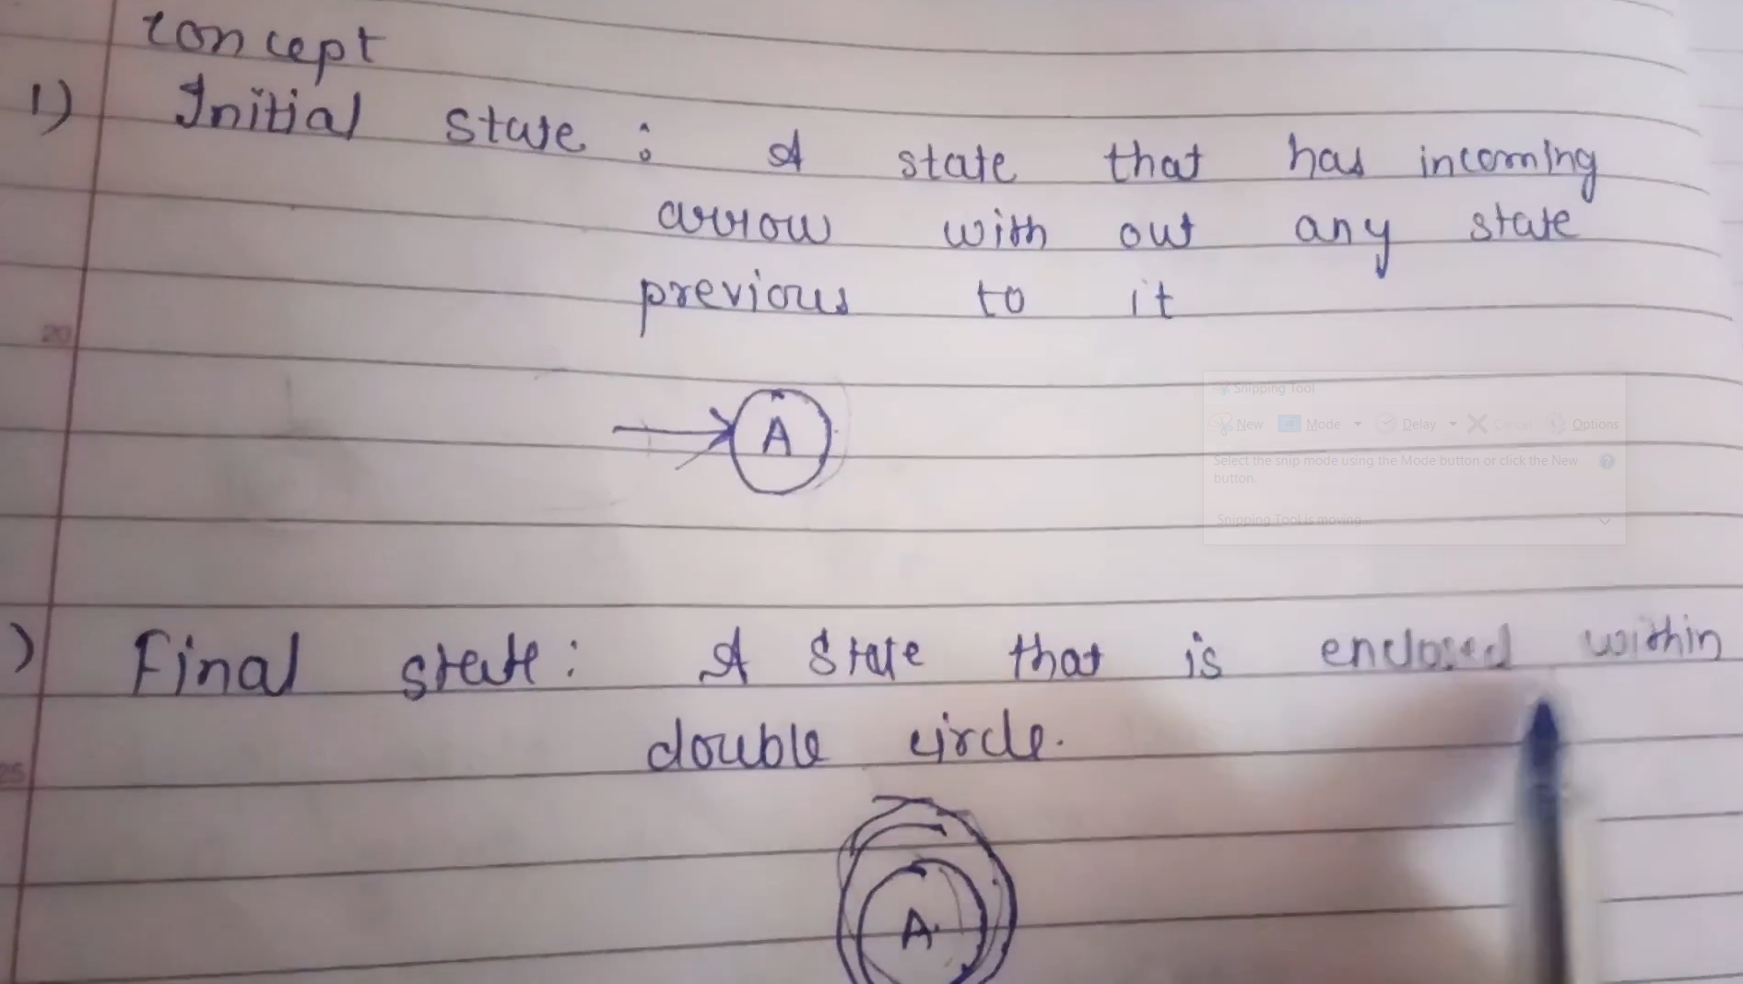

NOTE: transition system is also called as transition graph.

Transition table

<https://www.javatpoint.com/transition-table>

Transition diagram

<https://www.javatpoint.com/transition-diagram>

NDFA/NFA

<https://www.tutorialspoint.com/automata_theory/non_deterministic_finite_automaton.htm>