Web Technologies

Assignment 1

Submitted to: Jaswant Singh Taur

Submitted by:

Name: Gursimar Kaur

Uni. Roll no: 1820036

Class Roll no: 1715372

Class: D3 CSE E3

Ques 1: What are proxy servers?

Ans 1: A proxy server is a dedicated computer or a software system running on a computer that acts as an intermediary between an endpoint device, such as a computer, and another server from which a user or client is requesting a service. The proxy server may exist in the same machine as a firewall server or it may be on a separate server, which forwards requests through the [firewall](https://searchsecurity.techtarget.com/definition/firewall).

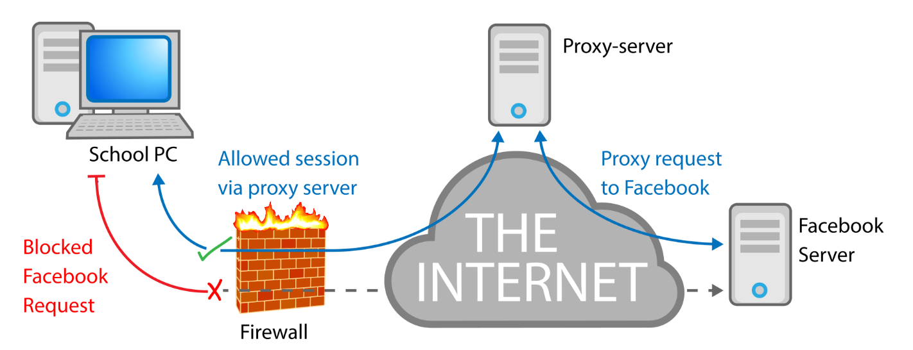

How does proxy servers work?

1. Every computer on the internet needs to have a unique Internet Protocol (IP) Address.
2. A proxy server is basically a computer on the internet with its own IP address that your computer knows.
3. When you send a web request, your request goes to the proxy server first.
4. The proxy server then makes your web request on your behalf, collects the response from the web server, and forwards you the web page data so you can see the page in your browser.
5. When the proxy server forwards your web requests, it can make changes to the data you send and still get you the information that you expect to see.

Why should be use proxy servers?

1. **To control internet usage of employees and children.**
2. **Bandwidth savings and improved speeds.**
3. **Privacy benefits.**
4. **Get access to blocked resources.**
5. **Improved security.**

Ques2: What are web servers?

Ans2: A Web [server](https://whatis.techtarget.com/definition/server) is a program that uses [HTTP](https://searchwindevelopment.techtarget.com/definition/HTTP) (Hypertext Transfer Protocol) to serve the files that form Web pages to users, in response to their requests, which are forwarded by their computers' HTTP clients. Dedicated computers and appliances may be referred to as Web servers as well.

The process is an example of the [client/server](https://searchnetworking.techtarget.com/definition/client-server) model. All computers that host Web sites must have Web server programs. Leading Web servers include [Apache](https://whatis.techtarget.com/definition/Apache) (the most widely-installed Web server), Microsoft's Internet Information Server ([IIS](https://searchwindowsserver.techtarget.com/definition/IIS)) and nginx (pronounced *engine X*) from NGNIX. Other Web servers include Novell's NetWare server, Google Web Server (GWS) and IBM's family of Domino servers.

How web servers work?

A page on internet can be viewed, when the browser requests it from the web server and the web server responds with that page. A simple diagrammatic representation of this is as given below in the figure:

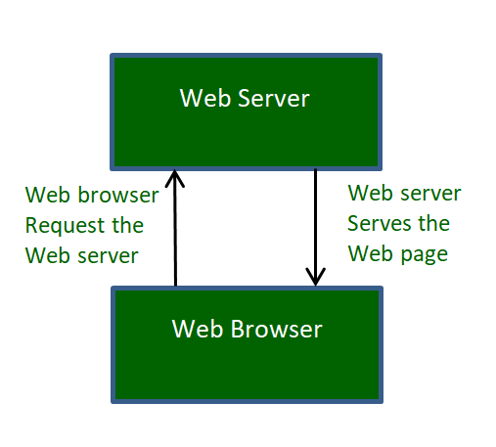

Simple process consists of 4 steps, they are:

1. Obtaining the IP Address from domain name: Our web browser first obtains the IP address the domain name (for e.g., for this page the domain name is www.geeksforgeeks.org) resolves to. It can obtain the IP address in 2 ways-
   * By searching in its cache.
   * By requesting one or more DNS (Domain Name System) Servers.

Note: Any website is assigned an IP address when it is first created on web server.

1. Browser requests the full URL : After knowing the IP Address, the browser now demands a full URL from the web server.
2. Web server responds to request: The web server responds to the browser by sending the desired pages, and in case, the pages do not exist or some other error occurs, it will send the appropriate error message.  
   For example:

You may have seen Error 404, while trying to open a webpage, which is the message sent by the server when the page does not exist.  
Another common one is Error 401 when access is denied to us due to incorrect credentials, like username or password, provided by us.

1. Browser displays the web page: The Browser finally gets the webpages and displays it, or displays the error message.

Ques3: What are cookies?

Ans3:

1. A [cookie](https://www.webopedia.com/TERM/C/cookie.html) (called an Internet or Web cookie) is the term given to describe a type of message that is given to a [web browser](https://www.webopedia.com/TERM/B/browser.html) by a [web server](https://www.webopedia.com/TERM/W/Web_server.html).
2. The main purpose of a cookie is to identify users and possibly prepare customized Web pages or to save site login information for you.

How cookies actually work?

1. When you enter a [website](https://www.webopedia.com/TERM/W/web_site.html) using cookies, you may be asked to fill out a form providing personal information; like your name, email address, and interests.
2. This information is packaged into a cookie and sent to your Web browser, which then stores the information for later use.
3. The next time you go to the same Web site, your browser will send the cookie to the Web server.
4. The message is sent back to the server each time the browser requests a page from the server.

What information does cookies contains?

Cookies have six parameters that can be passed to them:

1. The name of the cookie.
2. The value of the cookie.
3. The expiration date of the cookie - this determines how long the cookie will remain active in your browser.
4. The path the cookie is valid for - this sets the URL path the cookie us valid in. Web pages outside of that path cannot use the cookie.
5. The domain the cookie is valid for. This makes the cookie accessible to pages on any of the servers when a site uses multiple servers in a domain.
6. The need for a secure connection - this indicates that the cookie can only be used under a secure server condition, such as a site using [SSL](https://www.webopedia.com/TERM/S/SSL.html).

**Types of cookies**

1. [session cookie](https://www.webopedia.com/TERM/S/session_cookie.html)
2. Also called a transient cookie.
3. A cookie that is erased when you close the Web browser.
4. The session cookie is stored in temporary memory and is not retained after the browser is closed.
5. [persistent cookie](https://www.webopedia.com/TERM/P/persistent_cookie.html)
6. Also called a permanent cookie, or a stored cookie.
7. A cookie that is stored on your hard drive until it expires (persistent cookies are set with expiration dates) or until you delete the cookie.

Ques4: What are different types of web browsers?

Ans4: Web Browsers are software installed on your PC. To access the Web, you need a web browser, such as Netscape Navigator, Microsoft Internet Explorer or Mozilla Firefox.

Currently you must be using any sort of Web browser while you are navigating through our site tutorialspoint.com. On the Web, when you navigate through pages of information, this is commonly known as web browsing or web surfing.

Different types of web browsers are as follows:

1. Internet Explorer: Internet Explorer (IE) is a product from software giant Microsoft. This is the most commonly used browser in the universe. This was introduced in 1995 along with Windows 95 launch and it has passed Netscape popularity in 1998.

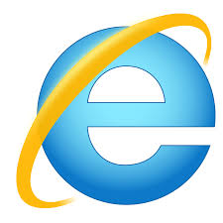

1. Google Chrome: This web browser is developed by Google and its beta version was first released on September 2, 2008 for Microsoft Windows. Today, chrome is known to be one of the most popular web browser with its global share of more than 50%.

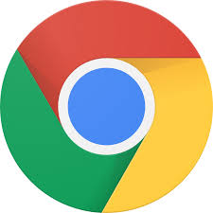

1. Mozilla Firefox: Firefox is a new browser derived from Mozilla. It was released in 2004 and has grown to be the second most popular browser on the Internet.



1. Safari: Safari is a web browser developed by Apple Inc. and included in Mac OS X. It was first released as a public beta in January 2003. Safari has very good support for latest technologies like XHTML, CSS2 etc.



1. Opera: Opera is smaller and faster than most other browsers, yet it is full- featured. Fast, user-friendly, with keyboard interface, multiple windows, zoom functions, and more. Java and non Java-enabled versions available. Ideal for newcomers to the Internet, school children, handicap and as a front-end for CD-Rom and kiosks.



1. Konqueror: Konqueror is an Open Source web browser with HTML 4.01 compliance, supporting Java applets, JavaScript, CSS 1, CSS 2.1, as well as Netscape plugins. This works as a file manager as well as it supports basic file management on local UNIX filesystems, from simple cut/copy and paste operations to advanced remote and local network file browsing.



1. Lynx: Lynx is a fully-featured World Wide Web browser for users on Unix, VMS, and other platforms running cursor-addressable, character-cell terminals or emulators.

