Q1:

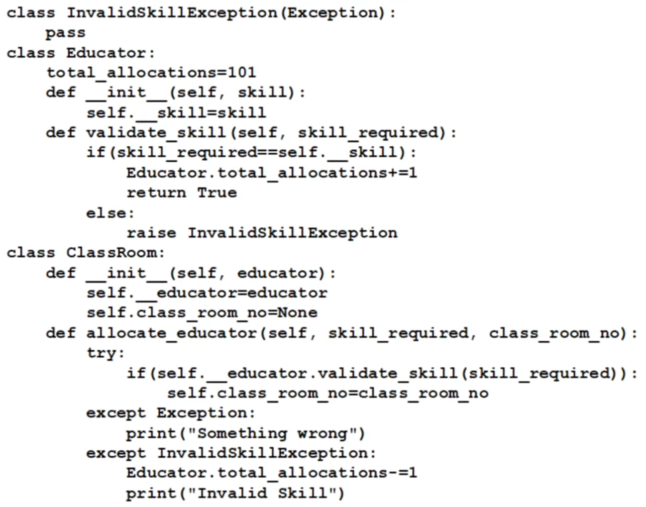

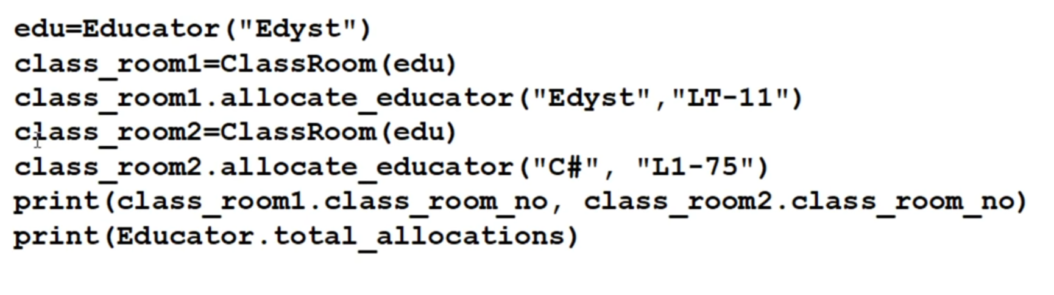

Q2.

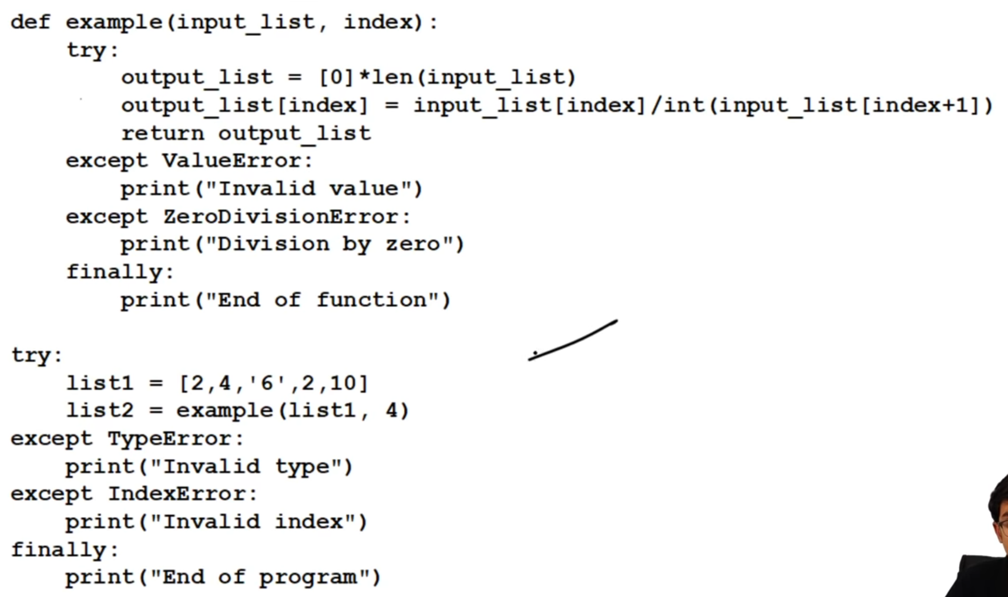

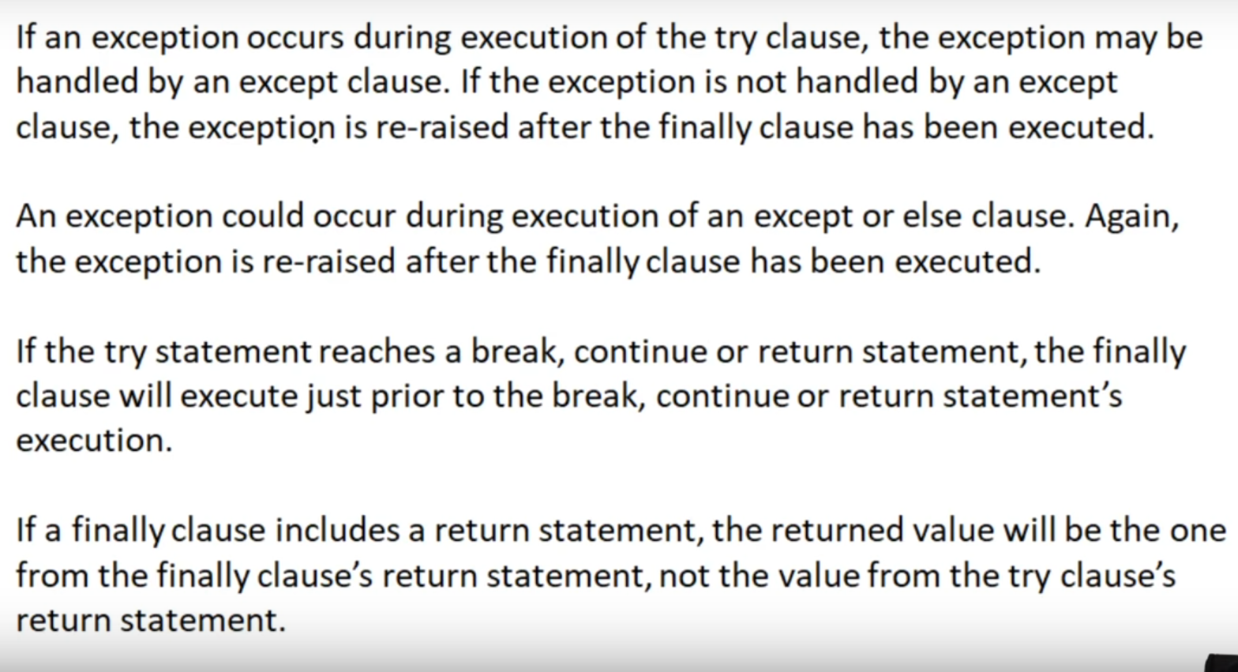

Q3.

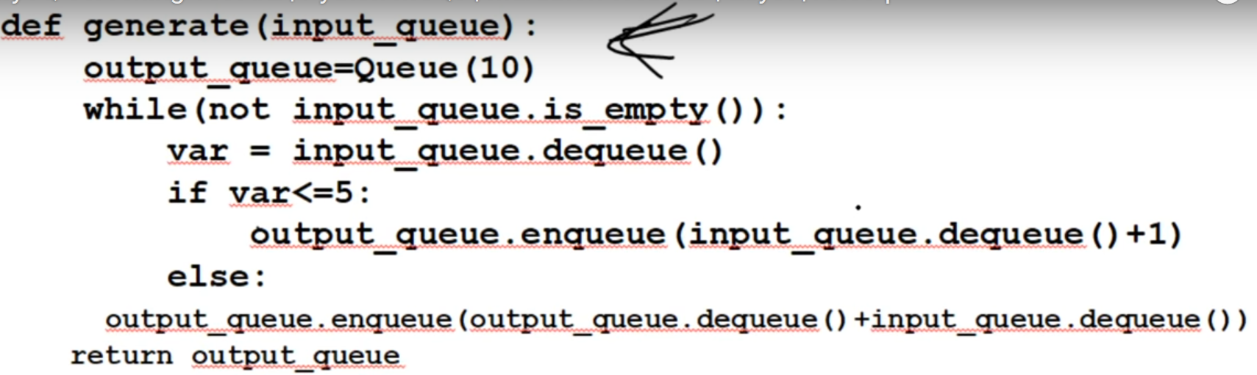

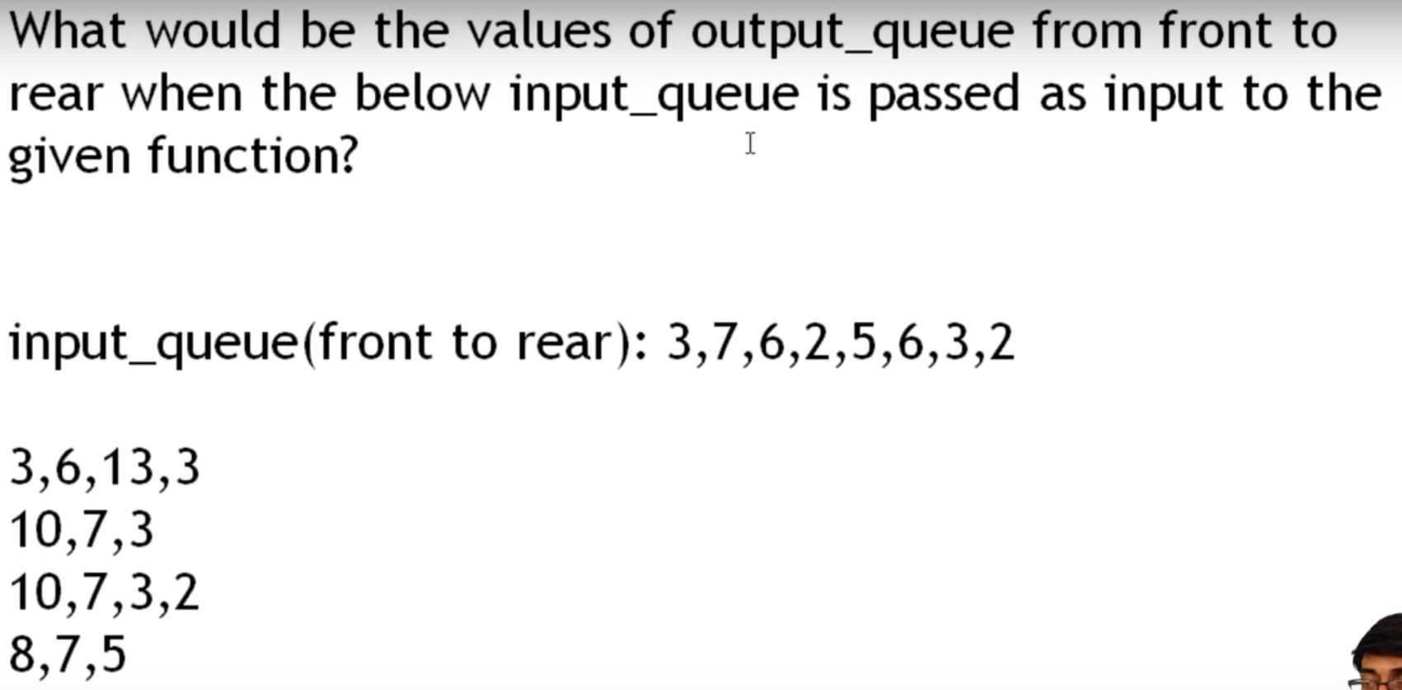

Q4.

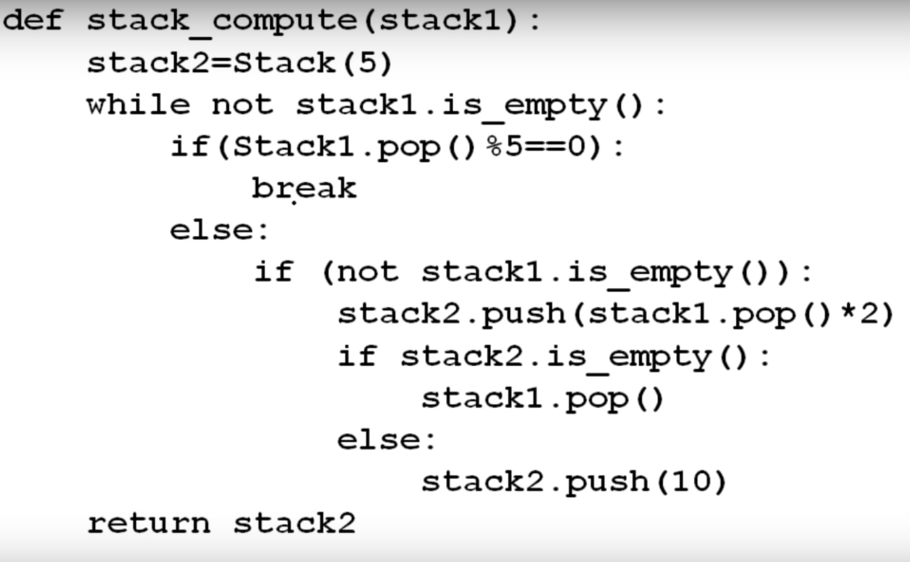

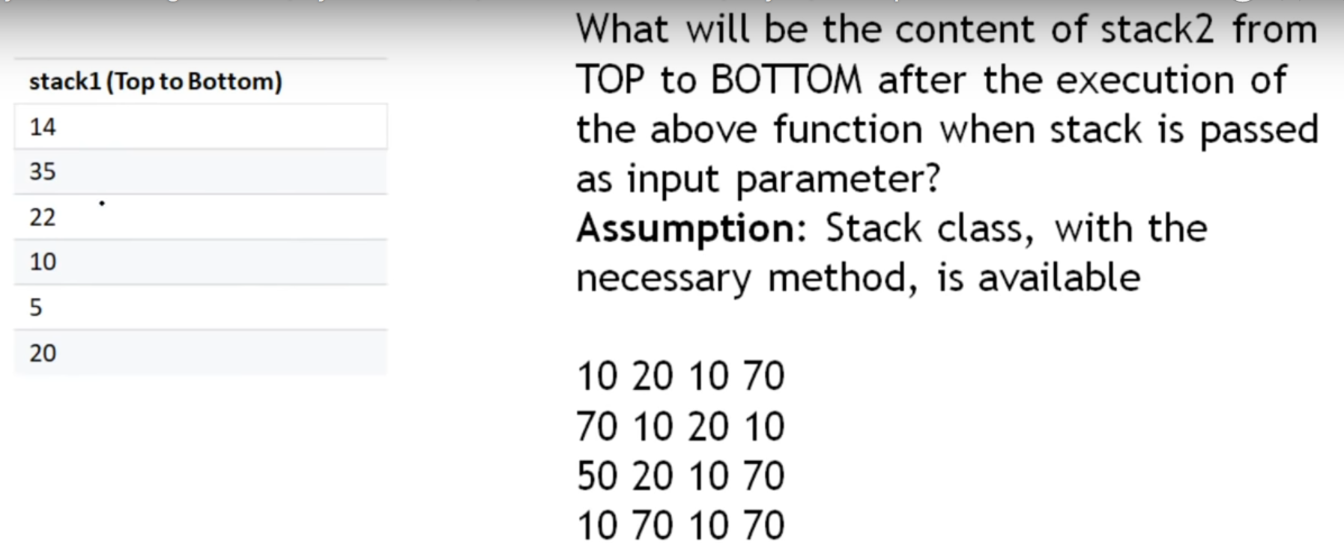

Use of Data Structures:

1. Graph: when number of nodes are there from number of positions.
2. Linked list: when u have something in the front and last.
3. Stack: to know most recent value.
4. Queue: plan a line or queue.