1. **Constructor:**

Constructor should be default

parameter should be for variable

super keyword in constructor to acces the constructor of movie class.

**Inheritance :** rental movie purchase movie should be estended

**Encapsulation :** variable should be private.

we should use getter setter .

enum:

2.

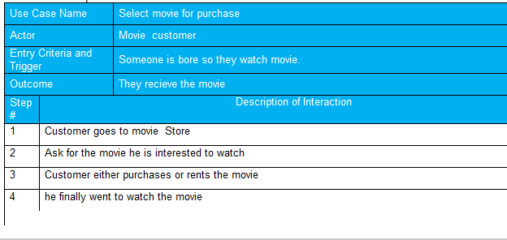

3.

4.

