

# SOEN 6441- Advanced Programming Practices

**Winter 2019**

Architectural Design Document for Risk Game Project

Submitted to: Prof Amin Ranj Bar

**Group 11**

Gursimran Singh - 40080981

Namita Faujdar - 40105179

Karanbir Singh Pannu - 40047216

Shriyans Athalye - 40037637

Table of Contents

SOEN 6441- Advanced Programming Practices 1

1. Introduction 2

1.2 Scope of Document 3

2. MVC Architecture 4

Bibliography 9

# Introduction

**1.1 Purpose of the Document**

This documents purpose is for building an architecture design model implementing predefined architectural model. The implemented design model was Model View Controller also following some of the known programming approach for smooth and effective game development.

* **Programming Concepts**: Some of the well-known programming practices were followed to maintain effectiveness of project development. Example such as pair programming where two programmers worked on same workstation to maintain productivity.
* **Simple Design**: Simple workflow of design made it easier to read and avoid faults.
* **Continuous Integration**: Bitbucket was used as version control for the project where all programmers were made to work with single branch and commit accordingly. Maintenance of frequent changes, rollbacks helped increase the productivity by automatic integration.
* **Coding standards**: Simple and understandable coding standards were followed including naming and file organization conventions.
* **Refactoring**: GamePlayModel, PlayerController, Country under Continent Model.

1. GamePlayModel: In the build 1, we made MapRiskModel for Map Creation and Editing and there were separate entities for the Startup, Reinforcement and Fortification phase as playing phase wasn’t implemented in the last build, there wasn’t any need for the same. Hence, For the Build 2, we refactored in such a way that a GamePlayModel would become responsible for each player’s Startup, Reinforcement, Attack and Fortification phase in a round robin fashion. This will help us to add strategies in future.

2. PlayerController: To add generic strategy for each player, Encapsulation of Reinforcement, Attack and Fortification phase is done in PlayerController. In GamePlayModel, the data flows into data flow model object and updates the view whenever data changes.

3. ArrayList<CountryModel> in ContinentsModel: We didn’t require cards and control values of the continents in the last build. For the build 2, we have added list of countries in one of the continents and stored in ContinentsModel.

## Scope of Document

This design covers the development of simple risk game using different builds covering different phases of game. Detailed explanations of design are covered in different sections below. The motives of design decisions made were crucial for implementing entire project working and help effective build. This document will cover overall project architecture by explaining from the base until final build process. Covers all the aspects of Build 2 according to requirement. This document covering the representation of the following of MVC design pattern for implementing user interfaces on computers. It divides a given application into three interconnected parts. This is done to separate internal representations of information from the way’s information is presented to, and accepted from, the user. The MVC design pattern decouples these major components allowing for efficient code reuse and parallel development

The scope of the build 2 is as per the instruction guidelines for the build:

**Functional requirements:**

Map Editor:

● User-driven creation of map elements, such as country, continent, and connectivity between countries.

● Saving a map to a file exactly as edited (using the “conquest” game map format). Loading a map from an existing “conquest” map file, then editing the map, or create a new map from scratch.

● Successfully load the 3dCliff.map and World.map file. Reject loading of map file by correctly verifying that continents are connected subgraphs

Start-up Phase:

● All countries are randomly assigned to players. Players are allocated a number of initial armies, depending on the number of players. In round-robin fashion, the players place one by one their given armies on their own countries.

Reinforcement phase:

● Calculation of correct number of reinforcement armies according to the Risk rules. Players place reinforcement armies on the map. Reinforcement ends automatically when all armies have been placed. Implementation of a “card exchange view” using the Observer pattern.

Fortification phase:

● Implementation of a valid fortification move according to the Risk rules. Fortification ends automatically when the armies have been moved.

Attack Phase:

* Player can declare an attack by selecting attacker and attacked country.
* Attacker and attacked player decide how many dice to roll.
* Proper number of armies are deducted from attacker/defender country during the attack(s).
* If defender is conquered, attacker can move any number of its armies in the conquered country (see the Risk rules). If it results in conquering the whole map, the attacker is declared the winner and the game ends.
* Player may decide to attack or not to attack again. If attack not possible, attack automatically ends.
* Implementation of an “all-out” mode.

Game Play:

* Implementation of a “phase view” using the Observer pattern.
* Implementation of a “players world domination view” using the Observer pattern.
* Implementation of the reinforcement, attack and fortification as methods of the Player class.

# MVC Architecture

Model view controller helps to decouple data access and business logic from the way it is displayed to the end user. This distribution of logic is done in different sections of the MVC architecture namely model, view and controller.

Model: Model being the lowest level of this architecture, it represents data and the rule that govern access to and updates of this data. Model mainly is responsible for maintaining data.

View: View renders contents of a model. View specifies how any model’s data should be presented. If incase any model data changes, view responsibility is to update its presentation as needed. The update feature can be achieved via a push model where view registers itself with model for change notifications or pull model for calling model whenever it retrieves most current data.

Controller: Controller translates user’s interaction with view into actions that model will perform. If considering standalone application, user interactions could be click of button or mouse event. Depending on the context controller may also select new view like web page of result for representation purpose to the user.

Figure 1 Model View Controller

**Development use:**

* **Model**: This model manages data of application domain. Main models of our project consist of **Country model, Continent Model, GamePlayModel, PlayerModel** where the application domain remains. If model gets a request for change from View, then they respond to instructions via controller.
* **View**: In View, it renders model into a form suitable for visualization or interaction in a form of UI. If model data changes, view must update its presentation as needed. Some of the views in our project are **MainGameview, MapEditView, StartupView, FortificationView**. This will be notified by model accordingly.
* **Controller**: Controller is designed to handle user input and initiate response based on event making calls on appropriate model objects. This will instruct model to perform operations by accepting user inputs. For example**, StartupController** is used to call the model to perform operation.
* **Interface View:** View extends observer to maintain state change. This interface consist of setter of setActionListener.

**Modules Description**

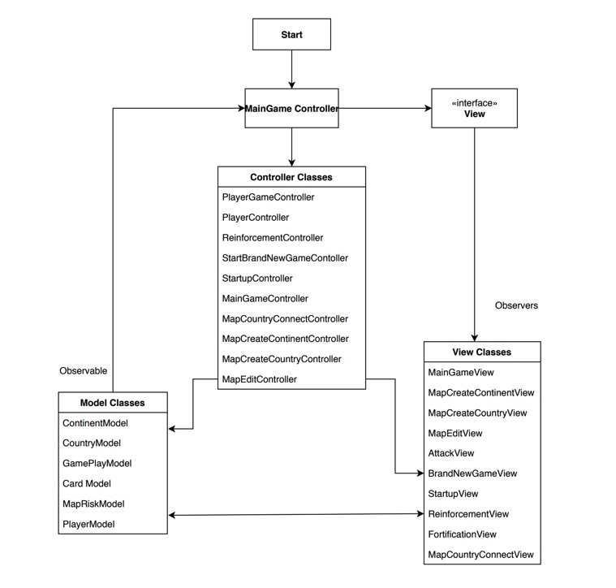

Figure 2 Architecture Diagram

**VIEW Classes**

|  |  |
| --- | --- |
| MainGameView | Creates a welcome screen. This View has the UI components for the main game view. |
| CreateContinent | Add continents with their control values to map file. |
| CreateCountry | Add countries to particular continents. It adds countries to the map while creation. |
| EditContinentView | The edit control value of continents and link between countries and continents. |
| NewGameView | Here we browse and upload the map to start the game. |
| StartUpView | Startup phase of the game. Map loaded an initial army assignment to players. |
| Reinforcement View | Calculate a number of armies and assign to players. |
| Fortification View | Move armies from one country to another. |
| Attack View | Attack by selecting attacker and attacked country |
| CountryConnectView | View for players to connect a country to another country during map creation |

**CONTROLLER Classes**

|  |  |
| --- | --- |
| PlayerGame Controller | The player game controller mainly handles the data change and update among the game risk model and view, |
| NewGameController | This controller is used to control the data when a new game is started. |
| StartUpController | Allocate  armies to respective player. |
| MainGameController | Starting point of game. |
| CountryConnectController | The CountryConnectController is used |
| CreateContinentController | The CreateContinentController controls and updates the model and view when a continent is created in the map editor. |
| CreateCountryController | The CreateCountryController controls and updates the model and view when a country is created in the map editor. |
| EditContinentController | It does the movement of data into the model corresponding to the view and controller. It also takes care of updating view whenever data is changed or updated. |
| PlayerController | Implementation of the reinforcement, attack and fortification. |

**MODEL Classes**

|  |  |
| --- | --- |
| ContinentModel | Stores all continents with the control value. |
| CountryModel | Stores all countries linked to continents. |
| PlayerModel | Stores data of all players. |
| CardModel | Stores card details. |
| GamePlayModel | Helps in creating and editing a new map. |

1. **Technology and Tools:**

3.1 **Technologies and tools used for the development of the game**:

|  |  |
| --- | --- |
| **Technology and Tools** | **Description** |
| IntelliJ | IDE for the game development |
| Maven | Maven as a build automation tool to manage all project dependencies. |
| Swing | Library to control the UI components of the Risk Game |
| Junit 4 | Junit 4 for writing test cases |

# Bibliography

|  |  |
| --- | --- |
| [1] | "Risk Game Rules," [Online]. Available: https://en.wikipedia.org/wiki/Risk_(game). |
| [2] | "MVC Architecture," Oracle, 2019. [Online]. Available: https://www.oracle.com/technetwork/articles/javase/index-142890.html. |
| [3] | "Junit Tutorial," [Online]. Available: https://www.tutorialspoint.com/junit/. |