**AI-Enhanced Personalized Learning and Career Pathway Platform**

**Team Members:**

Gursimran Singh - Student ID: [300377817] - Team Lead

Shubham Shubham - Student ID: [300352587]

**Course:** Applied Research Project – 4495- 071

**1. Introduction**

In today’s fast-paced educational environment, students often struggle to balance academic studies with preparing for future careers. While traditional learning platforms provide access to content, they lack personalization and fail to adapt to individual learning styles, strengths, and weaknesses. This creates a gap between academic performance and career readiness.

The problem addressed in this research is how to leverage artificial intelligence (AI) to provide personalized study support while also preparing students for career success. Key questions include: How can AI generate adaptive study plans tailored to student performance and preferences? How can these features be extended to support skill development, resume preparation, and interview readiness? These questions are important because students need guidance that connects learning with employability in today’s competitive job market.

Although prior studies show the benefits of adaptive learning systems, most focus only on academics or career preparation in isolation. Few provide a comprehensive approach that integrates both. This research assumes that combining AI-driven learning paths with career readiness tools will improve both academic outcomes and long-term employability.

The expected contribution is an AI-powered platform that generates weekly study plans, recommends skills and certifications, and offers tools for resume building and interview preparation. By addressing existing gaps, the project aims to enhance both academic performance and career development in a unified way.

**2. Problem Statement**

Students face multiple challenges:

1. Inefficient study strategies: Many students struggle to identify weak topics or prioritize study time effectively.
2. Lack of personalized learning: Traditional static study guides do not cater to individual learning styles.
3. Career readiness gaps: Students are often unaware of skills needed for specific career paths, relevant certifications, or how to prepare for interviews.
4. Fragmented resources: Students must navigate multiple platforms for academic content, skill development, and career tools.

**Research Question:**  
*Can an AI-driven platform that combines personalized learning paths with career readiness tools improve student learning outcomes, engagement, and employability preparation compared to traditional static methods?*

**3. Literature Review & Research Gap**

* **Personalized Learning:** Studies indicate that tailored learning paths improve retention, engagement, and performance (Bloom, 1984; Pane et al., 2017).
* **AI in Education:** AI tools such as intelligent tutoring systems, chatbots, and recommendation engines have been shown to effectively guide students through learning materials (Luckin et al., 2016).
* **Career Readiness Platforms:** Existing platforms (LinkedIn Learning, Coursera) provide skill suggestions but lack integration with academic performance and personalized study plans.
* **Gap Identified:** There is a lack of comprehensive platforms that combine AI-driven learning paths, career guidance, certificates, resume building, and interview prep into a single ecosystem.

**4. Assumptions, Hypotheses, and Potential Benefits**

This research assumes that students face difficulty in aligning academic learning with career preparation due to the lack of personalized guidance. It also assumes that AI can effectively analyze student performance, preferences, and career goals to provide tailored recommendations.

The initial hypothesis is that an AI-driven platform offering personalized study plans, career skill recommendations, certificates, resume-building tools, and interview preparation will lead to improved academic performance, stronger career readiness, and greater student confidence.

The potential benefits of this research include helping students study more efficiently, bridge the gap between education and employability, and prepare for real-world opportunities with guided, data-driven support.

**5. Project Objectives**

1. **Personalized Learning Paths:**
   * AI-generated weekly study plans tailored to individual strengths, weaknesses, and learning preferences.
2. **Career Skills Recommendation:**
   * Suggest skills aligned with academic subjects and career interests.
   * Recommend relevant online courses and certification programs.
3. **Resume Builder:**
   * Interactive module to create, customize, and export resumes.
   * Auto-suggest skills, achievements, and certifications.
4. **Interview Preparation:**
   * AI-generated practice questions for target careers.
   * Automated feedback on clarity, tone, and confidence.
5. **Analytics Dashboard:**
   * Track learning progress, skill acquisition, certificate completion, and interview readiness.
   * Provide visual analytics and reports for both students and instructors.

**6. Project Scope**

**Inclusions:**

* AI-generated weekly learning plans.
* Dashboard to track progress, skills, and certifications.
* Career skill recommendations and certificate suggestions.
* Resume builder module.
* AI-powered interview preparation module.

**Exclusions:**

* Real-time grading and LMS integration (outside MVP scope).
* Enterprise-level deployment or multi-institution access.

**Deliverables:**

1. Functional web/mobile app prototype.
2. User manual and technical documentation.
3. Research study report evaluating student performance and satisfaction.

**7. Methodology**

**7.1 System Architecture**

**Frontend:** React (Web) / React Native (Mobile)  
**Backend:** Firebase or Supabase for database, authentication, and storage  
**AI Modules:**

* OpenAI API or HuggingFace Transformers for:
  + Generating personalized learning plans
  + Resume recommendations
  + Interview question generation and evaluation

**Database:**

* Student profiles, quiz scores, learning plans, skills, certificates, resumes, and interview logs.

**7.2 Functional Modules**

1. **Personalized Learning Path Generator:**
   * Input: syllabus, quiz results, learning preferences
   * Output: weekly study plan with prioritized topics
2. **Career Skills Recommendation Engine:**
   * Maps student course performance to relevant skills
   * Suggests certifications and online courses
3. **Resume Builder:**
   * Interactive resume creation
   * Auto-suggest skills, certifications, and achievements
   * Export in PDF format
4. **Interview Preparation Module:**
   * AI-generated practice questions
   * Feedback on answers: clarity, confidence, and tone
   * Suggested improvements
5. **Analytics Dashboard:**
   * Tracks progress, skill acquisition, certificate completion, and interview readiness
   * Visualizations: charts, progress bars, and reports

**7.3 Development Process**

* **Agile methodology**: two-week sprints, weekly meetings
* **Tools:** Jira (task tracking), GitHub (version control), Figma (UI design)
* **Testing:** unit tests for backend, usability tests for frontend, AI validation for accuracy

**8. Technical Requirements**

**Software:**

* Node.js, React/React Native
* Firebase or Supabase
* Python (for AI/NLP modules)
* OpenAI API or HuggingFace Transformers
* Chart.js/Recharts for dashboards

**Hardware:**

* Standard development laptops
* Optional cloud GPU for AI model training

**Data Requirements:**

* Sample syllabi, mock quiz scores, career skill datasets
* Surveys for user feedback

**9. Research Methodology**

**Study Design:**

* Pilot study with 15–30 students
* Two groups: AI-driven learning path vs. traditional static plan

**Data Collection:**

* Quiz improvement, task completion rate, skill acquisition logs
* Survey: user satisfaction and perceived usefulness of resume builder and interview prep

**Analysis:**

* Compare academic outcomes, engagement, and career readiness using statistical methods (t-tests, ANOVA)

**Simplified Data Flow Diagram:**

* **Clean architecture**: Student → Frontend → Backend → AI Modules → Database
* **Core modules**: Learning Path Generator, Career Skills Engine, Resume Builder, Interview Prep, and Analytics
* **Clear data flow**: Shows how information moves through the system from user input to AI processing to data storage

**Simplified Sequence Diagram:**

* **Complete user journey in 5 key phases:** 
  1. **Initial Setup** - Syllabus upload and learning plan generation
  2. **Learning Progress** - Quiz completion and adaptive path updates
  3. **Career Development** - Goal setting and skill recommendations
  4. **Resume & Interview Prep** - Parallel resume building and interview practice
  5. **Progress Monitoring** - Analytics dashboard view
* Color-coded sections for easy visualization
* Parallel processing shown for resume and interview preparation
* End-to-end flow from login to progress tracking

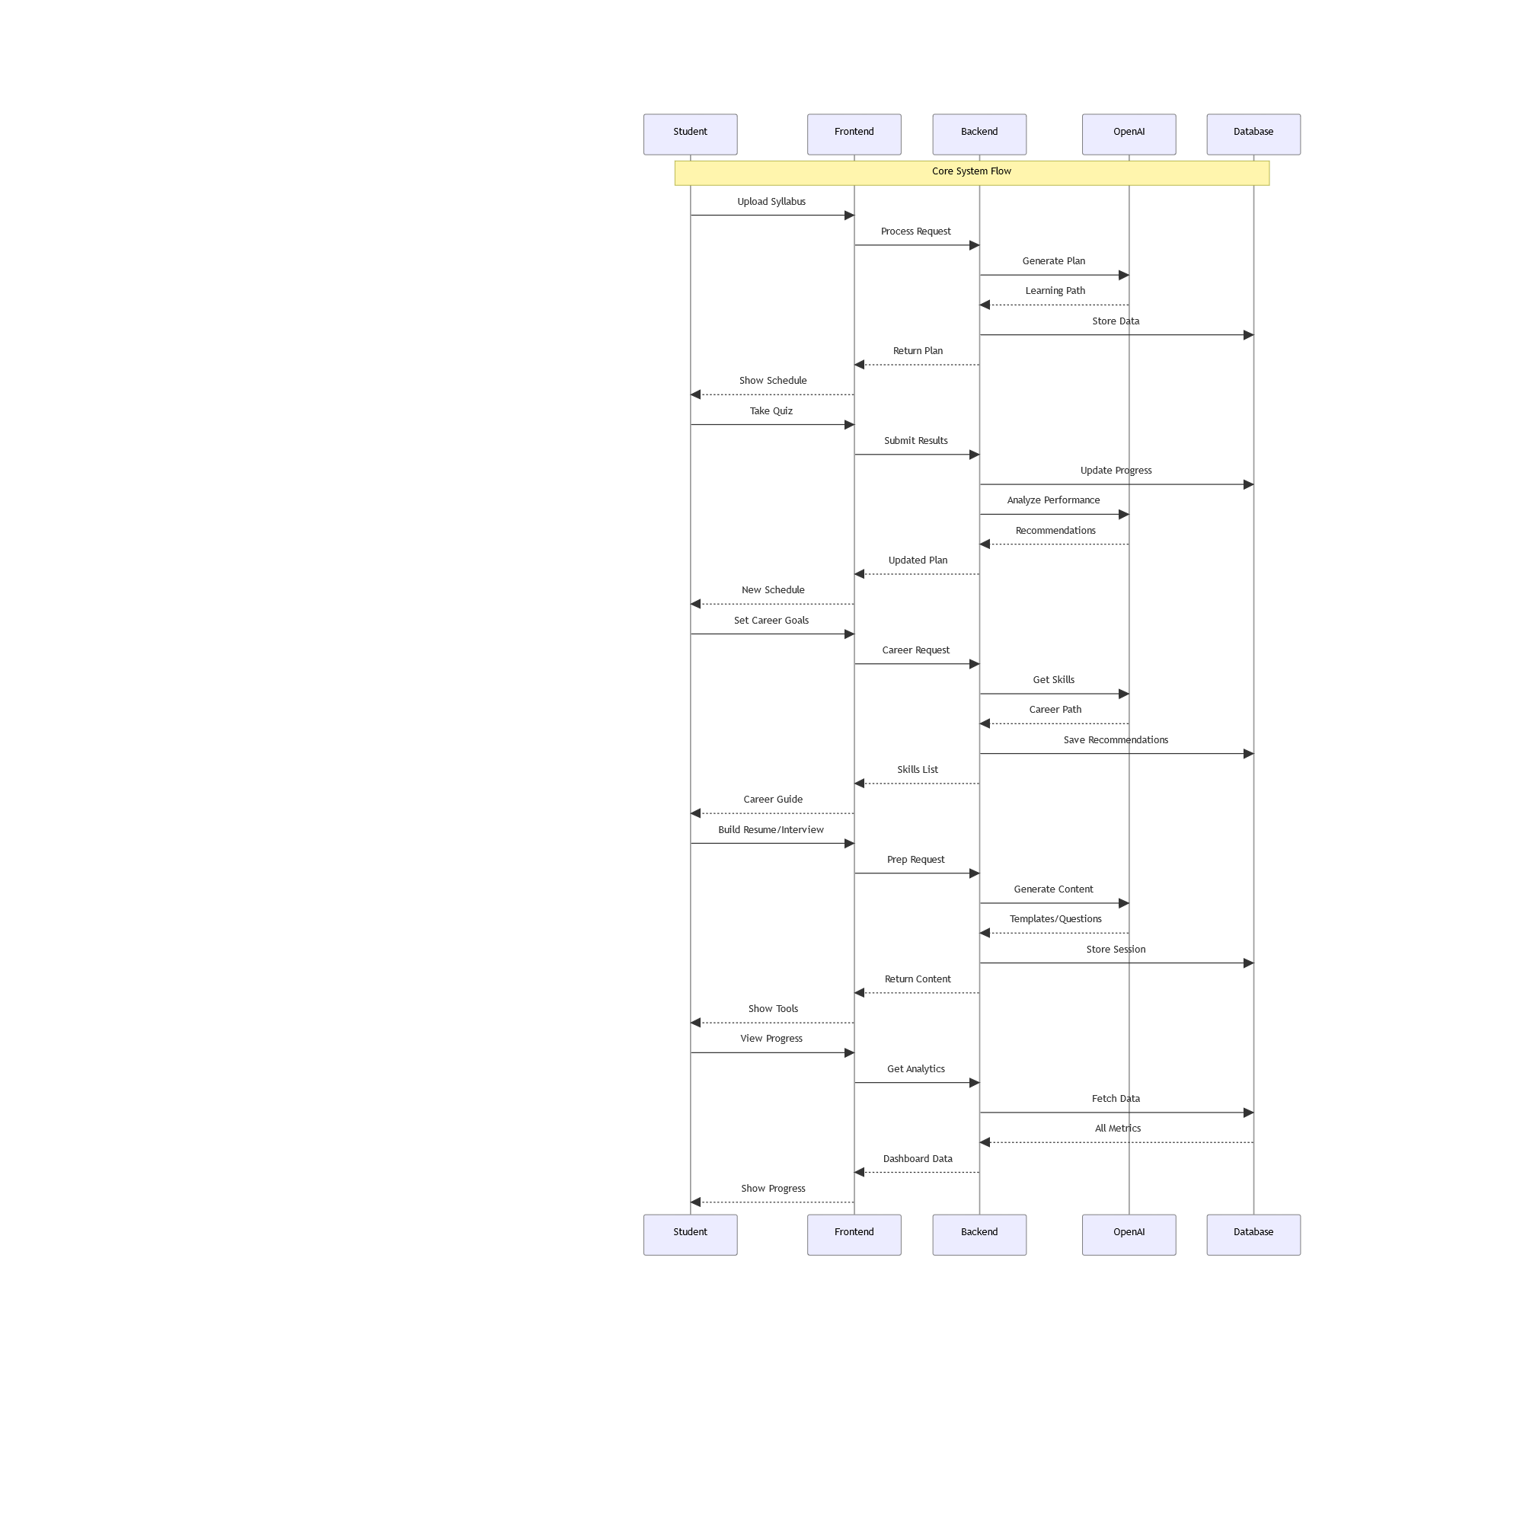

**10. Expected Outcomes**

* Improved academic performance and learning efficiency
* Clear roadmap for skill acquisition and career development
* Enhanced student confidence in resumes and interviews
* Evidence of AI-driven personalized guidance impact on learning and employability

**11. Timeline**

| **Week(s)** | **Milestone / Task** | **Description / Deliverables** | **Responsibilities** |
| --- | --- | --- | --- |
| 1–2 | Requirement Analysis & System Design | - Gather requirements- Define features- Design system architecture- Create initial Figma mockups- Assign team roles | **Gursimran Singh:** Lead requirements gathering and system design, assign roles  **Shubham Shubham:** Assist in design, create Figma mockups, document features |
| 3–4 | AI Learning Path Module Development | - Develop AI/NLP engine to parse syllabus and quiz results- Generate personalized weekly learning plans- Test with sample data | **Shubham Shubham:** Lead AI module development, test sample outputs  **Gursimran Singh:** Review outputs, ensure alignment with objectives |
| 5–6 | Career Skills & Certification Module | - Build skills recommendation engine- Suggest online courses/certifications- Link skills to career paths- Test accuracy of recommendations | **Shubham Shubham:** Develop recommendation engine, perform testing  **Gursimran Singh:** Verify skill mappings and recommendations |
| 7–8 | Resume Builder & Interview Prep Integration | - Implement interactive resume builder with auto-suggestions- Develop AI-powered interview practice module with automated feedback | **Shubham Shubham:** Implement AI feedback for interview module  **Gursimran Singh:** Oversee resume builder integration, test functionalities |
| 9–10 | Frontend & Backend Integration | - Integrate AI modules with frontend dashboard- Connect database (Firebase/Supabase) for student data, skills, certificates, resumes, and progress tracking | **Shubham Shubham:** Backend integration, database setup  **Gursimran Singh:** Frontend integration, ensure seamless UI/UX |
| 10 | Progress Dashboard Development | - Build dashboard visualizations for learning progress, skill acquisition, certificate completion, and interview readiness | **Shubham Shubham:** Backend data connections for dashboard  **Gursimran Singh:** Design visualizations, implement charts and progress bars |
| 11 | Testing & User Feedback Collection | - Conduct usability testing- Gather feedback from pilot users- Refine AI outputs- Validate learning paths, resume suggestions, and interview feedback | **Shubham Shubham:** Test AI modules, adjust recommendations  **Gursimran Singh:** Test frontend usability, collect and analyze user feedback |
| 12 | Final Report & Presentation | - Compile research findings- Analyze pilot study data- Finalize documentation- Submit proposal- Prepare presentation/demo for course evaluation | **Gursimran Singh:** Lead report writing and presentation preparation  **Shubham Shubham:** Contribute AI methodology details, prepare demo and visuals |

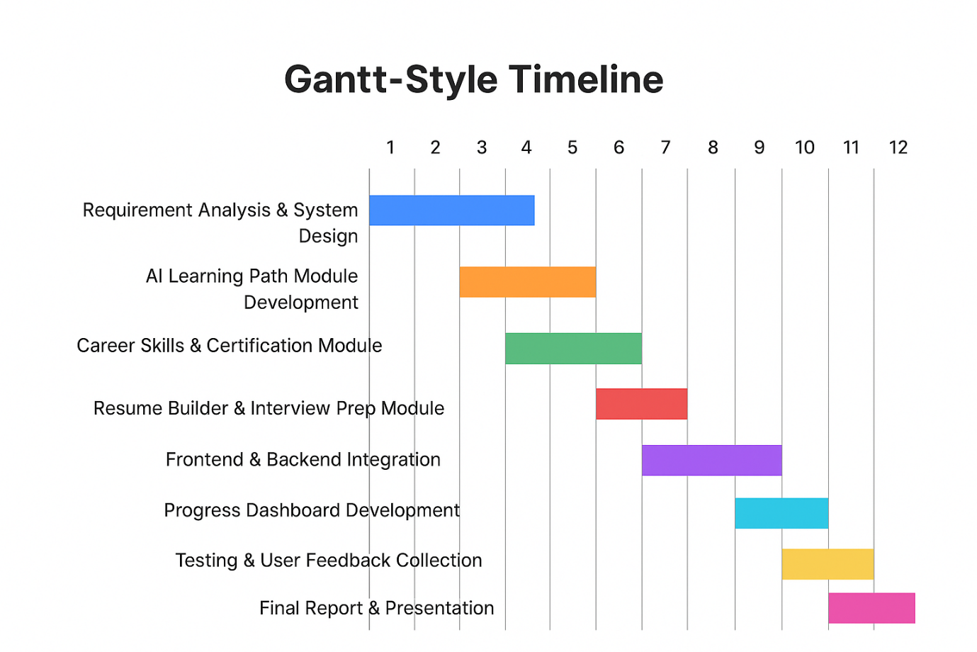

**12. Risk Analysis**

| **Risk** | **Mitigation** |
| --- | --- |
| AI-generated paths may be inaccurate | Manual review and iterative feedback loop |
| Data privacy concerns | Use secure auth and encrypted storage |
| Scope creep due to added features | Prioritize MVP first; additional features as optional |
|  |  |

**13. Work Logs**

| **Week** | **Date** | **Team Member** | **Hours Worked** | **Description of Work Done** |
| --- | --- | --- | --- | --- |
| 1 | 2025-09-06 | Shubham Shubham | 1 | Discussed project ideas, brainstormed concepts, contributed to proposal preparation, drafted initial sections. |
| 1 | 2025-09-06 | Gursimran Singh | 1 | Led discussion on project ideas, coordinated team roles, contributed to proposal drafting. |
| 2 | 2025-09-11 | Shubham Shubham | 1.5 | Finalized proposal sections, prepared submission documents, reviewed for errors. |
| 2 | 2025-09-11 | Gursimran Singh | 1.5 | Reviewed and edited proposal, ensured alignment with course requirements, submitted proposal. |
| 3 | 2025-09-25 | Shubham Shubham | 1 | Discussed feedback from rejection, brainstormed revisions, contributed ideas for new proposal. |
| 3 | 2025-09-25 | Gursimran Singh | 1 | Reviewed rejection feedback, led discussion for new proposal, coordinated next steps. |
| 4 | 2025-09-26 | Shubham Shubham | 3.5 | Finalized new proposal sections, incorporated suggestions, prepared submission documents. |
| 4 | 2025-09-25 | Gursimran Singh | 3.5 | Finalized new proposal sections, incorporated suggestions, prepared submission documents. |

**14. Conclusion**

This project creates a holistic platform integrating AI-driven personalized learning with career readiness tools. It allows students to optimize study efficiency, acquire relevant skills, build professional resumes, and practice interviews—all in a single platform.

The project is research-oriented, technologically challenging yet feasible, and offers measurable outcomes that contribute to both academic performance and career development.

**15. References**

1. Bloom, B. S. (1984). *The 2 Sigma Problem: The Search for Methods of Group Instruction as Effective as One-to-One Tutoring*. Educational Researcher.
2. Pane, J. F., Steiner, E. D., Baird, M. D., & Hamilton, L. S. (2017). *Informing Progress: Insights on Personalized Learning Implementation and Effects*. RAND Corporation.
3. Luckin, R., Holmes, W., Griffiths, M., & Forcier, L. B. (2016). *Intelligence Unleashed: An Argument for AI in Education*. Pearson.
4. OpenAI API Documentation, 2025.
5. HuggingFace Transformers Documentation, 2025.