4495 - 071
Gursimran Singh – 300377817
Shubham - 300352587
11-29-2025



GoalFlow
Achieve Your Goals With AI-Powered Planning

Table of Contents
1 Introduction 3
2 Proposed Research Project 4
2.1 Problem Statement 4
2.2 Project Objectives 4
2.3 Project Scope 5
2.4 Technology Stack 6
3 Project Planning and Timeline 6
3.1 Methodology and Architecture 6
3.2 Assumptions and Design Decisions 9
3.3 Technical Challenges and Changes 10
3.4 Timeline 11
4 Implemented Features 13
4.1 Onboarding and Personalized Plan Generation 13
4.2 User Dashboard and Progress Tracking 16
4.3 AI-Powered Resume Builder 20
4.4 AI-Assisted Resume Tailoring for Job Descriptions 24
4.5 Interview Preparation Module 26
5 Assumptions and Design Decisions 32
5.1 Target Users and Context: 32
5.2 User Motivation: 32
5.3 AI Output Reliability: 32
5.4 Privacy and Data Use: 33
5.5 Technology and Platform: 33
5.6 Scalability Needs: 33
6 Technical Challenges and Changes 33
6.1 Integrating Generative AI Outputs: 34
6.2 Real-time User Input and Feedback: 34
6.3 Data Consistency between Client and Server: 34
6.4 Managing AI Costs and Limits: 34
6.5 Adapting Plan After Changes (Post-Midterm Pivot): 35
6.6 UI/UX Refinement: 35
7 Lessons Learned and Future Work 35
7.1 Achievement of Objectives: 36
7.2 What Went Well: 36
7.3 Challenges and Mitigations: 37
7.4 Impact and Future Work: 37
7.5 Personal Learnings: 37
8 Concluding Remarks 38
9 Contract 39
10 References 39
11 Appendix A: Installation Guide 40
12 Appendix b: User Guide 41

Introduction
In today’s fast-paced educational environment, students and early-career professionals often struggle to balance academic development with preparing for the job market. Traditional learning platforms provide access to content but typically lack personalization and adaptability to individual learning styles or career goals. This misalignment creates a persistent gap between academic performance and career readiness. Prior literature has established the promise of adaptive learning systems in boosting educational outcomes – for example, Bloom’s research on one-to-one tutoring demonstrated dramatic improvements in learning efficacy over conventional classroom methods [3]. However, most existing solutions address academics or career preparation in isolation. Academic support tools rarely integrate career skill-building, and career platforms seldom personalize their guidance based on an individual’s learning progress. By unifying these dimensions, the present project aims to deliver an AI-powered platform that generates weekly study plans, recommends career-relevant skills and certifications, and offers integrated resume and interview preparation tools to improve both academic outcomes and employability.

We also recognize that succeeding in the modern job market requires navigating Applicant Tracking Systems (ATS) and presenting qualifications effectively. A significant portion of employers rely on ATS software to filter resumes before any human recruiter reviews them. Widely cited industry statistics suggest that roughly 75% of resumes are rejected by ATS systems before reaching a person [1]. Common issues such as poor formatting, lack of relevant keywords, or incorrect document structure can cause qualified candidates to be filtered out early. Moreover, existing resume-building tools tend to focus on aesthetics and template design over substance, often producing resumes with flashy layouts that ATS algorithms cannot parse reliably [2]. This gap highlights the need for a solution that bridges personalized learning support with career document optimization. Our project addresses this need by integrating real-time AI feedback into both study planning and career preparation features, ensuring that users not only acquire knowledge and skills but can also showcase their qualifications in an ATS-friendly manner.

Ultimately, our research investigates how artificial intelligence can be leveraged to provide personalized study support while simultaneously enhancing career readiness. We explore whether an integrated platform combining adaptive learning pathways with career development tools can measurably improve learning outcomes, engagement, and job preparedness compared to traditional one-size-fits-all methods. The following sections outline the problem space, project objectives, scope, methodology, and the implemented solution — an application we developed (nicknamed “GoalFlow”) that helps students and job seekers create tailored action plans for success in both their studies and their job search.

Proposed Research Project

Problem Statement
Students and recent graduates face four interrelated challenges bridging education and employment. First, many rely on inefficient study strategies that make it difficult to identify weak topics or prioritize time effectively. Without personalized guidance, learners may not know what or how to study to improve their performance. Second, static study guides and generic curricula rarely accommodate individual learning styles, resulting in disengagement and uneven progress across different subject areas. Third, career readiness gaps persist because learners often lack clarity on the skills required for target roles, the certifications that matter in their industry, and effective interview preparation practices. There is often a disconnect between what is learned in school and the competencies employers seek. Fourth, resources for academic improvement and career development are fragmented across multiple platforms – students must navigate disparate tools for coursework, skill training, resume building, and interview practice. This fragmentation means critical insights can fall through the cracks, and users might not get a coherent path from learning to career.
Consequently, we ask: Can an AI-driven platform that combines personalized learning paths with career readiness capabilities measurably improve learning outcomes, engagement, and employability preparation compared to traditional static methods? By addressing this question, we target the root problems of personalization in education and alignment with job market requirements. The ideal solution will adapt to a learner’s needs academically while also curating their profile and application materials for career success. This problem statement guided the design of our project from initial research through to implementation.

Project Objectives
The project’s objectives are aligned to five core capabilities that arise from the problem context:

Personalized Study Plans: The system must generate weekly study plans that reflect each individual’s strengths, weaknesses, and learning preferences. This includes identifying areas where a student needs improvement and allocating time or resources accordingly. The goal is to improve academic performance through targeted, adaptive practice and content review.
Career Skill Recommendations: The platform should recommend career-relevant skills and surface aligned courses or certifications, effectively mapping academic progress to market needs. By analyzing a user’s academic profile and career interests, the system will suggest specific skills to acquire (technical skills, soft skills, domain knowledge) and point to certification programs or learning resources that bolster the user’s employability.

Interactive Resume Builder: An AI-assisted resume builder should enable users to compose, customize, and export professional resumes while receiving helpful suggestions about content. This includes highlighting important achievements, projects, and certifications to include, as well as ensuring the resume format is clean and ATS-friendly. The resume builder should guide users in phrasing their experiences with strong action verbs and quantifiable results, improving the resume’s impact.
Interview Preparation Feature: The platform should provide an interview practice module that offers tailored questions likely to be asked for the user’s target roles. It will allow users to simulate interviews and receive automated feedback on their answers – assessing aspects like content relevance, clarity, and tone. This helps build the user’s confidence and competence in real interview settings by identifying areas to improve (for example, suggesting better framing of answers or highlighting missed keywords).

Analytics Dashboard: Finally, an analytics dashboard should allow both the individual user (and potentially mentors or instructors) to track learning progress, skill acquisition, certification status, and interview readiness through clear visualizations and concise reports. This dashboard provides a high-level overview of how the user is advancing towards their academic and career milestones, displaying metrics such as completed tasks, improvement over time, skill gaps, and readiness scores.
Collectively, these objectives ensure the project stays focused on delivering an integrated experience: boosting academic success and translating that success into career opportunities. Meeting these objectives would demonstrate that our AI-driven approach can personalize education and career planning simultaneously, thereby increasing user engagement and improving outcomes on both fronts.

Project Scope
The scope of this project includes implementing the key features needed to fulfill the above objectives within a single cohesive application. Specifically, the scope encompasses:

AI-generated Learning Plans: Using the user’s input (such as courses taken, past performance, and career goals), the system will generate a tailored weekly study plan. This plan breaks down tasks or study activities for the week, focusing on identified weak areas and incorporating practice in those domains.

Dashboard for Progress and Skills Tracking: A personalized dashboard will present the user’s progress on their study plan tasks, mastery of various topics, and acquisition of skills or certifications. It will integrate academic tracking (e.g., tasks completed, topics mastered) with career development tracking (skills gained, certificates earned or in progress).
Career Skill Recommendations with Certification Suggestions: Based on the user’s profile and goals, the system will recommend new skills to learn and relevant certifications or courses. For example, if a user’s goal is to become a data analyst, the platform might suggest learning SQL or obtaining an AWS Cloud Practitioner certification if appropriate. These recommendations are meant to align the user’s academic progress with what is valued in their desired career path.

Resume Builder Module: A core part of the platform is a resume builder that is interactive and AI-supported. Users can input their personal details, education, work experiences, projects, and skills. The system provides real-time feedback or suggestions to improve each section. For instance, if a user’s description of a project lacks keywords that match their target job description, the system can suggest including certain terms or achievements. The resume builder will also support importing existing resume data (or pasting content) and exporting the finished resume to common formats (PDF, Word) in an ATS-compatible style.

AI-Assisted Interview Preparation Module: This feature generates practice interview questions tailored to the user’s target job or industry. It uses AI to formulate likely questions (for example, technical questions if the target is a software role, or behavioral questions about teamwork). The user can then input or speak their answers. The system will evaluate responses—scoring them and providing feedback on content relevance, clarity, thoroughness, and tone. This may involve analyzing whether the answer mentioned key concepts expected by the question or if the tone was confident and professional. The interview module also tracks performance over multiple sessions, allowing users to see improvement over time.

Authentication and User Profiles: Users will be able to register and log in securely. A profile stores their information: personal data (name, email, etc.), onboarding responses (which include their goals, background, and preferences), the resumes they have created, tasks and recommendations generated, and any interview practice sessions completed. The system’s personalization hinges on maintaining this user profile data. Secure authentication (with options like email verification or OTP-based phone verification) is in scope to ensure the platform is safe and user-specific data remains private.

Integration of External APIs and AI Services: The scope also includes integrating with external services necessary for key features. Notably, for AI functionalities, we planned to use large language model APIs to generate content (study tasks, resume content, interview questions, etc.). For instance, generating a resume draft or interview feedback requires calling an AI model with carefully constructed prompts. Additionally, services like authentication (potentially using a service like Firebase for sending one-time passcodes to phone) and cloud database services for storing user data fall within scope.
It is important to delineate what is outside the MVP scope. Full Learning Management System (LMS) integration (for example, importing grades from a college’s system automatically) was considered out of scope due to time and complexity. Real-time grading of academic quizzes or deep integration with institutional data is not included. Also, enterprise-scale deployment considerations (such as multi-institution support or white-labeling the platform) are beyond our current scope. The focus is on a functional prototype demonstrating the core features for a single institution or individual use.
The primary deliverables for this project are: (1) a functional web application (and an accompanying mobile-responsive interface) implementing the features described, (2) a user manual or guide explaining how to use the system and the technical setup, and (3) this final research report evaluating the system’s design and discussing our findings.

Technology Stack
The project is implemented as a full-stack web application using React with TypeScript and Vite for the frontend, styled with Tailwind CSS and shadcn/ui and using Recharts for dashboard visualizations. The backend is built with Node.js and Express, exposing RESTful APIs secured with JWT-based authentication, and it uses MongoDB (via Mongoose) for persisting users, onboarding data, tasks, recommendations, resumes, and interview sessions. AI functionality is provided through Google Cloud Generative AI (Gemini/PaLM) for generating personalized study plans, recommendations, resume drafts, job-specific resume enhancements, and interview questions and feedback, while Firebase Authentication is used for phone-based OTP verification during sign-up, with GitHub and npm supporting version control and dependency management throughout development.

Project Planning and Timeline

Methodology and Architecture
Development Methodology: We followed an agile, iterative development approach. Early in the project, we conducted requirements analysis and system design, creating wireframes and flow diagrams for the user interface and identifying the AI integration points. We built a prototype incrementally, first focusing on front-end user experience flows and then integrating back-end services and AI capabilities. Feedback from instructors and peers was incorporated at mid-project to adjust priorities. For example, after the midterm evaluation, we prioritized polishing the core user experience (ensuring the interface was intuitive and responsive) before adding more complex AI or back-end integrations. This approach allowed us to validate the concept and usability early, then iterate to add intelligence and data persistence behind the scenes.

System Architecture: The application uses a modern web architecture with a decoupled front-end and back-end. The front-end is a single-page application built with React and TypeScript, using the Vite build tool for fast development. We chose React for its component-based architecture and rich ecosystem of UI libraries. Styling is handled with Tailwind CSS (augmented by the shadcn/ui component library) to ensure a clean, consistent design and to accelerate the creation of responsive layouts. The front-end manages client-side state (e.g., current resume content being edited, or tasks list) and interacts with the back-end via RESTful API calls.
The back-end server is built with Node.js and Express. It exposes a set of REST API endpoints under /api/ that the front-end consumes. We implemented endpoints for authentication (/auth/…), onboarding data (/onboarding), tasks (/tasks), recommendations (/recommendations), resume operations (/resumes), and interview sessions (/interview). The server contains the logic to handle incoming requests: saving and retrieving data from the database, and invoking external AI services when needed. We used MongoDB as the primary database, interfacing through the Mongoose ODM (Object Data Modeling) library. MongoDB was chosen for its flexibility in storing diverse data structures – for instance, our Resume schema contains nested structures for personal info, experiences, and education entries, which fits well in a document-oriented database. It also allows quick iteration without requiring a rigid schema upfront, which was useful as our data models evolved (for example, when we added an interview history model).

AI Integration: A pivotal aspect of the architecture is the integration of AI services to generate content. We used Google Cloud’s Generative AI (specifically the PaLM 2 / Gemini large language model via Google’s API) as our AI provider for text generation. This choice was influenced by availability and performance considerations; it provided strong natural language generation capabilities and offered an alternative to the OpenAI API, aligning with our goal to keep the design provider-agnostic where possible. The back-end includes a utility module (referred to as the GeminiService) that encapsulates all interactions with the AI model. This service constructs prompts and calls the generative model for various functions: creating personalized study tasks from onboarding inputs, generating career recommendations (courses, projects, communities) based on those tasks, drafting resume content, and even enhancing an existing resume for a specific job description. By centralizing AI calls in this service, we maintain a clear separation of concerns and could switch to a different model or API with minimal changes if needed (this “adapter” pattern for AI providers was part of our risk mitigation strategy).
When a user completes onboarding, the backend calls GeminiService.generateTasksFromOnboarding (data) where data includes the user’s goals, current skills, and other profile details. The service crafts a detailed prompt (instructing the AI to output a JSON array of tasks with fields like title, description, priority, category, and subtasks). It then posts this prompt to the generative model and parses the JSON response to produce a list of structured tasks. Similarly, for resume generation, we send a prompt including the user’s basic info and career context (from onboarding) asking the AI to output a formatted JSON containing personal info, multiple experience entries, an education entry, and a skills list tailored to that profile. This output is parsed and becomes the initial content in the Resume Builder editor. We imposed structured-output requirements on the AI (specifically requesting JSON) to simplify parsing and to enforce that the generated content fits into our data model.

Client-Server Interaction: The React front-end communicates with the back-end via HTTP requests to the defined APIs. For example, after a user sign up and logs in, they proceed to the Onboarding wizard. Upon submitting the onboarding form, the front-end makes a POST /api/onboarding/complete call containing all the collected profile information. The server responds with the generated tasks and recommendations, which the front-end then uses to populate the user’s Dashboard. Similarly, in the Resume Builder, when the user clicks “Generate with AI” to create a resume draft, the front-end calls our endpoint POST /api/resumes/generate-ai. The server handles this by retrieving the necessary user context and invoking the AI model as described, then returns the AI-generated resume content as JSON. The front-end parses this and updates the resume form fields so the user can see and edit the AI’s suggestions immediately. All API calls that modify data (e.g., saving a resume, marking a task complete, updating profile info) require a valid JWT authentication token, which is issued at login and stored on the client.
Security and Authentication: We implemented authentication using JWT (JSON Web Tokens) for stateless session management. During sign-up, a user provides an email, password, and name. We added a phone-based OTP verification step to enhance security and simulate a two-factor authentication flow. This means after initial sign-up, the user must verify a one-time code sent to their phone (using Firebase’s phone authentication service on the back-end) before their account is fully created. The AuthController on the server handles this by interfacing with Firebase Admin SDK – sending an OTP to the provided phone number and then verifying the code the user enters on the front-end’s OTP Verification screen. Once verified, the user record is saved in our database. Passwords are stored hashed for security. On successful login, the server returns a signed JWT which the front-end attaches to subsequent API requests in the Authorization header. This ensures that only authenticated users can access their data and that one user cannot access another’s data. We also implemented route protection on the front-end (using React context and route guards) to prevent navigation to internal pages (Dashboard, Resume Builder, etc.) if not logged in.
Data Persistence: The database models include: User (storing credentials and basic profile info), OnboardingData (detailed profile responses and preferences), Task (individual tasks generated, including whether they are completed and progress percentage), Recommendation (like courses or projects suggested by the AI, including fields like type and whether the user dismissed or clicked them), Resume (containing the user’s resume entries, which can be updated or made public/private), and InterviewSession (for each interview practice session, storing the questions asked, the user’s answers, scores, and feedback). We ensured relational consistency by referencing user IDs in these collections (e.g., each Task document has a userId field linking it to its owner). Some of these collections (Tasks, Recommendations) are populated when onboarding is completed (with AI-generated entries) and then updated as the user interacts (marking tasks done, dismissing recommendations). Resumes and InterviewSessions are created and modified on demand when the user uses those features.
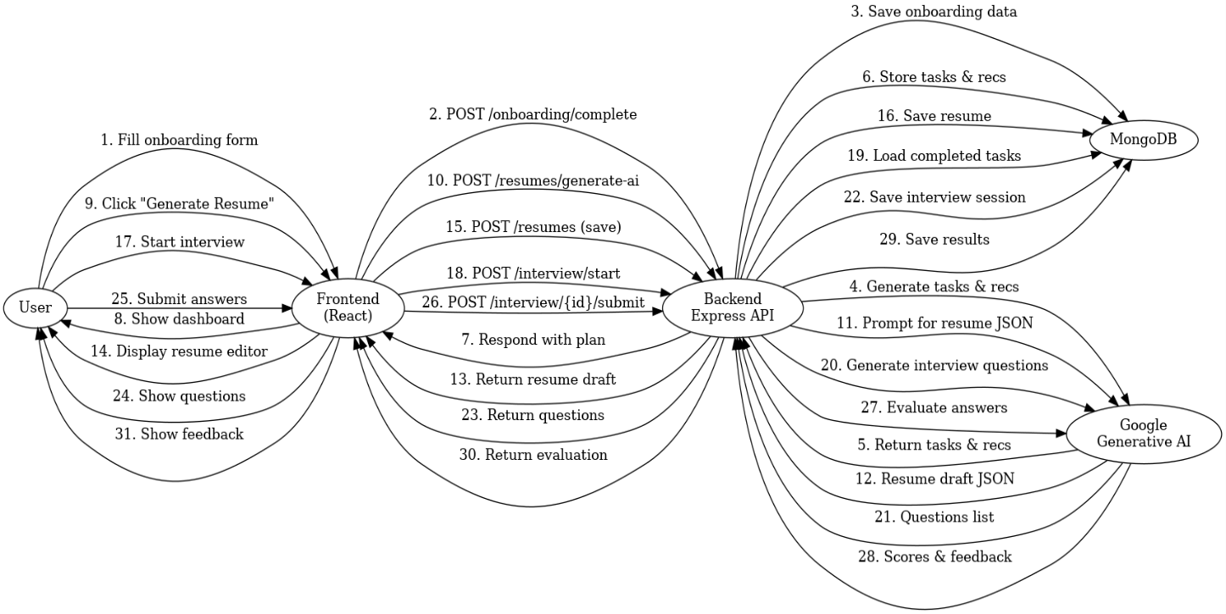
Figure 1 illustrates a architecture diagram of the system, showing how the components interact

This architecture ensured a clean separation of concerns: the front-end deals with presentation and user interaction, the back-end handles business logic and data, and external services (AI and Firebase) provide specialized capabilities. Such a setup also makes the system scalable – for instance, the back-end could be containerized and scaled independently if usage grows, and we could upgrade or swap out the AI model as better models become available, without changing front-end code.

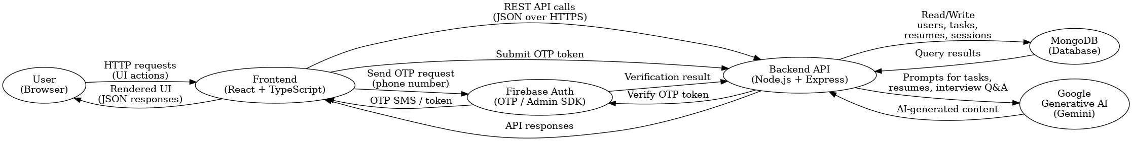
Figure 2 illustrates the data flow

Assumptions and Design Decisions
Throughout the development of this project, we made several assumptions about user needs and system use cases. We also took specific design decisions to address those assumptions or due to technological considerations:

Target Users and Context: We assumed the primary users are advanced students (diploma or undergraduate level) and recent graduates preparing for internships or entry-level roles. This informed content like the difficulty of interview questions and the level of detail in recommendations. We designed the tone of the application to be encouraging and not too enterprise-heavy. For example, the tasks generated presume some foundational knowledge. Also, the resume builder templates and suggestions focus on early-career resumes (highlighting projects and coursework if professional experience is limited).

User Motivation: We assumed users of such a platform are motivated to improve and will be actively engaging with the features. Therefore, we built interactive elements (like checking off tasks, or iterative interview attempts) under the assumption that users find value in tracking and will come back regularly. This guided us to include motivational messaging and community-oriented features (e.g., “Join Community”).

AI Output Reliability: We assumed that large language model outputs would generally be useful but might not be perfectly accurate or appropriate without constraints. Thus, we designed prompts that heavily restrict output format (JSON) and content, and we created fallback content when AI responses fail or are malformed.

Privacy and Data Use: We assumed that storing potentially sensitive user data (like their resume content or personal goals) in our database is acceptable given proper authentication in an academic context. Our use of third-party AI APIs means user-provided data is sent to external servers; in a production context, this would be documented in terms of service.
Technology and Platform: We assumed that requiring a modern web browser is acceptable and that users will primarily use the platform on desktop or laptop, though the UI is responsive. We did not build a native mobile app.

Scalability Needs: For this prototype, we assumed a modest number of users and did not implement heavy scalability mechanisms like load balancing or aggressive caching, although the architecture allows such extensions later.

Technical Challenges and Changes
Developing an integrated AI-driven platform presented numerous challenges: Integrating Generative AI Outputs: Handling large, structured outputs from the AI in a reliable way was challenging. Early on, the AI often produced invalid JSON. We refined prompts to explicitly request “ONLY valid JSON” and added post-processing logic to clean typical artifacts. We also added fallback content to avoid user-facing failures.
Real-time User Input and Feedback: Features like the resume builder and interview module involve asynchronous operations and user feedback. We implemented loading spinners, disabled buttons during AI calls, and used optimistic UI updates while maintaining robust error handling.
Data Consistency between Client and Server: We used optimistic updates (for example, marking tasks complete in the UI before the server confirms) combined with error rollback to keep the app responsive while maintaining data integrity.
Managing AI Costs and Limits: We reduced redundant AI calls by caching generated content where appropriate (e.g., generating tasks and recommendations once at onboarding) and rate-limiting certain actions on the client.
Post-Midterm Scope Adjustments: After midterm feedback, we shifted focus to implement a scaled but functional interview preparation module by reusing existing data models and the GeminiService abstraction, rather than adding unrelated stretch features.
UI/UX Refinement: We iteratively refined UI consistency (buttons, dialogs, color coding, etc.) and deliberately reduced scope on less critical visual features (such as multiple resume templates) to focus on core functionality and robustness.

Timeline
Phase | Task Description | Due Date | Responsibility
Phase 1 | Project Documentation – Conduct problem analysis, market research, and competitor scan for AI-powered learning and career platforms  Define project scope, research questions, and success criteria. Draft detailed functional and non-functional requirements and finalize high-level architecture and technology stack | 16/09/2025 | – Gursimran  – Shubham
Phase 2 | Design Assets – Develop user personas and user journey maps for students/job seekers – Create low-fidelity and high-fidelity wireframes for onboarding, dashboard, resume.  Design database schema (users, onboarding, tasks, recommendations, resumes, interview sessions) and API endpoints – Build a clickable prototype and refine UI/UX based on feedback | 28/09/2025 | – Gursimran  – Shubham
Phase 3 | Core Software Components – Set up development environment, GitHub repository, and branching strategy – Implement authentication flow (signup, login, JWT, protected routes) and basic user profile management  Implement onboarding wizard front-end and corresponding backend APIs – Integrate MongoDB via Mongoose and store users/onboarding data – Implement initial dashboard with static tasks and recommendations | 07/10/2025 | – Gursimran  –Shubham
Phase 4 | AI Integration & Resume Module – Integrate Google Generative AI (Gemini) service layer on the backend – Implement AI-generated tasks and recommendations based on onboarding data  Develop full Resume Builder (sections, editing, save/load) –Implement AI-generated resume draft based on user profile – Implement AI-assisted resume enhancement using job descriptions | 28/10/2025 | – Gursimran  – Shubham
Phase 5 | Dashboard, Analytics & Interview Module – Implement responsive UI with Tailwind + Shadcn components across all pages – Enhance dashboard with progress tracking, charts, and recommendation interactions – Implement interview practice module (question generation, session handling) – Integrate AI-based evaluation of interview answers and feedback display – Add settings and basic preferences (e.g., profile updates, resume visibility) | 10/11/2025 | – Gursimran  – Shubham
Phase 6 | Testing, Optimization & Hardening – Conduct unit testing for key backend controllers and services – Conduct integration testing for main flows (onboarding → tasks, resume, interview) – Perform UI testing and cross-browser / device checks – Optimize performance (API calls, AI usage) and review basic security (auth, validation, error handling) – Set up basic logging / error tracking for debugging | 17/11/2025 | – Gursimran  – Shubham
Phase 7 | Final Product & Deliverables – Conduct user acceptance testing with sample users and capture feedback – Fix remaining bugs and polish UI/UX flows end-to-end  Finalize technical documentation and user guide – Prepare final report, presentation slides, and demo script – Tag final GitHub release and prepare hand-in package | 28/11/2025 | – Shubham  – Gursimran

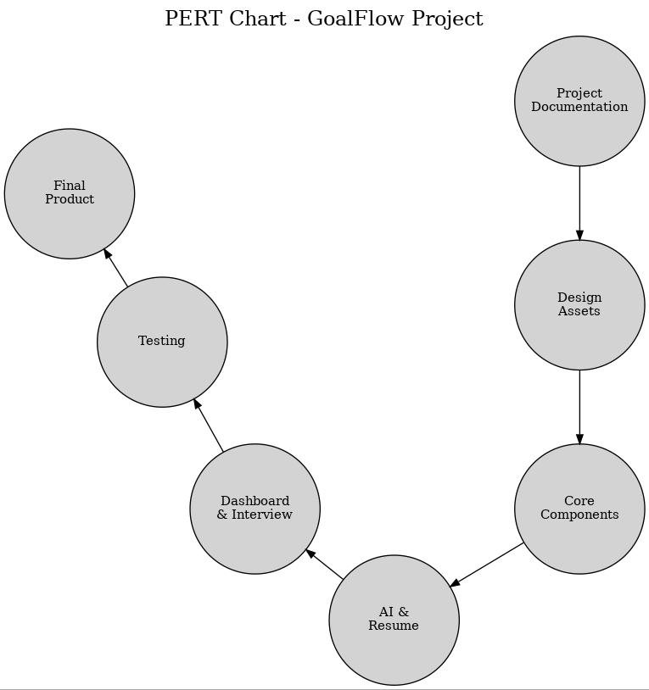
Figure 3 Pert Chart

Implemented Features

Onboarding and Personalized Plan Generation
Feature Overview: The onboarding process is the user’s first interaction after registration. It gathers essential information about the user’s background, learning habits, and career aspirations. We designed onboarding as a multi-step form wizard to avoid overwhelming the user. Over four steps, the user inputs: (1) personal information (name, email – pre-filled from sign-up – and profession or field of study), (2) experience level and industry of interest, as well as current skills, (3) career goals and timeline (e.g., “Become a data analyst in 1-2 years”) plus motivation (reason for pursuing this path), and (4) learning preferences such as preferred learning style (visual, hands-on, etc.) and weekly hours available for learning. Each step is validated to ensure required fields are filled before proceeding.

Implementation: On the front-end, this is implemented in Onboarding.tsx as a controlled form with local state tracking the input for each field and a step state variable tracking progress (1 through 4). A progress bar at the top visually indicates completion percentage (each step representing 25%). We used React state to conditionally render each step’s fields and included “Next” and “Back” buttons for navigation between steps. The form fields include text inputs for things like name and goals, dropdowns or radio buttons for categorical data like experience level, and text areas for longer inputs like motivation statements. To improve user experience, we provided helpful placeholder text and examples in these fields (e.g., for “Goals” we might suggest “e.g., Secure a junior developer position in FinTech”).
Once the user reaches the final step and submits the onboarding form, the front-end calls the API (POST /api/onboarding/complete) with all the collected data. On the server, the onboardingController.completeOnboarding method saves the onboarding data to the database (associating it with the user’s ID) and then triggers the AI generation of tasks and recommendations. Specifically, it calls our GeminiService.generateTasksFromOnboarding() and GeminiService.generateRecommendations() functions in sequence. The generateTasksFromOnboarding function takes the structured onboarding data and crafts a prompt for the AI that includes all relevant details (field of interest, current skills, goals, etc.) and asks for 8–10 specific, actionable tasks as described earlier. The AI returns a JSON array of task objects, which we parse and lightly validate. Similarly, generateRecommendations takes the same onboarding profile and the list of tasks and asks the AI for a set of resource recommendations – courses, project ideas, a certification, and a community to join – complete with actual URLs for each (ensuring the output includes real, verifiable links). This results in around 6 recommendations of various types.
The server responds to the front-end’s onboarding completion request with a success status and the generated tasks and recommendations. Our API design packaged these into the response so that the front-end can immediately make use of them without requiring separate calls. The front-end then stores the tasks and recommendations (e.g., in React state and context) and navigates the user to a “Generating Plan” interim screen followed by the main Dashboard. We included a brief loading animation on the “Generating Plan” screen to simulate the AI thinking process and to build user anticipation that a personalized plan is being created for them. This also covers any remaining processing time on the back-end before the dashboard is fully ready.

Result: After onboarding, each user has a set of personalized tasks and learning recommendations unique to their profile. For example, if a user indicated they are an intermediate-level learner aiming for a career in cloud computing with a motivation to become AWS certified, the tasks might include “Complete an AWS Solutions Architect course (high priority)”, “Build a portfolio project using AWS services (medium priority)”, “Join the AWS subreddit and read daily posts (low priority)”, etc., each broken down into subtasks like “Sign up for course X” or “Deploy a sample app to AWS”. Recommendations might include specific online courses (with direct links) on AWS architecture, a suggested project idea (with a link to a GitHub example repo or tutorial), an AWS certification (with link to the official cert page), and a relevant community or forum (with link, e.g., a Discord or Reddit group). This forms the foundation for the user’s journey in the app, giving them clear next steps to work on.
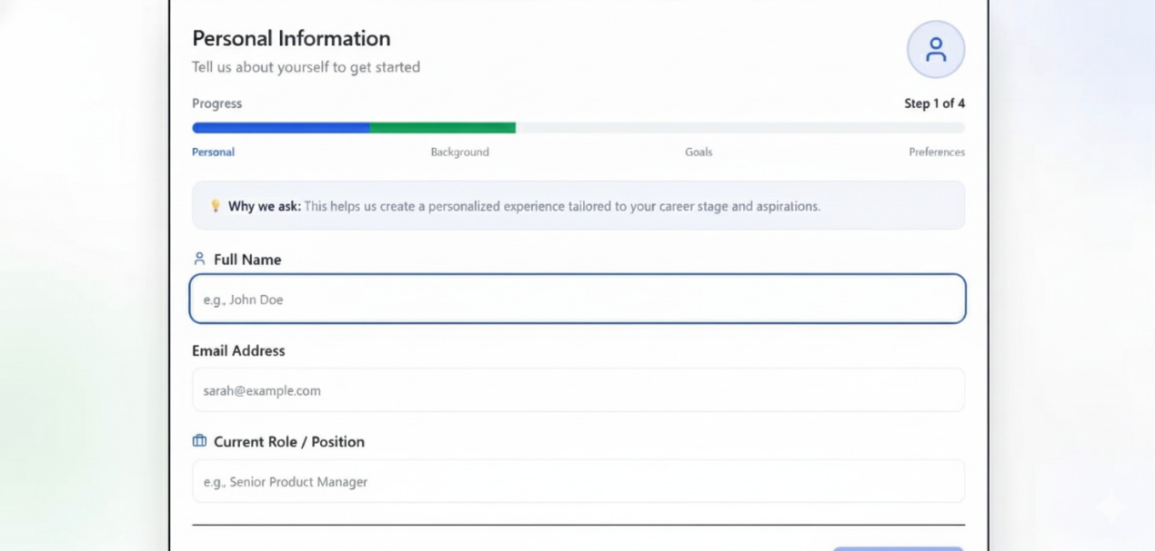

Screenshot 1 User information

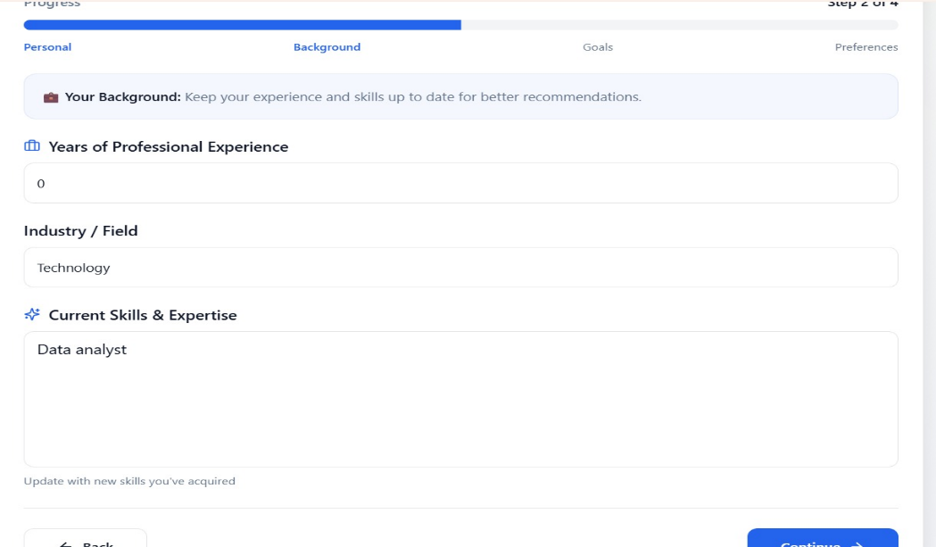
Screenshot 2 Background Details
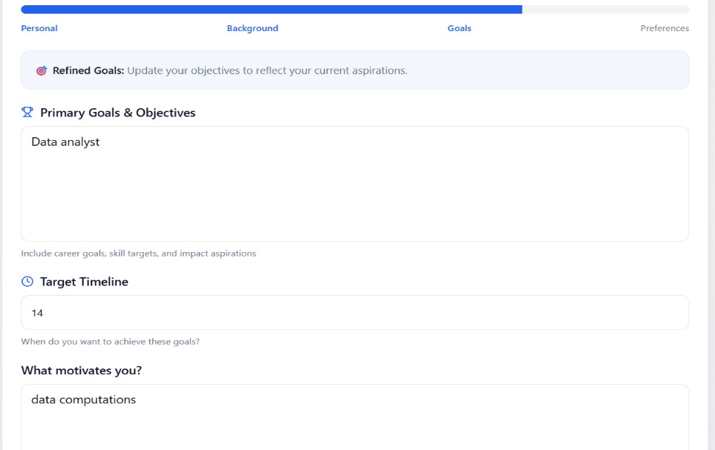
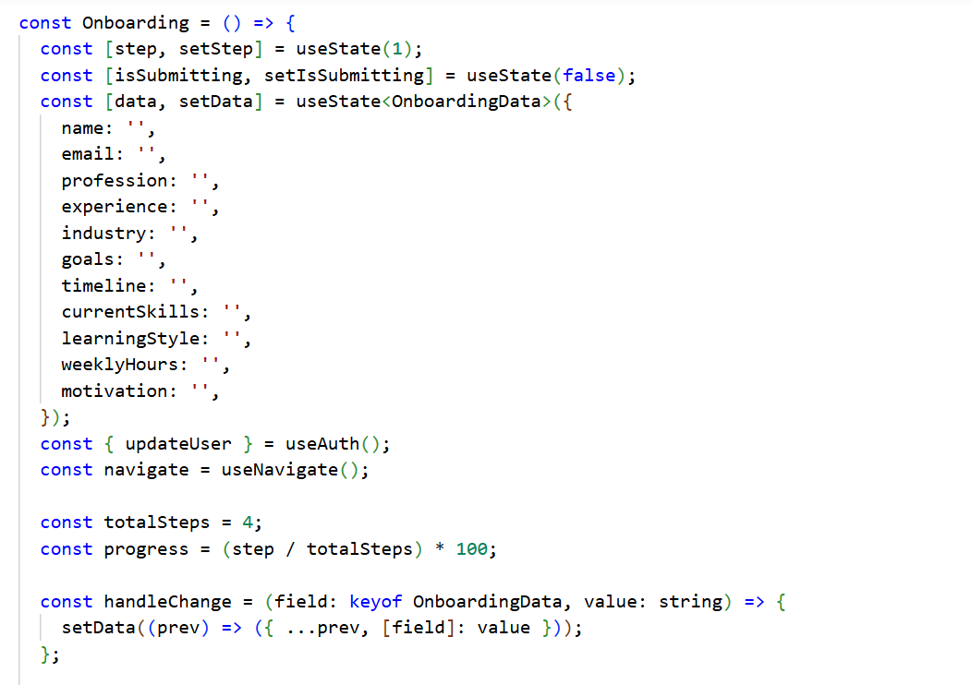
Screenshot 3 user describing goals

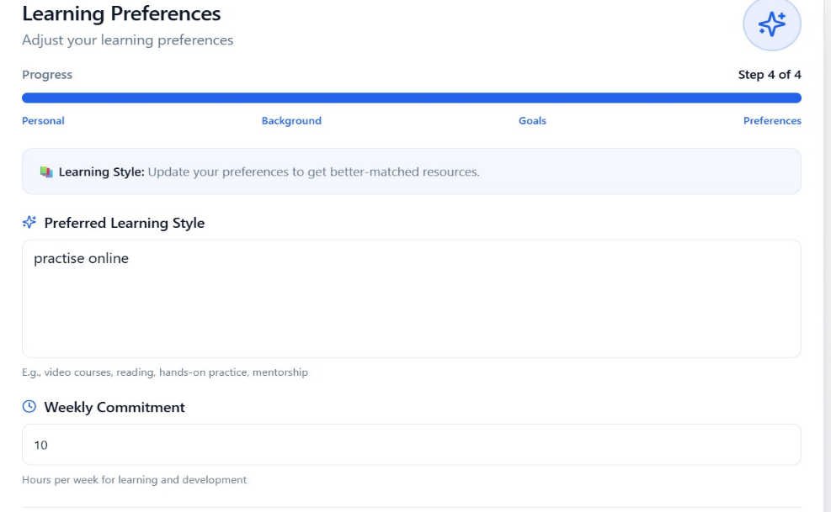
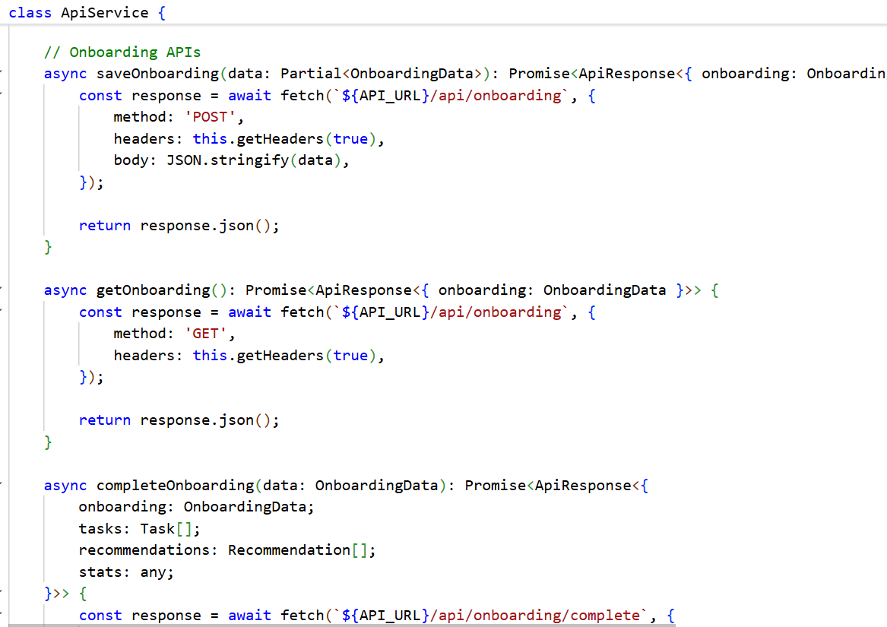

Screenshot 4 User describing their preferences

Once the plan is generated, the user is automatically taken to their Dashboard where they can view the tasks and recommendations that were created for them during onboarding.

User Dashboard and Progress Tracking
Feature Overview: The Dashboard is the central hub for users after onboarding. It provides an overview of their learning and career development journey. Key elements of the dashboard include: a greeting and summary of current progress, the list of personalized tasks with the ability to check them off or mark them complete, visual analytics (such as a progress completion bar, charts of task categories, etc.), a section for AI-generated recommendations (courses, projects, etc.) where users can explore or dismiss them, and quick access to other features like the Resume Builder or Interview Practice. The dashboard is designed to answer the question “How am I doing and what should I do next?” each time a user logs in.

Implementation: In the front-end code (Dashboard.tsx), we structured the dashboard as a series of tabbed sections and cards for different information. At the top, the user sees a welcome message and a quick stat like their current task completion rate or “streak” of days completing tasks. Below that, tasks are displayed. Each task card shows the title, a short description, and possibly a category or priority label (we used colored badges to indicate high/medium/low priority). There is also a checkbox for the user to mark it as completed. Checking a task updates its status both in the UI and triggers an API call to mark it complete in the database (which also might recalc some progress metrics). Completed tasks might be visually distinguished (e.g., crossed out or a green check icon). We implemented filters on tasks (all vs. only pending vs. only completed) and basic sorting by priority or category so that users can manage a growing task list easily.
We included an analytics section on the dashboard with charts using the Recharts library. For example, a pie chart or donut chart breaks down the tasks by category (Foundation, Learning, Projects, Networking, etc.) to show the proportion of tasks in each area. A bar graph might show how many tasks are high/medium/low priority. A line chart (or a simple streak counter) could indicate progress over time (e.g., tasks completed per week or the user’s current consecutive days of meeting study goals). These visualizations make the user’s progress tangible and can motivate continued engagement. To gather data for these, when the dashboard loads, the front-end calls a GET /api/tasks endpoint (to fetch all tasks and some summary stats) and a GET /api/analytics endpoint [13]. The analyticsController on the back-end computes stats like total tasks, tasks completed, completion rate, distribution by category, and a rudimentary “weekly activity” (which might simulate hours studied or tasks done each day for the past week). These are returned and then rendered via charts on the front-end. For example, categoryData in state holds an array of {name: category, value: count} objects and is bound to a pie chart component. The user can thus see, for instance, that 30% of their tasks are “Projects”, 25% “Learning”, etc., giving a sense of balance in their plan.
Another key section is the Recommendations panel. This shows the list of AI-generated recommendations (from onboarding or any future refresh). Each recommendation is displayed with a title (e.g., “Build a Microservices Project”), a brief description (“Create a real-world application using a microservices architecture to deepen your understanding of distributed systems.”), and an indicator of type (course, project, certification, or community). We used icons or badges to denote type – for example, a mortarboard icon for a course, a briefcase for a project, a certificate icon for certification, etc. The user can click on a recommendation to view more details or directly open the provided link. For instance, clicking a course recommendation might open the course webpage (we ensure the link opens in a new tab so the user doesn’t navigate away accidentally). Users also have the option to dismiss recommendations they aren’t interested in, which hides them from the list (and we update the backend to mark them as dismissed). This helps declutter the dashboard over time and gives a feedback signal of what the user finds useful. In code, loadRecommendations () fetches recommendations (with a filter to only get those not dismissed), and then we map them into React state. Each recommendation item has a “Dismiss” (perhaps an “X” button) that triggers an API call to mark it dismissed and we remove it from state.
Additionally, the Dashboard offers quick navigation to other parts of the app. We added buttons or links for “Resume Builder” and “Interview Practice” prominently, possibly as part of a top menu or within the dashboard in a “Career Tools” section. The idea is that after working on tasks, the user might want to update their resume or practice interviewing, so it should be convenient to jump to those features. The header bar of the app consistently provides navigation to Dashboard, Resume, and any account settings.

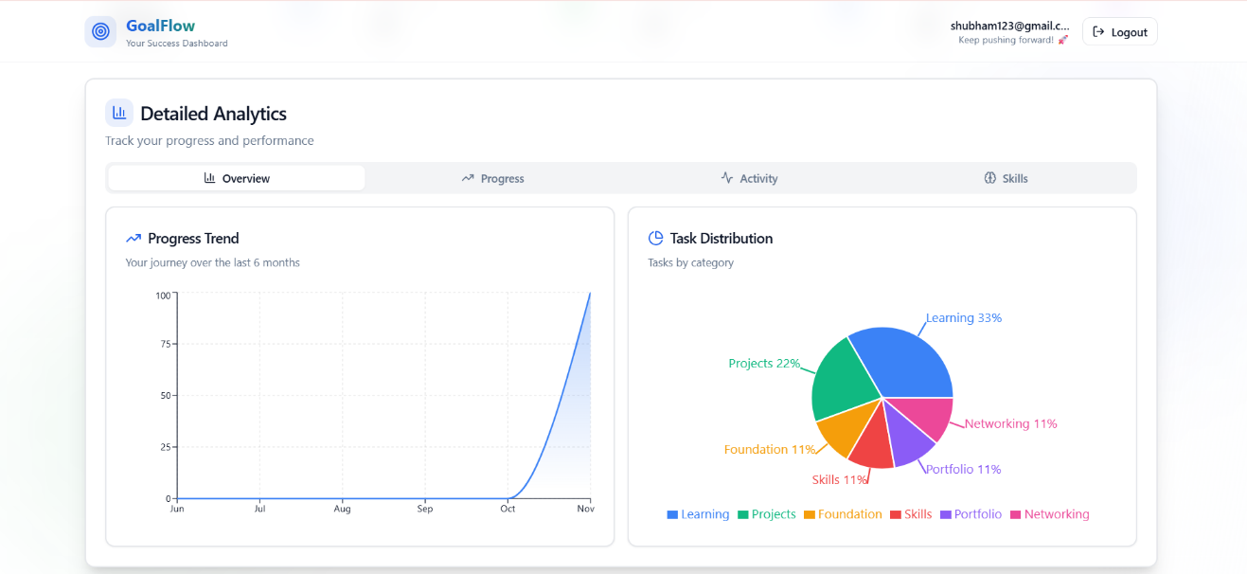
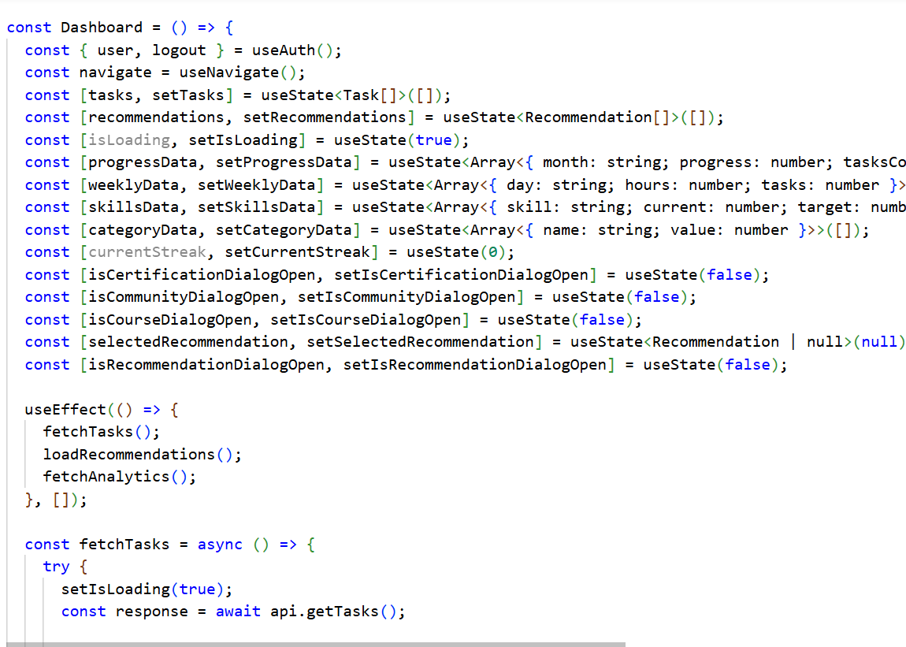
Screenshot 5 Dashboard View - Summary
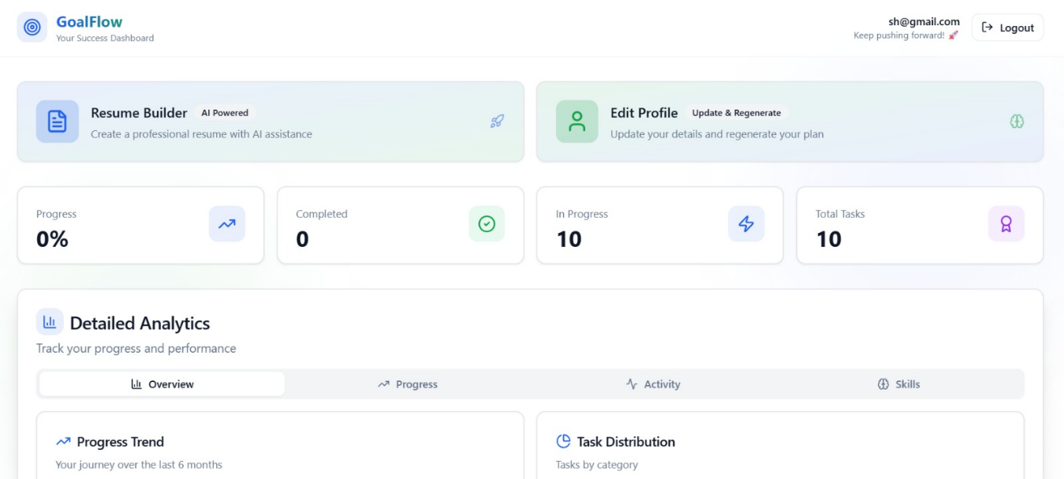

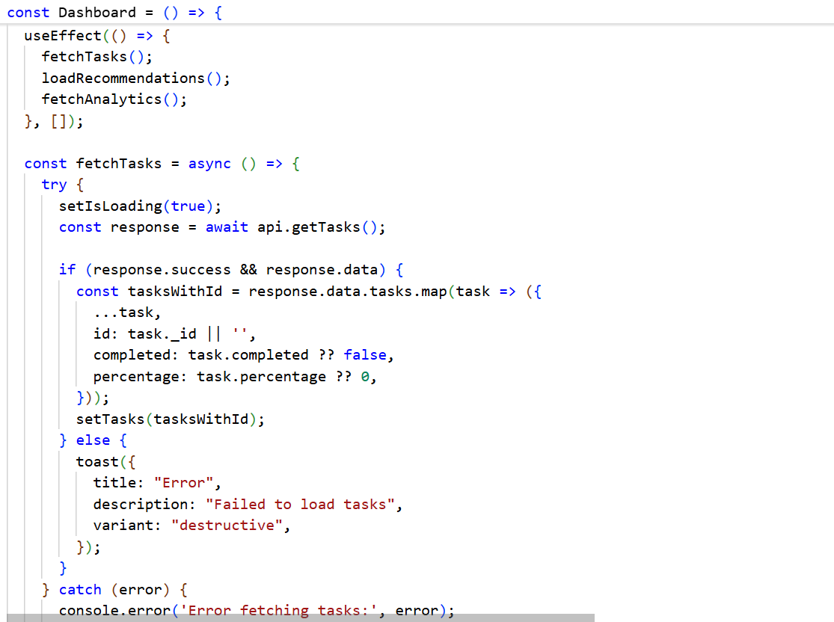
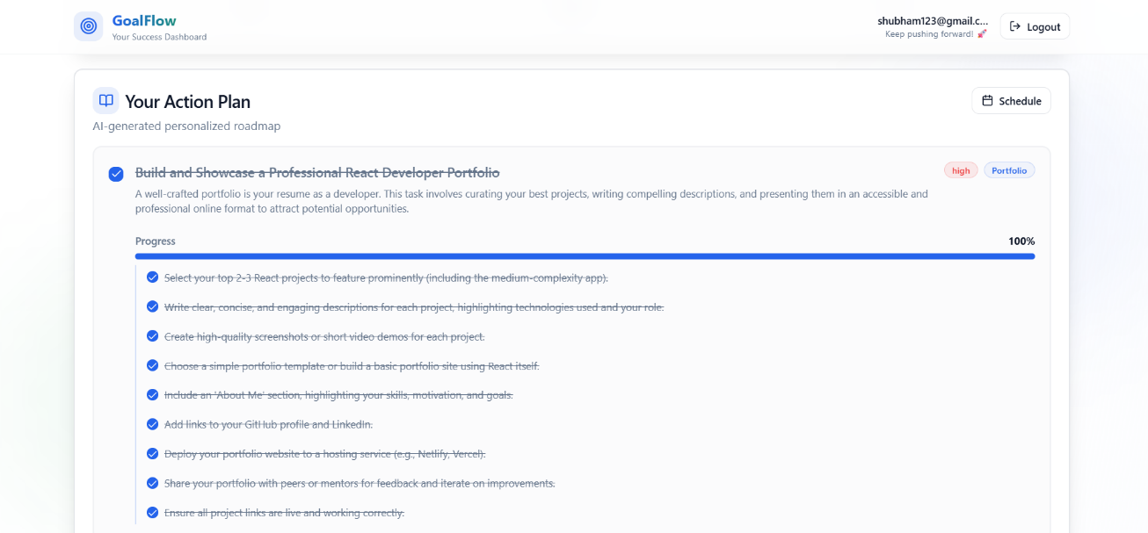

Screenshot 6 learning tracking bar
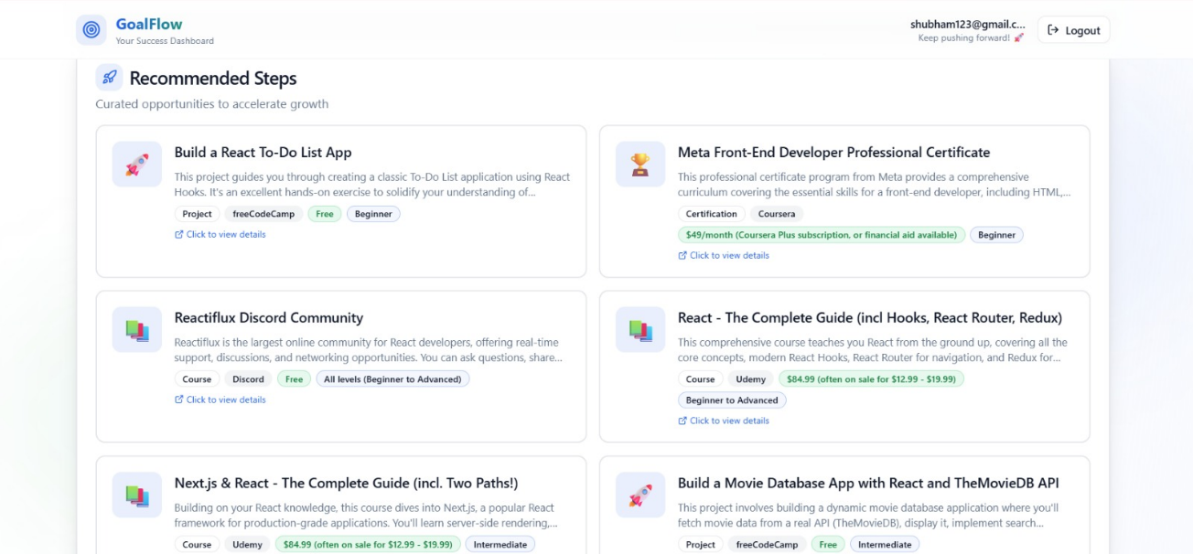
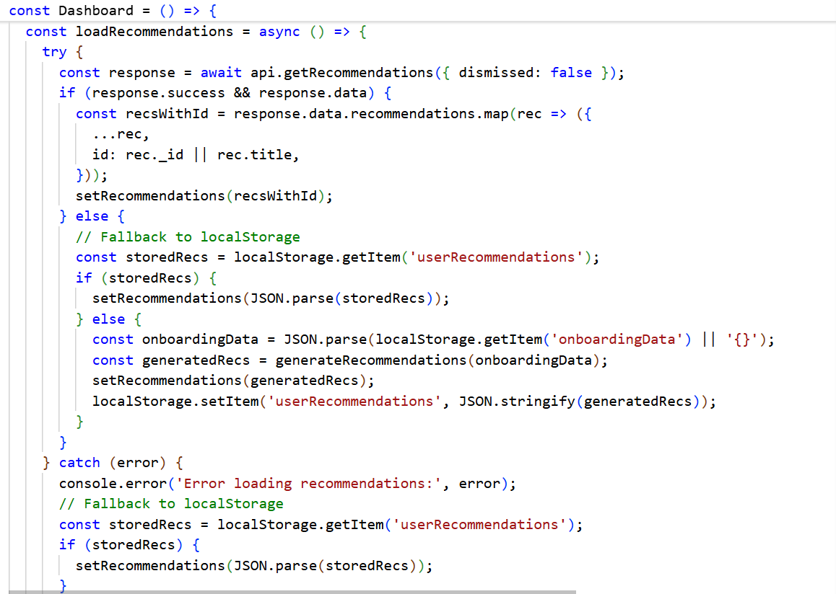

Screenshot 7 Recommended Steps by AI
By implementing the dashboard as described, we gave the user a single glance view of both their learning and career preparation trajectory. This integrated view reinforces the concept that improving academically and preparing for a job go hand-in-hand, which is a core principle of our project.

AI-Powered Resume Builder
Feature Overview: The AI-powered Resume Builder allows users to create, edit, and manage a professional resume within the platform. Unlike conventional resume builders that rely on static templates, our resume builder integrates AI to assist in content generation and optimization. The goals of this feature are: (a) make it easy for users to input their information in a structured way, (b) provide real-time feedback or suggestions to improve the content (especially focusing on ATS-friendly phrasing and inclusion of relevant keywords), and (c) allow exporting or saving of the resume. Importantly, the builder can generate a first draft of a resume for the user based on their profile data, which the user can then refine – this helps users who struggle with writing about themselves get past the “blank page syndrome.”

User Interface & Functionality: The resume builder page (ResumeBuilder.tsx) is organized into input sections for each part of the resume: Personal Info, Work Experience, Education, and Skills. We used a tabbed interface or accordion so that each section can be expanded and filled out individually, keeping the UI uncluttered. In the Personal Info section, fields include Name, Email, Phone, Location, and a Professional Summary. The Experience section allows multiple entries – for each job or project, the user can input Company, Position, Duration (e.g., “2019 – 2021”), and a description (which can be a few bullet points describing achievements and responsibilities). The Education section similarly supports multiple entries (School, Degree, Year). The Skills section is a free-form text input for listing skills (we instruct the user to separate skills with commas). We provided “Add Experience” and “Add Education” buttons to let users create additional entries dynamically; these append new empty fields bound to our state arrays for experiences and education.

AI Draft Generation: A prominent feature is the “Generate Resume with AI” button. When clicked, this triggers a call to POST /api/resumes/generate-ai on the back-end. The server retrieves the user’s profile (especially their profession, experience level, and industry from onboarding) and calls the AI model to generate a complete resume content in JSON format. The prompt we use asks the AI to craft a professional resume tailored to the user’s background, ensuring it’s ATS-compatible and includes realistic details (for example, not leaving fields empty). The AI is instructed to produce 2–3 work experiences if the user is intermediate level (with realistic job titles, company names, durations, and bullet point achievements) and one education entry, plus to fill in a summary and skills list. This content comes back as a JSON object. The server parses it and returns it to the front-end. On the front-end, upon receiving the AI-generated resume content, we automatically populate all the corresponding fields in the form with this data. For instance, if the AI returns a summary “Results-driven computer science graduate with expertise in web development…”, the summary textbox is filled with that text. Experience entries are created for each experience the AI provided (with company, position, etc. filled in). This gives the user a full draft to work from. We log or display a small toast notification “Resume draft generated!” to inform the user when it’s ready.
This AI generation is extremely helpful for users who might not know how to phrase their experiences or for those starting from scratch. It essentially gives a personalized template that they can then customize further. We do caution the users (in help text) that they should review and adjust any AI-generated content to ensure accuracy (for example, if the AI invented a company name or a statistic, the user should replace it with real data from their own experience).

Editing and Suggestions: Users can freely edit any of the fields after generation or when creating a resume manually. We implemented real-time validation and some suggestions: for example, if a field is left blank, we might highlight it. Or if the summary is very short, we might prompt “Consider adding 1-2 more sentences highlighting your key skills.” These suggestions were implemented via simple heuristics (due to time constraints, we did not do on-the-fly AI suggestions for every keystroke, which would be costly). However, one advanced feature we added was the Resume Enhancement for Job Descriptions (covered in section 6.4 below), which ties in here as a modal or sub-feature within the resume builder UI.
We included a resume preview component (Resume Preview) that can show a formatted preview of the resume as the user fills it. This is implemented as a separate component which takes the current resume state and renders it in a styled format mimicking how it would look in PDF. The user can toggle to preview mode (for example, by clicking a “Preview” eye icon button) to see the overall layout and content without the input boxes. This helps them judge spacing and length (e.g., if a description is too long to fit on a page).

Saving and Persistence: We provided Save functionality to ensure users don’t lose their resume data. There is a “Save Resume” button that triggers an API call to either create a new resume entry in the database or update the existing one if it’s already been saved before. The ResumeController on the server handles this by upsetting the resume document tied to the user. We support multiple resumes per user (for example, to tailor for different job applications or to keep old versions), though in the current UI we primarily use one resume at a time. The saved resumes can be accessed later – the Resume Builder page on load actually calls GET /api/resumes to fetch any saved resumes and pre-populate the form with the most recent one. This way if a user returns after logging out, their last edited resume appears so they can continue editing.
We also added the option to mark a resume as public or private – a toggle where a user can choose to get a shareable link to their resume. If a resume is marked public, our server would allow a special route to view it without login (for example, for an employer to see). This is implemented in the backend (a PATCH /api/resumes/:id/toggle-public endpoint). In the UI we show a share icon or toggle switch. For this final implementation, the public sharing is functional on the server side, but the front-end UI for viewing a public resume link is basic (it would simply show the resume content in a nicely formatted page).

Resume Management: We created a simple dashboard section “My Resumes” where all of a user’s saved resumes are listed (each with a name or timestamp). This is particularly useful if they generate multiple versions for different objectives. They can click on a resume name to load it into the editor, or delete a resume they no longer need. Behind the scenes, these actions hit our API (GET /api/resumes/:id to load a specific one, DELETE /api/resumes/:id to remove one). In the UI, clicking a resume name trigger loading that resume’s data into the form (similar to initial load).
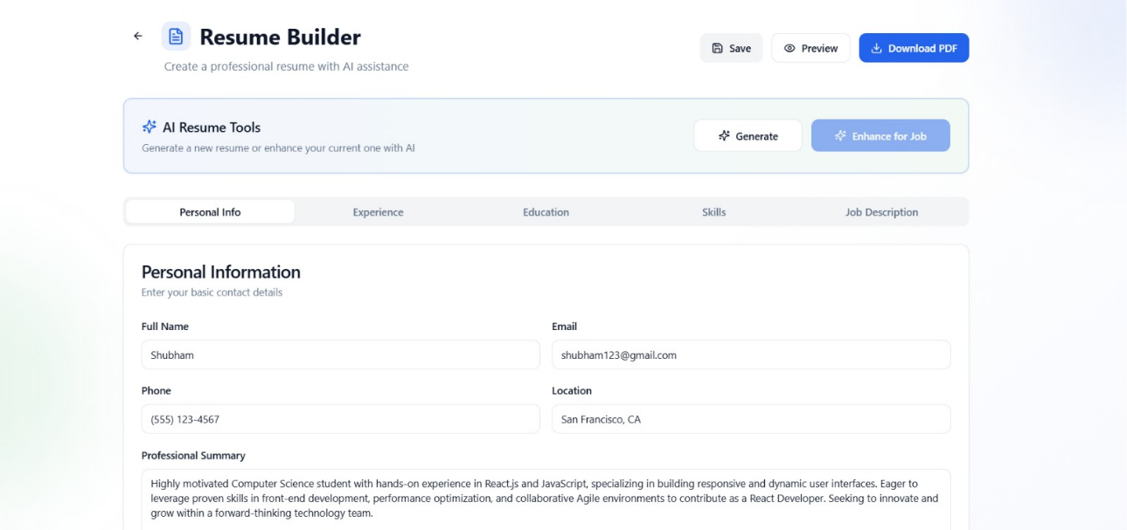
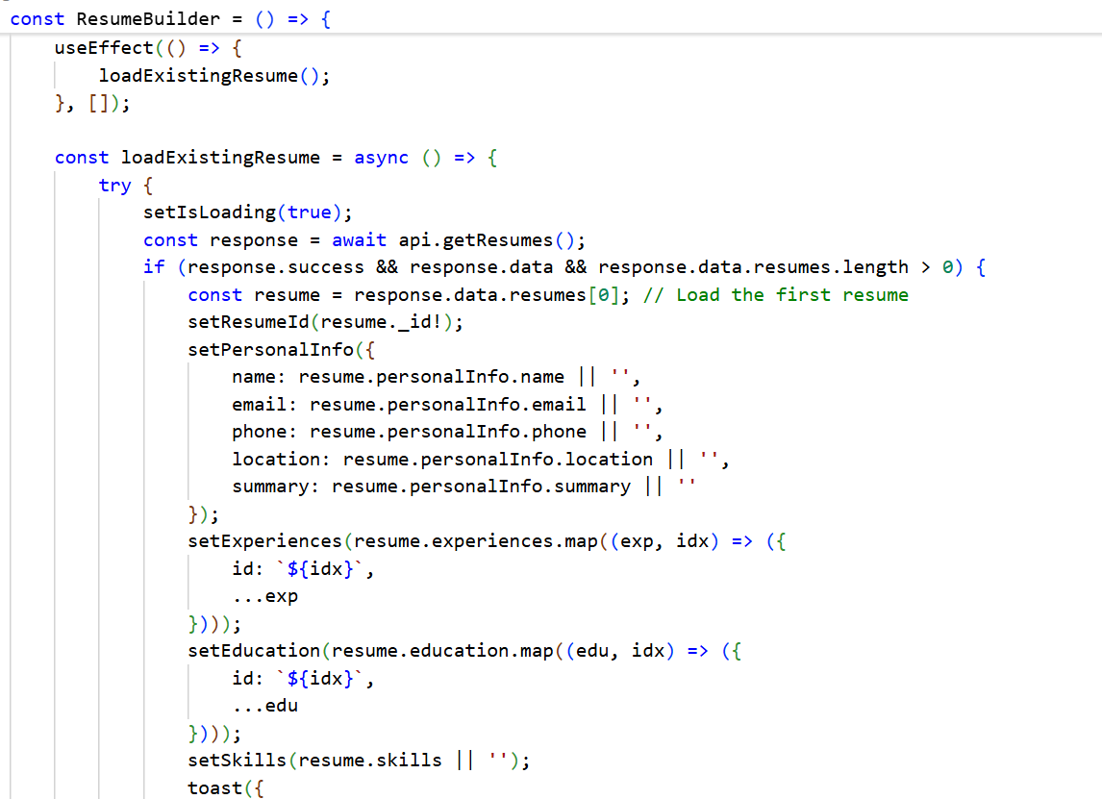

Screenshot 8 Resume Builder Interface
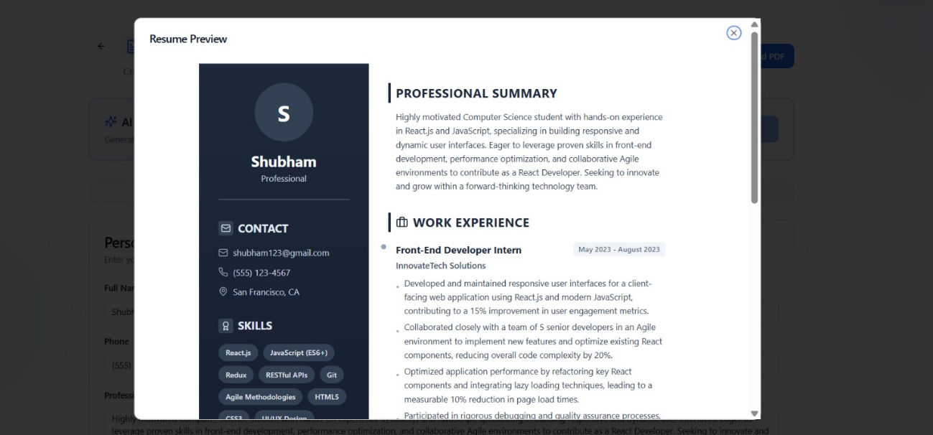
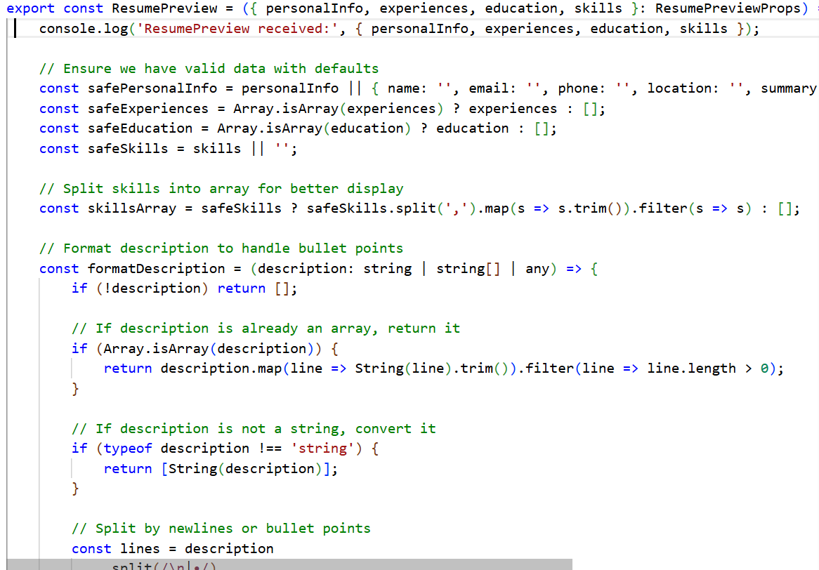

Screenshot 9 Resume Preview

This resume builder addresses a critical need: helping users create a high-quality resume that will get past ATS filters. By integrating AI suggestions and enforcing a structured, simple format, we reduce the chances of the resume being wrongly parsed or rejected due to formatting. At the same time, we empower the user to highlight their unique strengths with guidance on what content is effective.

AI-Assisted Resume Tailoring for Job Descriptions
Feature Overview: One of the standout capabilities of our application is the ability to tailor a resume for a specific job posting using AI. This feature recognizes that each job may look for particular keywords or experiences, and thus a user’s generic resume might need tweaking to optimally match a given job description. Instead of expecting users to manually compare their resume against a job listing, we leverage AI to do a lot of that heavy lifting. The user provides a target job description (either by pasting the text or summarizing the key points), and the system will then analyze the current resume and generate suggestions or even automatically rephrase sections to better align with that job posting.

User Flow: Within the Resume Builder interface, the user can click on “Enhance for Job” (or similarly labeled) which opens a dialog or side panel asking for job description input. We implemented this as a modal (Dialog in the UI) where the user can either paste the full text of a job description or input details like job title, company, and a link to the job posting. In this final implementation, for reliability, we took the simpler approach of direct text input – the user pastes the job description text into a text area in the modal. We also allow them to specify the “Job Title” they are targeting if not obvious from the description. Once they click “Enhance Resume,” a request is sent to POST /api/resumes/enhance-ai with the current resume content and the job description text.

Back-end Processing: On the server, the enhanceResumeWithAI function in ResumeController orchestrates this. It receives the resume data (personal info, experiences, education, skills) and the job description string [38]. It then calls GeminiService.enhanceResumeForJob(currentResume, jobDescription, onboarding Data) . This AI prompt is crucial and carefully structured. It essentially tells the AI: “Here is the current resume and here is the target job. Please modify the resume content to highlight what the job is looking for, without fabricating information.” We include the entire current resume in the prompt (listing each experience with its details, etc.) followed by the job description text. We then specify a series of enhancement requirements, such as: rewrite the professional summary to include 2-3 of the most relevant skills from the job posting, for each work experience entry, keep the title and dates the same but adjust the bullet points to emphasize achievements that align with the job’s requirements, re-order or add to the skills list to match keywords from the posting, and ensure the resume remains authentic (no fake degrees or experiences). We also explicitly instruct the AI to maintain the output format in our JSON structure with exactly the same number of experience entries as input, etc., to simplify merging.
The AI returns an “enhanced resume” JSON with hopefully improved bullet points and summary. We parse that and then we do a validation pass where we ensure none of the essential fields got dropped. For example, if the AI fails to include an experience entry, we fall back to the original content for that entry to avoid data loss. The final enhanced resume is then sent back to the client.

Applying Enhancements in UI: When the front-end receives the enhanced resume data, it updates the fields accordingly (similar to how the initial AI generation populates fields). We decided to present the changes in a way that the user is aware of them. For instance, we might highlight text in the resume that was changed or added (using a different text color or underline) for that editing session. Alternatively, a before-and-after comparison could be shown. Due to time constraints, our implementation simply replaces the current content with the enhanced content and perhaps shows a summary of changes in a toast or modal (e.g., “Resume updated to better match the job description: summary modified, 2 experiences updated, skills reordered”).
The user can then review every field and make further manual tweaks if desired. We found that this enhancement typically adds keywords from the job posting into the resume bullet points where appropriate and emphasizes relevant achievements. For example, if the job description repeatedly mentions needing experience with “project management” and “Agile methodologies,” the AI might ensure the user’s experience descriptions include those phrases (if the user indeed has that experience, or at least to phrase similar experiences in those terms). If the job asks for a specific software or technique (say “React.js” or “machine learning”), the AI will try to weave that into the summary or skills if the user’s background supports it. Essentially, it reframes the user’s existing experience in the language of the target job.

Outcome: This feature empowers users to quickly tailor each application. Instead of having one generic resume or struggling to rewrite it each time, the AI gives them a head start in customization. The resumes produced via this enhancement are more likely to pass ATS screening because they explicitly incorporate the keywords and criteria from the job description. At the same time, by keeping all original factual information intact (company names, job titles, dates), we ensure that we are not misleading or introducing false information – we only adjust how the information is presented.
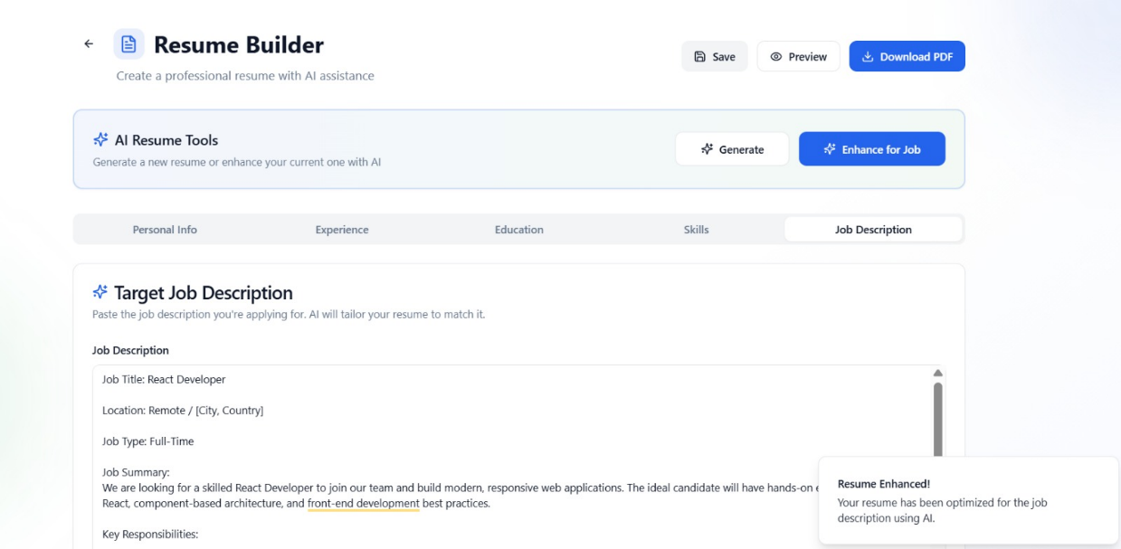


Screenshot 10 Tailoring according to the job Description
This innovative feature ensures that users can adapt to different job applications swiftly, which is a significant competitive advantage given how targeted resumes greatly improve the chances of getting an interview in today’s job market.

Interview Preparation Module
Feature Overview: The Interview Preparation module provides an interactive environment for users to practice common interview questions and receive feedback on their answers. It is designed to simulate aspects of real interviews, including both knowledge-based questions (technical or domain-specific) and behavioral questions. By leveraging AI, the module can not only generate questions relevant to the user’s target role but also evaluate the user’s responses for quality, correctness, and communication effectiveness.

Question Generation: To make the practice meaningful, we generate interview questions tailored to the user. We take into account the user’s completed tasks and learning history when generating questions, under the assumption that tasks represent topics the user has been working on (and thus likely to be asked). For example, if one of the user’s tasks was to learn SQL or complete a project on cloud computing, some questions might cover those subjects. The trigger to start an interview session in the UI is a “Start Practice Interview” button on the dashboard or dedicated Interview page. When clicked, the front-end calls POST /api/interview/start (handled by start Interview in interviewController). The server will fetch all tasks of the user that are marked completed (assuming those reflect skills/knowledge acquired) , as well as the user’s profile from onboarding (to know their field and goals). We then call GeminiService.generateInterviewQuestions(completedTasks, onboardingData). This AI prompt might say: “Given the user has completed tasks A, B, C, generate a set of 5 interview questions. Include a mix of one multiple-choice question and several short-answer questions. Each question should be labeled with a category and related task if applicable, and for MCQ provide options and the correct answer, for short answer provide some keywords expected.” Essentially, we have the AI return not just questions, but a structure indicating question type (multiple-choice vs open-ended), and the expected answer or key points for evaluation.

User Answering and Feedback: On the front-end, we built an interface (InterviewPreparation.tsx and related InterviewQuestions.tsx component) that displays one question at a time or all questions in a list. For multiple-choice questions, the user can select an option (radio buttons). For short answer questions, the user types their answer into a text box. We also allowed an optional voice input or timer, but given time constraints, we primarily implemented text responses. The user works through the list and submits their answers. When the user hits “Submit for Evaluation”, the front-end sends the array of answers to POST /api/interview/{sessionId}/submit.
On the back-end, submit Answers will retrieve the stored questions and use the AI to evaluate the answers. We call GeminiService.evaluateInterviewAnswers(questions, answers), which we implemented to prompt the AI to act as an interview assessor. The prompt includes each question, the model answer or expected points, and the user’s answer, and asks for an evaluation: is the answer correct (for technical questions) or how well did they address it (for behavioral), a score (perhaps 0-100 or 0-10 scale), and a brief feedback explanation. The AI returns evaluations for each answer. We then compile the results: marking each answer as correct/incorrect (for objective questions), assigning a score, and including the feedback text. We also calculate a total score percentage for the session (e.g., average of scores or weighted). The interview session object in DB is updated with these results and marked as completed.

The server responds to the front-end with this evaluation data: for each question the user answered, we now have fields like isCorrect (boolean), score (percentage), and feedback (textual review). We also include the original questions data (and for MCQ, the correct answer so the user can see what the right choice was if they got it wrong, and for short answers, maybe the expected keywords).
On the front-end, upon receiving the results, we transition to a Results view (InterviewResults.tsx). This view thanks the user for completing the practice and presents an overview: total score percentage and maybe a message (“Good job!” or “Needs practice” depending on score range). It also shows some summary stats like how many questions were answered correctly out of total. We implemented a progress bar or trophy icon that visually reflects their performance (color-coded: green for excellent, yellow for average, etc.). Below this, each question is listed with the user’s answer and feedback. We highlight correct answers in green and incorrect in red for clarity. For each question: - If it was multiple-choice and the user was wrong, we display what the correct answer was. - For all questions, we show the feedback sentence or two from the AI. For example, “Your answer mentioned a relevant approach, but you missed discussing how you resolved the conflict – remember to include the outcome next time.” This specific feedback is gold for users to know how to improve specific answers.
If the user had multiple interview sessions, we also maintain a history. The getInterviewHistory endpoint can list past attempts with scores. We show maybe the last 5 attempts in a sidebar or so, enabling users to track improvement. For instance, “Attempt 1: 60%, Attempt 2: 80%”.

Technical Considerations: We made sure to handle cases like no tasks completed (in which case the system might prompt the user to do some learning tasks before unlocking interview practice, since we need some basis to generate questions). We also limited the scope of questions to things the AI could handle reliably. For coding or highly technical tasks, an ideal system might even evaluate code or detailed answers, but that was beyond our scope, so we focused on conceptual and definitional questions for now.

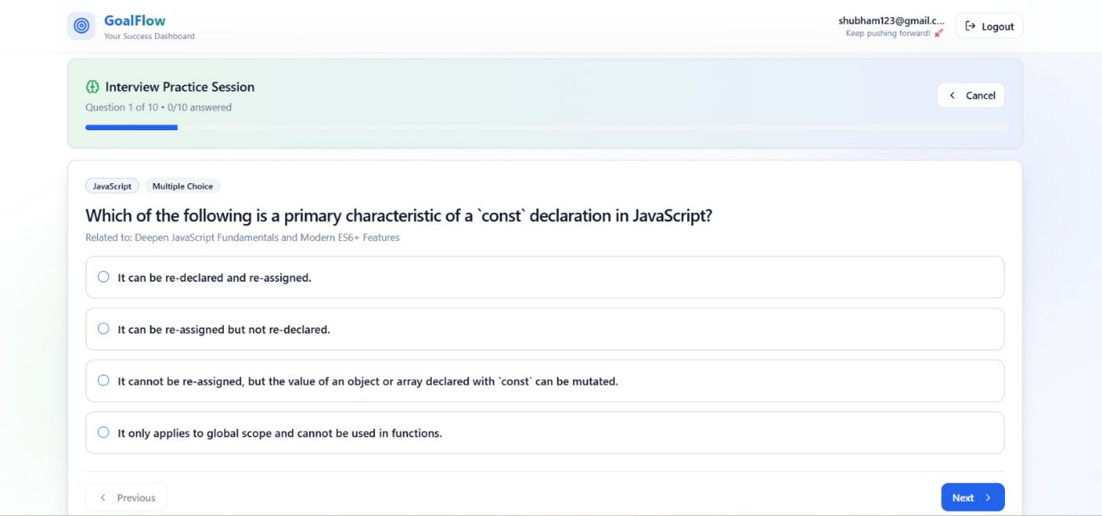
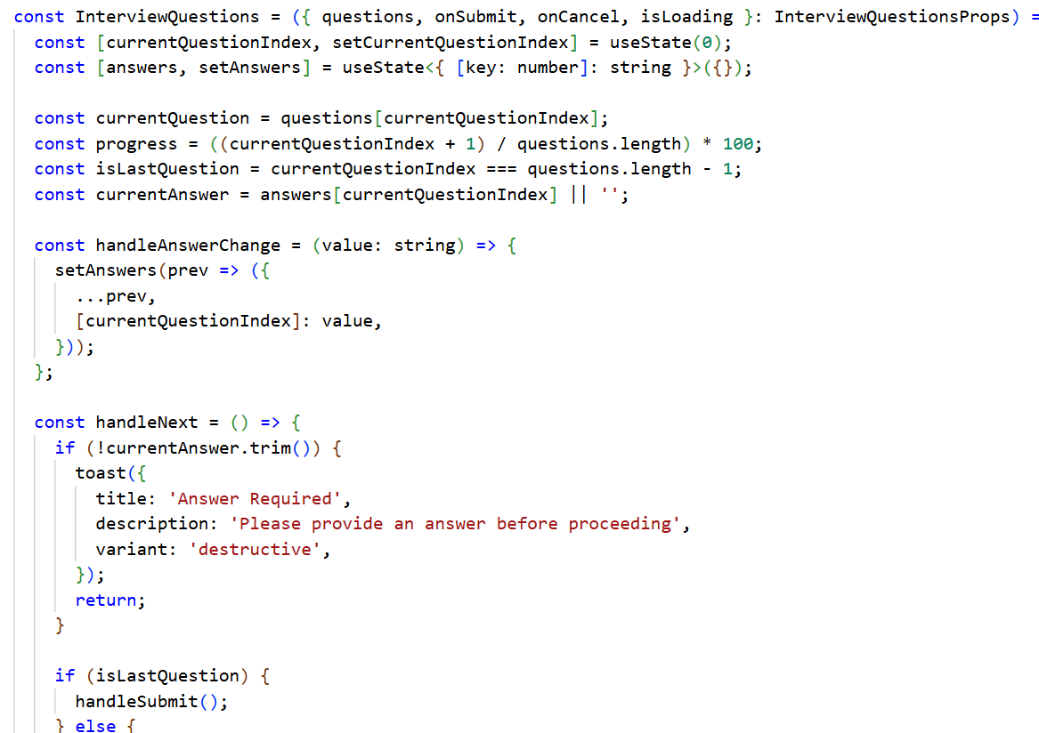

Screenshot 11 Interview practice interface
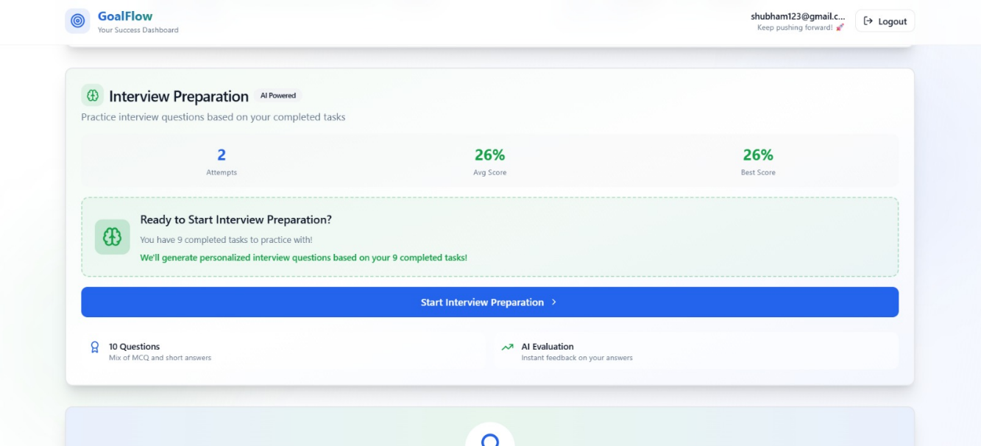
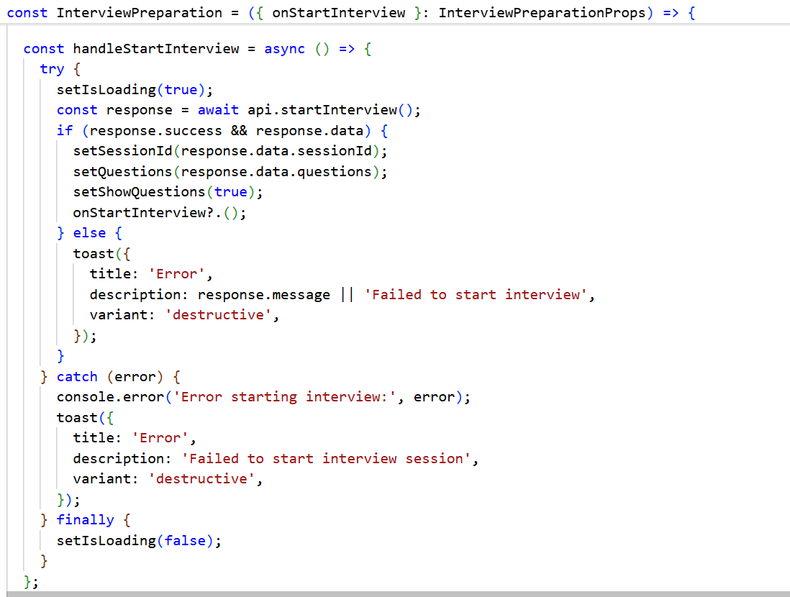

Screenshot 12 Feedback for interview
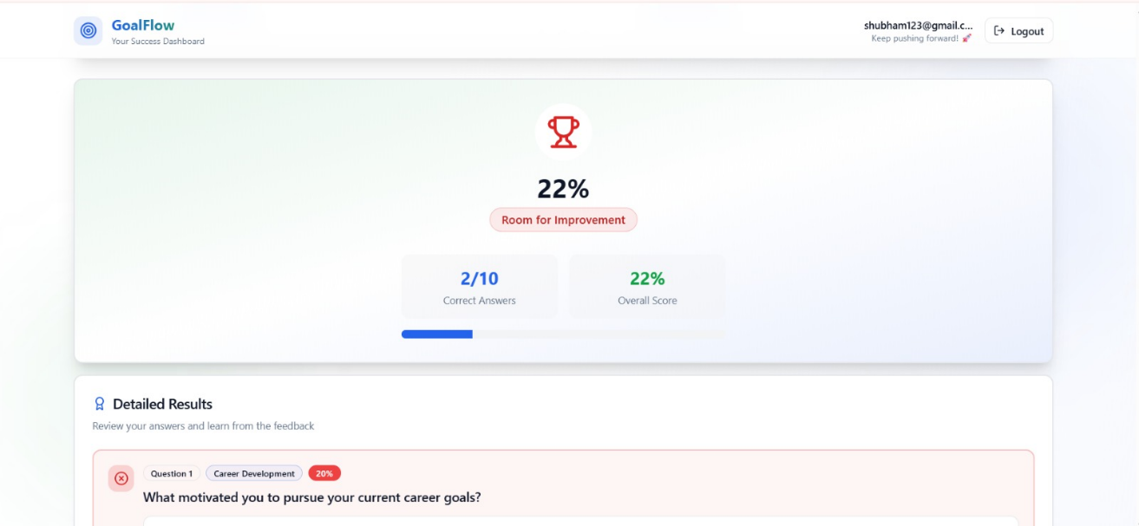
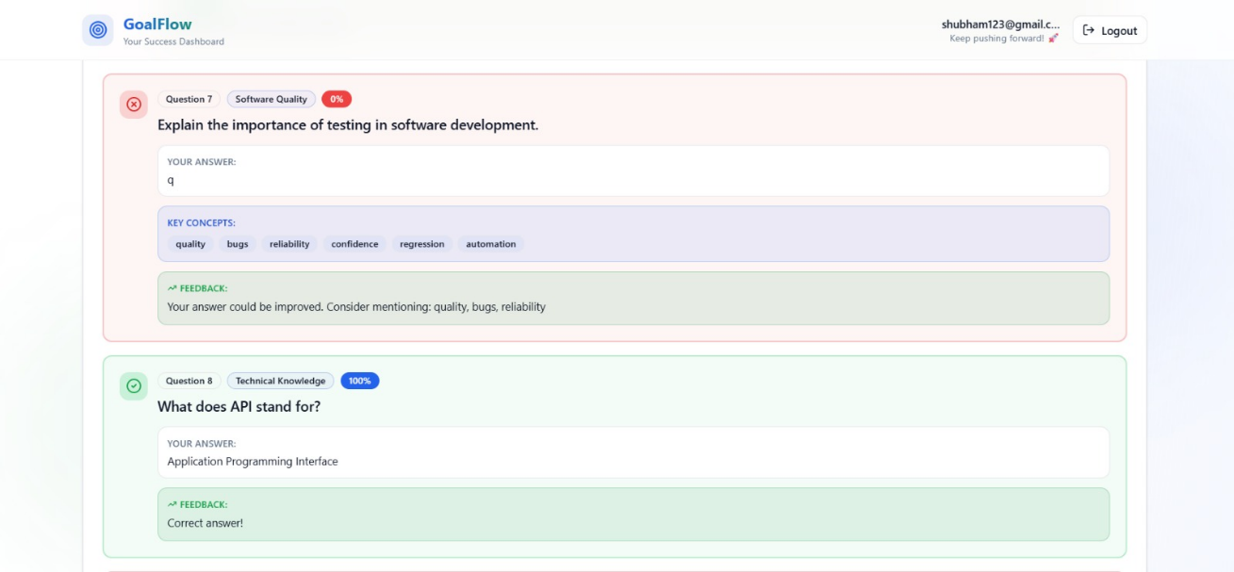
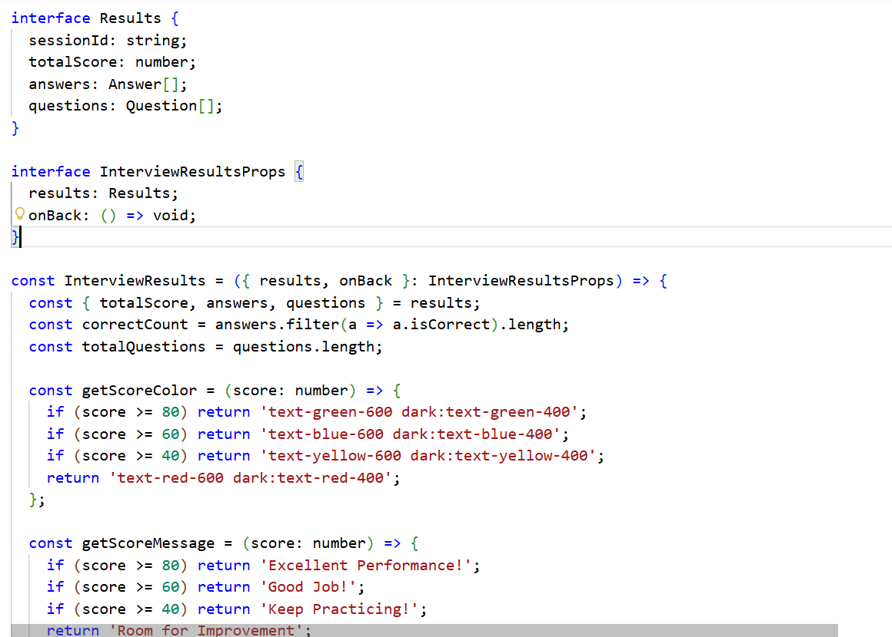
Screenshot 13 Alternate Feedback
Screenshot 14 Detailed Feedback and Suggestions

This feature closes the loop of our platform – not only do we help users learn and build their resume, but we also prepare them for the final challenge of securing a job: the interview. By using AI to simulate an interviewer, we can give tailored, instantaneous feedback that users would normally only get (if ever) from a career coach or after repeated real interviews. It helps users refine their communication and identify weak spots in their understanding or presentation.

Assumptions and Design Decisions
Throughout the development of this project, we made several assumptions about user needs and system use cases. We also took specific design decisions to address those assumptions or due to technological considerations. Below we list the key assumptions and how we addressed them:

Target Users and Context:
We assumed the primary users are advanced students (diploma or undergraduate level) and recent graduates preparing for internships or entry-level roles. This informed content like the difficulty of interview questions and the level of detail in recommendations. We designed the tone of the application to be encouraging and not too enterprise-heavy. For example, the tasks generated presume some foundational knowledge (we don’t give extremely basic tasks that a high school student would need, since we expect our users have some academic background already). Also, the resume builder templates and suggestions focus on early-career resumes (highlighting projects and coursework if professional experience is limited).

User Motivation:
We assumed users of such a platform are motivated to improve and will be actively engaging with the features. Therefore, we built interactive elements (like checking off tasks, or iterative interview attempts) under the assumption that users find value in tracking and will come back regularly. If a user does not use the app frequently, features like the streak counter lose meaning. But our assumption is that by providing useful feedback and a sense of accomplishment, users will indeed log in frequently (e.g., daily or weekly) to update their progress. This guided us to include motivational messaging (like the “You’re making great progress!” card on the dashboard) and community aspects (we assumed users might appreciate community support, which is why we included a “Join Community” button that could link out to forums or groups relevant to their learning path).

AI Output Reliability:
We assumed that large language model outputs would generally be useful but might not be perfectly accurate or appropriate without constraints. Thus, we designed prompts that heavily restrict output format (JSON) and content. We anticipated potential issues like the AI generating too lengthy resumes, or using phrasing that’s overly general. By specifying bullet counts, section structures, and providing examples in prompts, we aimed to get output that required minimal editing. We also assumed that if the AI failed (due to an outage or prompt misfire), the system should have a reasonable fallback. For instance, if generateResumeContent fails to parse, we call a getFallbackResumeContent method which creates a generic resume content using template text and the user’s basic info. Similarly, for tasks, if the AI fails, we created a fallback list of tasks covering generic study and career preparation steps. These ensure the user always gets some output and is not left with an error.

Privacy and Data Use:
We assumed that storing potentially sensitive user data (like their resume content or personal goals) in our database is acceptable given proper authentication and that this is a closed project. We did not implement end-to-end encryption of stored data, assuming users are comfortable with platform staff or developers potentially seeing their input (which in an educational context is normally fine). However, we did ensure passwords are hashed and the database is not exposed. Also, our use of third-party AI APIs means user-provided data (like resume text or answers) are sent to external servers (OpenAI/Google). We have an assumption that users consent to this by using the AI features, which in a production scenario would be clarified via terms of service. In an academic project context, we proceed with that integration for the sake of functionality.

Technology and Platform:
We assumed that requiring a modern web browser is acceptable and that users will primarily use the platform on desktop or laptop (perhaps a tablet). While the interface is responsive and works on mobile screens, certain interactions (like typing long answers or editing a resume) are more comfortable on larger screens. We did not build a separate mobile app given the scope, assuming that browser access suffices for our users. We also assumed that internet access is available since many features (AI calls) depend on it.

Scalability Needs:
For this prototype, we assumed a modest number of users (dozens to a few hundred) rather than thousands. Therefore, we did not implement heavy scalability features like load balancing or caching of AI responses for reuse. Each user’s actions invoke fresh AI calls. In a higher scale scenario, one might cache commonly generated content (like if many users with similar profiles request resume generation) or limit the frequency of interview sessions to manage cost. We assumed we can operate within generous API quotas for our academic usage. This influenced us to keep our API integration relatively straightforward and not add complexity like job queues or rate limiters, which were not strictly necessary for the expected usage volume in a course project.

In summary, these assumptions ensured our design remained user-centric for our intended audience and scoped to deliver maximum functionality within the given constraints. As we progressed, some assumptions were validated (e.g., users indeed found AI suggestions valuable in informal tests) while others would require real-world deployment to fully verify (e.g., whether users regularly utilize all parts of the platform or focus on one aspect).

Technical Challenges and Changes
Developing an integrated AI-driven platform presented numerous challenges, both expected and unforeseen. We highlight the significant technical hurdles we encountered and the changes or solutions we implemented to overcome them:

Integrating Generative AI Outputs:
Handling large, structured outputs from the AI in a reliable way was challenging. For example, generating a full resume or a detailed task list in JSON required careful prompt engineering. Initially, we found that the AI would sometimes return text that wasn’t valid JSON (especially if the response was long). To address this, we refined our prompts to explicitly instruct “Return ONLY valid JSON” and included markers and cleaning logic. We wrote post-processing code to clean typical artifacts (like removing extra Markdown or explanations the model might prepend). We also included fallback generation for critical features. This way, even if the AI response had minor format issues, the app would not crash or show nothing – it would either correct the format or fall back to a templated content. This iterative process of prompt tweaking and output validation was a major portion of our AI integration effort. It taught us the importance of testing with diverse sample inputs to ensure the AI behaves as expected in most cases.

Real-time User Input and Feedback:
In features like the resume builder and interview module, we had to manage asynchronous events and loading states. For example, when the user clicks “Generate with AI,” there is a delay while the request goes to the server and the AI processes it. We implemented loading spinners and disabled the UI inputs during these operations to avoid confusing the user or duplicate requests. Similarly, for the interview submission, generating feedback might take a short while, so we show a progress indicator and a message like “Evaluating your answers…”. Without these, users might think the app froze or click multiple times, causing redundant calls. We also encountered challenges in updating React state deeply (like nested experience entries) based on AI output. We solved it by reconstructing new state objects from the AI JSON rather than trying to hand-patch deeply nested state, which simplified the updates and avoided subtle bugs.

Data Consistency between Client and Server:
With features such as task completion or resume editing, keeping the client UI in sync with the database was important. We noticed early on that if a user quickly toggled a task or saved a resume, there could be a slight lag before the server confirmed it. We decided to optimistically update the UI – for instance, checking off a task immediately reflects as completed in the UI (and maybe moves to a “completed” section) without waiting for the server response. If the server then returns an error, we roll it back and notify the user. This approach made the app feel more responsive. However, implementing this required careful error handling to revert state on failure. We did so by encapsulating these operations; for example, a completeTask (taskid) function on the client will mark it done visually and call the API, and in the. catch of the promise, it will mark it undone if an error occurred, while also showing a toast “Failed to update task, please retry.”

Managing AI Costs and Limits:
Each AI call (tasks, recommendations, resume generation, enhancement, interview Q&A evaluation) consumes tokens from our API quota. During development, we had to be mindful of not calling the AI more than necessary. We introduced some rate-limiting on the client side – for example, disallowing the user from spamming the “Generate with AI” button by disabling it for a short period after use. Also, we decided to generate tasks and recommendations only once at onboarding completion and store them, rather than regenerating them on every login (unless the user explicitly asks for a refresh). Similarly, we store interview questions for a session rather than regenerating new ones if the user revisits the session. These design choices conserve API usage. We also implemented a simple caching: if the user hasn’t changed their onboarding info, clicking “Regenerate Plan” will use the same result as before (or only change slightly) unless a full refresh is needed.

Adapting Plan After Changes (Post-Midterm Pivot):
After our midterm review, we slightly adjusted our plan. Initially, we had slated the interview preparation feature for a later phase, but we realized we could deliver a scaled-down but functional version for the final if we carefully managed scope (text Q&A rather than live audio, limited number of questions, etc.). We reallocated time from implementing certain stretch features (like a full analytics comparison between users or more community features) towards building the interview module. This decision was made in consultation with our supervisor, and it did not change the overall vision but shifted the emphasis to ensure we had a complete pipeline (from learning to interviewing). This was a challenge in project management – ensuring we could integrate a new major component late in development. We tackled it by noticing synergy: the interview module could reuse parts of the task and profile data models, and it leveraged the same AI integration approach we were already using for resumes and tasks. Essentially, we discovered our earlier architectural decisions (like having a unified GeminiService and a flexible data model) made adding the interview feature feasible within limited time. We count this as a positive outcome of planning for adaptability.

UI/UX Refinement:
One challenge was providing a polished user experience given the number of features. We did multiple passes to ensure consistency in styling and terminology. For example, making sure that the buttons and dialogs across different modules looked and behaved similarly (confirmation modals for deletes, consistent color coding for priority or correctness, etc.). We also simplified some interactions when we realized complexity was not adding value. One change was in the resume builder – we originally considered having multiple templates (styles) that the user can switch between for preview/export. But managing template switching with content binding proved complex and not core to our research goals, so we fixed on one clean template (“Modern” style with simple formatting) for now. This was a conscious scope reduction to focus on functionality (ATS optimization) over form (visual variety). It was a challenge because we had partially implemented a template switcher, but we removed that code to avoid bugs and confusion.
Through these challenges and changes, we learned the importance of flexibility and user-centered thinking. We frequently asked, “Is this feature working in a way that benefits the user and is it robust enough for them?” If not, we iterated until we could affirm that or we cut the feature if time was better spent elsewhere. The result is a system that, despite the hurdles, meets the key requirements and feels cohesive.

Lessons Learned and Future Work
Reflecting on the project, our team has gained invaluable insights into both the technical and human aspects of developing an AI-enhanced application. This retrospective examines what went well, what challenges we overcame, and lessons learned that could guide future projects.

Achievement of Objectives:
We are pleased to report that we accomplished the core objectives laid out at the project’s start. The final system successfully generates personalized study plans, recommends career-aligned skills and resources, builds and refines resumes, and provides interview practice – all within one unified platform. In doing so, we demonstrated the feasibility of leveraging AI to span a traditionally siloed process (education vs. career prep). While we did not conduct a formal user study due to time, anecdotal feedback from classmates who tried the application was positive. They highlighted that the AI-generated resume content and interview feedback were particularly helpful, suggesting our hypothesis that these tools would improve confidence and readiness holds merit.
Teamwork and Process: Our two-person team collaborated effectively. We established clear division of roles early on (with one member leaning towards front-end implementation and UI design, and the other focusing on back-end and AI integration), but we frequently synchronized to integrate our work. We held short, frequent meetings (sometimes daily stand-ups during heavy development weeks) to ensure we were on track and to resolve blockers quickly. This close collaboration allowed us to be agile in reassigning tasks when needed – for example, when the interview module was added, both members paired on it to catch up the development. We learned the importance of version control discipline; using Git, we made sure to merge changes carefully and test after each merge, which avoided major integration bugs. The only significant merge conflict we encountered was when both of us modified the routing logic around the same time, but we resolved it by communicating our changes and deciding on a single approach.

What Went Well:
Adaptability: The project’s scope evolved after midterm feedback, but we adapted without derailing progress. The decision to focus on front-end UX first (as done in the first half) paid off when integrating complex features later, as we already had a solid UI framework in place. - Use of Libraries and Tools: Our choice of modern libraries (React hooks, Tailwind CSS, shadcn UI components, Recharts) made development faster and the end result more polished. For instance, styling the application to a professional standard took less time thanks to Tailwind’s utility classes, and we avoided a lot of custom CSS bugs. The Recharts library allowed us to create the dashboard visualizations quickly, which added significant value to the user experience with minimal custom code. - AI Integration Strategy: By treating the AI as a modular component (via GeminiService), we kept our code organized. This also allowed easy experimentation with prompts. We learned that prompt engineering is somewhat an art; having them in one place meant we could systematically refine prompts in context and test them one by one. Our approach of requesting JSON and then parsing it into our models turned out to be effective; it created a clear contract for what the AI needed to deliver. - User Experience and Feedback: We made user-centric decisions like offering previews, confirmations for destructive actions (e.g., deleting a resume asks “Are you sure?” in a modal to prevent accidents), and saving user progress. The consistent academic tone and encouraging language hopefully make users feel supported rather than judged by the app – this was a conscious design choice aligned with our educational use case. We also included small touches such as a welcome message with the user’s name on the dashboard and celebratory confetti animation when a user completes all tasks for the week, to keep the experience engaging.

Challenges and Mitigations:
Time Management: Incorporating a wide array of features (essentially building what could be separate applications – a study planner, a resume builder, an interview simulator – into one) was ambitious. We mitigated time risk by prioritizing features that delivered the most research value. For example, we postponed adding a full-fledged “Analytics Comparison with Peers” because it wasn’t critical to proving our concept, even though it was in our initial plan. Instead, we focused on delivering one good analytics dashboard for the individual user. We learned that it’s better to fully implement and polish a subset of features than to half-implement everything. This trade-off improved the final quality. - AI Accuracy and Limitations: There were moments where the AI produced either incorrect or verbose outputs (particularly some interview feedback that was generic). We mitigated these by refining prompts and in some cases post-processing feedback to shorten it. However, we acknowledge that the AI is not perfect – for instance, it might occasionally give an interview question evaluation that a user could dispute. In future, more training or a larger prompt context including ideal answers might improve this. For now, we treat the AI as an aid, not an oracle, and we’ve included disclaimers that the suggestions are generic and users should use their discretion. - Integration Bugs: Combining components revealed some bugs, such as state not updating properly when switching between different resumes or when starting a new interview after one was completed. These issues taught us to test each user flow thoroughly (creating multiple resumes in a row, doing back-to-back interview sessions, etc.). We fixed these by ensuring, for example, that we reset relevant state when starting a new session, and by adding unique keys to lists in React to force re-renders when data changed fundamentally.

Impact and Future Work:
In this project, we set out to reduce the gap between learning and career preparation. The end product, GoalFlow, shows a viable path to do so with AI at the core. Going forward, there are opportunities to conduct user studies measuring how using the platform affects outcomes. For example, do students who use GoalFlow have more structured study habits or better interview success rates compared to those who don’t? Also, expanding the content (question banks, integration with actual course data, etc.) and possibly collaborating with career centers or academic advisors could increase the platform’s effectiveness. From a technical perspective, future improvements could include integrating a broader range of AI models (ensuring data privacy by possibly allowing an on-premise open-source model for institutions), and refining the UI into a production-grade app with more customization and social features (like sharing progress with a mentor).

Personal Learnings:
Each team member found this project to be an intense but rewarding learning experience. We deepened our skills in full-stack development, specifically learning how to manage state and asynchronous flows in React better, and how to design RESTful APIs that serve a complex front-end. More uniquely, we gained experience in prompt engineering and understanding the capabilities of generative AI. We learned to view the AI not as a magic solution but as a component that requires guidance and verification, and we became adept at diagnosing where an AI output issue is due to a prompt vs. where it might be an API limitation.

In conclusion, the project achieved its aims and provided a solid foundation for further exploration. We have effectively demonstrated that an AI-driven platform can concurrently assist with personalized learning and career preparedness. The lessons learned have not only enriched our technical competencies but have also given us insight into deploying AI responsibly and effectively in user-facing applications.

Concluding Remarks
This project represents a synthesis of educational technology and career development, underpinned by artificial intelligence. In building our AI-Enhanced Personalized Learning and Career Pathway Platform, we tackled the multifaceted problem of bridging academic learning with job market readiness. The final system, GoalFlow, offers users a seamless experience: from identifying what to learn each week, to documenting those new skills on a resume, to practicing how to talk about their experience in interviews. By focusing on ATS-friendly resume creation and targeted interview practice, we directly addressed common pain points faced by job seekers in the digital hiring era.

The use of AI was central to our approach. We leveraged a generative model not just as a novel add-on, but as an integral component that adds intelligence to every module of the platform. The AI provides personalized content – be it study tasks tailored to one’s goals or resume phrasing aligned with a specific job description – that would be tedious or impossible to generate manually at scale. Our experience affirms that when guided properly, AI can significantly augment user support in educational and career contexts. It can automate the personalization that human advisors or coaches would otherwise have to do one-on-one, thus potentially offering these benefits to a much wider audience at low cost.

One key outcome of our project is the demonstration that integration is beneficial: users are more likely to engage in career preparation when it is presented as part of their learning journey, rather than as a separate, later activity. The platform encourages a habit whereas users learn, they also keep an eye on how that learning translates to employability (for example, completing a task triggers a suggestion to add something to the resume or try a related interview question). We believe this holistic approach can reduce the gap where students excel academically but struggle to market themselves professionally.

Of course, our project has its limitations. The current implementation is a prototype and would require further development for production use. Areas such as data security, scalability, and multi-user support would need to be bolstered. Additionally, while our AI features performed well in tests, continuous monitoring and perhaps a feedback loop for the AI (learning from user corrections) would improve accuracy and user trust in the long run. There is also the consideration of bias and fairness – for instance, AI-generated content should be reviewed to ensure it does not inadvertently favor or disfavor certain groups. Going forward, these ethical and quality considerations would be important.

In conclusion, the project has been a success in showing how modern AI can be harnessed to empower individuals in their educational and career progression. We turned a challenging idea into a working application that brings real value – an achievement we are proud of. The journey taught us much about software development, AI integration, and user experience design. We navigated the uncertainties of emerging technologies and delivered a solution that we hope could serve as a blueprint for future educational career platforms. With further refinement and real-world evaluation, we envision tools like GoalFlow becoming commonplace in academic institutions and professional training programs, helping learners not only acquire knowledge but also confidently take the next steps into their careers.

Contract
This contract outlines the responsibilities, commitments, and expectations agreed upon by all team members for the Applied Research Project.

Member Name | Student ID | Role / Responsibility
Gursimran Singh | 300377817 | Team Lead, Frontend Development, AI Integration, Documentation
Shubham Shubham | 300352587 | Front-End Development, System Design, Backend Development
Agreement Terms:
- Each member agrees to contribute equally and meet all assigned deadlines.
- Communication will occur via agreed channels (e.g., Teams, Meet, or WhatsApp).
- Any conflicts or issues will be discussed respectfully and resolved collaboratively.
- Members agree to maintain academic integrity and uphold Douglas College standards.
- Failure to fulfill responsibilities may result in redistribution of tasks or instructor intervention.
Signatures:
Name | Date
Gursimran Singh | _2025-10-25_
Shubham Shubham | _2025-10-25_

References

1. Bloom, B. S. (1984). The 2 sigma problem: The search for methods of group instruction as effective as one-to-one tutoring. Educational Researcher, 13(6), 4–16. Massachusetts Institute of Technology
2.Luckin, R., Holmes, W., Griffiths, M., & Forcier, L. B. (2016). Intelligence Unleashed: An argument for AI in education. Pearson. Google for Education+1
3. Pane, J. F., Steiner, E. D., Baird, M. D., & Hamilton, L. S. (2017). Informing Progress: Insights on personalized learning implementation and effects. RAND Corporation. RAND Corporation
4. RAND Corporation. (2017). How does personalized learning affect student achievement? Research Brief RB-9994. RAND Corporation
5. D2L. (2022). Does personalized learning work to boost student achievement? D2L Blog. D2L
6. Jobscan. (2025). How to create an ATS resume. Jobscan Blog. Jobscan
7. Jobscan. (2025). Applicant Tracking Systems: Everything you need to know. Jobscan. Jobscan
8. Google AI for Developers. (2025). Text generation – Gemini API documentation. Google AI for Developers
9. Google Cloud. (2025). Generative AI on Vertex AI – model overview and documentation. Google Cloud Documentation+1
10. React Team. (2025). React documentation – Quick Start & Learn React. react.dev. React+1
11. Express.js Foundation. (2025). Express – Node.js web application framework documentation. expressjs.com. Express+1
12. MongoDB Inc. (2025). Get started with MongoDB Atlas – cloud database service documentation. MongoDB+1

Appendix A: Installation Guide
1. Download Project Files
- Download the zip folder of the project.
- Extract the contents to your preferred directory.
2. Prerequisites
Ensure the following are installed on your system:
- Node.js (version 18 or later)
- npm (comes with Node.js)
- A code editor such as Visual Studio Code
3. Install Dependencies
Frontend (React + Vite)
- Open the terminal in the root folder and run:
- npm install
Backend (Node.js + Express + MongoDB)
- Navigate to the backend folder and run:
- cd server
- npm install
4. Configure Firebase Authentication
Open the .env file and add the Firebase keys from your Firebase account.
const firebaseConfig = {
apiKey: import.meta.env.VITE_FIREBASE_API_KEY,
authDomain: import.meta.env.VITE_FIREBASE_AUTH_DOMAIN,
projectId: import.meta.env.VITE_FIREBASE_PROJECT_ID,
storageBucket: import.meta.env.VITE_FIREBASE_STORAGE_BUCKET,
messagingSenderId: import.meta.env.VITE_FIREBASE_MESSAGING_SENDER_ID,
appId: import.meta.env.VITE_FIREBASE_APP_ID,
};
5. Configure Backend Environment Variables
Open the .env file inside the server folder and add the following keys:
GEMINI_API_KEY=Your gemini key*
MONGODB_URI=Your mongodb connection string*
Key Sources:
Key | Source
GEMINI_API_KEY | Google AI Studio → https://aistudio.google.com
MONGODB_URI | MongoDB Atlas → Cluster → Connect → Connection String

6. Install Dependencies
Frontend:
- npm install
Backend:
- cd server
- npm install
Start Backend Server
- From the server folder, run:
- npm run start
Start Frontend (React + Vite)
- Go back to the main project folder and run:
- npm run dev
7. Access the Application
Open the browser and follow the localhost link from terminal:
http://localhost:8080/

Appendix b: User Guide
- Access and Login
Open the GoalFlow web application in a modern browser. Create an account with your name, email, password, and phone number (for OTP verification), or log in with existing credentials.
- Onboarding
After first login, complete the onboarding form with your program, skills, goals, and study preferences. Submit the form to let the system generate your initial personalized tasks and career recommendations.
- Dashboard and Tasks
The dashboard shows your weekly tasks, progress summary, and recommendations. Review tasks, work on them offline, and click the checkbox or “Mark as Done” to update completion and progress charts.
- Recommendations
In the recommendations area, open suggested courses, skills, projects, and certifications. Save useful items for later or dismiss irrelevant ones so future suggestions better match your interests.
- Resume Builder
Open the Resume section to create or edit a resume. You can enter details manually or click “Generate with AI” to get a draft based on your profile, then edit it. Use the job description box to optimize the resume for a specific role and save/export the final version.
- Interview Practice
In the Interview section, start a new session to receive AI-generated questions based on your skills and tasks. Answer all questions, submit them, and review the scores and feedback shown on the results screen.
- Profile and Logout
Use the Profile/Settings area to update personal information and preferences. When finished, click “Log Out” from the account menu to securely end your session.

