

AI‑Enhanced Personalized Learning and Career Pathway Platform

Team Members:
Gursimran Singh — Student ID: 300377817 — Team Lead
Shubham Shubham — Student ID: 300352587
Course: Applied Research Project — 4495‑071

Table of Contents

1. Introduction
2. Problem Statement
3. Project Objectives
4. Project Scope
5. Methodology
6. Technical Requirements
7. Research Methodology
8. Timeline
9. Gantt-Style Timeline
10. Implemented Features (as of Oct 25, 2025)
11. Change of Direction (with Consultation)
12. Assumptions Made
13. Research and Comparison Conducted
14. Implementation Status, Gaps, and Mitigation
15. Plan for the Final Phase
16. Lessons Learned and Hurdles Overcome
17. Conclusion
18. Contract Page
19.Project/Code Running Shots
20. References

1. Introduction
In today’s fast‑paced educational environment, students often struggle to balance academic studies with preparing for future careers. Traditional learning platforms provide access to content but typically lack personalization and adaptability to individual learning styles, strengths, and weaknesses. This misalignment creates a persistent gap between academic performance and career readiness. The present project investigates how artificial intelligence can be leveraged to provide personalized study support while simultaneously preparing students for workforce entry. We explore how AI can generate adaptive study plans tailored to performance and preferences and how those capabilities can be extended to support skill development, resume preparation, and interview readiness. Although prior literature establishes the promise of adaptive systems, most solutions address academics or career preparation in isolation. By unifying these dimensions, this project aims to deliver an AI‑powered platform that generates weekly study plans, recommends skills and certifications, and offers integrated resume and interview tools to improve both academic outcomes and employability.

2. Problem Statement
Students face four interrelated challenges. First, many rely on inefficient study strategies that make it difficult to identify weak topics or prioritize time effectively. Second, static study guides rarely accommodate individual learning styles, resulting in disengagement and uneven progress. Third, career readiness gaps persist because learners often lack clarity on the skills required for target roles, the certifications that matter, and effective interview preparation practices. Fourth, resources are fragmented across multiple platforms, forcing students to navigate disparate tools for academic content, skills development, and career services. Consequently, we ask: can an AI‑driven platform that combines personalized learning paths with career readiness capabilities measurably improve learning outcomes, engagement, and employability preparation when compared with traditional static methods?

3. Project Objectives
The project’s objectives are aligned to five core capabilities. First, the system must generate weekly study plans that reflect individual strengths, weaknesses, and learning preferences. Second, it should recommend career‑relevant skills and surface aligned courses and certifications that map academic progress to market needs. Third, an interactive resume builder should enable students to compose, customize, and export professional resumes while receiving helpful suggestions about skills, achievements, and certifications. Fourth, an interview preparation feature should provide practice questions tailored to target roles and deliver automated feedback about clarity, tone, and confidence. Finally, an analytics dashboard should allow both students and instructors to track learning progress, skill acquisition, certification status, and interview readiness through clear visualizations and concise reports.

4. Project Scope
The scope includes AI‑generated weekly learning plans; a dashboard for tracking progress, skills, and certifications; career skill recommendations with certificate suggestions; a resume builder; and an AI‑assisted interview preparation module. Real‑time grading and full LMS integration are outside the MVP scope, as is enterprise‑scale, multi‑institution deployment. The primary deliverables are a functional web or mobile prototype, a user manual with technical documentation, and a research study report that evaluates student performance and satisfaction.

5. Methodology
The system architecture spans a web front end implemented in React and, if needed, a mobile client based on React Native. The back end will use Firebase or Supabase for authentication, database services, and storage, chosen for their developer velocity and managed security controls. AI modules will rely on the OpenAI API initially, while maintaining compatibility with open‑source models via the Hugging Face ecosystem to preserve portability. The database captures student profiles, quiz scores, learning plans, skills, certifications, resumes, and interview logs. Functionally, the platform ingests syllabi, quiz results, and learner preferences to generate a prioritized weekly plan; maps course performance to industry‑relevant skills; supports interactive resume authoring with context‑aware suggestions; conducts interview practice with structured feedback; and presents analytics through charts and progress indicators. This design keeps the architecture clean—student interactions traverse the front end, invoke back‑end services, call AI modules as needed, and persist structured data for analysis and reporting.

6. Technical Requirements
The software stack includes Node.js and React for the front end, optional React Native for mobile, and Firebase or Supabase for persistence and authentication. Python may be used for auxiliary AI/NLP tasks, with OpenAI or Hugging Face Transformers providing inference. For analytics, Chart.js or Recharts can render dashboard visualizations. Typical developer laptops are sufficient, with optional cloud GPUs for model experimentation. Data requirements include sample syllabi, mock quiz scores, curated skill datasets, and short surveys to capture user feedback.

7. Research Methodology
Evaluation proceeds through a pilot involving approximately fifteen to thirty students divided into two groups: one using AI‑driven learning paths and the other following a traditional static plan. We will capture quiz improvement, task completion rates, skill acquisition logs, and survey responses to assess perceived usefulness of the resume and interview modules. Comparative analysis using standard inferential statistics (for example, t‑tests and ANOVA, as appropriate given distributional assumptions) will determine whether the AI‑supported experience delivers measurable gains. A simplified data‑flow view highlights movement from learner inputs to AI processing and database persistence, while a companion sequence view describes five phases of the user journey—initial setup, learning progress, career development, resume and interview preparation in parallel, and progress monitoring through the analytics dashboard.

8. Timeline
Week(s) | Milestone / Task | Description / Deliverables | Responsibilities
1–2 | Requirements Analysis & System Design (Completed) | Gathered requirements, defined features, drafted architecture, created initial mockups, assigned roles. | Gursimran: lead requirements/design; Shubham: mockups & feature docs
3–4 | Front-End Scaffold & Routing (Completed) | Set up React + TypeScript (Vite), Tailwind, shadcn/ui. Implemented routing for Landing, Login/Signup, Onboarding, Generating Plan, Dashboard, Resume Builder. | Gursimran: front-end scaffold & routing; Shubham: component baselines
5–6 | Onboarding, Mock Plan Generation, Dashboard Basics (Completed) | Built onboarding forms (goals, skills). Added progress screen simulating plan generation. Implemented initial Dashboard sections (tasks/progress, certification pathway cards). | Gursimran: flows & UX; Shubham: dashboard sections
7–8 | Resume Builder & UX Validation (Completed) | Implemented resume forms (Personal, Experience, Education, Skills), live preview, and simulated “Generate with AI” to validate copy and UX. | Shubham: resume builder & preview; Gursimran: UX validation & fixes
9-10 | Auth & Persistence Integration (Planned) | Integrate Firebase (email/password). Persist profiles, plans, resume data; migrate from localStorage. Establish security rules. | Shubham: backend & rules; Gursimran: data model & UI wiring
10-11 | AI Integration for Plans & Resume Suggestions (Planned) | Connect provider adapter to OpenAI (with option for HF). Add rate limits, safety checks, prompt templates. E2E tests of suggestion flows. | Gursimran: prompts & adapters; Shubham: integration & tests
11-12 | Interview-Preparation MVP (Planned) | Deliver question banks by role, attempt logging, and structured feedback on clarity and tone. Basic analytics on practice sessions. | Shubham: feedback logic; Gursimran: UI & content curation
12-13 | Pilot & Telemetry (Planned) | Collect quiz deltas, task completion, resume completeness, and satisfaction Analyze results. | Gursimran: pilot coordination & analysis; Shubham: instrumentation
12-13 | Polish, Accessibility, Final Report (Planned) | Accessibility pass, bug fixes, dashboard charts, finalize documentation and presentation. | Gursimran: report/presentation; Shubham: bug fixes & charts

9. Gantt-style Timeline
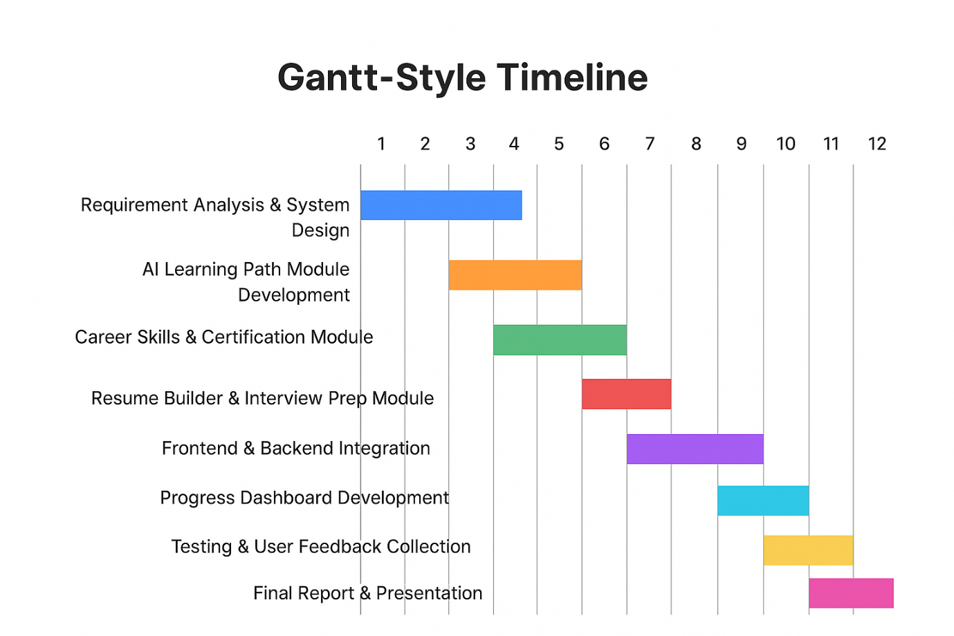

10. Implemented Features (as of Oct 25, 2025)
The current prototype delivers a scaffolded front end using React with TypeScript and Vite, styled with Tailwind and shadcn/ui. Routing covers the landing page, login and signup, onboarding, a progress screen that represents plan generation, the dashboard, and the resume builder. A lightweight Context‑plus‑localStorage mechanism supports mock authentication to enable a complete demonstration without a back end. Onboarding collects goals and skill profiles before directing users to the dashboard, where they can review tasks and explore certification pathways. The resume builder includes structured sections—personal information, experience, education, and skills—along with a live preview and a simulated “Generate with AI” feature used to validate user experience and copy prior to integrating real model calls. Development scripts for local iteration and production builds are configured, and the codebase has been smoke‑tested on desktop and mobile form factors.

11. Change of Direction (with Consultation)
There has been no pivot in vision; instead, the delivery sequence was revised following consultation to emphasize a polished front‑end MVP before adding AI providers and persistent storage. This approach prioritizes validation of the core user experience—onboarding, plan presentation, and resume authoring—while deferring integration complexity. Accordingly, the interview‑preparation capability moved to Phase‑2 so that learning‑plan design and resume workflows could be hardened first.

12. Assumptions Made
The target users are diploma and undergraduate students preparing for internships and entry‑level positions. During the MVP phase, only non‑sensitive profile data is stored in localStorage, with a planned migration to a managed authentication and database platform. AI‑assisted suggestions are subject to human‑in‑the‑loop review and designed with prompt templates and basic validations. Certification recommendations are grounded in public vendor frameworks and will be mapped to program outcomes in Phase‑2. Pilot success will be measured using task completion rates, a resume completeness score, and user satisfaction indicators such as NPS or CSAT.

13. Research and Comparison Conducted
The team compared shadcn/ui with Material UI and selected shadcn/ui for its lighter footprint and alignment with Tailwind conventions. For the back end, Firebase and Supabase were evaluated alongside MongoDB; Firebase is presently favored for its authentication and rules model, while MongoDB remains a viable database option depending on integration needs. For AI, OpenAI was chosen initially for quality and ease of integration, with a provider adapter retained to support open‑source alternatives through Hugging Face as requirements evolve. The resume data model is structured as section‑based JSON to simplify validation, AI assistance, and future exports to PDF or DOCX.

14. Implementation Status, Gaps, and Mitigation
The front‑end experience is in place, while back‑end and AI integrations are planned for the next phase. Specifically, API integration with OpenAI or compatible open‑source models is pending, as is migration from localStorage to a managed auth and database layer. The interview‑preparation feature is scheduled for Phase‑2. Risks include schedule pressure during integration and data‑privacy considerations; mitigations include freezing UX flows early, using adapter patterns for AI providers, enforcing least‑privilege access rules, and conducting targeted usability sessions before the pilot.

15. Plan for the Final Phase
The final phase will connect AI generation for study plans and resume suggestions via a provider‑adapter with rate limiting and safety checks. Authentication and persistence will move to Firebase or Supabase to store profiles, plans, and resume data. The interview‑preparation module will be delivered with curated question banks, attempt logging, and structured feedback. The analytics dashboard will persist progress metrics and visualize adherence and skill acquisition. A small pilot will collect quiz deltas, task completion rates, and satisfaction data to quantify impact.

16. Lessons Learned and Hurdles Overcome
Validating the user experience before wiring complex integrations prevents wasted effort and accelerates iteration. Establishing a consistent component system with Tailwind and shadcn/ui improved accessibility and reduced styling churn. Using mocked AI early allowed the team to tune prompts and copy without incurring operational costs. Architecturally, a front‑end‑first MVP with an adapter pattern for AI providers and a clear path to managed authentication and storage positioned the project to integrate safely and predictably in the next phase.

17. Conclusion
This project proposes and demonstrates a unified approach to AI‑assisted education that integrates personalized learning with career readiness. By combining adaptive planning, skills and certification guidance, resume authoring, and interview practice, the platform aims to help students study more effectively and prepare credibly for internships and entry‑level roles. The mid‑term deliverable validates core flows and sets a clear, feasible path to complete back‑end and AI integration, followed by a pilot that evaluates real‑world impact.

18. Contract Page

This contract outlines the responsibilities, commitments, and expectations agreed upon by all team members for the Applied Research Project.
Member Name | Student ID | Role / Responsibility
Gursimran Singh | 300377817 | Back-End Development, AI Integration, Documentation
Shubham Shubham | 300352587 | Team Lead, Front-End Development, System Design
Agreement Terms:
- Each member agrees to contribute equally and meet all assigned deadlines.
- Communication will occur via agreed channels (e.g., Teams, Meet, or WhatsApp).
- Any conflicts or issues will be discussed respectfully and resolved collaboratively.
- Members agree to maintain academic integrity and uphold Douglas College standards.
- Failure to fulfill responsibilities may result in redistribution of tasks or instructor intervention.
Signatures:
Name | Date
Gursimran Singh | _2025-10-25_
Shubham Shubham | _2025-10-25_

19.Project/Code Running Shots

Resume Builder Shot:
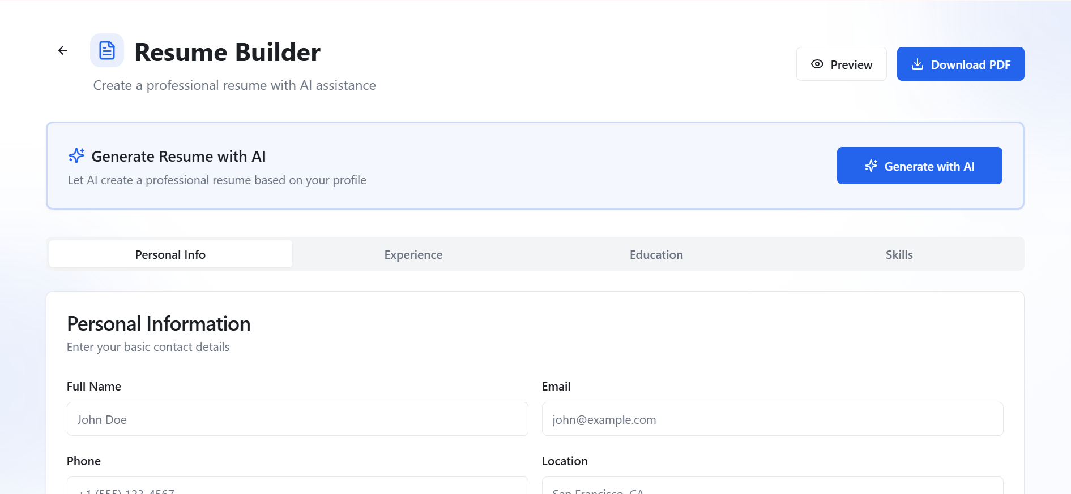

Generating Plan Shot:
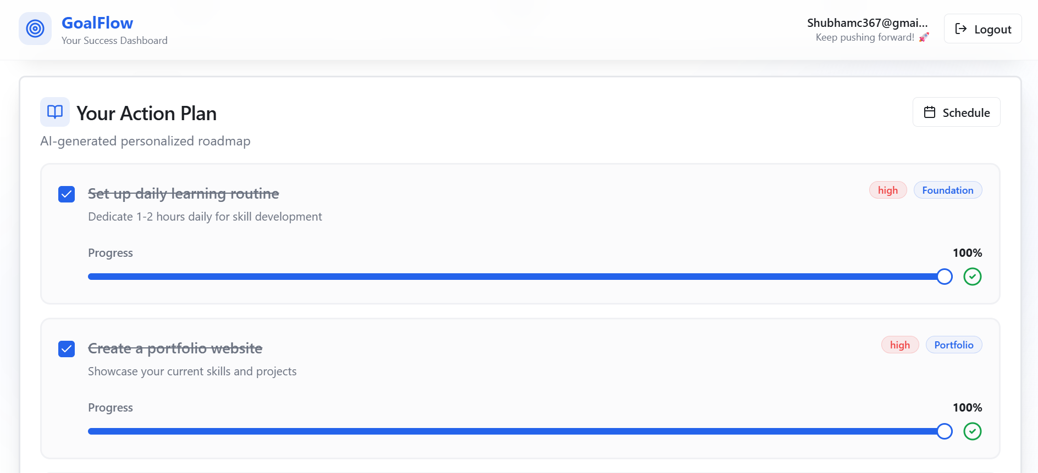

Certification Shot:
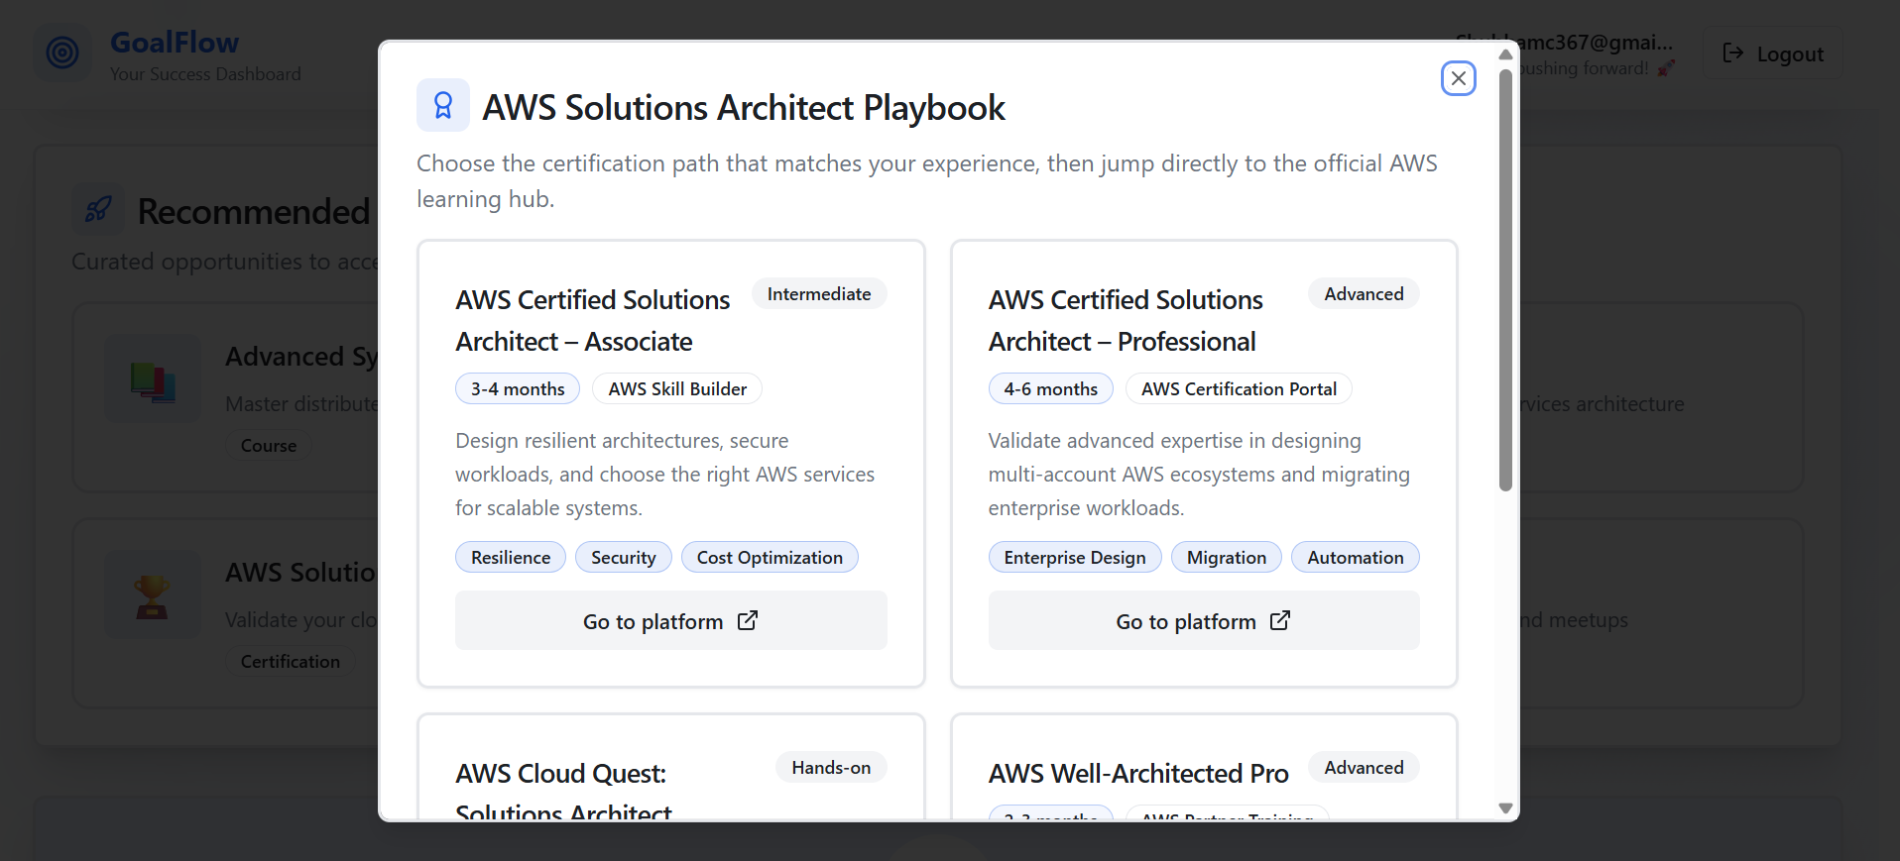

Networking Shot:
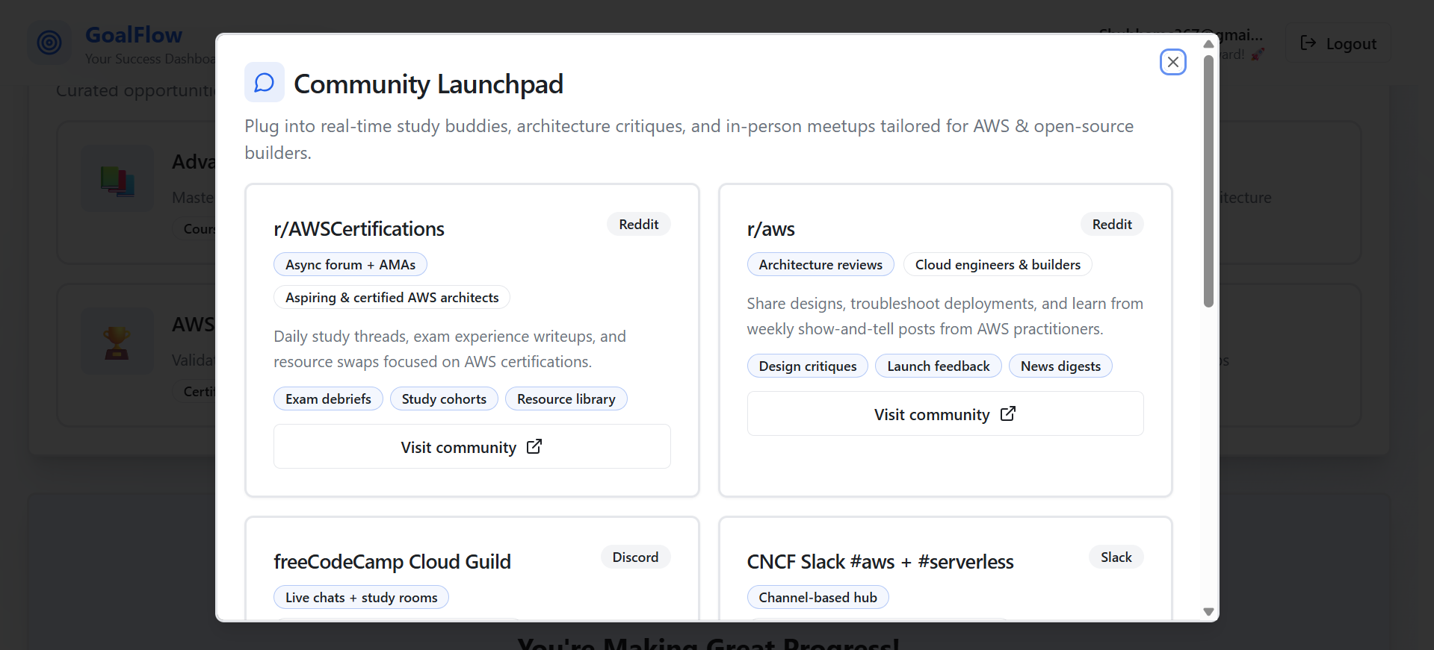

Dashboard.tsx:
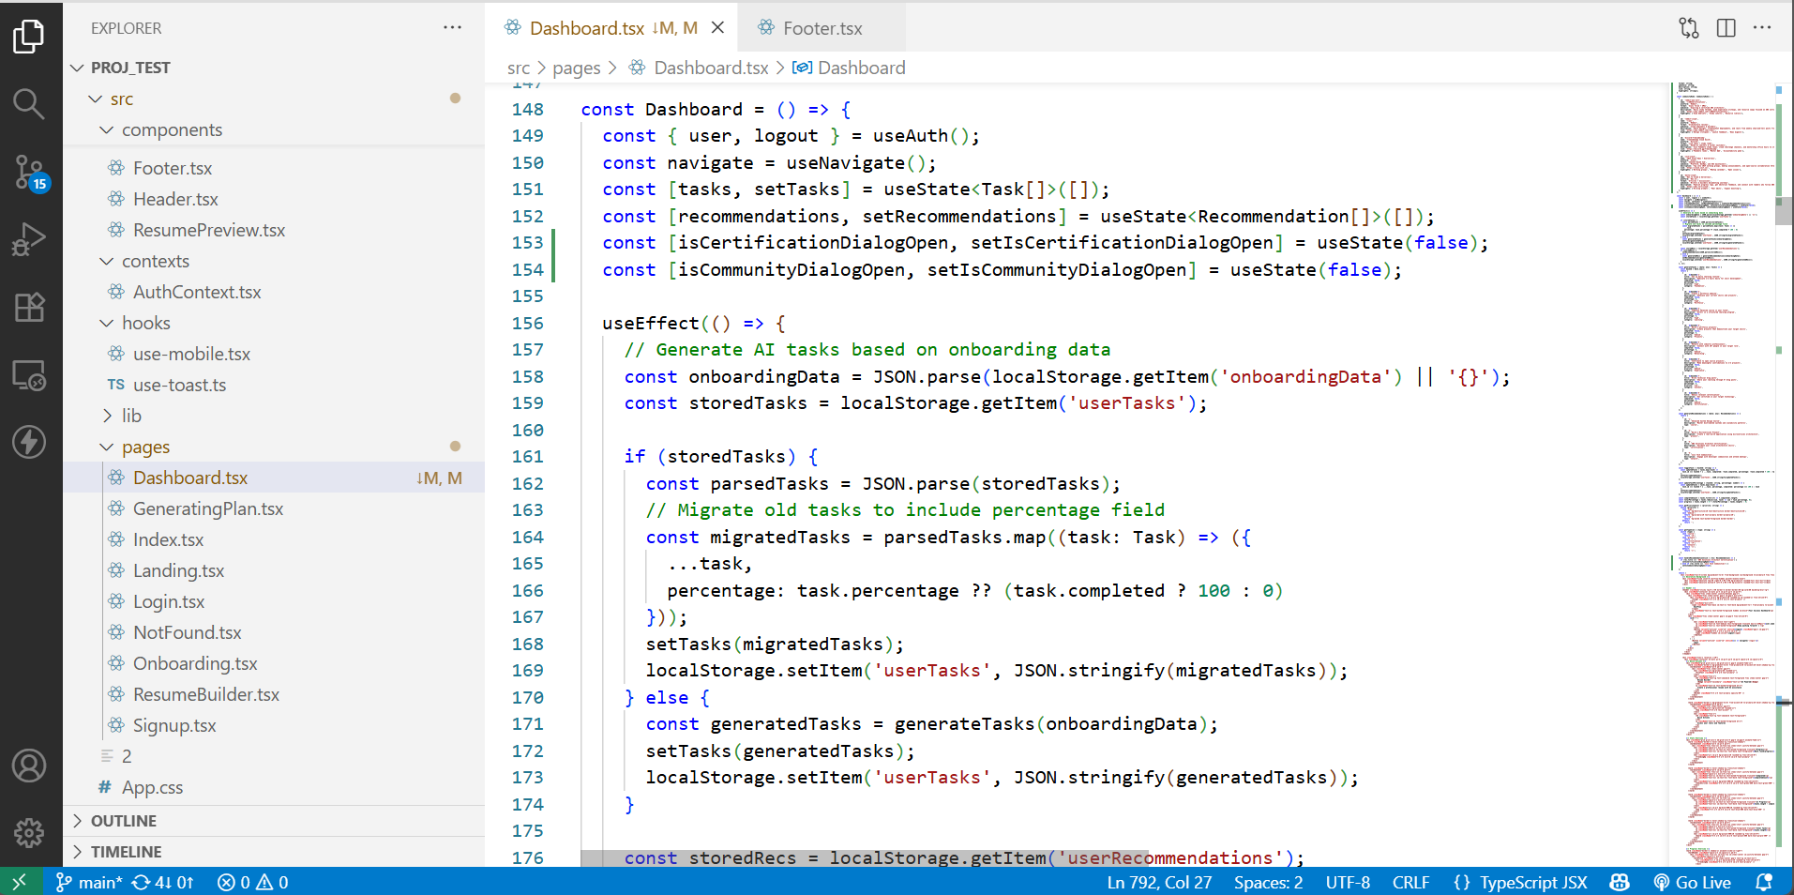

ResumeBuilder.tsx:
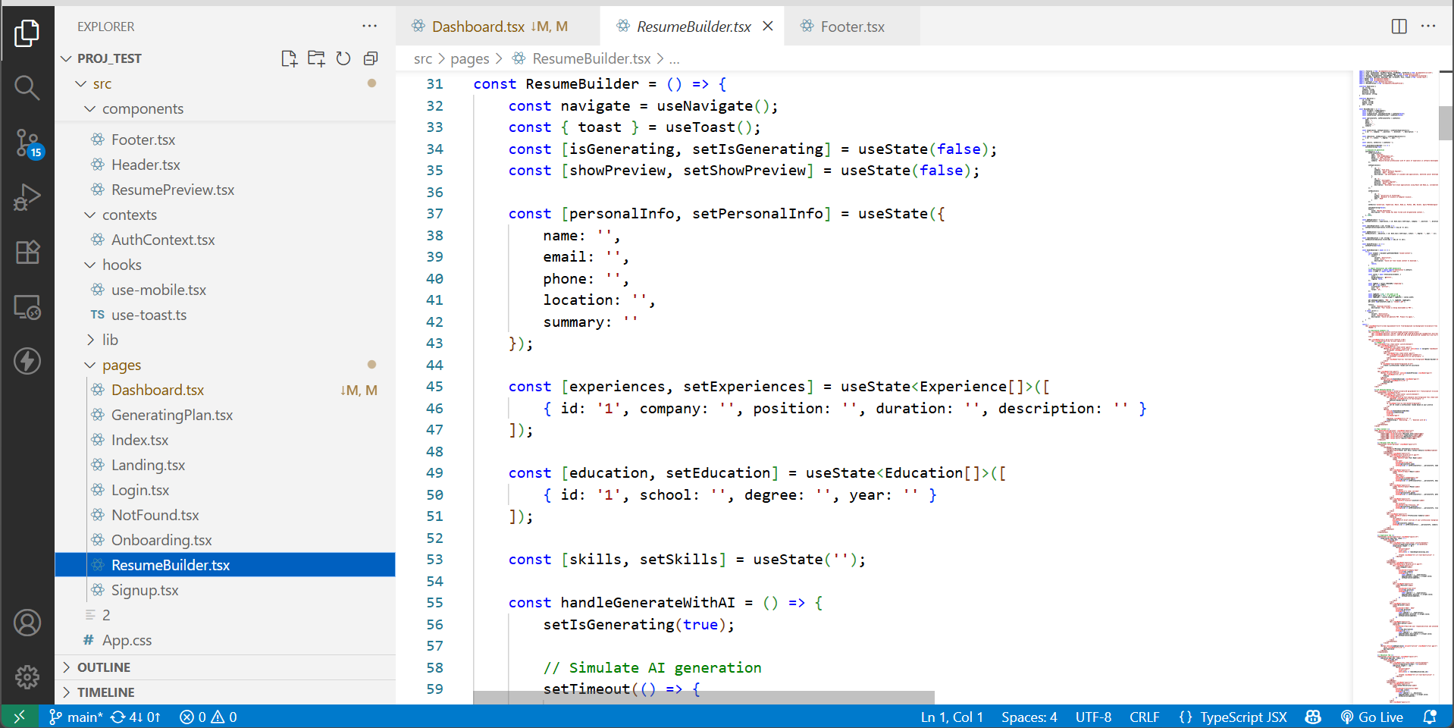

GeneratingPlan.tsx:
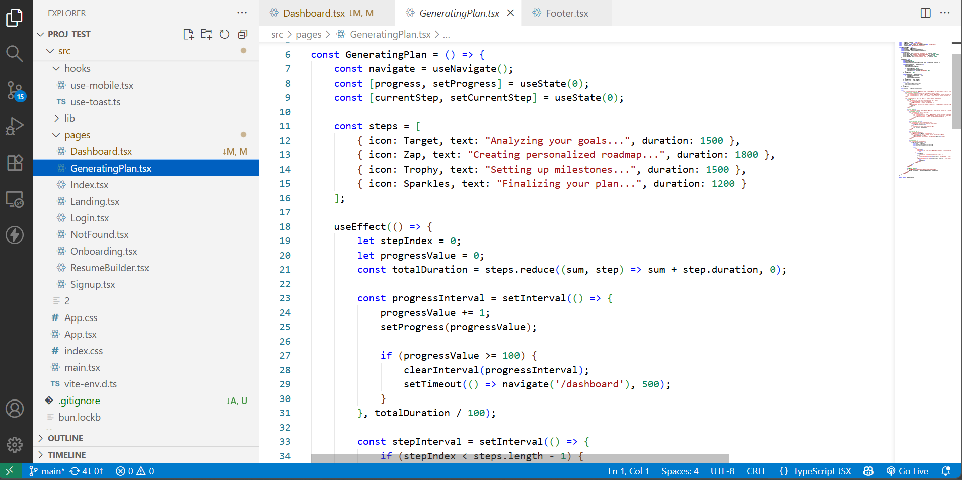

20. References
1. Bloom, B. S. (1984). The 2 Sigma Problem: The Search for Methods of Group Instruction as Effective as One‑to‑One Tutoring. Educational Researcher.
2. Pane, J. F., Steiner, E. D., Baird, M. D., & Hamilton, L. S. (2017). Informing Progress: Insights on Personalized Learning Implementation and Effects. RAND Corporation.
3. Luckin, R., Holmes, W., Griffiths, M., & Forcier, L. B. (2016). Intelligence Unleashed: An Argument for AI in Education. Pearson.
4. OpenAI API Documentation, 2025.
5. Hugging Face Transformers Documentation, 2025.

